**Before diving into the first of three topics that will be presented in this paper I would like to preface it by giving some preliminary information about Nepal regarding UNOOSA & ICAO. First of all starting with Nepal’s space program, or rather, lack thereof. Being in the same economical category as countries such as Haiti, it is easy to see that Nepal has struggled in the past financially and continues to do so especially with recent catastrophic events. Due to this fact Nepal has not had the easiest time attempting to develop a space initiative (not without lack of trying). The Nepal government has no ministry devoted to science of this type and therefore has no history of being part of any organization dealing with space. If things ever stabilize a future attempt to further any space development or research may be made but until that happens Nepal will mainly be offering ideas and opinions on how to go about adjusting policies and looking at different perspectives in regards to space activity.**

**The first topic at hand is ‘the environment and space activity’. Currently Nepal has not launched anything into space so far including any satellites. We believe that protecting the space environment will be extremely important for a sustainable future as we have first-hand proof what happens when we as a people do not clean up after ourselves. Sedimentation and the discharge of industrial effluents are polluting Nepal’s waters, along with deforestation leading to floods and soil erosion. Clearly we physically can’t deforest space, however the point still stands which is: we as a people need to clean up after ourselves if we want to help to create a sustainable future in space. This is why launching up countless satellites and debris into space is a danger to not only the environment but any astronauts trying to exit earth’s atmosphere. As Nicholas Johnson stated, “the greatest risk to space missions comes from non-trackable debris. Clearly some sort of regulation mechanism must be implemented to prevent countries that DO have an effective space program to launch countless objects into space.**

**Second on the list is ‘the militarization of space and international law’. Much like the previous topic, Nepal does not have an army that is of any certain significance. One of the biggest concerns with any form of space militarization for countries around the world is that of a sort of cold war scenario in which a space arms race begins and all countries involved in this would be such exceptional threats that earth could potentially be wiped out if a trigger was pulled. Of course Nepal in its current state is not a contender for such an arms race, however, we believe that a catastrophic situation like that would be lethal to any country that is not a military powerhouse and should be avoided by any country that does not want to get caught in the investable crossfire of a situation like that. This fact rings even more true when considering not only will these country’s citizens be put into danger directly by the weapons used but if a satellite or space-based object is targeted this could affect the innocent people of earth or a civilian ship in a potentially greater danger. Nepal believes that to protect the ‘little guys’ we must be very cautious of what degree this space militarization reaches, if it should even exist in the first place.**

**Finally, the last topic to discuss is ‘space commercialization'. There is much to consider when talking about the topic of space commercialization. The first thing that comes to mind is the safety concerns if space tourism becomes a public convention. This holds some risks but also some great rewards if it can be successfully implemented. The ability to send a civilian into space simply for recreational purposes shows extreme progress in the ability to colonize space and celestial bodies. The moon, for example, is the one we are reaching quickly. The ESA has been pushing these plans to create a permanent outpost for humans on the moon. Although this has many benefits as the non-renewable resources of earth are noticeably declining it is always good to look at a backup plan, the issues is raises are just as relevant. The pure amount of resources it will take to initially colonize and also sustain that environment could be much higher than estimated. Nepal is a country where many citizens would not be able to afford the inevitable costs of living on the moon, this leaves whoever cannot afford this on earth with rapidly depleting resources. Although moon colonization is a very interesting topic it must be discussed very carefully to ensure all members of all countries have a fair shot. This is especially confusing due to the law that no one can own a planet or other celestial body so the moon would not belong to any country in specific after it is colonized. Another market that would open is that of asteroid mining. Since we will need another source of energy and other resources we will have to search outside earth and into the stars. This leads us to asteroid mining. The issue the delegation of Nepal has with asteroid mining is that a situation synonymous to Nepal’s, in which the environment is being destroyed just for resources, is not an unlikely one. If all the world has to get its resources from asteroids simply in our immediate area we could easily lose another source of energy quickly while simultaneously ruining the environment for future generations. Providing a fair, sustainable future in space is the goal of Nepal in this committee and even without the manpower or industrial base to contribute to the construction of this space metropolis, we hope to help regulate and ensure that all of the proper rules are followed and we end up with a society more fair, and more sustainable than the one constructed on earth.**

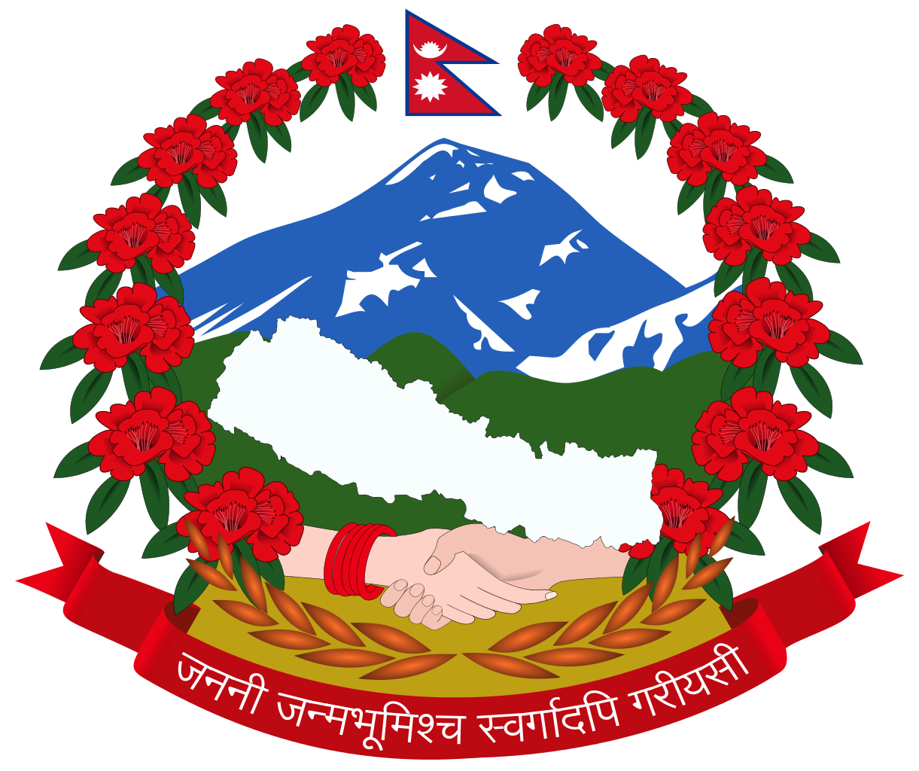

**Nepal**

**United Nations Office of Outer Space Affairs & International Civil Aviation Organization**