*Position Paper for the National Football League Committee*

The issues before the National Football League (NFL) are:

1. Concussions and Head Safety
2. Expansion
3. Players and Criminal Offenses

In general, Mr. Dean Blandino is of new school thinking, but also believes in respecting the old school. However, this is not to say this delegation does not have some innovative ideas to “tackle” these issues. His progressive work in the instant replay and technological division of officiating led to his position as **Senior Vice-President of Officiating**, and this delegate is exited to apply this forward thinking towards the topics at hand.

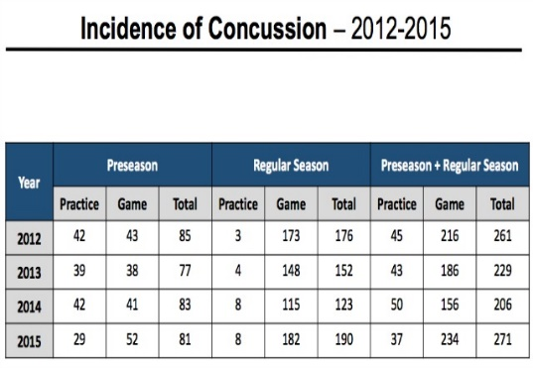**Topic 1:** Mr. Blandino recognizes the grave importance of the issue. With the massive amount of publicity directed towards concussions in football, there has been an information revolution in this aspect of the game, especially in the aftermath of the Hollywood blockbuster, “Concussion”. The changes the NFL has made in the past couple of years are definitely steps in the right direction. Recent rule changes, establishment of concussion protocols, return to play procedure, and neutral physicians are definitely steps in the right direction (NFL Operations, n.d.). While the number of diagnosed concussions spiked last year, it must be remembered that this does not mean the total number of head injuries have gone up, but rather that the NFL has been diagnosing earlier and more frequently. Evidently, the financial (player compensation) and public backlash about head injuries has sparked a change in philosophy. With that said, Mr. Blandino’s position is clear: player safety is the utmost concern of the National Football League, but any policy changes cannot compromise the integrity of the game (Blandino, 2013).

The first place where action must be taken is right on the field, and which rule changes can move towards the goal of minimal head injuries. Firstly, Mr. Blandino would like the personal foul associated with hits on a defenseless player to adopt the same name and punishment currently used in college football, which is an automatic ejection (if the foul occurs in the second half, the player must sit out of the first half of the following game) for the foul of “targeting” (Florio, 2016). Moreover, the foul of “targeting” should be expanded to include any initiated head contact in plays not involving the ball as this aims at decreasing injuries on blocking plays. Also, this delegate hopes to request an official point of emphasis on ball-carriers initiating contact with the crown of their helmet in an aggressive manner. In addition, any ejected player must have a disciplinary hearing in the following week before a committee comprised of neurologists, ex-players, and NFL officials, where supplementary action may be handed down based on factors such as intention and context of the play, victim’s injuries, and repeat offenses. Lastly, Mr. Blandino has historically lobbied for more officials and technology involved in the game (Schultz, 2016), so this delegate would like to add an eighth official in the booth with access to instant replays, and direct communication with the head referee. This official would have the power to pause the game in 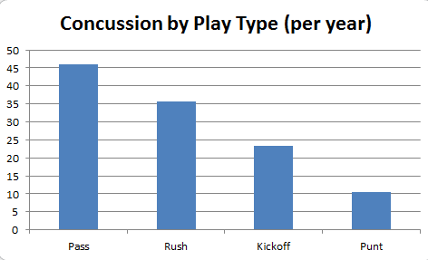order to assess “targeting” or “unnecessary roughness” penalties that were missed or impossible to see by the on-field officials, again in the hope of eliminating away from the play injuries. This goal also leads to the final policy proposal in revamping how the kickoff works. The receiving team can either choose to receive a kickoff or place the ball at their own 30-yard line. This would lead to more offense, and everyone knows that “offense sells”, as well as not compromising the integrity of the game as the kickoff would not be eradicated.

Moving on to the sideline once a concussion has happened, Mr. Blandino applauds the efforts taken this past offseason towards neutrality and the use of technology when dealing with on-field injuries, such as the appointment of an independent spotter not on field level and pocket devices for independent neurologists with which to administer concussion tests (NFL Operations, n.d.). As the rules are fairly new, Mr. Blandino would like to give them some time to see if they work in ensuring no player is on the field unless they pose no risk to their long-term health. However, this does not mean that this delegate believes there can be no policy that can supplement these rules. As seen with the Case Keenum incident last season when he came back into the game despite obvious evidence he was not healthy, teams do not always adhere to the rules, despite how neutral the process is. As such, this delegate, to the chagrin of the owners surely, would like to propose that the committee come up with some type of reprimand scale for teams that are found to have violated any rules, ranging from fines to forfeiture of draft picks.

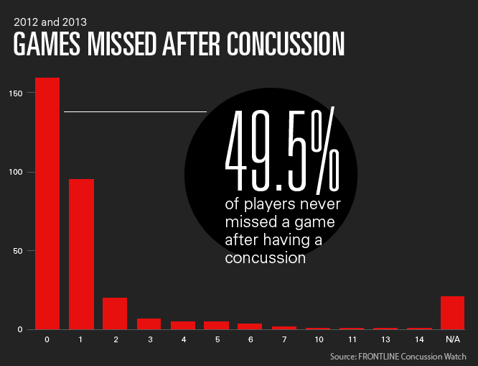Lastly, in the front office, there are administrative actions that can be taken in order to contribute to the NFL’s agenda of eliminating head injuries. Firstly, Mr. Blandino would appreciate increased funding to the Head, Neck and Spine Committee, specifically to the Subcommittee on Safety Equipment in order to design better equipment. Secondly, this delegate believes there is room to improve regarding the concussion protocol established this past offseason a player must enter after having being diagnosed that requires clearance from an independent neurologist at least 24 hours prior to game time. Some minor changes that are proposed are that any players who even show early signs of concussion or disorientation during or after a game must enter the protocol, and that players must require separate clearance to practise and to play. However, this delegate would like to propose a major change that again owners will oppose. This is to mandate that players who have any concussion history are not eligible to play the following week (if the next week is their bye week, then that will be the week missed) if they ever re-enter. There is much scientific evidence displaying that premature returns to action only lead to greater susceptibility, severer symptoms, and increased risk to long-term health (Dias Jr., 2015). Therefore something must be done to address this concern. However, there would be an amended rule in the postseason as the player would require the approval of three separate neurologists to play, as to not compromise the competitive integrity of the game.

**Topic 2:** Mr. Blandino is very excited at the opportunity to discuss expansion of the NFL. As a proponent of technology and an advocate for officials, Mr. Blandino would like to propose the following actions in terms of team movement:

1. Relocation of the Oakland Raiders to Las Vegas
2. Awarding of a second NFL franchise to Chicago
3. Awarding of an NFL franchise to either St. Louis or San Antonio

Firstly, Mr. Blandino has extreme reservations on international expansion. The only three viable international options (Mexico City, London, Toronto) all present various challenges and high risk. The initial point that must be made is that the name of the game is American Football. While success (excluding Toronto) in one-off games might function as a novelty, sustained attendance and dedication, especially during the initial brutal years of expansion will be hard to sell to a fan base not devoted and invested in or to this sport. Secondly, as a representative of the officials, Mr. Blandino must be hesitant on sending referees to potentially volatile venues. Estadio Azteca and Wembley Stadium are notorious as two of the most dangerous places for a soccer game. And in the past two iterations of the Major League Baseball and Major League Soccer playoffs, Toronto fans have thrown projectiles onto the field at umpires and players alike. What is more worrisome is that football is unique to other sports in the tailgate atmosphere, which as a by-product includes increased alcohol consumption, prompting increased fears of unruly and dangerous behaviour. Lastly, logistics such as time differences, taxation laws, economic conditions, language barriers, all pose difficult barriers. Therefore, why not just bypass all of it and instead focus on where the devoted fans lie?

Now that the case has been made for domestic expansion, here is the thought process behind this plan for relocation proposed by this delegate. Firstly, it is essential for business that the Oakland Raiders relocate to Las Vegas as soon as the new proposed stadium is built. The Oakland Raiders are last in league revenue (Statista, 2015) in an ageing venue, struggling to sell seats even with a team that’s leading its division, and sucking revenue out of the nearby San Francisco 49ers. This new stadium, located in prime real estate on the strip, would be home to a state-of-the-art stadium whose funding proposal is sustainable once Nevada passes the new hotel tax (Marroquin & Spousta, 2015). This stadium would be the perfect host for future Super Bowls, Pro Bowls, and complimentary to the new NHL franchise there. As well, the novelty of the franchise, and the allure of the destination should offset any struggles on the field for the first couple of years until the franchise can find its footing.

As for expansion, this delegate firmly believes in Chicago’s ability to support a second franchise. Firstly, Chicago, the NFL’s third biggest market, already boasts two successful MLB teams. As well, the elderly Soldier Field has a soon-to-be expiring lease, and a new stadium in downtown Chicago would be a hard financial burden for the Bears to hold. A second franchise would help shoulder the costs, and this stadium would allow Chicago to finally be able to host marquee events like Super Bowls, especially after proving cold-weather cities like New York can do it in a new stadium. Lastly, any fears over a split of the market or Bears loyalty are unfounded as even a 50/50 split of the fan base still puts each team would sin the top ten largest fan bases, as well as the Bears lack of recent success on the field signalling the need for some rejuvenation.

Lastly, this delegate would like to bring back the NFL to St. Louis after the Rams departure to Los Angeles this past offseason. However, the prospective ownership group would have to address the same concerns that prompted the last one to leave: stadium and ticket sales. There would need to be a clear financial plan laid out with a large sum of committed money to prove that a stadium can and will be built without starting off with too big of a deficit, or putting a strain on local and state government. Also, there would have to be a successful season and single game ticket drive with at least 80% of all seats sold, to ensure there is no repeat of the final Rams season when they finished last in overall attendance.

If this is not possible, there is a more than capable backup in San Antonio. This city, almost equidistant from Dallas and Houston, would be an ideal location for expansion. There are an abundance of football fans available all over Texas, and San Antonio would be able to pull from Austin, Houston suburbs, Dallas suburbs, as well as the San Antonio faithful. Combined, this franchise would begin with a fan base already in the top five largest in the league. They would play in the excellent venue that is the Alamodome, which is in such good condition due to a lack of tenants. The city has proved it can sustainably support a franchise, as seen by the revered San Antonio Spurs of the NBA. Therefore, no matter when the league is ready to expand to Chicago, it will not be in need of a second expansion team.

Lastly, the need to expand with two teams is simply for logistics. Under the proposed model, the second Chicago team would join the AFC and the other team the NFC. As for the schedule, this would be the opportunity for the NFL to switch to a more modern conference system. The most logical model for this is that each team would play each other team in the conference once, and the playoff format would stay the same, except that seeding would be based on record. This is again to Mr. Blandino’s preference in honouring the old school (baseball has rare interleague games) and the new school (modern system). This format would also take away the advantage of teams in weak divisions.

The sole drawback to expanding two teams at once is the on the field struggles the team might have in the first couple of years. However in football, because of the quick turnover rate of team rosters, this effect is less pronounced. The success of the expansion teams will probably rely on creating some sort of success within a reasonable timeframe. As such, an expansion draft similar to the NHL that greatly limits the amount of protected players is preferable. As well, the franchises will be awarded the first two draft picks in each round of the entry draft. There is a lot of enthusiasm on behalf of Dean Blandino in support of this expansion plan.

**Topic 3:** Last but not least, the topic of players and criminal offenses is not something Mr. Blandino takes lightly. As an impoverished child growing up on Long Island, Mr. Blandino has seen both sides of the coin. If the recent case of Josh Brown proves anything, it is that there needs to be some type of reform to domestic violence policies. As well, the league’s ambiguity and lack of transparency concerning substance abuse calls for some immediate change.

Firstly regarding player conduct, Mr. Blandino sees two key areas where the league can improve their stance: prevention and punishment. The time is long overdue for a culture change in the NFL that refuses to condone any inappropriate behaviour. This starts right at the NFL Entry Draft by mandating that anyone declaring for the draft complete sensitivity and awareness training (Waldron, 2014). This breeds an educated and cultured next generation of football players.

On the field, player hubris must be toned down. This is a job and players should be required to exhibit some form of professionalism. The hooliganism that is seen from week to week in ridiculous celebrations on even the most routine of plays need to be addressed. Mr. Blandino is appreciative of the new rule that ejects a player after two unsportsmanlike conduct fouls and wishes that officials enforce taunting penalties as a point of emphasis. Also, Mr. Blandino has stated in the past the NFL could follow suit like the NCAA and change taunting into a live ball foul which would negate any scores off the play. For example, just this past week, Golden Tate felt the need to mock his opponent when ending the game in overtime by carelessly flipping into the end zone for the game-winning touchdown. Under this proposal, that score would have been taken away and Detroit would have gotten the ball 15 yards from the previous spot on a repeated down.

Lastly, there needs to be a discussion with the NFLPA in the next collective bargaining sessions to create a new system of reprimand for players who violate the personal conduct policy. The main issue seems to be the controversy created when one person is judge, jury, and executioner. Therefore, it is better for all involved to create a committee that issues punishments that can set precedents for future cases. As well, bringing meaning to the lifetime ban by eradicating the commissioner’s exempt list is also a possibility, but as the most powerful man in corporate, and Mr. Blandino’s boss, it is necessary to tread carefully with Roger Goodell.

Finally, regarding the issue of substance abuse, this is something Mr. Blandino will not stand for as it directly interferes with the integrity of the game. When PEDs go unaddressed, a situation like the MLB happens. This is not what the fans or the league want to happen. This delegate believes in a blanket testing and punishment policy, instead of this case-by-case basis that is in effect right now. Special treatment of leverages found in contracts of higher-paid players creates a culture of elitism and favoritism that is not what the league wants to portray to the public. Simply put, you cannot buy less tests or softer punishments.

Secondly, regarding the science behind drug testing, Mr. Blandino would like to request that there be funding provided into research into the most effective and efficient ways of testing players. As a proponent of technology, Mr. Blandino would like to examine the plausibility of instant results, mobile testing sites, less intrusive methods, and modes of testing that do not necessarily need to happen so stringently. If the answer is out there in science, why not find it?

Lastly, this is the one area where punishments do not need to be handed out on a case-by-case basis, but rather off a predetermined scale of how many offenses you previously have and the type of substance. The current scale does not have set amount of games to be suspended, which leave it open to subjective interpretation when the issue is not subjective at all. It is very simple to mandate that anyone caught using a PED is suspended for half a season for the first offense, an entire season the next offense, and an *actual* lifetime ban the third time. For recreational drugs, there must be games missed on the first offense, and it needs to be standardized as to not create controversy. A similar scale proportional to the PED proposal can be designed, with a bigger emphasis on rehabilitation. Mr. Blandino would like to propose a state-of-the –art rehab facility to be built that is paid for by offending players or private patients and sponsors. Therefore the league can look to benefit both themselves and society as a whole with one swift action.

# Works Cited

Blandino, D. (2013, September 12). The Technology of NFL.com with Nicole Lapin on "Bloomberg West". (N. Lapin, Interviewer) Retrieved from https://www.youtube.com/watch?v=OBnDRUCpizY

Dias Jr., C. (2015, September 30). *The Long-Term Effects of Concussions on NFL Players*. Retrieved from Forbes: http://www.forbes.com/sites/carlosdiasjr/2015/09/30/the-long-term-effects-of-concussions-on-nfl-players/#bc7083321101

Florio, M. (2016, September 14). *Why Doesn't the NFL have a targeting rule like college?* Retrieved from Pro Football Talk: http://profootballtalk.nbcsports.com/2016/09/14/why-doesnt-the-nfl-have-a-targeting-rule-like-college/

Marroquin, A., & Spousta, T. (2015, September 2016). *Las Vegas committee sends Raiders stadium plan to governor*. Retrieved from Review Journal: http://www.reviewjournal.com/business/stadium/las-vegas-committee-sends-raiders-stadium-plan-governor

NFL Operations. (n.d.). *Health and Safety*. Retrieved from National Football Leaue: http://operations.nfl.com/football-ops/nfl-ops-honoring-the-game/health-safety/

Nielsen, J. (2013, October 31). *Dean Blandino: NFL may take a look at nullifying TDs that involve taunting*. Retrieved from Denver Post: http://blogs.denverpost.com/broncos/2013/10/31/dean-blandino-nfl-may-take-a-look-at-nullifying-tds-that-involve-taunting/22908/

Schultz, M. (2016, November 4). *8th official, full-time zebras, and expanded replay are still on the table*. Retrieved from Football Zebras: http://www.footballzebras.com/2016/11/04/8th-official-full-time-zebras-and-expanded-replay-are-still-on-the-table/

Statista. (2015). *National Football League revenue by team in 2015* . Retrieved from The Statistics Portal: https://www.statista.com/statistics/193553/revenue-of-national-football-league-teams-in-2010/

Waldron, T. (2014, August 28). *The Hidden Problems With The NFL’s New Domestic Violence Policy*. Retrieved from Think Progress: https://thinkprogress.org/the-hidden-problems-with-the-nfls-new-domestic-violence-policy-36931200bf34#.v8jtty5kg