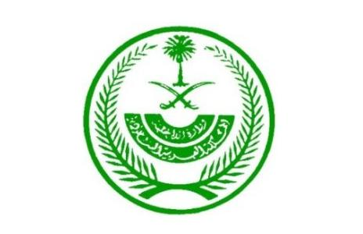

Saudi Arabia Delegation Position Paper

By

Renato Araujo

As Saudi Arabia when it comes towards the issue on Governance and its education we have a very close relationship to the schooling system; we only have 9 periods a week where we teach children of our religion. In our universities we have 23 periods a week of Mathematics, the Sciences, Social Studies, Arabic Language, English Language and Physical Education. Our government and monarchy has a very close relationship with our schooling system with it being a must to teach the Qur’an. We as well believe that we should not help refugees such as those of Syrians who are still under the reign of Bashar al-Assad, until then we shall not provide them asylum nor education. This is because of the conflict; yes for some they are Sunni however many of the Sunni areas of Syria are serving or have served for the Islamic State. Our government is slightly corrupt because it is over seen my a monarch whom is very controlling and we Saudi Arabia have yet to have the freedom of information law. We believe we must be open in what we do and where we spend our money and to be slightly open to our people however we must have our government control most of the funding of programs as well as we must remove Bashar al-Assad so that we may take refugees to educate them.

We believe a World Heritage site selection process should change to let any site that is of huge importance to that country to be considered a world site for we should not allow them to be destroyed or damaged like what happened in front of the Prophet’s Mosque in the city of Medina. The process should be quickened so that sites may be protected from any threat. On climate change we are torn for our need of oil as a resource to maintain our economy however we plan in the near future to no longer be dependable on oil; which is detrimental to the effects of climate change however we are very vulnerable to the adverse effects of climate change. Climate change should be acted upon by having it so it stays a steady level so that countries like ours may have water to drink as well as to save our glorious world cites which with the change in climate will start to erode the sites albeit natural or man-made. A way of doing this is to start to use solar energy for energy supply and need as well as limits on the amount of power that can be used by consumers.

The topic of Supporting and Accomplishing Education 2030 seems to us as unreasonable. As one of the goals is that “girls and boys are complete free, equitable and quality primary and secondary education leading to relevant and Goal-4 effective learning outcomes” however in our country women are not even free to make their own decisions without their male guardians consent; it is stated that “it must be cohesive with the local communities”, Education 2030 is being delivered to yet it would not work well with the social customs of our regions. We do have schooling for women although it is rare to see that they attend due to how the Qur’an does not encourage women to obtain a prominent position. We believe that SDG 4 should be done however with knowledge that it must work with the laws of countries and should not interfere with how society works.

The Delegation of Saudi Arabia,

Renato Araujo