Mexico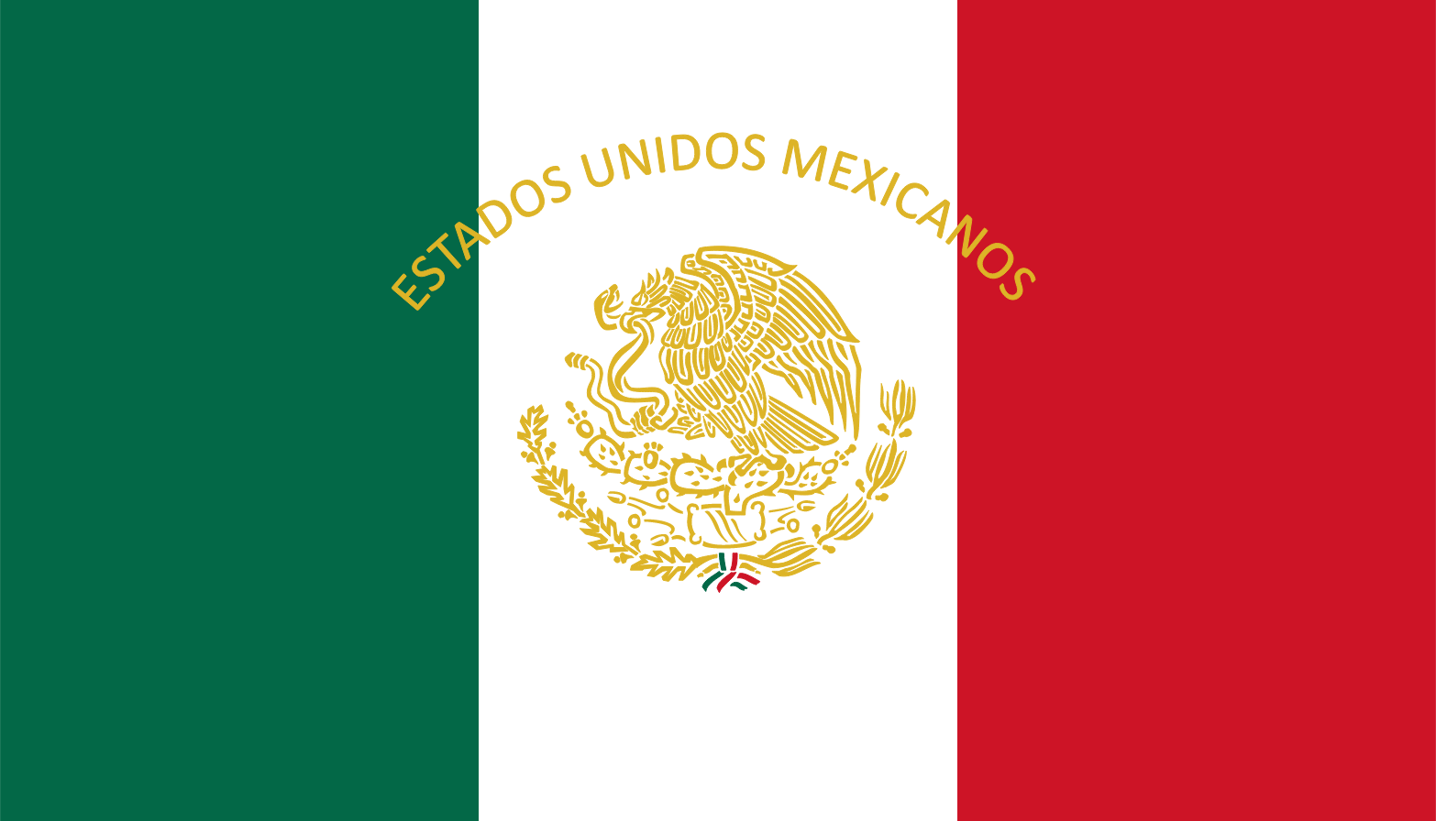

Mia Zang

UNESCO

Topic 1: Governance and its Effects on Education

According to the World Bank, “good governance in education systems promotes effective delivery of education services.[1] In order for governance to have an effective impact on education, several factors regarding a country’s situation must be considered, two of the most important being corruption and political stability, as well as the education system itself. Working together with other United Nations programs such as United Nations Office on Drugs and Crime (UNODC)[2] and United Nations Convention Against Corruption (UNCAC)[3], UNESCO has attempted to solve the issues surrounding governance and its effects on education. However, further action must be taken to decrease levels of corruption and promote political stability in order to universally improve education systems.

The delegation of Mexico, according to Transparency International, is ranked 95th out of 168 countries in terms of corruption.[4] The rampant levels of corruption are primarily due to the “violence and security problem that seriously undermines the rule of law and democracy, and social cohesion as a challenge for democracy”.[5] Specifically pertaining to Mexico’s system of education, it is over-unionized and spends wastefully.[6] President Pena Nieto has made effort to reform the public policy, but due to the lack of political stability, while he has had some impact, has lacked public support.[7] In 2013, Mexico passed an education reform bill, with the purpose of weakening powerful teacher unions in order to develop a meritocracy within the profession.[8] In order to break up the powerful teacher union, Mexico implemented the decentralization of education, giving states the power to decrease corruption within the system.[9] Since 1950, total Mexican student enrollment has increased from 3.25 million students to 28.22 million students in 2000.[10] However, while the quantity of Mexican education is above average in comparison to all PISA democracies, the quality of the education falls below average.[11]

In order to curb corruption, both within and outside of the education system, promote political stability, and improve the overall quality of education, Mexico supports the idea of promoting UN run programs to intervene in an effort to resolve these universal issues. Mexico recognizes that each nation has different levels of corruption and political instability, and therefore suggests that UNESCO works to create organizations to go into the nations with the highest levels to disband corrupt governments and instability through promoting democracy. In order to regulate each nation’s internal affairs, Mexico suggests that the policies of UNODC and UNCAC are enforced more strictly or would support the creation of a new program which would further implement and support these policies. To make education more available to refugees and during unstable times, Mexico proposes the creation of a UN funded, non-profit educational program to go into countries that lack a certain level of education, which these countries would be required to accept. In regards to improving education for nations which do not fall under these circumstances, Mexico suggests that a certain percentage of a nation’s GDP be required to go towards education, and that education becomes decentralized in order to decrease corruption. Other than corruption and political instability, nations can look to their percentage of employment and the division of wealth to see if they have reached good governance. Mexico, although faced with a large gap of division between the wealthy and poor, is looking to minimize the difference and equalize the distribution of resources, and suggests that other nations do so as well in order to promote good governance and decrease of corruption.

Works Cited

"Convention against Corruption (CAC)” United Nations Office on Drugs and Crime. Accessed May 31, 2016. https://www.unodc.org/unodc/en/treaties/CAC/. 9

E.V., Transparency International. "Thank You for Donating To Transparency International!" Transparency International. Accessed October 31, 2016. http://www.transparency.org/country.

Lewis, Maureen. "Governance in Education: Raising Performance." *World Bank*, December 22, 2009. Accessed October 31, 2016.

News, BBC. "Mexico's Pena Nieto Enacts Major Education Reform." BBC News. February 26, 2013. Accessed October 31, 2016. http://www.bbc.com/news/world-latin-america-21582629.

Philip, George, Jorg Faust, and Martin Thunert. "SGI Indicators Sustainable Governance." 2015. Accessed October 31, 2016. http://www.sgi-network.org/docs/2015/country/SGI2015_Mexico.pdf.

wespicks. "Education in Mexico ." WENR. Accessed October 31, 2016. http://wenr.wes.org/2016/08/education-in-mexico.

Zimmermann@stlouisfed.org, and World Bank. "Democratic Governance in Mexico : Beyond State Capture and Social Polarization." Democratic Governance in Mexico : Beyond State Capture and Social Polarization. Accessed October 31, 2016. https://ideas.repec.org/p/wbk/wboper/7689.html.

Mexico

Mia Zang

UNESCO

Topic 2: Preservation of World Heritage Sites

According to the World Heritage Committee, in order “to be included on the World Heritage List, sites must be of outstanding universal value and meet at least one out of ten selection criteria.”[12] Recently, many of the World Heritage Sites have been threatened due to war, natural disasters, pollution, poaching, uncontrolled urbanization, and unchecked tourist development.[13] Although the World Heritage Committee is attempting to curb the damage, such as establishing a list of World Heritage Sites in Danger which can receive immediate assistance from the World Heritage Fund[14], more needs to be done in order to ensure the preservation of these important sites of cultural value.

The delegation of Mexico is currently sixth in the world for number of World Heritage sites, with 33 sites in total.[15] In order for a site to become an official World Heritage Site, it is required to go through a comparative analysis, an inconsistent process amongst other countries because the World Heritage Committee does not use a universal scale.[16] Mexico has an extensive amount of tentatively listed sites, which all must go through the comparison process to be officiated, and are on average compared to 1.70 other sites, an average which pertains only to Mexico and varies between each country.[17] To protect its official World Heritage sites, including the Historic Center of Mexico City and Xochimilco, Mexico has passed several laws ensuring the preservation of the sites, such as the 1986 Federal Law on Monuments, A[rchaeological, Artistic, and Historical Zones](http://www.unesco.org/culture/natlaws/media/pdf/mexico/mx_fedlawmontszones1986_spaorof.pdf), and more recently, the 2001 Federal Law on National Properties.[18] Although these laws are beneficial to the preservation of the sites, they are dated and therefore, Mexico would look favorably upon the creation of new laws, both domestic and universal.

The delegation of Mexico is an advocate for improving upon the selection process of World Heritage sites, as well as the preservation of these sites in both stable and unstable regions. To improve the selection process of the sites, Mexico would look favorably upon the creation of a universal system. Although all tentatively listed sites must go through a comparison process, the process itself is not uniform amongst all nations. Mexico suggests the implementation of a more strict list of criteria and comparison process, where every tentative site from any nation must undergo the exact same process. This universal system would result in a more systematic selection process, thus improving the effectiveness of the World Heritage Committee. To entice private interests to cooperate in the preservation of sites, Mexico suggests the implementation of a penalty tax on private companies which put cultural sites at risk, whether because they have built up surrounding areas or have released toxins within a certain proximity of the site. To maintain balance between private interests such as tourism and the preservation of sites, Mexico suggests limiting the number of visits to sites as to control the population at the site. For sites in unstable regions, Mexico suggests the creation of a law which would make the destruction of any World Heritage site illegal and heavily punishable. This would hopefully prevent any attacks on the sites, therefore preserving their cultural integrity.

Works Cited

Centre, UNESCO World Heritage. "The Criteria for Selection." UNESCO World Heritage Centre -. Accessed November 03, 2016. http://whc.unesco.org/en/criteria/.

Centre, UNESCO World Heritage. "Mexico - UNESCO World Heritage Centre." Mexico - UNESCO World Heritage Centre. Accessed November 03, 2016. http://whc.unesco.org/en/statesparties/mx.

Centre, UNESCO World Heritage. "World Heritage in Danger." UNESCO World Heritage Centre -. Accessed November 03, 2016. <http://whc.unesco.org/en/158/>

"Chapter 4 Deconstructing World Heritage Site Selection." Accessed November 3, 2016. http://www.rug.nl/research/portal/files/9836835/c4.pdf!null.

Mexico

Mia Zang

UNESCO

Topic 3: Supporting and Accomplishing Education 2030

According to UNESCO, “education is a human right for all throughout life and that access must be matched by quality.”[19] The Education 2030 agenda has been supported by the Sustainment Development Goal 4, which states, “Obtaining a quality education is the foundation to improving people’s lives and sustainable development.”[20] While much progress has been made in this area, in undeveloped regions and for women and girls, there is still difficulty involved in making a quality education accessible.[21] Through the Education 2030 Framework for Action, FFA, UNESCO aims to “Ensure inclusive and equitable quality education and promote lifelong learning opportunities for all.”[22] However, a lack of universal standards in terms of education, as well as lack of funding has made it difficult to reach equal levels of education across the globe.

Mexico’s educational system is divided into three categories: Educación Basica, or primary education, Educación Média Superior, or secondary education, and Educación Superior, or higher education.[23] According to UNESCO, [gross enrollment ratio](http://www.uis.unesco.org/DataCentre/Pages/country-profile.aspx?code=MEX&regioncode=40520) at the secondary school level has increased from just 54 percent in 1991 to 90 percent in 2014.[24] Education in Mexico is universal for anyone between the ages of 5 and 14, but even with a growth of education enrollment, Mexico still has one of the smallest proportions of 15-19 year-olds enrolled in education (53%) among OECD and partner countries.[25] Mexico is working to further increase enrollment through the PRONABES Program, which aims at making tertiary education more accessible through the creation of scholarship programs, the redefinition of criteria to enroll, and the encouragement of pursuing a tertiary level of education.[26] In 2011, Mexico spent 5.15% of its GDP on education, which has remained pretty stable since for the past several years.[27]At this time, Mexican President Nieto is working to still increase in quality and accessibility of education, especially in less developed regions of the nations.

Mexico is a strong advocate for the improvement and enforcement of Education 2030. To create a bigger impact on the achievement of Education 2030, Mexico supports the idea of the contribution of developing countries contributing to the program through working together with international organizations and NGOs to make the effects of Education 2030 more present in their nations. With the aid of organizations such as UNDP and ILO, developing nations can work to improve the quality, equality, and accessibility of education in all regions. Mexico believes that the most effective way to provide quality education to all while still maintaining sovereignty would be to devise a specific level of standards which all countries must abide to in terms of the core curriculum, amount of required education and the accessibility of education to all, but to leave teaching methods and specifics of each curriculum to each individual nation in order to preserve sovereignty. Mexico would advocate to send international organizations with an education focus into underdeveloped countries to promote the standard education in order to ensure that the criteria is being followed in nations which struggle to maintain an equal education of quality. Furthermore, Mexico is a strong advocate of making tertiary levels of education more accessible to all citizens, especially in more developed nations such as itself. As such, Mexico does believe in the creation of an international standard for primary and secondary levels of education which will not infringe upon a nation’s sovereignty, which all countries should be required to meet. Mexico looks forward to working with other nations to improve upon the universal level of education.

Works Cited

“And Incheon Declaration Framework for Action." Accessed November 5, 2016. http://unesdoc.unesco.org/images/0024/002456/245656e.pdf.

Education for the 21st Century." UNESCO. 2016. Accessed November 05, 2016. http://en.unesco.org/themes/education-21st-century.

Education - United Nations Sustainable Development." UN News Center. Accessed November 05, 2016. http://www.un.org/sustainabledevelopment/education/.

"Mexico Increases Access to Tertiary Education." World Bank. Accessed November 05, 2016. http://www.worldbank.org/en/results/2013/07/04/mexico-increases-access-to-tertiary-education.

"Mexico." OECD. Accessed November 05, 2016. <https://www.oecd.org/edu/Mexico-EAG2014-Country-Note.pdf>

Uis. "Education : Expenditure on Education as % of GDP (from Government Sources)." Education : Expenditure on Education as % of GDP (from Government Sources). Accessed November 05, 2016. http://data.uis.unesco.org/?queryid=181.

wespicks. "Education in Mexico ." WENR. Accessed November 05, 2016. http://wenr.wes.org/2016/08/education-in-mexico.

1. Lewis, Maureen. "Governance in Education: Raising Performance." *World Bank*, December 22, 2009. Accessed October 31, 2016.
2. "Convention against Corruption (CAC)” United Nations Office on Drugs and Crime. Accessed May 31, 2016. https://www.unodc.org/unodc/en/treaties/CAC/. 9
3. *Ibid*
4. E.V., Transparency International. "Thank You for Donating To Transparency International!" Transparency International. Accessed October 31, 2016. http://www.transparency.org/country.
5. Philip, George, Jorg Faust, and Martin Thunert. "SGI Indicators Sustainable Governance." 2015. Accessed October 31, 2016. http://www.sgi-network.org/docs/2015/country/SGI2015_Mexico.pdf.
6. *Ibid*
7. *Ibid*
8. News, BBC. "Mexico's Pena Nieto Enacts Major Education Reform." BBC News. February 26, 2013. Accessed October 31, 2016. http://www.bbc.com/news/world-latin-america-21582629.
9. Zimmermann@stlouisfed.org, and World Bank. "Democratic Governance in Mexico : Beyond State Capture and Social Polarization." Democratic Governance in Mexico : Beyond State Capture and Social Polarization. Accessed October 31, 2016. https://ideas.repec.org/p/wbk/wboper/7689.html.
10. wespicks. "Education in Mexico ." WENR. Accessed October 31, 2016. http://wenr.wes.org/2016/08/education-in-mexico.
11. Zimmerman
12. Centre, UNESCO World Heritage. "The Criteria for Selection." UNESCO World Heritage Centre -. Accessed November 03, 2016. http://whc.unesco.org/en/criteria/.
13. Centre, UNESCO World Heritage. "World Heritage in Danger." UNESCO World Heritage Centre -. Accessed November 03, 2016. http://whc.unesco.org/en/158/.
14. *Ibid*
15. Centre, UNESCO World Heritage. "Mexico - UNESCO World Heritage Centre." Mexico - UNESCO World Heritage Centre. Accessed November 03, 2016. http://whc.unesco.org/en/statesparties/mx.
16. "Chapter 4 Deconstructing World Heritage Site Selection." Accessed November 3, 2016. http://www.rug.nl/research/portal/files/9836835/c4.pdf!null.
17. *Ibid*
18. Centre, UNESCO World Heritage. "Mexico - UNESCO World Heritage Centre." Mexico - UNESCO World Heritage Centre. Accessed November 03, 2016. http://whc.unesco.org/en/statesparties/mx/laws/.
19. "Education for the 21st Century." UNESCO. 2016. Accessed November 05, 2016. http://en.unesco.org/themes/education-21st-century.
20. "Education - United Nations Sustainable Development." UN News Center. Accessed November 05, 2016. http://www.un.org/sustainabledevelopment/education/.
21. *Ibid*
22. “And Incheon Declaration Framework for Action." Accessed November 5, 2016. http://unesdoc.unesco.org/images/0024/002456/245656e.pdf.
23. wespicks. "Education in Mexico ." WENR. Accessed November 05, 2016. http://wenr.wes.org/2016/08/education-in-mexico.
24. *Ibid*
25. "Mexico." OECD. Accessed November 05, 2016. https://www.oecd.org/edu/Mexico-EAG2014-Country-Note.pdf.
26. "Mexico Increases Access to Tertiary Education." World Bank. Accessed November 05, 2016. http://www.worldbank.org/en/results/2013/07/04/mexico-increases-access-to-tertiary-education.
27. Uis. "Education : Expenditure on Education as % of GDP (from Government Sources)." Education : Expenditure on Education as % of GDP (from Government Sources). Accessed November 05, 2016. http://data.uis.unesco.org/?queryid=181.