## Century College

## CSCI 2006

## Spring 2020

## Web Assignment 2 (WA2)

## Due March, 2 at 11:30PM

# Instructions

1. You have been provided with two HTML files (list.html and detail.html) that includes all the necessary markup. You have also been provided with an SQL import script (art-small.sql) as well as all the images needed for these two pages. You should create a database named art and import the data.
2. Create PHP versions of the two supplied HTML files named browse-paintings.php and single-painting.php. Extract the common header into a separate include file.
3. You will need to retrieve information from the Paintings table. You will be accessing the Artists, Shapes, Galleries, Genres, Subjects, and Reviews tables, along with the intermediate tables: PaintingGenres and PaintingSubjects. Since both pages will need to access these tables, you should generalize your database retrieval code into separate classes.
4. The browse-paintings.php page will initially potentially display all the paintings in the Painting table. However, because there are hundreds of paintings, only show the top 20 (use the sql LIMIT keyword). Each of the images shown must be links with the appropriate query string to the single-painting.php page. The user should be able to filter the list by specifying the artist or museum or shape in the three drop-down lists, populated from the artists (sorted by last name), museums (sorted by gallery name), and shapes (sorted by shape name) tables. As with the unfiltered list, only display the top 20 matches for the filter. To simplify your programming, assume that the user will filter only by one of artists, museums, or shapes. Be sure to use the PHP utf8_encode() function to properly display some of the foreign characters in the data.
5. It must display the information about a single painting (specified via the id passed in via a query string parameter). This page has a lot of information packed into it, and it uses Tab components (available as part of the SemanticUI CSS framework) to make it manageable. This page needs to display data from some other tables (Galleries, Genres, Subjects, and Reviews). The Frame, Glass, and Matt select lists should be populated from the appropriate tables (TypesFrame, TypesGlass, TypesMatt). This page should handle a missing or a noninteger query string parameter by displaying a default painting.

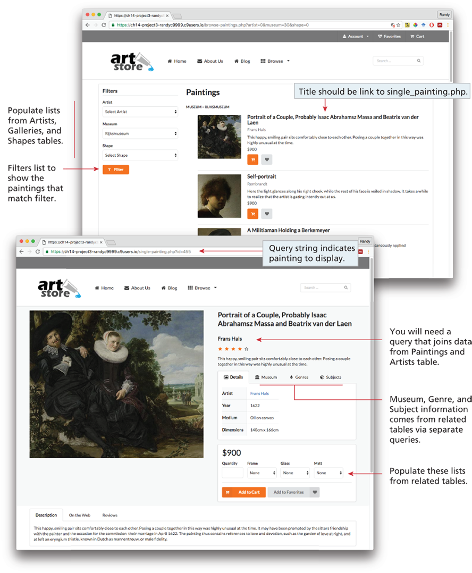

# Test

1. Test the page. Verify the filters work as expected and that the painting