Lake Superior (LKS) NERR Water Quality Metadata
January through December 2019
Latest Update: October 9, 2020

I. Data Set and Research Descriptors

1) Principal investigator(s) and contact persons –

Hannah Ramage, Monitoring Coordinator (SWMP)
14 Marina Drive, Superior, WI 54880
715-399-4088
Hannah.ramage@wisc.edu

SWMP Technician – Anna Hall (UMN-Duluth)
Anna.hall@wisc.edu

Dustin Haines, Research Coordinator
14 Marina Drive, Superior, WI 54880
715-399-4087
Dustin.haines@wisc.edu

2) Entry verification –

Deployment data are uploaded from the YSI EXO2 data logger to a personal computer (Windows 10 or newer operating system). Files are exported from KOR Software in an Excel File (.XLS) and uploaded to the CDMO where they undergo automated primary QAQC; automated depth/level corrections for changes in barometric pressure (cDepth or cLevel parameters); and become part of the CDMO’s online provisional database. All pre- and post-deployment data are removed from the file prior to upload. During primary QAQC, data are flagged if they are missing or out of sensor range. The edited file is then returned to the Reserve for secondary QAQC where it is opened in Microsoft Excel and processed using the CDMO’s NERRQAQC Excel macro. The macro inserts station codes, creates metadata worksheets for flagged data and summary statistics, and graphs the data for review. It allows the user to apply QAQC flags and codes to the data, remove any overlapping deployment data, append files, and export the resulting data file for upload to the CDMO. Upload after secondary QAQC results in ingestion into the database as provisional plus data, recalculation of cDepth or cLevel parameters, and finally tertiary QAQC by the CDMO and assimilation into the CDMO’s authoritative online database. Where deployment overlap occurs between files, the data produced by the newly calibrated sonde is generally accepted as being the most accurate. For more information on QAQC flags and codes, see Sections 11 and 12.

The Monitoring Coordinator, Hannah Ramage is responsible for data management.

3) Research objectives –

The Lake Superior NERR is situated on the freshwater estuary at the confluence of the St. Louis River and Lake Superior, the largest and most pristine of the Great Lakes. The Reserve is a diverse, 16,697-acre wetland complex that contains a variety of representative terrestrial and aquatic habitats, allowing for extensive research and educational opportunities. The Reserve provides opportunities for research and monitoring, experiential learning, and training and will continuing to contribute to the protection of the ecological health of the St. Louis River Freshwater Estuary and Lake Superior coastal habitats.

The Lake Superior NERR implements the NERR System-Wide Monitoring Program (SWMP). This includes four continuous water quality monitoring stations with monthly nutrient and chlorophyll sampling, a meteorological (MET) station, and monthly sampling at one site consisting of 12 nutrient and chlorophyll samples collected over a 24-hour period. Additional elective parameters include total suspended solids (TSS), total phosphorus (TP), and total nitrogen (TN). The objective of SWMP site locations is to obtain long-term data representative of the different sections of the river and tributaries that exhibit characteristics common to the southern shore of Lake Superior. Data will be archived at the Centralized Data Management Office (CDMO) as per established protocols.

The Barkers Islands (BA) station transmits 15-minute water quality data once every hour, via the GOES satellite system (since 2017). The CDMO real-time data application is able to access this data and make it available on the CDMO website. The MET station also transmits 15-minute data through the GOES satellite system, which began in 2013. Researchers, natural resource managers, and the public can access this data through the CDMO website. The Lake Superior NERR Education Coordinator regularly uses this water quality and meteorological data for educational programing including the Rivers2Lake teacher mentoring program.

The Lake Superior NERR climate change effects research site (Sentinel Site) is partially operational with the focus of measuring the impacts of storm events and lake levels on sediment delivery and aquatic plant communities (specifically wild rice, Zizania palustris). Required SWMP components that are integrated into the Sentinel Site include; the weather station located at the center of the site, a sonde mounted beside the weather station, and monthly nutrient and chlorophyll sampling. Permanent vegetation transects (80 plots) were established through five upper Pokegama bays surrounding the weather station in 2014 and are sampled at least bi-annually. Elevations of sondes were surveyed in 2014 and sonde water depth was linked to elevation to determine water level (NADV88, vertical control). However, due to ice-jacking of the MET station platform, the water elevations for 2015 were not accurate. The platform was repaired when longer pilings (30 ft helical anchors) were set in February 2016. The welding on two legs failed again due to ice-jacking in the winter of 2017. The station was relocated 10m to the NW and repaired Spring of 2018. Four surface elevation tables (SETs) were installed in 2012, but elevation surveys indicated they were also being ice-jacked (upward movement due to freeze-thaw), making full implementation of the Sentinel Site unfeasible.

The “Lake Superior Estuarium” opened September 30th 2017, which is an interpretive and learning center focused on the St. Louis River Estuary. The SWMP program information is featured in one of the panels and SWMP data is featured in an interactive display where users can look at live data through the CDMO website.

The Lake Superior NERR collected under ice, winter water quality, nutrient and chlorophyll data from 2015-2020 at sites across the estuary. This work was primarily investigating low dissolved oxygen prevalence and distribution throughout the estuary. The focus of the 2017-2018 study focused on relating low dissolved oxygen occurrences with algae and nutrients.

YSI Total Algae sensors have been added informally to some SWMP stations. We are currently working on verifying these florescence data with laboratory extractions of chlorophyll-an and phycocyanin. This will help managers better understand conditions leading to algal blooms in the estuary and Lake Superior.

4) Research methods –

All sondes deployed in 2019 were YSI EXO2s. Data were collected in 15-minute intervals. The sondes have not been painted or otherwise protected from fouling and biological growth. The Lake Superior NERR is a freshwater estuary on Lake Superior, therefore bio-fouling is minimal compared to that encountered by marine coast NERRs, and deployments currently can be up to 45 days long using the EXO2 sondes (previously 28 days).

All sondes were calibrated prior to deployment using the following commercial standard solutions:
pH – Ricca Buffer Solutions; 7.0 and 10.0
Turbidity – “0” in Type I reagent water and YSI Turbidity Standard (124 or 126 NTU)
Conductivity – Ricca Conductivity Standard, 1.00 mS/cm
Temperature – factory calibration
Dissolved Oxygen – air saturated water, DO% calibration to local barometric pressure as
reported by the Lake Superior MET station and uncorrected from the sea level correction
Depth – barometric pressure related to sea level by way of an offset (bp at MET station)
Total Algae - “0” RFU and ug/L in Type I reagent water and Bright Dyes Rhodamine WT Dye 0.625 mg/L solution for both chlorophyll-a and phycocyanin.

Sondes are housed in custom made 8” x 7.5” x 38” stainless steel enclosures open on the top. A hinged stainless-steel covering encloses the structure and covers the top allowing for the housings be locked. Sondes are attached to steel cable that is connected to the housing, lowered into the housing from the top, the covering is closed and is locked in place. The BA housing is bolted to a stainless-steel plate and wench system set up on a concrete dock piling. The wench is used to remove the housing over the winter months to avoid ice damage (however system was damaged by ice in Winter 2017-2018 and is no longer usable for winter removal). Blatnik Bridge (BL) housing was installed on sheet pile dolphin covering a bridge cell. ¾” holes were drilled for installation of 3/8” toggle anchors and bolts to hold the housing in place. The sonde housing at Oliver Bridge (OL) is attached to a concrete bridge footing using ½” Tapcon concrete anchors and bolts. The PO housing was bolted to a 3.5” x 3.5” steel piling of the meteorological station. But due to the relocation of the MET station and ice damage to the housing a temporary housing is installed every Spring by pounding an 8’ U-channel T-post with attached PVC pipe into the sediment at the location of the previous housing. The sonde fits into the perforated PVC and rests on a bolt fixed to the bottom of the PVC. The sonde is also attached via a cable to a remaining 30ft helical anchor from the previous MET station. The BA and PO sonde housings are deployed to follow NERR protocol and hold the sondes at 0.25 to 0.5 from the bottom. The PO sonde is in a very shallow site and sits at an average of 0.7-meter water depth. At all stations, during sonde deployments, sondes, housings, and cables are checked to maintain the appropriate water level/depth. The BL and OL sonde housings and cables are designed to hold the sondes at ~1.5m water depth and therefore do not follow NERR protocols (see below).

Sonde deployments for BL and OL sites do not follow NERRS protocols; specifically, they are not deployed between 0.25-0.50 meters from the bottom. This departure from SOP was approved by the NERRS Oversight Committee (OC) for the following reasons:

Due to the status of the St. Louis River Estuary as an Area of Concern (AOC) in the Great Lakes, there is significant interest in the water quality of the estuary and it is critical that SWMP data be both relevant in the process of Delisting of the Beneficial Use Impairments (BUIs) and for future environmental condition assessments. The overall consensus of stakeholders was that it was very important to continue sampling the Blatnik and Oliver Bridge sites due to legacy sampling that began in the 1940’s and continued sporadically up to the designation of the Lake Superior NERR.

The water depth at both the BL and OL sites is approximately 8m. Sampling near the surface allowed for the most direct comparison with the collection methods of prior samples (grab samples taken near the surface) and there was concern that sampling at 7m of depth or more would not be considered comparable. In addition, the entire estuary is frozen over from late November to early May each year and ice can cause major damage. To prevent damage to sondes, sonde housings were constructed from thick walled stainless steel and the weight of these precluded constructing and attaching 7m housings to the bridge cells (BL) or bridge footings (OL). Due to both the interest in collecting samples that were directly comparable to previous samples and the need to maintain infrastructure, including maintaining vertical control, in a very physically challenging environment the LSNERR proposed to set the depth of the sondes near the surface (approximately 1.5-2m) rather than near the bottom (7m). In order to demonstrate that the water is well mixed at the two bridge sties, LSNERR has taken monthly or seasonal sonde depth profiles from the top to the bottom of the water column during the ice-free season from 2012 – 2019 at all SWMP stations. These data have been included in metadata documents since 2015. See Other Remarks section in the annual metadata document for 2019 data.

One water quality data sonde, BA, transmits data using GOES telemetry systems. The CDMO accesses this data through The Hydrometerological Automated Data System (HADS) and pulls it into the NERRs real-time data application. The transmissions are scheduled hourly and contain four (4) data sets reflecting fifteen-minute data sampling intervals. Upon receipt by the CDMO, the data undergoes the same automated primary QAQC process detailed in Section 2 above. The “real-time” telemetry data becomes part of the provisional dataset until undergoing secondary and tertiary QAQC and assimilation in the CDMO’s authoritative online database. Provisional and authoritative data are available at http://cdmo.baruch.sc.edu.

5) Site location and character –

The Lake Superior NERR is located within the estuary of the St. Louis River. The St. Louis River Watershed covers approximately 3,634 square miles in northeast Minnesota and 263 square miles in northwest Wisconsin. The watershed is mostly forested, with some urban areas, especially at the estuary, and active iron mining in the upper reaches. In the upper watershed the river flows through lake clays and glacial deposits for approximately 100 miles. Near the city of Thomson, the river channel narrows and the river flows through a rocky rapid-filled gorge. Approximately 23 river miles upstream from Lake Superior is the Fond du Lac dam, the most downstream of several dams. Below the gorge and dams the river begins to take on the characteristics of a freshwater estuary. Near the mouth of the river on Lake Superior is the largest working harbor on the Great Lakes (by tonnage). A long baymouth sand bar protects the estuary form the wind and waves of Lake Superior. The natural entry through the bar is the Superior Entry to the southeast, while the Duluth Entry is an engineered entry with a lift bridge toward the northwest end.

Lake Superior does not produce a noticeable “tide” as on the ocean coasts, however, seiches, which occur when wind or atmospheric pressure causes oscillations in the water of Lake Superior, are common. For example, the USGS Sontek at the Duluth entry to the harbor has measured streamflow at between 4.0 cfs and -3.5 cfs. There tends to be a larger seiche period of about eight hours, while smaller seiches can be seen at approximately four and two hours. The change in water level as a result is usually less than a foot, however, a strong seiche can reverse the direction of the river’s flow as far upstream as Fond du Lac (approximately 12 river miles).

Oliver Bridge (OL)
a) -92.20166, 46.65685
b) This site is located on the downstream side of a bridge piling at Oliver, WI. The site is 11 miles upstream of Lake Superior and upstream of the majority of the estuary, receives downstream river flow below the Fond du Lac dam, but is influenced to some extent by Lake seiche.
c) salinity range 0.08 – 0.2 PPT
d) freshwater estuary site, receives flow of the St. Louis River (relatively undeveloped riparian area)
e) river approximately 8m deep, 126m wide
f) bottom habitat or type currently undocumented (suspected sand or soft sediment)
g) approximately 12 miles downstream of the Fond du Lac dam, historic paper mills above dam and active mining in the upper watershed
h) this site is the furthest upstream site monitored in the St. Louis River Estuary by LKS, approximately 11 miles upstream from the mouth at Lake Superior, this site does experience seiche
i) the sonde is deployed at a depth of 1.5-2.0 m from the surface at this site

Blatnik Bridge site (BL)
a) -92.10027, 46.748649
b) this site is located on the downstream side of a mid-river bridge protection cell off of Rice’s Point,
and is influenced by seiche
c) salinity range 0.1 – 0.25 PPT
d) freshwater estuary site, receives flow of the St. Louis River and tributaries to the estuary (urban)
e) water depth approximately 7m, river approximately 360 meters’ wide
f) bottom habitat or type currently undocumented (suspect mostly sand)
g) site is located within the urban area of Superior, WI, and Duluth, MN; site is immediately
downstream of the Western Lake Superior Sanitary District WWTP discharge.
h) this site is within the lower estuary, in the industrial harbor, the site is influenced by Lake seiche
i) the sonde is deployed at a depth of 1.5 – 2.0 m from the surface at this site

Barkers Island site (BA)
a) -92.06352, 46.721772
b) this site is located on the northwest end of Barkers Island in the St. Louis River, upstream of the Superior entry to the estuary, and is influenced by Lake seiche
c) salinity range 0.08 to 0.2 PPT
d) freshwater estuary, receives flow from the St. Louis River and tributaries (urban)
e) water depth approximately 2 m, approximately 1207m across Superior Bay at this location, navigation channel is at least 7m deep
f) bottom habitat or type mix of sand and soft sediments
g) site is downstream of the Superior WWTP and WLSSD WWTP, and near several storm water outfalls and Faxon Creek (an entirely urban stream) it is also adjacent to a public beach often closed throughout the summer due to E. coli standard exceedance
h) this site is the furthest downstream site monitored by LKS NERR in the St. Louis River Estuary, also within the lower industrial harbor. The Nemadji River (433 square mile watershed, mostly forested) also enters the St. Louis River Estuary near the Superior entry
i) the sonde is deployed at a depth of 0.5 m from the bottom at this site

Pokegama Bay site (PO)
a) -92.135614, 46.672360
b) this site is located in the Pokegama River, upstream of its mouth at the St. Louis River
c) salinity range 0.06 – 0.21 PPT
d) freshwater estuary, receives flow from a 20,144-acre sub-watershed of the St. Louis River
e) water depth approximately 1 to 2 m in the channel as it winds through shallower wetlands
f) bottom type is mostly red clay and silt, Pokegama Bay wetlands historically included large beds of wild rice
g) the Pokegama River is a tributary to the St. Louis River, entering the estuary on the Wisconsin side of Clough Island. The Pokegama River watershed measures approximately 20,144 acres, 51% of which is wetland, 37% forested, 4% developed and 6% agricultural use (the remainder is open water or bare land)
h) this site is on a red clay tributary to the St. Louis River, the mouth of which enters between the Oliver and Blatnik sites and is affected by Lake seiche.
i) the sonde is deployed at a depth of approximately 0.5 m from the surface at this site

SWMP Station Timeline:

Station Code | SWMP Status | Station Name | Location | Active Dates | Reason Decommissioned | Notes
BA | P | LKSBAWQ | 46° 43' 18.38 N, 92° 03' 48.67 W | 08/09/2012 00:00 -current | NA | NA
BL | P | LKSBLWQ | 46° 44' 55.14 N, 92° 06' 0.97 W | 08/09/2012 00:00 -current | NA | NA
OL | P | LKSOLWQ | 46° 39' 24.66 N, 92° 12' 5.98 W | 07/27/2012 00:00 -current | NA | NA
PO | P | LKSPOWQ | 46° 40' 20.50 N, 92° 8' 8.21 W | 10/01/2013 00:00 -current | NA | NA

6) Data collection period –

Site Initial Deployment | Deploy Date | Deploy Time | Retrieve Date | Retrieve Time | Sonde Model Number (Nickname) | Notes
Barkers Island (BA) | 3/28/2019 | 13:45 | 4/18/2019 | 11:45 | EXO2 (H) | miscalibrated for depth and dissolved oxygen
6/15/2012 | 4/18/2019 | 12:15 | 5/14/2019 | 10:00 | EXO2 (G) | miscalibrated for depth and dissolved oxygen
 | 5/14/2019 | 10:15 | 6/3/2019 | 10:15 | EXO2 (H)
 | 6/3/2019 | 10:30 | 6/26/2019 | 9:00 | EXO2 (G)
 | 6/26/2019 | 9:15 | 7/12/2019 | 10:15 | EXO2 (H)
 | 7/12/2019 | 10:30 | 7/30/2019 | 12:45 | EXO2 (G)
 | 7/30/2019 | 13:15 | 9/10/2019 | 12:00 | EXO2 (H)
 | 9/10/2019 | 12:15 | 10/1/2019 | 10:15 | EXO2 (G)
 | 10/1/2019 | 10:30 | 10/29/2019 | 13:45 | EXO2 (H)
Blatnik Bridge (BL)
7/3/2012 | 4/23/2019 | 12:00 | 5/15/2019 | 8:30 | EXO2 (D)
 | 5/15/2019 | 8:45 | 6/14/2019 | 9:30 | EXO2 (C)
 | 6/14/2019 | 10:00 | 7/3/2019 | 10:30 | EXO2 (D)
 | 7/3/2019 | 10:45 | 7/30/2019 | 9:15 | EXO2 (C)
 | 7/30/2019 | 9:45 | 8/16/2019 | 12:30 | EXO2 (D)
 | 8/16/2019 | 12:45 | 10/16/2019 | 10:45 | EXO2 (C)
Oliver Bridge (OL)
7/3/2012 | 4/16/2019 | 11:30 | 5/15/2019 | 9:00 | EXO2 (B)
 | 5/15/2019 | 9:15 | 6/11/2019 | 13:00 | EXO2 (A)
 | 6/11/2019 | 13:15 | 7/2/2019 | 13:15 | EXO2 (B)
 | 7/2/2019 | 13:30 | 7/30/2019 | 11:00 | EXO2 (A)
 | 7/30/2019 | 11:15 | 9/4/2019 | 8:45 | EXO2 (B)
 | 9/4/2019 | 9:00 | 10/16/2019 | 12:00 | EXO2 (A) | battery failure, no data collected
Pokegama Bay (PO)
9/18/2013 | 5/15/2019 | 10:15 | 6/14/2019 | 10:45 | EXO2 (F)
 | 6/14/2019 | 11:00 | 7/9/2019 | 11:15 | EXO2 (E)
 | 7/9/2019 | 11:30 | 7/30/2019 | 10:00 | EXO2 (F)
 | 7/30/2019 | 10:30 | 9/4/2019 | 9:30 | EXO2 (E)
 | 9/4/2019 | 9:45 | 10/17/2019 | 10:30 | EXO2 (F)

7) Distribution –

NOAA retains the right to analyze, synthesize and publish summaries of the NERRS System-wide Monitoring Program data. The NERRS retains the right to be fully credited for having collected and process the data. Following academic courtesy standards, the NERR site where the data were collected should be contacted and fully acknowledged in any subsequent publications in which any part of the data are used. The data set enclosed within this package/transmission is only as good as the quality assurance and quality control procedures outlined by the enclosed metadata reporting statement. The user bears all responsibility for its subsequent use/misuse in any further analyses or comparisons. The Federal government does not assume liability to the Recipient or third persons, nor will the Federal government reimburse or indemnify the Recipient for its liability due to any losses resulting in any way from the use of this data.

Requested citation format:
NOAA National Estuarine Research Reserve System (NERRS). System-wide Monitoring Program. Data accessed from the NOAA NERRS Centralized Data Management Office website: http://www.nerrsdata.org/; accessed 12 October 2020.

NERR water quality data and metadata can be obtained from the Research Coordinator at the individual NERR site (please see Principal Investigators and Contact Persons), from the Data Manager at the Centralized Data Management Office (please see personnel directory under the general information link on the CDMO home page) and online at the CDMO home page www.nerrsdata.org. Data are available in comma delimited format.

8) Associated researchers and projects –

Samples were taken monthly at these four sites (OL, PO, BL, BA) for the SWMP required nutrient and chlorophyll a analyses during the ice-free season beginning in 2014.

The SWMP weather station and data sonde site was established in Pokegama Bay and is the central location of a developing Great Lakes climate change Sentinel Site. Permanent vegetation surveys were established in the wetlands surrounding the SWMP site, with vegetation community data collection beginning in summer 2014. Vegetation surveys were again completed last in 2017. One focus of this project is wild rice, and the resulting data will be used to measure reference site conditions to compare to wild rice restoration efforts throughout the estuary.

SWMP water quality and nutrient data is contributing to the delisting of several Beneficial Use Impairments designated with in the St. Louis River Area of Concern.

The LKS NERR Monitoring Coordinator participates in a collaborative effort to coordinate a monitoring network in the estuary in order to best match management needs with monitoring data, including participation in the Lake Superior Nearshore Monitoring Group.
The St. Louis River Estuary was chosen as a NOAA Blueprint Habitat Focus Area (http://www.habitat.noaa.gov/habitatblueprint/pdf/hb_st_louis_river_factsheet.pdf). NOAA offices work in cooperation with local entities to meet multiple habitat objectives on a watershed scale.

II. Physical Structure Descriptors

9) Sensor specifications –

LKS NERR deployed only YSI EXO2s with central wipers in 2018. Two sondes are designated for each site and are swapped out every 45 days. All sondes have the same model Optical Dissolved Oxygen, pH, S

YSI EXO2 – Sonde nicknames A, B, C, D, E, F, G and H

Sondes A, B, C, and D:

Parameter: Temperature
Units: Celsius (C)
Sensor Type: Thermistor
Model#: 599870-01
Range: -5 to 50 C
Accuracy: -5 to 35: +/- 0.01, 35 to 50: +/- .005
Resolution: 0.01 C

Parameter: Conductivity
Units: milli-Siemens per cm (mS/cm)
Sensor Type: 4-electrode cell with autoranging
Model#: 599870-01
Range: 0 to 200 mS/cm
Accuracy: 0 to 100: +/- 0.5% of reading or 0.001 mS/cm; 100 to 200: +/- 1% of reading
Resolution: 0.001 mS/cm to 0.1 mS/cm (range dependent)

Parameter: Salinity
Units: practical salinity units (psu)/parts per thousand (ppt)
Sensor Type: Calculated from conductivity and temperature
Range: 0 to 70 psu
Accuracy: +/- 1.0% of reading pr 0.1 ppt, whichever is greater
Resolution: 0.01 psu

Sondes E, F, G, and H have:

Parameter: Temperature
Units: Celsius (C)
Sensor Type: Wiped probe; Thermistor
Model#: 599827
Range: -5 to 50 C
Accuracy: ±0.2 C
Resolution: 0.001 C

Parameter: Conductivity
Units: milli-Siemens per cm (mS/cm)
Sensor Type: Wiped probe; 4-electrode cell with autoranging
Model#: 599827
Range: 0 to 100 mS/cm
Accuracy: ±1% of the reading or 0.002 mS/cm, whichever is greater
Resolution: 0.0001 to 0.01 mS/cm (range dependent)

Parameter: Salinity
Units: practical salinity units (psu)/parts per thousand (ppt)
Model#: 599827
Sensor Type: Wiped probe; Calculated from conductivity and temperature
Range: 0 to 70 ppt
Accuracy: ±2% of the reading or 0.2 ppt, whichever is greater
Resolution: 0.01 psu

All Sondes:

Parameter: Dissolved Oxygen % saturation
Sensor Type: Optical probe w/ mechanical cleaning
Model#: 599100-01
Range: 0 to 500% air saturation
Accuracy: 0-200% air saturation: +/- 1% of the reading or 1% air saturation, whichever is greater 200-500% air saturation: +/- 5% or reading
Resolution: 0.1% air saturation

Parameter: Dissolved Oxygen mg/L (Calculated from % air saturation, temperature, and salinity)
Units: milligrams/Liter (mg/L)
Sensor Type: Optical probe w/ mechanical cleaning
Model#: 599100-01
Range: 0 to 50 mg/L
Accuracy: 0-20 mg/L: +/-0.1 mg/l or 1% of the reading, whichever is greater
20 to 50 mg/L: +/- 5% of the reading
Resolution: 0.01 mg/L

Sondes A, B, C, and D:

Parameter: Non-vented Level (Depth)
Units: feet or meters (ft or m)
Sensor Type: Stainless steel strain gauge
Range: 0 to 820ft (250m)
Accuracy: +/- 0.04% FS; +/- 0.33 ft (0.10 m)
Resolution: 0.001 ft (0.001 m)

Sondes E, F, G, and H:

Parameter: Non-vented Level - Shallow (Depth)
Units: feet or meters (ft or m)
Sensor Type: Stainless steel strain gauge
Range: 0 to 33 ft (10 m)
Accuracy: +/- 0.013 ft (0.004 m)
Resolution: 0.001 ft (0.001 m)

All sondes:

Parameter: pH
Units: pH units
Sensor Type: Glass combination electrode
Model#: 599701(guarded) or 599702(wiped)/599795-02(wiped)
Range: 0 to 14 units
Accuracy: +/- 0.01 units within +/- 10° of calibration temperature, +/- 0.02 units for entire temperature range
Resolution: 0.01 units

All sondes:

Parameter: Turbidity
Units: formazin nephelometric units (FNU)
Sensor Type: Optical, 90-degree scatter
Model#: 599101-01
Range: 0 to 4000 FNU
Accuracy: 0 to 999 FNU: 0.3 FNU or +/-2% of reading (whichever is greater); 1000 to 4000 FNU +/-5% of reading
Resolution: 0 to 999 FNU: 0.01 FNU, 1000 to 4000 FNU: 0.1 FNU

Sondes C, G, and H:

Parameter: Chlorophyll
Units: micrograms/Liter
Sensor Type: Optical probe
Model#: 599102-01
Range: 0 to 400 ug/Liter
Accuracy: Dependent on methodology
Resolution: 0.1 ug/L chl a, 0.1% FS

Depth Qualifier:
The NERR System-Wide Monitoring Program utilizes YSI data sondes that can be equipped with either vented or non-vented depth/level sensors. Readings for both vented and non-vented sensors are automatically compensated for water density change due to variations in temperature and salinity; but for all non-vented depth measurements, changes in atmospheric pressure between calibrations appear as changes in water depth. The error is equal to approximately 1.02 cm for every 1 millibar change in atmospheric pressure, and is eliminated for vented sensors because they are vented to the atmosphere throughout the deployment time interval.

Beginning in 2006, NERR SWMP standard calibration protocol calls for all non-vented depth sensors to read 0 meters at a (local) barometric pressure of 1013.25 mb (760 mm/hg). To achieve this, each site calibrates their depth sensor with a depth offset number, which is calculated using the actual atmospheric pressure at the time of calibration and the equation provided in the SWMP calibration sheet or digital calibration log. This offset procedure standardizes each depth calibration for the entire NERR System. If accurate atmospheric pressure data are available, non-vented sensor depth measurements at any NERR can be corrected.

In 2010, the CDMO began automatically correcting depth/level data for changes in barometric pressure as measured by the reserve’s associated meteorological station during data ingestion. These corrected depth/level data are reported as cDepth and cLevel, and are assigned QAQC flags and codes based on QAQC protocols. Please see sections 11 and 12 for QAQC flag and code definitions.

NOTE: older depth data cannot be corrected without verifying that the depth offset was in place and whether a vented or non-vented depth sensor was in use. No SWMP data prior to 2006 can be corrected using this method. The following equation is used for corrected depth/level data provided by the CDMO beginning in 2010:
((1013-BP)*0.0102)+Depth/Level = cDepth/cLevel.

Salinity Units Qualifier:
In 2013, EXO sondes were approved for SWMP use and began to be utilized by reserves. While the 6600 series sondes report salinity in parts per thousand (ppt) units, the EXO sondes report practical salinity units (psu). These units are essentially the same and for SWMP purposes are understood to be equivalent, however psu is considered the more appropriate designation. Moving forward the NERR System will assign psu salinity units for all data regardless of sonde type.

Turbidity Qualifier:
In 2013, EXO sondes were approved for SWMP use and began to be utilized by reserves. While the 6600 series sondes report turbidity in nephelometric turbidity units (NTU), the EXO sondes use formazin nephelometric units (FNU). These units are essentially the same but indicate a difference in sensor methodology, for SWMP purposes they will be considered equivalent. Moving forward, the NERR System will use FNU/NTU as the designated units for all turbidity data regardless of sonde type. If turbidity units and sensor methodology are of concern, please see the Sensor Specifications portion of the metadata.

Chlorophyll Fluorescence Disclaimer:
YSI chlorophyll sensors (6025 or 599102-01) are designed to serve as a proxy for chlorophyll concentrations in the field for monitoring applications and complement traditional lab extraction methods; therefore, there are accuracy limitations associated with the data that are detailed in the YSI manual including interference from other fluorescent species, differences in calibration method, and effects of cell structure, particle size, organism type, temperature, and light on sensor measurements.

10) Coded variable definitions –

Sampling station: Sampling site code: Station code:

Oliver Bridge OL lksolwq
Blatnik Bridge BL lksblwq
Barkers Island BA lksbawq
Pokegama Bay PO lkspowq

11) QAQC flag definitions –

QAQC flags provide documentation of the data and are applied to individual data points by insertion into the parameter’s associated flag column (header preceded by an F_). During primary automated QAQC (performed by the CDMO), -5, -4, and -2 flags are applied automatically to indicate data that is missing and above or below sensor range. All remaining data are then flagged 0, passing initial QAQC checks. During secondary and tertiary QAQC 1, -3, and 5 flags may be used to note data as suspect, rejected due to QAQC, or corrected.

-5 Outside High Sensor Range
-4 Outside Low Sensor Range
-3 Data Rejected due to QAQC
-2 Missing Data
-1 Optional SWMP Supported Parameter
0 Data Passed Initial QAQC Checks
1 Suspect Data
2 Open - reserved for later flag
3 Calculated data: non-vented depth/level sensor correction for changes in barometric pressure
4 Historical Data: Pre-Auto QAQC
5 Corrected Data

12) QAQC code definitions –

QAQC codes are used in conjunction with QAQC flags to provide further documentation of the data and are also applied by insertion into the associated flag column. There are three (3) different code categories, general, sensor, and comment. General errors document general problems with the deployment or YSI datasonde, sensor errors are sensor specific, and comment codes are used to further document conditions or a problem with the data. Only one general or sensor error and one comment code can be applied to a particular data point, but some comment codes (marked with an * below) can be applied to the entire record in the F_Record column.

General Errors
GIC No instrument deployed due to ice
GIM Instrument malfunction
GIT Instrument recording error; recovered telemetry data
GMC No instrument deployed due to maintenance/calibration
GNF Deployment tube clogged / no flow
GOW Out of water event
GPF Power failure / low battery
GQR Data rejected due to QA/QC checks
GSM See metadata
Corrected Depth/Level Data Codes
GCC Calculated with data that were corrected during QA/QC
GCM Calculated value could not be determined due to missing data
GCR Calculated value could not be determined due to rejected data
GCS Calculated value suspect due to questionable data
GCU Calculated value could not be determined due to unavailable data

Sensor Errors
SBO Blocked optic
SCF Conductivity sensor failure
SCS Chlorophyll spike
SDF Depth port frozen
SDG Suspect due to sensor diagnostics
SDO DO suspect
SDP DO membrane puncture
SIC Incorrect calibration / contaminated standard
SNV Negative value
SOW Sensor out of water
SPC Post calibration out of range
SQR Data rejected due to QAQC checks
SSD Sensor drift
SSM Sensor malfunction
SSR Sensor removed / not deployed
STF Catastrophic temperature sensor failure
STS Turbidity spike
SWM Wiper malfunction / loss

Comments
CAB* Algal bloom
CAF Acceptable calibration/accuracy error of sensor
CAP Depth sensor in water, affected by atmospheric pressure
CBF Biofouling
CCU Cause unknown
CDA* DO hypoxia (<3 mg/L)
CDB* Disturbed bottom
CDF Data appear to fit conditions
CFK* Fish kill
CIP * Surface ice present at sample station
CLT* Low tide
CMC* In field maintenance/cleaning
CMD* Mud in probe guard
CND New deployment begins
CRE* Significant rain event
CSM* See metadata
CTS Turbidity spike
CVT* Possible vandalism/tampering
CWD* Data collected at wrong depth
CWE* Significant weather event

13) Post deployment information –

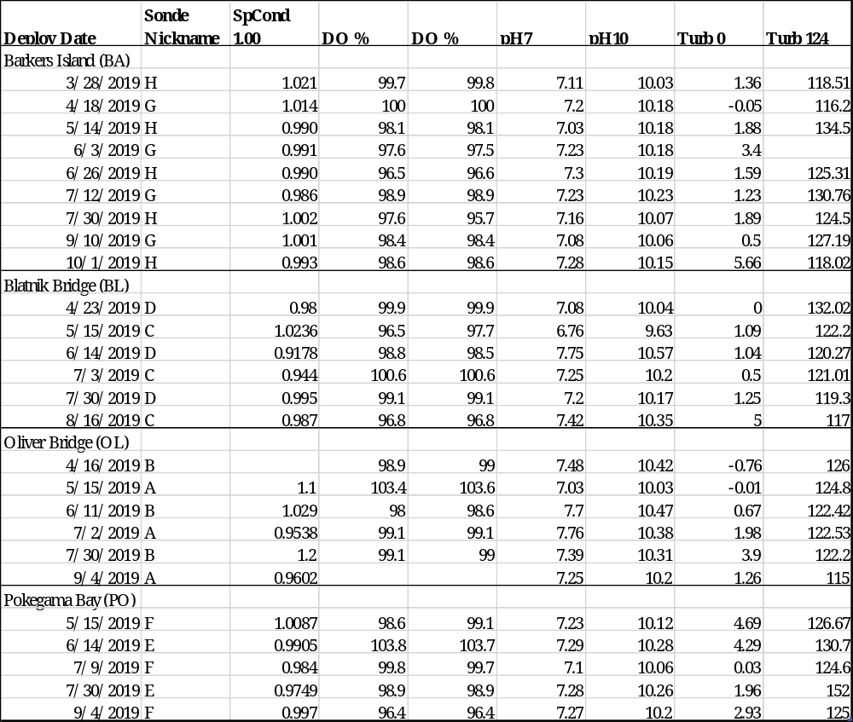

*Note: pH post-deployment readings are temperature dependent and minor variations are expected as a result.

14) Other remarks/notes –

Data are missing due to equipment or associated specific probes not being deployed, equipment failure, time of maintenance or calibration of equipment, or repair/replacement of a sampling station platform. Any NANs in the dataset stand for “not a number” and are the result of low power, disconnected wires, or out of range readings. If additional information on missing data is needed, contact the Research Coordinator at the reserve submitting the data.

Barkers Island:

The sonde deployed 03/28/2019 13:45 though 04/18/2019 12:00 was miscalibrated for depth and oxygen because of an erroneous barometric pressure reading. Depth was calibrated using a corrected for altitude, barometric pressure reading of 749.75 mmHg, therefore a -0.14 offset of m meters was applied to the data. The corrected for altitude, barometric pressure was actually 765.00 mmHg, meaning an offset of 0.068m was required. Depth data was corrected by adding 0.208 m and flagged <5> [SIC] (CSM). An altitude uncorrected barometer pressure reading of 765 mmHg was used to calibrate dissolved oxygen, however the actual barometer pressure was 749.75 mmHg. Because dissolved oxygen saturation increases with increasing pressure, the values for percent saturation and mg/L are underestimated due to the miscalibration and flagged <1> [SIC] (CSM).

The sonde deployed 04/18/2019 12:15 though 05/14/2019 10:00 was miscalibrated for depth and oxygen because of an erroneous barometric pressure reading. Depth was calibrated using a corrected for altitude, barometric pressure reading of 741.5 mmHg, therefore a -0.252 offset of m meters was applied to the data. The corrected for altitude, barometric pressure was however, really 756.75 mmHg, meaning an offset of -0.045was required. Depth data was corrected by adding 0.207m and flagged <5> [SIC] (CSM). An altitude uncorrected barometer pressure reading of 756.75 mmHg was used to calibrate dissolved oxygen, however the real barometer pressure was 741.5 mmHg. Because dissolved oxygen saturation increases with increasing pressure, the values for percent saturation and mg/L are underestimated due to the miscalibration and flagged <1> [SIC] (CSM).

The sonde deployed 06/03/2019 10:30 was miscalibrated for dissolved oxygen. The dissolved oxygen data from 06/03/2019 10:30-13:30 is flagged <-3> [SIC] (CSM) due to the calibration issue. The sonde was then pulled from the tube from 06/03/2019 13:45 – 14:15 and returned to the lab so that the probe could be calibrated correctly. The data when the sonde was in the lab is flagged <-3> [GMC] (CSM). The sonde was the deployed with the new probe at 06/03/2019 14:30.

Blatnik Bridge:

The sonde deployed on 8/16/2019, 12:45 was deployed for 61 days, 16 days past the required 45-day threshold, because of inability to visit the site. Very little fouling was present on sensors and post-deployment checks were good, therefore no parameters are flagged.

Oliver Bridge:
Currently the barometric pressure from the weather station is used to calibrate both depth and Dissolved oxygen for all sondes. At times the difference between the atmospheric pressure at the weather station can be different than the pressure at the laboratory where the datasondes are calibrated. We believe a small difference in atmospheric pressure at the weather station versus the laboratory caused a slight disjunction in Dissolved oxygen at the 5/15 swap.

A sonde was deployed on 9/04/19 and was retrieved 10/16/19, however there was a battery failure and the sonde did not log any data.

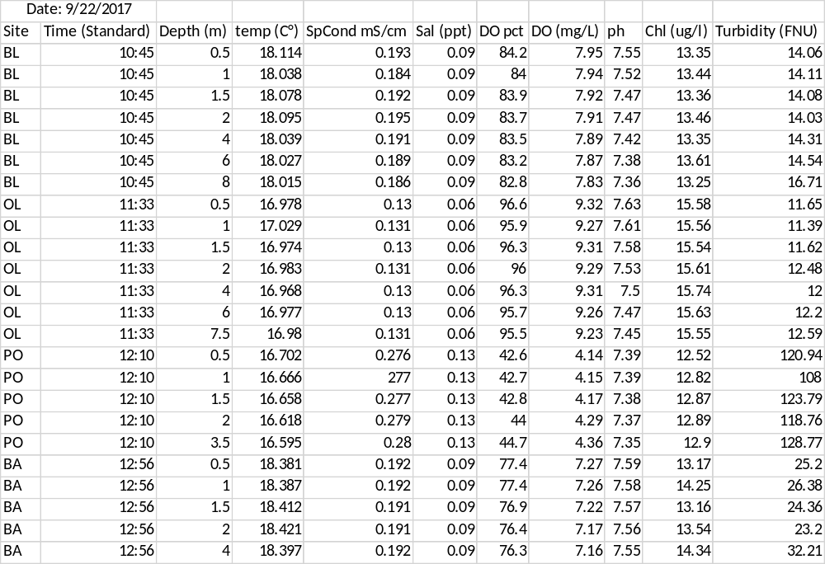
Depth Profile Data:
