Apalachicola (APA) NERR Nutrient Metadata
January – December 2004
Latest Update: December 14, 2011

I. Data Set and Research Descriptors

- Principal investigators and contact persons –
  - Reserve Contact

Lee Edmiston, Research Coordinator
350 Carroll Street
Eastpoint, Fl 32328
850-670-4783
lee.edmiston@dep.state.fl.us

Lauren Levi, Environmental Specialist II
350 Carroll Street
Eastpoint, Fl 32328
850-670-4783
lauren.levi@dep.state.fl.us

  - Laboratory Contact

Dr. William Landing
Professor of Environmental and Marine Chemistry
Department of Oceanography, 325 OSB
Florida State University
Tallahassee, FL 32306-4320
VOICE: 850-644-6037; FAX 850-644-2581
WLANDING@MAILER.FSU.EDU

Matt Young
Department of Oceanography
Florida State University
Tallahassee, FL 32306-4320
850-644-6753
may0173@garnet.acns.fsu.edu

  - Other Contacts and Programs

Richard L. Iverson
Department of Oceanography
Florida State University
Tallahassee, FL 32306-4320
850-644-1730
riverson@ocean.fsu.edu

Joel E. Kostka
Department of Oceanography
Florida State University
Tallahassee, FL 32306-4320
850-645-3334
jkostka@ocean.fsu.edu

- Research objectives

Previous studies have shown the importance of river flow and flushing rates on nutrients and primary productivity in the bay. Similar studies have determined nitrogen and phosphorus budgets for Apalachicola Bay as well as nutrient limitations related to seasonality and riverflow. There is currently a controversy between the States of Florida, Georgia, and Alabama over the upstream diversion of water. Approximately 88% of the drainage basin for the Apalachicola River and Bay is located in Georgia and Alabama and historical flows are being threatened by upstream development. A tri-state compact, between the states and approved by the US Congress, required negotiations between the states to develop a water allocation formula during the last six years. The states were unable to come to an agreement, the compact has expired, and legal proceedings, which could end up in the US Supreme Court, are underway. This study is one of many looking at short-term variability, long-term change, and the relationship of other environmental factors to the productivity of the Apalachicola Bay system as well as trying to separate natural from man-made variability.

  - Monthly Grab

Monthly grab samples are collected at 11 sites located across Apalachicola Bay to monitor spatial and temporal fluctuations in nutrient/chlorophyll a concentrations occurring in diverse sections of the bay. The stations have been chosen to help determine the influence of the river, local rainfall, adjacent habitats and man’s impact on these parameters. A sampling site is located in the lower Apalachicola River as well as in the coastal area, offshore of the barrier islands. Seasonal, climatic, and anthropogenic factors all impact riverflow, which in turn affects nutrient/ chlorophyll a concentrations in the bay. Nutrient/chlorophyll a concentrations are also influenced by tidal action, wind direction and speed, and the hydrodynamics of the system.

  - Diel Sampling Program

Diel sampling is performed once a month in conjunction with grab sampling for nutrients/ chlorophyll a. The East Bay Surface water quality datalogger site (APAESNUT) is utilized each month for placement of the sampler so that temporal water quality data may be compared with the spatial nutrient/ chlorophyll a data collected at this site. Other studies by the Reserve have shown the influence of tidal action and runoff on other physical parameters in the bay.

- Research methods

  - Monthly Grab Sampling Program

Monthly grab samples are collected at eleven stations (see Table 1) within and adjacent to Apalachicola Bay, including a station in the Apalachicola River and the offshore coastal area (Figure 1). Weather permitting, all grab samples are collected on the same day. Due to the distance between the stations it is not always possible to collect all the samples several hours prior to low tide. Tidal condition, wind direction, speed, and cloud cover are recorded for each station at the time of sampling but are not included in this dataset and are available upon request. Significant weather events, such as heavy rains occurring immediately before sampling periods, are also noted. Sampling after heavy rains is avoided if at all possible. Water temperature, salinity, and dissolved oxygen are measured at each station with a YSI 85 handheld meter. pH is also measured and is available on request. Turbidity samples are collected at each site and are tested in the ANERR lab with a DRT-15CE Turbidimeter. A horizontal Van Dorn-style sampler is used to collect 2.2 liters of water from a depth of 0.5 meters at all stations
Table 1. Nutrient and chlorophyll a sampling sites for the Apalachicola NERR SWMP.

STATION CODE | STATION NAME | LATITUDE | LONGITUDE | TIDAL RANGE AVERAGE (meters) | SALINITY RANGE | WATER DEPTH AVERAGE (meters) | BOTTOM HABITAT | DATALOGGER  STATION NAME | SAMPLE DEPTH  (meters)
APAWPNUT | West Pass | 29 38.279 | 85 5.341 | 0.7 | euryhaline | 5.0 | sand |  | 0.5
APADBNUT | Dry Bar | 29 40.482 | 85 3.502 | 0.7 | euryhaline | 1.7 | oyster bar | APA DB | 1.5
APAPCNUT | Pilot's Cove | 29 36.473 | 85 1.173 | 0.7 | euryhaline | 1.8 | patchy seagrass |  | 0.5
APAMBNUT | Mid Bay | 29 40.061 | 84 59.641 | 0.7 | euryhaline | 2.2 | sandy silt |  | 0.5
APAEGNUT | East Bay Bridge | 29 43.848 | 84 56.711 | 0.7 | euryhaline | 1.6 | silty clay |  | 0.5
APAESNUT | East Bay Surface | 29 47.147 | 84 52.512 | 0.7 | euryhaline | 1.7 | clayey sand | APA ES | 0.5
APAEBNUT | East Bay Bottom | 29 47.147 | 84 52.512 | 0.7 | euryhaline | 1.7 | clayey sand | APA EB | 1.5
APASCNUT | Sikes Cut Offshore | 29 36.401 | 84 56.799 | 0.7 | marine | >5.0 | sand |  | 0.5
APANHNUT | Nick's Hole | 29 39.022 | 84 55.732 | 0.7 | euryhaline | 1.0 | patchy seagrass |  | 0.5
APACPNUT | Cat Point | 29 42.128 | 84 52.811 | 0.7 | euryhaline | 1.8 | oyster bar | APA CP | 2.0
APARVNUT | River | 29 46.743 | 85 2.606 | 0.7 | oligohaline | NA | sandy silt |  | 0.5

Note: Diel samples are collected 2.5 hours apart at the East Bay Surface datalogger site, APAESNUT, with the ISCO
automated water sampler. No duplicate diel samples are taken, however there is some overlap with monthly grabs
collected at the East Bay Surface station at deployment of the ISCO sampler.

Figure 1. Station locations.

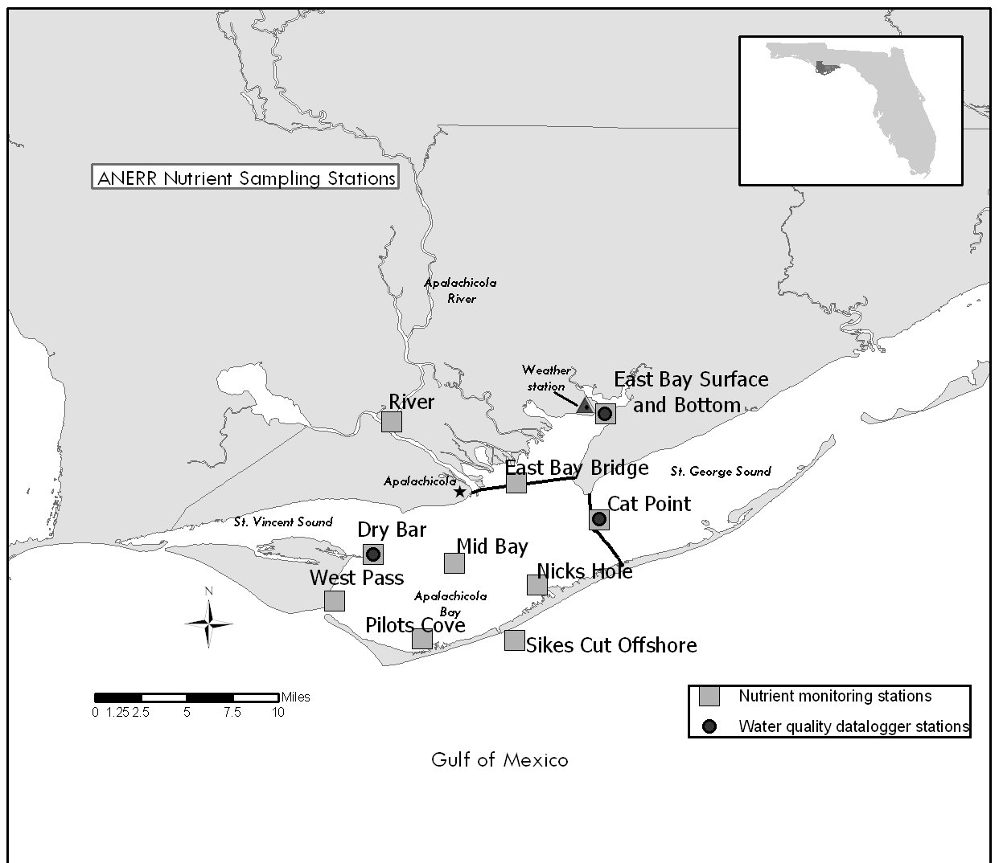

not associated with a SWMP datalogger site. At the Cat Point and Dry Bar SWMP datalogger stations, water samples are collected at a depth of approximately 2 and 1.5 meters (one-half meter from the bottom) respectively, a depth equivalent to the probes of the data loggers deployed at these sites. At the East Bay datalogger station water samples are collected from surface (0.5 meters) and bottom (1.5 meters) depths, equivalent to the depths of the two dataloggers deployed at this site. Water from the sampler is delivered into two one-liter opaque polyethylene bottles. One bottle (acid washed) is designated for nutrient analysis, the other is designated for chlorophyll a analysis. Duplicate samples are collected at all monthly grab stations, but from different grabs. The duplicate sample is collected with a second dip of the horizontal sampler, with the sample being split between a second set of one-liter polyethylene bottles for nutrient and chlorophyll a analysis. Polyethylene bottles designated for nutrient samples have been previously acid washed with 3% HCl and then rinsed (5x) with deionized water. No ambient rinsing is performed. Bottles for chlorophyll a analysis have been thoroughly rinsed with tap water prior to use. Samples are placed in coolers of ice and kept in the dark immediately after collection. Nutrient samples remain on ice until delivery to the Florida State University Oceanography Department laboratory, which occurs within 36 hours of collection. The nutrient samples are filtered immediately upon arrival at the FSU laboratory . Chlorophyll a samples are filtered by ANERR staff within 8 hours of collection, frozen, and delivered to the laboratory within the same 36 hours as the nutrients.

  - Diel Sampling Program

Diel sampling is performed with an ISCO 3700 Portable Automated Sampler. Whenever possible, the ISCO is deployed on the same day that the bay-wide grab samples are collected. The sampler is programmed to collect a sample for nutrient and chlorophyll a every 2.5 hours, over a 25-hour period at the same depth as the datalogger probes. This captures a complete 24 hr: 48min lunar-tidal cycle. The sampler is programmed to collect two samples, of one-liter each, every two and one-half hours. Each sample is distributed by the sampler into plastic one-liter ISCO bottles held in the base of the sampler. One of the sample bottles in each set has been acid washed with 3% HCl prior to collection and then rinsed (5x) with deionized water; this bottle is used for nutrient collection. The other bottle in each set has been thoroughly rinsed with tap water and this sample is used for chlorophyll a analysis. The ISCO sampler is programmed to purge the suction line before and after each sample collection. The center of the ISCO sampler is filled with ice to aid in sample presevation. All samples are placed in coolers of ice upon retrieval of the ISCO sampler at the end of the 25-hour sampling period. All samples are stored on ice in the dark until laboratory filtering and analysis. The nutrient samples are delivered to the Florida State University Oceanography Department laboratory within 36 hours of collection for immediate filtering. The chlorophyll a samples are filtered by ANERR staff immediately upon retrieval and the filters are frozen and delivered to the lab within 36 hours of collection. The ISCO sampler is deployed at the East Bay datalogger station (Figure 1). The ISCO suction strainer is deployed at a depth equivalent to the probes of the surface datalogger deployed at this station, which are 1.7 meters above the bottom sediment.

- Site location and character

The Apalachicola Drainage Basin encompasses over 19,600 square miles and includes parts of three states (Alabama, Georgia, and Florida). The Apalachicola River is the largest in Florida in terms of flow. The amount of river discharge has been shown to be highly significant to the ecology of the estuary, which acts as a buffer between the Gulf of Mexico and fresh water input from upland areas. The nutrient rich plume of "green water" moving out of Apalachicola Bay is also important to the productivity of the northeastern Gulf of Mexico. The Apalachicola National Estuarine Research Reserve is located in the northwestern part of Florida, generally called the panhandle. It is located adjacent to the City of Apalachicola, and encompasses most of the Apalachicola Bay system, including 52 miles of the lower Apalachicola River. Passes, both natural and manmade, connect Apalachicola Bay to the northeastern Gulf of Mexico.

  - East Bay datalogger and nutrient station
East Bay is separated from Apalachicola Bay by two bridges and a causeway and is located to the north of the bay proper. The bay is 8.2 km long, has an average depth of approximately 1.0 m MHW, and an average width of 1.8 km. The tides in East Bay are mixed and range from 0.3 m to 1.0 m (average 0.5 m). The datalogger and nutrient sampling site is located in the upper reaches of East Bay. The piling location for the two East Bay dataloggers (ES and EB) is latitude 29°47.15' N and longitude 84°52.52' W. At the sampling site, the depth is 2.2 m MHW and the width of the bay is 1 km. The tides in the system are mixed, meaning the number of tides can range from one to five tides during a 24 hour period and are not evenly distributed throughout the day. At the East Bay bottom site the meter probes are 0.3 m above the bottom sediment. Salinity ranges from 0 to 30 ppt and the long-term average salinity is approximately 8 ppt. At the East Bay surface site the meter probes are 1.7 m above the bottom sediment and salinity ranges from 0 ppt to 30 ppt with a long term average salinity of 6.3 ppt. The freshwater input is very tannic and usually dark colored. Flows vary with local rainfall and are not quantified due to the diverse sources of the runoff. The bottom habitat at this bay site is soft sediment, primarily silt and clay, with no vegetation present. The dominant marsh vegetation near the sampling site (approximately300 meters away) is Juncus roemerianus and Cladium jamaicense. The dominant upland vegetation is primarily pineland forests which includes slash pine, saw palmetto, and sand pine. Upland land use near the sampling site includes conservation and silviculture uses with some single family residential in the lower East Bay area. The sampling site is influenced by local runoff from Tate's Hell Swamp, the East Bay marshes, and distributary flow, some of which comes from the Apalachicola River via the East River. Tate's Hell Swamp was ditched, diked, and altered back in the late 1960’s and early 1970’s by timber companies. These changes shortened the drainage period and allowed increased runoff with a concomitant decrease in pH and increase in color, which had a drastic affect on the biological communities in East Bay. Restoration of Tate's Hell Swamp began in 1995 to reduce non-point source runoff and restore historic sheet flow in the area.

  - Cat Point datalogger and nutrient station
The Cat Point datalogger and nutrient sampling site is located in St. George Sound, approximately 400 meters east of the St. George Island Bridge. The piling location is latitude 29°42.12′ N and longitude 84°52.81′ W. The tides at Cat Point are mixed and range from 0.3m to 1.0m (average 0.5m). At the sampling site, the depth is 2.5 m MHW. (The site was moved approximately 600 meters south in October 1997) and the width of the bay is 4 miles. At the Cat Point site the meter probes are 0.3 meters above the bottom sediment. This is also the depth where nutrients are collected monthly. Salinity ranges from 0 to 32 ppt with an average salinity of 20.9 ppt.. Flows vary with local rainfall and are not quantified due to the diverse sources of the runoff. The bottom type is oyster bar with no vegetation present except algae growing on the oysters in the summer. The dominant upland vegetation is primarily pineland forests, which include slash pine, saw palmetto, and sand pine. Upland land use near the sampling site, includes single family residential and commercial use in the Eastpoint area. The sampling site is influenced by local runoff from Tate's Hell Swamp and flow from the Apalachicola River. High salinity water comes mainly from the east, through East Pass at the end of St. George Island.

  - Dry Bar datalogger and nutrient station
The Dry Bar datalogger and nutrient sampling site is located near St. Vincent Sound, in the western part of the Apalachicola Bay system, approximately one-half mile east of St. Vincent Island. The piling location is latitude 29°40.48′ N and longitude 85°03.50′ W. At the sampling site, the depth is 2 meters and the width of the bay is 7 miles. At the Dry Bar site the datalogger probes are located 0.3 meters above the bottom sediment. This is also the depth where nutrients are collected monthly. The tides are mixed and range from 0.3 to 1.0 meters. Salinity ranges from 0 to 34 ppt with an average salinity of 20.2 ppt. The bottom type is oyster bar with no vegetation present, except algae that grows on the oysters during the summer months. The dominant upland vegetation includes slash pine flatwoods with various combinations of gallberry, smooth cordgrass, fetterbush, cabbage palm, saw palmetto, magnolia, and grasses. Upland use near the sampling site includes state owned and managed Cape St. George Island, St. Vincent National Wildlife Refuge, as well as, single family residential and commercial use in the Apalachicola area. The sampling site is influenced by the flow of the Apalachicola River and high salinity water coming through West Pass and Sikes Cut.

  - Additional Apalachicola Bay nutrient stations
Information for an additional 7 nutrient stations, not associated with the required sampling at the datalogger sites, as well as the datalogger sites, is included in Table 1. Duplicate samples are collected at all monthly grab stations. A map of station locations is given in Figure 1.

- Code variable definitions

Station code names:
apacpnut = Apalachicola Reserve nutrient data for Cat Point
apadbnut = Apalachicola Reserve nutrient data for Dry Bar
apaebnut = Apalachicola Reserve nutrient data for East Bay Bottom
apaegnut = Apalachicola Reserve nutrient data for East Bay Bridge
apaesnut = Apalachicola Reserve nutrient data for East Bay Surface
apambnut = Apalachicola Reserve nutrient data for Mid Bay
apanhnut = Apalachicola Reserve nutrient data for Nicks Hole
apapcnut = Apalachicola Reserve nutrient data for Pilots Cove
aparvnut = Apalachicola Reserve nutrient data for River
apascnut = Apalachicola Reserve nutrient data for Sikes Cut
apawpnut = Apalachicola Reserve nutrient data for West Pass

Monitoring Programs:
Monthly grab samples (1), Diel grab sampling (2).

- Data collection period
Nutrient monitoring began in April 2002 at all stations listed. Sampling has been performed monthly at all stations. This table lists collection times for all nutrient and chlorophyll a samples in 2004. The below Start and End time reflect the times that Rep 1 (Start Time) and Rep 2 (End time) was collected. Time is coded based on a 2400 hour clock and is referenced to Eastern Standard Time (EST), without Daylight Savings Time adjustments.

Grab Sampling (Monitoring Program 1)
Site | Start Date | Start Time | End Date | End Time
apacpnut | 01/08/2004 | 10:50 | 01/08/2004 | 10:52
apacpnut | 02/09/2004 | 11:55 | 02/09/2004 | 12:00
apacpnut | 03/09/2004 | 11:10 | 03/09/2004 | 11:12
apacpnut | 04/05/2004 | 9:50 | 04/05/2004 | 9:55
apacpnut | 05/04/2004 | 10:05 | 05/04/2004 | 10:07
apacpnut | 06/07/2004 | 9:16 | 06/07/2004 | 9:18
apacpnut | 07/06/2004 | 8:55 | 07/06/2004 | 9:00
apacpnut | 08/02/2004 | 12:40 | 08/02/2004 | 12:42
apacpnut | 9/8/2004 | 14:05 | 9/8/2004 | 14:10
apacpnut | 10/4/2004 | 10:07 | 10/4/2004 | 10:10
apacpnut | 11/8/2004 | 10:15 | 11/8/2004 | 10:18
apacpnut | 11/30/2004 | 12:01 | 11/30/2004 | 12:03
Site | Start Date | Start Time | Start Date | End Time
apadbnut | 01/08/2004 | 12:20 | 01/08/2004 | 12:23
apadbnut | 02/09/2004 | 15:10 | 02/09/2004 | 15:14
apadbnut | 03/09/2004 | 9:51 | 03/09/2004 | 9:54
apadbnut | 04/05/2004 | 11:20 | 04/05/2004 | 11:25
apadbnut | 05/04/2004 | 8:55 | 05/04/2004 | 9:00
apadbnut | 06/07/2004 | 10:50 | 06/07/2004 | 10:53
apadbnut | 07/06/2004 | 10:55 | 07/06/2004 | 11:00
apadbnut | 08/02/2004 | 10:30 | 08/02/2004 | 10:33
apadbnut | 9/8/2004 | 11:25 | 9/8/2004 | 11:27
apadbnut | 10/4/2004 | 11:33 | 10/4/2004 | 11:36
apadbnut | 11/8/2004 | 11:37 | 11/8/2004 | 11:40
apadbnut | 11/30/2004 | 13:11 | 11/30/2004 | 13:13
Site | Start Date | Start Time | Start Date | End Time
apaebnut | 01/08/2004 | 10:11 | 01/08/2004 | 10:13
apaebnut | 02/10/2004 | 9:00 | 02/10/2004 | 9:05
apaebnut | 03/09/2004 | 11:37 | 03/09/2004 | 11:42
apaebnut | 04/05/2004 | 9:10 | 04/05/2004 | 9:14
apaebnut | 05/03/2004 | 10:15 | 05/03/2004 | 10:17
apaebnut | 06/07/2004 | 8:33 | 06/07/2004 | 8:39
apaebnut | 07/06/2004 | 8:23 | 07/06/2004 | 8:25
apaebnut | 08/02/2004 | 8:31 | 08/02/2004 | 8:34
apaebnut | 9/8/2004 | 9:25 | 9/8/2004 | 9:27
apaebnut | 10/4/2004 | 9:14 | 10/4/2004 | 9:16
apaebnut | 11/8/2004 | 9:43 | 11/8/2004 | 9:46
apaebnut | 11/30/2004 | 10:09 | 11/30/2004 | 10:11
Site | Start Date | Start Time | Start Date | End Time
apaegnut | 01/08/2004 | 10:40 | 01/08/2004 | 10:43
apaegnut | 02/09/2004 | 13:35 | 02/09/2004 | 13:38
apaegnut | 03/09/2004 | 12:03 | 03/09/2004 | 12:05
apaegnut | 04/05/2004 | 9:30 | 04/05/2004 | 9:35
apaegnut | 05/04/2004 | 10:23 | 05/04/2004 | 10:25
apaegnut | 06/07/2004 | 8:55 | 06/07/2004 | 9:00
apaegnut | 07/06/2004 | 12:45 | 07/06/2004 | 12:47
apaegnut | 08/02/2004 | 8:55 | 08/02/2004 | 8:59
apaegnut | 9/8/2004 | 9:45 | 9/8/2004 | 9:47
apaegnut | 10/4/2004 | 9:54 | 10/4/2004 | 9:57
apaegnut | 11/8/2004 | 10:00 | 11/8/2004 | 10:03
apaegnut | 11/30/2004 | 11:48 | 11/30/2004 | 11:50
Site | Start Date | Start Time | Start Date | End Time
apaesnut | 01/08/2004 | 10:05 | 01/08/2004 | 10:08
apaesnut | 02/10/2004 | 8:50 | 02/10/2004 | 8:55
apaesnut | 03/09/2004 | 11:31 | 03/09/2004 | 11:34
apaesnut | 04/05/2004 | 9:15 | 04/05/2004 | 9:20
apaesnut | 05/03/2004 | 10:10 | 05/03/2004 | 10:12
apaesnut | 06/07/2004 | 8:25 | 06/07/2004 | 8:29
apaesnut | 07/06/2004 | 8:14 | 07/06/2004 | 8:20
apaesnut | 08/02/2004 | 8:25 | 08/02/2004 | 8:27
apaesnut | 9/8/2004 | 9:20 | 9/8/2004 | 9:22
apaesnut | 10/4/2004 | 9:10 | 10/4/2004 | 9:12
apaesnut | 11/8/2004 | 9:37 | 11/8/2004 | 9:40
apaesnut | 11/30/2004 | 10:05 | 11/30/2004 | 10:07
Site | Start Date | Start Time | Start Date | End Time
apambnut | 01/08/2004 | 12:35 | 01/08/2004 | 12:39
apambnut | 02/09/2004 | 11:30 | 02/09/2004 | 11:35
apambnut | 03/09/2004 | 9:35 | 03/09/2004 | 9:42
apambnut | 04/05/2004 | 11:10 | 04/05/2004 | 11:15
apambnut | 05/04/2004 | 8:45 | 05/04/2004 | 8:47
apambnut | 06/07/2004 | 11:00 | 06/07/2004 | 11:04
apambnut | 07/06/2004 | 10:03 | 07/06/2004 | 10:05
apambnut | 08/02/2004 | 10:50 | 08/02/2004 | 10:53
apambnut | 9/8/2004 | 11:50 | 9/8/2004 | 11:52
apambnut | 10/4/2004 | 11:45 | 10/4/2004 | 11:48
apambnut | 11/8/2004 | 11:53 | 11/8/2004 | 11:56
apambnut | 11/30/2004 | 13:27 | 11/30/2004 | 13:30
Site | Start Date | Start Time | Start Date | End Time
apanhnut | 1/8/2004 | 11:10 | 1/8/2004 | 11:12
apanhnut | 02/09/2004 | 12:15 | 02/09/2004 | 12:18
apanhnut | 03/09/2004 | 10:54 | 03/09/2004 | 10:57
apanhnut | 04/05/2004 | 10:01 | 04/05/2004 | 10:06
apanhnut | 05/04/2004 | 9:45 | 05/04/2004 | 9:50
apanhnut | 06/07/2004 | 9:30 | 06/07/2004 | 9:35
apanhnut | 07/06/2004 | 9:20 | 07/06/2004 | 9:25
apanhnut | 08/02/2004 | 12:17 | 08/02/2004 | 12:20
apanhnut | 9/8/2004 | 13:35 | 9/8/2004 | 13:37
apanhnut | 10/4/2004 | 10:20 | 10/4/2004 | 10:24
apanhnut | 11/8/2004 | 10:30 | 11/8/2004 | 10:33
apanhnut | 11/30/2004 | 12:20 | 11/30/2004 | 12:23
Site | Start Date | Start Time | Start Date | End Time
apapcnut | 01/08/2004 | 11:45 | 01/08/2004 | 11:48
apapcnut | 02/09/2004 | 15:45 | 02/09/2004 | 15:50
apapcnut | 03/09/2004 | 10:21 | 03/09/2004 | 10:25
apapcnut | 04/05/2004 | 10:35 | 04/05/2004 | 10:40
apapcnut | 05/04/2004 | 9:25 | 05/04/2004 | 9:28
apapcnut | 06/07/2004 | 10:20 | 06/07/2004 | 10:23
apapcnut | 07/06/2004 | 11:35 | 07/06/2004 | 11:40
apapcnut | 08/02/2004 | 11:30 | 08/02/2004 | 11:35
apapcnut | 9/8/2004 | 12:45 | 9/8/2004 | 12:47
apapcnut | 10/4/2004 | 10:58 | 10/4/2004 | 11:04
apapcnut | 11/8/2004 | 11:06 | 11/8/2004 | 11:09
apapcnut | 11/30/2004 | 12:38 | 11/30/2004 | 12:40
Site | Start Date | Start Time | Start Date | End Time
aparvnut | 01/08/2004 | 13:15 | 01/08/2004 | 13:20
aparvnut | 02/10/2004 | 7:58 | 02/10/2004 | 8:00
aparvnut | 03/09/2004 | 12:42 | 03/09/2004 | 12:49
aparvnut | 04/05/2004 | 11:50 | 04/05/2004 | 11:55
aparvnut | 05/04/2004 | 8:25 | 05/04/2004 | 8:28
aparvnut | 06/07/2004 | 11:36 | 06/07/2004 | 11:38
aparvnut | 07/06/2004 | 12:15 | 07/06/2004 | 12:20
aparvnut | 08/02/2004 | 9:30 | 08/02/2004 | 9:32
aparvnut | 9/8/2004 | 10:25 | 9/8/2004 | 10:27
aparvnut | 10/4/2004 | 12:06 | 10/4/2004 | 12:10
aparvnut | 11/8/2004 | 12:26 | 11/8/2004 | 12:29
aparvnut | 11/30/2004 | 14:17 | 11/30/2004 | 14:19
Site | Start Date | Start Time | Start Date | End Time
apascnut | 01/08/2004 | 11:25 | 01/08/2004 | 11:30
apascnut | 02/09/2004 | no sample | 02/09/2004 | no sample
apascnut | 03/09/2004 | 10:40 | 03/09/2004 | 10:43
apascnut | 04/05/2004 | 10:20 | 04/05/2004 | 10:25
apascnut | 05/03/2004 | no sample | 05/03/2004 | no sample
apascnut | 06/07/2004 | 9:50 | 06/07/2004 | 9:53
apascnut | 07/06/2004 | 9:45 | 07/06/2004 | 9:48
apascnut | 08/02/2004 | 11:52 | 08/02/2004 | 11:55
apascnut | 9/8/2004 | 13:15 | 9/8/2004 | 13:17
apascnut | 10/4/2004 | 10:42 | 10/4/2004 | 10:44
apascnut | 11/8/2004 | 10:43 | 11/8/2004 | 10:46
apascnut | 11/30/2004 | no sample | 11/30/2004 | no sample
Site | Start Date | Start Time | Start Date | End Time
apawpnut | 01/08/2004 | 12:00 | 01/08/2004 | 12:05
apawpnut | 02/09/2004 | 15:25 | 02/09/2004 | 15:30
apawpnut | 03/09/2004 | 10:08 | 03/09/2004 | 10:11
apawpnut | 04/05/2004 | 10:58 | 04/05/2004 | 11:00
apawpnut | 05/04/2004 | 9:10 | 05/04/2004 | 9:12
apawpnut | 06/07/2004 | 10:35 | 06/07/2004 | 10:37
apawpnut | 07/06/2004 | 11:15 | 07/06/2004 | 11:20
apawpnut | 08/02/2004 | 11:15 | 08/02/2004 | 11:17
apawpnut | 9/8/2004 | 12:25 | 9/8/2004 | 12:27
apawpnut | 10/4/2004 | 11:16 | 10/4/2004 | 11:20
apawpnut | 11/8/2004 | 11:23 | 11/8/2004 | 11:26
apawpnut | 11/30/2004 | 12:55 | 11/30/2004 | 12:57

Diel Sampling (Monitoring Program 2)
Site | Start Date | Start Time | End Date | End Time
apaesnut | 1/8/2004 | 10:30 | 1/9/2004 | 11:30
apaesnut | 2/10/2004 | 9:06 | 2/11/2004 | 10:00
apaesnut | 3/9/2004 | 11:45 | 3/10/2004 | 12:45
apaesnut | 4/5/2004 | 10:30 | 4/6/2004 | 11:30
apaesnut | 5/3/2004 | 10:15 | 5/4/2004 | 11:15
apaesnut | 6/7/2004 | 8:30 | 6/8/2004 | 9:30
apaesnut | 7/6/2004 | 8:15 | 7/7/2004 | 9:15
apaesnut | 8/2/2004 | 8:30 | 8/3/2004 | 9:30
apaesnut | 9/8/2004 | 9:15 | 9/9/2004 | 10:15
apaesnut | 10/4/2005 | 9:15 | 10/5/2004 | 10:15
apaesnut | 11/8/2004 | 9:45 | 11/9/2004 | 10:45
apaesnut | 11/30/2004 | 10:00 | 12/1/2004 | 11:00

- Associated researchers and projects

The Reserve conducts long-term water quality monitoring and maintains a weather station as part of the NERRS SWMP. Other ongoing projects or data that relate to the nutrient monitoring project includes:

Apalachicola River Discharge
U.S. Geological Survey
http://waterdata.usgs.gov/nwis/

Northwest Florida Water Management District
Tate's Hell Restoration Project
Apalachicola Bay Freshwater Needs Study

Jennifer Putland
Florida State University Department of Oceanography
NOAA Graduate Research Fellowship
"Planktonic food web variations related to salinity and nutrient patterns
in Apalachicola Bay."

Henrieta Dulaiova
Florida State University Department of Oceanography
NOAA Graduate Research Fellowship
“Evaluation of flushing rates of estuaries and embayments via natural geochemical tracers.”

Donnato Surratt
Florida Agricultural and Mechanical University
Environmental Sciences Institute
“Historic trophic status and present trophic status for the Apalachicola Bay compared and contrasted.”

Edmiston,HL., Wanat, J., Levi, L., Wren, K., Stewart, J. Lamb, M.,
Apalachicola National Estuarine Research Reserve.
Distribution and density of fishes and benthic invertebrates in Apalachicola Bay.

Edmiston,HL., Lamb, M.,Stewart, J., Wren, K., Wanat, J., Levi, L.
Apalachicola National Estuarine Research Reserve
System Wide Monitoring Program
Long-Term Water Quality Monitoring

Edmiston,HL., Wanat, J., Levi, L., Wren, K., Stewart, J.
Apalachicola National Estuarine Research Reserve
System Wide Monitoring Program
Long-Term Meteorological Monitoring

Edmiston,HL., Wren, K., Bolen, L., Wanat, J., Levi, L., Stewart, J. Lamb, M.
Apalachicola National Estuarine Research Reserve
Submerged Aquatic Vegetation Monitoring

Edmiston, HL., Stewart, J., Wanat, J., Levi, L., Lamb, M.
Apalachicola National Estuarine Research Reserve
Apalachicola Bay Oyster Growth Monitoring

- Distribution

NOAA/ERD retains the right to analyze, synthesize and publish summaries of the NERRS System-wide Monitoring Program data. The PI retains the right to be fully credited for having collected and processed the data. Following academic courtesy standards, the PI and NERR site where the data were collected will be contacted and fully acknowledged in any subsequent publications in which any part of the data are used. Manuscripts resulting from this NOAA/OCRM supported research that are produced for publication in open literature, including refereed scientific journals, will acknowledge that the research was conducted under an award from the Estuarine Reserves Division, Office of Ocean and Coastal Resource Management, National Ocean Service, National Oceanic and Atmospheric Administration. The data set enclosed within this package/transmission is only as good as the quality assurance and quality control procedures outlined by the enclosed metadata reporting statement. The user bears all responsibility for its subsequent use/misuse in any further analyses or comparisons. The Federal government does not assume liability to the Recipient or third persons, nor will the Federal government reimburse or indemnify the Recipient for its liability due to any losses resulting in any way from the use of this data.

NERR water quality data and metadata can be obtained from the Research Coordinator at the individual NERR site (please see Section 1. Principal investigators and contact persons), from the Data Manager at the Centralized Data Management Office (please see personnel directory under the general information link on the CDMO home page) and online at the CDMO home page http://cdmo.baruch.sc.edu/. Data are available in text tab-delimited format, Microsoft Excel spreadsheet format, and comma-delimited format.

II. Physical Structure Descriptors

- Entry verification
A hardcopy of the original ANERR Field Sample Collection logsheet accompanies the samples from ANERR to FSU Oceanography laboratory. Results data are entered into excel by FSU Oceanography laboratory staff, reviewed and signed off by the laboratory supervisor (Dr. William Landing). The excel data file is then electronically transmitted to ANERR. Lauren Levi , ANERR staff, review the data file for completeness and other possible anomalies. Missing data are verified by review of field logs and are denoted by a blank space in the database. ANERR staff utilize the CDMO Rounding Macro, and format the file in excel to meet the CDMO standards. Calculations to determine NO3F and DIN are performed by ANERR staff. Values below the method detection limit (MDL) are replaced with the MDL value and flagged with a “B”. Affected calculated values are also flagged with a “B”. Other applicable codes are used as specified in section 14 of this report. After review by ANERR staff the data are electronically transmitted to the CDMO.

- Parameter Titles and Variable Names by Data Category

Data Category Parameter Variable Name Units of Measure

i) Phosphorus:
Orthophosphate, filtered PO4F mg/L as P

ii) Nitrogen:
Nitrite + Nitrate, filtered NO23F mg/L as N
Nitrite, filtered NO2F mg/L as N
Nitrate, filtered NO3F mg/L as N
Ammonium, filtered NH4F mg/L as N
Dissolved Inorganic Nitrogen DIN mg/L as N

iii) Plant Pigments:
Chlorophyll a CHLA_N μg/ L

iv) Field Parameters:
Water temperature WTEM_N ⁰C
Salinity SALT_N ppt
Dissolved oxygen DO_N mg/L
%Saturated dissolved oxygen DO_S_N %
Turbidity TURB_N NTU

Notes:
            - Time is coded based on a 2400 hour clock and is referenced to Standard Time.
            - Reserves have the option of measuring either NO23 or NO2 or NO3.

11) Measured and Calculated Laboratory Parameters

Variables Measured Directly
Nitrogen species: NO2F, NO23F, NH4F
Phosphorus species: PO4F
Other: CHLA_N

Computed Variables
NO3: NO23F-NO2F
DIN: NO23F+NH4F

12) Limits of Detection

Analytical detection limits were established by replicate analysis of a low sample or blank, and are reported as 3SD. The analytical detection limits for each analyte are reported in Table 2.

Table 2. Analytical Detection Limits

Parameter Variable MDL Dates in use
Ammonium NH4F 0.004 mg-N/l 2002-2004
Nitrite NO2F 0.002 mg-N/l 2002-2004
Nitrate-Nitrite NO23F 0.007 mg-N/l 2002-2004
Nitrate NO3F 0.007 mg-N/l 2003-2004
Orthophosphate PO4F 0.001 mg-P/l 2002-2004
Chlorophyll a CHLA_N 0.5 ug/l 2002-2004

Note: (Explanation for NO3 MDL) The MDLs for each analysis are calculated as 3 times the standard deviation of a low sample or blank. The NO2+3 MDL is 0.007 mgN/L and the MDL for NO2 is 0.002 mgN/L. The MDL for the NO3 by itself is calculated by squaring those two MDL values, adding them together, then taking the square root, which comes out to 0.0073 mgN/L, which is rounded off to 0.007mgN/L.

13) Laboratory Methods

i) Parameter: NH4F

Method Reference: Procedure adapted from Bower and Holm-Hansen, Can. J. Fish, Aquat. Sci. 1980. V.37. pp. 794-798.
Method Descriptors:
Solutions:
Solution #1. 110 g sodium salicylate and 0.07 g sodium nitroprusside diluted to 250 ml ddH₂O, store in brown glass @ 5C
Solution #2. 18.5 g sodium hydroxide and 100 g sodium citrate diluted to 1 L ddH₂O, stable
Solution #3. 1 part fresh Chlorox bleach (5.25% sodium hypochlorite), 9 parts Soln. 2. Use within 1 hour of preparation. 5 ml : 45 ml
Procedure:
Reagent addition to be carried out in the dark
To 5 ml sample, add 0.6 ml S #1, Mix, add 1 ml S #3, Mix. Stopper flask and allow color to develop for 1-3 hours in the dark. Sample can be exposed to light after color development is complete.
Read Absorbance @ 640 nm with a 1 cm path length cell
Standards:
Standards: (in mg/L), 0.0, 0.005, 0.0200, 0.0500, 0.2000, 0.5000
Primary Stock: 0.1909 g NH4Cl/ 1 L = 50 mg N / L
Dilute for working stds (ul to 100ml): 0, 10, 40, 100, 400, 1000
Preservation Method: Nutrient samples are collected monthly via Van Dorn bottle grabs and placed into 1L bottles on ice until transport to the FSU Department of Oceanography Laboratory in Tallahassee, Florida (within 36 hours). Samples are filtered through 0.45 µm membrane filters (Pall Gelman Supor) and the filtrate is collected into new bottles and placed on ice until analysis (within 48 hours).
ii) Parameter: PO4F

Method Reference: Adapted from EPA standard method and Strickland and Parsons.
Method Descriptor:
Solution #1. 78 ml conc. H₂SO₄ diluted up to 500 ml ddH₂O
Solution #2. 1.35 g C₆H ₈O₆ (Ascorbic Acid) dissolved in 25 ml ddH₂O (make new weekly, store in refrigerator)
Solution #3. 0.34 g K(SbO)C₄H₄O₆ *_{1/2}H₂O dissolved in 250 ml ddH₂O (store in refrigerator).
Solution #4. 7.5 g (NH₄)₆Mo₇O₂₄*H₂O dissolved in 250 ml ddH₂O (store in dark in plastic, stable, discard is see precipitate).
Solution #5. Mixed Reagent. Add in order: 62.5 ml #1, 25 ml #2, 12.5 ml #3, 25 ml #4. Solution should be light yellow, makes 125 ml. Stable < 6 hours.
Procedure:
For 10 ml samples (or 5 ml samples).
- Allow samples to come to room temperature
- Add 2.0 ml Soln #5 (or 1.0 ml to 5 ml samples)
- Wait 30 minutes for light blue-green color to develop
- Read absorbance @ 880 nm, in 10 cm cell for 10 ml sample, or 1 cm cuvette
If necessary, samples can be run in pairs, one set for color development and the other as a turbidity blank if necessary(no mixed reagent added). Concentration is determined by subtracting the blank from the sample and multiplying by the standard line slope.
Standards (in mg P / L): 0.0000, 0.0005, 0.0020, 0.0050, 0.0200, 0.0500
Primary Stock: 0.022 g KH2PO4 / 1 L = 5 mg P / L
Dilute for working stds (ul to 100ml): 0, 10, 40, 100, 400, 1000
Preservation Method: Nutrient samples are collected monthly via Van Dorn bottle grabs and placed into 1L bottles on ice until transport to the FSU Department of Oceanography Laboratory in Tallahassee, Florida (within 36 hours). Samples are filtered through 0.45 µm membrane filters (Pall Gelman Supor) and the filtrate is collected into new bottles and placed on ice until analysis (within 48 hours).

iii) Parameter: CHLA_N

Method Reference: Adapted from Parsons and Strickland, J. Marine Res., 21: 155, 1963, and from A Practical Handbook of Seawater Analysis, Chapter IV.3.
Method Descriptors:
Filtration:
Up to 1 L of sample is filtered onto Gelman AE 1 micron 47mm filter, 1 ml of magnesium carbonate solution (1 g per 100 ml ddH₂O) is added during final few hundred ml of filtering, desiccate the filter well under suction. The filter is placed in a 15 ml centrifuge tube and placed on ice until analysis.
Analysis:
12 ml of 90% acetone/ 10% water added, the tube is sealed and shaken vigorously.
The tubes are placed in a refrigerator (in the dark) for about 20 hours, shaking them once more at 1 or 2 hours.
Shake once more and spin the filters down for 15 minutes @ 5000 rpm.
Decant the supernatant into a 10 cm path length cell, or 1 cm cuvette (multiply the extinction values by 1.2 to normalize to values expected from 10 ml extract).
Immediately read and record absorbance @ 750nm and @ 664nm, then acidify with 100 ul (10 cm cell) or 20 ul (1 cm cell) of 1.2M HCl, mix well and read again @ 750nm and 664nm.
Make a filter blank by extracting a clean filter along with the sample filters. This measurement should be subtracted from the others OR used to zero spec.
Use Strickland and Parsons, 1972, formula to calculate concentration

Chl a = 26.7 L/g/cm x (664 before – 664 acid) x 12 ml (extract volume) / Volume filtered (L) x 8.5cm (cuvette length) = ug/L
Equation 664 = 664 nm measurement minus 750 nm
For Apalachicola Bay, chl a ~0.1 to 25 ug/L
Spec measurements should be ~ 0.02 to 0.20, with after acid numbers ~ 50-75% less then before acidification
mg pigment/m3 = C/V
C obtained from following equations
V is volume filtered
Preservation Method: Chlorophyll a samples are collected monthly via Van Dorn bottle grabs and placed into 1L bottles on ice until transport to ANERR laboratory (2-4 hours). Samples are filtered through glass 47 mm filters at the ANERR laboratory. The filters are frozen and transported to the FSU laboratory for analysis (within 36 hours). The above methods are used at the FSU Oceanography Laboratory.

iv) Parameter: NO2F

Method Reference: contact Florida State University lab for information
Method Descriptor:
Solutions:
Sulphanilamide solution: 5 g Sulphanilamide in a mixture of 50 ml concentrated HCl and
300 ml nano H₂O. Dilute up to 500 ml with nano H₂O.
N-(1-Naphthyl)-Ethylenediamine dihydrochloride solution (NED): 0.10 g
Dihydrochloride in 100 ml nano H₂O. Store in a dark brown bottle. Renew Weekly.
Analysis of Samples:
10 ml each sample into properly labeled sample tube
Add 0.2 ml sulphanilamide, vortex, wait 2-8 minutes
Add 0.2 ml dihydrochloride, vortex quickly, wait at least 10 minutes
Read Absorbance @ 543 nm
Standards:
Standards (in mg N / L): 0.0000, 0.0007, 0.0014, 0.0140, 0.0700
Primary Standard: 0.346 g NaNO2 / 1L = 5 mM
Dilute for working stds (ul to 100ml): 0, 1, 2, 20, 100
If necessary, samples can be run in pairs, one set for color development and the other as a
turbidity blank (no mixed reagent added). The concentration is determined by subtracting the
blank from the sample and multiplying by the slope of the standard curve.
Preservation Method: Nutrient samples are collected monthly via Van Dorn bottle grabs and placed into 1L bottles on ice until transport to the FSU Department of Oceanography Laboratory in Tallahassee, Florida (within 36 hours). Samples are filtered through 0.45 µm membrane filters (Pall Gelman Supor) and the filtrate is collected into new bottles and placed on ice until analysis (within 48 hours).

v) Parameter: NO23F

Method Reference: Adapted from Instruction manual for model 42 chemiluminescence analyzer and Braman, R.S. and S. A. Hendrix. Nanogram Nitrite and Nitrate determination in environmental and biological materials by Vanadium (III) reduction with chemiluminescence detection. Anal. Chem. 1989, 61, 2715-2718.
Method Descriptor: Nitrate (85C) and Nitrite (23C) are rapidly reduced to Nitrous Oxide in acidic Vanadium(III). The nitric oxide is removed via helium carrier gas and detected via analyzer: NO + O₃ = NO₂ + O₂ + hv, with the luminescence proportional to the concentration of NO.
Solutions and gases needed:
Helium, Air, Nitrogen
Isoproponyl in dry ice
2 M NaOH in ice
Reducing Reagent:
0.1 M Vanadium Sulfate = 8.15 g VoSO_{4 *} nH₂O in 500 ml of 2.0 M HCl (2 M in 500 ml = 83.3 ml HCl + 416.7 ml H2O).
Prep: Place ~2 Tbs. Zinc pellets in a 125 ml flask.
Add 30 mls of 2% HgCl (2g in 100ml), swirl, add 70 mls more HgCl. Wait 10 min.
Dump HgCl. Add VoSO₄ acid solution. Cover loosely with parafilm and Bubble Nitrogen gas for 20 minutes until purple color develops (Vo(II)). Decant solution only to new flask and bubble with Oxygen (or Air) for 30+ minutes until Marine Blue color.
Apparatus setup:
Check all flow rates and connections before turning power on.
1) Isoproponyl in ice mixed well, with condensation trap in
2) Water and ice with NaOH impinger inside
3) Carefully connect Swagelock fittings Finger Tight Only!
Turn on power and wait 1.5 hours for analyzer to stabilize.
Push the STAT button on the front panel 4 times to attain NO_{x} mode.
Use the thumbwheel switches to set the range and press Enter.
Ranges include: 050, 100, 200, 500, 1000, 2000, and 5000 ppb.
Push the Stat button one more time to set the averaging time, thumb it and Enter.
Ave. times: 0.5, 1, 2, 3, 4, 5 (=0050), 6, 7, 8, 9, and 10 to 300 sec in mult.of 10.
Push the Man. (manual) button twice to be in NO_{x} mode.
(should read 3. with a value between 2-10)
100 ul Samples are added to the reducing solution via syringe.
Procedure: Nitrites are reduced at room temp to NO in Vo(III).
Nitrate + Nitrite: Nitrate is reduced by Vo(III) at 80-90C. The Vanadium impinger is heated to 85C and the 100 ul sample is added. Nitrites are also reduced by this method, so the Nitrite concentration measured previously is subtracted to get the Nitrate concentration.

Standards (in mg N / L): 0.0000, 0.0070, 0.0140, 0.1401, 0.2802, 0.7004
Primary Stock: 0.425 NaNO3 / 1 L
Dilute for working stds (ul to 100ml): 0, 10, 20, 200, 400, 1000
Preservation Method: Nutrient samples are collected monthly via Van Dorn bottle grabs and placed into 1L bottles on ice until transport to the FSU Department of Oceanography Laboratory in Tallahassee, Florida (within 36 hours). Samples are filtered through 0.45 µm membrane filters (Pall Gelman Supor) and the filtrate is collected into new bottles and placed on ice until analysis (within 48 hours).

14) Reporting of Missing Data, Data with Concentrations Lower than Method Detection Limits

Nutrient/Chla comment codes and definitions are provided in the following table. Missing data are denoted by a blank cell “ ” and commented coded with an “M”. Laboratories in the NERRS System submit data that are censored at a lower detection rate limit, called the Method Detection Limit or MDL. MDL’s for specific parameters are listed in the Laboratory Methods and Detection Limits Section (Section II, Part 14) of this document. Measured concentrations that are less than this limit are replaced with the minimum detection limit value and comment coded with a “B” in the variable code comment column. For example, the measured concentration of NO23F was 0.0005 mg/L as N (MDL=0.0008), the reported value would be 0.0008 with a “B” placed in the NO23F comment code column. Calculated parameters are comment coded with a “C” and if any of the components used in the calculation are below the MDL, the calculated value is removed and also comment coded with a “B”. If a calculated value is negative, the value is removed and comment coded with an “N”.

Note: The way below MDL values are handled in the NERRS SWMP dataset was changed in November of 2011. Previously, below MDL data from 2002-2006 were also coded with a B, but replaced with -9999 place holders. Any 2002-2006 nutrient/pigment data downloaded from the CDMO prior to December November of 2011 will contain -9999s representing below MDL concentrations.

It should be noted that for the field parameters (water temperature, salinity, turbidity, dissolved oxygen in mg/L and %) readings are only taken once at each grab station. Field parameters are not displayed in the database for duplicate grab samples or diel samples. The appearance of numerous blank data fields in the database for field parameter results are due to the formatting necessary to display duplicate grab sample data and diel sampling data. Comment codes are utilized only for those field parameter data that are concurrent with a primary grab sample.

Comment Code | Definition
A | Value above upper limit of method detection
B | Value below method detection limit
C | Calculated value
D | Data deleted or calculated value could not be determined due to deleted data, see metadata for details
H | Sample held beyond specified holding time
K | Check metadata for further details
M | Data missing, sample never collected or calculated value could not be determined due to missing data
P | Significant precipitation (reserve defined, see metadata for further details)
U | Lab analysis from unpreserved sample
S | Data suspect, see metadata for further details

- Deleted Data (comment code “D”)
Orthophosphate (PO4F) data was deleted for the following sites and dates, due to possible contamination.

Station code Date Time Monitoring Program Rep
apaesnut 10/04/2004 09:10 1 1
apaesnut 10/04/2004 09:12 1 2
apaebnut 10/04/2004 09:14 1 1
apaesnut 10/04/2004 09:15 2 1
apaebnut 10/04/2004 09:16 1 2
apaegnut 10/04/2004 09:54 1 1
apaegnut 10/04/2004 09:57 1 2
apacpnut 10/04/2004 10:07 1 1
apacpnut 10/04/2004 10:10 1 2
apanhnut 10/04/2004 10:20 1 1
apanhnut 10/04/2004 10:24 1 2
apascnut 10/04/2004 10:42 1 1
apascnut 10/04/2004 10:44 1 2
apapcnut 10/04/2004 10:58 1 1
apapcnut 10/04/2004 11:04 1 2
apawpnut 10/04/2004 11:16 1 1
apawpnut 10/04/2004 11:20 1 2
apadbnut 10/04/2004 11:33 1 1
apadbnut 10/04/2004 11:36 1 2
apaesnut 10/04/2004 11:45 2 1
apambnut 10/04/2004 11:45 1 1
apambnut 10/04/2004 11:48 1 2
aparvnut 10/04/2004 12:06 1 1
aparvnut 10/04/2004 12:10 1 2
apaesnut 10/04/2004 14:15 2 1
apaesnut 10/04/2004 16:45 2 1
apaesnut 10/04/2004 19:15 2 1
apaesnut 10/04/2004 21:45 2 1
apaesnut 10/05/2004 00:15 2 1
apaesnut 10/05/2004 02:45 2 1
apaesnut 10/05/2004 05:15 2 1
apaesnut 10/05/2004 08:45 2 1
apaesnut 10/05/2004 10:15 2 1

- Suspect data (comment code “S”)
Orthophosphate (PO4F), nitrite + nitrate (NO23F), ammonium (NH4F), and dissolved inorganic nitrogen (DIN) are considered suspect for the following site and date, due to the removal of the automated sampler strainer from the water by vandals.

Station code | Date | Time | Monitoring Program | Rep
apaesnut | 03/09/2004 | 0:15 | 2 | 1

Orthophosphate (PO4F), nitrite + nitrate (NO23F), nitrate (NO3F), nitrite (NO2F), ammonium (NH4F), and dissolved inorganic nitrogen (DIN) are considered suspect for the following site and date, due to cracked sampling bottle.

Station code | Date | Time | Monitoring Program | Rep
apaesnut | 11/8/2004 | 17:15 | 2 | 1

15) QA/QC Programs

- Precision
i) Field Variability – ANERR staff collected field replicate samples from a successive grab sample. Replicate samples are collected from separate grabs at each sampling station. There were no field replicates collected during diel sampling.
ii) Laboratory Variability – Laboratory duplicate sampling was performed monthly in 2004.
iii) Inter-organizational splits – No inter-organizational splits were performed in 2004.

- Accuracy
i) Sample Spikes – FSU Oceanography lab runs an independently prepared set of internal check samples every month. The check samples are prepared using primary nutrient standards.
ii) Standard Reference Material Analysis – None performed in 2004.
iii) Cross Calibration Exercises – None performed in 2004

16) Other Remarks

a) Precipitation

Monitoring Program | 3 days prior to sampling, and sampling date | East Bay Weather Station, Precipitation in mm | Comment
Monthly Grab | 1/5/2004 | 1.8
Monthly Grab | 1/6/2004 | 0.3
Monthly Grab | 1/7/2004 | 0.0
Monthly Grab | 1/8/2004 | 1.5
Diel | 1/6/2014 | 0.3
Diel | 1/7/2004 | 0.0
Diel | 1/8/2004 | 1.5
Diel | 1/9/2004 | 2.3
Monthly Grab | 2/6/2004 | 20.6
Monthly Grab | 2/7/2004 | 0.0
Monthly Grab | 2/8/2004 | 0.0
Monthly Grab | 2/9/2004 | 0.5
Diel | 2/7/2004 | 0.0
Diel | 2/8/2004 | 0.0
Diel | 2/9/2004 | 0.5
Diel | 2/10/2004 | 21.1
Monthly Grab | 3/6/2004 | 1.5
Monthly Grab | 3/7/2004 | 0.3
Monthly Grab | 3/8/2004 | 0.0
Monthly Grab | 3/9/2004 | 0.0
Diel | 3/7/2004 | 0.3
Diel | 3/8/2004 | 0.0
Diel | 3/9/2004 | 0.0
Diel | 3/10/2004 | 0.0
Monthly Grab | 4/2/2004 | 0.0
Monthly Grab | 4/3/2004 | 0.0
Monthly Grab | 4/4/2004 | 0.0
Monthly Grab | 4/5/2004 | 0.0
Diel | 4/3/2004 | 0.0
Diel | 4/4/2004 | 0.0
Diel | 4/5/2004 | 0.0
Diel | 4/6/2004 | 0.0
Monthly Grab | 4/30/2004 | 0.3
Monthly Grab | 5/1/2004 | 0.0
Monthly Grab | 5/2/2004 | 6.1
Monthly Grab | 5/3/2004 | 0.8
Diel | 5/1/2004 | 0.0
Diel | 5/2/2004 | 6.1
Diel | 5/3/2004 | 0.8
Diel | 5/4/2004 | 0.0
Monthly Grab | 6/4/2004 | 0.0
Monthly Grab | 6/5/2004 | 0.0
Monthly Grab | 6/6/2004 | 5.8
Monthly Grab | 6/7/2004 | 33.3 | Precipitation occurred after grab sampling.
Diel | 6/5/2004 | 0.0
Diel | 6/6/2004 | 5.8
Diel | 6/7/2004 | 33.3 | Precipitation occurred between 15:00 and 16:00 hours.
Diel | 6/8/2004 | 0.0
Monthly Grab | 7/3/2004 | 2.0
Monthly Grab | 7/4/2004 | 10.2
Monthly Grab | 7/5/2004 | 0.0
Monthly Grab | 7/6/2004 | 0.0
Diel | 7/4/2004 | 10.2
Diel | 7/5/2004 | 0.0
Diel | 7/6/2004 | 0.0
Diel | 7/7/2004 | 2.5
Monthly Grab | 7/30/2004 | 2.8
Monthly Grab | 7/31/2004 | 6.1
Monthly Grab | 8/1/2004 | 0.0
Monthly Grab | 8/2/2004 | 0.0
Diel | 7/31/2004 | 6.1
Diel | 8/1/2004 | 0.0
Diel | 8/2/2004 | 0.0
Diel | 8/3/2004 | 0.0
Monthly Grab | 9/5/2004 | 15.5
Monthly Grab | 9/6/2004 | 15.5
Monthly Grab | 9/7/2004 | 0.5
Monthly Grab | 9/8/2004 | 0.0
Diel | 9/6/2004 | 15.5
Diel | 9/7/2004 | 0.5
Diel | 9/8/2004 | 0.0
Diel | 9/9/2004 | 0.0
Monthly Grab | 10/1/2004 | 0.0
Monthly Grab | 10/2/2004 | 0.0
Monthly Grab | 10/3/2004 | 0.0
Monthly Grab | 10/4/2004 | 25.4 | Precipitation occurred after grab sampling.
Diel | 10/2/2004 | 0.0
Diel | 10/3/2004 | 0.0
Diel | 10/4/2004 | 25.4 | Precipitation occurred between 17:00 and 19:00 hours.
Diel | 10/5/2004 | 0.0
Monthly Grab | 11/5/2004 | 0.0
Monthly Grab | 11/6/2004 | 0.0
Monthly Grab | 11/7/2004 | 0.0
Monthly Grab | 11/8/2004 | 0.0
Diel | 11/6/2004 | 0.0
Diel | 11/7/2004 | 0.0
Diel | 11/8/2004 | 0.0
Diel | 11/9/2004 | 0.0
Monthly Grab | 11/27/2004 | 41.9
Monthly Grab | 11/28/2004 | 0.3
Monthly Grab | 11/29/2004 | 0.3
Monthly Grab | 11/30/2004 | 0.0
Diel | 11/28/2004 | 0.3
Diel | 11/29/2004 | 0.3
Diel | 11/30/2004 | 0.0
Diel | 12/1/2004 | 0.0

b) Named storm events
The following hurricanes and tropical storms impacted the Apalachicola Bay area in 2004. These images are from the Southeast Regional Climate Center website. http://www.dnr.state.sc.us/climate/sercc/

Tropical Storm Bonnie impacted the Apalachicola Bay area on August 12th, 2004.
Hurricane Frances impacted the Apalachicola Bay area on September 5th and 6th, 2004.
Hurricane Ivan impacted the Apalachicola Bay area on September 15th and 16th, 2004.
Hurricane Jeanne impacted the Apalachicola Bay area on September 26th and 27th, 2004.

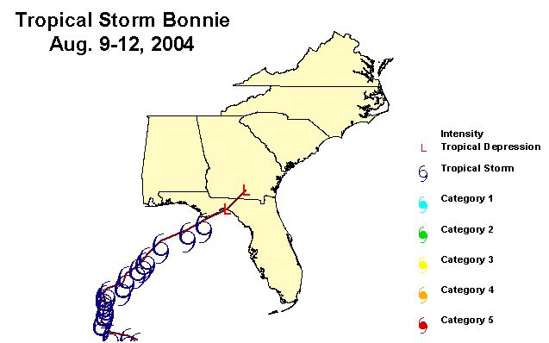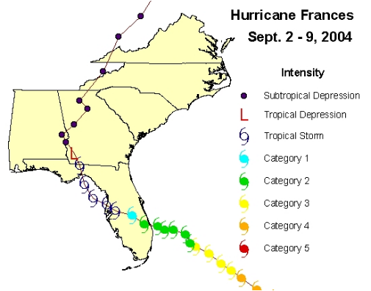

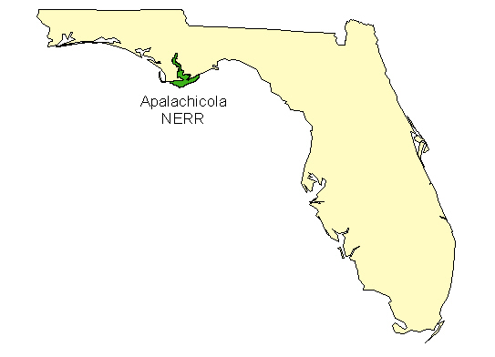

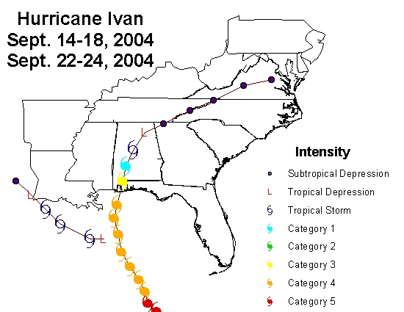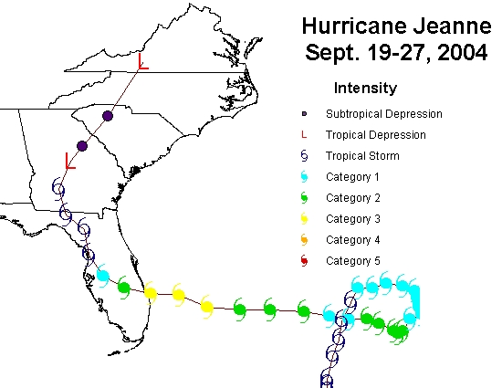

- 2004 Data recalculations:

Data for the following months and parameters has been recalculated by the laboratory prior to final submission.

Monitoring Program 1 (Grab Samples)
Parameter code | Months for which this parameter was recalculated by laboratory
PO4 | August
 | September
 | November
NH4* | August
 | September
 | October
 | December
NO2** | November
Monitoring Program 2 (Diel Samples)
Parameter code | Months for which this parameter was recalculated by laboratory
PO4 | August
 | September
 | November
NH4* | August
 | September
 | October
 | December
NO2** | November
*DIN values have been recalculated by ANERR staff, based on the affected raw data received from laboratory.
**NO3 values have been recalculated by ANERR staff, based on the affected raw data received from laboratory.

- Quality Assurance Report

Apalachicola NERRS SWMP Nutrient Analysis Project
2004-2005 Quality Assurance Report

FDEP PO No. S 3700 762557
FSU Budget No. 1368-889-37

Project Manager:
Lee Edmiston
DEP-Apalachicola National Estuarine Research Reserve
350 Carroll St.
Eastpoint, FL 32328
850-670-4783

Principal Investigators:
William M. Landing, Richard L. Iverson, and Joel E. Kostka
Department of Oceanography
Florida State University
Tallahassee, FL 32306-4320
850-644-6037

1. Analytical Detection Limits

Analytical detection limits were established by replicate analysis of a low sample or blank, and are reported as 3SD. The analytical detection limits for each analyte are reported in Figure 1.

2. Analytical Accuracy

Accuracy was determined by analysis of external nutrient QA/QC samples. In 2005, we participated in the NERRS-SWMP analytical laboratory intercomparison for nutrients in seawater. One “unknown” sample was provided, which we analyzed in duplicate for nitrate+nitrite, nitrite, and Soluble Reactive Phosphorus (SRP). The results are reported in Table 1. Our nitrite and nitrate+nitrite results are within 1SD of the mean values reported for the intercomparison project, while our ortho-P results are within 2SD of the mean. We will continue to participate in these intercalibration exercises when they are offered.

Table 1. | Analytical accuracy determined in the 2005 NOAA/SWMP
 | Analytical Laboratory Intercomparison
 | Reported |  |  | Detected
Soluble Reactive
Phosphorus (SRP; mg-P/L) | 0.021 | ± | 0.003 | 0.015
Nitrate+Nitrite (mg-N/L) | 0.171 | ± | 0.019 | 0.154
Nitrite (mg-N/L) | 0.023 | ± | 0.002 | 0.022

Accuracy was also checked by analysis of “check samples” prepared independently from the staff members conducting the analyses. Sets of eight check samples covering a salinity range from 4.9 to 35, and with a series of “low” to “high” added nutrient concentrations were prepared from open-ocean low-nutrient surface seawater and primary nutrient standard solutions prepared from analytical-grade reagents. These check samples were then analyzed along with the regular monthly NERRS sample sets. Figure 1 shows the comparison between the “added” and “measured” concentrations of ammonia, SRP, nitrite, and nitrate+nitrite. Data falling on the 1:1 lines reflect “perfect” analytical agreement. Data fall above the 1:1 lines when the “measured” values are higher than the “added” values. Data fall below the 1:1 lines when the “measured” values are less than the “added” values. With the exception of NO3+2, the measured values were not significantly different from the “added” concentrations, considering the analytical detection limits for each analyte. The NO3+2 analysis was hampered by a failing component on our NOx analyzer. Overall, the analytical recovery for NO3+2 for October 2004 through February 2005 was 80±9%. We have not corrected the field data for this modestly low recovery. The instrument has been sent back for repair, and we are currently using a comparable instrument at FAMU for the NOx analyses, where the check standards agree much better with the expected concentrations. (NOTE: our NOx detector has been repaired, and we are once again making the NO2+3 measurements in our FSU lab. The analytical NOx recovery for May, June and July 2005 are back up to >98%). We will continue this procedure of analyzing check samples each month to keep track of the analytical accuracy.
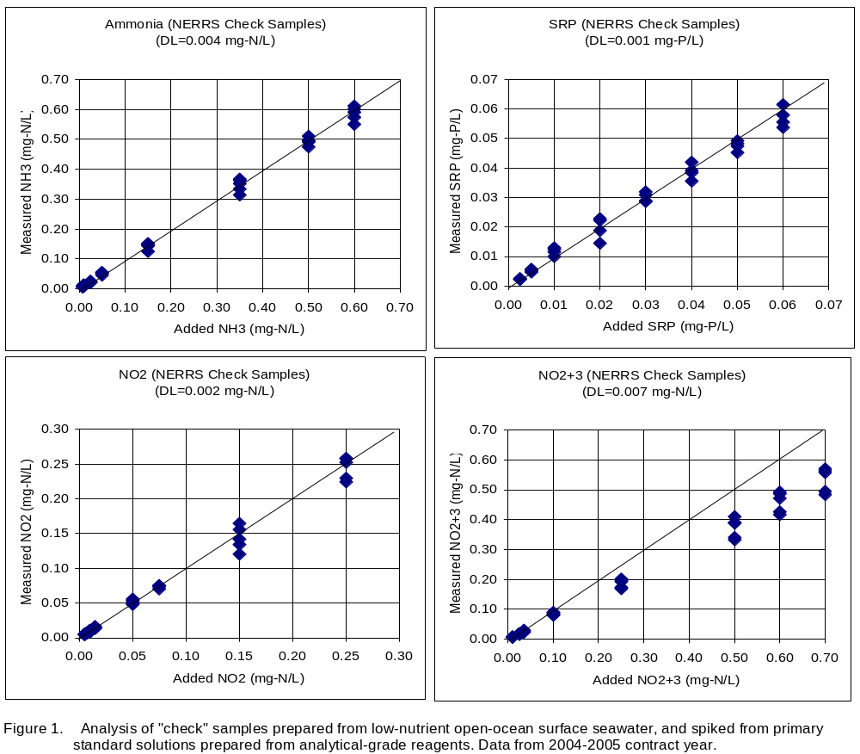

3. Replicate Precision

Duplicate samples were collected from each station during the second year to assess the sampling and analytical reproducibility. The results are shown in Figure 2, where the analysis of each duplicate pair is plotted on a 1:1 plot. Perfect sampling and analytical replication would result in values falling exactly on the 1:1 line. As the sample concentrations approach the analytical detection limit, one expects to see more divergence from the 1:1 line. While the replicate agreement is extremely good for most samples, we observed deviations among the replicate samples that exceeded our analytical precision. Additional sources of variance include: true environmental variance, sample bottle cleanliness (and field rinsing), and low-level contamination during filtration. The samples we have collected thus far do not permit an evaluation of these other sources of variance. The replicate precision of the Nitrite measurements shows several sample sets with poor replicate precision. As far as we can tell from the laboratory data, this is not due to analytical variability; witness the Check Sample analysis in Fig. 1, showing excellent accuracy and recovery. The replicate chlorophyll measurements have precision comparable to what was observed in the first year of the project (2002), where replicate variability at high chlorophyll concentrations was attributed to natural phytoplankton patchiness.
