Apalachicola (APA) NERR Nutrient Metadata
January – December 2013
Latest Update: April 30, 2014

Note: This is a provisional metadata document; it has not been authenticated as of its download date. Contents of this document are subject to change throughout the QAQC process and it should not be considered a final record of data documentation until that process is complete. Contact the CDMO (cdmosupport@belle.baruch.sc.edu) or Reserve with any additional questions.

I. Data Set and Research Descriptors

- Principal investigators and contact persons
  - Reserve Contact

Jennifer Harper, Research Coordinator
108 Island Drive
Eastpoint, Fl 32328
850-670-7716
Jennifer.harper@dep.state.fl.us

Lauren Levi, Environmental Specialist II
108 Island Drive
Eastpoint, Fl 32328
850-670-7710
lauren.levi@dep.state.fl.us

  - Laboratory Contact

Edward J. Phlips, Professor
Department of Fisheries and Aquatic Sciences
University of Florida
7922 N.W. 71st Street
Gainesville, Florida 32653
352-273-3603
phlips@ufl.edu

Timothy W. Fitzpatrick
Chemistry Section
Florida Department of Environmental Protection
2600 Blair Stone Road
Tallahassee, Fl 32399
850-245-8085

David D. Whiting
Biology Section
Florida Department of Environmental Protection
2600 Blair Stone Road
Tallahassee, Fl 32399
850-245-8177

- Research objectives

Previous studies have shown the importance of river flow and flushing rates on nutrients and primary productivity in the bay. Similar studies have determined nitrogen and phosphorus budgets for Apalachicola Bay as well as nutrient limitations related to seasonality and riverflow. There has been an ongoing controversy between the States of Florida, Georgia, and Alabama over the upstream diversion of water for 23 years. Approximately 88% of the drainage basin for the Apalachicola River and Bay is located in Georgia and Alabama and historical flows are being threatened by upstream development. A tri-state compact, between the states and approved by the US Congress, required negotiations between the states to develop a water allocation formula. The states were unable to come to an agreement, the compact expired, and legal proceedings, which could end up in the US Supreme Court, are underway. This study is one of many looking at short-term variability, long-term change, and the relationship of other environmental factors to the productivity of the Apalachicola Bay system as well as trying to separate natural from man-made variability.

  - Monthly Grab
Monthly grab samples are collected at 11 sites located across Apalachicola Bay to monitor spatial and temporal fluctuations in nutrient/chlorophyll a concentrations occurring in diverse sections of the bay. The stations have been chosen to help determine the influence of the river, local rainfall, adjacent habitats and man’s impact on these parameters. Sampling sites are located in the lower Apalachicola River, in the coastal area, offshore of the barrier islands, at the SWMP datalogger locations, and throughout the bay. Seasonal, climatic, and anthropogenic factors all impact riverflow, which in turn affects nutrient/ chlorophyll a concentrations in the bay. Nutrient/chlorophyll a concentrations are also influenced by tidal action, wind direction and speed, and the hydrodynamics of the system.

  - Diel Sampling Program
Diel sampling is performed once a month in conjunction with grab sampling for nutrients/ chlorophyll a. The East Bay Surface water quality datalogger site (apaesnut) is utilized each month for placement of the sampler so that temporal water quality data may be compared with the spatial nutrient/ chlorophyll a data collected at this site. Studies by the Reserve and others have shown the influence of tidal action and runoff on other physical parameters in the bay.

- Research methods

  - Monthly Grab Sampling Program
Monthly grab samples are collected at eleven stations (see Table 1) within and adjacent to Apalachicola Bay. All grab samples are collected on the same day. Due to the distance between the stations it is not always possible to collect all the samples several hours prior to low tide. Tidal condition, wind direction, speed, and cloud cover are recorded for each station at the time of sampling but are not included in this dataset and are available upon request. Climatic data from the ANERR weather station is available online at http://cdmo.baruch.sc.edu/QueryPages/googlemap.cfm. Sampling after heavy rains is avoided if at all possible. Water temperature, salinity, and dissolved oxygen are measured at surface and bottom for each station with a YSI 2030 handheld meter. Surface measurements only are included in this dataset for temperature, salinity and dissolved oxygen. Bottom measurements for temperature, salinity, and dissolved oxygen are available on request. pH is also measured and is available on request. Secchi data is also included in this dataset. Turbidity samples are collected at each site and are tested in the ANERR lab with a DRT-15CE Turbidimeter. January through June 2013 all samples are analyzed at the University of Florida (UF) laboratory. July through December 2013 all samples are analyzed at the Florida Department of Environmental Protection laboratory (FLDEP).

i) Grab sample collection January through June 2013:
A horizontal Van Dorn-style sampler is used to collect 2.2 liters of water from a depth of 0.5 meters at all stations not associated with a SWMP datalogger site. At the Cat Point and Dry Bar SWMP datalogger stations, water samples are collected at a depth of approximately 2 and 1.5 meters (one-half meter from the bottom) respectively, a depth equivalent to the probes of the data loggers deployed at these sites. At the East Bay datalogger station water samples are collected from surface (0.5 meters) and bottom (1.5 meters) depths, equivalent to the depths of the two dataloggers deployed at this site. Triplicate samples are collected each month at one station, rotating through all station locations. The triplicate samples are collected with subsequent dips of the horizontal sampler.

ii) Grab sample filtration and handling January through June 2013:
Water from the Van Dorn sampler is delivered into a polyethylene graduated cylinder. A preliminary discard rinse is performed to flush the sampler spigot and also to rinse the graduated cylinder. The water sample is then filtered through a GFF filter. The GFF filter for chlorophyll a analysis is wrapped in aluminum foil and frozen in the dark until delivered to the UF laboratory. The filtrate is split between two acid washed and rinsed polyethylene bottles, provided by the UF laboratory. One bottle contains unpreserved filtrate, the other bottle contains 5N H2SO4 as preservative. Both bottles are placed on ice in the dark until delivery to the UF laboratory. All filtration funnels and containers are rinsed with DI water at least 3 times in between samples. A field blank is also run each month, using DI water for sample blank. The field blank is filtered as described above. All grab samples are delivered to the UF laboratory on the same day as collection.

iii) Grab sample collection July through December 2013:
A submersible pump and flexible clear plastic tubing is used to collect water from a depth of 0.5 meters at all stations not associated with a SWMP datalogger site. At the Cat Point and Dry Bar SWMP datalogger stations, water samples are collected at a depth of approximately 2 and 1.5 meters (one-half meter from the bottom) respectively, a depth equivalent to the probes of the data loggers deployed at these sites. At the East Bay datalogger station water samples are collected from surface (0.5 meters) and bottom (1.5 meters) depths, equivalent to the depths of the two dataloggers deployed at this site. Triplicate samples are collected every other month at one station, rotating through all station locations.

iv) Grab sample filtration and handling July through December 2013:
Water from the submersible pump is delivered directly into the appropriate sample bottles. A filter is attached to the end of the flexible tubing for collection of nutrient samples requiring filtration, water filtered in this manner is delivered directly to the appropriate sample bottles. Necessary preservatives are added prior to water sample. Whole water samples for chlorophyll a analysis are filtered at the FLDEP laboratory. All samples are placed on ice in the dark until delivery to the FLDEP laboratory. The submersible pump and tubing are flushed with ambient water prior to sample collection at each station. Filter holders are rinsed with DI prior to addition of a new filter at each station. A field blank is also run each month, using DI water for sample blank. The field blank is delivered using the pump, tubing and filter as described above. All grab samples are delivered to the FLDEP laboratory 24 to 36 hours after collection.

  - Diel Sampling Program

    - Diel sampling program January through June 2013:
Diel sampling is performed with an ISCO 3700 Portable Automated Sampler at the East Bay surface (apaesnut) station. For January through March 2013 the ISCO sampler is deployed on a floating platform that is towed to the site each month at time of deployment. Beginning with the April 2013 sampling event the ISCO is deployed on a fixed platform at the same location used for all prior sampling. Whenever possible, the ISCO is deployed the day before the bay-wide grab samples are collected and retrieved during the grab sample collection run. The sampler is programmed to collect one 1000 ml water sample every 2.5 hours, over a 25-hour period at the same depth as the East Bay surface datalogger probes (1.7 m above the bottom sediment). This captures a complete 24 hr: 48min lunar-tidal cycle. The ISCO sampler is programmed to purge the suction line before and after each sample collection. The center of the ISCO sampler is filled with ice to aid in sample preservation. All samples are placed in coolers of ice upon retrieval of the ISCO sampler at the end of the sampling period. All diel samples are stored on ice in the dark and are filtered at ANERR laboratory within one hour of retrieval from the ISCO sampler. GFF filters are stored frozen in the dark. Filtrate samples are held on ice in the dark. All diel samples are delivered to the UF laboratory on the same day as sampler retrieval.

    - Diel sampling program July through December 2013:
Diel sampling is performed with an ISCO 3700 Portable Automated Sampler at the East Bay surface (apaesnut) station. The ISCO is deployed on a fixed platform located at the East Bay surface site. Generally the ISCO is deployed at the beginning of the grab sample collection trip and retrieved the following morning. In some months adverse weather conditions result in deployment of the ISCO sampler during a week prior to grab sample collection. The sampler is programmed to collect two 1000 ml water samples every 2.5 hours, over a 25-hour period at the same depth as the East Bay surface datalogger probes (1.7 m above the bottom sediment). This captures a complete 24 hr: 48min lunar-tidal cycle. The ISCO sampler is programmed to purge the suction line before and after each sample collection. The center of the ISCO sampler is filled with ice to aid in sample preservation. All samples are placed on ice upon retrieval of the ISCO sampler at the end of the sampling period. Nutrient sample filtration is performed at ANERR laboratory within one hour of retrieval from the ISCO sampler. Whole water samples for chlorophyll a analysis are filtered at the FLDEP laboratory. All diel samples are delivered to the FLDEP laboratory within 36 hours of the first sample collection time.

Equipment QAQC and maintenance – Grab and Diel Sampling Program:

    - January through June 2013:
The horizontal Varn Dorn sampler is thoroughly rinsed with tap water after each sampling trip. Spare parts for the sampler are kept on hand and replaced as needed. Filtration funnels, receivers, and graduated cylinders are acid washed with 10% HCl and rinsed at least 3 times with DI water after each sampling trip. Diel sample collection bottles used in the ISCO automated sampler are acid washed and rinsed at least 3 times with DI water after each sampling trip. The ISCO automated sampler tubing is acid washed and rinsed at least 3 times with DI water after each monthly sampling event. The overall condition of the pump and tubing is checked each month prior to deployment, tubing is replaced as needed. Bottles used to hold sample filtrate, both preserved and unpreserved, are supplied and cleaned by UF laboratory. The YSI 2030, pH meter, and Turbidimeter are calibrated each day of use.

    - July through December 2013:
The submersible pump, tubing, and field use filter holders are acid rinsed with 10% HCl and rinsed at least 3 times with DI water after each sampling trip. In lab use filtration funnels and receivers are acid washed with 10% HCl and rinsed at least 3 times with DI water after each sampling trip. Diel sample collection bottles used in the ISCO automated sampler are acid washed and rinsed at least 3 times with DI water after each sampling trip. The ISCO automated sampler tubing is acid washed and rinsed at least 3 times with DI water after each monthly sampling event. The overall condition of the pump and tubing is checked each month prior to deployment, tubing is replaced as needed. New unused sample bottles are supplied by FLDEP laboratory for each sampling event. The YSI 2030, pH meter, and Turbidimeter are calibrated each day of use.

Table 1. Nutrient and chlorophyll a sampling sites for the Apalachicola NERR SWMP.

Station code | Station name | Latitude | Longitude | Tidal range average (meters) | Salinity range | Water depth average (meters) | Bottom habitat | Datalogger station name |  | Sample depth  (meters)
apawpnut | West Pass | 29 38.279 | 85 5.341 | 0.7 | euryhaline | 5.0 | sand |  |  | 0.5
apadbnut | Dry Bar | 29 40.482 | 85 3.502 | 0.7 | euryhaline | 1.7 | oyster bar | apadb |  | 1.5
apapcnut | Pilot's Cove | 29 36.473 | 85 1.173 | 0.7 | euryhaline | 1.8 | patchy seagrass |  |  | 0.5
apambnut | Mid Bay | 29 40.061 | 84 59.641 | 0.7 | euryhaline | 2.2 | sandy silt |  |  | 0.5
apaegnut | East Bay Bridge | 29 43.848 | 84 56.711 | 0.7 | euryhaline | 1.6 | silty clay |  |  | 0.5
apaesnut | East Bay Surface | 29 47.147 | 84 52.512 | 0.7 | euryhaline | 1.7 | clayey sand | apaes |  | 0.5
apaebnut | East Bay Bottom | 29 47.147 | 84 52.512 | 0.7 | euryhaline | 1.7 | clayey sand | apaeb |  | 1.5
apascnut | Sikes Cut Offshore | 29 36.401 | 84 56.799 | 0.7 | marine | >5.0 | sand |  |  | 0.5
apanhnut | Nick's Hole | 29 39.022 | 84 55.732 | 0.7 | euryhaline | 1.0 | patchy seagrass |  |  | 0.5
apacpnut | Cat Point | 29 42.128 | 84 52.811 | 0.7 | euryhaline | 1.8 | oyster bar | apacp |  | 2.0
aparvnut | River | 29 46.743 | 85 2.606 | 0.7 | oligohaline | 3-4 | sandy silt |  |  | 0.5

Note: Diel samples are collected 2.5 hours apart at the East Bay Surface datalogger site, APAESNUT, with the ISCO
automated water sampler. No duplicate diel samples are taken, however there is some overlap with monthly grabs
collected at the East Bay Surface station and deployment of the ISCO sampler.

Figure 1. Station locations.

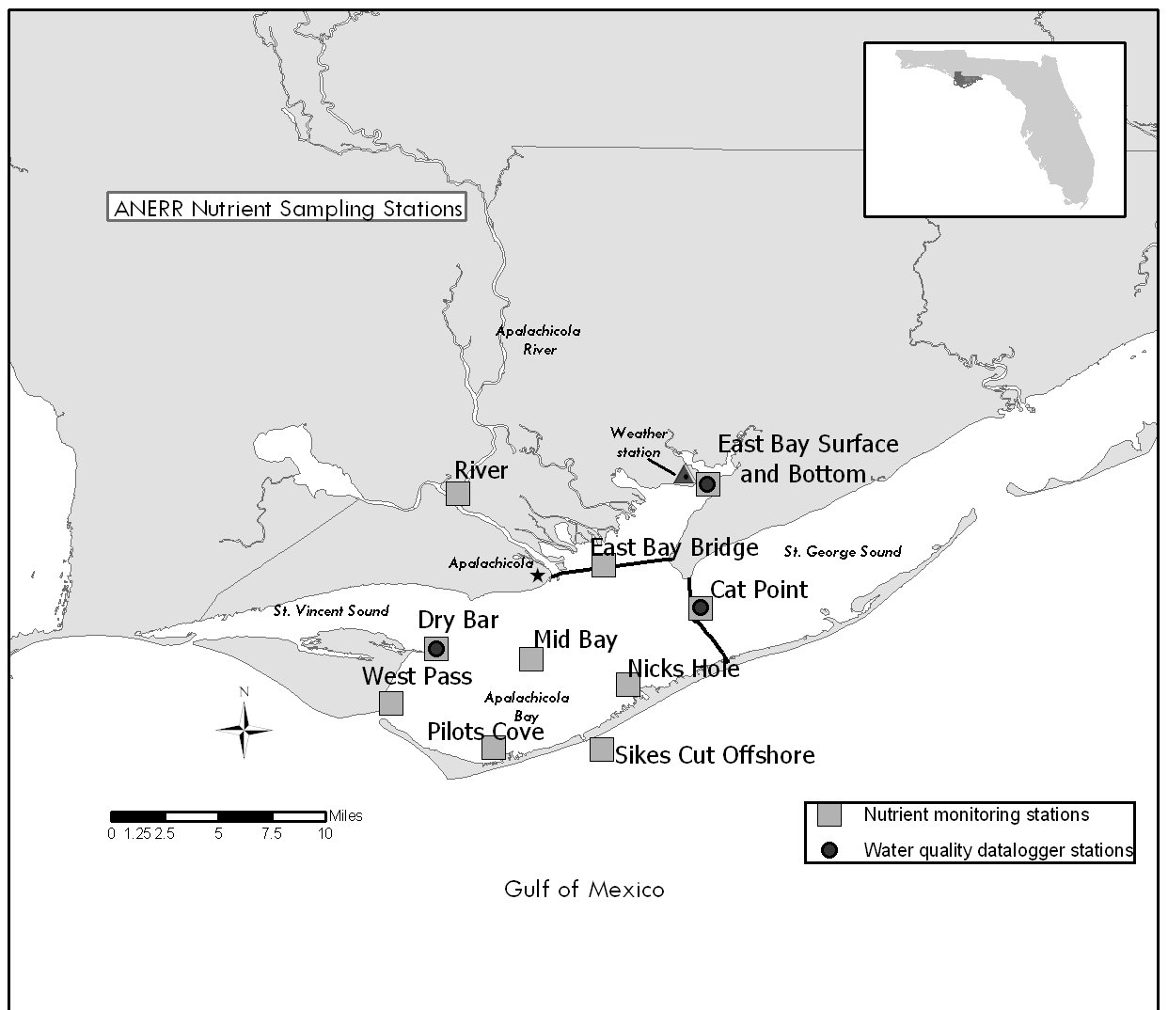

- Site location and character

The Apalachicola Drainage Basin encompasses over 19,600 square miles and includes parts of three states (Alabama, Georgia, and Florida). The Apalachicola River is the largest in Florida in terms of flow. The amount of river discharge has been shown to be highly significant to the ecology of the estuary, which acts as a buffer between the Gulf of Mexico and fresh water input from upland areas. The nutrient rich plume of "green water" moving out of Apalachicola Bay is also important to the productivity of the northeastern Gulf of Mexico. The Apalachicola National Estuarine Research Reserve is located in the northwestern part of Florida, generally called the panhandle. It is located adjacent to the City of Apalachicola, and encompasses most of the Apalachicola Bay system, including 52 miles of the lower Apalachicola River. Passes, both natural and manmade, connect Apalachicola Bay to the northeastern Gulf of Mexico.

  - East Bay datalogger and nutrient station
East Bay is separated from Apalachicola Bay by two bridges and a causeway and is located to the north of the bay proper. The bay is 8.2 km long, has an average Depth of approximately 1.0 m MHW, and an average width of 1.8 km. The tides in East Bay are mixed and range from 0.3 m to 1.0 m (average 0.5 m). The datalogger and nutrient sampling site is located in the upper reaches of East Bay. The piling location for the two East Bay dataloggers (ES and EB) is latitude 29°47.15' N and longitude 84°52.52' W. At the sampling site, the Depth is 2.2 m MHW and the width of the bay is 1 km. The tides in the system are mixed, meaning the number of tides can range from one to five tides during a 24 hour period and are not evenly distributed throughout the day. At the East Bay bottom site the meter probes are 0.3 m above the bottom sediment. Salinity ranges from 0 to 30 ppt and the long-term (1993-2013) average salinity is approximately 10.6 ppt. At the East Bay surface site the meter probes are 1.7 m above the bottom sediment and salinity ranges from 0 ppt to 30 ppt with a long term (1995-2013) average salinity of 9.6 ppt. The freshwater input is very tannic and usually dark colored. Flows vary with local rainfall and are not quantified due to the diverse sources of the runoff. The bottom habitat at this bay site is soft sediment, primarily silt and clay, with no vegetation present. The dominant marsh vegetation near the sampling site (approximately300 meters away) is Juncus roemerianus and Cladium jamaicense. The dominant upland vegetation is primarily pineland forests which includes slash pine, saw palmetto, and sand pine. Upland land use near the sampling site includes conservation and silviculture uses with some single family residential in the lower East Bay area. The sampling site is influenced by local runoff from Tate's Hell Swamp, the East Bay marshes, and distributary flow, some of which comes from the Apalachicola River via the East River. Tate's Hell Swamp was ditched, diked, and altered in the late 1960’s and early 1970’s by timber companies. These changes shortened the drainage period and allowed increased runoff with a concomitant decrease in pH and increase in color, which had a drastic affect on the biological communities in East Bay. Restoration of Tate's Hell Swamp began in 1995 to reduce non-point source runoff and restore historic sheet flow in the area.

  - Cat Point datalogger and nutrient station
The Cat Point datalogger and nutrient sampling site is located in St. George Sound, approximately 400 meters east of the St. George Island Bridge. The piling location is latitude 29°42.12′ N and longitude 84°52.81′ W. The tides at Cat Point are mixed and range from 0.3m to 1.0m (average 0.5m). At the sampling site, the Depth is 2.5 m MHW. (The site was moved approximately 600 meters south in October 1997) and the width of the bay is 4 miles. At the Cat Point site the meter probes are 0.3 meters above the bottom sediment. This is also the Depth where nutrients are collected monthly. Salinity ranges from 0 to 32 ppt with a long-term (1992-2013) average salinity of 21.4 ppt.. Flows vary with local rainfall and are not quantified due to the diverse sources of the runoff. The bottom type is oyster bar with no vegetation present except algae growing on the oysters in the summer. The dominant upland vegetation is primarily pineland forests, which include slash pine, saw palmetto, and sand pine. Upland land use near the sampling site, includes single family residential and commercial use in the Eastpoint area. The sampling site is influenced by local runoff from Tate's Hell Swamp and flow from the Apalachicola River. High salinity water comes mainly from the east, through East Pass at the eastern end of St. George Island.

  - Dry Bar datalogger and nutrient station
The Dry Bar datalogger and nutrient sampling site is located near St. Vincent Sound, in the western part of the Apalachicola Bay system, approximately one-half mile east of St. Vincent Island. The piling location is latitude 29°40.48′ N and longitude 85°03.50′ W. At the sampling site, the Depth is 2 meters and the width of the bay is 7 miles. At the Dry Bar site the datalogger probes are located 0.3 meters above the bottom sediment. This is also the Depth where nutrients are collected monthly. The tides are mixed and range from 0.3 to 1.0 meters. Salinity ranges from 0 to 34 ppt with a long-term (1992-2013) average salinity of 20.9 ppt. The bottom type is oyster bar with no vegetation present, except algae that grows on the oysters during the summer months. The dominant upland vegetation includes slash pine flatwoods with various combinations of gallberry, smooth cordgrass, fetterbush, cabbage palm, saw palmetto, magnolia, and grasses. Upland use near the sampling site includes state owned and managed Cape St. George Island, St. Vincent National Wildlife Refuge, as well as, single family residential and commercial use in the Apalachicola area. The sampling site is influenced by the flow of the Apalachicola River and high salinity water coming through West Pass and Sikes Cut.

  - Additional Apalachicola Bay nutrient stations
Information for an additional 7 nutrient stations, not associated with the required sampling at the datalogger sites, as well as the datalogger sites, is included in Table 1. Monthly grab samples are collected at all nutrient monitoring stations. A map of station locations is given in Figure 1.

- Code variable definitions

Station code names:
apacpnut = Apalachicola Reserve nutrient data for Cat Point
apadbnut = Apalachicola Reserve nutrient data for Dry Bar
apaebnut = Apalachicola Reserve nutrient data for East Bay Bottom
apaegnut = Apalachicola Reserve nutrient data for East Bay Bridge
apaesnut = Apalachicola Reserve nutrient data for East Bay Surface
apambnut = Apalachicola Reserve nutrient data for Mid Bay
apanhnut = Apalachicola Reserve nutrient data for Nicks Hole
apapcnut = Apalachicola Reserve nutrient data for Pilots Cove
aparvnut = Apalachicola Reserve nutrient data for River
apascnut = Apalachicola Reserve nutrient data for Sikes Cut
apawpnut = Apalachicola Reserve nutrient data for West Pass

Monitoring Programs:
Monthly grab samples = 1
Diel grab sampling = 2

- Data collection period
Nutrient monitoring began in April 2002 at all stations listed. Sampling has been performed monthly at all stations, unless otherwise noted. This table lists collection times for all nutrient and chlorophyll a samples in 2013. The below Start and End time reflect the times that the first and last diel samples were collected for each monthly diel sampling event. Grab sample end time is not recorded in the field. Generally grab sample collection, filtering, and icing are completed within 10 minutes or less depending upon field conditions at the time of sampling. Time is coded based on a 2400 hour clock and is referenced to Eastern Standard Time (EST), without Daylight Savings Time adjustments.

a) Start Date and Time for Monitoring Program 1 (Grab Samples)

Site | Start Date/Time |  | Site | Start Date/Time
apacpnut | 01/08/2013 10:54 |  | apambnut | 01/08/2013 10:03
apacpnut | 02/05/2013 10:23 |  | apambnut | 02/05/2013 08:45
apacpnut | 03/05/2013 15:44 |  | apambnut | 03/05/2013 14:13
apacpnut | 03/05/2013 15:47 |  | apambnut | 04/02/2013 08:04
apacpnut | 03/05/2013 15:51 |  | apambnut | 05/08/2013 08:25
apacpnut | 04/02/2013 10:18 |  | apambnut | 06/03/2013 10:43
apacpnut | 05/08/2013 10:07 |  | apambnut | 07/09/2013 10:37
apacpnut | 06/03/2013 09:10 |  | apambnut | 08/12/2013 09:43
apacpnut | 06/03/2013 09:12 |  | apambnut | 09/04/2013 09:21
apacpnut | 06/03/2013 09:15 |  | apambnut | 09/04/2013 09:24
apacpnut | 07/09/2013 08:56 |  | apambnut | 09/04/2013 09:31
apacpnut | 08/12/2013 09:22 |  | apambnut | 10/08/2013 08:39
apacpnut | 09/04/2013 08:13 |  | apambnut | 10/29/2013 09:58
apacpnut | 10/08/2013 10:07 |  | apambnut | 12/03/2013 13:15
apacpnut | 10/29/2013 09:30
apacpnut | 12/03/2013 11:07
Site | Start Date/Time |  | Site | Start Date/Time
apadbnut | 01/08/2013 10:19 |  | apanhnut | 01/8/2013 no sample
apadbnut | 02/05/2013 08:56 |  | apanhnut | 02/05/2013 10:01
apadbnut | 02/05/2013 08:58 |  | apanhnut | 03/05/2013 15:31
apadbnut | 02/05/2013 09:01 |  | apanhnut | 04/02/2013 09:56
apadbnut | 03/05/2013 14:25 |  | apanhnut | 05/08/2013 09:48
apadbnut | 04/02/2013 08:21 |  | apanhnut | 06/03/2013 09:27
apadbnut | 04/02/2013 08:23 |  | apanhnut | 07/09/2013 09:11
apadbnut | 04/02/2013 08:25 |  | apanhnut | 08/12/2013 no sample
apadbnut | 05/08/2013 08:39 |  | apanhnut | 09/04/2013 08:34
apadbnut | 06/03/2013 10:30 |  | apanhnut | 10/08/2013 no sample
apadbnut | 07/09/2013 10:25 |  | apanhnut | 10/29/2013 no sample
apadbnut | 08/12/2013 09:57 |  | apanhnut | 12/03/2013 11:30
apadbnut | 09/04/2013 09:40
apadbnut | 10/08/2013 08:17
apadbnut | 10/29/2013 10:16
apadbnut | 12/03/2013 12:57
Site | Start Date/Time |  | Site | Start Date/Time
apaebnut | 01/08/2013 11:53 |  | apapcnut | 01/8/2013 no sample
apaebnut | 02/05/2013 10:56 |  | apapcnut | 02/05/2013 09:30
apaebnut | 03/05/2013 10:07 |  | apapcnut | 03/05/2013 14:54
apaebnut | 04/02/2013 11:11 |  | apapcnut | 04/02/2013 09:05
apaebnut | 05/08/2013 10:43 |  | apapcnut | 05/08/2013 09:07
apaebnut | 06/03/2013 08:40 |  | apapcnut | 06/03/2013 10:02
apaebnut | 07/09/2013 08:34 |  | apapcnut | 07/09/2013 09:50
apaebnut | 08/12/2013 08:50 |  | apapcnut | 08/13/2013 no sample
apaebnut | 09/04/2013 07:35 |  | apapcnut | 09/04/2013 10:08
apaebnut | 10/08/2013 10:46 |  | apapcnut | 10/08/2013 09:15
apaebnut | 10/29/2013 08:35 |  | apapcnut | 10/29/2013 no sample
apaebnut | 12/03/2013 09:18 |  | apapcnut | 12/03/2013 12:20
Site | Start Date/Time |  | Site | Start Date/Time
apaegnut | 01/08/2013 12:09 |  | aparvnut | 01/08/2013 09:30
apaegnut | 02/05/2013 10:42 |  | aparvnut | 01/08/2013 09:34
apaegnut | 03/05/2013 16:01 |  | aparvnut | 01/08/2013 09:40
apaegnut | 04/02/2013 10:37 |  | aparvnut | 02/05/2013 12:18
apaegnut | 05/8/2013 no sample |  | aparvnut | 03/05/2013 16:26
apaegnut | 06/03/2013 08:13 |  | aparvnut | 04/02/2013 11:48
apaegnut | 07/09/2013 07:44 |  | aparvnut | 05/08/2013 07:54
apaegnut | 08/12/2013 08:31 |  | aparvnut | 06/03/2013 11:15
apaegnut | 09/04/2013 07:19 |  | aparvnut | 07/09/2013 11:01
apaegnut | 10/08/2013 11:17 |  | aparvnut | 08/12/2013 10:51
apaegnut | 10/29/2013 11:42 |  | aparvnut | 09/04/2013 10:38
apaegnut | 12/03/2013 10:48 |  | aparvnut | 10/08/2013 07:43
 |  |  | aparvnut | 10/29/2013 10:55
 |  |  | aparvnut | 12/03/2013 13:41
Site | Start Date/Time |  | Site | Start Date/Time
apaesnut | 01/08/2013 11:53 |  | apascnut | 01/8/2013 no sample
apaesnut | 02/05/2013 10:56 |  | apascnut | 02/05/2013 09:46
apaesnut | 03/05/2013 10:07 |  | apascnut | 03/05/2013 15:18
apaesnut | 04/02/2013 11:09 |  | apascnut | 04/02/2013 09:36
apaesnut | 05/08/2013 10:43 |  | apascnut | 05/08/2013 09:29
apaesnut | 05/08/2013 10:45 |  | apascnut | 06/03/2013 09:43
apaesnut | 05/08/2013 10:47 |  | apascnut | 07/09/2013 09:31
apaesnut | 06/03/2013 08:40 |  | apascnut | 08/12/2013 10:19
apaesnut | 07/09/2013 08:12 |  | apascnut | 09/04/2013 08:55
apaesnut | 07/09/2013 08:25 |  | apascnut | 10/08/2013 09:36
apaesnut | 07/09/2013 08:32 |  | apascnut | 10/29/2013 no sample
apaesnut | 08/12/2013 08:48 |  | apascnut | 12/03/2013 11:53
apaesnut | 09/04/2013 07:33
apaesnut | 10/08/2013 10:44 |  | Site | Start Date/Time
apaesnut | 10/29/2013 08:33 |  | apawpnut | 01/8/2013 no sample
apaesnut | 10/29/2013 08:40 |  | apawpnut | 02/05/2013 09:15
apaesnut | 10/29/2013 08:45 |  | apawpnut | 03/05/2013 14:40
apaesnut | 12/03/2013 09:15 |  | apawpnut | 04/02/2013 08:42
 |  |  | apawpnut | 05/08/2013 08:54
 |  |  | apawpnut | 06/03/2013 10:15
 |  |  | apawpnut | 07/09/2013 10:08
 |  |  | apawpnut | 08/12/2013 no sample
 |  |  | apawpnut | 09/04/2013 09:50
 |  |  | apawpnut | 10/08/2013 08:57
 |  |  | apawpnut | 10/29/2013 no sample
 |  |  | apawpnut | 12/03/2013 12:37

  - Start and End Date/Time for Monitoring Program 2 (Diel Sampling)
Site | Start Date/Time | End Date/Time
apaesnut | 01/08/2013 12:00 | 01/09/2013 10:30
apaesnut | 03/04/2013 10:15 | 03/05/2013 08:45
apaesnut | 04/01/2013 09:30 | 04/02/2013 10:30
apaesnut | 05/07/2013 08:15 | 05/08/2013 09:15
apaesnut | 06/03/2013 09:00 | 06/04/2013 10:00
apaesnut | 07/09/2013 08:15 | 07/10/2013 09:15
apaesnut | 08/07/2013 08:15 | 08/08/2013 09:15
apaesnut | 09/04/2013 07:45 | 09/05/2013 06:15
apaesnut | 10/01/2013 09:45 | 10/02/2013 10:45
apaesnut | 10/29/2013 08:45 | 10/30/2013 09:45
apaesnut | 12/03/2013 09:30 | 12/04/2013 10:30

- Associated researchers and projects

The Reserve conducts long-term water quality monitoring and maintains a weather station as part of the NERRS SWMP. Other ongoing projects or data that relate to the nutrient monitoring project includes:

Apalachicola River Discharge, U.S. Geological Survey, http://waterdata.usgs.gov/nwis/

Byars, Natalie, Florida State University
How does climatic- and human-induced variability in river flow affect the spatial-temporal distribution of phytoplankton and their subsequent availability to oysters in Apalachicola Bay, Florida?

Caffrey, Jane, University of West Florida
Effect of Diurnal and Weekly Water Column Hypoxic Events on Nitrification and Nitrogen
Transformations in Estuarine Sediments

Hagen, S., DeLorme, D., Walters, L., Wang, D., Weishampel, J., Yeh, G., Huang, W., Slinn, D., Morris, J. Ecological Effects of Sea Level Rise

“Gauging the effects of the BP Oil Spill on diatoms, calcareous nanoplankton, and related protists at or near the base of the food chain in the NE Gulf of Mexico", funded to principal Investigators, Drs Sherwood W. Wise, Jr. and Akshitnhala K. S. K. Prasad.

Garwood, J., Harper, J., Lamb, M., Jones, D., Levi, L.
Apalachicola National Estuarine Research Reserve.
Distribution and density of fishes and benthic invertebrates in Apalachicola Bay.

Harper, J., Wren, K., Jones, D., Garwood, J., Canedo, J., Snyder, C., Levi, L./ NERRS Sentinel Sites Program for Understanding Climate Change Impacts on Estuaries

Jones, D., Lamb, M., Wanat, J., Levi, L., Garwood, J.
Apalachicola National Estuarine Research Reserve
System Wide Monitoring Program
Long-Term Water Quality Monitoring

Levi, L., Harper, J., Garwood, J.
Apalachicola National Estuarine Research Reserve
System Wide Monitoring Program
Long-Term Meteorological Monitoring

Site-Specific Information in Support of Establishing Numeric Nutrient Criteria in Apalachicola Bay, Nutrient Criteria Technical Support Document. Division of Assessment and Restoration, Florida Department of Environmental Protection, July, 2013.

Tucker, Kim, Florida Agricultural and Mechanical University, Department of Civil and Environmental Engineering, Master’s Thesis, Effects of river flow and rainfall on chlorophyll a in Apalachicola River. 2011.

Viveros, Paula, NOAA Graduate Research Fellowship, University of Florida
Phytoplankton composition and abundance in relation to salinity, nutrient and light gradients in the Apalachicola National Estuarine Research Reserve (ANERR)

Wang, H., W. Huang, M. Harwell, L. Edmiston, E. Johnson, P. Hsieh, K. Milla, J. Christensen,
J. Stewart, X. Liu. 2008. Modeling oyster growth rate by coupling oyster population and hydrodynamic models for Apalachicola Bay, Florida, USA. Ecological Modeling 211:77-89.

- Distribution

NOAA/ERD retains the right to analyze, synthesize and publish summaries of the NERRS System-wide Monitoring Program data. The PI retains the right to be fully credited for having collected and processed the data. Following academic courtesy standards, the PI and NERR site where the data were collected will be contacted and fully acknowledged in any subsequent publications in which any part of the data are used. Manuscripts resulting from this NOAA/OCRM supported research that are produced for publication in open literature, including refereed scientific journals, will acknowledge that the research was conducted under an award from the Estuarine Reserves Division, Office of Ocean and Coastal Resource Management, National Ocean Service, National Oceanic and Atmospheric Administration. The data set enclosed within this package/transmission is only as good as the quality assurance and quality control procedures outlined by the enclosed metadata reporting statement. The user bears all responsibility for its subsequent use/misuse in any further analyses or comparisons. The Federal government does not assume liability to the Recipient or third persons, nor will the Federal government reimburse or indemnify the Recipient for its liability due to any losses resulting in any way from the use of this data.

NERR nutrient data and metadata can be obtained from the Research Coordinator at the individual NERR site (please see Principal investigators and contact persons), from the Data Manager at the Centralized Data Management Office (please see personnel directory under the general information link on the CDMO home page) and online at the CDMO home page http://cdmo.baruch.sc.edu/. Data are available in text tab-delimited format.

II. Physical Structure Descriptors

- Entry verification

    - January through June 2013:
A hardcopy of the original ANERR Field Sample Collection logsheet accompanies the samples from ANERR to the UF laboratory. Results data are entered into an Excel spreadsheet by UF laboratory staff, reviewed and signed off by the laboratory supervisor (Dr. Ed Phlips). The Excel data file is then electronically transmitted to ANERR. Lauren Levi, ANERR staff, reviews the data file for completeness and processes the data using the NutrientQAQC Excel macro. Missing data are verified by review of field logs and are denoted by a blank space in the database. The NutrientQAQC macro (version 2.031022014) sets up the data worksheet, metadata worksheets, and MDL worksheet; adds chosen parameters and facilitates data entry; allows the user to set the number of significant figures to be reported for each parameter and rounds using banker’s rounding rules; allows the user to input MDL values and automatically flags/codes values below MDL; calculates parameters chosen by the user and automatically flags/codes for component values below MDL, negative calculated values, and missing data; allows the user to apply QAQC flags and codes to the data; produces summary statistics; graphs selected parameters for review; and exports the resulting data file to the CDMO for tertiary QAQC and assimilation into the CDMO’s authoritative online database. Flag and code definitions are listed in sections 15 and 16 of this document.

    - July through December 2013:
A hard copy of the FLDEP Central Laboratory Sample Submittal Form accompanies the samples from ANERR to the FLDEP laboratory. FLDEP laboratory results and final reports are transmitted to ANERR by electronic download via the FLDEP Laboratory Information Management System (LIMS). Analysis data is exported from LIMS in Excel format and is then formatted by Lauren Levi, ANERR staff, according NERR CDMO SOPs. Original FLDEP LIMS downloaded data files, formatted data files and field logs are all compared with each other to ensure accuracy. Missing data are verified by review of field logs and are denoted by a blank space in the database. The NutrientQAQC macro (version 2.03102014) sets up the data worksheet, metadata worksheets, and MDL worksheet; adds chosen parameters and facilitates data entry; allows the user to set the number of significant figures to be reported for each parameter and rounds using banker’s rounding rules; allows the user to input MDL values and automatically flags/codes values below MDL; calculates parameters chosen by the user and automatically flags/codes for component values below MDL, negative calculated values, and missing data; allows the user to apply QAQC flags and codes to the data; produces summary statistics; graphs selected parameters for review; and exports the resulting data file to the CDMO for tertiary QAQC and assimilation into the CDMO’s authoritative online database. Flag and code definitions are listed in sections 15 and 16 of this document.

- Parameter Titles and Variable Names by Data Category

Required NOAA/NERRS System-wide Monitoring Program nutrient parameters are denoted by an asterisks”*”.

Data Category Parameter Variable Name Units of Measure Collection Period

Phosphorus:
*Orthophosphate, filtered PO4F mg/L as P Jan-Dec 2013
Total Dissolved Phosphorus TDP mg/L as P Jan-Jun 2013
Total Phosphorus TP mg/L as P Jul-Dec 2013
Nitrogen:
*Nitrite + Nitrate, filtered NO23F mg/L as N Jan-Dec 2013
*Ammonium, filtered NH4F mg/L as N Jan-Dec 2013
Dissolved Inorganic Nitrogen DIN mg/L as N Jan-Dec 2013
Total Dissolved Nitrogen TDN mg/L as N Jan-Jun 2013
Total Kjeldahl Nitrogen whole TKN mg/L as N Jul-Dec 2013
Total Nitrogen TN mg/L as N Jul-Dec 2013

Plant Pigments:
*Chlorophyll a CHLA_N μg/ L Jan-Dec 2013
Uncorrected Chlorophyll a UncCHLA_N μg/L Jan-Dec 2013
Phaeophytin PHEA μg/ L Jan-Dec 2013

Other Laboratory
Parameters: Total Suspended Solids TSS mg/L Jul-Dec 2013

Field Parameters:
Water temperature WTEM_N ⁰C Jan-Dec 2013
Salinity SALT_N ppt Jan-Dec 2013
Dissolved oxygen DO_N mg/L Jan-Dec 2013
% Saturated dissolved oxygen DO_S_N % Jan-Dec 2013
Turbidity TURB_N NTU Jan-Dec 2013
Secchi Disk Depth SECCHI meters Jan-Dec 2013

Notes:
            - Time is coded based on a 2400 hour clock and is referenced to Standard Time.
            - Reserves have the option of measuring either NO2 and NO3 or they may substitute NO23 for individual analyses if they can show that NO2 is a minor component relative to NO3. ANERR has shown NO2 to be a minor component of NO23.

11) Measured and Calculated Laboratory Parameters

a) Parameters Measured Directly
Nitrogen species: NO23F, NH4F, TDN, TKN
Phosphorus species: PO4F, TDP, TP
Other: UncCHLA_N, CHLA_N, PHEA, TSS, WTEMP_N, SALT_N, DO_N, DO_S_N, TURB_N

b) Calculated Parameters
DIN: NO23F+NH4F
TN: NO23F + TKN

- Limits of Detection

All information in this section is provided by UF and FLDEP laboratories.

- UF laboratory MDL determination:

Method detection Limits (MDL) are derived from the replicate samples method in APHA (American Public Health Association). 1998. Standard Methods for the Examination of Water and Wastewater, 20th edition. United Book Press, Inc. Baltimore, Maryland. MDL will change with the background levels of samples; therefore, there is no constant MDL.

- FLDEP laboratory MDL determination:

MDLs are set such that the risk of reporting a false positive is less than 1%. MDLs are determined using the method specified in the Federal Register, 40 CFR Part 136 Appendix B, using LCS (laboratory control samples) prepared near the estimated detection limit as surrogates to estimate methodological noise for censored methods (e.g., chromatographic methods which censor analytical noise) or, for uncensored methods, using actual method blanks to directly measure methodological noise. Where the possibility exists for significant systematic bias from sample preparation and handling or from the analytical determinative step (typically inorganic analyses), bias is taken into account when calculating detection limits. Published MDLs may be set higher than experimentally determined MDLs to (1) avoid observed positive interferences from matrix effects or common reagent contaminants or (2) for reporting convenience (i.e., to group common compounds with similar but slightly different experimentally determined MDLs). MDLs are determined in a suitable analyte-free matrix when possible. For certain analytes and matrices, no suitable, analyte-free matrix may be available. In those cases, MDLs are determined in the absence of any matrix, but in the presence of all preparatory reagents carried through the full preparatory and determinative steps. LOD (level of detection) verification procedures may be found in SOP LB-031, Limit of Detection Verification. (From page 39 of FLDEP Laboratory Quality Manual 2014 http://www.FLDEP.state.fl.us/labs/docs/lab_qualitymanual14.pdf)

Table 3. Method Detection Limits for UF and FLDEP laboratories.
UF in use from January through June 2013.
FLDEP in use from July through December 2013.

Parameter | Start Date | End Date | MDL
PO4F | 01/01/13 | 06/30/13 | 0.003
PO4F | 07/01/13 | 12/31/13 | 0.004
TDP | 01/01/13 | 06/30/13 | 0.004
TP | 07/01/13 | 12/31/13 | 0.005
NH4F | 01/01/13 | 06/30/13 | 0.0134
NH4F | 07/01/13 | 12/31/13 | 0.002
NO23F | 01/01/13 | 06/30/13 | 0.0024
NO23F | 07/01/13 | 12/31/13 | 0.004
TDN | 01/01/13 | 06/30/13 | 0.0314
TKN | 07/01/13 | 12/31/13 | 0.08
CHLA_N | 01/01/13 | 06/30/13 | 0.2
CHLA_N | 07/01/13 | 12/31/13 | 0.55
UncCHLa_N | 01/01/13 | 06/30/13 | 0.2
UncCHLa_N | 07/01/13 | 12/31/13 | 0.4
PHEA | 01/01/13 | 06/30/13 | 0.2
PHEA | 07/01/13 | 12/31/13 | 0.4
TSS | 07/01/13 | 12/31/13 | 2.0

13) Laboratory Methods

- UF Laboratory methods:

i) Parameter: PO4
1) Method Reference: APHA (American Public Health Association). 1998. Standard Methods for the Examination of Water and Wastewater, 20th Edition. Method SM 4500-P-E (Ascorbic acid method). United Book Press, Inc., Baltimore, Maryland.
2) Method Description: Ammonium molybdate and potassium antimony in acid medium react with orthophosphate to form an acid that is reduced to a bright blue by ascorbic acid. Concentrations are measured on a dual-beam scanning spectrophotometer at 882 nm. The curve is read within 30 minutes.
3) Preservation Method: Samples are filtered through 0.7 µm pore size glass-fiber filters and stored at 4ºC and run within 48 hours.

ii) Parameter: TDP
1) Method Reference: APHA (American Public Health Association). 1998. Standard Methods for the Examination of Water and Wastewater, 20th Edition. Method SM 4500-P-E+B5 (Ascorbic acid method with persulfate digestion). United Book Press, Inc., Baltimore, Maryland.
2) Method Description: Potassium persulfate in DI H₂O is added to sample which is then autoclaved for 30 minutes at 15 psi and cooled to room temperature. Ammonium molybdate and potassium antimony in acid medium are added to sample which reacts with orthophosphate to form an acid that is reduced to a bright blue by ascorbic acid. Concentrations are measured on a dual-beam scanning spectrophotometer at 882 nm. The curve is read within 30 minutes.
3) Preservation Method: Samples are filtered through 0.7 µm pore size glass-fiber filters,
acidified with 1ml of 5N H₂SO₄ per 125ml sample and stored at 4ºC, and run within 28
days.

iii) Parameter: NH4
1) Method Reference: Strickland & Parsons. 1972. A Practical Handbook of Seawater Analysis: Determination of Ammonia (Oxidation Method). Fisheries Research Board of Canada. APHA (American Public Health Association). 1998. Standard Methods for the Examination of Water and Wastewater, (SM 4500-N I). 20th Edition. Baltimore, Maryland: United Book Press, Inc.
2) Method Description: Photometric determination of ammonia in seawater based on the
oxidation reaction with hypochlorite in an alkaline medium. Results are read on a Bran- Luebbe autoanalyzer without the cadmium column. Final ammonium concentrations are corrected for the original nitrite concentrations in the sample.
3) Preservation Method: Samples are filtered through 0.7 µm pore size glass-fiber filters in the field, acidified with 1ml of 5N H₂SO₄ per 125ml sample, stored at 4ºC, and run within 28 days.

iv) Parameter: NO23
1) Method Reference: APHA (American Public Health Association). 1998. Standard Methods for the Examination of Water and Wastewater, 20th Edition. Method SM4500-NO3-F. United Book Press, Inc. Baltimore, Maryland. Bran + Luebbe Autoanalyzer Applications. Method No. US-158-71 D.
2) Method Description: A water sample is passed though a cadmium column where the nitrate is reduced to nitrite, which is then diazotized with sulfanilamide and coupled with N-(1-naphthyl)-ethylenediamine to form a colored azo dye that is measured colorometrically on a Bran-Luebbe autoanalyzer. The procedure is the same for nitrite analysis less the cadmium column.
3) Preservation Method: Samples for nitrite + nitrate analysis are filtered through 0.7 µm pore size glass-fiber filters in the field. Analysis is performed on non-acidified samples to avoid potential interferences associated with acidification, as described in Standard Methods.

v) Parameter: TDN
1) Method Reference: APHA (American Public Health Association). 1998. Standard Methods for the Examination of Water and Wastewater, 20th Edition. Method SM4500-N C. United Book Press, Inc.,Baltimore, Maryland. Bran + Luebbe Autoanalyzer Applications. Method No. G-172-96 Rev. 10.
2) Method Description: Potassium persulfate in DI H₂O is added to sample which is then autoclaved for 30 minutes at 15 psi and cooled to room temperature. The digested sample is passed though a cadmium column where the nitrate is reduced to nitrite which is then diazotized with sulfanilamide and coupled with N-(1-naphthyl)-ethylenediamine to form a colored azo dye that is measured colorometrically on a Bran-Luebbe autoanalyzer.
3) Preservation Method: Samples are filtered through 0.7 µm pore size glass-fiber filters in the field. Analysis is performed on non-acidified samples to avoid potential interferences associated with acidification, as described in Standard Methods.

vi) Parameter: CHLA_N and UncCHLA_N and PHEA
1) Method Reference: APHA (American Public Health Association). 1998. Standard Methods for the Examination of Water and Wastewater, 20th Edition. Method SM 10200 H.2. United Book Press, Inc., Baltimore, Maryland. Extraction method for chlorophyll from Sartory, D. P. & Grobbelaar, J. U. 1984. Hydrobiologia 114, 177-187.
2) Method Description: Filters are thawed, placed in test tubes with 90% ethanol and heated in a water bath at 78ºC for 5 minutes. They are subsequently placed in the dark for 24 hours followed by centrifugation to remove particulate material. Absorbances are read on a dual-beam scanning spectrophotometer according to Standard Methods. After the initial reading, 0.2N HCl is added to the sample and re-run for pheophytin a determination. Chlorophyll a (CHLA_N) was determined by correcting chlorophyll for pheophytin content using the method described in Standard Methods. Chlorophyll a (UncCHLA_N) represents the chlorophyll a concentration, without correction for pheophytin, using a simplified equation based on the extinction coefficient for chlorophyll a in ethanol solvent.
3) Preservation Method: Samples are filtered onto 0.7 µm pore size glass-fiber filters, wrapped in aluminum foil, stored in plastic bags in the dark at –20ºC, and run within 28 days.

- FLDEP laboratory methods:

i) Parameter: PO4
1) Method Reference: The described procedure is based on EPA Method 365.1, Rev. 2.0 (1993) and the Bran+Lubbe method G-146-95 Rev. 3.
2) Method Description: Orthophosphate reacts with molybdenum (VI) and antimony (III) in an acid medium to form an antimony-phospho-molybdate complex. The complex is reduced with ascorbic acid to form a blue complex that absorbs at
3) Preservation Method: Samples are filtered through 0.7 µm pore size glass-fiber filters in the field, placed on ice in the dark and analyzed within 48 hours.

ii) Parameter: TP
1) Method Reference: This SOP is based on EPA Method 365.1, Rev. 2.0 (1993) and SEAL Analytical AQ2 Method: EPA-119-A Rev. 5.
2) Method Description: Prior to analysis the samples are acid-persulfate digested according to the DEP SOP NU-049. This process converts inorganic and organic forms of phosphorus to ortho-phosphate. Ortho-phosphate reacts with molybdenum and antimony in an acidic medium to form a phosphoantimony/molybdenum complex, which is reduced with ascorbic acid. The AQ2 Discrete Analyzer is used to measure the absorbance of the complex at 880 nm.
3) Preservation Method: Whole water is acidified in the field to pH <2, placed on ice in the dark and analyzed within 28 days.

iii) Parameter: NH4
1) Method Reference: This SOP is based upon EPA Method 350.1, Rev. 2.0 (1993) and OI Analytical Method 3271152 utilizing gas diffusion.
2) Method Description: The sample pH is raised to a pH of >11. The ammonia molecules generated at this pH pass through a gas diffusion membrane and are absorbed into an alkaline hypochlorite solution to form chloramine. The chloramine reacts with salicylate to form indophenol blue in an amount that is proportional to the ammonia concentration. Sodium nitroferricyanide intensifies the blue color. The absorbance is measured at 660 nm
3) Preservation Method: Samples are filtered through 0.7 µm pore size glass-fiber filters in the field, acidifed to pH <2, placed on ice in the dark and analyzed within 28 days.

iv) Parameter: NO23
1) Method Reference: This method is based on EPA method 353.2, Rev 2.0 (1993) and Lachat method 10-107-04-1-C.
2) Method Description: A filtered sample is passed through a column containing granular copper-cadmium, which reduces nitrate to nitrite. The nitrite originally present plus the reduced nitrate can then be determined by colorimetry. The nitrite is diazotized with sulfanilamide and coupled with N-(1-naphthyl)ethylenediamine dihydrochloride to form a highly colored azo dye, which is measured at a wavelength of 520 nm.
3) Preservation Method: Samples are filtered through 0.7 µm pore size glass-fiber filters in the field, acidifed to pH <2, placed on ice in the dark and analyzed within 28 days.

v) Parameter: TKN
1) Method Reference: This SOP is based on EPA method 351.2, Rev. 2.0 (1993) and Seal AQ2 method EPA-111-A Rev. 4.
2) Method Description: Prior to analysis, digestion converts free ammonia and organic nitrogen compounds to ammonium sulfate (DEP SOP NU-091). Ammonium reacts with salicylate and hypochlorite in a buffered, alkaline solution in the presence of sodium nitroferricyanide (pH = 12.4-12.7) to form the salicylic acid analog of indophenol blue. The blue-green color produced is measured at 660 nm.
3) Preservation Method: Whole water is acidified in the field to pH <2, placed on ice in the dark and analyzed within 28 days.

vi) Parameter: CHLA_N and UncCHLA_N and PHEA
1) Method Reference: This method is based on Standard Methods 10200H and EPA Method
446.0.
2) Method Description: This method is used to determine the amount of chlorophyll a and pheophytin a in marine and freshwater algae by visible spectrophotometry. Uncorrected chlorophyll a is calculated using the trichromatic equation. Corrected chlorophyll a and pheophytin are calculated using the monochromatic equation. The absorption-peak-ratio (chlorophyll/pheophytin) is also determined.
3) Preservation Method: Whole water is collected in brown Nalgene bottles, placed on ice in the dark, and delivered to the FLDEP lab within 36 hours for filtration.

vii) Parameter: TSS
1) Method Reference: This method is based on Standard Methods 2540 D-1997.
2) Method Description: A well-mixed sample is filtered through a pre-weighed glass fiber filter. The filter and any residue are then dried to a constant weight at 103-105 °C. The filter is cooled in a desiccator, weighed and the result used to compute the TSS of the sample.
3) Preservation Method: Whole water is placed on ice in the dark for analysis within 7 days.

14) Field and Laboratory QAQC programs:

a) Field and UF laboratory QAQC programs:
i) Precision
1) Field Variability – Field Blanks are included in monthly sampling events. ANERR staff collected field triplicate samples from a successive grab sample. Triplicate samples are collected from separate grabs at one sampling station every other month, rotating through stations. There were no field triplicates collected during diel sampling.
2) Laboratory Variability – Method blanks (MB) and duplicate samples are run at least every 20 samples. Precision is measured by Relative Percent Difference (RPD).
3) Inter-organizational splits – None.

ii) Accuracy
1) Sample Spikes – Two sample spike recoveries (SR) are performed with each monthly sample run.
2) Standard Reference Material Analysis – NIST traceable check standards (QC) are included in each run at least every 20 samples. The Florida FLDEPartment of Health certification process also includes ‘Blind Tests’ of accuracy on a semi-annual basis. Accuracy is measured by percent recovery (% R), the measured value divided by the expected value, multiplied by 100.
3) Cross Calibration Exercises – None for 2013.

b) Field and FLDEP laboratory QAQC programs:
i) Precision
1) Field Variability – Field Blanks are included in all monthly sampling events. ANERR staff collected field triplicate samples from a successive grab sample. Triplicate samples are collected from separate grabs at one sampling station every other month, rotating through stations. There were no field triplicates collected during diel sampling.
2) Laboratory Variability – Method blanks (MB) and duplicate samples are run with every sample batch. Batches are groups of 20 or less samples that are analyzed concurrently. Precision is measured by Relative Percent Difference (RPD).
3) Inter-organizational splits – None.

ii) Accuracy
1) Sample Spikes – At least two sample spikes are performed with each sample batch. The acceptance limits for sample or spike duplicates is a RPD of less than 20% if both results are above the PQL. Laboratory fortified blanks are run with each sample batch, acceptance limits for recovery are 85-115%.
2) Standard Reference Material Analysis – Check standards are included in each batch and at the beginning and end of each run. Check standard acceptance limits are 85-115% recovery. (FLDEP Central Laboratory NU-043-2.16)
3) Cross Calibration Exercises – None for 2013.

15) QAQC flag definitions:

QAQC flags provide documentation of the data and are applied to individual data points by insertion into the parameter’s associated flag column (header preceded by an F_). QAQC flags are applied to the nutrient data during secondary QAQC to indicate data that are out of sensor range low (-4), rejected due to QAQC checks (-3), missing (-2), optional and were not collected (-1), suspect (1), and that have been corrected (5). All remaining data are flagged as having passed initial QAQC checks (0) when the data are uploaded and assimilated into the CDMO ODIS as provisional plus data. The historical data flag (4) is used to indicate data that were submitted to the CDMO prior to the initiation of secondary QAQC flags and codes (and the use of the automated primary QAQC system for WQ and MET data). This flag is only present in historical data that are exported from the CDMO ODIS.

-4 Outside Low Sensor Range
-3 Data Rejected due to QAQC
-2 Missing Data
-1 Optional SWMP Supported Parameter
0 Data Passed Initial QAQC Checks
1 Suspect Data
4 Historical Data: Pre-Auto QAQC
5 Corrected Data

16) QAQC code definitions:

QAQC codes are used in conjunction with QAQC flags to provide further documentation of the data and are also applied by insertion into the associated flag column. There are three (3) different code categories, general, sensor, and comment. General errors document general problems with the sample or sample collection, sensor errors document common sensor or parameter specific problems, and comment codes are used to further document conditions or a problem with the data. Only one general or sensor error and one comment code can be applied to a particular data point. However, a record flag column (F_Record) in the nutrient data allows multiple comment codes to be applied to the entire data record.

General errors
GCM Calculated value could not be determined due to missing data
GCR Calculated value could not be determined due to rejected data
GDM Data missing or sample never collected
GQD Data rejected due to QA/QC checks
GQS Data suspect due to QA/QC checks

Sensor errors
SBL Value below minimum limit of method detection
SCB Calculated value could not be determined due to a below MDL component
SCC Calculation with this component resulted in a negative value
SNV Calculated value is negative
SRD Replicate values differ substantially
SUL Value above upper limit of method detection

Parameter Comments
CAB Algal bloom
CDR Sample diluted and rerun
CHB Sample held beyond specified holding time
CIP Ice present in sample vicinity
CIF Flotsam present in sample vicinity
CLE Sample collected later/earlier than scheduled
CRE Significant rain event
CSM See metadata
CUS Lab analysis from unpreserved sample

17) Other remarks/notes:

Data may be missing due to problems with sample collection or processing. Laboratories in the NERRS System submit data that are censored at a lower detection rate limit, called the Method Detection Limit or MDL. MDLs for specific parameters are listed in the Laboratory Methods and Detection Limits Section (Section II, Part 12) of this document. Concentrations that are less than this limit are censored with the use of a QAQC flag and code, and the reported value is the method detection limit itself rather than a measured value. For example, if the measured concentration of NO23F was 0.0005 mg/l as N (MDL=0.0008), the reported value would be 0.0008 and would be flagged as out of sensor range low (-4) and coded SBL. In addition, if any of the components used to calculate a variable are below the MDL, the calculated variable is removed and flagged/coded -4 SCB. If a calculated value is negative, it is rejected and all measured components are marked suspect. If additional information on MDL’s or missing, suspect, or rejected data is needed, contact the Research Coordinator at the Reserve submitting the data.

SRD coding: The code indicating “replicate values differ significantly” is used as follows in this dataset. SRD code applied when any NO23, NH4, TDN, TKN, PO4 or TP replicates exceed one standard deviation. SRD code applied when any CHLA, uncCHLA, or PHEA replicates exceed two standard deviations. It should be noted that samples are collected from onboard a boat during free drift conditions. Anchoring or tying to pilings is avoided to prevent sediment suspension and introduction of debris, primarily bird droppings, into the water column during sample collection. Replicate samples are collected as rapidly as possible however wind and current conditions may account for unavoidable variance in sample composition.

February 2013: Platform construction at East Bay station interfered with automated sampler operation, no diel samples collected.

August 2013: Due to weather issues grab and diel samples were collected 5 days apart.

October 2013: Due to weather issues grab and diel samples were collected 7 days apart.

There were no named tropical systems impacting the Apalachicola area in 2013. However 2013 was a very wet year for the Apalachicola bay area. Precipitation and Apalachicola river flow were elevated in comparison with recent years (Figures 2 and 3). The nutrient sampling event on 3/5/2013 occurred 2 days after one of the highest river flows seen since 2009 (Figure 4). Numerous precipitation events totaling 40 millimeters or greater over a 24 hour period also occurred in 2013 (Figure 5).

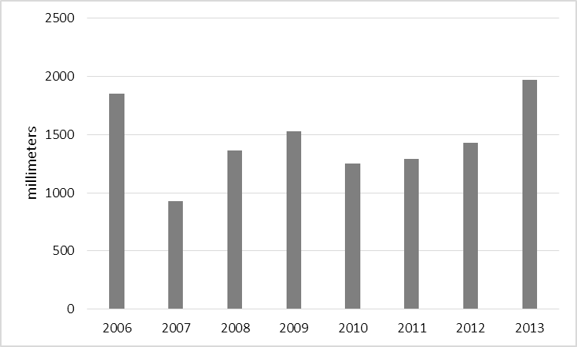

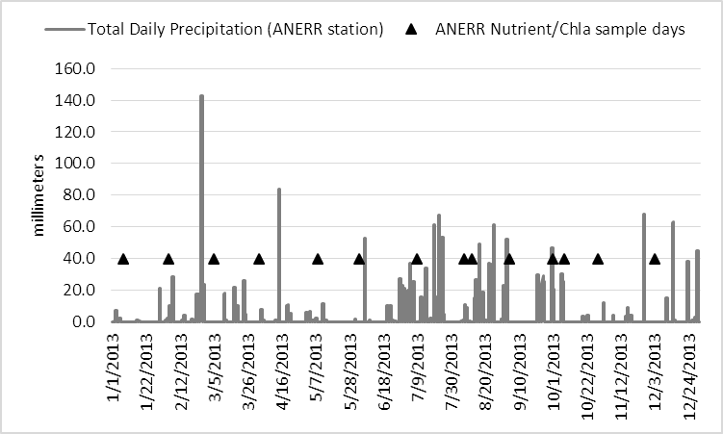
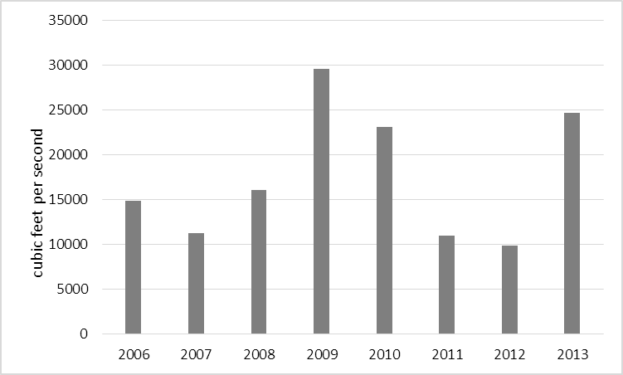

Figure 2. Total annual precipitation 2006 through 2013.
(ANERR Meteorological station)

Figure 3. Average annual flow 2006 through 2013.
(Apalachicola river, Sumatra gage)

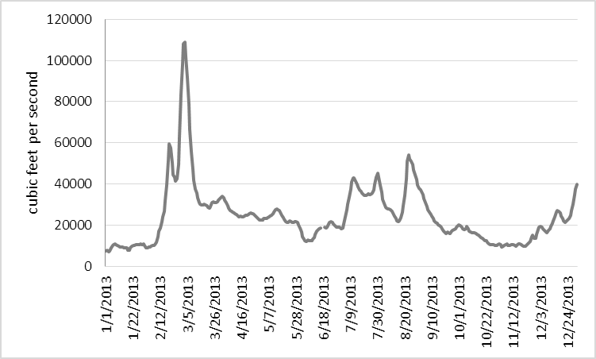

Figure 4. 2013 Apalachicola river flow, Sumatra gage. Peak flow of 109,000 cfs occurred on March 3, 2013. Nutrient sampling occurred 2 days later on March 5, 2013.

Figure 5. 2013 total daily precipitation in millimeters, triangles represent nutrient sampling events.

