Jobos Bay NERR Nutrient Metadata

January 2003 to December 2003

Latest Update: October 22, 2018

I. Data Set and Research Descriptors

- Principal investigator(s) and contact persons

  - Reserve Contact

Carmen González
Reserve Manager
sifontecarmen@hotmail.com

Iris Tirado Santana
Research Coordinator
irislymari@yahoo.com

Luis A. Encarnación
Biologist II, JBNERR
luisenca@coqui.net

Lic. Enid Malavé
Chemist I, JBNERR

Mailing Address:
Call Box B
Aguirre, Puerto Rico 00704
Phone: (787) 853-4617
Fax: (787) 853-4618

  - Laboratory Contact

Jane A. López
Director, Sponsored Programs
Virginia Institute of Marine Science
PO Box 1346
Gloucester Point, VA 23062

  - Other Contacts and Programs

- Research objectives

Inorganic nutrients, particularly nitrogen and phosphorus are naturally found in mangrove and estuarine habitats. They can be significantly increased by human activities reaching the system through non-point source run-off or direct discharge. Eutrophication is defined as gradual accumulation of nutrients and organic biomass accompanied with an increase in photosynthesis and a decrease in the average depth of the water column caused by the accumulation of sediment.

The objective of this study is to provide baseline information on inorganic nutrients and chlorophyll levels in the Jobos Bay estuary. It will also assess nutrients and chlorophyll levels in areas within the reserve that may be receiving impact from human activities from surroundings areas or may act as a habitat gradient in the Bay. In order to compare these with physical water quality parameters, monitoring sites were established at the four YSI’s datasonde stations.

Station number nine (9), the impacted site, collects water quality data in a site associated with runoff from littoral and basin mangrove areas. This sampling station is located in the most inland lagoon, closest to the Thermoelectric Power Plant. It is subjected to runoff, which may include potential oil spill contamination from this industrial facility. Information compiled from historical environmental documents, indicate that station nine (9) was used as a disposal site for residues of the previously operating sugar mill operation, and therefore might have high organic input into the sediments.

Station number ten (10), located in a mangrove lagoon area towards the southwestern section of Mar Negro is considered the reference or non-impacted site.

Station 19 is located in Jobos Bay surrounded by sea grass beds composed of Thallasia testudinum. This station is close to the Power Plant transit channel, which allows barges to bring oil and gas into the Power Plant pier. This area is exposed to barge standings, sediment re-suspension and oil spills.

Station 20 is located adjacent to Cayos Caribe reef. Water streams coming from the platform may bring to this station an indication of water conditions behind the coral reef wall. This water are part of the main marine current coming from the eastern side of Jobos Bay that runs along the coast, getting in contact with sensitive areas like coal plant, Phillips Core, Chemsource and other industries.

- Research methods

  - Monthly Grab Sampling Program

Monthly grab samples are taken at the four datasonde stations. Grab samples are take on the same day at or as near as possible to slack low-tide conditions. Efforts are made to collect samples at approximately monthly intervals. Samples are not influenced by previous storm events. Grab samples are reflective of the water mass sampled by the datasonde. Because we have shallow and well-mixed water on our stations, two surface grab samples are collected that are reflective of the datasonde sampling area. Replicate (N=2) sample were collected by hand at an approximate depth of 30 cm.

Grab samples are taken in duplicate (two separate sample collections not two samples from a single water sample); this will result in a total of eight samples. All samples were collected in amber, wide mouth, nalgene sample bottles that were previously acid washed (10%) rinsed (3x) with distilled-deionized water, dried and followed by rinsing (3x) of ambient water prior to collection of the sample. Samples were immediately placed on ice, in the dark and returned to the laboratory. All samples are filtered immediately after collection or as soon as possible. All samples were immediately placed on ice again, in the dark and sent to Virginia Institute of Marine Sciences (VIMS) laboratory.

  - Diel Sampling Program

Diel grab samples are taken at long-term datasonde station 9. Samples are collected over a full lunar day (24 hr: 48min) time period at 2 hour intervals using ISCO auto-samplers. Efforts are made to collect samples at approximately monthly (30 days) interval. Samples are not influenced by previous storm events; an antecedent dry period of 72 hours is desirable but may not be practical at all locations throughout the year. Sampling depth follows the following designs; samples are collected at a fixed depth from the bottom, generally 0.5 meters, and reflect the water mass sampled by the data sonde. This device automatically samples 1000 ml of water every 2 hrs. All samples are pumped into polyethylene sample bottles that were previously acid washed (10%), rinsed (3x) with distilled-deionized water and dried. At the end of the 24 hr period, the 12 samples are kept in the dark and returned to the laboratory for immediate processing. All samples are filtered immediately after collection placed on ice, in the dark (cooler) and sent to Virginia Institute of Marine Sciences (VIMS) laboratory.

- Site location and character

The Jobos Bay National Estuarine Research Reserve (JBNERR) is located on the southern coastal plain of the island of Puerto Rico, a reserve within the West Indies geographical area. JBNERR is composed of two major areas: (1) Mar Negro, located on the western margin of the Bay, and (2) Cayos Caribe, a chain of 15 tear-shaped islets located to the southeast. The Mar Negro area comprises the bulk of the Reserve, and consists of mangrove forests and a complex system of lagoons and channels interspersed with salt and mud flats. Coral reefs and sea grass beds, with small beach deposits and upland areas fringe Cayos Caribe mangrove islands.

Station 9 is an impacted site and is located on the northeastern section of the Mar Negro component. This sampling station is associated with mangrove lagoon areas and receives runoff from mudflats, the Thermoelectric Power Plant, and adjacent areas. The tidal range varies from 12 to 14 inches in the vicinity of the monitoring station. The salinity at the vicinity of the monitoring station varies from 0.0 ppt to 41.1 ppt. The average depth at station 09 is 1 meter. A thick layer of thin sediments with a high content of organic material covers the bottom. Brown and green algae are also present at this site, but a better assessment is needed. The station pole is located at 17° 56' 36.8" N and 66° 14' 18.5" W.

Station 10 is located in a mangrove lagoon not impacted directly by any upland or marine activities. It provides a reference for comparison of data obtained in other stations, especially to the station in Mar Negro lagoon. The tidal range varies from 12 to 14 inches. The salinity at the vicinity of the monitoring station varies from 0.0 ppt to 41.7 ppt. The average depth at station 10 is 1 meter. The bottom is covered with a layer of fine sediments with organic material, followed by a layer of calcareous material mainly from shells and oysters. At this site we can find sea grass (Thalassia), calcareous algae (Halimeda sp.), green algae (Caulerpa sp.) and brown algae (Dictyota sp.) among
others. The pole is located at 17° 56' 20.3" N and 66° 45' 26.7" W.

Station 19 is located in the Bay surrounded by sea grass beds (Thallasia testudinum). The tidal range varies from 12 in. to 14 in. in the vicinity of the monitoring station. No fresh water input in the vicinity of the station is probable. The salinity at the vicinity of the monitoring station is approximately 35 ppt. The average depth at this station is 2-3m. The pole is located at 17° 56' 28.15885" N and 66° 13' 45.28784" W.

Station 20 is located near Cayos Caribe islets. The sonde is in contact with three streams of water that comes from Cayos Caribe reef platform. The tidal range varies from 12 in. to 14 in. in the vicinity of the monitoring station. No fresh water input in the vicinity of the station is probable. The salinity at the vicinity of the monitoring station is approximately 35 ppt. The average depth at this station is 2-3m. The pole is located at 17° 55' 49.14258" N and 66° 12' 41.29771" W.

- Coded variable code definitions

Site definitions: job09nut = Station 9
Site definitions: job10nut = Station 10
Site definitions: job19nut = Station 19
Site definitions: job20nut = Station 20
File definitions: site/month/year (ex: 100801 = Station 10 data from August of 2001).

Monitoring Programs:
Grab Sampling Program =1
Diel Sampling Program = 2

- Data collection period

Station nine (9) sampling of nutrients began on January 21, 2003
Station ten (10) sampling of nutrients began on January 22, 2003
Station nineteen (19) sampling of nutrients began on January 22, 2003
Station twenty (20) sampling of nutrients began on January 22, 2003
Diel Sampling

Station | Start Date | Start Time | End Date | End Time
job09nut | 1/21/2003 | 09:30 | 1/22/2003 | 07:30
job09nut | 2/18/2003 | 09:30 | 2/19/2003 | 07:30
job09nut | 3/18/2003 | 08:30 | 3/19/2003 | 06:30
job09nut | 4/15/2003 | 09:30 | 4/16/2003 | 07:30
job09nut | 5/14/2003 | 09:30 | 5/15/2003 | 07:30
job09nut | 6/17/2003 | 08:30 | 6/18/2003 | 06:30
job09nut | 7/30/2003 | 08:30 | 7/31/2003 | 06:30
job09nut | 8/12/2003 | 09:30 | 8/13/2003 | 07:30
job09nut | 9/9/2003 | 09:30 | 9/10/2003 | 07:30
job09nut | 10/15/2003 | 09:30 | 10/16/2003 | 07:30
job09nut | 11/24/2003 | 08:30 | 11/25/2003 | 08:30
job09nut | 12/9/2003 | 08:30 | 12/10/2003 | 06:30

Grab Sampling

Site | Start Date | Rep #1 Time | Rep #2 Time
S09 | 1/22/2003 | 8:15 | 8:15
S10 | 1/22/2003 | 8:00 | 8:00
S19 | 1/22/2003 | 7:30 | 7:30
S20 | 1/22/2003 | 8:45 | 8:45
S09 | 2/19/2003 | 9:11 | 9:11
S10 | 2/19/2003 | 8:52 | 8:52
S19 | 2/19/2003 | 8:33 | 8:33
S20 | 2/19/2003 | 9:30 | 9:30
S09 | 3/19/2003 | 9:28 | 9:28
S10 | 3/19/2003 | 9:54 | 9:54
S19 | 3/19/2003 | 9:05 | 9:05
S20 | 3/19/2003 | 10:53 | 10:53
S09 | 4/16/2003 | 10:12 | 10:12
S10 | 4/16/2003 | 9:34 | 9:34
S19 | 4/16/2003 | 8:49 | 8:49
S20 | 4/16/2003 | 8:12 | 8:12
S09 | 5/15/2003 | 8:49 | 8:49
S10 | 5/15/2003 | 8:25 | 8:25
S19 | 5/15/2003 | 8:04 | 8:04
S20 | 5/15/2003 | 9:31 | 9:31
S09 | 6/18/2003 | 9:24 | 9:24
S10 | 6/18/2003 | 8:51 | 8:51
S19 | 6/18/2003 | 8:15 | 8:15
S20 | 6/18/2003 | 9:44 | 9:44
S09 | 7/31/2003 | 8:55 | 8:55
S10 | 7/31/2003 | 8:39 | 8:39
S19 | 7/31/2003 | 8:11 | 8:11
S20 | 7/31/2003 | 8:18 | 8:18
S09 | 9/10/2003 | 8:19 | 8:19
S10 | 9/10/2003 | 8:34 | 8:34
S19 | 9/10/2003 | 7:56 | 7:56
S20 | 9/10/2003 | 9:16 | 9:16
S09 | 10/16/2003 | 8:03 | 8:03
S10 | 10/16/2003 | 8:37 | 8:37
S19 | 10/16/2003 | 7:41 | 7:41
S20 | 10/16/2003 | 9:15 | 9:15
S09 | 11/25/2003 | 8:55 | 8:55
S10 | 11/25/2003 | 8:30 | 8:30
S19 | 11/25/2003 | 8:03 | 8:03
S20 | 11/25/2003 | 9:17 | 9:17
S09 | 12/10/2003 | 8:33 | 8:33
S10 | 12/10/2003 | 8:13 | 8:13
S19 | 12/10/2003 | 7:48 | 7:48
S20 | 12/10/2003 | 9:02 | 9:02

- Associated researchers and projects

A water quality monitoring using YSI 6000 data loggers started in December, 1995 to determine pH, salinity, turbidity, temperature, specific conductance, depth, dissolved oxygen saturation and concentration.

In April of 2003, an expanded nutrient and chlorophyll monitoring program was established. This one year program will assess nitrogen and chlorophyll loading in a broader geographical area of the Bay. Nine additional stations are being monitored.

- Distribution

NOAA/ERD retains the right to analyze, synthesize and publish summaries of the NERRS System-wide Monitoring Program data. The PI retains the right to be fully credited for having collected and processed the data. Following academic courtesy standards, the PI and NERR site where the data were collected will be contacted and fully acknowledged in any subsequent publications in which any part of the data are used. Manuscripts resulting from this NOAA/OCRM supported research that are produced for publication in open literature, including refereed scientific journals, will acknowledge that the research was conducted under an award from the Estuarine Reserves Division, Office of Ocean and Coastal Resource Management, National Ocean Service, National Oceanic and Atmospheric Administration. The data set enclosed within this package/transmission is only as good as the quality assurance and quality control procedures outlined by the enclosed metadata reporting statement. The user bears all responsibility for its subsequent use/misuse in any further analyses or comparisons. The Federal government does not assume liability to the Recipient or third persons, nor will the Federal government reimburse or indemnify the Recipient for its liability due to any losses resulting in any way from the use of this data.

NERR water quality data and metadata can be obtained from the Research Coordinator at the individual NERR site (please see Section 1. Principal investigators and contact persons), from the Data Manager at the Centralized Data Management Office (please see personnel directory under the general information link on the CDMO home page) and online at the CDMO home page http://cdmo.baruch.sc.edu/. Data are available in text tab-delimited format, Microsoft Excel spreadsheet format and comma-delimited format.

II. Physical Structure Descriptors

- Entry verification

After the results of nutrients sampling arrives from VIMS laboratory to Jobos Bay NERR the data was verified before being sent to the CDMO to be archived into the permanent database. The person responsible of this task is the Research Coordinator of the reserve Iris L. Tirado.

- Parameter Titles and Variable Names by Data Category
Required NOAA/NERRS System-wide Monitoring Program water quality parameters are denoted by an asterisks “*”.

Data Category Parameter Variable Name Units of Measure

Phosphorus: *Orthophosphate PO4F mg/L as P

Nitrogen:
*Nitrite + Nitrate, Filtered NO23 mg/L as N
*Nitrite, Filtered NO2 mg/L as N
*Nitrate, Filtered NO3 mg/L as N
*Ammonium, Filtered NH4 mg/L as N
*Dissolved Inorganic Nitrogen DIN mg/L as N

    - Other Lab Parameters:
Chlorophyll a CHLA μg/L
Phaeophytin PHEA μg/L

Notes:

1. Time is coded based on a 2400 hour clock and is referenced to Eastern Standard Time
(EST).
2. Reserves have the option of measuring either NO23 or NO2 or NO3.

- Measured and Calculated Laboratory Parameters

    - Variables Measured Directly
Nitrogen species: NO₂, NO₂₃, NH₄,
Phosphorus species: PO₄F
Chlorophyll a CHLA
Pheophytin PHEA

    - Computed Variables
NO₃: NO₂₃-NO₂
DIN: NO₂₃+NH₄

- Limits of Detection

The VIMS Nutrient Analytical Laboratory has established Method Detection Limits (MDL), the lowest concentration of a parameter that an analytical procedure can reliably detect. The MDL is determined as 3 times the standard deviation of a minimum of 7 replicates of a single low concentration sample. Table 1 presents the current MDL’s; these values are reviewed and revised periodically.

Table 1. Method Detection Limits (MDL) for measured water quality parameters.
Parameter | Variable | Mean Conc.  mg/L as N or P | Std. Dev. | MDL  mg/L as N or P | Dates in use
Ammonium | NH₄ | 0.1634 | 0.1172 | 0.0015 | Jan-May 2003
Ammonium | NH₄ | 0.1634 | 0.1172 | 0.0054 | Jun-Dec 2003
Nitrate+Nitrite | NO₂₃ | 0.0039 | 0.0059 | 0.0008 | Jan-May 2003
Nitrate+Nitrite | NO₂₃ | 0.0039 | 0.0059 | 0.0010 | Jun-Dec 2003
Nitrite | NO₂ | 0.0045 | 0.0077 | 0.0002 | Jan-Dec 2003
Orthophosphate | PO₄F | 0.0228 | 0.0190 | 0.0006 | Jan-May 2003
Orthophosphate | PO₄F | 0.0228 | 0.0190 | 0.0015 | Jun-Dec 2003
Chlorophyll | CHLA | 0.40 | 0.15 | 0.25 | Jan-May 2003
Chlorophyll | CHLA | 0.40 | 0.15 | 0.5 | Jun-Dec 2003
Pheophytin | PHEA | 0.40 | 0.16 | 0.25 | Jan-May 2003
Pheophytin | PHEA | 0.40 | 0.16 | 0.5 | Jun-Dec 2003

- Laboratory Methods

Variable: Orthophosphate

Abbreviation: PO4F

Sample Collection: Water Samples are collected from the effluent tubing of the Dataflow System in pre-rinsed (w/ambient water) darkened 1L Nalgene bottles. Exact time of collection is noted to facilitate comparison with data generated by the YSI 6600.

Sample Preservation and Processing: Samples are placed in darkened bottles and are packed in ice until return to the lab and immediate processing can take place. Upon return to the laboratory, all samples are filtered into sterile Whirlpak bags using 0.45μm Gelman Supor Acrodisc syringe filters. Samples are immediately frozen until analyses can be conducted.
Method Summary: Ammonium molybdate and antimony potassium tartrate react in a sulfuric acid environment to form an antimony-phospho-molybdo complex, which is reduced to a blue colored complex by ascorbic acid. Reaction is heat catalizyed at 40°C and measured colorimetrically at 880nm. The range is 1-50 ppb.

Instrumentation: SKALAR San-Plus continuous flow autoanalyzer.

Reported Units: mg/L

Detection Limits: .0006 mg/L

References:

Virginia Institute of Marine Science Analytical Service Center.

SKALAR Method: O-Phosphate / Total Phosphate Catnr. 503-365.1, issue 042993/MH/93-Demo1.

Murphy, J. and J.P. Riley. 1962. A modified single solution method for the determination of phosphate in natural waters. Analytica Chim. Acta 27 : 31-36.

EPA 600/R-97/072 Method 365.5 Determination of Orthophosphate in Estuarine and Coastal Waters by Automated Colorimetric Analysis. IN: Methods for the Determination of Chemical Substances in Marine and Estuarine Environmental Matrices - 2nd Edition. National Exposure Research Laboratory, Office of Research and Development . U.S. EPA, Cincinnati, Ohio 45268.

________________________________________________________________________

Variable: Nitrite

Abbreviation: NO2F

Sample Collection: Water Samples are collected from the effluent tubing of the Dataflow System in pre-rinsed (w/ambient water) darkened 1L Nalgene bottles. Exact time of collection is noted to facilitate comparison with data generated by the YSI 6600.

Sample Preservation and Processing: Samples are placed in darkened bottles and are packed in ice until return to the lab and immediate processing can take place. Upon return to the laboratory, all samples are filtered into sterile Whirlpak bags using 0.45μm Gelman Supor Acrodisc syringe filters. Samples are immediately frozen until analyses can be conducted.

Method Summary: An adaptation of the diazotization method. Under acidic conditions, nitrite ion reacts with sulfanilimide to yield a diazo compound which couples with
N-1-napthylethylenediamine dihydrochloride to form a soluble dye which is measured colorimetrically at 540nm. The range is 0.001 to 0.050 mg/L.
Instrumentation: SKALAR San-Plus continuous flow autoanalyzer.

Reported Units: mg/L

Detection Limits: .0008 mg/L

References:

Virginia Institute of Marine Science Analytical Service Center.

SKALAR Method 467

________________________________________________________________________

Variable: Nitrate + Nitrite

Abbreviation: NO23F

Sample Collection: Water Samples are collected from the effluent tubing of the Dataflow System in pre-rinsed (w/ambient water) darkened 1L Nalgene bottles. Exact time of collection is noted to facilitate comparison with data generated by the YSI 6600.

Sample Preservation and Processing: Samples are placed in darkened bottles and are packed in ice until return to the lab and immediate processing can take place. Upon return to the laboratory, all samples are filtered into sterile Whirlpak bags using 0.45μm Gelman Supor Acrodisc syringe filters. Samples are immediately frozen until analyses can be conducted.

Method Summary: Nitrate is reduced to nitrite by a copper/cadmium reductor column. The nitrite ion then reacts with sulfanilimide to form a diazo compound. This compound then couples with n-1-napthylenediamine dihydrochloride to form a reddish/purple azo dye and is read colorimetrical at 540 nm. Nitrate concentration is obtained by subtracting the corresponding nitrite value from the NO₃⁻ + NO₂⁻ concentration. The color development chemistry is the same as that used in Nitrite. Range is 0 -1.2 mg/L.

Instrumentation: SKALAR San-Plus continuous flow autoanalyzer.

Reported Units: mg/L

Detection Limits: .0008 mg/L

References:

Virginia Institute of Marine Science Analytical Service Center.

SKALAR Method: Nitrate + Nitrite/ Total Dissolved Nitrogen Catnr. 461-353.2 issue 120293/MH/93128060.
U.S. EPA. 1974 Methods for Chemical Analysis of Water and Wastes, pp. 207 -212.

Wood, E.D., F.A.G. Armstrong and F.A. Richards. 1967. Determination of nitrate in seawater by cadmium-copper reduction to nitrite. J. Mar. Biol. Assoc. U.K. 47: 23.

Grasshoff, K., M. Ehrhardt and K. Kremling. 1983. Methods of Seawater Analysis. Verlag Chemie, Federal Republic of Germany. 419 pp.

EPA 600/R-97/072 Method 353.4 Determination of Nitrate and Nitrite in Estuarine and Coastal Waters by Gas Segmented Flow Colorimetric Analysis. IN: Methods for the Determination of Chemical Substances in Marine and Estuarine Environmental Matrices - 2nd Edition. National Exposure Research Laboratory, Office of Research and Development U.S. EPA, Cincinnati, Ohio 45268.

________________________________________________________________________

Variable: Ammonia

Abbreviation: NH4F

Sample Collection: Water Samples are collected from the effluent tubing of the Dataflow System in pre-rinsed (w/ambient water) darkened 1L Nalgene bottles. Exact time of collection is noted to facilitate comparison with data generated by the YSI 6600.

Sample Preservation and Processing: Samples are placed in darkened bottles and are packed in ice until return to the lab and immediate processing can take place. Upon return to the laboratory, all samples are filtered into sterile Whirlpak bags using 0.45μm Gelman Supor Acrodisc syringe filters. Samples are immediately frozen until analyses can be conducted.

Method Summary: Alkaline phenol and hypochlorite react with ammonia to form indophenol blue that is proportional to the ammonia concentration. The blue color formed is intensified with sodium nitroprusside. Reaction is heat catalyzed at 37ºC and is measured colorimetrically at 660 nm. The range is 0.01 - 2.0 mg/L.

Instrumentation: SKALAR San-Plus continuous flow autoanalyzer.

Reported Units: mg/L

Detection Limits: .0015 mg/L

References:

Virginia Institute of Marine Science Analytical Service Center.

U.S. EPA. 1974. Methods for Chemical Analysis of Water and Wastes, pp. 168-174.

Standard Methods for the Examination of Water and Wastewater, 14th edition. p 410. Method 418A and 418B (1975).

Annual Book of ASTM Standards, Part 31. "Water", Standard 1426-74, Method A, p 237 (1976).

EPA 600/R-97/072 Method 349.0. Determination of Ammonia in Estuarine and Coastal Waters by Gas Segmented Continuous Flow Colorimetric Analysis. IN: Methods for the Determination of Chemical Substances in Marine and Estuarine Environmental Matrices - 2nd Edition. National Exposure Research Laboratory, Office of Research and Development U.S. EPA, Cincinnati, Ohio 45268.

________________________________________________________________________

Variable: Chlorophyll and Pheophytin

Abbreviation: Chla

Sample Collection: Water Samples are collected from the effluent tubing of the Dataflow System in pre-rinsed (w/ambient water) darkened 1L Nalgene bottles. Exact time of collection is noted to facilitate comparison with data generated by the YSI 6600.

Sample Preservation: Samples are place in darkened bottles and are packed in ice until return to the lab and immediate processing can take place.

Method Summary: The two methods for determining Chlorophyll a given here are with 1) a scanning spectrophotometer and 2) a Turner Design fluorometer. The method used requires filtering a known quantity of water through a glass fiber filter (4.7 cm GF/F). This filter is later ground with a tissue grinder made of teflon/glass. Approximately 1-3mLs of 90% acetone are added to the filter before grinding. Acetone is also used to wash the filter into 17 x 150 test tube with tight fitting cap. The sample is steeped at least 2 hours and not exceeding 24 hours at 4ºC, in the dark. The samples are centrifuged and read on a spectrophotometer or fluorometer. If the samples can not be read within that time period, storage in the freezer at -20ºC for a few days is acceptable. If pheophytin measurements are desired, the sample is acidified and read again.

Instrumentation: Milton Roy Spectronic 1201 spectrophometer or Turner Designs TD-700 fluorometer.

Reported Units: µg/L

Detection Limits: 0.50µg/L

References:

Virginia Institute of Marine Science Analytical Service Center.

Strickland, J.D.H., and Parson, T.R. 1972. A Practical Handbook of Seawater Analysis. Fish. Res. Bd. Canada 167:310.

TD-700 Laboratory Fluorometer Operating Manual. Version 1.8. July 7, 1999. Turner Designs, 845 West Maude Avenue, Sunnyvale, CA 94086.

EPA /600/ R-97/072 - Method 445.0. In Vitro Determination of Chlorophyll a and Pheophytin a in Marine and Freshwater Algae by Fluoresence. Methods for the Determination of Chemical Substances in Marine and Estuarine Environmental Matrices Revision 1.2. September 1997.

  - Using the Turner Designs Model 10 Analog, The 10AU Digital, Or the TD-700 Fluorometer with EPA Method 445.0. January 19, 1999. Turner Designs, 845 West Maude Avenue, Sunnyvale, CA 94086.

- Reporting of Missing Data and Data with Concentrations Lower than Method Detection Limits –
Nutrient/Chla comment codes and definitions are provided in the following table. Missing data are denoted by a blank cell “ ” and commented coded with an “M”. Laboratories in the NERRS System submit data that are censored at a lower detection rate limit, called the Method Detection Limit or MDL. MDL’s for specific parameters are listed in the Laboratory Methods and Detection Limits Section (Section II, Part 14) of this document. Measured concentrations that are less than this limit are replaced with the minimum detection limit value and comment coded with a “B” in the variable code comment column. For example, the measured concentration of NO23F was 0.0005 mg/L as N (MDL=0.0008), the reported value would be 0.0008 with a “B” placed in the NO23F comment code column. Calculated parameters are comment coded with a “C” and if any of the components used in the calculation are below the MDL, the calculated value is removed and also comment coded with a “B”. If a calculated value is negative, the value is removed and comment coded with an “N”.

Note: The way below MDL values are handled in the NERRS SWMP dataset was changed in November of 2011. Previously, below MDL data from 2002-2006 were also coded with a B, but replaced with -9999 place holders. Any 2002-2006 nutrient/pigment data downloaded from the CDMO prior to December November of 2011 will contain -9999s representing below MDL concentrations.

Comment Code | Definition
A | Value above upper limit of method detection
B | Value below method detection limit
C | Calculated value
D | Data deleted or calculated value could not be determined due to deleted data, see metadata for details
H | Sample held beyond specified holding time
K | Check metadata for further details
M | Data missing, sample never collected or calculated value could not be determined due to missing data
P | Significant precipitation (reserve defined, see metadata for further details)
U | Lab analysis from unpreserved sample
S | Data suspect, see metadata for further details

- QA/QC Programs –

  - Precision

    - Field Variability

Field replicates are collected using grab sampling method at an approximate depth of 30 cm. The technician takes two separate water samples at each sampling station this result in a total of eight samples.

    - Laboratory Variability
Duplicates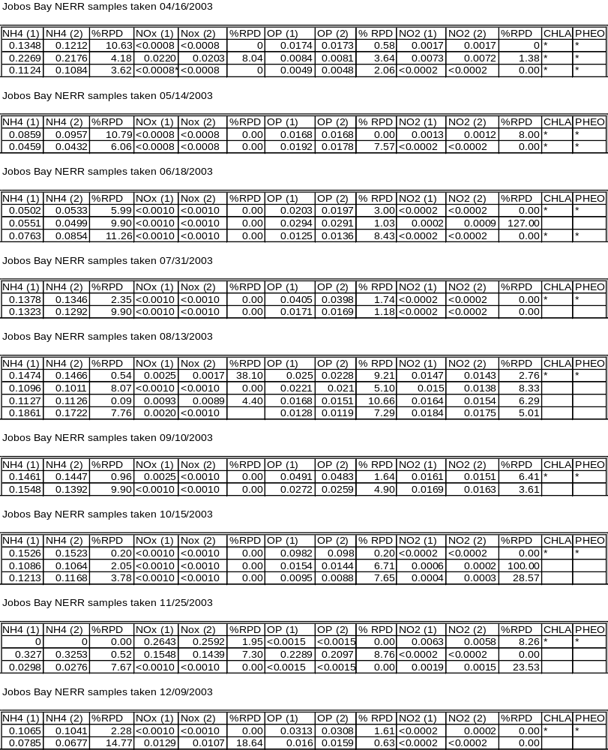

    - Inter-organizational splits <None>

  - Accuracy
    - Sample Spikes

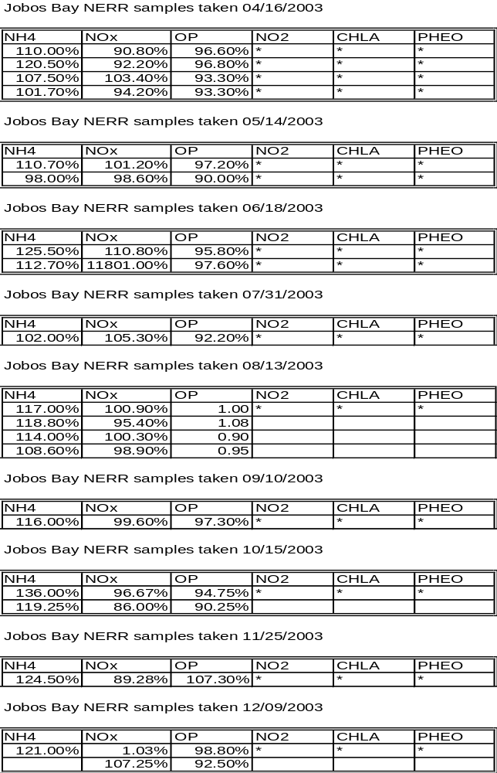

    - Standard Reference Material Analysis

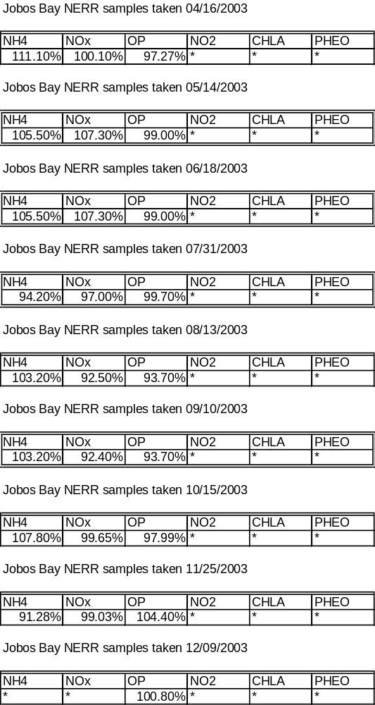

    - Cross Calibration Exercises <None>

- Other Remarks

During year 2003 five (5) important rainfall events occur that had effects in the measurements of the different parameters of the sondes. These events occur:
1) april 8 to 20 with 172.47mm of rainfall
2) august 16 to 29 with 89.66mm of rainfall
3) october 5 to 11 with 145.03mm of rainfall
4) the most important november 6 to 19 with 564.64mm of rainfall, equal to the mean
anual rainfall.
5) december 5 to 7 with 100.58mm of rainfall

Stations 19 and 20 were found at areas that receive strong waves. Stations 9 and 10 were more protected, receive less wave impact.

All chlorophyll a and phaeophytin data prior to May 2007 were removed from the dataset (or rejected for 2007 data) on 10/22/2018 (07/2002-04/2007). These measured values were all very low with little to no fluctuation. A dramatic change is noticed in the May 2007 onward measured values, which exhibit results that align with expected pigment levels. It was ultimately discovered that the pre-May 2007 filters had been stored in 10% acetone prior to analysis, resulting in damaged samples and inaccurate measurements. Users of this data were notified of the update.

