Reserve Name: Jobos Bay (JOB) NERR Nutrient Metadata
Months and year the documentation covers: January-December 2018
Latest Update: May 16, 2022

I. Data Set and Research Descriptors

1) Principal investigator(s) and contact persons –
  - Reserve Contact

Jobos Bay National Estuarine Research Reserve
PO Box 159
Salinas, PR 00704-0159
Ph. 787-853-4617 Fax. 787-853-4618

Angel Dieppa, Research Coordinator
Ph. 787-853-4617, ext. 1010
Email. adieppa.jbnerr@gmail.com, adieppa@drna.pr.gov

Enid Malavé, Chemist and SWMP technician
Ph. 787-853-4617, ext. 1003
Email. enidmalave18@gmail.com, emalave@drna.pr.gov

  - Laboratory Contact (Nutrient analysis)

Carol Pollard
Laboratory Manager
Virginia Institute of Marine Science
PO Box 1346
Gloucester Point, VA 23062
Email. pollard@vims.edu
Ph: 804-684-7213
Fx: 804-684-7614

Annelisse Ramos, MS
Laboratory Manager
Priscila Casanova
Laboratory Analyst
Laboratorio Central Analítico
1193 Calle Guayacán Jardín Botánico Sur
San Juan, PR 00926-1118
Email: laboratorio.central@upr.edu
Ph: (787)767-9705, ext. 2134, 2187

2) Research objectives –
The main objective of this monitoring program is to understand the nutrients dynamics within Jobos Bay that may come from the watershed affecting the health of the estuary. Inorganic nutrients, particularly nitrogen and phosphorus are naturally found in mangrove and estuarine habitats. They can be significantly increased by human activities reaching the system through non-point source run-off or direct discharge. Eutrophication is defined as gradual accumulation of nutrients and organic biomass accompanied with an increase in photosynthesis and a decrease in the average depth of the water column caused by the accumulation of sediment.

- Monthly grab sampling program

The objective of this study is to provide baseline information on inorganic nutrients and chlorophyll levels in the Jobos Bay estuary. It will also assess nutrients and chlorophyll levels in areas within the reserve that may be receiving impact from human activities from surroundings areas or may act as a habitat gradient in the Bay. In order to compare these with physical (abiotic) water quality parameters, monitoring sites were established at the four SWMP datasonde stations.
Station number nine (9), was chosen as the impacted site, collects water quality data in a site associated with runoff from littoral and basin mangrove areas. This lagoon has an average depth of 1.5 meters and its water regime is subject to high concentrations of tannin pigments associated with red mangroves. This station is characterized by a low water exchange due to a low circulation pattern. This sampling station is located in the most inland lagoon northeast of Mar Negro, closest to the thermoelectric power plant. It is subjected to runoff, which may include potential oil spill contamination from this industrial facility and agrochemicals from agricultural activities within the northern boundary of the reserve. Information compiled from historical environmental documents, indicate that station nine (9) was used as a disposal site for residues of the previously operating sugar mill operation, and therefore might have high organic input into the sediments. Of the four water quality monitoring stations, this has the lowest dissolved oxygen values during the year. Benthic vegetation is scarce.
Station number ten (10), located in a mangrove lagoon area towards the southwestern section of Mar Negro is considered the reference or non-impacted site. This station is characterized by a low water exchange due to a low circulation pattern. This lagoon has an average depth of 2 meters and its water regime is subject to high concentrations of tannin pigments associated with red mangroves. Benthic vegetation is scarce.
Station number nineteen (19) is located in Jobos Bay surrounded by sea grass beds composed of Thallasia testudinum. This station is close to the power plant navigation channel, used by barges to bring oil and gas into the power plant pier. This area is exposed to barge standings and sediment re-suspension, and oil spills are always a threat.
Station number twenty (20) is located adjacent to the Cayos Caribe reef system. Water currents coming from the reef platform may bring to this station an indication of water conditions behind the coral reef. These water currents are part of the main marine current coming from the eastern side of Jobos Bay that runs along the coast, coming in contact with sensitive areas like agricultural fields, a coal power plant, an oil refinery (Phillips Core - shut down in 2005) and other industries.
See the Site Location and Character section for more information on the chosen sample sites.

- Diel sampling program

The diel sampling program objective is to quantify the temporal variability of important nutrients and sediment loading in the water column as a function of tidal forcing.

3) Research methods –
  - Monthly Grab Sampling Program

Monthly grab samples are taken at the four datasonde stations. Grab samples are taken on the same day at or as near as possible to slack low-tide conditions. Efforts are made to collect samples at approximately monthly intervals. Samples are not influenced by previous storm events. Grab samples are representative of the water mass sampled by the datasonde. Because we have shallow and well-mixed water on our stations, two surface grab samples are collected that are representative of the datasonde sampling area. Replicate (N=2) sample were collected by hand at an approximate depth of 30 cm.

Grab samples are taken in duplicate (two separate samples collected in different bottles); this will result in a total of eight samples. All samples were collected in amber, NalgeneTM sample bottles that were previously acid washed (10%) rinsed (3x) with distilled-deionized water, dried and followed by rinsing (3x) with ambient water prior to collection of the sample. Samples were immediately placed on ice, in the dark and returned to the laboratory. Samples from March to July were filtered immediately after collection using a vacuum pump. Membrane filters are used for nutrient samples and GF/F are used for Chlorophyll samples. All samples were immediately placed on ice again, in the dark and sent to the Virginia Institute of Marine Sciences (VIMS) laboratory next day delivery. Samples from October to December were immediately placed on ice in the dark bottles for Chlorophyll and clear bottles for nutrients and sent to the Laboratorio Central Analitico at UPR for filtering and analysis.

  - Diel Sampling Program

Diel samples are taken at long-term datasonde station 9. Samples are collected over a full lunar cycle (24hr:48min) time period at 2 hours 11 minute intervals using an ISCO auto-sampler model 6712. The suction line is set to sample at 0.5 meters from the bottom, and is covered with a mesh to avoid clogging with organic debris. Efforts are made to collect samples at approximately monthly (30 days) intervals. Samples are not influenced by previous storm events; an antecedent dry period of 72 hours is desirable but may not be practical at all locations throughout the year. Sampling depth follows the following design; samples are collected at a fixed depth from the bottom, generally 0.5 meters, and reflect the water mass sampled by the datasonde. This device automatically samples 1000 ml of water every 2 hrs. A field blank consisting of DI water is placed in the bottle rack and left open during the diel sampling. All samples are pumped into polyethylene sample bottles that were previously acid washed (10%), rinsed (3x) with distilled-deionized water and dried. At the end of the 24 hr period, the 12 samples are kept in the dark and returned to the laboratory for immediate processing. Samples from March to July were filtered immediately after collection. The nutrient filtered sample is placed in 250 ml Nalgene bottles and Chl-a filter in amber (empty) vials, stored in a cooler (dark) with ice packs and sent to the Virginia Institute of Marine Sciences (VIMS) laboratory. Samples from October to December were immediately placed on ice in dark bottles for Chlorophyll and clear bottles for nutrients and sent to the Laboratorio Central Analitico at UPR for filtering and analysis.

4) Site location and character –
The Jobos Bay National Estuarine Research Reserve (JOB NERR) is located on the southern coastal plain of the island of Puerto Rico, a reserve within the West Indies geographical area. JOB NERR is composed of two major areas: (1) Mar Negro, located on the western margin of the Bay, and (2) Cayos Caribe (a chain of 17 tear-shaped islets located to the southeast) and Cayos Barca (a chain of 7 tear-shaped islets located to the southwest boundaries) both with a back-reef system. The Mar Negro area comprises the bulk of the reserve, and consists of mangrove forests and a complex system of lagoons and channels interspersed with salt and mud flats. Coral reefs and sea grass beds, with small beach deposits and upland areas fringe the Cayos Caribe and Cayos Barca mangrove islands. Few areas in the watershed drain directly to the bay. Rio Seco to the north-east of the bay is active only during heavy rain events during the wet season. A small creek, Quebrada Coqui, near JOB NERR’s pier to the north of the bay, drains into an extensive mangrove fringe forest in a laminar flow. During heavy rain events, Station 09 receives runoff water from the upland, and finally, a diffuse flow of water reaches the bay from the local aquifer.
Station 9 is an impacted site and is located on the northeastern section of the Mar Negro component. This sampling station is associated with mangrove lagoon areas and receives runoff from mudflats, the thermoelectric power plant, and adjacent areas. The tidal range varies from 0.3 to 0.36 meters near the monitoring station. The salinity at the vicinity of the monitoring station varies from 32.6 to 40.7 psu. The average depth and total depth at station 09 is 0.62 and 1.22 meters respectively. The bottom is covered by a thick layer of thin sediments with a high content of organic material. Microcoleus sp. (blue-green algae), brown and green algae (Caulerpa sp.) are also present at this site, but a better assessment is needed. The station was located at 17° 56' 34.87" N and 66° 14' 18.64" W until 09/02/2010 12:00PM, then it was relocated to 17° 56' 35.0" N and 66° 14' 18.9" W approximately 65.0 meters from its original position. The relocation was due to sedimentation issues and the construction of a new telemetry station. Fresh water input to the station comes only from runoff and rain. This station has been subject of several studies indicating the presence of relatively high levels of copper and pesticides compared to other stations. Since 2015 an invasive seagrass, Halophila stipulacea was reported at Jobos Bay; it was after the passage of Hurricane Maria in September 21, 2017 that it was more evident and widely distributed. Although it is not present at Station 9, it is present in the channels toward the station and we expect it will colonize the area in the near future.

Statistics for station 9 during 2018
 | Temp | SpCond | Sal | DO_pct | DO_mgl | Depth | pH | Turb
Min | 24.8 | 49.99 | 32.6 | 11.7 | 0.7 | 0.39 | 7.4 | 0
Max | 34.6 | 61.06 | 40.7 | 151.5 | 9.1 | 0.84 | 8.2 | 99
Average | 29.4 | 56.59 | 37.5 | 75.5 | 4.6 | 0.62 | 7.8 | 6
Std Dev | 1.7 | 2.16 | 1.6 | 23.6 | 1.4 | 0.09 | 0.1 | 8

Station 10 is located in a mangrove lagoon not impacted directly by any upland or marine activities. It provides a reference for comparison of data obtained at other stations, especially to the station in Mar Negro lagoon. The tidal range varies from 0.3 to 0.36 meters. The salinity at the vicinity of the monitoring station varies from 34.0 to 39.1 psu. The average depth and total depth at station 10 is 0.62 and 1.00 meters respectively. The bottom is covered with a layer of fine sediments with organic material, followed by a layer of calcareous material mainly from shells and oysters. At this site, we can find sea grass (Thalassia testudinum), calcareous algae (Halimeda sp.), green algae (Caulerpa sp.) and brown algae (Dictyota sp.) among others. The station is located at 17° 56' 19.00 N, 66° 15' 27.85 W. Fresh water input to the station comes only from runoff and rain. There is not any direct source of fresh water. Since 2015 an invasive seagrass, Halophila stipulacea was reported at Jobos Bay; it was after the passing of Hurricane Maria in September 21, 2017 that it was more evident and wide distributed. It has been observed in the perimeter of the station.
Statistics for station 10 during 2018

 | Temp | SpCond | Sal | DO_pct | DO_mgl | Depth | pH | Turb
Min | 27.1 | 51.90 | 34.0 | 5.8 | 0.4 | 0.38 | 6.9 | 0
Max | 31.9 | 58.67 | 39.1 | 105.7 | 6.7 | 0.85 | 7.9 | 19
Average | 29.3 | 56.76 | 37.6 | 76.7 | 4.8 | 0.62 | 7.7 | 1
Std Dev | 0.9 | 0.90 | 0.7 | 14.8 | 0.9 | 0.09 | 0.2 | 1

Station 19 is located on the western inner section of the bay at a distance of 233 meters from Cayo Colchones mangroves over sea grass beds (Thallasia testudinum). Tidal ranges in this area vary from 0.3 to 0.36 meters. The salinity at the vicinity of the monitoring station varies from 33.1 to 37.7 psu. The average depth and total depth at this station is 0.73 and 2.00 meters respectively. The datasonde is deployed at about 0.5 meters from the bottom. The bottom is of sandy composition, and sea grass, algae, echinoderms and other related organisms can be found in the area. The station is located at 17° 56' 34.49" N, 66° 13' 43.77" W. This station is close to the power plant navigation channel, used by barges to bring oil and gas into the power plant pier. This area is exposed to barge standings and sediment re-suspension. Oil spills are always a threat although the operation is under strict controls. There is no freshwater input to this area. Since 2015 an invasive seagrass, Halophila stipulacea was reported at Jobos Bay; it was after the passing of Hurricane Maria in September 21, 2017 that it was more evident and widely distributed. It has been observed in the perimeter of the station.
 | Temp | SpCond | Sal | DO_pct | DO_mgl | Depth | pH | Turb
Min | 27.2 | 50.67 | 33.1 | 68.4 | 4.3 | 0.55 | 8.0 | 0
Max | 30.3 | 56.85 | 37.7 | 143.4 | 9.0 | 0.94 | 8.3 | 48
Average | 28.4 | 55.49 | 36.7 | 104.1 | 6.6 | 0.73 | 8.2 | 3
Std Dev | 0.7 | 0.87 | 0.7 | 13.2 | 0.8 | 0.08 | 0.1 | 3
Statistics for station 19 during 2018

Station 20 is located in the inner eastern section at about 190 meters from the Cayos Caribe Mangrove islets and at about 688 meters from the coral reef barrier. This station is the closest to Mar Caribe. It has a sandy bottom with calcareous and coral fragments, sea grass (Thalassia testudinum) communities, echinoderms and other associated organisms. Tidal ranges in this area vary from 0.3 to 0.36 meters. The salinity at the vicinity of the monitoring station varies from 34.3 to 37.1 psu. The average depth and total depth at this station is 0.42 and 2.00 meters respectively. There is no surface freshwater input to this area. These waters are part of the main marine current coming from the eastern side of Jobos Bay that runs along the coast, getting in contact with sensitive areas like agricultural fields, a coal power plant, an oil refinery Phillips Core (shut down in 2005) and other industries. The station is located at 17° 55' 49.14" N, 66° 12' 41.30" W. Since 2015 an invasive seagrass, Halophila stipulacea was reported at Jobos Bay; it was after the passing of Hurricane Maria in September 21, 2017 that it was more evident and widely distributed. It has been observed in the perimeter of the station.
Statistics for station 20 during 2018
 | Temp | SpCond | Sal | DO_pct | DO_mgl | Depth | pH | Turb
Min | 26.8 | 52.16 | 34.3 | 60.3 | 3.8 | 0.21 | 7.8 | 0
Max | 31.3 | 56.05 | 37.1 | 158.2 | 9.6 | 0.64 | 8.4 | 77
Average | 28.4 | 55.00 | 36.3 | 102.3 | 6.5 | 0.42 | 8.0 | 4
Std Dev | 0.8 | 0.59 | 0.4 | 17.1 | 1.0 | 0.08 | 0.1 | 5

Nutrient data from stations 9, 10, 19 and 20 is being submitted to the CDMO. In addition, eight datasondes are permanently devoted to taking water quality readings from these four sites, to assure continuous readings while datasondes are taken out of the water for data upload and maintenance. This will avoid data gaps for the stations between datasonde maintenance procedures. All monitoring is considered long term.

All Jobos Bay NERR historical nutrient/pigment monitoring stations:

Station Code | SWMP Status | Station Name | Location | Active Dates | Reason Decommissioned | Notes
JOB09NUT | P | STATION 9 | 17° 56' 35.0" N 66° 14' 18.9" W | 07/2002 - current | NA | NA
JOB10NUT | P | STATION 10 | 17° 56' 19.00 N, 66° 15' 27.85 W | 07/2002 - current | NA | NA
JOB19NUT | P | STATION 19 | 17° 56' 34.49"N, 66° 13' 43.77"W | 07/2002 - current | NA | NA
JOB20NUT | P | STATION 20 | 17° 55' 49.14"N, 66° 12' 41.30" W | 07/2002 - current | NA | NA

5) Coded variable definitions –
Station Code Names:
job09nut – Station 9
job10nut – Station 10
job19nut – Station 19
job20nut – Station 20

Monitoring Programs:
Monthly grab sample program (1)
Diel grab sample program (2)

6) Data collection period –

Sampling did not occur for January, February, August and September 2108 due to administrative issues related to laboratory contract.

Diel:
Site | Start Date/ Time | Stop Date/ Time
9 | 03/20/2018 09:30 | 03/21/2018 09:31
9 | 04/10/2018 09:30 | 04/11/2018 09:31
9 | 05/08/2018 10:00 | 05/09/2018 10:01
9 | 06/05/2018 10:00 | 06/06/2018 10:01
9 | 07/17/2018 09:30 | 07/18/2018 09:31
9 | 10/01/2018 11:00 | 10/02/2018 11:01
9 | 11/13/2018 10:15 | 11/14/2018 10:16
9 | 12/18/2018 10:00 | 12/19/2018 10:01

Grab:

Site | Start Date/ Time | Stop Date/ Time |  | Site | Start Date/ Time | Stop Date/ Time
9 | 03/21/2018 10:15 | 03/21/2018 10:16 |  | 19 | 03/21/2018 09:30 | 03/21/2018 09:31
9 | 04/11/2018 10:11 | 04/11/2018 10:12 |  | 19 | 04/11/2018 09:14 | 04/11/2018 09:15
9 | 05/09/2018 10:05 | 05/09/2018 10:06 |  | 19 | 05/09/2018 09:21 | 05/09/2018 09:22
9 | 06/06/2018 10:00 | 06/06/2018 10:02 |  | 19 | 06/06/2018 09:29 | 06/06/2018 09:30
9 | 07/18/2018 10:05 | 07/18/2018 10:06 |  | 19 | 07/18/2018 10:55 | 07/18/2018 10:56
9 | 10/02/2018 10:50 | 10/02/2018 10:51 |  | 19 | 10/02/2018 09:40 | 10/02/2018 09:41
9 | 11/14/2018 10:23 | 11/14/2018 10:24 |  | 19 | 11/14/2018 09:35 | 11/14/2018 09:36
9 | 12/19/2018 10:05 | 12/19/2018 10:06 |  | 19 | 12/19/2018 11:27 | 12/19/2018 11:28
Site | Start Date/ Time | Stop Date/ Time |  | Site | Start Date/ Time | Stop Date/ Time
10 | 03/21/2018 09:55 | 03/21/2018 09:56 |  | 20 | 03/21/2018 09:15 | 03/21/2018 09:16
10 | 04/11/2018 09:49 | 04/11/2018 09:50 |  | 20 | 04/11/2018 09:03 | 04/11/2018 09:04
10 | 05/09/2018 11:03 | 05/09/2018 11:04 |  | 20 | 05/09/2018 12:10 | 05/09/2018 12:11
10 | 06/06/2018 10:22 | 06/06/2018 10:23 |  | 20 | 06/06/2018 10:56 | 06/06/2018 10:57
10 | 07/18/2018 10:31 | 07/18/2018 10:32 |  | 20 | 07/18/2018 08:58 | 07/18/2018 08:59
10 | 10/02/2018 10:27 | 10/02/2018 10:28 |  | 20 | 10/02/2018 09:24 | 10/02/2018 09:25
10 | 11/14/2018 09:50 | 11/14/2018 09:51 |  | 20 | 11/14/2018 09:10 | 11/14/2018 09:11
10 | 12/19/2018 11:00 | 12/19/2018 11:01 |  | 20 | 12/19/2018 09:50 | 12/19/2018 09:51

7) Associated researchers and projects–

As part of the SWMP long-term monitoring program, JOB NERR also monitors 15-minute meteorological and water quality data which may be correlated with this nutrient/pigment dataset. These data are available at www.nerrsdata.org.

The JOB NERR water quality monitoring data has been incorporated into the Puerto Rico Environmental Quality Board (EQB) Integrated Report 303(d)/305(b) of the Federal Clean Water Act. This document consists of a water quality inventory and list of impaired waters and is used by the Environmental Protection Agency (EPA) to inform Congress of the progress made at the national level towards the achievement of the statutory water quality goals and purposes established by the Federal Clean Water Act.

8) Distribution –

NOAA retains the right to analyze, synthesize and publish summaries of the NERRS System-wide Monitoring Program data. The NERRS retains the right to be fully credited for having collected and process the data. Following academic courtesy standards, the NERR site where the data were collected should be contacted and fully acknowledged in any subsequent publications in which any part of the data are used. The data set enclosed within this package/transmission is only as good as the quality assurance and quality control procedures outlined by the enclosed metadata reporting statement. The user bears all responsibility for its subsequent use/misuse in any further analyses or comparisons. The Federal government does not assume liability to the Recipient or third persons, nor will the Federal government reimburse or indemnify the Recipient for its liability due to any losses resulting in any way from the use of this data.

Requested citation format:
NOAA National Estuarine Research Reserve System (NERRS). System-wide Monitoring Program. Data accessed from the NOAA NERRS Centralized Data Management Office website: www.nerrsdata.org; accessed 12 October 2018.

NERR nutrient data and metadata can be obtained from the Research Coordinator at the individual NERR site (please see Principal investigators and contact persons), from the Data Manager at the Centralized Data Management Office (please see personnel directory under the general information link on the CDMO home page) and online at the CDMO home page www.nerrsdata.org. Data are available in comma separated version format.

II. Physical Structure Descriptors

9) Entry verification –

Nutrient data are entered into a Microsoft Excel worksheet and processed using the NutrientQAQC Excel macro. The NutrientQAQC macro sets up the data worksheet, metadata worksheets, and MDL worksheet; adds chosen parameters and facilitates data entry; allows the user to set the number of significant figures to be reported for each parameter and rounds using banker’s rounding rules; allows the user to input MDL values and then automatically flags/codes measured values below MDL and inserts the MDL; calculates parameters chosen by the user and automatically flags/codes for component values below MDL, negative calculated values, and missing data; allows the user to apply QAQC flags and codes to the data; produces summary statistics; graphs selected parameters for review; and exports the resulting data file to the CDMO for tertiary QAQC and assimilation into the CDMO’s authoritative online database.

10) Parameter titles and variable names by category –

Required NOAA/NERRS System-wide Monitoring Program nutrient parameters are denoted by an asterisks “*”.

Data Category Parameter Variable Name Units of Measure

Phosphorus and Nitrogen:
*Orthophosphate PO4F mg/L as P
*Ammonium, Filtered NH4F mg/L as N
*Nitrite, Filtered NO2F mg/L as N
*Nitrate, Filtered NO3F mg/L as N
*Nitrite + Nitrate, Filtered NO23F mg/L as N
Dissolved Inorganic Nitrogen DIN mg/L as N
Plant Pigments:
*Chlorophyll-a CHLA_N µg/L
Phaeophytin PHEA µg/L

Notes:
1. Time is coded based on a 2400 clock and is referenced to Standard Time.
2. Reserves have the option of measuring either NO2 and NO3 or they may substitute NO23 for individual analyses if they can show that NO2 is a minor component relative to NO3.

11) Measured or calculated laboratory parameters –

- Parameters measured directly
Nitrogen species: NH4F, NO2F, NO23F
Phosphorus species: PO4F
Other: CHLA_N, PHEA

- Calculated parameters
NO3F NO23F-NO2F
DIN NO23F+NH4F

12) Limits of detection –

Method Detection Limits (MDL), the lowest concentration of a parameter that an analytical procedure can reliably detect, have been established by the VIMS Nutrient Analytical Laboratory. The MDL is determined as 3 times the standard deviation of a minimum of 7 replicates of a single low concentration sample. These values are reviewed and revised periodically. The method used to determine MDLs for the UPR laboratory is not available.

Parameter | Start Date | End Date | MDL | Revisited*
PO4F | 3/01/18 | 07/31/18 | 0.0016 mg/L | 03/01/18
PO4F | 10/01/18 | 12/31/18 | 0.015mg/L
NH4F | 3/01/18 | 07/31/18 | 0.0062 mg/L | 03/01/18
NH4F | 10/01/18 | 12/31/18 | 0.010 mg/L
NO2F | 3/01/18 | 07/31/18 | 0.0016 mg/L | 03/01/18
NO2F | 10/01/18 | 12/31/18 | 0.016mg/L
NO23F | 3/01/18 | 07/31/18 | 0.0055mg/L | 03/01/18
NO23F | 10/01/18 | 12/31/18 | 0.022mg/L
CHLA_N | 3/01/18 | 07/31/18 | 0.10 ug/L | 03/01/18
CHLA_N | 10/01/18 | 12/31/18 | 0.10 ug/L
PHEA | 3/01/18 | 07/31/18 | 0.10 ug/L | 03/01/18
PHEA | 10/01/18 | 12/31/18 | 0.10 ug/L

*Dates VIMS revisited MDLs are based on the first samples they were in effect for, not necessarily the actual date the MDL was re-calculated. CHLA and PHEA MDLs did not change from 2017 to 2018, but we are assuming they were revisited as well. There are no MDL calculation dates available for the UPR laboratory.

13) Laboratory methods –

  - Parameter: NH4F
VIMS Laboratory Method:
EPA or other Reference Method: SM 4500-NH3 H-1997
Reference: Standard Methods for the Analysis of Water and Wastes, 21st Ed. 2005. 4500-NH3 H. Nitrogen (Ammonia) by Flow Injection Analysis.
US.EPA 1974. Methods for Chemical Analysis of Water and Wastes pp.168-174
Method Descriptor: Samples were filtered with a 0.45 μm membrane filter.
Preservation Method: Samples are stored at 4°C up to 24 hours, followed by freezing @ -20°C.

Summary of Method:
Automated Continuous flow, segmented stream, no bubble gating. Dual wavelength detection and matrix correction.

Chemistry:
Alkaline phenol and hypo chlorite react with ammonia to form indophenols blue that is proportional to the ammonia concentration. The blue color formed is intensified with sodium nitroprusside. Reaction is heat catalyzed at 37˚C. The range is 0.001-2.0 mg/L.
Interferences:
Alkalinity over 500 mg/L
Acidity over 100 mg/L
Ca and Mg ions will precipitate unless complexed
Color intensity is pH dependent

Laboratorio Central Analitico (UPR) Method:
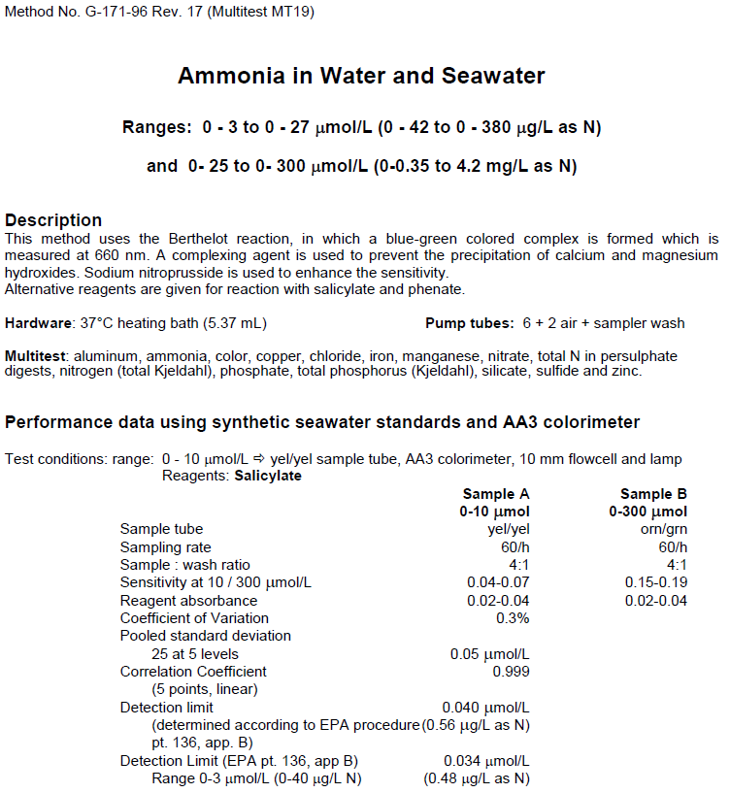

  - Parameter: NO2F
VIMS Laboratory Method:
EPA or other Reference Method: SM 4500 NO3-F-2000
Method Reference: Standard Methods for the Analysis of Water and Wastes, 21st Ed. 2005. 4500-NO3 F. Nitrogen (Nitrite) by Flow Injection Analysis.
US.EPA 1994. USEPA 600/R-97/072. Method 353.4
Method Descriptor: Samples were filtered with a 0.45 μm membrane filter.
Preservation Method: Samples are stored at 4°C up to 24 hours, followed by freezing @ -20°C.

Summary of Method:
Automated continuous flow, segmented stream, no bubble gating. Dual wavelength detection and matrix correction.

Chemistry:
An adaptation of the diazotization method. Under acidic conditions, nitrite ion reacts with sulfanilamide to yield a diazole compound, which couples with N-1 napthylenediamine dihydrochloride to form a soluble dye, which is measured colorimetrically. The range is 0.001 to 0.050 mg/L.

Interferences:
NCl3 false positive
These metal ions cause precipitation at high concentrations:
Sb +3, Au +3, Bi +3, Fe +3, Pb +2, Hg +2, Ag +, PtCl6-2, VO3-2
Cupric ion may catalyze decomposition of diazole compound.

Laboratorio Central Analitico (UPR) Method:
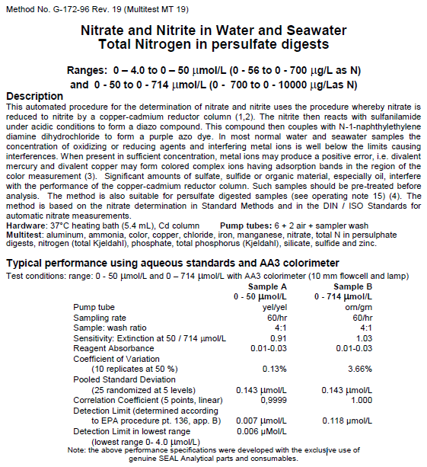

  - Parameter: NOx F
VIMS Laboratory Method:
EPA or other Reference Method: SM 4500 NO3-F-2000
Method Reference: Standard Methods for the Analysis of Water and Wastes, 21st Ed. 2005. 4500-NO3 F, Nitrogen (Nitrate) Automated Cadmium Reduction Method; US.EPA 1994. USEPA 600/R-97/072. Method 353.4
Method Descriptor: Samples were filtered with a 0.45 µm membrane filter.
Preservation Method: Samples are stored at 4°C up to 24 hours, followed by freezing @ -20°C.

Summary of Method:
Automated continuous flow, segmented stream, no bubble gating. Dual wavelength detection and matrix correction.

Chemistry:
Nitrate is reduced to nitrite by a copper/cadmium reductor column. The nitrite ion then reacts with sulfanilamide to form diazole compound. This compound then couples with n-1-napthylenediamine dihydrochloride to form a reddish/purple azo dye. The color development chemistry is the same as that used in nitrite, Method #5. Range is 0-1.2 mg/L.

Interferences:
High concentrations of Fe, Cu (>10 mg/L)
Oil and Grease will coat Cd column
Residual Chlorine oxidizes Cd column
Sulfates will consume Cd column in the formation of S -2

Laboratorio Central Analitico (UPR) Method:

  - Parameter: PO4F
VIMS Laboratory Method:
EPA or other Reference Method: SM 4500-P F-2011
Method Reference: Standard Methods for the Analysis of Water and Wastes, 21st Ed. 2005. 4500-P F. Phosphorus by Flow Injection Analysis; US.EPA 1994. USEPA 600/R-97/072. Method 365.5
Method Descriptor: Samples were filtered with a 0.45 μm membrane filter.
Preservation Method: Samples are stored at 4°C up to 24 hours, followed by freezing @ -20°C.

Summary of Method:
Automated continuous flow, segmented stream, no bubble gating. Dual wavelength detection and matrix correction.

Chemistry:
Ammonium molybdate and antimony potassium tartrate react in a sulfuric acid environment to form an antimony-phospho-molybdo complex, which is reduced to a blue colored complex by ascorbic acid. Reaction is heat catalyzed at 40 °C. Range is 1-50 ppb.

Interferences:
Fe +3 at concentrations greater than 50 mg/L
SiO2 at conc.>10 mg/L positive interference- not naturally present
Hydrogen sulfide
Mercuric Chloride (used as preservative by some)

Laboratorio Central Analitico (UPR) Method:
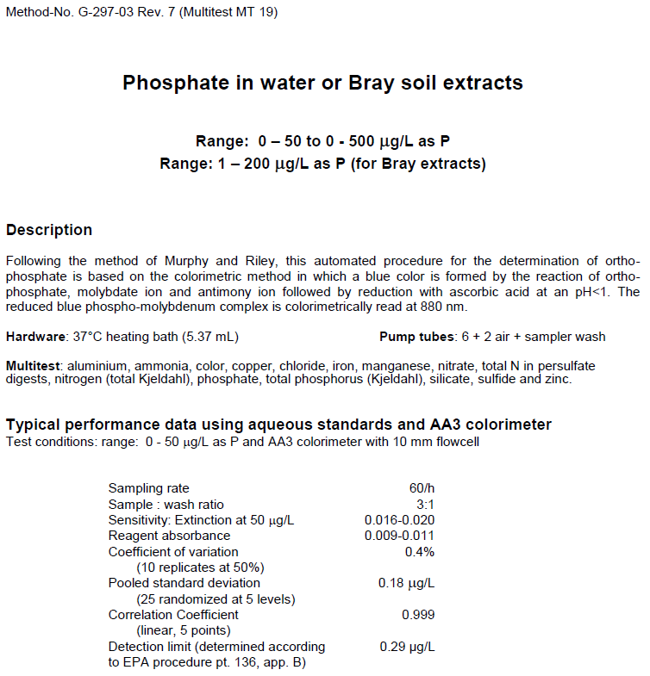

  - Parameter: CHLA_N and PHA
VIMS Laboratory and Laboratorio Central Analitico Method:
EPA or other Reference Method: EPA 445 REV 1.2
Method Reference: US.EPA 1997. USEPA 600/R-97/072. Method 445.0
Method Descriptor: Samples were filtered with a 0.47 μm membrane filter, placed dry in an amber vial and stored with ice packs. They were kept in the dark and extracted at VIMS using 90% acetone.
Preservation Method: Samples are stored at 4°C up to 24 hours, followed by freezing @ -20°C.

Summary of Method:

The method for determining Chlorophyll-a is using Fluorometry with a Turner Design fluorometer. The method used requires filtering a known quantity of water through a glass fiber filter. This filter is later ground with a tissue grinder made of Teflon/glass. Approximately 2-3 ml of 90% acetone are added to the filter before grinding. Acetone is also used to wash the filter in to a 17 x 150 test tube with tight fitting cap. The sample is steeped at least 2 hours and not exceeding 24 hours at 4°C, in the dark. The samples are centrifuged and read on the Turner fluorometer. If pheaophytin measurements are desired, the sample is acidified and read again.

14) Field and Laboratory QAQC programs – information is not available for the UPR laboratory. Information for the VIMS laboratory is included below.

  - Precision
    - Field variability –
Two successive true replicate grab samples are collected for the monthly grab samples at each of the four stations ensuring that replicate samples are collected at the same depth. They are collected successively by hand within the same minute.
    - Laboratory variability –
10% of samples are replicated and RPD should not exceed 20% except in specific circumstances which are defined for VIMS
    - Inter-organizational splits – None

  - Accuracy
    - Sample spikes –
The VIMS Analytical Service Center for Nutrients analyzes a matrix spike once for every ten samples Standard reference material analysis – This will result from samples sent out from EPA to each lab. 10% of samples are spiked acceptable range is 80-120% recovery except in specific circumstances which are defined.
    - Standard reference material analysis – This will result from samples sent out from EPA to each lab.
    - Cross calibration exercises – None.

15) QAQC flag definitions –

QAQC flags provide documentation of the data and are applied to individual data points by insertion into the parameter’s associated flag column (header preceded by an F_). QAQC flags are applied to the nutrient data during secondary QAQC to indicate data that are out of sensor range low (-4), rejected due to QAQC checks (-3), missing (-2), optional and were not collected (-1), suspect (1), and that have been corrected (5). All remaining data are flagged as having passed initial QAQC checks (0) when the data are uploaded and assimilated into the CDMO ODIS as provisional plus data. The historical data flag (4) is used to indicate data that were submitted to the CDMO prior to the initiation of secondary QAQC flags and codes (and the use of the automated primary QAQC system for WQ and MET data). This flag is only present in historical data that are exported from the CDMO ODIS.

-4 Outside Low Sensor Range
-3 Data Rejected due to QAQC
-2 Missing Data
-1 Optional SWMP Supported Parameter
0 Data Passed Initial QAQC Checks
1 Suspect Data
4 Historical Data: Pre-Auto QAQC
5 Corrected Data

16) QAQC code definitions –

QAQC codes are used in conjunction with QAQC flags to provide further documentation of the data and are also applied by insertion into the associated flag column. There are three (3) different code categories, general, sensor, and comment. General errors document general problems with the sample or sample collection, sensor errors document common sensor or parameter specific problems, and comment codes are used to further document conditions or a problem with the data. Only one general or sensor error and one comment code can be applied to a particular data point. However, a record flag column (F_Record) in the nutrient data allows multiple comment codes to be applied to the entire data record.

General errors
GCM Calculated value could not be determined due to missing data
GCR Calculated value could not be determined due to rejected data
GDM Data missing or sample never collected
GQD Data rejected due to QA/QC checks
GQS Data suspect due to QA/QC checks
GSM See metadata

Sensor errors
SBL Value below minimum limit of method detection
SCB Calculated value could not be determined due to a below MDL component
SCC Calculation with this component resulted in a negative value
SNV Calculated value is negative
SRD Replicate values differ substantially
SUL Value above upper limit of method detection

Parameter Comments
CAB Algal bloom
CDR Sample diluted and rerun
CHB Sample held beyond specified holding time
CIP Ice present in sample vicinity
CIF Flotsam present in sample vicinity
CLE Sample collected later/earlier than scheduled
CRE Significant rain event
CSM See metadata
CUS Lab analysis from unpreserved sample

Record comments
CAB Algal bloom
CHB Sample held beyond specified holding time
CIP Ice present in sample vicinity
CIF Flotsam present in sample vicinity
CLE Sample collected later/earlier than scheduled
CRE Significant rain event
CSM See metadata
CUS Lab analysis from unpreserved sample
Cloud cover
CCL clear (0-10%)
CSP scattered to partly cloudy (10-50%)
CPB partly to broken (50-90%)
COC overcast (>90%)
CFY foggy
CHY hazy
CCC cloud (no percentage)
Precipitation
PNP none
PDR drizzle
PLR light rain
PHR heavy rain
PSQ squally
PFQ frozen precipitation (sleet/snow/freezing rain)
PSR mixed rain and snow
Tide stage
TSE ebb tide
TSF flood tide
TSH high tide
TSL low tide
Wave height
WH0 0 to <0.1 meters
WH1 0.1 to 0.3 meters
WH2 0.3 to 0.6 meters
WH3 0.6 to > 1.0 meters
WH4 1.0 to 1.3 meters
WH5 1.3 or greater meters
Wind direction
N from the north
NNE from the north northeast
NE from the northeast
ENE from the east northeast
E from the east
ESE from the east southeast
SE from the southeast
SSE from the south southeast
S from the south
SSW from the south southwest
SW from the southwest
WSW from the west southwest
W from the west
WNW from the west northwest
NW from the northwest
NNW from the north northwest
Wind speed
WS0 0 to 1 knot
WS1 > 1 to 10 knots
WS2 > 10 to 20 knots
WS3 > 20 to 30 knots
WS4 > 30 to 40 knots
WS5 > 40 knots

17) Other remarks/notes –

Data may be missing due to problems with sample collection or processing. Laboratories in the NERRS System submit data that are censored at a lower detection rate limit, called the Method Detection Limit or MDL. MDLs for specific parameters are listed in the Laboratory Methods and Detection Limits Section (Section II, Part 12) of this document. Concentrations that are less than this limit are censored with the use of a QAQC flag and code, and the reported value is the method detection limit itself rather than a measured value. For example, if the measured concentration of NO23F was 0.0005 mg/l as N (MDL=0.0008), the reported value would be 0.0008 and would be flagged as out of sensor range low (-4) and coded SBL. In addition, if any of the components used to calculate a variable are below the MDL, the calculated variable is removed and flagged/coded -4 SCB. If a calculated value is negative, it is rejected and all measured components are marked suspect. If additional information on MDL’s or missing, suspect, or rejected data is needed, contact the Research Coordinator at the Reserve submitting the data.

Note: The way below MDL values are handled in the NERRS SWMP dataset was changed in November of 2011. Previously, below MDL data from 2007-2010 were also flagged/coded, but either reported as the measured value or a blank cell. Any 2007-2011 nutrient/pigment data downloaded from the CDMO prior to November of 2011 will reflect this difference.

Sample hold times for 2018: Samples are held at -20°C. NERRS SOP allows nutrient samples to be held for up to 28 days (CHLA for 30) at -20°C, plus allows for up to 5 days for collecting, processing, and shipping samples. Samples held beyond that time period are flagged suspect and coded CHB.

 | Date of lab analysis
Collect_Date | CHLA | PHEO | NH3 | NOx | NO2 | O-PO4
03/20-21/2018 | 4/10/2018 | 4/10/2018 | 4/12/2018 | 4/12/2018 | 4/12/2018 | 4/12/2018
04/10-11/2018 | 4/23/2018 | 4/23/2018 | 4/27/2018 | 4/27/2018 | 4/27/2018 | 4/27/2018
05/08-09/2018 | 5/22/2018 | 5/22/2018 | 5/24/2018 | 5/24/2018 | 5/24/2018 | 5/24/2018
06/05-06/2018 | 6/25/2018 | 6/25/2018 | 6/26/2018 | 6/26/2018 | 6/26/2018 | 6/26/2108
07/17-18/2018 | 7/31/2018 | 7/31/2018 | 8/10/2018 | 8/10/2018 | 8/13/2018 | 8/10/2018
10/01-02/2018
11/13-14/2018 | 12/04/2018 | 12/04/2018 | 11/20/2018 | 12/17/2018 | 11/26/2018 | 04/22/2019*
12/18-19/2018 | 01/30/2019* | 01/30/2019* | 04/03/2019* | 04/10/2019* | 04/04/2019* | 04/22/2019*
*sample held longer than allowed by NERRS protocols

Missing Data:

03/20/2018 Lab# 18-021-004 Diel Sample Station 09 data (2) at 16:03am. Sample empty. Flagged <-2> [GDM]

04/10/2018 Lab# 18-032-005 Diel Sample Station 09 data (2) at 18:14pm. Sample empty. Flagged <-2> [GDM]

05/08/2018 to 05/09/2018: Diel Sample Station 09 data (2) Samples empty. Flagged <-2> [GDM].
Sample numbers:

Lab# 18-046-005 at 18:44pm
Lab# 18-046-006 at 20:55pm
Lab# 18-046-007 at 23:06pm
Lab# 18-046-008 at 01:17am
Lab# 18-046-009 at 03:28am
Lab# 18-046-010 at 05:39am
Lab# 18-046-011 at 07:50am
Lab# 18-046-012 at 10:01am

Sampling did not occur for January, February, August and September 2108 due to administrative issues related to laboratory contract.

Rain Event:

Date | Precipitation (mm) | Event associated with
01/06/2018 | 11.2
01/07/2018 | 14.0
01/08/2018 | 2.3
01/09/2018 | 2.3
01/10/2018 | 1.0
01/11/2018 | 10.2
01/13/2018 | 7.6
01/27/2018 | 1.0
02/06/2018 | 2.8
02/09/2018 | 2.0
02/11/2018 | 1.0
02/12/2018 | 1.0
02/18/2018 | 1.8
02/21/2018 | 1.3
02/28/2018 | 34.0
03/15/2018 | 1.5
03/19/2018 | 3.3
03/24/2018 | 2.5
03/27/2018 | 1.3
04/09/2018 | 2.3
04/12/2018 | 1.8
04/16/2018 | 4.1
04/19/2018 | 9.4
04/26/2018 | 8.13
04/27/2018 | 3.81
05/03/2018 | 13.97
05/04/2018 | 12.19
05/06/2018 | 4.32
05/08/2018 | 2.29
05/09/2018 | 7.11
05/11/2018 | 1.27
05/12/2018 | 16.25
05/13/2018 | 2.79
05/17/2018 | 1.77
05/18/2018 | 1.77
05/20/2018 | 3.05
05/24/2018 | 1.01
05/25/2018 | 6.60
05/29/2018 | 9.14
05/30/2018 | 4.57
06/10/2018 | 21.59 | Tropical depression Beryl
06/17/2018 | 2.03
06/19/2018 | 25.15
06/20/2018 | 2.28
06/22/2018 | 3.81
06/23/2018 | 48.26
06/24/2018 | 1.01
07/09/2018 | 59.7
07/16/2018 | 1.5
07/19/2018 | 1.0
07/22/2018 | 1.3
07/23/2018 | 2.0
07/24/2018 | 7.6
08/12/2018 | 10.9
08/16/2018 | 3.3
08/17/2018 | 8.6
08/18/2018 | 5.8
08/24/2018 | 5.6
08/25/2018 | 1.8
08/30/2018 | 48.0
09/05/2018 | 1.0
09/14/2018 | 11.9
09/15/2018 | 18.0
09/16/2018 | 1.0
09/17/2018 | 2.5
09/18/2018 | 2.3
09/24/2018 | 1.5
09/29/2018 | 6.6
09/30/2018 | 21.1
10/04/2018 | 4.3
10/11/2018 | 1.8
10/12/2018 | 29.0
10/13/2018 | 77.2
10/17/2018 | 2.5
11/04/2018 | 6.6
11/11/2018 | 7.1
11/13/2018 | 10.7
11/14/2018 | 6.6
11/15/2018 | 2.0
11/16/2018 | 1.5
11/17/2018 | 4.3
11/21/2018 | 1.8
12/11/2018 | 2.3
12/14/2018 | 4.6
12/16/2018 | 6.1
12/22/2018 | 2.5
12/25/2018 | 2.8
12/27/2018 | 1.5
12/28/2018 | 1.5
12/29/2018 | 1.5

