Apalachicola NERR Meteorological Metadata

January - December 2010

Last Update: May 21, 2013

**I. Data Set & Research Descriptors**

**1) Principal investigator & contact persons:**

Jenna Wanat, Research Coordinator

Jennifer.wanat@dep.state.fl.us

850-670-7716

Lauren Levi, Environmental Specialist

[lauren.levi@dep.state.fl.us](mailto:lauren.levi@dep.state.fl.us)

850-670-7710

Jason Garwood, Enviromental Specialist

[Jason.garwood@dep.state.fl.us](mailto:Jason.garwood@dep.state.fl.us)

850-670-7705

Florida Department of Environmental Protection

Apalachicola National Estuarine Research Reserve

108 Island Drive

Eastpoint, FL 32328

**2) Entry verification:**

The Data Logger program (APALACHICOLA_APAEBMET.CR1) controls the sampling of the sensors. Meteorological conditions are measured every 5 seconds from each sensor and stored on the CR1000 datalogger. Data are output to a file in array 15, which stores 15-minute averages, max, and min data, and totals. Compact flash module cards (CFM100) are used to interface between the CR1000 and the LoggerNet software. LoggerNet is used as a desktop application, and when necessary, as a laptop application for direct communication with the CR1000 in the field.

Files are exported from LoggerNet in a comma-delimited format and uploaded to the CDMO where they undergo automated primary QAQC and become part of the CDMO’s online provisional database. During primary QAQC, data are flagged if they are missing or out of sensor range. The edited file is then returned to the Reserve where it is opened in Microsoft Excel and processed using the CDMO’s NERRQAQC Excel macro. The macro inserts station codes, creates metadata worksheets for flagged data, and graphs the data for review. The Reserve performs secondary QAQC review by comparing flagged data and graphs produced during automated primary QAQC against monthly field logs and external data sources, when available. Outliers, suspect, and erroneous data found during this secondary review are appropriately flagged and coded using the NERRQAQC Excel macro. After secondary review by the Reserve is completed, the NERRQAQC Excel macro is used to append files and export them to the CDMO for tertiary QAQC and assimilation into the CDMO’s authoritative online database. For more information on QAQC flags and QAQC codes, see Sections 11 and 12.

Lauren Levi and Jason Garwood are responsible for all Meteorological data management.

**3) Research objectives:**

Data collected from the East Bay weather station complement those data taken from the East Bay water quality station. Data are also used for the analysis of other datalogger data collected at Cat Point and Dry Bar. Positioning the weather station in East Bay allows the Reserve to monitor changes in rainfall, photosynthetically active radiation, temperature, and other weather parameters influencing the water quality of East Bay. East Bay drains the Tate's Hell Swamp area, which was altered in the late 1960's and early 1970's by timber companies. An EPA grant allowed the Northwest Florida Water Management District to begin restoration of the site in 1995 to reduce non-point source runoff. East Bay is also an important nursery area for numerous fish and invertebrate species within Apalachicola Bay.

**4) Research methods:**

Data Collection (CR1000)

The 15 minute Data are collected in the following formats for the CR1000:

Averages from 5-second data:

Air Temperature (°C), Relative Humidity (%), Barometric Pressure (mb), Wind Speed (m/s), Wind Direction (degrees), Battery Voltage (volts)

Maximum, Minimum, and their times from 5-second data:

Air Temperature (°C) (these data are not in the dataset but are available from APA NERR)

Maximum and their time from 5-second data:

Wind Speed, (m/s)

Wind Direction Standard Deviation (degrees) from 5-second data

Totals:

Precipitation (mm), PAR (millimoles/m2), and Cumulative Precipitation (mm)

Sensor Calibration QA/QC

Sensors are calibrated either annually or biannually according to the maintenance schedule dictated by the Weather SOPs. The sensors and their wires are inspected monthly to make sure that they are clean, moving freely, and undamaged. The arm of the wind sensor is checked monthly to assure that it is aligned to true north.

Data Storage/Interface with LoggerNet

Compact flash module cards (CFM 100) are used to interface between the CR1000 and the LoggerNet software supplied by Campbell Scientific. CFM100 cards are exchanged monthly. At the time of the exchange, a handheld Kestrel 4000 is used to measure weather conditions and compare them to the measurements of the sensors on the weather station. The CFM 100 card is downloaded with the LoggerNet software.

Telemetry

Campbell Scientific data telemetry equipment was installed at the East Bay weather station on 06/22/06 and transmits data to the NOAA GOES satellite, NESDIS ID #3B01C09E. The transmissions are scheduled hourly and contain four (4) data sets reflecting fifteen minute data sampling intervals. Upon receipt by the CDMO, the data undergoes the same automated primary QAQC process detailed in Section 2 above. The “real-time” telemetry data become part of the provisional dataset until undergoing secondary and tertiary QAQC and assimilation in the CDMO’s authoritative online database. Provisional and authoritative data are available at [http://cdmo.baruch.sc.edu](http://cdmo.baruch.sc.edu/).

Data QA/QC

Data are uploaded from the CR1000 datalogger to a personal computer (IBM compatible). Files are exported from LoggerNet in a comma-delimited format and uploaded to the CDMO where they undergo automated primary QAQC and become part of the CDMO’s online provisional database. During primary QAQC, data are flagged if they are missing or out of sensor range. The edited file is then returned to the Reserve where it is undergoes secondary QAQC and export to the CDMO, as detailed in section 2 above.

**5) Site location and character:**

The Apalachicola National Estuarine Research Reserve is located in the northwestern part of Florida, generally called the panhandle. It is located adjacent to the City of Apalachicola, and encompasses most of the Apalachicola Bay system, including 52 miles of the lower Apalachicola River. Passes, both natural and manmade, connect Apalachicola Bay to the northeastern Gulf of Mexico. The sampling site is located in the upper reaches of East Bay. East Bay is separated from Apalachicola Bay by two bridges and a causeway and is located to the north of Apalachicola Bay proper. The bay is 8.2 km long, has an average depth of approximately 1.0 m MHW, and an average width of 1.8 km. The tides in East Bay are mixed and range from 0.3 m to 1.0 m (average 0.5 m).

The weather station is located at latitude 29o 47’27.24 N and longitude 84o 53’0.24 W This site is less than 0.5 nautical miles west of the East Bay water quality station. The site is located near the tip of a peninsula, which separates Blount's Bay from West Bayou. The peninsula is dominated by marsh vegetation (mainly *Juncus roemerianus*). There is a cabbage palm hammock along the southeastern shoreline of the peninsula. The dominant upland habitat is primarily pineland forest to the northwest, which includes slash pine, saw palmetto, and sand pine. The wind and PAR sensors are mounted at the top of a 3-meter tower. The temperature/relative humidity sensor and barometric pressure sensor (in CR1000 enclosure) are mounted on the tower at 1.5 meters. The tower is mounted on a 2m platform. The tipping bucket rain gauge is mounted on a 1m platform approximately 4m from the weather station platform. There is nothing nearby to shade the tower and the nearest wind block is the edge of the pine forest about one-half to three-quarters of a mile north to northwest of the station.

**6) Data collection period: January-December, 2010**

The Apalachicola weather monitoring station was erected on August 27, 1999 and began monitoring on September 3, 1999. The data submitted with this report encompasses data collected from 00:00 January 1, 2010 through 23:45 December 31, 2010.

**7) Distribution**

NOAA/ERD retains the right to analyze, synthesize and publish summaries of the NERRS System-wide Monitoring Program data. The PI retains the right to be fully credited for having collected and processed the data. Following academic courtesy standards, the PI and NERR site where the data were collected will be contacted and fully acknowledged in any subsequent publications in which any part of the data are used. Manuscripts resulting from this NOAA/OCRM supported research that are produced for publication in open literature, including refereed scientific journals, will acknowledge that the research was conducted under an award from the Estuarine Reserves Division, Office of Ocean and Coastal Resource Management, National Ocean Service, National Oceanic and Atmospheric Administration. The data set enclosed within this package/transmission is only as good as the quality assurance and quality control procedures outlined by the enclosed metadata reporting statement. The user bears all responsibility for its subsequent use/misuse in any further analyses or comparisons. The Federal government does not assume liability to the Recipient or third persons, nor will the Federal government reimburse or indemnify the Recipient for its liability due to any losses resulting in any way from the use of this data.

NERR weather data and metadata can be obtained from the Research Coordinator at the individual NERR site (please see Principal investigators and contact persons), from the Data Manager at the Centralized Data Management Office (please see personnel directory under the general information link on the CDMO home page) and online at the CDMO home page [http://cdmo.baruch.sc.edu/](http://cfcdmo.baruch.sc.edu/). Data are available in comma separated format.

**8) Associated researchers and projects:**

Edmiston, H.L., Farhny, S., Lamb, M., Levi, L., Wanat, J., Avant, J., Selly, N./ Apalachicola National Estuarine Research Reserve. Tropical Storm and Hurricane Impacts on a Gulf Coast Estuary: Apalachicola Bay, Florida USA.

Dulaiova, H. / Florida State University Department of Oceanography. NOAA Graduate Research Fellowship. Determination of the distribution and volume of groundwater entering Apalachicola Bay from St. George Island.

Edmiston, H.L., Wanat, J., Levi, L., Stewart, J., Lamb, M., Fahrny, S./ Apalachicola

National Estuarine Research Reserve. Distribution and density of fishes and benthic invertebrates in Apalachicola Bay.

Edmiston, H.L., Levi, L., Wanat, J., Stewart, J., Lamb, M., Fahrny, S./ Apalachicola National Estuarine Research Reserve. System-Wide Monitoring Program (SWMP) for water quality, weather, nutrients & chlorophyll A, and submerged aquatic vegetation monitoring in Apalachicola Bay.

Gilhring, T./ Florida State University. The role of oligohaline marshes as a source or sink of nitrogen to the Apalachicola Bay.

Lewis, G. and Galperin, B./University of South Florida. A hydrodynamic model of Apalachicola Bay.

Niu, X./ Florida State University Department of Statistics, Edmiston, H.L., Bailey, G.O./ Apalachicola

National Estuarine Research Reserve. Time series models for salinity and other environmental factors in the Apalachicola estuarine system (1998). Estuarine, Coastal, and Shelf Science 46:549-563.

Peterson, R./ Florida State University. Origin and fate of suspended particulates in the Apalachicola River: Impact on Apalachicola Bay

Putland, J./ Florida State University Department of Oceanography. NOAA Graduate Research Fellowship.

Planktonic food web variations related to salinity and nutrient patterns in Apalachicola Bay.

Wang, H., W. Huang, M. Harwell, L. Edmiston, E. Johnson, P. Hsieh, K. Milla, J. Christensen,

J. Stewart, X. Liu. 2008. Modeling oyster growth rate by coupling oyster population and hydrodynamic models for Apalachicola Bay, Florida, USA. Ecological Modeling 211:77-89.

Paula Viveros, NOAA Graduate Research Fellowship, Phytoplankton composition and abundance in relation to salinity, nutrient and light gradients in the Apalachicola National Estuarine Research Reserve (ANERR)

Chris Anderson, Auburn University, School of Forestry and Wildlife Sciences

Response of coastal riverine wetlands to water allocations in an urbanizing watershed

Stacy Smith, Ph.D., Florida A&M University post-doctoral research associate, ECSC/Environmental Sciences Institute, Drought, Reduced River Flow and Sea Level Rise: Exploring Climate Impacts on Carbon and Nitrogen Cycling in the Apalachicola Bay System

Edmiston, HL., Dean, B., Wanat, J., Wren, N., Selly, N., Levi, L., Lamb, M.,

Apalachicola National Estuarine Research Reserve, Apalachicola Bay Oyster Growth Monitoring

**II. Physical Structure Descriptors**

**9) Sensor Specifications:**

Parameter: Temperature

Units: Celsius

Sensor type: Platinum resistance temperature detector (PRT)

Model #: HMP45C Temperature and Relative Humidity Probe

Operating Temperature: -40°C to +60°C

Range: -40°C to +60°C

Accuracy: ± 0.2 °C @ 20°C

Date of Last calibration: (S/N A4350035) 7/30/2009

In Use Dates are from 00:00 9/30/2009 to 10:00 8/9/2010

Date of Last calibration: (S/N D3950069) 7/12/2010

In Use Dates are from 10:00 8/9/2010 to 23:45 12/31/2010

Parameter: Relative Humidity

Units: Percent

Sensor type: Vaisala HUMICAP© 180 capacitive relative humidity sensor

Model #: HMP45C Temperature and Relative Humidity Probe

Range: 0-100% non-condensing

Accuracy at 20°C: +/- 2% RH (0-90%) and +/- 3% (90-100%)

Temperature dependence of RH measurement: +/- 0.05% RH/°C

Date of Last calibration: (S/N A4350035) 7/30/2009

In Use Dates are from 00:00 9/30/2009 to 10:00 8/9/2010

Date of Last calibration: (S/N D3950069) 7/12/2010

In Use Dates are from 10:00 8/9/2010 to 23:45 12/31/2010

Parameter: Barometric Pressure

Units: millibars (mb)

Sensor type: Vaisala Barocap © silicon capacitive pressure sensor

Model #: CS-105

Operating Range: Pressure: 600 to 1060 mb; Temperature: -40°C to +60°C;

Humidity: non-condensing

Accuracy: ± 0.5 mb @ 20°C; +/- 2 mb @ 0°C to 40°C; +/- 4 mb @ -20°C to 45°C; +/- 6 mb @ -40°C to 60°C

Stability: ± 0.1 mb per year

Date of Last calibration: (S/N R1630017) 3/20/2008

In Use Dates are from 00:00 1/1/2010 to 14:03 3/31/2010

Date of Last calibration: (S/N W5040015) 3/5/2010

In Use Dates are from 14:03 3/31/2010 to 23:45 12/31/2010

Parameter: Wind speed

Units: meter per second (m/s)

Sensor type: 18 cm diameter 4-blade helicoids propeller molded of polypropylene

Model #: R.M. Young 05103 Wind Monitor

Range: 0-60 m/s (134 mph); gust survival 100 m/s (220 mph)

Accuracy: +/- 0.3 m/s

Date of last calibration: (S/N WM69121) 7/28/2009

In Use Dates are from 00:00 8/28/2009 to 23:45 12/31/2010

Parameter: Wind direction

Units: degrees

Sensor type: balanced vane, 38 cm turning radius

Model #: R.M. Young 05103 Wind Monitor

Range: 360° mechanical, 355° electrical (5° open)

Accuracy: +/- 3 degrees

Date of last calibration: (S/N WM69121) 7/28/2009

In Use Dates are from 00:00 8/28/2009 to 23:45 12/31/2010

**Note** The arm of the wind sensor is checked monthly to ensure that it remains aligned to true north.

Parameter:

Photosynthetically Active Radiation

Units: mmoles m-2 (total flux)

Sensor type: High stability silicon photovoltaic detector (blue enhanced)

Model #: LI190SB

Light spectrum waveband: 400 to 700 nm

Temperature dependence: 0.15% per °C maximum

Stability: <±2% change over 1 yr

Operating Temperature: -40°C to 65°C; Humidity: 0 to 100%

Sensitivity: typically 5 µA per 1000 µmoles s-1 m-2

Date of last calibration: (S/N Q22438) 3/21/2008

In Use Dates are from 00:00 6/11/2008 to 10:20 4/5/2010

Multiplier: 1.235

Date of last calibration: (S/N Q99240) 3/17/2010

In Use Dates are from 10:20 4/5/2010 to 23:45 12/31/2010

Multiplier: 1.281

Parameter: Precipitation (specify if heated rain gauge)

Units: millimeters (mm)

Sensor type: Tipping Bucket Rain Gauge

Model #: TE525

Rainfall per tip: 0.01 inch

Operating range: Temperature: 0° to 50°C; Humidity: 0 to 100%

Accuracy: +/- 1.0% up to 1 in./hr; +0, -3% from 1 to 2 in./hr; +0, -5% from 2 to 3 in./hr

Date installed: 8/19/2005

Date of Last calibration: 7/2/2010

In Use Dates are from 00:00 1/01/2010 through 23:45 12/31/2010

Compact Flash Module

Model #: CFM100

Storage capacity: 64 MB

Operating range: Temperature: -35° to +65°C

Memory type: user selectable for either ring style (default) or fill and drop.

Power requirements: 12 V supplied through CR1000 peripheral port

In Use Dates are from 00:15 1/01/2010 to 23:45 12/31/2010

The CR1000 has two MB Flash EEPROM that are used to store the Operating System. Another 128 K Flash is used to store configuration settings. A minimum of 2 MB SRAM is (4 MB optional) is available for program storage (16K), operating system use, and data storage. Additional storage is available by using a compact flash card in the optional CFM100 Compact Flash Module.

Date CR1000 Installed: 6/28/2006

Date CFM100 Installed : 8/7/2006

**10) Coded variable indicator and variable code definitions:**

Sampling station:

East Bay

Sampling site code:

EB

Station code:

apaebmet

**11)QAQC flag definitions:**

QAQC flags provide documentation of the data and are applied to individual data points by insertion into the parameter’s associated flag column (header preceded by an F_). During primary automated QAQC (performed by the CDMO), -5, -4, and -2 flags are applied automatically to indicate data that is above or below sensor range or missing. All remaining data are then flagged 0, as passing initial QAQC checks. During secondary and tertiary QAQC 1, -3, and 5 flags may be used to note data as suspect, rejected due to QAQC, or corrected.

-5 Outside High Sensor Range

-4 Outside Low Sensor Range

-3 Data Rejected due to QAQC

-2 Missing Data

-1 Optional SWMP supported parameter

0 Passed Initial QAQC Checks

1 Suspect Data

2 *Open - reserved for later flag*

3 *Open - reserved for later flag*

4 Historical Data: Pre-Auto QAQC

5 Corrected Data

**12) QAQC code definitions:**

QAQC codes are used in conjunction with QAQC flags to provide further documentation of the data and are also applied by insertion into the associated flag column. There are three (3) different code categories, general, sensor, and comment. General errors document general problems with the CR1000, sensor errors are sensor specific, and comment codes are used to further document conditions or a problem with the data. Only one general or sensor error and one comment code can be applied to a particular data point, but some comment codes (marked with an * below) can be applied to the entire record in the F_Record column.

General Errors

GIM Instrument Malfunction

GIT Instrument Recording Error, Recovered Telemetry Data

GMC No Instrument Deployed due to Maintenance/Calibration

GMT Instrument Maintenance

GPD Power Down

GPF Power Failure / Low Battery

GPR Program Reload

GQR Data Rejected Due to QA/QC Checks

GSM See Metadata

Sensor Errors

SIC Incorrect Calibration Constant, Multiplier or Offset

SIW Incorrect Wiring

SMT Sensor Maintenance

SNV Negative Value

SOC Out of Calibration

SSN Not a Number / Unknown Value

SSM Sensor Malfunction

SSR Sensor Removed

Comments

CAF Acceptable Calibration/Accuracy Error of Sensor

CDF Data Appear to Fit Conditions

CRE* Significant Rain Event

CSM* See Metadata

CCU Cause Unknown

CVT* Possible Vandalism/Tampering

CWE* Significant Weather Event

**13) Other Remarks/ Notes**

Data are missing due to equipment or associated specific sensors not being deployed, equipment failure, time of maintenance or calibration of equipment, or repair/replacement of a sampling station platform. Any NANs in the dataset stand for “not a number” and are the result of low power, disconnected wires, or out of range readings. If additional information on missing data is needed, contact the Research Coordinator at the reserve submitting the data.

Small negative PAR  values are within range of the sensor and are due to normal errors in the sensor and the CR1000 Datalogger. The Maximum signal noise error for the Licor sensor is +/- 2.214 mmoles/m2 over a 15 minute interval.

Relative Humidity data greater than 100 are within range of the sensor accuracy of +/-3%.

Data recorded for all parameters (with the exception of cumulative precipitation) at the midnight timestamp (00:00) are the 15 minute averages and totals for the 23:45-23:59 time period of the previous day. Cumulative precipitation data at the midnight timestamp (00:00) are the sum of raw (unrounded) precipitation data from 00:00 to 23:59 of the previous day. Summing each individual 15-minute total precipitation value from the same period will result in small differences from cumulative precipitation due to rounding. It is especially important to note how data at the midnight timestamp are recorded when using January 1st and December 31st data.

All PAR data for the entire 2010 dataset is commented due to the variation seen in nighttime PAR readings.   Nighttime PAR readings slightly elevated (greater than 0.0 and less than 20 mmole/m2) and are commented as suspect {<1> (CSM)}.    Nighttime PAR significantly elevated (greater than or equal to 20 mmole/m2) and are commented as rejected {<-3> [GQR] (CSM)}.    All remaining nighttime and daytime PAR values are commented as {<0> (CSM)}, indicating that those particular data values appear satisfactory however users should be aware of possible data inconsistencies.  Nighttime periods were determined on a monthly basis by using sunrise-sunset times obtained from <http://www.sunrisesunset.com>. It is thought that moisture intrusion into the sensor and/or sensor cable is responsible for the elevated nighttime PAR readings.    This issue is still under investigation.

All parameters are coded as Missing, See Metadata (<-2> CSM) for date/time 4/4/2010 7:15 through 4/5/2010 11:15 due to a corrupted CFM card. These data were not downloaded prior to the program reload that occurred at 4/5/2010 11:00.

A prescribed burn was conducted in the vicinity of the station on April 6, 2010. All parameters are coded as Suspect, See Metadata (<1> CSM) for date/time 4/6/2010 14:45 through 4/6/2010 16:00. The marsh area surrounding the station was mowed by staff at least a year before this burn event in an effort to reduce available fuel as this area is subject to lightning strike fires as well as prescribed burns. The mowing effort proved successful, with the prescribed fire completely surrounding the station, but not entering the mowed area encircling the station.

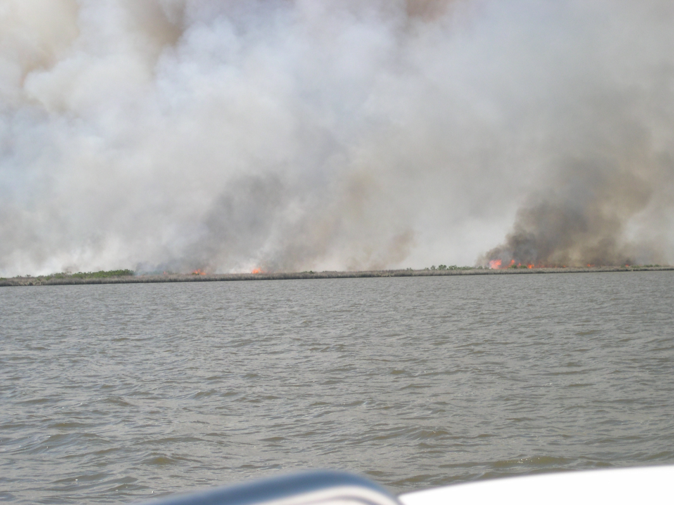

Figure 1. ANERR weather station is located on the other side of those flames. April 6, 2010.

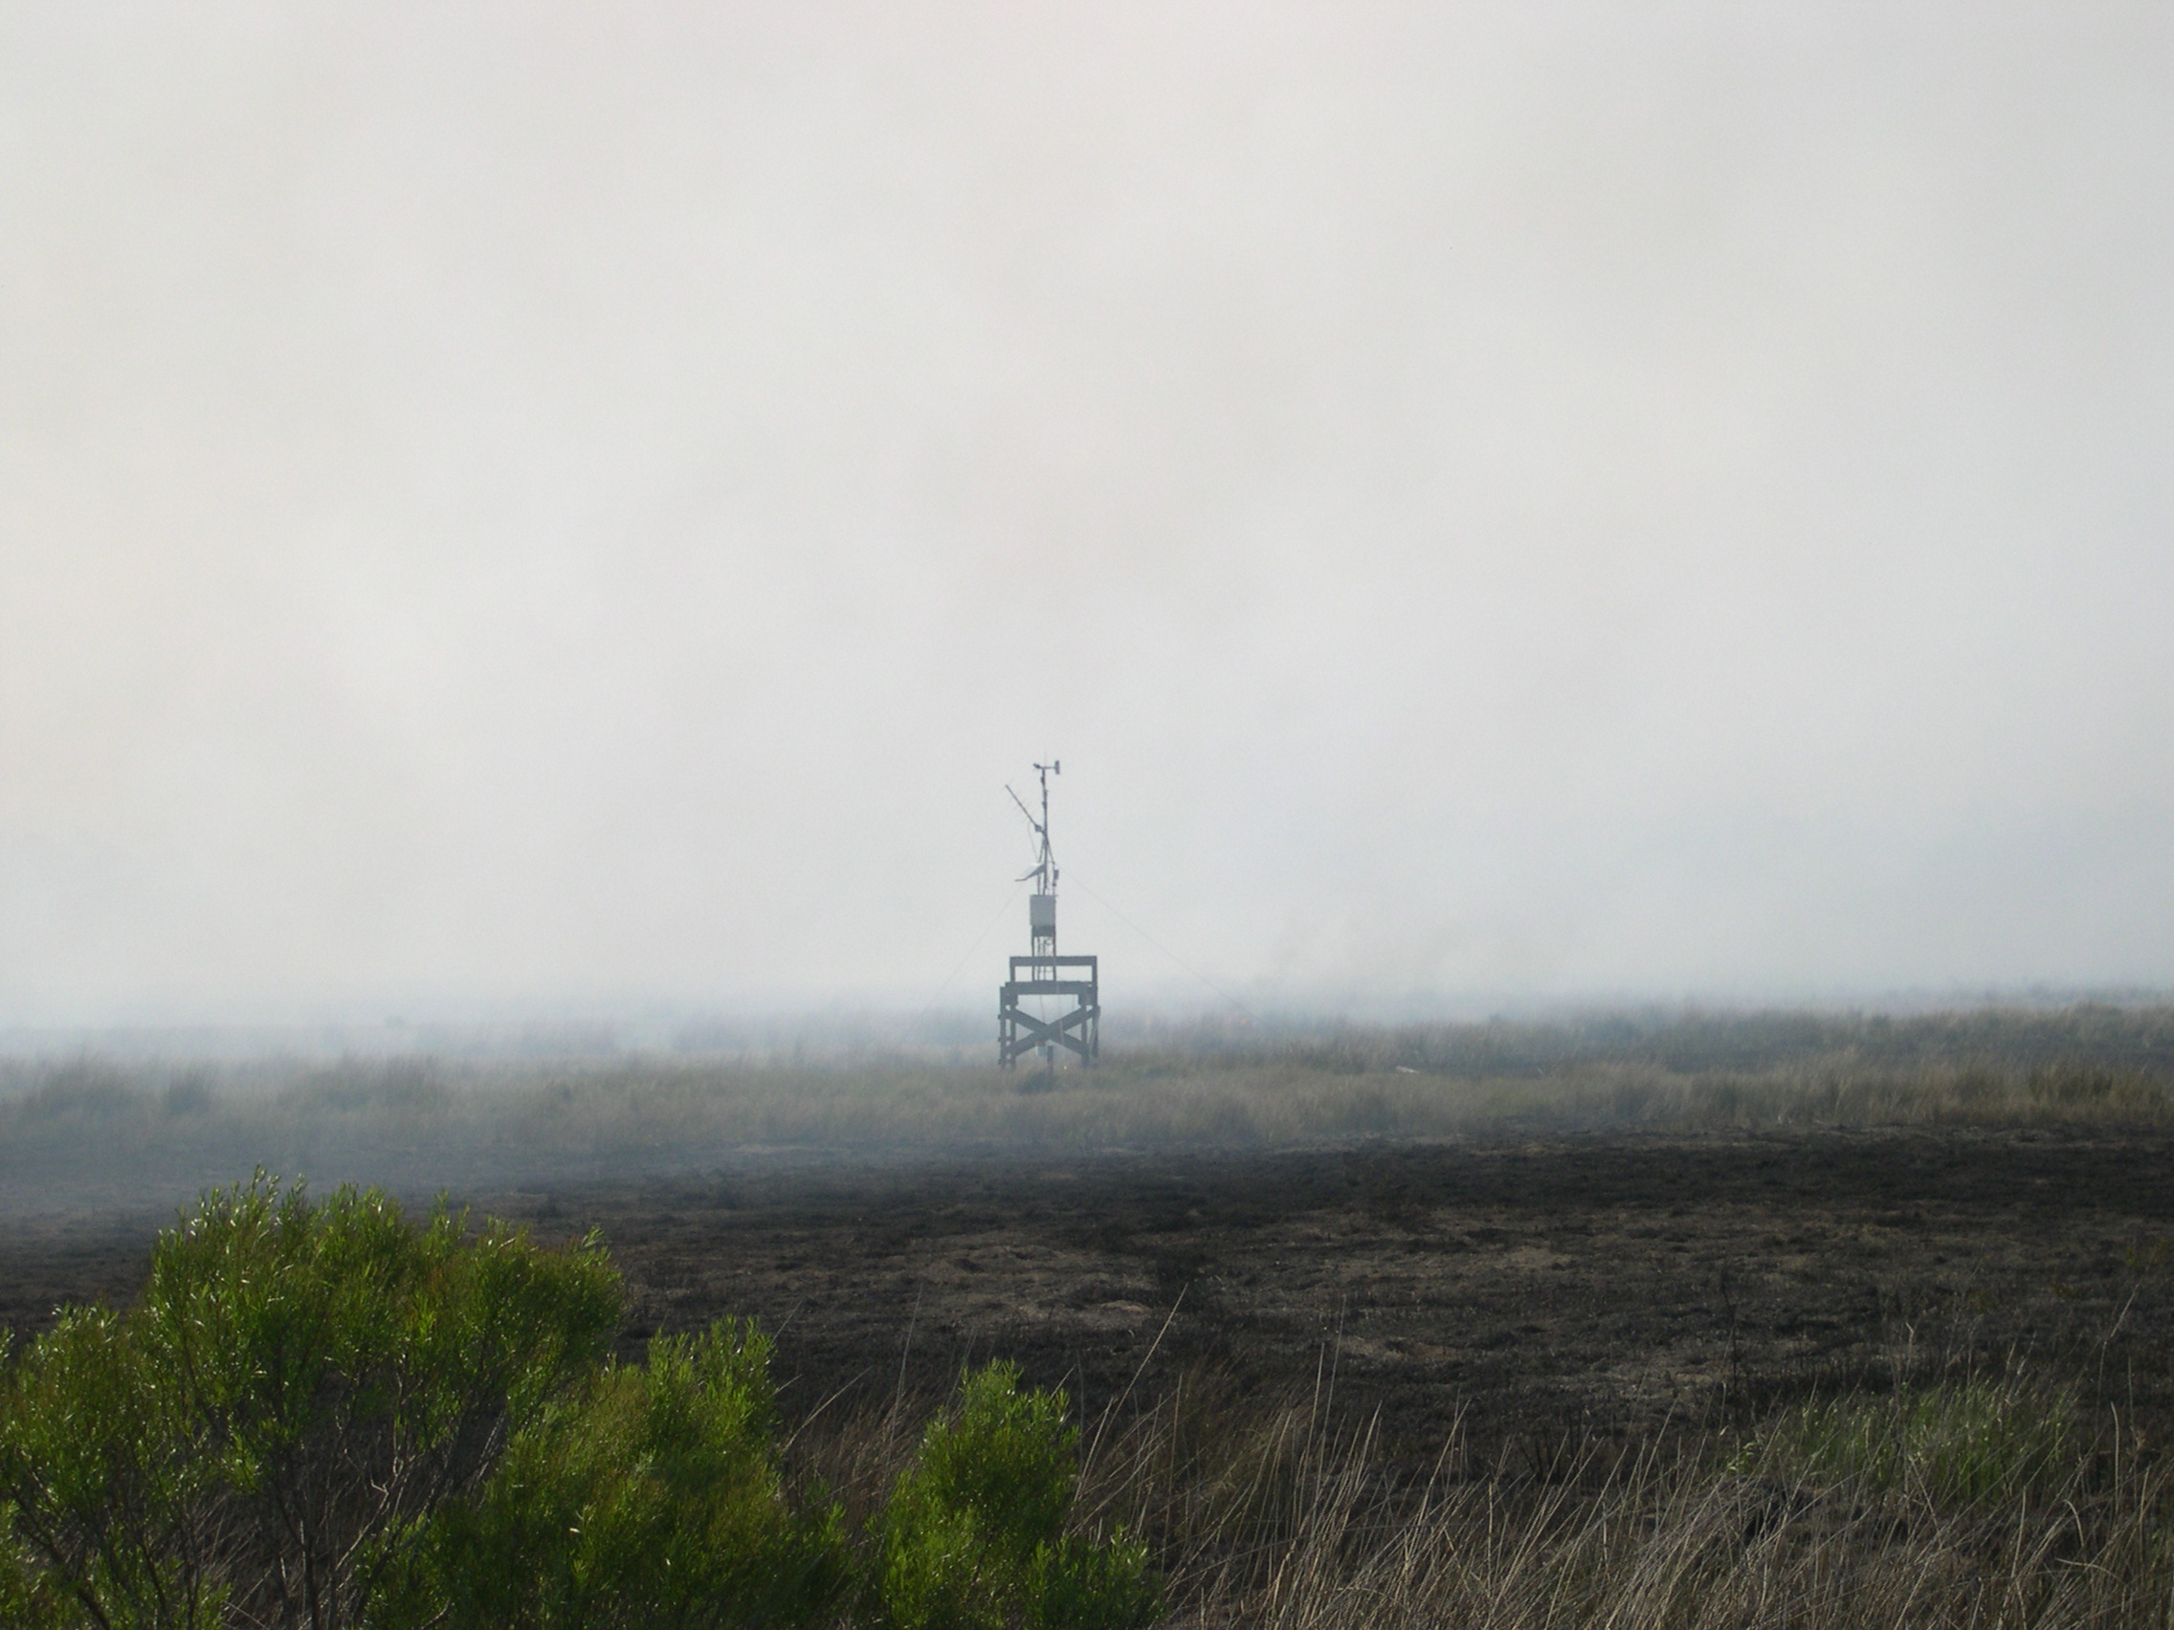

Figure 2. Still standing and still transmitting! Note unburned vegetation in mowed area surrounding ANERR weather station. April 6, 2010.