**Reserve Name** **JOB** **NERR Water Quality Metadata**

**Months and year the documentation covers: 01/01/2021 to 12/31/2021**

**Latest Update**: 06/06/2024

**I. Data Set and Research Descriptors**

**1. Principal investigator<s> and contact persons**

**Jobos Bay National Estuarine Research Reserve**

**PO Box 159**

**Salinas, PR 00704-0159**

**Ph. 787-853-4617**

**Fx. 787-853-4618**

**Angel Dieppa, Research Coordinator**

**Ph. 787-853-4617**

**Email.** [**adieppa.jbnerr@gmail.com**](mailto:adieppa.jbnerr@gmail.com)**,** [**adieppa@drna.pr.gov**](mailto:adieppa@drna.pr.gov)

**Enid Malavé, Chemist, SWMP Technician**

**Ph. 787-853-4617**

**Email.** [**enidmalave18@gmail.com**](mailto:enidmalave18@gmail.com)**,** [**emalave@drna.pr.gov**](mailto:emalave@drna.pr.gov)

**2. Entry verification**

Deployment data are uploaded from the YSI data logger to a Personal Computer <IBM compatible> by Enid Malavé. Files are exported from EcoWatch in a comma-delimited format <*.CDF> and uploaded to the CDMO by Enid Malavé and Angel Dieppa where they undergo automated primary QAQC and become part of the CDMO’s online provisional database. Excessive pre- and post-deployment data are removed from the file prior to upload with up to 2 hours of pre- and post-deployment data retained to assist in data management. During primary QAQC, data are flagged if they are missing or out of sensor range. The edited file is then returned to the Reserve where it is opened in Microsoft Excel and processed using the CDMO’s NERRQAQC Excel macro by Enid Malavé and Angel Dieppa. The macro inserts station codes, creates metadata worksheets for flagged data and summary statistics, and graphs the data for review. It allows the user to apply QAQC flags and codes to the data, remove any overlapping deployment data, append files, and export the resulting data file for upload to the CDMO. Upload after secondary QAQC results in ingestion into the database as provisional plus data, recalculation of cDepth or cLevel parameters, and finally tertiary QAQC by the CDMO and assimilation into the CDMO’s authoritative online database. Where deployment overlap occurs between files, the data produced by the newly calibrated sonde is generally accepted as being the most accurate. The final yearly file and metadata was submitted by Enid Malavé and Angel Dieppa. For more information on QAQC flags and codes, see Sections 11 and 12.

**3. Research objectives**

The principal objective is to record and track long-term changes and short term variability in water quality parameters that can be associated to changes in estuarine habitats. Through this, we support management decisions based on scientific data. A secondary objective is to promote the access and use of reliable baseline information by federal and local agencies, universities, researchers, educators and local communities to enhance the process by which they make decisions regarding their daily activities. This data is also invaluable in the identification and development of future monitoring and research activities.

A total of four data loggers <YSI EXO-2> are deployed in Jobos Bay. Two sondes are deployed in the inner lagoons of the Mar Negro Component and the other two in the Jobos Bay. The instruments are depth-fixed from a pole at a distance at about 0.5 meters from the bottom at each selected site. Data from stations 9, 10, 19 and 20 are being submitted to the Centralized Data Management Office as part of the System-Wide Monitoring Program. Measurements are taken at fifteen-minute intervals for approximately two-week periods. The sites are identified as representative of areas within the reserve and comparable to the sites that may be receiving impact from human activities from surroundings areas or may act as a habitat gradient in the Bay.

Station number nine <9>, subject to impacts from coastal processes <close to a power plant retentions pond>, collects water quality data in a site associated with runoff from littoral and basin mangrove areas. This sampling station is located in the most inland lagoon, closest to the Thermoelectric Power Plant <oil and natural gas>. It is subjected to runoff, which may include potential oil spill contamination from this industrial facility. Information compiled from historical environmental documents, indicate that station nine <9> was used as a disposal site for residues of the previously operating sugar mill operation, and therefore might have high organic input into the sediments.

Station number ten <10>, located in a mangrove lagoon area towards the southwestern section of Mar Negro is considered the reference or non-impacted site.

Station number <19> is located over a sea grass bed <*Thalassia testudinum*> in the inner western part of the bay just northeast of Cayo Colchones. This station is located near the thermal outfall and operating piers of the Aguirre Power Plant Complex, both activities may have significant effects on sea grass communities. This area is exposed to barge stranding, sediment re-suspension and oil spills.

Station number <20> is located on the eastern inner bay section of the Cayos Caribe cays. This station is just south of the mangrove islets associated with the Reserve's coral reefs. Water streams coming through the coral platform may help characterize water conditions of the main marine currents reaching Jobos Bay, as well as possible effects of industrial and chemical activities associated with Phillips Core, AES Coal Energy Plant and Pharmaceuticals located just east to this system.

**4. Research methods**

The National Estuarine Research Reserve Water Quality Monitoring Program began sampling at Station nine <9> on December 20, 1995 and Station ten <10> on February 1, 1996. Monitoring at station 19 began in April 2004 and at station 20 in June 2004. Long term water quality monitoring is being performed at these stations.

Before each YSI 6600 or EXO-2 data logger is deployed, calibration and maintenance is performed following the Standard Operation Procedures of the NERRS. Calibration standards are only required for pH, salinity, and turbidity, all other parameters are done as described in the manual. Buffer solutions for two-point calibration <pH 7 and pH 10> are purchased from a scientific supply company. Salinity is calibrated with a specific conductance standard 50 mS/cm and is purchased from YSI.

The two-point turbidity calibration is performed using a 0 NTU <DI water> and 124 FNU <for EXO-2> standard purchased from a scientific company. EXO-2 are equipped with dissolved oxygen optical sensors, both are allowed to sit at least 24 hours after proper calibration. Weather conditions and tide stage are recorded in the field observation log during deployment. Measurements of DO, pH, salinity, specific conductance, turbidity, and temperature are taken at the deployment time to check the accuracy and functionality of the instruments.

Each YSI data logger hangs inside a 6-inch diameter PVC pipe which is attached to a concrete filled PVC stable pole. Data loggers are at approximately 0.5 meter from the bottom of the selected site. Data is recorded every 15 minutes. The following measurements are recorded: date, time, temperature, specific conductance, salinity, dissolved oxygen saturation, dissolved oxygen concentration, depth, pH, and turbidity, all station have an optical chlorophyll-a sensor. Chl-a is an optional parameter non-required for SWMP program. Approximately, every two weeks the data loggers are retrieved, inspected, cleaned, data is downloaded into a personal computer and re-calibrated as noted previously. The data logger is then ready to be deployed again.

The data is processed through a standard quality control/quality assurance established for all 29 reserves within the system. It consists in submitting the raw data to the Centralized Data Management Office <CDMO> server where data undergoes through a macro to flag anomalies predetermine for each station. The data is sent back to the reserve to pass through a secondary QA/QC and finally resubmitted to CDMO for the final approval. Data may be available in different stages of the QA/QC process.

A Sutron Sat-Link2 transmitter was installed at the JOB20 station on 07/20/06 and a second station JOB09, transmits data to the NOAA GOES satellite, NESDIS ID # 3B0297EC and NESDIS ID # 3B0424AC respectively. The transmissions are scheduled hourly and contain four <4> data sets reflecting fifteen-minute data sampling intervals. Upon receipt by the CDMO, the data undergoes the same automated primary QAQC process detailed in Section 2 above. The “real-time” telemetry data become part of the provisional dataset until undergoing secondary and tertiary QAQC and assimilation in the CDMO’s authoritative online database. Provisional and authoritative data are available at [http://cdmo.baruch.sc.edu](http://cdmo.baruch.sc.edu/).

Station 20 and Station 9 telemetry was interrupted on 09/20/17 after Hurricane Maria destroyed the platform losing all the equipment. We are planning to reestablish communication in the near future.

**5. Site location and character**

The Jobos Bay National Estuarine Research Reserve <JBNERR> is located on the southern coastal plain of the island of Puerto Rico, a reserve within the West Indies geographical area. JBNERR is composed of two major areas: <1> Mar Negro, located on the western margin of the Bay, and <2> Cayos Caribe <a chain of 17 tear-shaped islets located to the southeast> and Cayos Barca <a chain of 7 tear-shaped islets located to the southwest boundaries> both with a back-reef system. The Mar Negro area comprises the bulk of the Reserve, and consists of mangrove forests and a complex system of lagoons and channels interspersed with salt and mud flats. Coral reefs and sea grass beds, with small beach deposits and upland areas fringe Cayos Caribe and Cayos Barca mangrove islands. Few areas in the watershed drain directly to the bay. Rio Seco to the north-east of the bay is active only during heavy rain events during the wet season. A small creek, Quebrada Coqui, near JBNERR’s pier to the north of the bay, drains into an extensive mangrove fringe forest in a laminar flow. During heavy rain events, Station 09 received runoff water from upland and finally, a diffuse flow of water reaches the bay from the local aquifer.

Station 9 is an impacted site and is located on the northeastern section of the Mar Negro component. This sampling station is associated with mangrove lagoon areas and receives runoff from mudflats, the Thermoelectric Power Plant, and adjacent areas. The tidal range varies from 12 to 14 inches near the monitoring station. The salinity at the vicinity of the monitoring station during this quarter varies from 30.0 ppt to 39.5 ppt. The average depth and total depth at station 09 is 0.29 and 0.97 meters respectively. The bottom is covered by a thick layer of thin sediments with a high content of organic material. *Microcoleus sp.* <blue-green algae>, brown and green algae <*Caulerpa sp*.> are also present at this site, but a better assessment is needed. The station pole was located at 17°56'34.87"N and 66°14'18.64"W until 09/02/2010 12:00PM, then it was relocated to 17° 56' 35.0" N and 66° 14' 18.9" W approximately 65.0 meters from original position. The relocalization was due to sedimentation issues and the construction of a new telemetry station. Fresh water input to the station comes only from runoff and rain. This station has been subject of several studies indicating the presence of relatively high level of cooper and pesticides compared to other stations. Since 2015 an invasive seagrass, *Halophila stipulacea* was reported at Jobos Bay, it was after the pass of Hurricane Maria in September 21, 2017 that it was more evident and wide distributed. Although it is not present at Station 9, it is present in the channels toward the station and we expect it will colonize the area in the near future.

Station 10 is located in a mangrove lagoon not impacted directly by any upland or marine activities. It provides a reference for comparison of data obtained in other stations, especially to the station in Mar Negro lagoon. The tidal range varies from 12 to 14 inches. The salinity at the vicinity of the monitoring station during this quarter varies from 17.0 ppt to 39.7ppt. The average depth and total depth at station 10 is 0.20 and 0.94 meters respectively. The bottom is covered with a layer of fine sediments with organic material, followed by a layer of calcareous material mainly from shells and oysters. At this site, we can find sea grass <*Thalassia testudinum*>, calcareous algae <*Halimeda* *sp.*>, green algae <*Caulerpa* *sp*.> and brown algae <*Dictyota* *sp*.> among others. The pole is located at 17° 56' 19.00 N, 66° 15' 27.85 W. Fresh water input to the station comes only from runoff and rain. There is not any direct source of fresh water. Since 2015 an invasive seagrass, *Halophila stipulacea* was reported at Jobos Bay, it was after the pass of Hurricane Maria in September 21, 2017 that it was more evident and wide distributed been observed in the perimeter of the station. See notes below regarding Sargassum arrivals.

Station 19 is located on the western inner section of the bay at a distance of 233 meters from Cayo Colchones Mangroves over sea grass beds <*Thallasia testudinum*>. Tidal ranges in this area vary from 12 to 14 inches. The salinity at the vicinity of the monitoring station during this quarter varies from 31.3 ppt to 37.0ppt. The average depth and total depth at this station is 0.45 and 1.13 meters respectively. The YSI sonde is deployed at about .05 meter from the bottom. The bottom is of sandy composition. Sea grass, algae, echinoderms and other related organisms could be found in the area. The pole is located at 17° 56' 34.49"N, 66° 13' 43.77"W. There is no freshwater input to this area. Since 2015 an invasive seagrass, *Halophila stipulacea* was reported at Jobos Bay, it was after the pass of Hurricane Maria in September 21, 2017 that it was more evident and wide distributed been observed in the perimeter of the station.

Station 20 is located in the inner eastern section at about 190 meters of Cayos Caribe Mangrove islets and at about 688 meters from the coral reef barrier. This station is the closest to Mar Caribe. It has a sandy bottom, with calcareous and coral fragments, sea grass <*Thalassia testudinum*> communities, echinoderms and other associated organisms. Tidal ranges in this area vary from 12 to 14 inches. The salinity at the vicinity of the monitoring station during this quarter varies from 26.4 ppt to 38.6 ppt. The average depth and total depth at this station is 0.23 and 0.86 meters respectively. There is no surface freshwater input to this area. The pole is located at 17° 55' 49.14"N, 66° 12' 41.30"W. Since 2015 an invasive seagrass, *Halophila stipulacea* was reported at Jobos Bay, it was after the pass of Hurricane Maria in September 21, 2017 that it was more evident and wide distributed been observed in the perimeter of the station.

Data from stations 9, 10, 19 and 20 is being submitted to the CDMO. Eight sondes are permanently devoted to taking readings from these two sites, to assure continuous readings while sondes are taken out of the water for data upload and maintenance. This will avoid data gaps for the stations between sonde maintenance procedures. Due to errors in calibration, turbidity data in these files is considered inadequate. All monitoring is considered long term.

|  |  |  |  |  |  |  |
| --- | --- | --- | --- | --- | --- | --- |
| **Station Code** | **SWMP Status** | **Station Name** | **Location** | **Active Dates** | **Reason Decommissioned** | **Notes** |
| JOB09 WQ | P | Station 9 | 17.94306 N 66.23858 W | 12/20/1995  Present | NA | NA |
| JOB10 WQ | P | Station 10 | 17.93861 N 66.25774 W | 02/01/1996  Present | NA | NA |
| JOB19 WQ | P | Station 19 | 17.94291 N 66.22883 W | 04/01/2004  Present | NA | NA |
| JOB20 WQ | P | Station 20 | 17.93032 N  66.21147 W | 03/13/2004  Present | NA | NA |
| JOB06WQ | P | Station 06 | 17.93499 N 66.22793 W | 12/1996-12/1998 | Affected by thermal outfall | NA |
| JOB11WQ | P | Station 11 | 17.94461 N 66.26203 W | 03/1996-12/1998 | Exposed to vandalism | NA |
| JOB18WQ | P | Station 18 | 17.94443 N 66.23188 W | 10/1998-11/1998 | Does not represent normal conditions | NA |

**6. Data collection period –** Include each YSI deployment and retrieval date and time <**first** and **last** readings in the water> for each monitoring site for the year. Do not include times of pre- and post-deployment or datasondes’ transport. Note when data collection began initially for your Reserve or sample sites.

Station nine <9> water quality monitoring began on December 20, 1995.

Station ten <10> water quality monitoring began on February 1, 1996.

Station nineteen <19> water quality monitoring began on April 1, 2004.

Station twenty <20> water quality monitoring began on May 13, 2004.

**Deployment and Retrieval Dates 2021:**

|  |  |  |  |  |  |  |  |  |  |
| --- | --- | --- | --- | --- | --- | --- | --- | --- | --- |
| **Station 09** |  |  |  |  | **Station 19** |  | |  |  |
| **Date/** | **Time In** | **Date/ Time Out** | |  | **Date/ Time In** | | | **Date/ Time Out** | |
| 12/18/2020 | 08:45 | 01/19/2021 | 10:15 |  | 12/14/2020 | | 10:30 | 01/07/2021 | 10:30 |
| 01/19/2021 | 10:45 | 02/01/2021 | 10:45 |  | 01/07/2021 | | 11:00 | 01/25/2021 | 09:30 |
| 02/01/2021 | 11:00 | 02/11/2021 | 10:30 |  | 01/25/2021 | | 09:45 | 02/08/2021 | 10:00 |
| 02/11/2021 | 10:45 | 02/25/2021 | 11:15 |  | 02/08/2021 | | 10:15 | 02/19/2021 | 11:00 |
| 02/25/2021 | 11:30 | 03/08/2021 | 11:00 |  | 02/19/2021 | | 11:15 | 03/03/2021 | 09:00 |
| 03/08/2021 | 11:30 | 03/30/2021 | 11:15 |  | 03/03/2021 | | 09:15 | 03/15/2021 | 09:45 |
| 03/30/2021 | 11:30 | 04/12/2021 | 11:45 |  | 03/15/2021 | | 10:00 | 04/06/2021 | 09:45 |
| 04/12/2021 | 12:45 | 04/26/2021 | 14:15 |  | 04/06/2021 | | 10:00 | 04/19/2021 | 09:30 |
| 04/26/2021 | 14:30 | 05/11/2021 | 11:00 |  | 04/19/2021 | | 11:00 | 05/03/2021 | 09:00 |
| 05/11/2021 | 11:15 | 05/25/2021 | 11:15 |  | 05/03/2021 | | 10:00 | 05/18/2021 | 09:30 |
| 05/25/2021 | 12:30 | 06/07/2021 | 11:00 |  | 05/18/2021 | | 10:45 | 06/01/2021 | 09:30 |
| 06/10/2021 | 12:45 | 07/01/2021 | 09:45 |  | 06/01/2021 | | 11:00 | 06/07/2021 | 09:15 |
| 07/07/2021 | 11:30 | 07/19/2021 | 11:45 |  | 06/15/2021 | | 09:15 | 07/01/2021 | 10:00 |
| 07/22/2021 | 10:15 | 08/09/2021 | 11:15 |  | 07/07/2021 | | 09:30 | 07/19/2021 | 12:00 |
| 08/12/2021 | 12:30 | 08/23/2021 | 11:00 |  | 07/22/2021 | | 09:00 | 08/09/2021 | 08:30 |
| 08/25/2021 | 12:00 | 09/13/2021 | 10:45 |  | 08/12/2021 | | 12:15 | 08/23/2021 | 09:00 |
| 09/15/2021 | 11:45 | 09/28/2021 | 11:30 |  | 08/25/2021 | | 09:45 | 09/13/2021 | 10:15 |
| 09/30/2021 | 11:45 | 10/12/2021 | 10:30 |  | 09/15/2021 | | 09:45 | 09/28/2021 | 10:00 |
| 10/14/2021 | 12:00 | 10/25/2021 | 13:00 |  | 09/30/2021 | | 11:15 | 10/12/2021 | 09:15 |
| 10/28/2021 | 11:00 | 11/08/2021 | 09:15 |  | 10/14/2021 | | 10:15 | 10/25/2021 | 13:15 |
| 11/10/2021 | 14:00 | 11/22/2021 | 10:30 |  | 10/28/2021 | | 09:00 | 11/08/2021 | 11:45 |
| 11/24/2021 | 11:30 | 12/13/2021 | 09:45 |  | 11/10/2021 | | 15:00 | 11/19/2021 | 08:30 |
| 12/15/2021 | 11:30 | 01/02/2022 | 18:00 |  | 11/24/2021 | | 10:15 | 12/13/2021 | 10:15 |
|  |  |  |  |  | 12/15/2021 | | 10:00 | 01/10/2022 | 10:45 |

**\*No Data**

|  |  |  |  |  |  |  |  |  |  |  |
| --- | --- | --- | --- | --- | --- | --- | --- | --- | --- | --- |
| **Station 10** |  |  |  | |  | **Station 20** | |  |  |  |
| **Date/** | **Time In** | **Date Time Out** | | |  | **Date/ Time In** | | | **Date/ Time Out** | |
| 12/18/2020 | 08:00 | 01/19/2021 | | 09:45 |  | 12/14/2020 | 11:15 | | 01/07/2021 | 11:00 |
| 01/19/2021 | 10:00 | 02/01/2021 | | 10:15 |  | 01/07/2021 | 11:15 | | 01/25/2021 | 11:45 |
| 02/01/2021 | 10:45 | 02/11/2021 | | 10:00 |  | 01/25/2021 | 12:00 | | 02/08/2021 | 10:15 |
| 02/11/2021 | 10:15 | 02/25/2021 | | 10:45 |  | 02/08/2021 | 10:30 | | 02/19/2021 | 11:15 |
| 02/25/2021 | 11:00 | 03/08/2021 | | 10:30 |  | 02/19/2021 | 11:30 | | 03/03/2021 | 10:30 |
| 03/08/2021 | 10:45 | 03/30/2021 | | 10:15 |  | 03/03/2021 | 10:45 | | 03/15/2021 | 10:45 |
| 03/30/2021 | 10:30 | 04/12/2021 | | 11:15 |  | 03/15/2021 | 11:00 | | 04/06/2021 | 10:00 |
| 04/12/2021 | 11:30 | 04/26/2021 | | 12:45 |  | 04/06/2021 | 10:15 | | 04/19/2021 | 11:30 |
| 04/26/2021 | 13:45 | 05/11/2021 | | 10:00 |  | 04/19/2021 | 11:45 | | 05/03/2021 | 10:30 |
| 05/11/2021 | 10:45 | 05/25/2021 | | 10:15 |  | 05/03/2021 | 10:45 | | 05/18/2021 | 11:00 |
| 05/25/2021* | 10:30 | 06/10/2021 | | 10:15 |  | 05/18/2021 | 12:30 | | 06/01/2021 | 12:30 |
| 06/11/2021 | 11:45 | 07/01/2021 | | 09:30 |  | 06/01/2021 | 13:30 | | 06/07/2021 | 11:30 |
| 07/07/2021 | 10:30 | 07/19/2021 | | 11:15 |  | 06/10/2021 | 10:00 | | 06/29/2021 | 19:45 |
| 07/22/2021 | 09:45 | 08/02/2021 | | 03:45 |  | 07/07/2021 | 09:15 | | 07/19/2021 | 12:15 |
| 08/12/2021 | 11:15 | 08/23/2021 | | 10:15 |  | 07/22/2022 | 08:45 | | 08/01/2021 | 16:00 |
| 08/25/2021 | 11:00 | 09/07/2021 | | 15:30 |  | 08/12/2021 | 09:00 | | 08/23/2021 | 14:30 |
| 09/07/2021 | 15:45 | 09/28/2021 | | 11:00 |  | 09/15/2021 | 12:30 | | 09/28/2021 | 09:30 |
| 09/30/2021 | 12:45 | 10/12/2021 | | 10:15 |  | 09/30/2021 | 14:30 | | 10/12/2021 | 09:00 |
| 10/14/2021 | 09:30 | 10/25/2021 | | 07:15 |  | 10/14/2021 | 09:30 | | 10/25/2021 | 09:15 |
| 10/28/2021 | 11:15 | 11/08/2021 | | 09:00 |  | 10/28/2021 | 09:30 | | 11/08/2021 | 08:30 |
| 11/10/2021 | 13:15 | 11/22/2021 | | 10:00 |  | 11/10/2021 | 11:00 | | 11/22/2021 | 08:45 |
| 11/24/2021 | 11:00 | 12/13/2021 | | 09:00 |  | 11/24/2021 | 09:30 | | 12/13/2021 | 08:15 |
| 12/15/2021 | 10:30 | 12/23/2021 | | 02:00 |  | 12/15/2021 | 09:30 | | 01/10/2022 | 10:30 |

**\*No Data, sonde deployed but due to malfunction no data collected.**

**7. Distribution**

NOAA retains the right to analyze, synthesize and publish summaries of the NERRS System-wide Monitoring Program data.  The NERRS retains the right to be fully credited for having collected and process the data.  Following academic courtesy standards, the NERR site where the data were collected should be contacted and fully acknowledged in any subsequent publications in which any part of the data are used.  The data set enclosed within this package/transmission is only as good as the quality assurance and quality control procedures outlined by the enclosed metadata reporting statement.  The user bears all responsibility for its subsequent use/misuse in any further analyses or comparisons.  The Federal government does not assume liability to the Recipient or third persons, nor will the Federal government reimburse or indemnify the Recipient for its liability due to any losses resulting in any way from the use of this data.

.

**Requested citation format:**

NOAA National Estuarine Research Reserve System <NERRS>. System-wide Monitoring Program. Data accessed from the NOAA NERRS Centralized Data Management Office website: <http://www.nerrsdata.org/>; accessed 12 October 2020.

NERR water quality data and metadata can be obtained from the Research Coordinator at the individual NERR site <please see Principal Investigators and Contact Persons>, from the Data Manager at the Centralized Data Management Office <please see personnel directory under the general information link on the CDMO home page> and online at the CDMO home page **www.nerrsdata.org.** Data are available in text tab-delimited format.

**8. Associated researchers and projects**

The Jobos Bay NERR maintains four water quality monitoring stations as part of the System Wide Monitoring Program <SWMP> to monitor variability in the estuarine environment. Meteorological station collects continuous information that support water quality data intended to address short-term variability and long-term changes in estuarine water parameters within the bay <i.e., localized impacts of seasonal storms and hurricane events, variability due to tidal circulation, seasonal and interannual differences in rainfall, magnitude and influence of major events such hurricanes, spatial extent of oceanic and tidal forcing.

Our water quality monitoring program is a key component of SWMP. Variables measured include Temperature, Dissolved Oxygen, Turbidity, pH, Salinity and Depth in 4 permanent stations equipped with YSI data sondes. The program supports a nutrient monitoring at the same stations, nitrogen, phosphorus, and chlorophyll are measured in a monthly basis. Also, a diel nutrient sampling is performed in a monthly basis.

SWMP data has been used by:

* Caribbean Regional Association for the Caribbean Regional Coastal Ocean Observing System <CariCOOS> who monitors Real Time data from our SWMP stations.
* Environmental Quality Board for their biennial Puerto Rico 305<b>/303<d>

Integrated Report

* Puerto Rico Energy Power Authority <PREPA>
* Department of Natural and Environmental Resources
* Ocean Physics Education (OPE) an educational effort by physical oceanographer Dr. Edwin Alfonso-Sosa.

**II. Physical Structure Descriptors**

**9. Sensor specifications**

YSI EXO-2 sondes were used at all sites at JOB NERR in 2021.

**YSI EXO-2 Sonde:**

Parameter: Temperature

Units: Celsius <C>

Sensor Type: Thermistor

Model#: 599870-01

Range: -5 to 50 C

Accuracy: -5 to 35: +/- 0.01, 35 to 50: +/- .005

Resolution: 0.01 C

Parameter: Conductivity

Units: milli-Siemens per cm <mS/cm>

Sensor Type: 4-electrode cell with auto ranging

Model#: 599870-01

Range: 0 to 200 mS/cm

Accuracy: 0 to 100: +/- 0.5% of reading or 0.001 mS/cm; 100 to 200: +/- 1% of reading

Resolution: 0.001 mS/cm to 0.1 mS/cm <range dependent>

Parameter: Salinity

Units: practical salinity units <psu>/parts per thousand <ppt>

Sensor Type: Calculated from conductivity and temperature

Range: 0 to 70 psu

Accuracy: +/- 1.0% of reading pr 0.1 ppt, whichever is greater

Resolution: 0.01 psu

Parameter: Dissolved Oxygen % saturation

Sensor Type: Optical probe w/ mechanical cleaning

Model#: 599100-01

Range: 0 to 500% air saturation

Accuracy: 0-200% air saturation: +/- 1% of the reading or 1% air saturation, whichever is greater 200-500% air saturation: +/- 5% or reading

Resolution: 0.1% air saturation

Parameter: Dissolved Oxygen mg/L <Calculated from % air saturation, temperature, and salinity>

Units: milligrams/Liter <mg/L>

Sensor Type: Optical probe w/ mechanical cleaning

Model#: 599100-01

Range: 0 to 50 mg/L

Accuracy: 0-20 mg/L: +/-0.1 mg/l or 1% of the reading, whichever is greater

20 to 50 mg/L: +/- 5% of the reading

Resolution: 0.01 mg/L

Parameter: Non-vented Level - Shallow <Depth>

Units: feet or meters <ft or m>

Sensor Type: Stainless steel strain gauge

Range: 0 to 33 ft <10 m>

Accuracy: +/- 0.013 ft <0.004 m>

Resolution: 0.001 ft <0.001 m>

Parameter: pH

Units: pH units

Sensor Type: Glass combination electrode

Model#: 599701<guarded> or 599702<wiped>

Range: 0 to 14 units

Accuracy: +/- 0.01 units within +/- 10° of calibration temperature, +/- 0.02 units for entire temperature range

Resolution: 0.01 units

Parameter: Turbidity

Units: formazin nephelometric units <FNU>

Sensor Type: Optical, 90-degree scatter

Model#: 599101-01

Range: 0 to 4000 FNU

Accuracy: 0 to 999 FNU: 0.3 FNU or +/-2% of reading <whichever is greater>; 1000 to 4000 FNU +/-5% of reading

Resolution: 0 to 999 FNU: 0.01 FNU, 1000 to 4000 FNU: 0.1 FNU

Parameter: Chlorophyll

Units: micrograms/Liter

Sensor Type: Optical probe

Model#: 599102-01

Range: 0 to 400 ug/Liter

Accuracy: Dependent on methodology

Resolution: 0.1 ug/L chl a, 0.1% FS

**Depth Qualifier:**

The NERR System-Wide Monitoring Program utilizes YSI data sondes that can be equipped with either vented or non-vented depth/level sensors.  Readings for both vented and non-vented sensors are automatically compensated for water density change due to variations in temperature and salinity; but for all non-vented depth measurements, changes in atmospheric pressure between calibrations appear as changes in water depth.  The error is equal to approximately 1.02 cm for every 1 millibar change in atmospheric pressure, and is eliminated for vented sensors because they are vented to the atmosphere throughout the deployment time interval.

Beginning in 2006, NERR SWMP standard calibration protocol calls for all non-vented depth sensors to read 0 meters at a <local> barometric pressure of 1013.25 mb <760 mm/hg>.  To achieve this, each site calibrates their depth sensor with a depth offset number, which is calculated using the actual atmospheric pressure at the time of calibration and the equation provided in the SWMP calibration sheet or digital calibration log.  This offset procedure standardizes each depth calibration for the entire NERR System.  If accurate atmospheric pressure data are available, non-vented sensor depth measurements at any NERR can be corrected.

In 2010, the CDMO began automatically correcting depth/level data for changes in barometric pressure as measured by the Reserve’s associated meteorological station during data ingestion. These corrected depth/level data are reported as cDepth and cLevel, and are assigned QAQC flags and codes based on QAQC protocols. Please see sections 11 and 12 for QAQC flag and code definitions.

**NOTE: older depth data cannot be corrected without verifying that the depth offset was in place and whether a vented or non-vented depth sensor was in use. No SWMP data prior to 2006 can be corrected using this method.** The following equation is used for corrected depth/level data provided by the CDMO beginning in 2010:

<<1013-BP> * 0.0102> +Depth/Level = cDepth/cLevel.

**Salinity Units Qualifier:**

In 2013, EXO sondes were approved for SWMP use and began to be utilized by Reserves. While the 6600 series sondes report salinity in parts per thousand <ppt> units, the EXO sondes report practical salinity units <psu>. These units are essentially the same and for SWMP purposes are understood to be equivalent, however psu is considered the more appropriate designation. Moving forward the NERR System will assign psu salinity units for all data regardless of sonde type.

**Turbidity Qualifier:**

In 2013, EXO sondes were approved for SWMP use and began to be utilized by Reserves. While the 6600 series sondes report turbidity in nephelometric turbidity units <NTU>, the EXO sondes use formazin nephelometric units <FNU>. These units are essentially the same but indicate a difference in sensor methodology, for SWMP purposes they will be considered equivalent. Moving forward, the NERR System will use FNU/NTU as the designated units for all turbidity data regardless of sonde type. If turbidity units and sensor methodology are of concern, please see the Sensor Specifications portion of the metadata.

**Chlorophyll Fluorescence Disclaimer:**

YSI chlorophyll sensors <6025 or 599102-01> are designed to serve as a proxy for chlorophyll concentrations in the field for monitoring applications and complement traditional lab extraction methods; therefore, there are accuracy limitations associated with the data that are detailed in the YSI manual including interference from other fluorescent species, differences in calibration method, and effects of cell structure, particle size, organism type, temperature, and light on sensor measurements.

**10. Coded variable definitions**

Sampling station: Sampling site code: Station code:

Station 9 ST09 job09wq

Station 10 ST10 job10wq

Station 19 ST19 job19wq

Station 20 ST20 job20wq

**11. QAQC flag definitions**

QAQC flags provide documentation of the data and are applied to individual data points by insertion into the parameter’s associated flag column <header preceded by an F_>. During primary automated QAQC <performed by the CDMO>, -5, -4, and -2 flags are applied automatically to indicate data that is missing and above or below sensor range. All remaining data are then flagged 0, passing initial QAQC checks. During secondary and tertiary QAQC 1, -3, and 5 flags may be used to note data as suspect, rejected due to QAQC, or corrected.

-5 Outside High Sensor Range

-4 Outside Low Sensor Range

-3 Data Rejected due to QAQC

-2 Missing Data

-1 Optional SWMP Supported Parameter

0 Data Passed Initial QAQC Checks

1 Suspect Data

2 *Open - reserved for later flag*

3 Calculated data: non-vented depth/level sensor correction for changes in barometric pressure

4 Historical Data: Pre-Auto QAQC

5 Corrected Data

**12. QAQC code definitions**

QAQC codes are used in conjunction with QAQC flags to provide further documentation of the data and are also applied by insertion into the associated flag column. There are three <3> different code categories, general, sensor, and comment. General errors document general problems with the deployment or YSI data sonde, sensor errors are sensor specific, and comment codes are used to further document conditions or a problem with the data. Only one general or sensor error and one comment code can be applied to a particular data point, but some comment codes <marked with an * below> can be applied to the entire record in the FRecord column.

General Errors

GIC No instrument deployed due to ice

GIM Instrument malfunction

GIT Instrument recording error; recovered telemetry data

GMC No instrument deployed due to maintenance/calibration

GNF Deployment tube clogged / no flow

GOW Out of water event

GPF Power failure / low battery

GQR Data rejected due to QA/QC checks

GSM See metadata

Corrected Depth/Level Data Codes

GCC Calculated with data that were corrected during QA/QC

GCM Calculated value could not be determined due to missing data

GCR Calculated value could not be determined due to rejected data

GCS Calculated value suspect due to questionable data

GCU Calculated value could not be determined due to unavailable data

Sensor Errors

SBO Blocked optic

SCF Conductivity sensor failure

SCS Chlorophyll spike

SDF Depth port frozen

SDG Suspect due to sensor diagnostics

SDO DO suspect

SDP DO membrane puncture

SIC Incorrect calibration / contaminated standard

SNV Negative value

SOW Sensor out of water

SPC Post calibration out of range

SQR Data rejected due to QAQC checks

SSD Sensor drift

SSM Sensor malfunction

SSR Sensor removed / not deployed

STF Catastrophic temperature sensor failure

STS Turbidity spike

SWM Wiper malfunction / loss

Comments

CAB* Algal bloom

CAF Acceptable calibration/accuracy error of sensor

CAP Depth sensor in water, affected by atmospheric pressure

CBF Biofouling

CCU Cause unknowCDA* DO hypoxia <<3 mg/L>

CDB* Disturbed bottom

CDF Data appear to fit conditions

CFK* Fish kill

CIP * Surface ice present at sample station

CLT* Low tide

CMC* In field maintenance/cleaning

CMD* Mud in probe guard

CND New deployment begins

CRE* Significant rain event

CSM* See metadata

CTS Turbidity spike

CVT* Possible vandalism/tampering

CWD* Data collected at wrong depth

CWE* Significant weather event

**13. Post deployment information**

|  |  |  |  |  |  |
| --- | --- | --- | --- | --- | --- |
| **STATION 09** |  |  | **Post Deployment Calibration Values** |  |  |
| **Date In** | **Date Out** | **SpCond <50mS/cm>** | **DO%** | **pH <7>** | **Turb <0 NTU>** |
| 12/18/2020 | 01/19/2021 | 49.89 | 98 | 7.11 | 0.15 |
| 01/19/2021 | 02/01/2021 | 50.57 | 100.1 | 6.75* | -0.09 |
| 02/01/2021 | 02/11/2021 | 50.02 | 100 | 7.13 | 0.63 |
| 02/11/2021 | 02/25/2021 | 49.60 | 100.9 | 7.05 | 0.09 |
| 02/25/2021 | 03/08/2021 | 49.76 | 98.6 | 7.06 | -0.04 |
| 03/08/2021 | 03/30/2021 | 49.16 | 100.1 | 7.23 | 0.07 |
| 03/30/2021 | 04/12/2021 | 57.31 | 91.9 | 7.05 | 0.14 |
| 04/12/2021 | 04/26/2021 | 49.82 | 97.8 | 6.98 | 0.35 |
| 04/26/2021 | 05/11/2021 | 41.82 | 97.9 | 7.08 | 0.31 |
| 05/11/2021 | 05/25/2021 | 50.33 | 87.4 | 7.17 | 0.02 |
| 05/25/2021 | 06/07/2021 | 50.51 | 113.5 | 6.99 | 0.49 |
| 06/10/2021 | 07/01/2021 | 49.34 | 98 | 7.09 | 0.82 |
| 07/07/2021 | 07/19/2021 | 49.96 | 99.1 | 7.05 | 0.23 |
| 07/22/2021 | 08/09/2021 | 49.83 | 98.6 | 7.03 | 0.14 |
| 08/12/2021 | 08/23/2021 | 50.79 | 97.9 | 7.16 | 0.50 |
| 08/25/2021 | 09/13/2021 | 49.0 | 99.5 | 7.02 | 0.09 |
| 09/15/2021 | 09/28/2021 | 49.78 | 98.2 | 7.08 | 0.26 |
| 09/30/2021 | 10/12/2021 | 49.05 | 96.9 | 7.34 | 0.97 |
| 10/14/2021 | 10/25/2021 | 50.00 | 92.7 | 7.06 | 0.06 |
| 10/28/2021 | 11/08/2021 | 50.27 | 100.8 | 7.10 | -0.13 |
| 11/10/2021 | 11/22/2021 | 49.0 | 98.8 | 7.05 | 0.31 |
| 11/24/2021 | 12/13/2021 | 48.92 | 101.2 | 7.02 | -0.14 |
| 12/15/2021 | 01/10/2022 | 50.25 | 100 | 7.06 | -0.30 |

|  |  |  |  |  |  |
| --- | --- | --- | --- | --- | --- |
| **STATION 10** |  |  | **Post Deployment Calibration Values** |  |  |
| **Date In** | **Date Out** | **SpCond <50mS/cm>** | **DO%** | **pH <7>** | **Turb <0 NTU>** |
| 12/18/2020 | 01/19/2021 | 49.77 | 99.2 | 7.11 | 0.18 |
| 01/19/2021 | 02/01/2021 | 50.66 | 99.5 | 7.06 | 0.13 |
| 02/01/2021 | 02/11/2021 | 49.18 | 100.1 | 6.99 | 0.49 |
| 02/11/2021 | 02/25/2021 | 49.99 | 101.8 | 7.02 | 0.11 |
| 02/25/2021 | 03/08/2021 | 49.41 | 99.3 | 6.99 | 0.23 |
| 03/08/2021 | 03/30/2021 | 47.22 | 101.5 | 7.01 | 0.26 |
| 03/30/2021 | 04/12/2021 | 49.68 | 97.4 | 7.04 | 0.04 |
| 04/12/2021 | 04/26/2021 | 57.71 | 101.6 | 7.01 | 0.49 |
| 04/26/2021 | 05/11/2021 | 50.13 | 99.4 | 7.12 | 0.47 |
| 05/11/2021 | 05/25/2021 | 49.13 | 89.5 | 7.04 | 0.20 |
| 05/25/2021 | 06/10/2021 | 52.32 | 115.0 | 7.09 | -0.10 |
| 06/11/2021 | 07/01/2021 | 49.0 | 99.8 | 7.13 | 0.48 |
| 07/07/2021 | 07/12/2021 | 48.0 | 99.3 | 7.02 | 0.55 |
| 07/22/2021 | 08/02/2021 | 50.81 | 99.6 | 7.04 | 0.01 |
| 08/12/2021 | 08/23/2021 | 42.6 | 71.7 | 7.07 | 0.18 |
| 08/25/2021 | 09/02/2021 | 47.49 | 99.0 | 7.12 | 0.14 |
| 09/02/2021 | 09/07/2021 | 47.49 | 99.0 | 7.12 | 0.14 |
| 09/07/2021 | 09/28/2021 | 50.10 | 99.7 | 7.01 | 0.16 |
| 09/30/2021 | 10/12/2021 | 44.93 | 100.7 | 7.10 | -0.31 |
| 10/14/2021 | 10/25/2021 | 47.40 | 99.5 | 7.05 | -0.49 |
| 10/28/2021 | 11/08/2021 | 2.66** | 101.1 | 7.01 | 0.02 |
| 11/10/2021 | 11/22/2021 | 48.0 | 100.1 | 7.01 | 0.23 |
| 11/24/2021 | 12/13/2021 | 49.34 | 101.5 | 7.39 | 0.20 |
| 12/15/2021 | 01/10/2022 | 48.03 | 99.5 | 8.41** | -0.32 |

|  |  |  |  |  |  |
| --- | --- | --- | --- | --- | --- |
| **STATION 19** |  |  | **Post Deployment Calibration Values** |  |  |
| **Date In** | **Date Out** | **SpCond <50mS/cm>** | **DO%** | **pH <7>** | **Turb <0 NTU>** |
| 12/14/2020 | 01/07/2021 | 49.11 | 100.5 | 7.10 | 0.12 |
| 01/07/2021 | 01/25/2021 | 49.98 | 99.2 | 7.09 | 0.33 |
| 01/25/2021 | 02/08/2021 | 49.34 | 98 | 7.09 | 0.37 |
| 02/08/2021 | 02/19/2021 | 49.75 | 101 | 7.10 | 0.36 |
| 02/19/2021 | 03/03/2021 | 49.83 | 100.4 | 6.98 | 0.08 |
| 03/03/2021 | 03/15/2021 | 49.87 | 99.4 | 7.05 | 0.26 |
| 03/15/2021 | 04/06/2021 | 50.06 | 100.4 | 7.06 | 0.03 |
| 04/06/2021 | 04/19/2021 | 38.2 | 100.5 | 7.01 | 0.11 |
| 04/19/2021 | 05/03/2021 | 49.57 | 101.4 | 7.03 | 0.29 |
| 05/03/2021 | 05/18/2021 | 51.11 | 89.7 | 7.18 | 0.20 |
| 05/18/2021 | 06/01/2021 | 49.82 | 101.1 | 16.52* | 0.02 |
| 06/01/2021 | 06/07/2021 | 49.59 | 100.2 | 6.99 | 0.08 |
| 06/15/2021 | 07/01/2021 | 49.32 | 99.9 | 7.14 | 0.65 |
| 07/07/2021 | 07/19/2021 | 49.05 | 98.0 | 6.99 | 0.25 |
| 07/22/2021 | 08/09/2021 | 50.19 | 97.3 | 7.10 | 0.01 |
| 08/12/2021 | 08/23/2021 | 50.69 | 97.0 | 7.02 | 0.24 |
| 08/25/2021 | 09/13/2021 | 49.0 | 99.1 | 7.05 | 0.36 |
| 09/15/2021 | 09/28/2021 | 49.95 | 100.2 | 7.06 | 0.15 |
| 09/30/2021 | 10/12/2021 | 49.16 | 100.9 | 7.04 | -0.25 |
| 10/14/2021 | 10/25/2021 | 4.51* | 100 | 7.09 | 0.20 |
| 10/28/2021 | 11/08/2021 | 43.88 | 100.3 | 7.15 | 0.30 |
| 11/10/2021 | 11/19/2021 | * | 99.3 | 7.20 | 0.23 |
| 11/24/2021 | 12/13/2021 | 49.11 | 100.6 | 7.07 | 0.02 |
| 12/15/2021 | 01/10/2022 | 50.36 | 100.1 | 7.26 | 0.23 |

|  |  |  |  |  |  |
| --- | --- | --- | --- | --- | --- |
| **STATION 20** |  |  | **Post Deployment Calibration Values** |  |  |
| **Date In** | **Date Out** | **SpCond <50mS/cm>** | **DO%** | **pH <7>** | **Turb <0 NTU>** |
| 12/14/2020 | 01/07/2021 | 49.10 | 101.4 | 7.11 | 0.54 |
| 01/07/2021 | 01/25/2021 | 49.91 | 99.3 | 6.98 | 0.44 |
| 01/25/2021 | 02/08/2021 | 49.59 | 99.2 | 7.08 | 0.41 |
| 02/08/2021 | 02/19/2021 | 50.06 | 101 | 7.32 | 0.18 |
| 02/19/2021 | 03/03/2021 | 49.7 | 99.9 | 7.21 | 0.28 |
| 03/03/2021 | 03/15/2021 | 49.57 | 98.0 | 7.06 | 0.01 |
| 03/15/2021 | 04/06/2021 | 20.41* | 100.4 | 7.06 | 0.70 |
| 04/06/2021 | 04/19/2021 | 46.23 | 99.9 | 7.15 | 0.43 |
| 04/19/2021 | 05/03/2021 | 50.13 | 101.3 | 7.13 | -0.05 |
| 05/03/2021 | 05/18/2021 | 51.45 | 90.0 | 7.05 | 0.69 |
| 05/18/2021 | 06/01/2021 | 50.37 | 89.3 | 7.30 | 0.01 |
| 06/01/2021 | 06/07/2021 | 49.46 | 109.6 | 7.14 | 0.11 |
| 06/10/2021 | 07/01/2021 | 23.31** | 102.1 | 7.07 | 0.64 |
| 07/07/2021 | 07/19/2021 | 43.16 | 99.9 | 6.99 | 0.30 |
| 07/22/2022 | 08/09/2021 | 45.9 | 100.5 | 7.03 | 0.32 |
| 08/12/2021 | 08/23/2021 | 49.75 | 123.6 | 7.04 | 0.01 |
| 08/25/2021 | 09/13/2021 | 49.05 | 100.8 | 7.15 | 0.26 |
| 09/15/2021 | 09/28/2021 | 49.98 | 99.9 | 6.90 | 0.06 |
| 09/30/2021 | 10/12/2021 | 48.85 | 100.5 | 7.20 | -0.23 |
| 10/14/2021 | 10/25/2021 | 49.23 | 100.5 | 7.06 | 0.04 |
| 10/28/2021 | 11/08/2021 | 49.71 | 99.8 | 7.0 | 0.13 |
| 11/10/2021 | 11/22/2021 | 49.07 | 100.7 | 7.06 | 0.45 |
| 11/24/2021 | 12/13/2021 | 50.90 | 102.9 | 7.02 | 0.25 |
| 12/15/2021 | 01/10/2022 | 70.22* | 122.3 | 7.11 | 0.37 |

**\*Bad sensor, **Fouling, ***No Data**

**14. Other remarks/notes**

Data are missing due to equipment or associated specific probes not being deployed, equipment failure, time of maintenance or calibration of equipment, or repair/replacement of a sampling station platform. Any NaNs in the dataset stand for “not a number” and are the result of low power, disconnected wires, or out of range readings. If additional information on missing data is needed, contact the Research Coordinator at the reserve submitting the data.

**Conductivity/Salinity comments:**

**JOB09WQ:** From 05/09/2021 at 17:30 to 05/11/2021 at 11:00 Cond/Temp sensor read low

Values. The probe also read low at the post. Mineral accumulation at the electrodes were visible.

**JOB09WQ:** On 05/20/2021 at 22:45, 05/23/2021 at 16:45, 5/24/2021 at 16:00 to 16:15 no data recorded <-2> CCU.

**JOB09WQ:** From 05/25/2021 at 11:30 to 12:15 missing data due to maintenance, <-2> GMC.

**JOB09WQ:** From 06/22/2021 at 06:30 to 21:15 sensor malfunction <-3> SSM.

**JOB09WQ:** From 07/14/2021 at 10:30 to 07/19/2021 at 11:45 Cond/Temp sensor read low

values. Mineral accumulation at the electrodes were visible. Data marked (1, SSM, CSM) and (-3, SCF, CSM)

**JOB09WQ:** From 08/03/2021 at 22:00; 22:45; 23;00; 23:45; 08/04/2021 at 00:00; 23:15; 08/05/2021 at 13:15;

13:30 to 08/06/2021 at 04:30 sensor malfunction <-3> SSM.

**JOB10WQ:** From 05/18/2021 at 10:30 to 05/25/2021 at 10:15 Cond/Temp sensor failure <-3> SCF

**JOB10WQ:** From 07/07/2021 at 10:45 to 07/12/2021 at 10:45 <-2> GIM

**JOB10WQ:** From 08/13/2021 at 20:00 to 08/23/2021 at 10:15 Cond/Temp sensor failure <-3> SCF, affected

Salinity, DO and depth.

**JOB10WQ:** From 10/17/2021 at 09:45 to 10/25/2021 at 07:15 sensor malfunction <-3> SSM read low

values.

**JOB10WQ:** From 10/28/2021 at 14:45 to 11/08/2021 at 09:00 sensor malfunction <-3> SSM.

**JOB10WQ:** From 11/16/2021 at 05:00 to 11/22/2021 at 10:00 sensor malfunction <-3> SSM read low

values.

**JOB10WQ:** From 11/27/2021 at 15:45 to 12/13/2021 at 09:00 sensor malfunction <-3> SSM.

**JOB10WQ:** From 12/22/2021 at 21:15 and from 22:15 to 23:15 (-3, SCF) sensor failure.

From 12/23/2021 at 02:15 stop reading sonde.

**JOB19WQ:** From 04/09/2021 at 09:30 to 04/19/2021 at 09:30 sensor malfunction. The sonde read 38.2 at the

post for 50. <-3> SPC.

**JOB19WQ:** From 07/22/2021 to 12/31/2021 the same sonde was used at Station 19 for all deployments.

While the conductivity probe was changed on 10/28/2021 there appears to an issue with

temperature/SpCond/salinity data after 07/22/2021. We believe this may be due to the sonde

used. Data are marked <1> SSM.

**JOB19WQ:** From 10/19/2021 at 03:45 to 10/25/2021 at13:15 sensor malfunction <-3> SSM.

**JOB19WQ:** From 11/06/2021 at 12:00 to 11/08/2021 at 11:45 Cond/Temp sensor read low

values. Mineral accumulation. <1> CBF.

**JOB19WQ:** New Conductivity sensor SN 16B101682 for EXO sonde SN 13J101770 on 10/28/2021.

**JOB19WQ:** Conductivity sensor from 11/10/2021 at 15:00 to 11/19/2021 at 08:30

sensor malfunction <-3> SCF.

**JOB20WQ:** New Conductivity sensor SN 20E101973 for EXO sonde SN 13J101771 on 11/10/2020.

**JOB20WQ:** From 06/15/2021 at 22:45 to 06/29/2021 at 19:45 Cond/Temp sensor read low

values. Mineral accumulation at the electrodes were visible. The post for this deployment read

23.31. Data are marked <-3> SPC.

**JOB20WQ:** From 07/23/2021 at 15:00 to 08/01/2021 at 16:00 Cond/Temp sensor read low

values. Mineral accumulation. (-3, SSM)

**JOB20WQ:** From 12/30/2021 at 17:00 show low temperature values. Conductivity/Temp from

12/30/2021at 20:15 to 01/10/2022 at 10:30 read bad values sensor malfunction <-3> STF.

**DO Data comments:**

**JOB10WQ:** DO all data from 05/11/2021 at 10:45 to 05/25/2021 at 10:15 DO sensor failed <-3> SSM.

**JOB10WQ:** DO data from 06/12/2021 at 05:15 to 09:45, 11:45 to 12:45 and 19:00 to 20:15; 20:45 to 21:15

<-4> SNV change for <1> SNV. DO data from 06/13/2021 at 12:45 to 13:30 and 18:15 to 20:00

<-3> SNV change for <1> SNV. DO data from 06/14/2021 at 09:30, 10:30 to 12:00 and 12:30

to 13:15 <-3> SNV change for <1> SNV.

**JOB19WQ:** New Optical DO sensor SN 18C104348 on EXO sonde SN14K101409 on 12/08/2020.

**JOB20WQ:** On 06/07/2021 at 10:15 no data for DO <-2> CCU.

**pH Data comments:**

**JOB09WQ:** From 01/29/2021 at 04:00 to 02/01/2021 at 10:45 pH sensor malfunction <-3> SSM.

**JOB09WQ:** Change pH sensor SN 18D104343 on EXO sonde SN 13J101771 on 01/26/2021.

**JOB09WQ:** New pH Unguarded tip SN 19L100361 on SN 17L100028 sensor on EXO sonde 14K101410 on

10/25/2021.

**JOB19WQ:** New pH sensor SN 19L101547 on EXO sonde SN 16J100690 on 11/24/2020.

On 05/30/2021 pH values started to increase, it may be due to Sargassum accumulation west of the station 19.

**JOB20WQ:** On 01/25/2021on Post Deployment the pH slopes out of range on 13J101771 on 19L101549 sensor.

**JOB20WQ:** New pH Unguarded tip SN 19L100528 on SN 17L100028 sensor on EXO sonde 14K101408 on

02/02/2021.

**Chlorophyll Data comments:**

**JOB09WQ:** Change Chlorophyll sensor SN 16F100582 on EXO sonde SN 13J101771 on 01/26/2021.

**JOB09WQ:** Chlorophyll sensor from SN 16F100582 on EXO sonde SN 13J101771 from 02/07/2021 at 07:30

to 16:00didn’t read.

**JOB10WQ**:

**JOB19WQ:**

**JOB20WQ:**

**Turbidity Data comments:**

**JOB09WQ:**

**JOB10WQ:** Change Turbidity sensor SN 16B101679 on EXO sonde SN 15G100841 by sensor SN

16C101391on 10/13/2021.

**JOB19WQ:**

**JOB20WQ:** Change Turbidity sensor SN 16F102170 on EXO sonde SN 13J101771 by sensor SN

16H100893 on 10/13/2021.

**JOB20WQ:** Change Turbidity sensor SN 16H100893 on EXO sonde SN 13J101771 by sensor SN

16F102175 on 10/25/2021.

**Depth Data Comments:**

**JOB19WQ:** From 10/14/2021 10:15 to 10/20/2021 11:15 depth is odd. We believe that the sonde

may have gotten hung up in the tube before falling to the correct depth. Depth data are

marked <1> GSM CWD during this time period with other parameters marked <0>

GSM CWD.

**Notes:**

**JOB09WQ:** From 06/07/2021 at 11:15 to 06/10/2021 at 12:30 missing data. No instrument deployed due to maintenance and calibration, <-2> GMC.

**JOB09WQ:** No data collect on 09/30/2021 at 11:45 to finish 10/12/2021 -2, GIM.

**JOB09WQ:** From 10/08/2021 change instrument 14K101408 by 14K101410 on Station 09.

**JOB09WQ:** From 01/02/2022 at 18:15 to 01/10/2022 low battery, <-2> GPF.

**JOB10WQ:** New repaired EXO WIPER sensor 14K100029 put on 14K101409 EXO sonde on 01/07/2021.

**JOB10WQ:** All data lost from 05/25/2021 at 10:30 to 06/10/2021 at 10:15 <-2> GIM

**JOB10WQ:** All Data from 06/10/2021 at 10:30 to 06/11/2021 at 11:30 <-2> GMC.

**JOB10WQ:** From 07/07/2021 at 10:30 to 07/12/2021 at 10:45 data are missing due to a malfunction. The

sonde was deployed on 7/7 but the sonde did not start logging until 07/12/2021 at 11:00. We are

unsure what caused this issue.

**JOB19WQ:** From 06/07/2021 at 09:30 to 06/15/2021 at 09:00 missing data. No instrument deployed due to

maintenance and calibration, <-2> GMC.

**JOB19WQ:** No data collect on 6/28/2021 at 08:00, 09:15, 10:15, 12:00, 13:00, 16:30 and 18:00 <-2> GIM

**JOB20WQ:** From 03/24/2021 at 05:00 to 04/06/2021 at 10:00, started reading bad conductivity values. CT

sensor SN 16F101023 on EXO Sonde SN 14K101408. When returned to laboratory the sensor

had a pin broken. Part of the pin stock in bulkhead. Affected Cond/Sal.

**JOB20WQ:** From 06/07/2021 at 11:45 to 06/10/2021 at 09:45 missing data in between deployment due to

maintenance, <-2> GMC.

**JOB20WQ:** On 06/10/2021 at 15:00 rejected suspect data <-3> CCU.

**JOB20WQ:** From 06/29/2021 at 20:00 to 07/01/2021 missing data low battery, <-2> GPF.

**JOB20WQ:** From 08/01/2021 at 16:15 to 08/09/2021 at 11:15 low battery, <-2> GPF.

**JOB20WQ:** From 08/12/2021 at 09:00 to 08/23/2021 at 14:30 missing data low battery, <-2> GPF.

**Other:**

**Significant rain events:**

|  |  |  |
| --- | --- | --- |
| **Date** | **Precipitation <mm>** | **Event associated with** |
| 06/03/2021 | 8.1 |  |
| 06/08/2021 | 24.6 |  |
| 06/22/2021 | 12.7 |  |
| 06/27/2021 | 8.1 |  |
| 06/28/2021 | 8.6 |  |
| 07/03/2021 | 10.4 |  |
| 08/04/2021 | 7.6 |  |
| 08/10/2021 | 13.7 | Tropical depression Fred cyclone#6 |
| 08/15/2021 | 75.4 | Grace Tropical Storm |
| 09/12/2021 | 7.87 |  |
| 09/15/2021 | 9.65 |  |
| 09/20/2021 | 7.4 |  |
| 09/23/2021 | 30.5 |  |
| 10/02/2021 | 28.7 |  |
| 10/10/2021 | 22.10 |  |
| 10/11/2021 | 18.8 |  |
| 10/21/2021 | 7.9 |  |
|  |  |  |
|  |  |  |
|  |  |  |
|  |  |  |

**Other events:**

We recorded the highest temperature (>32.70 C/ 91 F) in the water at Station 20 on:

|  |  |
| --- | --- |
| **Date Time Stamp** | **Temp C** |
| **10/01/2021 16:30** | **32.810** |
| **10/01/2021 15:45** | **32.799** |
| **10/01/2021 16:15** | **32.784** |
| **10/01/2021 15:30** | **32.767** |
| **09/22/2021 17:15** | **32.755** |
| **09/22/2021 17:30** | **32.753** |
| **10/01/2021 16:00** | **32.750** |
| **09/22/2021 17:00** | **32.748** |
| **10/01/2021 15:00** | **32.741** |
| **09/22/2021 17:45** | **32.728** |
| **10/01/2021 15:15** | **32.700** |
| **10/19/2021 12:15** | **32.357** |

During the months of April to July Puerto Rico experiences the effects of the Amazon River plume/pulse and the influence of the Orinoco River during September to November (see table of most significant oceanographic events in Puerto Rico as detailed by Dr. Edwin Alfonso-Sosa’s page Ocean Physics Education (OPE).

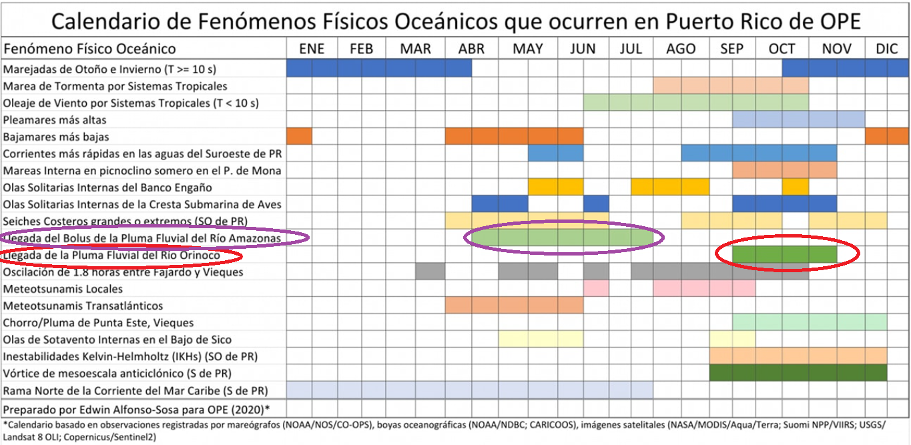Calendar of Oceanic and Coastal Processes Occurring in Puerto Rico. Source OPE.

<https://www.facebook.com/OceanPhysicsEducation/photos/a.762560633842491/3406159556149239/>).

We also receive the influence of the Saharan Dust from mid-June to October every year, this and the Orinoco River plume has the potential to increase chlorophyll-a concentrations in oceanic and coastal waters of Puerto Rico.

During 2021, we had a significant plume from Orinoco River that reached Jobos Bay early October by lowering the surface salinity and increasing chlorophyll content as published by Dr. Alfonso-Sosa (see graphs). He also presented graphs of Carbon Dioxide Concentrations (air and sea) at La Parguera, Lajas, PR, NOAA PMEL Carbon Program Station west of Jobos Bay NERR. OPE reported a significant drop or CO2 concentrations in the water used by phytoplankton as correlated to the high chlorophyll-a concentrations due to the effects of the Orinoco River plume.

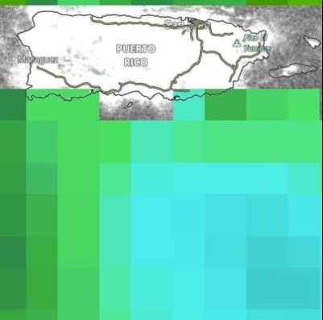

Surface Salinity influence by Orinoco River (6 OCT 2021). Source (OPE) Facebook page.

(blue=lower salinity, dark green= higher salinity) (<https://www.facebook.com/OceanPhysicsEducation/photos/pcb.4268237386608114/4268237103274809/>)

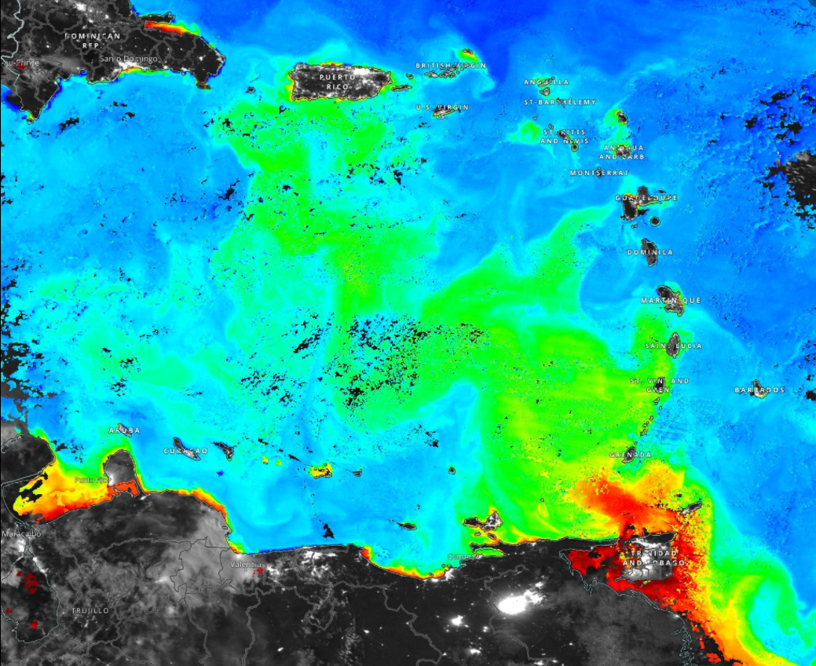

Image of Chlorophyll-a concentration over the Eastern Caribbean. 17 OCT 2021Source OPE.

(Chl-a concentration Red, Orange, Yellow, Green, Blue, high to low respectively) (<https://www.facebook.com/OceanPhysicsEducation/photos/a.762560633842491/4282238008541385/>)

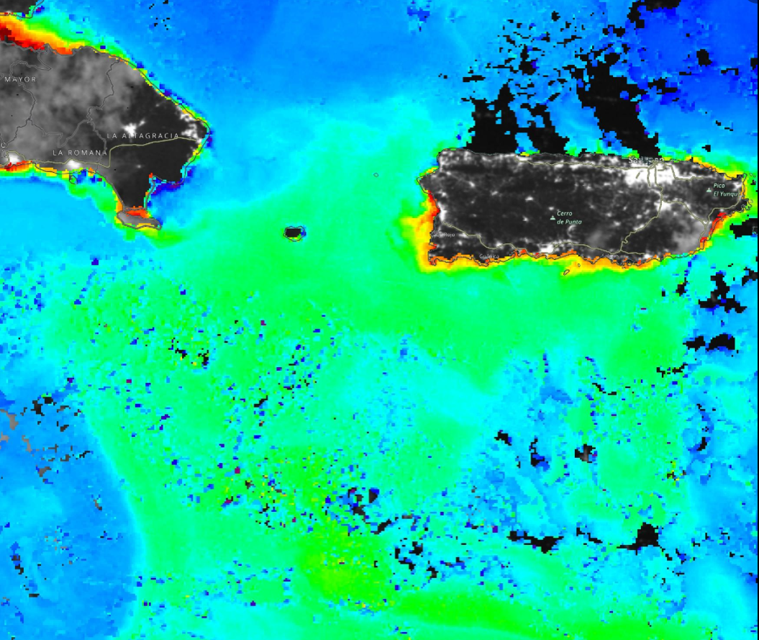

Image of Chlorophyll-a concentration over the Eastern Caribbean 24 OCT 2021. Source OPE.

(Chl-a concentration Red, Orange, Yellow, Green, Blue, high to low respectively)

(<https://www.facebook.com/OceanPhysicsEducation/photos/a.762560633842491/4301168683314984/>)

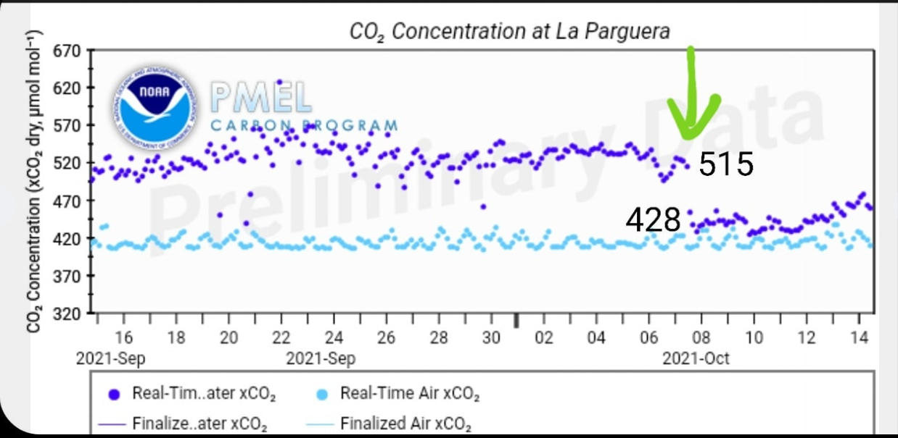Carbon Dioxide Concentrations (air and sea) at La Parguera, Lajas, PR, NOAA PMEL Carbon Program Station. OPE reported a significant drop or CO2 concentrations in the water used by phytoplankton as correlated to the high chlorophyll-a concentrations due to the effects of the Orinoco River plume. (<https://www.facebook.com/OceanPhysicsEducation/photos/pcb.4269815479783638/4269815433116976/>)