**Jobos Bay (JOB) NERR Nutrient Metadata**

**January-July 2019**

**Latest Update: September 24, 2024**

**I. Data Set and Research Descriptors**

**1) Principal investigator(s) and contact persons –**

* 1. **Reserve contact**

Jobos Bay National Estuarine Research Reserve

PO Box 159

Salinas, PR 00704-0159

Ph. 787-853-4617 Fax. 787-853-4618

Angel Dieppa, Research Coordinator

Ph. 787-853-4617, ext. 1010

Email. [adieppa.jbnerr@gmail.com](mailto:adieppa.jbnerr@gmail.com), [adieppa@drna.pr.gov](mailto:adieppa@drna.pr.gov%20)

Enid Malavé, Chemist and SWMP technician

Ph. 787-853-4617, ext. 1003

Email. [enidmalave18@gmail.com](mailto:enidmalave18@gmail.com), emalave@drna.pr.gov

* 1. **Laboratory contact (nutrient analysis)**

Annelisse Ramos, MS

Laboratory Manager

Priscila Casanova

Laboratory Analyst

Laboratorio Central Analítico

1193 Calle Guayacán Jardín Botánico Sur

San Juan, PR 00926-1118

Email: [laboratorio.central@upr.edu](mailto:laboratorio.central@upr.edu)

Ph: (787)767-9705, ext. 2134, 2187

**2) Research objectives** –

The main objective of this monitoring program is to understand the nutrients dynamics within Jobos Bay that may come from the watershed affecting the health of the estuary. Inorganic nutrients, particularly nitrogen and phosphorus are naturally found in mangrove and estuarine habitats. They can be significantly increased by human activities reaching the system through non-point source run-off or direct discharge. Eutrophication is defined as gradual accumulation of nutrients and organic biomass accompanied with an increase in photosynthesis and a decrease in the average depth of the water column caused by the accumulation of sediment.

1. **Monthly grab sampling program**

The objective of this study is to provide baseline information on inorganic nutrients and chlorophyll levels in the Jobos Bay estuary. It will also assess nutrients and chlorophyll levels in areas within the Reserve that may be receiving impact from human activities from surrounding areas or may act as a habitat gradient in the Bay. In order to compare these with physical (abiotic) water quality parameters, monitoring sites were established at the four SWMP datasonde stations.

Station number nine (9), was chosen as the impacted site, and collects water quality data in a site associated with runoff from littoral and basin mangrove areas. This lagoon has an average depth of 1.5 meters and its water regime is subject to high concentrations of tannin pigments associated with red mangroves. This station is characterized by a low water exchange due to a low circulation pattern. This sampling station is located in the most inland lagoon northeast of Mar Negro, closest to the thermoelectric power plant. It is subjected to runoff, which may include potential oil spill contamination from this industrial facility and agrochemicals from agricultural activities within the northern boundary of the reserve. Information compiled from historical environmental documents, indicate that station nine (9) was used as a disposal site for residues of the previously operating sugar mill operation, and therefore might have high organic input into the sediments. Of the four water quality monitoring stations, this has the lowest dissolved oxygen values during the year. Benthic vegetation is scarce.

Station number ten (10), located in a mangrove lagoon area towards the southwestern section of Mar Negro is considered the reference or non-impacted site. This station is characterized by a low water exchange due to a low circulation pattern. This lagoon has an average depth of 2 meters and the water regime is subject to high concentrations of tannin pigments associated with red mangroves. Benthic vegetation is scarce.

Station number nineteen (19) is located in Jobos Bay surrounded by sea grass beds composed of *Thallasia testudinum*. This station is close to the power plant navigation channel, used by barges to bring oil and gas into the power plant pier. This area is exposed to barge standings and sediment re-suspension, and oil spills are always a threat.

Station number twenty (20) is located adjacent to the Cayos Caribe reef system. Water currents coming from the reef platform may bring to this station an indication of water conditions behind the coral reef. These water currents are part of the main marine current coming from the eastern side of Jobos Bay that runs along the coast, coming in contact with sensitive areas like agricultural fields, a coal power plant, an oil refinery (Phillips Core - shut down in 2005) and other industries.

See the Site location and character section for more information on the chosen sample sites.

1. **Diel sampling program**

The diel sampling program objective is to quantify the temporal variability of important nutrients and sediment loading in the water column as a function of tidal forcing.

**3) Research methods** –

* 1. **Monthly grab sampling program**

## Monthly grab samples are taken at the four datasonde stations. Grab samples are taken on the same day, at or as near as possible to slack low-tide conditions. Efforts are made to collect samples at approximately monthly intervals. Samples are not influenced by previous storm events. Grab samples are representative of the water mass sampled by the datasonde. Because we have shallow and well-mixed water at our stations, two surface grab samples are collected that are representative of the datasonde sampling area. Replicate (N=2) sample were collected by hand at an approximate depth of 30 cm.

Grab samples are taken in duplicate (two separate samples collected in different bottles); resulting in a total of eight samples. All samples were collected in amber, NalgeneTM sample bottles that were previously acid washed (10%) rinsed (3x) with distilled-deionized water, dried and followed by rinsing (3x) with ambient water prior to collection of the sample. Samples were immediately placed on ice, in the dark and returned to the laboratory. Samples from January to July were immediately placed on ice in dark bottles for chlorophyll and clear bottles for nutrients, and sent to the Laboratorio Central Analitico at UPR for filtering and analysis.

* 1. **Diel sampling program**

Diel samples are taken at long-term datasonde station 9. Samples are collected over a full lunar cycle (24 hr:48 min) time period at 2 hours 11 minute intervals using an ISCO auto-sampler model 6712. The suction line is set to sample at 0.5 meters from the bottom, and is covered with a mesh to avoid clogging with organic debris. Efforts are made to collect samples at approximately monthly (30 days) intervals. Samples are not influenced by previous storm events; an antecedent dry period of 72 hours is desirable but may not be practical at all locations throughout the year. Sampling depth follows the following design; samples are collected at a fixed depth from the bottom, generally 0.5 meter, and reflect the water mass sampled by the datasonde. The ISCO automatically samples 1000 ml of water every 2 hrs 11 min. A field blank consisting of DI water is placed in the bottle rack and left open during the diel sampling. All samples are pumped into polyethylene sample bottles that were previously acid washed (10%), rinsed (3x) with distilled-deionized water and dried. At the end of the 24 hr period, the 12 samples are kept in the dark and returned to the laboratory for immediate processing. Samples from January to July were immediately placed on ice in the dark bottles for Chlorophyll and clear bottles for nutrients and sent to the Laboratorio Central Analitico at UPR for filtering and analysis.

**4) Site location and character –**

The Jobos Bay National Estuarine Research Reserve (JOB NERR) is located on the southern coastal plain of the island of Puerto Rico, a reserve within the West Indies geographical area. JOB NERR is composed of two major areas: (1) Mar Negro, located on the western margin of the Bay, and (2) Cayos Caribe (a chain of 17 tear-shaped islets located to the southeast) and Cayos Barca (a chain of 7 tear-shaped islets located to the southwest boundaries), both with a back-reef system. The Mar Negro area comprises the bulk of the reserve, and consists of mangrove forests and a complex system of lagoons and channels interspersed with salt and mud flats. Coral reefs and sea grass beds, with small beach deposits and upland areas fringe the Cayos Caribe and Cayos Barca mangrove islands. Few areas in the watershed drain directly to the bay. Rio Seco to the north-east of the bay is active only during heavy rain events during the wet season. A small creek, Quebrada Coqui, near JOB NERR’s pier to the north of the bay, drains into an extensive mangrove fringe forest in a laminar flow. During heavy rain events, Station 09 receives runoff water from the upland, and finally, a diffuse flow of water reaches the bay from the local aquifer.

**Station 9** is an impacted site and is located on the northeastern section of the Mar Negro component. This sampling station is associated with mangrove lagoon areas and receives runoff from mudflats, the thermoelectric power plant, and adjacent areas. The tidal range varies from 0.3 to 0.36 meters near the monitoring station. The salinity at the vicinity of the monitoring station varies from 30.9 to 37.5 psu. The average depth and total depth at station 09 is 0.72 and 1.22 meters respectively. The bottom is covered by a thick layer of thin sediments with a high content of organic material. *Microcoleus* sp. (blue-green algae), brown and green algae (*Caulerpa* sp.) are also present at this site, but a better assessment is needed. The station was located at 17°56'34.87" N and 66°14'18.64" W until 09/02/2010 12:00PM, then it was relocated to 17°56'35.0" N and 66°14'18.9" W approximately 65.0 meters from its original position. The relocation was due to sedimentation issues and the construction of a new telemetry station. Fresh water input to the station comes only from runoff and rain. This station has been the subject of several studies indicating the presence of relatively high levels of copper and pesticides compared to other stations. Since 2015 an invasive seagrass, *Halophila stipulacea* was reported at Jobos Bay, and it was after the passage of Hurricane Maria on September 21, 2017 that it was more evident and widely distributed. Although it is not present at Station 9, it is present in the channels toward the station and we expect it will colonize the area in the near future.

**Statistics for station 9 during 2019**

|  |  |  |  |  |  |  |  |  |
| --- | --- | --- | --- | --- | --- | --- | --- | --- |
|  | Temp | SpCond | Sal | DO_pct | DO_mgl | Depth | pH | Turb |
| Min | 25.0 | 47.48 | 30.9 | 1.5 | 0.1 | 0.39 | 6.9 | 0 |
| Max | 32.9 | 56.50 | 37.5 | 108.5 | 9.8 | 0.90 | 8.2 | 32 |
| Average | 29.2 | 53.29 | 35.0 | 56.1 | 3.8 | 0.66 | 7.5 | 2 |
| Std Dev | 1.4 | 1.02 | 0.7 | 18.9 | 1.4 | 0.09 | 0.2 | 1 |

**Station 10** is located in a mangrove lagoon not impacted directly by any upland or marine activities. It provides a reference for comparison of data obtained in other stations, especially to the station in Mar Negro lagoon. The tidal range varies from 0.3 to 0.36 meters. The salinity at the vicinity of the monitoring station varies from 20.7 to 36.7 psu. The average depth and total depth at station 10 is 0.66 and 1.00 meters respectively. The bottom is covered with a layer of fine sediments with organic material, followed by a layer of calcareous material mainly from shells and oysters. At this site, we can find sea grass (*Thalassia testudinum*), calcareous algae (*Halimeda* sp.), green algae (*Caulerpa* sp.) and brown algae (*Dictyota* sp.) among others. The station is located at 17°56'19.00 N, 66°15'27.85 W. Fresh water input to the station comes only from runoff and rain. There is no direct source of fresh water. Since 2015 an invasive seagrass, *Halophila stipulacea* was reported at Jobos Bay, and it was after the passage of Hurricane Maria on September 21, 2017 that it was more evident and widely distributed, and has been observed in the perimeter of the station.

**Statistics for station 10 during 2019**

|  |  |  |  |  |  |  |  |  |
| --- | --- | --- | --- | --- | --- | --- | --- | --- |
|  | Temp | SpCond | Sal | DO_pct | DO_mgl | Depth | pH | Turb |
| Min | 25.1 | 33.30 | 20.7 | 3.0 | 0.2 | 0.34 | 7.2 | 0 |
| Max | 32.9 | 55.68 | 36.7 | 101.8 | 7.7 | 0.97 | 8.0 | 17 |
| Average | 29.4 | 51.10 | 33.4 | 68.5 | 4.5 | 0.68 | 7.7 | 2 |
| Std Dev | 1.4 | 4.26 | 3.1 | 17.7 | 1.3 | 0.14 | 0.1 | 2 |

**Station 19** is located on the western inner section of the bay at a distance of 233 meters from Cayo Colchones Mangroves over sea grass beds (*Thallasia testudinum*). Tidal ranges in this area vary from 0.3 to 0.36 meters. The salinity at the vicinity of the monitoring station varies from 32.0 to 35.4 psu. The average depth and total depth at this station is 0.77 and 2.00 meters respectively. The datasonde is deployed at about 0.5 meter from the bottom. The bottom is of sandy composition, and sea grass, algae, echinoderms and other related organisms can be found in the area. The station is located at 17°56'34.49" N, 66°13'43.77" W. There is no freshwater input to this area. Since 2015 an invasive seagrass, *Halophila stipulacea* was reported at Jobos Bay, and it was after the passage of Hurricane Maria in September 21, 2017 that it was more evident and widely distributed, and has been observed in the perimeter of the station.

**Statistics for station 19 during 2019**

|  |  |  |  |  |  |  |  |  |
| --- | --- | --- | --- | --- | --- | --- | --- | --- |
|  | Temp | SpCond | Sal | DO_pct | DO_mgl | Depth | pH | Turb |
| Min | 25.3 | 49.14 | 32.0 | 56.6 | 3.5 | 0.60 | 7.7 | 0 |
| Max | 31.8 | 53.77 | 35.4 | 147.4 | 9.1 | 1.07 | 8.3 | 77 |
| Average | 28.8 | 52.32 | 34.3 | 99.1 | 6.3 | 0.84 | 8.0 | 1 |
| Std Dev | 1.4 | 0.84 | 0.6 | 14.9 | 0.9 | 0.09 | 0.1 | 2 |

**Station 20** is located in the inner eastern section at about 190 meters from the Cayos Caribe mangrove islets and at about 688 meters from the coral reef barrier. This station is the closest to Mar Caribe. It has a sandy bottom, with calcareous and coral fragments, sea grass (*Thalassia testudinum*) communities, echinoderms and other associated organisms. Tidal range in this area varies from 0.3 to 0.36 meters. The salinity at the vicinity of the monitoring station varies from 31.1 to 37.4 psu. The average depth and total depth at this station is 0.48 and 2.00 meters respectively. There is no surface freshwater input to this area. These waters are part of the main marine current coming from the eastern side of Jobos Bay that runs along the coast, getting in contact with sensitive areas like agricultural fields, a coal power plant, an oil refinery Phillips Core (shut down in 2005) and other industries.The station is located at 17°55'49.14" N, 66°12'41.30". Since 2015 an invasive seagrass, *Halophila stipulacea* was reported at Jobos Bay, and it was after the passage of Hurricane Maria in September 21, 2017 that it was more evident and widely distributed. It has been observed in the perimeter of the station.

**Statistics for station 20 during 2019**

|  |  |  |  |  |  |  |  |  |
| --- | --- | --- | --- | --- | --- | --- | --- | --- |
|  | Temp | SpCond | Sal | DO_pct | DO_mgl | Depth | pH | Turb |
| Min | 25.5 | 47.87 | 31.1 | 48.3 | 3.2 | 0.02 | 7.5 | 0 |
| Max | 31.8 | 56.35 | 37.4 | 157.2 | 10.9 | 0.84 | 9.7 | 9 |
| Average | 28.6 | 52.61 | 34.6 | 96.5 | 6.6 | 0.60 | 8.1 | 2 |
| Std Dev | 1.3 | 1.06 | 0.8 | 19.0 | 1.4 | 0.09 | 0.1 | 1 |

Nutrient data from stations 9, 10, 19 and 20 is being submitted to the CDMO. In addition, eight datasondes are permanently devoted to taking water quality readings from these four sites, to assure continuous readings while datasondes are taken out of the water for data upload and maintenance. This will avoid data gaps for the stations between datasonde maintenance procedures. Due to errors in calibration, turbidity data in these files is considered inadequate. All monitoring is considered long term.

All Jobos Bay NERR historical nutrient/pigment monitoring stations:

|  |  |  |  |  |  |  |
| --- | --- | --- | --- | --- | --- | --- |
| Station Code | SWMP Status | Station Name | Location | Active Dates | Reason Decommissioned | Notes |
| JOB09NUT | P | STATION 9 | 17° 56' 35.0" N 66° 14' 18.9" W | 07/2002 - current | NA | NA |
| JOB10NUT | P | STATION 10 | 17° 56' 19.00 N, 66° 15' 27.85 W | 07/2002 - current | NA | NA |
| JOB19NUT | P | STATION 19 | 17° 56' 34.49"N, 66° 13' 43.77"W | 07/2002 - current | NA | NA |
| JOB20NUT | P | STATION 20 | 17° 55' 49.14"N, 66° 12' 41.30"W | 07/2002 - current | NA | NA |

**5) Coded variable definitions** –

Station Code Names:

job09nut – Station 9

job10nut – Station 10

job19nut – Station 19

job20nut – Station 20

Monitoring Programs:

Monthly grab sample program (1)

Diel grab sample program (2)

**6) Data collection period** –

Sampling did not occur from August to December 2019 due to administrative issues related to laboratory contract.

**Diel:**

|  |  |  |
| --- | --- | --- |
| Site | Start Date/ Time | Stop Date/ Time |
| 9 | 01/16/2019 09:00 | 01/17/2019 09:01 |
| 9 | 02/26/2019 09:00 | 02/27/2019 09:01 |
| 9 | 03/19/2019 10:10 | 03/20/2019 10:11 |
| 9 | 04/10/2019 09:00 | 04/11/2019 09:01 |
| 9 | 05/07/2019 09:00 | 05/08/2019 09:01 |
| 9 | 07/01/2019 09:00* | 07/02/2019 09:01* |
| 9 | 07/15/2019 10:00 | 07/16/2019 10:01 |

**Grab:**

|  |  |  |  |  |  |  |
| --- | --- | --- | --- | --- | --- | --- |
| Site | Start Date/ Time | Stop Date/ Time |  | Site | Start Date/ Time | Stop Date/ Time |
| 9 | 01/17/2019 10:31 | 01/17/2019 10:33 |  | 19 | 01/17/2019 09:45 | 01/17/2019 09:46 |
| 9 | 02/27/2019 09:21 | 02/27/2019 09:22 |  | 19 | 02/27/2019 08:55 | 02/27/2019 08:56 |
| 9 | 03/20/2019 10:50 | 03/20/2019 10:51 |  | 19 | 03/20/2019 09:05 | 03/20/2019 09:06 |
| 9 | 04/11/2019 09:20 | 04/11/2019 09:21 |  | 19 | 04/11/2019 08:30 | 04/11/2019 08:31 |
| 9 | 05/08/2019 09:20 | 05/08/2019 09:21 |  | 19 | 05/08/2019 10:53 | 05/08/2019 10:54 |
| 9 | 07/02/2019 10:20* | 07/02/2019 10:21* |  | 19 | 07/02/2019 08:52* | 07/02/2019 08:53* |
| 9 | 07/16/2019 11:18 | 07/16/2019 11:19 |  | 19 | 07/16/2019 09:05 | 07/16/2019 09:06 |
| **Grab (CONT):** |  |  |  |  |  |  |
| Site | Start Date/ Time | Stop Date/ Time |  | Site | Start Date/ Time | Stop Date/ Time |
| 10 | 01/17/2019 10:10 | 01/17/2019 10:11 |  | 20 | 01/17/2019 09:25 | 01/17/2019 09:26 |
| 10 | 02/27/2019 09:50 | 02/27/2019 09:51 |  | 20 | 02/27/2019 08:33 | 02/27/2019 08:34 |
| 10 | 03/20/2019 10:15 | 03/20/2019 10:16 |  | 20 | 03/20/2019 09:35 | 03/20/2019 09:36 |
| 10 | 04/11/2019 08:55 | 04/11/2019 08:56 |  | 20 | 04/11/2019 09:57 | 04/11/2019 09:58 |
| 10 | 05/08/2019 10:16 | 05/08/2019 10:17 |  | 20 | 05/08/2019 09:00 | 05/08/2019 09:01 |
| 10 | 07/02/2019 10:00* | 07/02/2019 10:01* |  | 20 | 07/02/2019 08:33* | 07/02/2019 08:34* |
| 10 | 07/16/2019 10:07 | 07/16/2019 10:08 |  | 20 | 07/16/2019 08:35 | 07/16/2019 08:36 |

*June grab and diel samples were collected in early July due to boat failure.

**7) Associated researchers and projects–**

As part of the SWMP long-term monitoring program, JOB NERR also monitors 15-minute meteorological and water quality data which may be correlated with this nutrient/pigment dataset. These data are available at [www.nerrsdata.org](http://www.nerrsdata.org).

The JOB NERR water quality monitoring data has been incorporated into the Puerto Rico Environmental Quality Board (EQB) Integrated Report 303(d)/305(b) of the Federal Clean Water Act. This document consists of a water quality inventory and list of impaired waters and is used by the Environmental Protection Agency (EPA) to inform Congress of the progress made at the national level towards the achievement of the statutory water quality goals and purposes established by the Federal Clean Water Act.

**8) Distribution** –

NOAA retains the right to analyze, synthesize and publish summaries of the NERRS System-wide Monitoring Program data.  The NERRS retains the right to be fully credited for having collected and processed the data.  Following academic courtesy standards, the NERR site where the data were collected should be contacted and fully acknowledged in any subsequent publications in which any part of the data are used.  The data set enclosed within this package/transmission is only as good as the quality assurance and quality control procedures outlined by the enclosed metadata reporting statement.  The user bears all responsibility for its subsequent use/misuse in any further analyses or comparisons.  The Federal government does not assume liability to the Recipient or third persons, nor will the Federal government reimburse or indemnify the Recipient for its liability due to any losses resulting in any way from the use of this data.

Requested citation format:

NOAA National Estuarine Research Reserve System (NERRS). System-wide Monitoring Program. Data accessed from the NOAA NERRS Centralized Data Management Office website: [www.nerrsdata.org](http://www.nerrsdata.org); *accessed* 12 October 2020.

NERR nutrient data and metadata can be obtained from the Research Coordinator at the individual NERR site (please see Principal investigators and contact persons), from the Data Manager at the Centralized Data Management Office (please see personnel directory under the general information link on the CDMO home page) and online at the CDMO home page [www.nerrsdata.org](http://cfcdmo.baruch.sc.edu/). Data are available in comma separated version format.

**II. Physical Structure Descriptors**

**9) Entry verification** –

Nutrient data are entered into a Microsoft Excel worksheet and processed using the NutrientQAQC Excel macro. The NutrientQAQC macro sets up the data worksheet, metadata worksheets, and MDL worksheet; adds chosen parameters and facilitates data entry; allows the user to set the number of significant figures to be reported for each parameter and rounds using banker’s rounding rules; allows the user to input MDL values and then automatically flags/codes measured values below MDL and inserts the MDL; calculates parameters chosen by the user and automatically flags/codes for component values below MDL, negative calculated values, and missing data; allows the user to apply QAQC flags and codes to the data; produces summary statistics; graphs selected parameters for review; and exports the resulting data file to the CDMO for tertiary QAQC and assimilation into the CDMO’s authoritative online database.

**10) Parameter titles and variable names by category –**

Required NOAA/NERRS System-wide Monitoring Program nutrient parameters are denoted by an asterisks “*”.

Data Category Parameter Variable Name Units of Measure

Phosphorus and Nitrogen:

*Orthophosphate PO4F mg/L as P

*Ammonium, Filtered NH4F mg/L as N

*Nitrite, Filtered NO2F mg/L as N

*Nitrate, Filtered NO3F mg/L as N

*Nitrite + Nitrate, Filtered NO23F mg/L as N

Dissolved Inorganic Nitrogen DIN mg/L as N

Plant Pigments:

*Chlorophyll-a CHLA_N µg/L

Phaeophytin PHEA µg/L

Notes:

1. Time is coded based on a 2400 clock and is referenced to Standard Time.

2. Reserves have the option of measuring either NO2 and NO3 or they may substitute NO23 for individual analyses if they can show that NO2 is a minor component relative to NO3.

**11) Measured or calculated laboratory parameters** –

1. **Parameters measured directly**

Nitrogen species: NH4F, NO2F, NO23F

Phosphorus species: PO4F

Other: CHLA_N, PHEA

1. **Calculated parameters**

NO3F NO23F-NO2F

DIN NO23F+NH4F

**12) Limits of detection** –

Method Detection Limits (MDL), the lowest concentration of a parameter that an analytical procedure can reliably detect, have been established by the Laboratorio Central Analitico at UPR. The MDL is determined as 3 times the standard deviation of a minimum of 7 replicates of a single low concentration sample. These values are reviewed and revised periodically.

|  |  |  |  |  |
| --- | --- | --- | --- | --- |
| **Parameter** | **Start Date** | **End Date** | **MDL** | **Revisited** |
| PO4F | 01/01/19 | 07/31/19 | 0.015mg/L | 06/12/20 |
| NH4F | 01/01/19 | 07/31/19 | 0.010 mg/L | 06/12/20 |
| NO2F | 01/01/19 | 07/31/19 | 0.016mg/L | 06/12/20 |
| NO23F | 01/01/19 | 07/31/19 | 0.022mg/L | 06/12/20 |
| CHLA_N | 01/01/19 | 07/31/19 | 0.10 ug/L | 06/12/20 |
| PHEA | 01/01/19 | 07/31/19 | 0.10 ug/L | 06/12/20 |

**13) Laboratory methods** – all samples were held at -20ºC until analysis.

* 1. **Parameter: NH4F**

**Laboratorio Central Analitico (UPR) Method:**

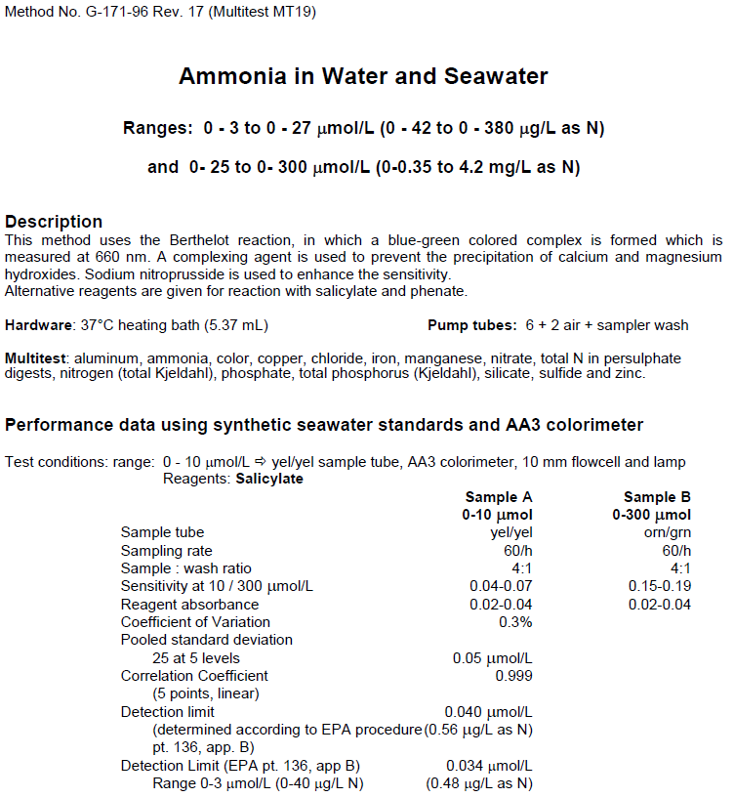

* 1. **Parameter: NO2F**

**Laboratorio Central Analitico (UPR) Method:**

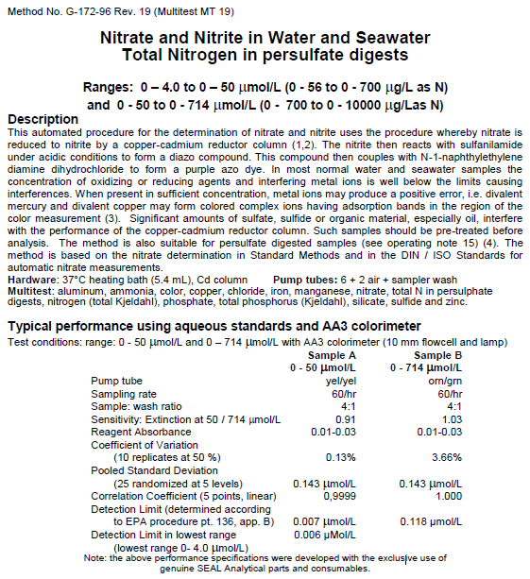

* 1. **Parameter: NO23F**

**Laboratorio Central Analitico (UPR) Method:**



* 1. **Parameter: PO4F**

**Laboratorio Central Analitico (UPR) Method:**

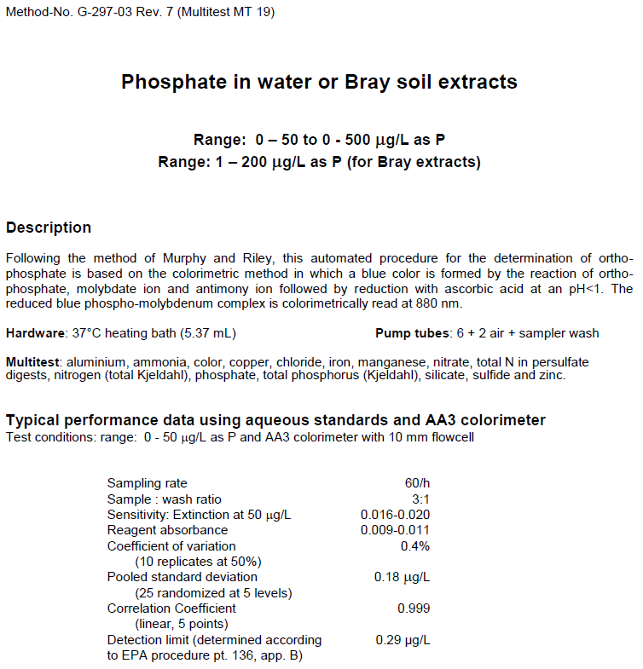

* 1. **Parameter: CHLA_N and PHA**

**Laboratorio Central Analitico Method:**

EPA or other Reference Method: EPA 445 REV 1.2

Method Reference: US.EPA 1997. USEPA 600/R-97/072. Method 445.0

Method Descriptor: Samples were filtered with a 0.47 μm membrane filter, placed dry in an amber vial and stored with ice packs. They were kept in the dark and extracted using 90% acetone.

Preservation Method: Samples are stored at 4°C up to 24 hours, followed by freezing @ -20°C.

**Summary of Method:**

The method for determining Chlorophyll-a is using fluorometry with a Turner Designs fluorometer.  The method used requires filtering a known quantity of water through a glass fiber filter.  This filter is later ground with a tissue grinder made of Teflon/glass.  Approximately 2-3 mls of 90% acetone are added to the filter before grinding.  Acetone is also used to wash the filter in to 17 x 150 test tube with tight fitting cap.  The sample is steeped at least 2 hours and not exceeding 24 hours at 4°C, in the dark.  The samples are centrifuged and read on the Turner fluorometer.  If pheaophytin measurements are desired, the sample is acidified and read again.

**14) Field and Laboratory QAQC programs** –

* 1. **Precision**
     1. **Field variability** – Two successive true replicate grab samples are collected for the monthly grab samples at each of the four stations ensuring that replicate samples are collected at the same depth. They are collected successively by hand within the same minute.
     2. **Laboratory variability** – n/a
     3. **Inter-organizational splits** –n/a
  2. **Accuracy**
     1. **Sample spikes** – n/a
     2. **Standard reference material analysis –** n/a
     3. **Cross calibration exercises** – *None.*

**15) QAQC flag definitions –**

QAQC flags provide documentation of the data and are applied to individual data points by insertion into the parameter’s associated flag column (header preceded by an F_). QAQC flags are applied to the nutrient data during secondary QAQC to indicate data that are out of sensor range low (-4), rejected due to QAQC checks (-3), missing (-2), optional and were not collected (-1), suspect (1), and that have been corrected (5). All remaining data are flagged as having passed initial QAQC checks (0) when the data are uploaded and assimilated into the CDMO ODIS as provisional plus data. The historical data flag (4) is used to indicate data that were submitted to the CDMO prior to the initiation of secondary QAQC flags and codes (and the use of the automated primary QAQC system for WQ and MET data). This flag is only present in historical data that are exported from the CDMO ODIS.

-4 Outside Low Sensor Range

-3 Data Rejected due to QAQC

-2 Missing Data

-1 Optional SWMP Supported Parameter

0 Data Passed Initial QAQC Checks

1 Suspect Data

4 Historical Data: Pre-Auto QAQC

5 Corrected Data

**16) QAQC code definitions** –

QAQC codes are used in conjunction with QAQC flags to provide further documentation of the data and are also applied by insertion into the associated flag column. There are three (3) different code categories, general, sensor, and comment. General errors document general problems with the sample or sample collection, sensor errors document common sensor or parameter specific problems, and comment codes are used to further document conditions or a problem with the data. Only one general or sensor error and one comment code can be applied to a particular data point. However, a record flag column (F_Record) in the nutrient data allows multiple comment codes to be applied to the entire data record.

General errors

GCM Calculated value could not be determined due to missing data

GCR Calculated value could not be determined due to rejected data

GDM Data missing or sample never collected

GQD Data rejected due to QA/QC checks

GQS Data suspect due to QA/QC checks

GSM See metadata

Sensor errors

SBL Value below minimum limit of method detection

SCB Calculated value could not be determined due to a below MDL component

SCC Calculation with this component resulted in a negative value

SNV Calculated value is negative

SRD Replicate values differ substantially

SUL Value above upper limit of method detection

Parameter Comments

CAB Algal bloom

CDR Sample diluted and rerun

CHB Sample held beyond specified holding time

CIP Ice present in sample vicinity

CIF Flotsam present in sample vicinity

CLE Sample collected later/earlier than scheduled

CRE Significant rain event

CSM See metadata

CUS Lab analysis from unpreserved sample

Record comments

CAB Algal bloom

CHB Sample held beyond specified holding time

CIP Ice present in sample vicinity

CIF Flotsam present in sample vicinity

CLE Sample collected later/earlier than scheduled

CRE Significant rain event

CSM See metadata

CUS Lab analysis from unpreserved sample

*Cloud cover*

CCL clear (0-10%)

CSP scattered to partly cloudy (10-50%)

CPB partly to broken (50-90%)

COC overcast (>90%)

CFY foggy

CHY hazy

CCC cloud (no percentage)

*Precipitation*

PNP none

PDR drizzle

PLR light rain

PHR heavy rain

PSQ squally

PFQ frozen precipitation (sleet/snow/freezing rain)

PSR mixed rain and snow

*Tide stage*

TSE ebb tide

TSF flood tide

TSH high tide

TSL low tide

*Wave height*

WH0 0 to <0.1 meters

WH1 0.1 to 0.3 meters

WH2 0.3 to 0.6 meters

WH3 0.6 to > 1.0 meters

WH4 1.0 to 1.3 meters

WH5 1.3 or greater meters

*Wind direction*

N from the north

NNE from the north northeast

NE from the northeast

ENE from the east northeast

E from the east

ESE from the east southeast

SE from the southeast

SSE from the south southeast

S from the south

SSW from the south southwest

SW from the southwest

WSW from the west southwest

W from the west

WNW from the west northwest

NW from the northwest

NNW from the north northwest

*Wind speed*

WS0 0 to 1 knot

WS1 > 1 to 10 knots

WS2 > 10 to 20 knots

WS3 > 20 to 30 knots

WS4 > 30 to 40 knots

WS5 > 40 knots

**17) Other remarks/notes –**

Data may be missing due to problems with sample collection or processing. Laboratories in the NERRS System submit data that are censored at a lower detection rate limit, called the Method Detection Limit or MDL. MDLs for specific parameters are listed in the Laboratory Methods and Detection Limits Section (Section II, Part 12) of this document. Concentrations that are less than this limit are censored with the use of a QAQC flag and code, and the reported value is the method detection limit itself rather than a measured value. For example, if the measured concentration of NO23F was 0.0005 mg/l as N (MDL=0.0008), the reported value would be 0.0008 and would be flagged as out of sensor range low (-4) and coded SBL. In addition, if any of the components used to calculate a variable are below the MDL, the calculated variable is removed and flagged/coded -4 SCB. If a calculated value is negative, it is rejected and all measured components are marked suspect. If additional information on MDL’s or missing, suspect, or rejected data is needed, contact the Research Coordinator at the reserve submitting the data.

Note: The way below MDL values are handled in the NERRS SWMP dataset was changed in November of 2011.  Previously, below MDL data from 2007-2010 were also flagged/coded, but either reported as the measured value or a blank cell.  Any 2007-2011 nutrient/pigment data downloaded from the CDMO prior to November of 2011 will reflect this difference.

**Sample hold times for 2019:** Samples are held at -20°C. NERRS SOP allows nutrient samples to be held for up to 28 days (CHLA for 30) at -20°C, plus allows for up to 5 days for collecting, processing, and shipping samples. Samples held beyond that time period are flagged suspect and coded CHB.

|  |  |  |  |  |  |  |
| --- | --- | --- | --- | --- | --- | --- |
|  | **Date of lab analysis** | | | | | |
| **Collection_Date** | **CHLA** | **PHEO** | **NH3** | **NOx** | **NO2** | **O-PO4** |
| 01/16/2019-  01/17/2019 | 1/30/2019 | 1/30/2019 | 4/3/2019* | 4/10/2019* | 4/4/2019* | 4/23/2019* |
| 02/26/2019-  02/27/2019 | 6/24/2019* | 6/24/2019* | 4/3/2019* | 4/10/2019* | 4/4/2019* | 4/23/2019* |
| 03/19/2019-  03/20/2019 | 6/24/2019* | 6/24/2019* | 4/3/2019 | 4/10/2019 | 4/4/2019 | 4/25/2019* |
| 04/10/2019-  04/11/2019 | NA | NA | 5/15/2019* | 5/17/2019* | 5/8/2019 | 4/25/2019 |
| 05/07/2019-  05/08/2019 | NA | NA | 5/15/2019 | 5/17/2019 | 5/20/2019 | 5/22/2019 |
| 07/01/2019-  07/02/2019 | NA | NA | 7/11/2019 | 7/11/2019 | 7/12/2019 | 7/16/2019 |
| 07/15/2019-07/16/2019 | NA | NA | 7/19/2019 | 7/22/2019 | 8/7/2019 | 8/15/2019 |

*sample held longer than allowed by NERRS protocols. NA means sample not analyzed.

**Missing data:**

From 04/10/2019 to 04/11/2019 collected samples for CHLA/PHEO Lab# A-19-0382 to

A-19-0401. The water was filtered in the laboratory on April 12, 2019, but was not analyzed.

From 05/07/2019 to 05/08/2019 collected samples for CHLA/PHEO Lab# A-19-0448 to

A-19-0467. The water was filtered in the laboratory on May 9, 2019 but was not analyzed.

From 07/01/2019 to 07/02/2019 collected samples for CHLA/PHEO Lab# A-19-0596 to

A-19-0607. The water was filtered in the laboratory on July 3, 2019 but was not analyzed.

From 07/15/2019 to 07/16/2019 collected samples for CHLA/PHEO Lab# A-19-0622 to

A-19-0641. The water was filtered in the laboratory on July 17, 2019 but was not analyzed.

07/01/2019 Diel Sample Station 09 data (5,6,7,8,9,10,11,12) from 17:44 to 22:06 and

07/02/2019 from 00:17 to 09:01. Sample empty. Flagged <-2> [GDM]

Lab# 5 at 17:44

Lab# 6 at 19:55

Lab# 7 at 22:06

Lab# 8 at 00:17

Lab# 9 at 02:26

Lab# 10 at 04:39

Lab# 11 at 06:50

Lab# 12 at 09:01

**Rain event:**

|  |  |  |
| --- | --- | --- |
| **Date** | **Precipitation (mm)** | **Event associated with** |
| 03/29/2019 | 25.4 |  |
| 04/28/2019 | 23.4 |  |
| 05/24/2019 | 42.9 |  |
| 05/27/2019 | 18.54 |  |
| 08/22/2019 | 30.5 |  |
| 09/24/2019 | 64.0 | Tropical Storm Karen |
| 09/26/2019 | 30.7 |  |
| 11/30/2019 | 51.1 |  |

**Remarks:**

Sampling did not occur from August to December 2019 due to administrative issues related to laboratory contract.

The high minimum detection limits (MDLs) provided by the UPR laboratory resulted in much of the data registering below the MDL and therefore being replaced by the MDL value itself. Users should be aware that this difference in methodology can significantly impact the dataset for the time period that UPR analyzed samples and should consider this when looking for trends or performing data syntheses.