Narragansett Bay (NAR) NERR

Meteorological Metadata

January – December 2012

Latest Update: Wednesday, December 4, 2024

I. Data Set and Research Descriptors

1) Principal Investigator(s) and Contact Persons

Address: Narragansett Bay NERR

55 South Reserve Drive

Prudence Island, RI 02872

Phone: 401-683-6780

Fax: 401-682-7366

Contact Persons:

Dr. Kenneth Raposa, Research Coordinator

E-mail: [kenneth.raposa@dem.ri.gov](mailto:kenneth.raposa@dem.ri.gov);

(401) 683-7849

Dr. Daisy Durant, Marine Research Specialist II

E-mail: daisy.durant@dem.ri.gov;

(401) 683-7368

2) Entry Verification

Data are uploaded from the CR1000 data logger to a Personal Computer (IBM compatible). Files are exported from LoggerNet in a comma-delimited format and uploaded to the CDMO where they undergo automated primary QAQC and become part of the CDMO’s online provisional database. During primary QAQC, data are flagged if they are missing or out of sensor range. The edited file is then returned to the Reserve where it is opened in Microsoft Excel and processed using the CDMO’s NERRQAQC Excel macro. The macro inserts station codes, creates metadata worksheets for flagged data and summary statistics, and graphs the data for review. It allows the user to apply QAQC flags and codes to the data, append files, and export the resulting data file to the CDMO for tertiary QAQC and assimilation into the CDMO’s authoritative online database. For more information on QAQC flags and QAQC codes, see Sections 11 and 12.

Daisy Durant, PhD (Marine Research Specialist II), was responsible for compiling and error checking the January through October 2012 weather data.

3) Research Objectives

The principal objective is to record long-term meteorological data for Narragansett Bay in order to observe any environmental changes or trends over time. These data are also used to support ongoing water quality and biological monitoring as well as scientific research.

4) Research Methods

Campbell Scientific data telemetry equipment was installed at the Potter Cove weather station on July 31, 2006 and transmits data to the NOAA GOES satellite, NESDIS ID 3B0211F8. The transmissions are scheduled hourly and contain four (4) data sets reflecting fifteen-minute data sampling intervals. Upon receipt by the CDMO, the data undergoes the same automated primary QAQC process detailed in Section 2 above. The “real-time” telemetry data become part of the provisional dataset until undergoing secondary and tertiary QAQC and assimilation in the CDMO’s authoritative online database. Provisional and authoritative data are available at [http://cdmo.baruch.sc.edu](http://cdmo.baruch.sc.edu/).

The 15-minute Data are collected in the following formats for the **CR1000**:

Averages from 5-second data:

Air Temperature (°C), Relative Humidity (%), Barometric Pressure (mb), Wind Speed (m/s), Wind Direction (degrees), Battery Voltage (volts)

Maximum and Minimum Air Temperature (oC) and their times from 5-second data (these data are available from the Reserve)

Maximum Wind Speed (m/s) and time from 5-second data

Wind Direction Standard Deviation (degrees)

Totals:

Precipitation (mm)

PAR (millimoles/m2)

Cumulative Precipitation (mm)

5) Site Location and Character

The Narragansett Bay NERR consists of approximately 4453 acres of diverse estuarine and terrestrial habitats ranging from open estuarine water to salt marshes to forested uplands. The land holdings include 65% of Prudence Island, most of nearby Patience Island, all of Hope Island off the west shore of Prudence Island, and Dyer Island located in the East Passage of Narragansett Bay. The Reserve is located close to the geographic center of Narragansett Bay in Rhode Island. The Bay has a drainage basin of 1,800 square miles.

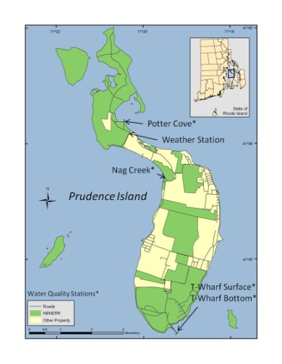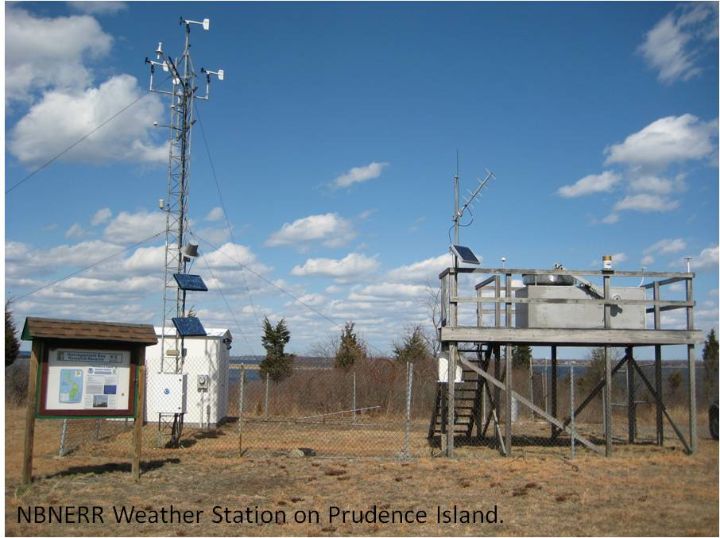The weather station is located on Prudence Island, approximately 389 m south of Potter Cove (41o 38’ 13.703” N, 71o 20’ 21.790” W, Trimble Geo XT, GeoExplorer 2008 Series), and approximately 49 m from shore. The wind monitor is located at the top of a 10 m high aluminum tower, the temperature and humidity sensor are located at approximately 2.0 m off the ground on the same aluminum tower. A large wooden platform approximately 2.4 m W x 1.8 m D x 2.1 m H has been situated at the weather station for about the past 16 years*.* It was originally constructed by the U.S. Environmental Protection Agency (EPA) to hold atmospheric deposition equipment which is no longer in use. We secured permission from the EPA to use this platform for weather station equipment. The Campbell housing unit is situated under the platform and contains the CR1000 data logger and all associated hardware (and telemetry equipment) as well as the barometric pressure unit (approximately 1.8 m off the ground). On top of the platform railing, we placed the GPS antenna, solar panel, and Yagi antenna. The PAR meter was also relocated here to make it more accessible for cleaning than the previous location (approximately 3.68 m off the ground). The rain gauge is also on the platform (3.46 m off the ground). All sensors were located in accordance with manufacturer recommendations to avoid the possible influence of shading, wind blocks, etc.

6) Data Collection Period

Meteorological data has been collected at the weather station on Potter Cove since 1992. However, it wasn’t until 2001 when the meteorological station was updated and became part of NERR-SWMP. Data were collected for the entire year for 2012 from January 01 to December 31.

| **First Reading in File** | | **Last Reading in File** | |
| --- | --- | --- | --- |
| **Date** | **Time** | **Date** | **Time** |
| 12/05/2011 | 13:00 | 01/03/2012 | 14:00 |
| 01/03/2012 | 14:15 | 01/13/2012 | 11:15 |
| 01/13/2012 | 11:30 | 02/03/2012 | 11:30 |
| 02/03/2012 | 11:45 | 03/07/2012 | 13:15 |
| 03/07/2012 | 13:30 | 04/04/2012 | 12:00 |
| 04/04/2012 | 12:15 | 04/20/2012 | 11:00 |
| 05/04/2012 | 06:45 | 05/08/2012 | 08:00 |
| 05/08/2012 | 08:15 | 05/24/2012 | 12:45 |
| 05/24/2012 | 13:00 | 05/30/2012 | 12:30 |
| 05/30/2012 | 12:45 | 06/11/2012 | 11:45 |
| 06/11/2012 | 12:00 | 07/02/2012 | 10:45 |
| 07/02/2012 | 11:00 | 08/06/2012 | 13:30 |
| 08/06/2012 | 13:45 | 08/22/2012 | 13:00 |
| 08/24/2012 | 12:45 | 08/27/2012 | 10:00 |
| 08/27/2012 | 10:45 | 09/10/2012 | 10:15 |
| 09/10/2012 | 10:45 | 10/05/2012 | 11:30 |
| 10/05/2012 | 11:45 | 11/09/2012 | 13:15 |
| 11/09/2012 | 13:30 | 12/07/2012 | 09:30 |
| 12/07/2012 | 09:45 | 01/04/2013 | 13:30 |

7) Distribution

NOAA retains the right to analyze, synthesize and publish summaries of the NERRS System-wide Monitoring Program data. The NERRS retains the right to be fully credited for having collected and process the data. Following academic courtesy standards, the NERR site where the data were collected should be contacted and fully acknowledged in any subsequent publications in which any part of the data are used. The data set enclosed within this package/transmission is only as good as the quality assurance and quality control procedures outlined by the enclosed metadata reporting statement. The user bears all responsibility for its subsequent use/misuse in any further analyses or comparisons. The Federal government does not assume liability to the Recipient or third persons, nor will the Federal government reimburse or indemnify the Recipient for its liability due to any losses resulting in any way from the use of this data.

Requested citation format:

NOAA National Estuarine Research Reserve System (NERRS). System-wide Monitoring Program. Data accessed from the NOAA NERRS Centralized Data Management Office website: <http://www.nerrsdata.org/>; *accessed* 12 October 2012.

NERR meteorological data and metadata can be obtained from the Research Coordinator at the individual NERR site (please see Principal Investigators and Contact Persons), from the Data Manager at the Centralized Data Management Office (please see personnel directory under the general information link on the CDMO home page) and online at the CDMO home page [www.nerrsdata.org](http://www.nerrsdata.org). Data are available in comma delimited format.

8) Associated Researchers and Projects

The NBNERR System-Wide Monitoring Program has a water quality monitoring station located nearby at Potter Cove. The principal objective of the SWMP program is to record long-term water quality data for Narragansett Bay in order to observe any physical changes or trends in water quality over time. Four sites were selected; one to represent an impacted site, two in open water (at both the surface and near-bottom), and one located in a salt marsh tidal creek. Potter Cove site is located on Prudence Island’s northeastern shore and is impacted by boat traffic and storm runoff from mainland urban and residential areas. Measurements are taken every 15 minutes over roughly two-week collecting periods at all water quality monitoring locations throughout the year.

A Physical Oceanographic Real-Time System (PORTS) meteorological station is housed in the NERRS weather station at Potter’s Cove and independently records air temperature, atmospheric pressure, wind speed, and wind direction. This is one of six PORTS meteorological stations in Narragansett Bay. The purpose of PORTS is to support safe and cost efficient navigation. Data are available real-time and the system is managed for quality control.

Lauren Szathmary, a Ph.D. student at Brown University, is using the long-term meteorological data to study climate change and its impacts on salt marsh plant communities on Prudence Island.

Bob Marshall of the Prudence Island Groundwater Task Force has been using the NBNERR precipitation data since 2006. These data are being used in conjunction with groundwater level and stream-flow monitoring efforts to evaluate the status of the groundwater resource on Prudence Island.

Courtney Schmidt, a Ph.D. student (and former GRF of NBNERR) at the Graduate School of Oceanography, University of Rhode Island, is using weather data from our station to examine patterns in atmospheric deposition of nitrogen.

Robin Weber, GIS/Natural Resources Specialist from the NBNERR. The Reserve has been conducting biweekly monitoring of tick populations since 2008 which, over time, may inform management of the deer population and indicate the degree of public health risk for tick borne disease. Sampling success for ticks is influenced by environmental conditions (e.g., relative humidity, air temperature) so meteorological data available from NBNERR’s weather station for is being incorporated in the data analysis each sampling date and time to remove potential sources of variation in annual abundance levels.

II. Physical Structure Descriptors

9) Sensor Specifications, Operating Range, Accuracy, Date of Last Calibration

Parameter:  **Temperature**

Units: Celsius

Sensor type: Platinum resistance temperature detector (PRT)

Operating Temperature: -40°C to +60°C

Range: -40°C to +60°C

Accuracy: ± 0.2°C at 20°C

Model #: HMP45C Temperature and Relative Humidity Probe

Serial Number: X3410026

Date of last calibration: 11/10/2011

Dates of Sensor Use: 11/28/2011 – 08/24/2012

Sensor type: PT100RTD, IEC751 1/3 Class B

Model #: HC2S3L Temperature and Relative Humidity Probe

Serial Number: 60835193

Operating Temperature: -40°C to +100°C

Range: -40°C to +60°C

Accuracy: ± 0.1°C at 23°C

Date of Last calibration: 11/16/2011

Dates of Sensor Use: 08/24/2012 – 09/12/2013

Parameter: **Relative Humidity**

Units: Percent

Sensor type: Vaisala HUMICAP© 180 capacitive relative humidity sensor

Range: 0-100% non-condensing

Accuracy: ± 2% RH (0-90%) and ± 3% (90-100%), at 20oC

Temperature dependence: ± 0.05% RH/°C

Model #: HMP45C Temperature and Relative Humidity Probe

Serial Number: X3410026

Date of last calibration: 11/10/11

Dates of Sensor Use: 11/28/2011 – 08/24/2012

Sensor type: ROTRONIC Hygromer® IN-1

Model #: HC2S3L Temperature and Relative Humidity Probe

Serial Number: 60835193

Range: 0-100%, non-condensing

Accuracy: ± 0.8% at 23oC

Temperature dependence: ± 0.05% RH/°C

Date of Last calibration: 11/16/2011

Installed on: 11/22/2011

Dates of Sensor Use: 08/24/2012 – 09/12/2013

Parameter: **Barometric Pressure**

Units: millibars (mb)

Sensor type: Vaisala Barocap © silicon capacitive pressure sensor

Model #: CS-105

Serial Number: P4910009

Operating Range: Pressure: 600 to 1060 mb; Temperature: -40°C to +60°C

Humidity: non-condensing

Accuracy: ± 0.5 mb at +20°C

± 1.5mb at 0°C to 40°C

± 2.0 mb at -20°C to +45°C

± 3.0 mb at -40°C to +60°C

Stability: ± 0.1 mb per year

Serial Number: X13220022

Date of last calibration: 02/22/2010

Dates of Sensor Use: 08/04/2010 – 08/22/2012

Serial Number: P4910009

Date of Last calibration: 08/09/2011

Dates of Sensor Use: 08/22/2012 – 07/02/2014

Parameter: **Wind Speed**

Units: meter per second (m s-1)

Sensor type: 18 cm diameter 4-blade helicoids propeller molded of

polypropylene

Model #: R.M. Young 05103 Wind Monitor

Serial Number: 83868

Range: 0-60 m s-1 (134 mph); gust survival 100 m s-1 (220 mph)

Accuracy: ± 0.3 m s-1

Date of last calibration: 08/19/2011

Dates of Sensor Use: 10/17/2011 – 07/31/2013

Parameter: **Wind Direction**

Units: degrees

Sensor type: balanced vane, 38 cm turning radius

Model #: R.M. Young 05103 Wind Monitor

Serial Number: 83868

Range: 0-360° mechanical, 355° electrical (5° open)

Accuracy: ±3°

Date of last calibration: 08/19/2011

Dates of Sensor Use: 10/17/2011 – 07/31/2013

Parameter: **Photosynthetically Active Radiation (PAR)**

LI-COR Quantum Sensor

Units: mmoles m-2 (total flux)

Sensor type: High stability silicon photovoltaic detector (blue enhanced)

Model #: LI-190SZ

Light spectrum waveband: 400 to 700 nm

Temperature dependence: 0.15% per °C maximum

Stability: ± 2% change over 1 yr.

Operating Temperature: -40°C to 65°C; Humidity: 0 to 100%

Sensitivity: Typically, 5 µA per 1000 µmoles s-1 m-2

Model #: LI-190SZ

Serial Number: Q22179

Date of last calibration: 03/01/2010

Dates of Sensor Use: 08/04/2010 – 08/22/2012

Multiplier: 1.582819445

Model #: LI190SB

Serial Number: Q31076

Light spectrum waveband: 400 to 700 nm

Temperature dependence: 0.15% per °C maximum

Stability: <± 2% change over 1 yr period

Response time: 10µs

Operating range: Temperature: -40°C to 65°C; Relative Humidity: 0 to 100%

Sensitivity: Typically, 5 µA per 1000 µmoles s-1 m-2

Multiplier: 1.488875125065510, changed on 08/22/12

Date of last calibration: 08/16/2011

Dates of Sensor Use: 08/22/2012 – 07/02/2014

Parameter: **Precipitation**

Units: millimeters (mm)

Sensor type: Tipping bucket/magnetic reed switch

Model #: TE525

Serial Number: 24701-899

Funnel collector diameter: 6.06 inches (16.4 cm)

Rainfall per tip: 0.01 inch (0.254 mm)

Operating range: Temperature: 0° to 50°C; Humidity: 0 to 100%

Accuracy: ± 1% up to 1 in/hr;

+0, -3% from 1 to 2 in/hr;

+0, -5% from 2 to3 in/hr

Date of last calibration: 08/27/2012 (in the field), previous calibration 10/07/2011

Date of Sensor use: 10/07/2011 - 08/27/2012, 08/27/2012 08/21/2013

The CR1000 has 2 MB Flash EEPROM that is used to store the Operating System. Another 128 K Flash is used to store configuration settings. A minimum of 2 MB SRAM is (4 MB optional) is available for program storage (16K), operating system use, and data storage. Additional storage is available by using a compact flash card in the optional CFM100 Compact Flash Module.

CR1000 was installed in August 2006.

CR1000 Firmware Version (s): *Version(s) and dates changed*

OS 24 uploaded on 04/04/12 current as of 12/31/2012

OS 21 uploaded on 04/06/11 to 04/04/12

CR1000 Program Version(s)

| **Program** | **Changes or notes included in the program** |
| --- | --- |
| narpcmet_V6.2_082312.CR1 | Last modified on August 23, 2012 by Daisy Durant and Jeff Adams (Campbell Sci). Added PAR Multiplier of 1.48887512506610. Added new ATRH sensor HC2S3 and comment on wiring. |
| narpcmet_V6.2_082212.CR1 | Last modified on August 22, 2012 by Daisy Durant. Added PAR Multiplier of 1.488875125065510. |
| narpcmet_V6.1_082212.CR1 | Last modified on August 04, 2010 by Daisy Durant & Jay Poucher. Added PAR Multiplier of 1.582819445. |

10) Coded Variable Definitions

Sampling station: Sampling site code: Station code:

Potter Cove PC narpcmet

11) QAQC Flag Definitions

QAQC flags provide documentation of the data and are applied to individual data points by insertion into the parameter’s associated flag column (header preceded by an *F*_). During primary automated QAQC (performed by the CDMO), -5, -4, and -2 flags are applied automatically to indicate data that is above or below sensor range, or missing. All remaining data are then flagged 0, as passing initial QAQC checks. During secondary and tertiary QAQC, 1, -3, and 5 flags may be used to note data as suspect, rejected due to QAQC, or corrected.

-5 Outside High Sensor Range

-4 Outside Low Sensor Range

-3 Data Rejected due to QAQC

-2 Missing Data

-1 Optional SWMP supported parameter

0 Passed Initial QAQC Checks

1 Suspect Data

2 *Open - reserved for later flag*

3 *Open - reserved for later flag*

4 Historical Data: Pre-Auto QAQC

5 Corrected Data

12) QAQC Code Definitions

QAQC codes are used in conjunction with QAQC flags to provide further documentation of the data and are also applied by insertion into the associated flag column. There are three (3) different code categories, general, sensor, and comment. General errors document general problems with the CR1000, sensor errors are sensor specific, and comment codes are used to further document conditions or a problem with the data. Only one general or sensor error and one comment code can be applied to a particular data point, but some comment codes (marked with an * below) can be applied to the entire record in the F_Record column.

## General Errors

GIM Instrument Malfunction

GIT Instrument Recording Error, Recovered Telemetry Data

GMC No Instrument Deployed due to Maintenance/Calibration

GMT Instrument Maintenance

GPD Power Down

GPF Power Failure / Low Battery

GPR Program Reload

GQR Data Rejected Due to QA/QC Checks

GSM See Metadata

## Sensor Errors

SDG Suspect due to sensor diagnostics

SIC Incorrect Calibration Constant, Multiplier or Offset

SIW Incorrect Wiring

SMT Sensor Maintenance

SNV Negative Value

SOC Out of Calibration

SQR Data rejected due to QAQC checks

SSN Not a Number / Unknown Value

SSM Sensor Malfunction

SSR Sensor Removed

## Comments

CAF Acceptable Calibration/Accuracy Error of Sensor

CDF Data Appear to Fit Conditions

CML Snow melt from previous snowfall event

CRE* Significant Rain Event

CSM* See Metadata

CCU Cause Unknown

CVT* Possible Vandalism/Tampering

CWE* Significant weather event

13) Other Remarks and Notes

Data are missing due to equipment or associated specific sensors not being deployed, equipment failure, time of maintenance or calibration of equipment, or repair/replacement of a sampling station platform. Any NANs in the dataset stand for “not a number” and are the result of low power, disconnected wires, or out of range readings. If additional information on missing data is needed, contact the Research Coordinator at the reserve submitting the data.

Small negative PAR values are within range of the sensor and are due to normal errors in the sensor and the CR1000 data logger. The maximum signal noise error for the LiCOR sensor is ± 2.214 mmoles m-2 over a 15-minute interval.

Relative Humidity data greater than 100 are within range of the sensor accuracy of ± 3%.

Data recorded for all parameters (with the exception of cumulative precipitation) at the midnight timestamp (00:00) are the 15-minute averages and totals for the 23:45-23:59 time period of the previous day. Cumulative precipitation data at the midnight timestamp (00:00) are the sum of raw (unrounded) precipitation data from 00:00 to 23:59 of the previous day. Summing each individual 15-minute total precipitation value from the same period will result in small differences from cumulative precipitation due to rounding. It is especially important to note how data at the midnight timestamp are recorded when using January 1st and December 31st data.

**During the NAR 2023 MET review the CDMO discovered that the wind speed multiplier had not been updated in the logger program following sensor swaps. Wind speed and maximum wind speed values were corrected from 01/01/2012 00:00 through the end of 2012. The R.M. Young 5305 model (SN 75311) has a multiplier of 0.1024 while the R.M. Young 5103 (SN 83868) has a multiplier of 0.0980. To make the corrections, data were divided by the incorrect multiplier, 0.1024, and that value was multiplied by correct multiplier, 0.0980. The data were flagged and coded 5 SIC CSM, unless rejected or missing. Corrected data are considered suspect.**

During 2017 the CDMO discovered an incorrect line in the CR1000 programming. If RHumidity>100 And RHumidity<108 Then RHumidity=100. A decision was made by the DMC during 2006 to discontinue correcting >100 RH values to 100. This change was never made in our program and has remained in each updated version until it was removed during 2017. By correcting all values >100 during data collection we may have missed erroneous values that could have indicated a problem with the RH sensor. CSM coding was added to all RH data from 2007 until the programming change in 2017.

The telemetry station was transmitting weather data intermittently during 2012. After troubleshooting with Campbell Scientific, the transmitter (TX312) was sent out for repair on July 02, 2012 and installed back on Sep 10, 2012. Data were not affected, and no flagging or coding was necessary.

The following are descriptions of different events that happened at the weather station during 2012, and explanations to the CSM (Comment-See Metadata) code used in the data file.

Elevated nighttime PAR data

We observed slightly elevated nighttime PAR throughout the year. However, no visible light in the PAR range (400 - 700 nm) before sunrise or after sunset are to be recorded at nighttime by the PAR sensor. This elevated nighttime PAR might be related, among others, to moisture trapped in the sensor, or electromagnetic noise such as ambient light pollution, electromagnetic radiation, etc.; thus, the data were flagged as suspect. These small nighttime readings could not be due to moonlight due to the resolution of the PAR sensor and datalogger. To determine sunrise and sunset times for Prudence Island, the www.sunrisesunset.com website was used to flag and coded the slightly elevated nighttime PAR as 1 CSM.

February 03 12:00 and February 21 12:15. The station was powered down to perform a test on battery voltage and get information for a new battery, respectively. As a result,

* 02/03 12:00 & 02/21 12:15 – data were rejected because it is possible this timestamp is not a full 15-minutes of averaged 5-second data. The data were flagged and coded -3 GPD CSM.

April 20 11:00 – May 05 06:45. Data was downloaded from the station then it was powered down to update the operating system to OS24 and reload the program (NARPCMET_V6.0_110411A.cr1). It seems OS24 and/or the program did not install correctly, and data was not collected during this period. To correct this issue, OS24 was installed again, and the program was reloaded. As a result,

* 04/20 11:00 - The photosynthetic active radiation (PAR) sensor platform leveling was corrected before downloading data. The PAR data point was rejected because the sensor was moved while trying to level the platform during this time. The data point was flagged and coded -3 SMT CSM.
* 04/20 11:15 – 05/04 06:30, missing data were flagged and coded -2 GIM CSM.
* 05/04 06:45 – program was uploaded. Data were rejected because it is possible this timestamp is not a full 15-minutes of averaged 5-second data. The data were flagged and coded -3 GPR CSM.

May 04 06:45 – May 05 00:00. The cumulative precipitation column (CumPrcp) showed data when the total precipitation (TotPrcp) column did not record any data. Those values may have been stored in the data logger during the time when data were missing (see above). CumPrcp data were corrected and flagged and coded 5 CSM. Even though the CumPrcp data in the file were corrected, it is still considered suspect.

May 24 12:45 – 13:00. The station was powered down to install a new battery. As a result,

* 05/24 12:45 and 13:00 – data were rejected because it is possible this timestamp is not a full 15-minutes of averaged 5-second data. The data were flagged and coded -3 GPD CSM.

July 02 11:00, August 06 13:30. The photosynthetic active radiation (PAR) sensor platform leveling was corrected before downloading data. As a result,

* These PAR data points were rejected because the sensor was moved while trying to level the platform during this time. The data points were flagged and coded -3 SMT CSM.

August 22 13:15 – August 24 12:45. The station was powered down to swap the air temperature/relative humidity sensor, barometric pressure sensor and the photosynthetic active radiation (PAR) sensor with recalibrated ones and reload the program (NARPCMET_V6.2_082212.CR1). PAR multiplier used is 1.488875125065510. However, it seems the program did not reload appropriately, and data was lost. As a result,

* 08/22 13:15 – 08/24 12:30, missing data were flagged and coded -2 GIM CSM.
* 08/24 12:45 – program was reloaded. Data were rejected because it is possible this timestamp is not a full 15-minutes of averaged 5-second data. The data were flagged and coded -3 GPR CSM.

August 27 09:45 – 08/28 00:00. Recalibrating the rain gauge. As a result,

* 08/27 09:45 – 10:00, total precipitation (TotPrcp) and cumulative precipitation (CumPrcp) data were a result of recalibrating the rain gauge, not rain. TotPrcp data were rejected and flagged and coded as -3 SMT CSM; CumPrcp data was corrected and flagged and coded 5 SMT CSM.
* 08/27 10:15 – 10:30. The station was powered down to disconnect the rain gauge from the data logger and continue the recalibration. The missing data were flagged and coded as -2 GPD CSM.
* 08/27 10:45. The weather station was powered back up after reconnecting the rain gauge to the data logger. The data were rejected because it is possible this timestamp is not a full 15-minutes of averaged 5 second data. The data were flagged and coded -3 GPD CSM. The program was not uploaded at this time.
* 08/27 11:30, 12:00. total precipitation (TotPrcp) data were a result of checking the rain gauge, not rain. TotPrcp data were rejected and flagged and coded as -3 SMT CSM.
* 08/27 11:00 – 08/28 0:00. Cumulative precipitation (CumPrcp) data were corrected to reflect actual precipitation for the day and are flagged and coded 5 SMT CSM.

August 27 11:15 – 12:15. The photosynthetic active radiation sensor did not collect data correctly.

* 08/27 11:15 – 12:00. The photosynthetic active radiation sensor did not collect data correctly and it was recorded as NAN (not a number). It was found that the wires became loose while disconnecting/connecting the rain gauge for recalibration. NAN data were flagged and coded -3 SSN CSM.
* 08/27 12:15. The weather station was powered down for about 5 minutes to fix the PAR wiring. These data were rejected because this timestamp is not a full 15-minutes of averaged 5-second data. The data were flagged and coded -3 GMT CSM. The program was not uploaded at this time; data were not affected by this.

September 10 10:30 – 11:00. The station was powered down to install the TX312 GOES transmitter. As a result,

* 09/10 10:30. The station was powered down to install the TX312 and no data were collected. Missing data were flagged and coded -2 GPD CSM.
* 09/10 10:45. The station was powered back up. Data collected were rejected because this timestamp might not be a full 15-minutes of averaged 5-second data. The data were flagged and coded -3 GMT CSM.
* 09/10 11:00. The photosynthetic active radiation sensor data point is a very low reading. Perhaps the sensor was shaded during inspection. Data point collected was rejected because this timestamp might not be a full 15-minutes of averaged 5-second data. The data point was flagged and coded -3 GMT CSM.

Calibration Certificate – Air Temperature and Relative Humidity sensor

Model HC2S3 sensor

Date calibraated – November 21, 2011

Date installed – August 24, 2012

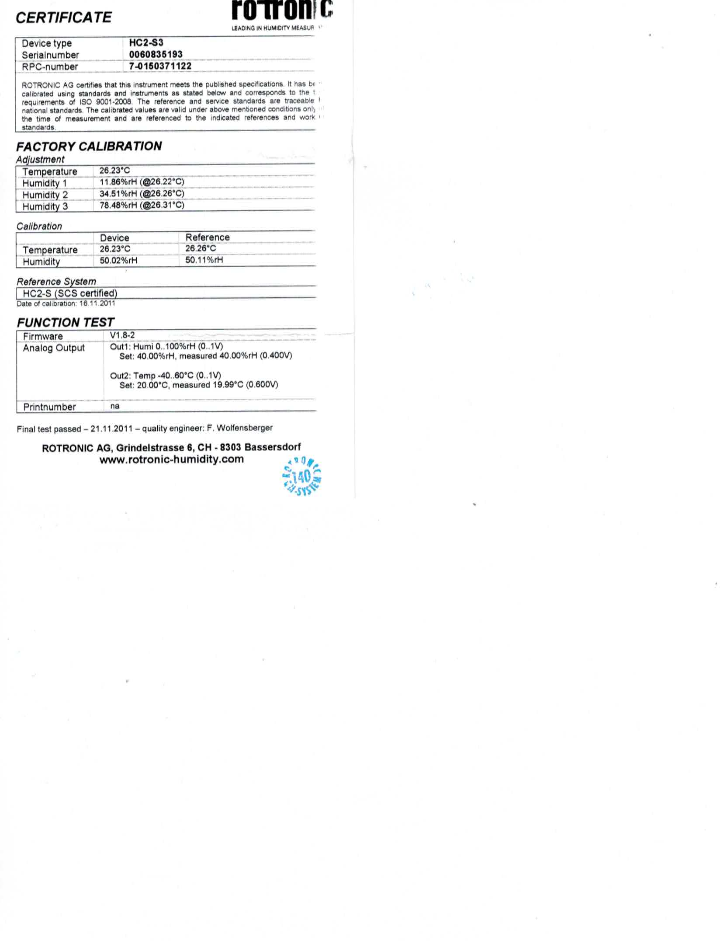

Calibration Certificate –Photosyntheic active radiation sensor

Model LI-190SB sensor

Date calibrated – August 16, 2011

Date installed – August 22, 2012

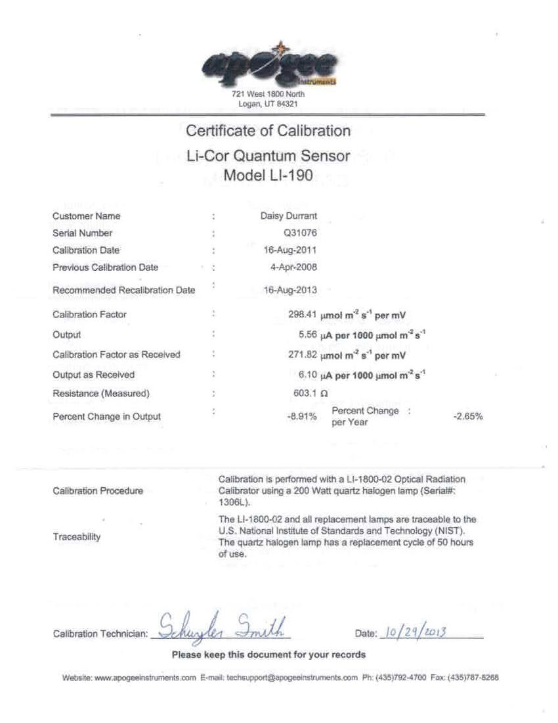

Calibration Certificate – Barometric Pressure sensor

Model CS-105 Vaisala PTB101B Barometer

Date calibrated – August 19, 2011

Date installed – August 22, 2012

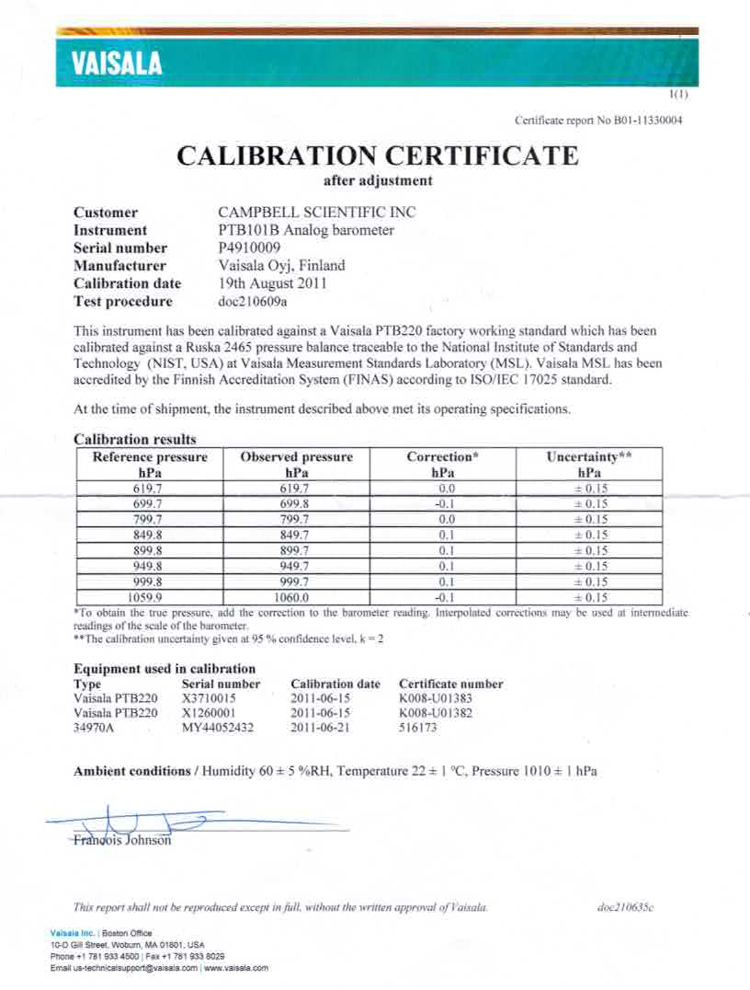

Calibration Certificate – Barometric Pressure sensor (continuation)

Model CS-105 Vaisala PTB101B Barometer

Date calibrated – August 19, 2011

Date installed – August 22, 2012

