

Narragansett Bay (NAR)

National Estuarine Research Reserve

Meteorological Metadata

January – December 2015

Latest Update: Wednesday, December 4, 2024

I. Data Set and Research Descriptors

1) Principal Investigator(s) and Contact Persons

Contact Persons:

Dr. Kenneth Raposa, Research Coordinator

E-mail: [kenny@nbnerr.org](mailto:kenny@nbnerr.org);

(401) 683-7849

Dr. Daisy Durant, Marine Research Specialist II

SWMP Coordinator and Data Manager

E-mail: [daisy@nbnerr.org](mailto:daisy@nbnerr.org);

(401) 683-7368

Address: Narragansett Bay NERR

55 South Reserve Drive

(PO Box 151)

Prudence Island, RI 02872

Phone: 401-683-6780

Fax: 401-682-7366

[www.nbnerr.org](http://www.nbnerr.org)

2) Entry Verification

Data are uploaded from the CR1000 data logger to a Personal Computer (IBM compatible). Files are exported from LoggerNet in a comma-delimited format and uploaded to the CDMO where they undergo automated primary QAQC and become part of the CDMO’s online provisional database. During primary QAQC, data are flagged if they are missing or out of sensor range. The edited file is then returned to the Reserve where it is opened in Microsoft Excel and processed using the CDMO’s NERRQAQC Excel macro. The macro inserts station codes, creates metadata worksheets for flagged data and summary statistics, and graphs the data for review. It allows the user to apply QAQC flags and codes to the data, append files, and export the resulting data file to the CDMO for tertiary QAQC and assimilation into the CDMO’s authoritative online database. For more information on QAQC flags and QAQC codes, see Sections 11 and 12.

Daisy Durant, PhD (Marine Research Specialist II), was responsible for compiling and error checking the January through December 2015 weather data.

3) Research Objectives

The principal objective is to record long-term meteorological data for Narragansett Bay in order to observe any environmental changes or trends over time. These data are also used to support ongoing water quality and biological monitoring as well as scientific research.

4) Research Methods

Campbell Scientific data telemetry equipment was installed at the Potter Cove weather station on July 31, 2006 and transmits data to the NOAA GOES satellite, NESDIS ID 3B0211F8. The transmissions are scheduled hourly and contain four (4) data sets reflecting fifteen minute data sampling intervals. Upon receipt by the CDMO, the data undergoes the same automated primary QAQC process detailed in Section 2 above. The “real-time” telemetry data become part of the provisional dataset until undergoing secondary and tertiary QAQC and assimilation in the CDMO’s authoritative online database. Provisional and authoritative data are available at [http://cdmo.baruch.sc.edu](http://cdmo.baruch.sc.edu/).

The 15 minute data are collected in the following formats for the CR1000:

Averages from 5-second data:

Air Temperature (°C), Relative Humidity (%), Barometric Pressure (mb), Wind Speed (m/s), Wind Direction (degrees), Battery Voltage (volts)

Maximum and Minimum Air Temperature (oC) and their times from 5-second data (available from the Reserve)

Maximum Wind Speed (m/s) and time from 5-second data

Wind Direction Standard Deviation (degrees)

Totals:

Precipitation (mm)

PAR (millimoles/m2)

Cumulative Precipitation (mm)

Recommended calibration frequency for the MET station sensors:

Temperature/Humidity yearly recalibration

Rain Gauge yearly recalibration

Wind Speed/Direction yearly or every 2 years (depending on the sensor)

Barometric Pressure every 2 years recalibration

PAR every 2 years recalibration

CR1000 every 5 years (required beginning 2014, one year initial grace period)

5) Site Location and Character

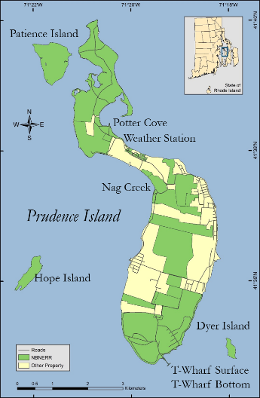The NBNERR consists of 1802 hectares (4453 acres) of diverse estuarine and terrestrial habitats ranging from deep water to salt marshes to forested uplands. The land holdings include 65% of Prudence Island, most of nearby Patience Island, and all of Hope and Dyer Islands. The Reserve is located close to the geographic center of Narragansett Bay in Rhode Island.

The Narragansett Bay watershed consists of nine subwatersheds draining an area of approximately 4,836square km [1](Pilson, 1985) and numerous and substantial freshwater inputs to the Bay. Approximately 39% of the watershed lies in Rhode Island and 61% in Massachusetts. It is referred to as a shallow estuary; however, its water depth varies considerably. Depth averages approximately 9.0 m throughout the Bay, but it’s deeper in the East Passage (approximately 15.2 m) and shallower in the West Passage (approximately 7.5 m). More information and a detailed description of the Narragansett Bay NERR and the Narragansett Bay watershed can be found in [2]Raposa and Schwartz, available at <http://nbnerr.org/research-and-monitoring/publications/>.

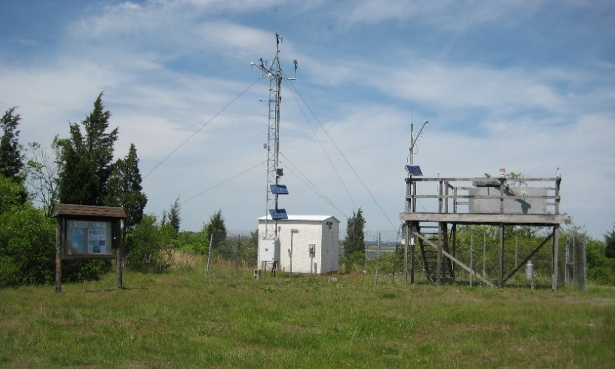The weather station is located on Prudence Island, approximately 389 m south of Potter Cove (41o 38’ 13.703” N, 71o 20’ 21.790” W, Trimble Geo XT, GeoExplorer 2008 Series). The Wind Monitor is located at the top of a 10 m high aluminum tower, the temperature and humidity sensor are located at approximately 2.0 m off the ground on the same aluminum tower. A large wooden platform approximately 2.4 m W x 1.8 m D x 2.1 m H has been situated at the weather station, approximately, since 1991. It was originally constructed by the U.S. Environmental Protection Agency (EPA) to hold atmospheric deposition equipment which is no longer in use. We secured permission from the EPA to use this platform for weather station equipment. The Campbell housing unit is situated under the platform and contains the CR1000 data logger and all associated hardware (and telemetry equipment) as well as the barometric pressure unit (approximately 1.8 m off the ground). On top of the platform railing we placed the GPS antenna, solar panel, and Yagi antenna. The PAR meter was also relocated here to make it more accessible for cleaning than the previous location on the tower. It is approximately at 3.68 m off the ground. The rain gauge is also on the platform railing at approximately 3.46 m off the ground. All sensors were located in accordance with manufacturer recommendations to avoid the possible influence of shading, wind blocks, etc.

6) Data Collection Period

Meteorological data has been collected at the weather station on Potter Cove since 1992. However, it wasn’t until 2001 when the meteorological station was updated and became part of NERR-SWMP.

Data collected during 2015 are included in files downloaded from the weather station from December 17, 2014 09:45 to December 21, 2016 11:45 (Table 1).

Table 1. Date and time of the first and last readings on data files downloaded from the CR1000 data logger at the weather station on Prudence Island.

|  |  |  |  |
| --- | --- | --- | --- |
| First Reading in File | | Last Reading in File | |
| Date | **Time** | **Date** | **Time** |
| 12/17/14 | 09:45 | 01/16/15 | 11:45 |
| 01/16/15 | 00:00 | 02/10/15 | 11:15 |
| 02/09/15 | 13:30 | 02/10/15 | 14:15 |
| 02/10/15 | 11:30 | 03/10/15 | 09:00 |
| 03/10/15 | 09:15 | 04/21/15 | 12:15 |
| 04/21/15 | 12:30 | 05/13/15 | 09:15 |
| 05/13/15 | 09:00 | 06/17/15 | 10:00 |
| 06/17/15 | 10:15 | 07/14/15 | 09:30 |
| 07/14/15 | 09:45 | 08/12/15 | 09:00 |
| 08/12/15 | 09:15 | 09/17/15 | 08:00 |
| 09/17/15 | 11:30 | 09/28/15 | 09:15 |
| 09/28/15 | 09:30 | 10/15/15 | 12:15 |
| 10/15/15 | 12:15 | 11/10/15 | 11:00 |
| 11/10/15 | 11:15 | 12/21/15 | 11:30 |
| 12/21/15 | 11:45 | 01/20/16 | 09:30 |

7) Distribution

NOAA retains the right to analyze, synthesize and publish summaries of the NERRS System-wide Monitoring Program data.  The NERRS retains the right to be fully credited for having collected and process the data.  Following academic courtesy standards, the NERR site where the data were collected should be contacted and fully acknowledged in any subsequent publications in which any part of the data are used.  The data set enclosed within this package/transmission is only as good as the quality assurance and quality control procedures outlined by the enclosed metadata reporting statement.  The user bears all responsibility for its subsequent use/misuse in any further analyses or comparisons.  The Federal government does not assume liability to the Recipient or third persons, nor will the Federal government reimburse or indemnify the Recipient for its liability due to any losses resulting in any way from the use of this data.

Requested citation format:

NOAA National Estuarine Research Reserve System (NERRS). System-wide Monitoring Program. Data accessed from the NOAA NERRS Centralized Data Management Office website: <http://www.nerrsdata.org/>; *accessed* 12 October 2012.

NERR meteorological data and metadata can be obtained from the Research Coordinator at the individual NERR site (please see Principal Investigators and Contact Persons), from the Data Manager at the Centralized Data Management Office (please see personnel directory under the general information link on the CDMO home page) and online at the CDMO home page [www.nerrsdata.org](http://www.nerrsdata.org).  Data are available in comma delimited format.

8) Associated Researchers and Projects

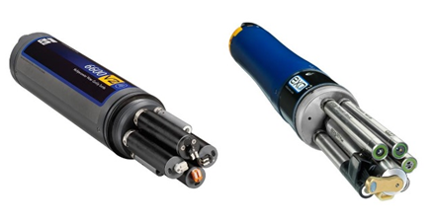The NBNERR System-Wide Monitoring Program (SWMP) has four water quality monitoring station around Prudence Island. The principal objective of the SWMP program is to record short-term variability and long-term changes in water quality data in order to observe trends or patterns in water quality over time. Water quality parameters have been collected since 1995 with the establishment of the first water quality monitoring station at Potter Cove. Other three water quality stations (Nag Creek, T-Wharf Surface and T-Wharf Bottom) were brought online in 2002. These stations were selected to represent a gradient in habitat types that range from salt marsh (Nag Creek station) to shallow cove (Potter Cove) to open Bay water (T-Wharf Surface and T-Wharf Bottom). Water temperature, specific conductivity, salinity, dissolved oxygen (% saturation, and mg L-1), pH, turbidity, and chlorophyll fluorescence data are collected at each station every 15 minutes using YSI 6600 V2 and EXO2 data loggers (see image at right) that are calibrated and swapped out at each station approximately every two to four weeks.

YSI 6600 V2 (left) and EXO2 (right) data logger used to collect water quality data at the Reserve (pictures from YSI.com).

Complementary to the existing long-term water quality monitoring program, the NERRS implemented a nutrient and chlorophyll monitoring program in 2002. The two sub-components of this program include monthly grab sampling at each of the four water quality stations, and diel sampling once a month at one site. The grab sampling program requires the collection of duplicate water samples every month from each of the four long-term water quality monitoring stations with the purpose of quantify seasonal patterns of nutrient and chlorophyll concentrations in different estuarine habitats (marsh creek, cove, surface open water, bottom open water).. The diel sampling program requires to collect a series of samples from one station over an approximately 24-hour period each month to examine how nutrient and chlorophyll concentrations change over diel and tidal cycles. Previously (from 2002 to 2010) the diel station was located at T-Wharf. However, after analyzing the historic data from the site, no significant trends or patterns were found over time. Therefore, the diel station was moved to Potter Cove in January of 2011 in order to characterize nutrients and chlorophyll from this site. All collected grab and diel samples are analyzed for concentrations of phosphates (PO4), ammonia (NH4), nitrite (NO2), nitrate (NO3), NO2+NO3, dissolved inorganic nitrogen (DIN), silicates (SiO4) and chlorophyll *a*.

Meteorological data collected at the NBNERR since 2001 is continuously used to support the aforementioned water quality and nutrient monitoring in addition to biological monitoring efforts at the Reserve, to assist scientific research and monitoring projects, and stewardship, training, and educational activities around Narragansett Bay.

A Physical Oceanographic Real-Time System (PORTS) meteorological station is housed in the NERRS weather station at Potter’s Cove and independently records air temperature, atmospheric pressure, wind speed, and wind direction. This is one of six PORTS meteorological stations in Narragansett Bay; data available at <http://tidesandcurrents.noaa.gov/ports/index.html?port=nb>. The purpose of PORTS is to support safe and cost efficient navigation. Data are available real-time and the system is managed for quality control.

Bob Marshall of the Prudence Island Groundwater Task Force has been using the NBNERR precipitation data since 2006. These data are being used in conjunction with groundwater level and stream-flow monitoring efforts to evaluate the status of the groundwater resource on Prudence Island.

Robin Weber, GIS/Natural Resources Specialist from the NBNERR has been conducting biweekly monitoring of tick populations since 2008 during the warmer months which, over time, may inform management of the deer population and indicate the degree of public health risk for tick borne disease. Sampling success for ticks is influenced by environmental conditions (e.g., relative humidity, air temperature) so meteorological data available from NBNERR’s weather station for is being incorporated in the data analysis each sampling date and time to remove potential sources of variation in annual abundance levels.

II. Physical Structure Descriptors

9) Sensor Specifications, Operating Range, Accuracy, Date of Last Calibration

Parameter: **Temperature**

Units: Celsius

Sensor type: Platinum resistance temperature detector (PRT)

Operating Temperature: -40°C to +60°C

Range: -40°C to +60°C

Accuracy: ± 0.2°C at 20°C

*Model #:*  *HC2S3 Temperature and Relative Humidity Probe*

Serial Number: 60835193

Date of calibration: 02/12/14

Dates of sensor use: 08/12/14 to 09/17/15

Serial Number: 61180509

Date of calibration: 03/17/15

Dates of sensor use: 09/17/15 current as of 05/10/16

Parameter: **Relative Humidity**

Units: Percent

Sensor type: Vaisala HUMICAP© 180 capacitive relative humidity sensor

Range: 0-100% non-condensing

Accuracy: ± 2% RH (0-90%) and ± 3% (90-100%), at 20oC

Temperature dependence: ± 0.05% RH/°C

*Model #:*  *HC2S3 Temperature and Relative Humidity Probe*

Serial Number: 60835193

Date of calibration: 02/12/14

Dates of sensor use: 08/12/14 to 09/17/15

Serial Number: 61180509

Date of calibration: 03/17/15

Dates of sensor use: 09/17/15 current as of 05/10/16

Parameter: **Barometric Pressure**

Units: millibars (mb)

Sensor type: Vaisala Barocap © silicon capacitive pressure sensor

Operating Range: Pressure: 600 to 1060 mb; Temperature: -40°C to +60°C

Humidity: non-condensing

Accuracy: ± 0.5 mb at +20°C, ± 1.5mb at 0°C to 40°C, ± 2.0 mb at -20°C to +45°C,

± 3.0 mb at -40°C to +60°C

Stability: ± 0.1 mb per year

*Model #:*  *CS-105*

Serial Number: P4910009

Date of calibration: 08/09/2011

Dates of sensor use: 08/22/2012 to 07/02/2014

Serial Number: X132022

Date of calibration: 02/21/14

Dates of sensor use: 07/02/14 current as of 05/10/16

Parameter: **Wind Speed**

Units: meter per second (m s-1)

Model # R.M. Young 5305 L - AQ

Sensor type: 20 cm diameter 4-blade helicoid propeller carbon fiber thermoplastic

Range: 0-50 m/s (112 mph)

Accuracy: ±0.2 m/s (0.4 mph)

or

Model # R.M. Young 5103 - 5 Wind Monitor

Sensor type: 18 cm diameter 4-blade helicoids propeller molded of polypropylene

Range: 0-60 m s-1 (0-134 mph); gust survival 100 m s-1 (220 mph)

Accuracy: ± 0.3 m s-1 (± 0.6 mph)

*Model #:*  *R.M. Young 05305 L-AQ Wind Monitor*

Serial Number: 75311

Date of calibration: 01/28/13

Dates of sensor use: 07/31/13 to 09/17/15

*Model #:*  *R.M. Young 05103-5 Wind Monitor*

Serial Number: 83868

Date of calibration: 03/18/15

Dates of sensor use: 09/17/15 current as of 05/10/16

Parameter: **Wind Direction**

Units: degrees

Model # R.M. Young 5305 L – AQ

Sensor type: balanced vane, 48.3 cm turning radius

Range: 0-360° mechanical, 355° electrical (5° open)

Accuracy: ±3°

or

Model # R.M. Young 5103 -5 Wind Monitor

Sensor type: balanced vane, 38 cm turning radius

Range: 0-360° mechanical, 355° electrical (5° open)

Accuracy: ±3°

*Model #:*  *R.M. Young 05305 L-AQ Wind Monitor*

Serial Number: 75311

Date of calibration: 01/28/13

Dates of sensor use: 07/31/13 to 09/17/15

*Model #:*  *R.M. Young 05103-5 Wind Monitor*

Serial Number: 83868

Date of calibration: 03/18/15

Dates of sensor use: 09/17/15 current as of 05/10/16

Parameter: **Photosynthetic Active Radiation**

Units: mmoles m-2 (total flux)

Sensor type: High stability silicon photovoltaic detector (blue enhanced)

Light spectrum waveband: 400 to 700 nm

Temperature dependence: 0.15% per °C maximum

Stability: <± 2% change over 1 yr period

Response time: 10µs

Operating range: Temperature: -40°C to 65°C; Relative Humidity: 0 to 100%

Sensitivity: typically 5 µA per 1000 µmoles s-1 m-2

*Model #:*  *LI190SB*

Serial Number: Q31076

Multiplier: 1.488875125065510, changed on 08/22/12

Date of calibration: 08/16/2011

Dates of sensor use: 08/22/2012 to 07/02/14

Serial Number: Q22179

Multiplier: 1.635997172996880, changed on 07/02/14

Date of calibration: 02/14/14

Dates of sensor use: 07/02/2014 current as of 05/10/16

Parameter: **Precipitation**

Units: millimeters (mm)

Sensor type: Tipping bucket/magnetic reed switch

Funnel collector diameter: 6.06 inches (16.4 cm)

Rainfall per tip: 0.01 inch (0.254 mm)

Operating range: Temperature: 0° to 50°C; Humidity: 0 to 100%

Accuracy: ± 1% up to 1 in/hr; +0, -3% from 1 to 2 in/hr; +0, -5% from 2 to3 in/hr

*Model #:*  *TE525*

Serial Number: 24701-899

Date of calibration: 03/05/14

Dates of sensor use: 07/02/14 to 09/17/15

*Model #:*  *TR525I-R3*

Serial Number: 31194-902

Date of calibration: 03/19/15

Dates of sensor use: 09/17/15 current as of 05/10/16

The CR1000 has 2 MB Flash EEPROM that is used to store the Operating System. Another 128 K Flash is used to store configuration settings. A minimum of 2 MB SRAM is (4 MB optional) is available for program storage (16K), operating system use, and data storage. Additional storage is available by using a compact flash card in the optional CFM100 Compact Flash Module.

**CR1000 Serial Number 5245**

**Date of Manufacture: 2006**

**Date Installed: August 01, 2006**

**Date Calibrated: October 13, 2014**

**CR1000 Firmware Version (s):** OS27 uploaded on 06/09/14 current as of 09/08/16.

**CR1000 Program Version(s):**

| Program | Changes or notes included in the program |
| --- | --- |
| NARPCMET_7.0_091815 | Last modified on September 18, 2015 by Daisy Durant. No major changes to the program, just added a note regarding the new cable installed on the rain bucket. |
| NARPCMET_7.0_112414 | Last modified on November 24, 2014 by Daisy Durant. No major changes to the program, just added a note regarding the calibration of the CR1000. |
| NARPCMET_7.0_070214 | Last modified on July 02, 2014 by Daisy Durant to include the specs of a new ATRH bought and installed in August. |
| NARPCMET_6.4_091213 | Last modified on Sep 12 2013 by Daisy Durant. Installed HMP45C SN 1294801 (same as X3410026) Temperature & Relative Humidity Sensor. Needed changes in the program because this sensor was initially 7-wire but was switched to 6 at Campbell Scientific. |
| NARPCMET_6.4_082113 | Last modified on August 21 2013 by Daisy Durant. Added the details of a different rain gauge to the program. |
| NARPCMET_6.3_073113 | Last modified on July 31, 2013 by Daisy Durant. Uploaded new version of the program that includes models, serial numbers, frequency of calibration, and wiring of all sensors currently being used at this station. |
| NARPCMET_V6.2_082312 | Last modified on August 23, 2012 by Daisy Durant and Jeff Adams (Campbell Sci). Added PAR Multiplier of 1.48887512506610. Added new AT/RH sensor HC2S3 and comment on wiring. |
| NARPCMET_V6.2_082212 | Last modified on August 22, 2012 by Daisy Durant. Added PAR Multiplier of 1.488875125065510. |
| NARPCMET_V6.1_082212 | Last modified on August 04, 2010 by Daisy Durant & Jay Poucher. Added PAR Multiplier of 1.582819445. |

10) Coded Variable Definitions

Sampling station: Sampling site code: Station code:

Potter Cove PC narpcmet

11) QAQC Flag Definitions

QAQC flags provide documentation of the data and are applied to individual data points by insertion into the parameter’s associated flag column (header preceded by an *F*_). During primary automated QAQC (performed by the CDMO), -5, -4, and -2 flags are applied automatically to indicate data that is above or below sensor range, or missing. All remaining data are then flagged 0, as passing initial QAQC checks. During secondary and tertiary QAQC, 1, -3, and 5 flags may be used to note data as suspect, rejected due to QAQC, or corrected.

-5 Outside High Sensor Range

-4 Outside Low Sensor Range

-3 Data Rejected due to QAQC

-2 Missing Data

-1 Optional SWMP supported parameter

0 Passed Initial QAQC Checks

1 Suspect Data

2 *Open - reserved for later flag*

3 *Open - reserved for later flag*

4 Historical Data: Pre-Auto QAQC

5 Corrected Data

12) QAQC Code Definitions

QAQC codes are used in conjunction with QAQC flags to provide further documentation of the data and are also applied by insertion into the associated flag column. There are three (3) different code categories, general, sensor, and comment. General errors document general problems with the CR1000, sensor errors are sensor specific, and comment codes are used to further document conditions or a problem with the data. Only one general or sensor error and one comment code can be applied to a particular data point, but some comment codes (marked with an * below) can be applied to the entire record in the F_Record column.

## General Errors

GIM Instrument Malfunction

GIT Instrument Recording Error, Recovered Telemetry Data

GMC No Instrument Deployed due to Maintenance/Calibration

GMT Instrument Maintenance

GPD Power Down

GPF Power Failure / Low Battery

GPR Program Reload

GQR Data Rejected Due to QA/QC Checks

GSM See Metadata

## Sensor Errors

SDG Suspect due to sensor diagnostics

SIC Incorrect Calibration Constant, Multiplier or Offset

SIW Incorrect Wiring

SMT Sensor Maintenance

SNV Negative Value

SOC Out of Calibration

SQR Data rejected due to QAQC checks

SSD Sensor Drift

SSN Not a Number / Unknown Value

SSM Sensor Malfunction

SSR Sensor Removed

## Comments

CAF Acceptable Calibration/Accuracy Error of Sensor

CDF Data Appear to Fit Conditions

CML Snow melt from previous snowfall event

CRE* Significant Rain Event

CSM* See Metadata

CCU Cause Unknown

CVT* Possible Vandalism/Tampering

CWE* Significant weather event

13) Other Remarks and Notes

Data are missing due to equipment or associated specific sensors not being deployed, equipment failure, time of maintenance or calibration of equipment, or repair/replacement of a sampling station platform. Any NANs in the dataset stand for “not a number” and are the result of low power, disconnected wires, or out of range readings. If additional information on missing data is needed, contact the Research Coordinator at the reserve submitting the data.

Relative Humidity data greater than 100 are within range of the sensor accuracy of ± 3%.

Data recorded for all parameters (with the exception of cumulative precipitation) at the midnight timestamp (00:00) are the 15 minute averages and totals for the 23:45-23:59 time period of the previous day. Cumulative precipitation data at the midnight timestamp (00:00) are the sum of raw (unrounded) precipitation data from 00:00 to 23:59 of the previous day. Summing each individual 15-minute total precipitation value from the same period will result in small differences from cumulative precipitation due to rounding. It is especially important to note how data at the midnight timestamp are recorded when using January 1st and December 31st data. Note: Cumulative precipitation is no longer available via export from the CDMO. Please contact the Reserve or the CDMO for more information or to obtain these data.

Small negative PAR values are within range of the sensor and are due to normal errors in the sensor and the CR1000 data logger. The maximum signal noise error for the LiCOR sensor is ± 2.214 mmoles m-2 over a 15 minute interval.

**During the NAR 2023 MET review the CDMO discovered that the wind speed multiplier had not been updated in the logger program following sensor swaps. Wind speed and maximum wind speed values were corrected from 09/17/2015 11:45 through the end of 2015. The R.M. Young 5305 model (SN 75311) has a multiplier of 0.1024 while the R.M. Young 5103 (SN 83868) has a multiplier of 0.0980. To make the corrections, data were divided by the incorrect multiplier, 0.1024, and that value was multiplied by correct multiplier, 0.0980. The data were flagged and coded 5 SIC CSM, unless rejected or missing. Corrected data are considered suspect.**

**During 2017 the CDMO discovered an incorrect line in the CR1000 programming.  If RHumidity>100 And RHumidity<108 Then RHumidity=100.  A decision was made by the DMC during 2006 to discontinue correcting >100 RH values to 100. This change was never made in our program and has remained in each updated version until it was removed during 2017.  By correcting all values >100 during data collection we may have missed erroneous values that could have indicated a problem with the RH sensor.  CSM coding was added to all RH data from 2007 until the programming change in 2017.**

F_Record column

CWE refers to weather events observed at the Reserve and officially recorded by NOAA National Center for Environmental Information (NCEI) on their Storm Event Database available at https://www.ncdc.noaa.gov/stormevents/choosedates.jsp?statefips=44,RHODE%20ISLAND.

Sensor Swap/Program Reload

The Air temperature/RH, wind, and precipitation gauge were swapped on Sept 17. The sensor swap was followed by a program reload that reset the CR1000 and resulted in missing 5-second data for the 11:30 reading. Data are missing from 08:15-11:15 due to the station being powered down and rejected at 11:30.

Elevated nighttime PAR data

We observed slightly elevated nighttime PAR throughout the year. However, no visible light in the PAR range (400 - 700 nm) before sunrise or after sunset are to be recorded at nighttime by the PAR sensor. This elevated nighttime PAR might be related, among others, to moisture trapped in the sensor, or electromagnetic noise such as ambient light pollution, electromagnetic radiation, etc.; thus, the data were flagged as suspect. These small nighttime readings could not be due to moonlight due to the resolution of the PAR sensor and data logger. To determine sunrise and sunset times for Prudence Island, the www.sunrisesunset.com website was used to flag and coded the data accordingly.

Precipitation Data

Sept 17 to 29: During this period, the precipitation gauge was not recording data because the cable connecting to the data logger was sent for repair. However, it recorded zeros because the gauge was not turned off in the program. All precipitation data, both total and cumulative, were rejected from Sept 17 11:45 - Sept 19 09:15. Nevertheless, there was no precipitation during this period according to our observations at the Reserve and to the NOAA Record of Climatological Observations from the TF Green weather station which is approximately 12 km to the North-northwest of our weather station. Precipitation data from was obtained from the TF Green Airport weather station found at <https://www.ncdc.noaa.gov/cdo-web/datasets/GHCND/stations/GHCND:USW00014765/detail>, or see the table below.

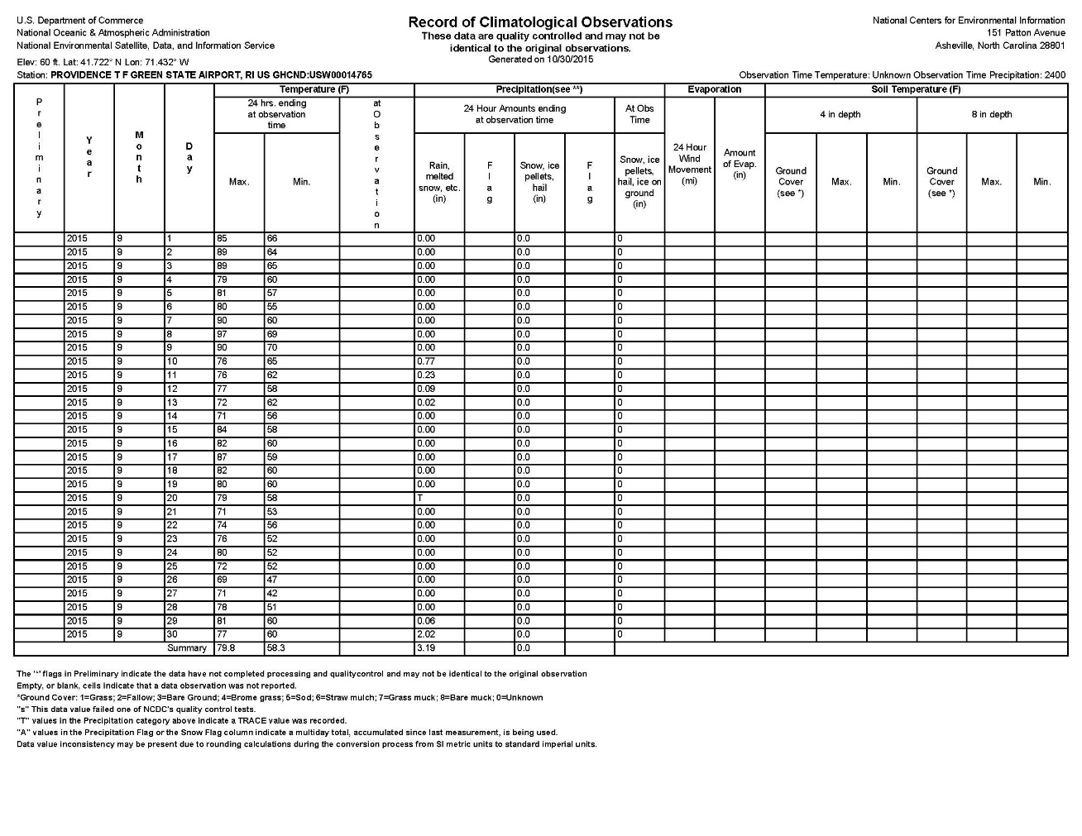

Calibration Certificates of Instruments Serviced and/or Recalibrated and Installed at the Narragansett Bay NERR Weather Station during 2015.

Air Temperature & Relative Humidity

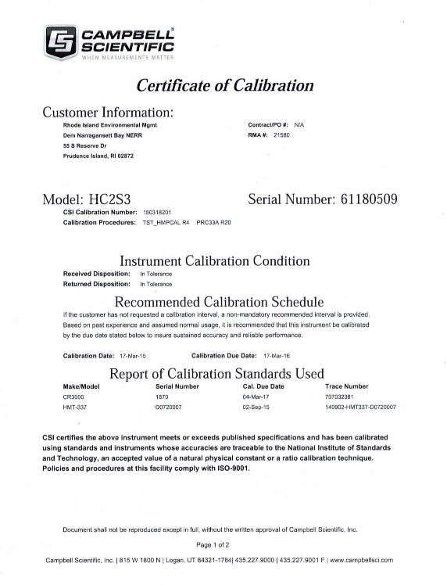 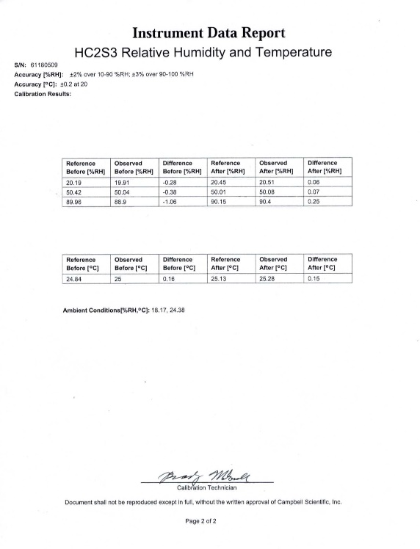

Wind meter Rain Gauge

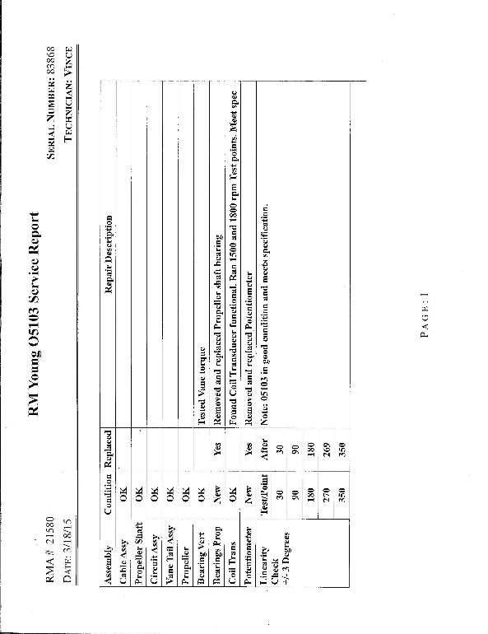 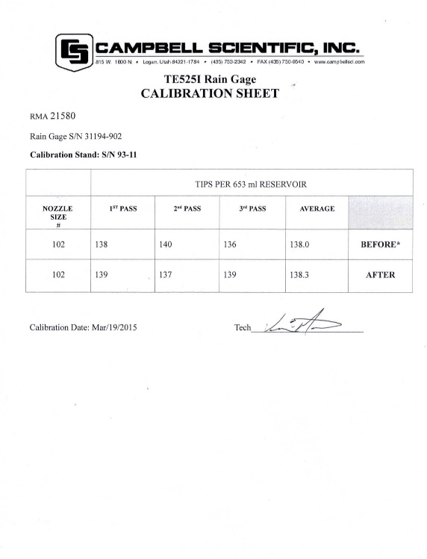

1. Pilson, M.E.Q. 1985. On the residence time of water in Narragansett Bay. *Estuaries* 8:2–14.
2. Narragansett Bay National Estuarine Research Reserve. 2007. An Ecological Profile of the Narragansett Bay National Estuarine Research Reserve. K.B. Raposa and M.L. Schwartz (eds.), *Rhode Island Sea Grant, Narragansett, R.I*. 176pp.