

Narragansett Bay (NAR) NERR

Meteorological Metadata

January – December 2018

Latest Update: Wednesday, December 4, 2024

# I. Data Set and Research Descriptors

## Principal Investigator(s) and Contact Persons

Contact Persons:

Dr. Kenneth Raposa

Research Coordinator

E-mail: [kenneth.raposa@dem.ri.gov](mailto:kenneth.raposa@dem.ri.gov);

(401) 683-7849

Dr. Daisy Durant

Marine Research Specialist II

SWMP Coordinator and Data Manager

E-mail: daisy.durant@dem.ri.gov;

(401) 683-7368

Address: Narragansett Bay NERR

55 South Reserve Drive

(PO Box 151)

Prudence Island, RI 02872

Phone: 401-683-6780

Fax: 401-682-7366

## Entry Verification

Data are uploaded from the CR1000/CR1000X data logger to a Personal Computer (IBM compatible). Files are exported from LoggerNet in a comma-delimited format and uploaded to the CDMO where they undergo automated primary QAQC and become part of the CDMO’s online provisional database. During primary QAQC, data are flagged if they are missing or out of sensor range. The edited file is then returned to the Reserve where it is opened in Microsoft Excel and processed using the CDMO’s NERRQAQC Excel macro. The macro inserts station codes, creates metadata worksheets for flagged data and summary statistics, and graphs the data for review. It allows the user to apply QAQC flags and codes to the data, append files, and export the resulting data file to the CDMO for tertiary QAQC and assimilation into the CDMO’s authoritative online database. For more information on QAQC flags and QAQC codes, see Sections 11 and 12.

Daisy Durant, PhD (Marine Research Specialist II), was responsible for compiling and error checking the January through December 2018 weather data covered in this document.

## Research Objectives

The principal objective is to record long-term meteorological data for Narragansett Bay in order to observe any environmental changes or trends over time. These data are also used to support ongoing water quality and biological monitoring, scientific research, as well as stewardship, training and education activities.

## Research Methods

The Campbell Scientific CR1000 data logger collects data every 5 seconds to produce 15-minute averages of those measurements of air temperature, relative humidity, barometric pressure, wind speed and wind direction; the data logger collects totals for precipitation and photosynthetic active radiation, not averages. The CR1000 program directs how and when the sensors measure and store data. All data are collected in Eastern Standard Time (UTC -%) and stored in the CR1000 data logger. Monthly trips to the weather station are done to inspect, clean and maintain all sensors and all other weather station related equipment. During these monthly trips, data are downloaded from the data logger via a RS-232 connection serial cable to a laptop using the Campbell Scientific LoggerNet (v 3.4.1) program. The data logger is housed in a Campbell Scientific weather resistant enclosure. A satellite transmitter (TX312), a 12 V sealed rechargeable battery, a regulator (CH-100, which provides built-in temperature compensation to optimize battery performance), and a barometric pressure sensor (vented to the outside of the enclosure) are housed in the enclosure as well.

In July 31st, 2006, the Campbell Scientific data telemetry equipment was installed at the Potter Cove weather station which allowed the transmission of data to the NOAA GOES satellite, NESDIS ID 3B0211F8. The transmissions are scheduled hourly and contain four (4) data sets reflecting fifteen-minute data sampling intervals. Upon receipt by the CDMO, the data undergoes the same automated primary QAQC process detailed in Section 2 above. The “real-time” telemetry data become part of the provisional dataset until undergoing secondary and tertiary QAQC and assimilation in the CDMO’s authoritative online database. Provisional and authoritative data are available at [http://cdmo.baruch.sc.edu](http://cdmo.baruch.sc.edu/).

The 15-minute data are collected in the following formats for the CR1000:

Averages from 5-second data:

Air Temperature (°C), Relative Humidity (%), Barometric Pressure (mb), Wind Speed (m/s), Wind Direction (degrees), and Battery Voltage (volts).

Maximum and Minimum Air Temperature (oC) and their times from 5-second data (these data are available from the Reserve).

Maximum Wind Speed (m/s) and time from 5-second data.

Wind Direction Standard Deviation (degrees).

Totals:

* Precipitation (mm)
* PAR (millimoles/m2)
* Cumulative Precipitation (mm) (Cumulative precipitation is no longer available via export from the CDMO. Please contact the Reserve or the CDMO for more information or to obtain these data.)

The recommended calibration frequency for the MET station sensors according to manufacturer are:

Temperature/Humidity yearly recalibration

Rain Gauge yearly recalibration

Wind Speed/Direction yearly or every 2 years (depending on the sensor)

Barometric Pressure every 2 years recalibration

PAR every 2 years recalibration

CR1000 every 5 years (required beginning 2014, one-year initial grace period)

Ground-truthing is conducted during the monthly trips, and data on air temperature, relative humidity, barometric pressure, and wind speed are collected with a Kestrel 4000 weather meter; wind direction is determined with a handheld compass; and photosynthetic active radiation is measured with a LiCor 1400 equipped with a LI-190SB quantum sensor; total precipitation is checked from the T.F. Green Airport NOAA weather station in Providence, RI; weather data collected from the airport is available online at https://w2.weather.gov/climate/index.php?wfo=box. These ground-truthing data are used to compare with the data collected by the weather station on Prudence Island and ensure accuracy of the readings. Ground-truthing data are recorded on the meteorological monthly log, kept at the Reserve and at CDMO, and available upon request.

## Site Location and Character

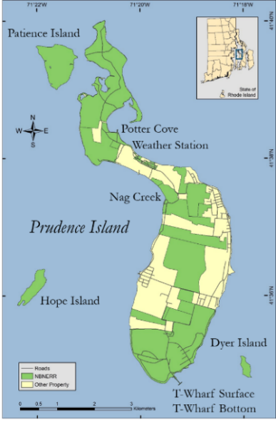The NBNERR is located close to the geographic center of Narragansett Bay in Rhode Island. It consists of approximately 1802 hectares (4453 acres: 2544 acres of land plus 1909 acres of surrounding estuarine waters, approximately) of diverse estuarine and terrestrial habitats ranging from deep water to salt marshes to forested uplands. The land holdings include approximately 65% of Prudence Island, most of nearby Patience Island, and all of Hope and Dyer Islands. The most recent land acquisition was the Eugene Chase Farm property, made official by the end of year 2015.

The Narragansett Bay watershed consists of nine subwatersheds draining an area of approximately 4,836square km [1](Pilson, 1985) and numerous and substantial freshwater inputs to the Bay. Approximately 39% of the watershed lies in Rhode Island and 61% in Massachusetts. It is referred to as a shallow estuary; however, its water depth varies considerably. Depth averages approximately 9.0 m throughout the Bay, but it is deeper in the East Passage (approximately 15.2 m) and shallower in the West Passage (approximately 7.5 m). More information and a detailed description of the Narragansett Bay NERR and the Narragansett Bay watershed can be found in [2]Raposa and Schwartz (2007), available to download at <http://nbnerr.org/research-and-monitoring/publications/>.

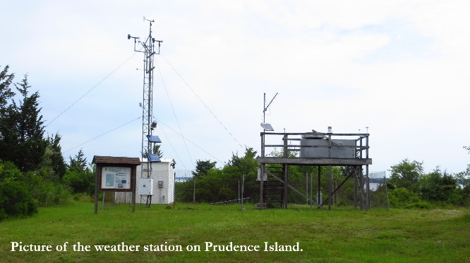The weather station is located on Prudence Island, approximately 389 m south of Potter Cove (41o 38’ 13.703” N, 71o 20’ 21.790” W, Trimble Geo XT, GeoExplorer 2008 Series). The Wind Monitor is located at the top of a 10 m high aluminum tower, the temperature and humidity sensor are located at approximately 2.0 m off the ground on the same aluminum tower. A large wooden platform approximately 2.4 m W x 1.8 m D x 2.1 m H has been situated at the weather station, approximately, since 1991. It was originally constructed by the U.S. Environmental Protection Agency (EPA) to hold atmospheric deposition equipment, which is no longer in use.

Permission secured from the EPA gave access to this platform for weather station equipment. The Campbell housing unit is situated under the platform and contains the CR1000 data logger and all associated hardware (and telemetry equipment) as well as the barometric pressure unit (approximately 1.8 m off the ground). On top of the platform railing, we placed the GPS antenna, solar panel, and Yagi antenna. The PAR meter was also relocated here to make it more accessible for cleaning than the previous location. It is approximately at 3.68 m off the ground. The rain gauge is also on the platform railing at approximately 3.46 m off the ground. All sensors were located in accordance with manufacturer recommendations to avoid the possible influence of shading, wind blocks, etc.

Details of NBNERR SWMP Weather Station Timeline. SWMP Status Column: P = primary SWMP Station, Reason Decommissioned Column and Notes Column: NA = Not applicable.

|  |  |  |  |  |  |  |
| --- | --- | --- | --- | --- | --- | --- |
| **Station Code** | **Station Name** | **SWMP Status** | **Location** | **Active Dates** | **Reason Decommissioned** | **Notes** |
| NARPCMET | Potter Cove | P | 41° 38' 13.70 N  71° 20' 21.79 W | 01/01/2001- present | NA | NA |

## Data Collection Period

Meteorological data has been collected at the weather station on Potter Cove since 1992. However, it was not until 2001 when the meteorological station was updated and became part of NERR-SWMP.

Data collected in 2018 are included in files downloaded from the weather station from January 01 to December 31 (Table 1).

Table 1. Date and time of the first and last readings in raw data files downloaded from the CR1000 data logger at the weather station on Prudence Island from January to December 2018.

| First Reading in File | | Last Reading in File | |
| --- | --- | --- | --- |
| Date | **Time** | **Date** | **Time** |
| 12/01/17 | 00:00 | 01/14/18 | 23:45 |
| 01/15/18 | 00:00 | 01/31/18 | 23:45 |
| 01/15/18 | 00:00 | 03/14/18 | 23:45 |
| 03/15/18 | 00:00 | 03/31/18 | 23:45 |
| 04/01/18 | 00:00 | 04/30/18 | 23:45 |
| 05/01/18 | 00:00 | 05/21/18 | 12:00 |
| 05/21/18 | 13:15 | 05/31/18 | 23:45 |
| 06/01/18 | 00:00 | 06/30/18 | 23:45 |
| 07/01/18 | 00:00 | 07/31/18 | 23:45 |
| 08/01/18 | 00:00 | 08/31/18 | 23:45 |
| 09/01/18 | 00:00 | 09/30/18 | 23:45 |
| 10/01/18 | 00:00 | 10/22/18 | 12:15 |
| 10/22/18 | 13:00 | 10/23/18 | 07:45 |
| 10/23/18 | 08:00 | 10/24/18 | 08:30 |
| 10/24/18 | 08:45 | 10/31/18 | 23:45 |
| 11/01/18 | 00:00 | 11/30/18 | 23:45 |
| 12/01/18 | 00:00 | 12/31/18 | 23:45 |

## Distribution

NOAA retains the right to analyze, synthesize and publish summaries of the NERRS System-wide Monitoring Program data. The NERRS retains the right to be fully credited for having collected and process the data. Following academic courtesy standards, the NERR site where the data were collected should be contacted and fully acknowledged in any subsequent publications in which any part of the data are used. The data set enclosed within this package/transmission is only as good as the quality assurance and quality control procedures outlined by the enclosed metadata reporting statement. The user bears all responsibility for its subsequent use/misuse in any further analyses or comparisons. The Federal government does not assume liability to the Recipient or third persons, nor will the Federal government reimburse or indemnify the Recipient for its liability due to any losses resulting in any way from the use of this data.

Requested citation format:

NOAA National Estuarine Research Reserve System (NERRS). System-wide Monitoring Program. Data accessed from the NOAA NERRS Centralized Data Management Office website: <http://www.nerrsdata.org/>; *accessed* 12 October 2018.

NERR meteorological data and metadata can be obtained from the Research Coordinator at the individual NERR site (please see Principal investigators and contact persons), from the Data Manager at the Centralized Data Management Office (please see personnel directory under the general information link on the CDMO home page) and online at the CDMO home page [www.nerrsdata.org](http://www.nerrsdata.org). Data are available in comma delimited format.

## Associated Researchers and Projects

A close up of a device

Description generated with very high confidenceThe NBNERR System-Wide Monitoring Program (SWMP) has four water quality monitoring station around Prudence Island (see map on Section 5, Site Location and Character). The principal objective of the SWMP program is to record short-term variability and long-term changes in water quality data in order to observe trends or patterns in water quality over time. Water quality parameters have been collected since 1995 with the establishment of the first water quality monitoring station at Potter Cove. Other three water quality stations (Nag Creek, T-Wharf Surface and T-Wharf Bottom) were brought online in 2002. These stations were selected to represent a gradient in habitat types that range from salt marsh (Nag Creek station) to shallow cove (Potter Cove) to open Bay water (T-Wharf Surface and T-Wharf Bottom). Water temperature, salinity, dissolved oxygen (% saturation, and mg L-1), pH, turbidity, and chlorophyll fluorescence data are collected at each station every 15 minutes using YSI 6600 V2 and EXO2 dataloggers (see image at right) that are calibrated and swapped out at each station approximately every two to four weeks.

Complementary to the existing long-term water quality monitoring program, the NERRS implemented a new nutrient and chlorophyll monitoring program in 2002. The two sub-components of this program include monthly grab sampling at each of the four water quality stations, and diel sampling once a month at one site. The grab sampling program requires the collection of duplicate water samples every month from each of the 4 long-term water quality monitoring stations with the purpose of quantify seasonal patterns of nutrient and chlorophyll concentrations in different estuarine habitats (marsh creek, cove, surface open water, bottom open water). The diel sampling program requires to collect a series of samples from one station over an approximately a full tidal cycle (lunar day) each month to examine how nutrient and chlorophyll concentrations change over diel and tidal cycles. Previously (from 2002 to 2010) the diel station was located at T-Wharf. However, after analyzing the historic data from the site, no significant trends or patterns were found over time. Therefore, the diel station was moved to Potter Cove in January of 2011 in order to characterize nutrients and chlorophyll from this site. All collected grab and diel samples are analyzed for concentrations of phosphates (PO4), ammonia (NH4), nitrite (NO2), nitrate (NO3), NO2+NO3, dissolved inorganic nitrogen (DIN), silicates (SiO4) and chlorophyll *a*.

Meteorological data collected at the NBNERR since 2001 is continuously used to support the aforementioned water quality and nutrient monitoring programs, the biological monitoring efforts at the Reserve, and to assist scientific research and monitoring projects, as well as stewardship, training, and educational activities around Narragansett Bay.

A Physical Oceanographic Real-Time System (PORTS) meteorological station is housed in the NERRS weather station at Potter’s Cove and independently records air temperature, atmospheric pressure, wind speed, and wind direction. This is one of six PORTS meteorological stations in Narragansett Bay. The purpose of PORTS is to support safe and cost-efficient navigation. Data are available real-time and the system is managed for quality control.

Bob Marshall of the Prudence Island Groundwater Task Force has been using the NBNERR precipitation data since 2006. These data are being used in conjunction with groundwater level and stream-flow monitoring efforts to evaluate the status of the groundwater resource on Prudence Island.

Robin Weber, GIS/Natural Resources Specialist from the NBNERR has been conducting biweekly monitoring of tick populations since 2008 during the warmer months, which over time, may inform management of the deer population and indicate the degree of public health risk for tick borne disease. Sampling success for ticks is influenced by environmental conditions (e.g., relative humidity, air temperature, precipitation), thus, meteorological data available from NBNERR’s weather station is being incorporated in the data analysis for each sampling date and time to remove potential sources of variation in annual tick abundance levels.

Wendell Waters, an NSF Postdoctoral Fellow at Brown University, collected atmospheric gases and particulate matter at a 6-hr interval over the course of 3 days in April 2018 at NBNERR. Together with data from NBNERR weather station, Wendell will use isotope specific ammonia measurements to quantify the fossil fuel related sources in Rhode Island, Indianapolis and Philadelphia. The results will help determine how fossil energy use and pollution abatement technologies are affecting urban ammonia sources and human health. More information <https://www.nsf.gov/awardsearch/showAward?AWD_ID=1624618&HistoricalAwards=false>.

# II. Physical Structure Descriptors

## Sensor Specifications, Operating Range, Accuracy, Date of Last Calibration

Parameter: **Temperature**

Units: Celsius

Sensor type: PT100 RTD, IEC 751 1/3 Class B, with calibrated signal conditioning

Operating Temperature: -40°C to +60°C

Range: -40°C to +60°C

Accuracy: ± 0.1°C at 23°C

*Model #:*  *HC2-S3*

**Serial Number: 60835193**

Date of calibration: 02/12/14

Dates of sensor use: 08/12/14 to 09/17/15

*Model #:*  *HC2-S3*

**Serial Number: 61180509**

Date of calibration: 03/17/15

Dates of sensor use: 09/17/15 to 09/08/16

*Model #:* ……………………...*HC2-S3*

**Serial Number: 60835193**

Date of calibration: 02/02/16

Dates of sensor use: 09/08/16 to 08/03/17

*Model #:*  *HC2-S3*

**Serial Number: 61180509**

Date of calibration: 06/16/17

Dates of sensor use: 08/03/17 to 10/22/18

*Model #:*  *HC2-S3*

**Serial Number: 60835193**

Date of calibration: 07/20/18

Dates of sensor use: 10/22/18 current as of 12/31/18

Parameter: **Relative Humidity**

Units: Percent

Sensor type: ROTRONIC® Hygromer IN-1

Range: 0-100% non-condensing

Accuracy: ± 0.8% RH at 23°C with standard configuration settings

Temperature dependence: ± 3% (-40 to 60C)

*Model #:*  *HC2S3 (Temperature and Relative Humidity Probe)*

**Serial Number: 60835193**

Date of calibration: 02/12/14

Dates of sensor use: 08/12/14 to 09/17/15

*Model #:*  *HC2S3*

**Serial Number: 61180509**

Date of calibration: 03/17/15

Dates of sensor use: 09/17/15 to 09/08/16

*Model #:*  *HC2S3*

**Serial Number: 60835193**

Date of calibration: 02/02/16

Dates of sensor use: 09/08/16 to 08/03/17

*Model #:*  *HC2-S3*

**Serial Number: 61180509**

Date of calibration: 06/16/17

Dates of sensor use: 08/03/17 to 10/22/18

*Model #:*  *HC2-S3*

**Serial Number: 60835193**

Date of calibration: 07/20/18

Dates of sensor use: 10/22/18 current as of 12/31/18

Parameter: **Barometric Pressure**

Units: millibars (mb)

Sensor type: Vaisala Barocap © silicon capacitive pressure sensor

Operating Range: Pressure: 600 to 1060 mb; Temperature: -40°C to +60°C

Humidity: non-condensing

Accuracy: ± 0.5 mb at +20°C, ± 1.5mb at 0°C to 40°C, ± 2.0 mb at -20°C to +45°C,

± 3.0 mb at -40°C to +60°C

Stability: ± 0.1 mb per year

***Model #:*  *CS-105***

**Serial Number: P4910009**

Date of calibration: 08/09/11

Dates of sensor use: 08/22/12 to 07/02/14

*Model #:*  *CS-105*

**Serial Number: X132022**

Date of calibration: 02/21/14

Dates of sensor use: 07/02/14 to 09/08/16

*Model #:*  *CS-105*

**Serial Number: P4910009**

Date of calibration: 02/29/2016

Dates of sensor use: 09/08/16 to 08/28/17

Parameter: **Barometric Pressure**

Units: millibars (mb)

Sensor type: Vaisala Barocap © silicon capacitive pressure sensor

Operating Range: Pressure: 500 to 1100 mb; Temperature: -40°C to +60°C

Humidity: non-condensing

Accuracy: ± 0.3 mb at +20°C, ± 0.6 mb at 0°C to 40°C, ± 1 mb at -20°C to +45°C,

± 1.5 mb at -40°C to +60°C

Stability: ± 0.1 mb per year

***Model #:*  *CS-106***

**Serial Number: N0410377**

Date of calibration: 01/24/17

Dates of sensor use: 08/28/17 current as 12/31/18

Parameter: **Wind Speed**

Units: meter per second (m s-1)

Model # R.M. Young 5305 L - AQ

Sensor type: 20 cm diameter 4-blade helicoid propeller carbon fiber thermoplastic

Range: 0-50 m/s (112 mph)

Accuracy: ±0.2 m/s (0.4 mph)

or

Model # R.M. Young 5103 - 5 Wind Monitor

Sensor type: 18 cm diameter 4-blade helicoids propeller molded of polypropylene

Range: 0-60 m s-1 (0-134 mph); gust survival 100 m s-1 (220 mph)

Accuracy: ± 0.3 m s-1 (± 0.6 mph)

*Model #:*  *R.M. Young 05305 L-AQ Wind Monitor*

**Serial Number: 75311**

Date of calibration: 01/28/13

Dates of sensor use: 07/31/13 to 09/17/15

*Model #:*  *R.M. Young 05103-5 Wind Monitor*

**Serial Number: 83868**

Date of calibration: 03/18/15

Dates of sensor use: 09/17/15 to 08/28/2017

*Model #:*  *R.M. Young 05305 L-AQ Wind Monitor*

**Serial Number: 75311**

Date of calibration: 06/20/17

Dates of sensor use: 08/28/17 current as of 12/31/18

Parameter: **Wind Direction**

Units: degrees

Model # R.M. Young 5305 L – AQ

Sensor type: balanced vane, 48.3 cm turning radius

Range: 0-360° mechanical, 355° electrical (5° open)

Accuracy: ±3°

or

Model # R.M. Young 5103 -5 Wind Monitor

Sensor type: balanced vane, 38 cm turning radius

Range: 0-360° mechanical, 355° electrical (5° open)

Accuracy: ±3°

*Model #:*  *R.M. Young 05305 L-AQ Wind Monitor*

**Serial Number: 75311**

Date of calibration: 01/28/13

Dates of sensor use: 07/31/13 to 09/17/15

*Model #:*  *R.M. Young 05103-5 Wind Monitor*

**Serial Number: 83868**

Date of calibration: 03/18/15

Dates of sensor use: 09/17/15 to 08/28/17

*Model #:*  *R.M. Young 05305 L-AQ Wind Monitor*

**Serial Number: 75311**

Date of calibration: 06/20/17

Dates of sensor use: 08/28/17 current as of 12/31/18

Parameter: **Photosynthetic Active Radiation**

Units: mmoles m-2 (total flux)

Sensor type: High stability silicon photovoltaic detector (blue enhanced)

Light spectrum waveband: 400 to 700 nm

Temperature dependence: 0.15% per °C maximum

Stability: <± 2% change over 1 yr. period

Response time: 10µs

Operating range: Temperature: -40°C to 65°C; relative humidity: 0 to 100%

Sensitivity: typically, 5 µA per 1000 µmoles s-1 m-2

*Model #:*  *LI190SB*

**Serial Number: Q31076**

Multiplier: 1.488875125065510, changed on 08/22/12

Date of calibration: 08/16/2011

Dates of sensor use: 08/22/2012 to 07/02/14

*Model #:*  *LI190SB*

**Serial Number: Q22179**

Multiplier: 1.635997172996880, changed on 07/02/14

Date of calibration: 02/14/14

Dates of sensor use: 07/02/2014 to 10/13/16

Parameter: **Photosynthetic Active Radiation**

Units: mmoles m-2 (total flux)

Sensor type: photodiode

Light spectrum waveband: 410 to 655 nm

Temperature dependence: 0.06% ± 0.06 per °C

Stability: <± 2% change over 1 yr.

Operating range: Temperature: -40°C to 70°C; relative humidity: 0 to 100%

Cosine Response: 45° zenith angle: ± 2%; 75° zenith angle: ± 5%

Sensitivity: 0.2mV per µmoles s-1 m-2

*Model #:*  *SQ110 Apogee Quantum Sensor*

Multiplier:……………………..0.025(multiplier never changes with this model)

**Serial Number: 19451**

Date of calibration: 01/11/2015

Dates of sensor use: 10/13/16 to 07/05/17

**Serial Number: 23189**

Date of calibration: 05/01/17

Dates of sensor use: 07/05/17 current as of 12/31/18

Parameter: **Precipitation**

Units: millimeters (mm)

Sensor type: Tipping bucket/magnetic reed switch

Funnel collector diameter: 6.06 inches (16.4 cm)

Rainfall per tip: 0.01 inch (0.254 mm)

Operating range: Temperature: 0° to 50°C; Humidity: 0 to 100%

Accuracy: ± 1% up to 1 in/hr; +0, -3% from 1 to 2 in/hr; +0, -5% from 2 to3 in/hr

*Model #:*  *TE525*

**Serial Number: 24701-899**

Date of calibration: 03/05/14

Dates of sensor use: 07/02/14 to 09/17/15

*Model #:*  *TR525I-R3*

**Serial Number: 31194-902**

Date of calibration: 03/19/15

Dates of sensor use: 09/17/15 to 10/13/16

*Model #:*  *TR525I-R3*

**Serial Number: 31194-902**

Date of calibration: 10/13/16

Dates of sensor use: 10/13/16 to 01/04/2017

Parameter: **Precipitation**

Units: millimeters (mm)

Sensor type: Tipping bucket/magnetic reed switch

Funnel collector diameter: 6.36 inches (16.0 cm)

Rainfall per tip: 0.004 inch (0.1 mm)

Operating range: Temperature: -20° to 50°C; Humidity: 0 to 100%

Heated thermostat set point: 10°C ± 3°C

Accuracy: ± 2% up to 1 in/hr; 3% for up to 2 in/hr

*Model #:*  52202

**Serial Number: TB13505**

Date of calibration: 11/03/2016

Dates of sensor use: 01/04/2017 to 09/05/17

**Serial Number: TB13505**

Date of calibration: 09/05/17

Dates of sensor use: 09/05/17 to 10/22/18

**Serial Number: TB13505**

Date of calibration: 10/22/18

Dates of sensor use: 10/22/18 current as of 12/31/18

The CR1000 datalogger has 2 MB Flash EEPROM that is used to store the Operating System. Another 128 K Flash is used to store configuration settings. A minimum of 2 MB SRAM is available for program storage (16K), operating system use, and data storage. Additional storage is available by using a compact flash card in the optional CFM100 Compact Flash Module.

CR1000 Serial Number: 5245

Year of Manufacture: 2006

Date Installed: August 01, 2006, 11/24/2014 – current as of 12/31/2018

Date Calibrated: October 13, 2014

CR1000 Firmware Version (s): OS31 uploaded on 02/02/17 current as of 12/31/18

OS29 uploaded on 09/08/16 to 02/02/17

OS27 uploaded on 06/09/2014 to 09/08/16

CR1000 Program Version(s):

| **Program** | **Changes or notes included in the program** |
| --- | --- |
| narpcmet_7.0_102318.CR1 | Uploaded program to correct barometric sensor multiplier. |
| narpcmet_7.0_102218.CR1 | Uploaded program for air temperature / relative humidity sensor swap. |
| narpcmet_7.0_052118.CR1 | Last modified on May 21, 2018 by Daisy Durant. Uploaded the program to correct the barometric pressure multiplier. |
| narpcmet_7.0_082817.CR1 | Last modified on August 28, 2017 by Daisy Durant. Installed a new barometric pressure sensor C106 PTB110 SN WQ#263492 and updated the program. |
| narpcmet_7.0_080317.CR1 | Last modified on August 03, 2017 by Daisy Durant. Installed sensor to monitor humidity inside the enclosure that houses the telemetry equipment, power and CR1000. |
| narpcmet_7.0_070517.CR1 | Last modified on July 05, 2017 by Daisy Durant. Installed a new PAR sensor (Apogee SQ-110); specs included in the program. |
| narpcmet_7.0_051017.CR1 | Last modified on May 10, 2017 by Daisy Durant. Uploaded the program to delete an incorrect line in the CR1000 code: If RHumidity>100 and RHumidity<108 then RHumidity=100. A decision was made by the DMC to discontinue correcting >100 RH values to 100. |
| narpcmet_7.0_010417.CR1 | Last modified on January 04, 2017 by Daisy Durant. Included the new RM Young heated rain gauge Model 52202. |
| narpcmet_7.0_101316.CR1 | Last modified on October 13, 2016 by Daisy Durant. Included the new PAR sensor, Apogee SQ-110. |
| narpcmet_7.0_090816.CR1 | Uploaded the program after updating the OS27 to OS29, and after switching the air temp/relative humidity and barometric pressure sensor with recalibrated ones. |
| narpcmet_7.0_091815.CR1 | Last modified on September 18, 2015 by Daisy Durant. No major changes to the program, just added a note regarding the new cable installed on the rain gauge. |
| narpcmet_7.0_112414.CR1 | Last modified on November 24, 2014 by Daisy Durant. No major changes to the program, just added a note regarding the calibration of the CR1000. |
| narpcmet_7.0_070214.CR1 | Last modified on July 02, 2014 by Daisy Durant to include the specs of a new ATRH bought and installed in August. |
| narpcmet_6.4_091213.CR1 | Last modified on Sep 12 2013 by Daisy Durant. Installed HMP45C SN 1294801 (same as X3410026) Temperature & Relative Humidity Sensor. Needed changes in the program because this sensor was initially 7-wire but was switched to 6 at Campbell Scientific. |
| narpcmet_6.4_082113.CR1 | Last modified on August 21 2013 by Daisy Durant. Added the details of a different rain gauge to the program. |
| narpcmet_6.3_073113.CR1 | Last modified on July 31, 2013 by Daisy Durant. Uploaded new version of the program that includes models, serial numbers, frequency of calibration, and wiring of all sensors currently being used at this station. |
| narpcmet_V6.2_082312.CR1 | Last modified on August 23, 2012 by Daisy Durant and Jeff Adams (Campbell Sci). Added PAR Multiplier of 1.48887512506610. Added new AT/RH sensor HC2S3 and comment on wiring. |
| narpcmet_V6.2_082212.CR1 | Last modified on August 22, 2012 by Daisy Durant. Added PAR Multiplier of 1.488875125065510. |
| narpcmet_V6.1_082212.CR1 | Last modified on August 04, 2010 by Daisy Durant & Jay Poucher. Added PAR Multiplier of 1.582819445. |

## Coded Variable Definitions

Sampling station Sampling site code Station code

Potter Cove PC narpcmet

## QAQC Flag Definitions

QAQC flags provide documentation of the data and are applied to individual data points by insertion into the parameter’s associated flag column (header preceded by an F_). During primary automated QAQC (performed by the CDMO), -5, -4, and -2 flags are applied automatically to indicate data that is above or below sensor range or missing. All remaining data are then flagged 0, as passing initial QAQC checks. During secondary and tertiary QAQC 1, -3, and 5 flags may be used to note data as suspect, rejected due to QAQC, or corrected.

-5 Outside High Sensor Range

-4 Outside Low Sensor Range

-3 Data Rejected due to QAQC

-2 Missing Data

-1 Optional SWMP supported parameter

0 Passed Initial QAQC Checks

1 Suspect Data

2 *Open - reserved for later flag*

3 *Open - reserved for later flag*

4 Historical Data: Pre-Auto QAQC

5 Corrected Data

## QAQC Code Definitions

QAQC codes are used in conjunction with QAQC flags to provide further documentation of the data and are also applied by insertion into the associated flag column. There are three (3) different code categories, general, sensor, and comment. General errors document general problems with the CR1000/CR1000X, sensor errors are sensor specific, and comment codes are used to further document conditions or a problem with the data. Only one general or sensor error and one comment code can be applied to a particular data point, but some comment codes (marked with an * below) can be applied to the entire record in the F_Record column.

General Errors

GIM Instrument Malfunction

GIT Instrument Recording Error, Recovered Telemetry Data

GMC No Instrument Deployed due to Maintenance/Calibration

GMT Instrument Maintenance

GPD Power Down

GPF Power Failure / Low Battery

GPR Program Reload

GQR Data Rejected Due to QA/QC Checks

GSM See Metadata

Sensor Errors

SDG Suspect due to sensor diagnostics

SIC Incorrect Calibration Constant, Multiplier or Offset

SIW Incorrect Wiring

SMT Sensor Maintenance

SNV Negative Value

SOC Out of Calibration

SQR Data rejected due to QAQC checks

SSD Sensor Drift

SSN Not a Number / Unknown Value

SSM Sensor Malfunction

SSR Sensor Removed

Comments

CAF Acceptable Calibration/Accuracy Error of Sensor

CCU Cause Unknown

CDF Data Appear to Fit Conditions

CML Snow melt from previous snowfall event

CRE* Significant Rain Event

CSM* See Metadata

CVT* Possible Vandalism/Tampering

CWE* Significant weather event

## Other Remarks and Notes

Data are missing due to equipment or associated specific sensors not being deployed, equipment failure, time of maintenance or calibration of equipment, or repair/replacement of a sampling station platform. Any NANs in the dataset stand for “not a number” and are the result of low power, disconnected wires, or out of range readings. If additional information on missing data is needed, contact the Research Coordinator at the reserve submitting the data.

Small negative PAR values are within range of the LI-COR sensor and are due to normal errors in the sensor and the CR1000 Datalogger. The Maximum signal noise error for the LI-COR sensor is ± 2.214 mmoles/m2 over a 15-minute interval. These values are automatically flagged and coded as <1> (CAF).

Relative Humidity data greater than 100 are within range of the sensor accuracy of ± 3% and are flagged and coded as suspect, <1> (CAF). Values greater than 103 are rejected <-3>.

Data recorded for all parameters (with the exception of cumulative precipitation) at the midnight timestamp (00:00) are the 15-minute averages and totals for the 23:45-23:59 time period of the previous day. Cumulative precipitation data at the midnight timestamp (00:00) are the sum of raw (unrounded) precipitation data from 00:00 to 23:59 of the previous day. Summing each individual 15-minute total precipitation value from the same period will result in small differences from cumulative precipitation due to rounding. It is especially important to note how data at the midnight timestamp are recorded when using January 1st and December 31st data. **Note: Cumulative precipitation is no longer available via export from the CDMO. Please contact the Reserve or the CDMO for more information or to obtain these data.**

The following are descriptions of different events that happened at the weather station from January to December of 2018, and explanations to the CSM (Comment-See Metadata) code used in the data file.

**During the NAR 2023 MET review the CDMO discovered that the wind speed multiplier had not been updated in the logger program following sensor swaps. Wind speed and maximum wind speed values were corrected for the time periods when the incorrect multiplier was used. Data for 2018 did not need to be corrected; however, the Sensor Specifications section of the metadata was updated to include both sensors. The R.M. Young 5305 model (SN 75311) has a multiplier of 0.1024 while the R.M. Young 5103 (SN 83868) has a multiplier of 0.0980. To make the corrections when the multiplier was not updated, data were divided by the incorrect multiplier, 0.1024, and that value was multiplied by correct multiplier, 0.0980. The data were flagged and coded 5 SIC CSM, unless rejected or missing. Corrected data are considered suspect.**

Jan 01 00:00 – May 21 12:00. Barometric Pressure data were flagged and codded 5 SIC CSM due to an error in the program which calculated the barometric pressure wrong. The data in the file was corrected; however, it is still considered suspect.

Incorrect multiplier and offset (0.184,600)

Correct multiplier and offset (0.240,500)

Snow Events. The following were snow events reported by NOAA on the National Weather Service website at [https://www.weather.gov/box/pastevents#](https://www.weather.gov/box/pastevents). The Reserve’s heated rain gauge capture these events and recorded them as snow melt in the Total Precipitation Column and the Cumulative Precipitation Column of the dataset. The data are considered suspect and were flagged and coded as 1 GSM CML.

* January 04 08:00 – 17:45; until January 05 00:00 for Cumulative
* January 17 07:15 – 10:45; until January 18 00:00 for Cumulative
* January 29 23:45 – January 30 10:30; until January 31 00:00 for Cumulative
* February 17 20:45 – February 18 05:30; until February 19 00:00 for Cumulative
* March 07 13:00 – March 08 02:00 (nor’easter); until March 09 00:00 for Cumulative
* March 13 00:00 - 19:15 (nor’easter); until March 14 00:00 for Cumulative
* March 21 10:15 – March 22 08:15 (nor’easter); until March 23 00:00 for Cumulative

May 21. A new program (narpcmet_V7.0_052118) was uploaded to correct the barometric pressure multiplier code. As a result,

* 05/21 12:15 – the new program was uploaded. However, for some reason, the station did not collect data or added a record number on the Record Column; -2 GPR CSM was used in the data file.
* 05/21 12:30 – 13:00 the station did not collect any data; -2 GIM CSM was used in the data file.
* 05/21 13:15 the station started collecting data. The Record Column indicates it is the 4th row of data collected since the program upload. Data were rejected, <-3> GPR CSM, at 13:15 since those readings were most likely not a full 15 minutes of 5-second data.

Sep 11 – Oct 11. During our trip to the weather station on October 11, we found the rain gauge funnel full of water because it was clogged. It was unclogged at 10/11 09:30. As a result,

* 09/12 00:15 to 10/11 09:30– the rain gauge did not record precipitation correctly during this period. Total Precipitation (TotPrcp) and Cumulative precipitation (CumPrcp) data were flagged and coded as 1 SSM CSM.
* 10/11 09:45 to 10/11 23:45 – Cumulative precipitation (CumPrcp) data were rejected and flagged and coded -3 SSM CSM.

October 22. The weather station was powered down to swap the air temperature/relative humidity (ATRH) sensor for a recently recalibrated one and to check if the rain gauge needs recalibration. As a result,

* 10/22 12:30 – 12:45 the station was powered down. During this time, the ATRH sensor was swapped with a different one and the rain gauge calibration was checked, and we found it was up to specs. Data are missing due to a station power down and -2 GPD CSM flag and code were used.
* 10/22 13:00 – the station was powered back on and a new program (narpcmet_V7.0_102218) was reloaded. These data were rejected because it is possible that this timestamp is not a full 15 minutes of averaged 5 second data. The data were flagged and coded -3 GPR CSM.

October 23. A new program (narpcmet_V7.0_102318) was uploaded to correct the barometric pressure multiplier code. As a result,

* 10/23 08:00 program was uploaded. The data were rejected because it is possible that this timestamp is not a full 15 minutes of averaged 5 second data. The data was flagged and coded -3 GPR CSM.
* 10/22 13:15 – 10/23 07:45 These data were flagged and coded 5 SIC CSM due to using the wrong multiplier and offset which calculate the barometric pressure wrong. The data in the file was corrected using the correct multiplier and offset; however, it is still considered suspect.
  + Incorrect multiplier and offset (0.184,600)
  + Correct multiplier and offset (0.240,500)
* 10/23 08:15 – 10/24 08:15 barometric pressure data were rejected. It seemed the program was not running the new barometric pressure multiplier correctly. Data were flagged and coded -3 SIC CSM.

October 24. We notice the station was not transmitting data after the program uploaded on 10/23. As a troubleshooting option, the same program was reloaded. As a result,

* 10/24 08:30 the data were rejected because it is possible that this timestamp is not a full 15 minutes of averaged 5 second data.
* 10/24 08:45 the data were rejected due program reload. It is possible that this timestamp is not a full 15 minutes of averaged 5 second data.
* Note: Eventhough the station was not transmitting data, all data for this period was collected and downloaded previous troubleshooting the station.

Calibration Certificate – Air temperature and relative humidity sensor, Model HC2S3

Date calibraated – June 20, 2018

Date installed – October 22, 2018

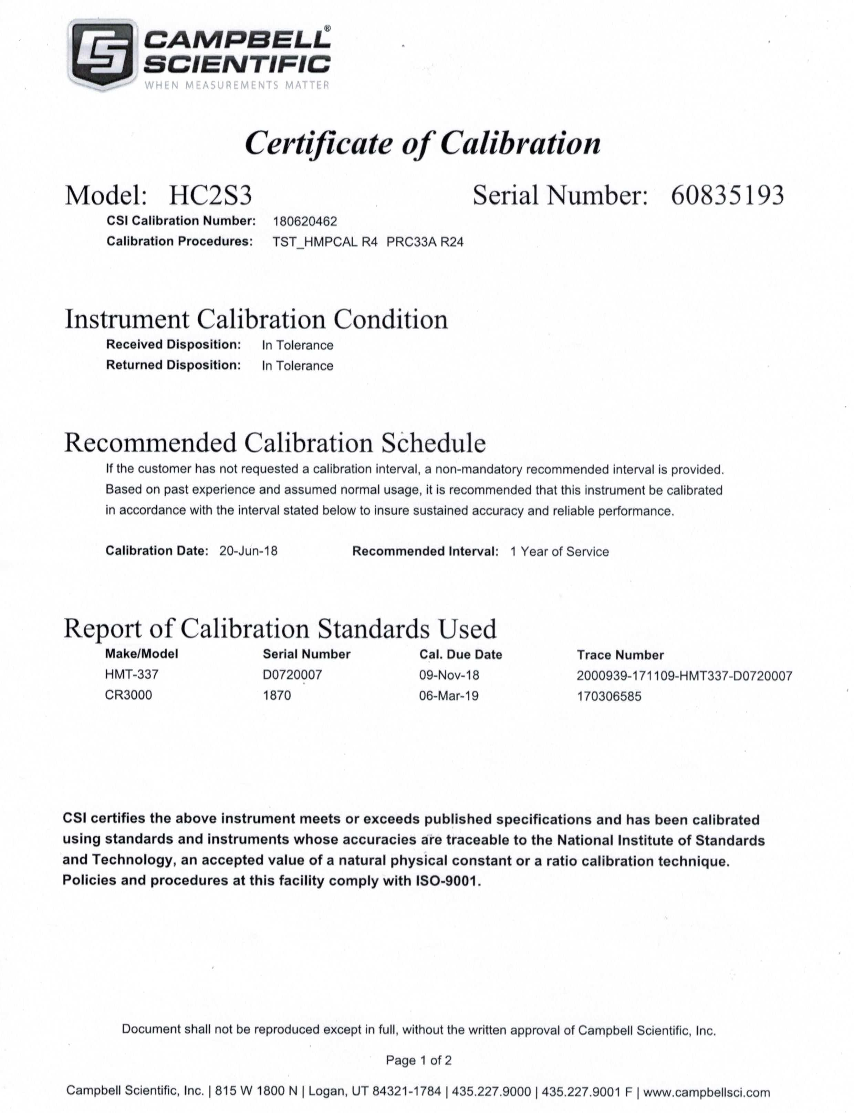

Calibration Certificate – Air temperature and relative humidity sensor, Model HC2S3

Date calibraated – June 20, 2018

Date installed – October 22, 2018

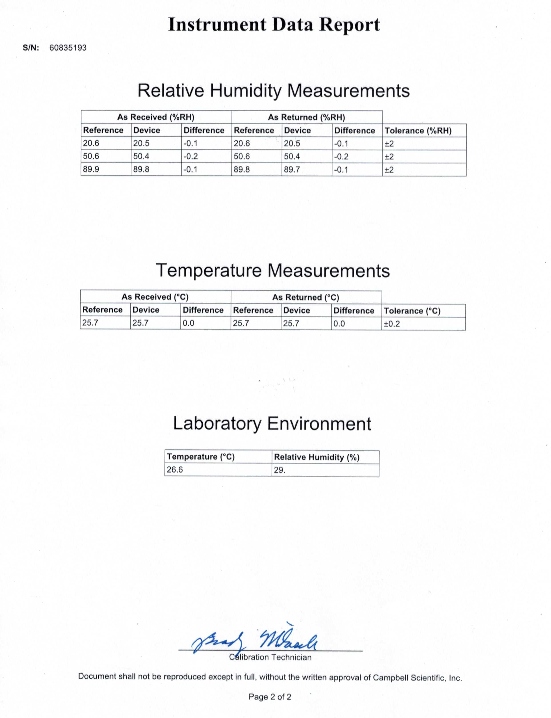

1. Pilson, M.E.Q. 1985. On the residence time of water in Narragansett Bay. *Estuaries* 8:2–14.
2. Narragansett Bay National Estuarine Research Reserve. 2007. An Ecological Profile of the Narragansett Bay National Estuarine Research Reserve. K.B. Raposa and M.L. Schwartz (eds.), *Rhode Island Sea Grant, Narragansett, R.I*. 176pp.