

**Narragansett Bay (NAR) NERR**

**Meteorological Metadata**

January – December 2019

Latest Update: Wednesday, December 4, 2024

# I. Data Set and Research Descriptors

## Principal Investigator(s) and Contact Persons

Contact Persons:

Dr. Kenneth Raposa

Research Coordinator

E-mail: [kenneth.raposa@dem.ri.gov](mailto:kenneth.raposa@dem.ri.gov);

(401) 683-7849

Dr. Daisy Durant

Marine Research Specialist II

SWMP Coordinator and Data Manager

E-mail: [daisy.durant@dem.ri.gov](mailto:daisy.durant@dem.ri.gov);

(401) 683-7368

Address: Narragansett Bay NERR

55 South Reserve Drive

(PO Box 151)

Prudence Island, RI 02872

Phone: 401-683-6780

Fax: 401-682-7366

## Entry Verification

Data are uploaded from the CR1000/CR1000X data logger to a personal computer with a Windows 7 or newer operating system. Files are exported from LoggerNet in a comma-delimited format and uploaded to the CDMO where they undergo automated primary QAQC and become part of the CDMO’s online provisional database. During primary QAQC, data are flagged if they are missing or out of sensor range. The edited file is then returned to the reserve where it is opened in Microsoft Excel and processed using the CDMO’s NERRQAQC Excel macro. The macro inserts station codes, creates metadata worksheets for flagged data and summary statistics, and graphs the data for review. It allows the user to apply QAQC flags and codes to the data, append files, and export the resulting data file to the CDMO for tertiary QAQC and assimilation into the CDMO’s authoritative online database. For more information on QAQC flags and QAQC codes, see Sections 11 and 12.

Daisy Durant, PhD (Marine Research Specialist II), was responsible for compiling and error checking the January through December 2019 weather data covered in this document.

## Research Objectives

The principal objective is to record long-term meteorological data for Narragansett Bay in order to observe any environmental changes or trends over time. These data are also used to support ongoing water quality and biological monitoring, scientific research, as well as stewardship, training and education activities.

## Research Methods

At the Reserve, the Campbell Scientific data logger CR1000 has been used to collect meteorological parameters data from August 2006 to December 23, 2019 when an upgraded model, the CR1000X, was installed. The CR1000 is kept at the Reserve as backup. The data logger’s operating system is upgraded when Campbell Scientific releases new upgrades. Both data loggers are programed to collect data every 5 seconds to produce 15-minute averages of those measurements of air temperature, relative humidity, barometric pressure, wind speed and wind direction; the data loggers collect totals for precipitation and photosynthetic active radiation, not averages. The CR1000/CR1000X program directs how and when the sensors measure and store data. All data are collected in Eastern Standard Time (UTC -5) and stored in the CR1000/CR1000X data logger. Monthly trips to the weather station are done to inspect, clean and maintain all sensors and all other weather station related equipment. During these monthly trips, data are downloaded from the data logger via a RS-232 connection serial cable or USB cable (CR1000, CR1000X, respectively) to a laptop using the Campbell Scientific LoggerNet (v 3.4.1) program. The LoggerNet program was updated (v 4.5) in July 2019. The data logger is housed in a Campbell Scientific weather resistant enclosure. A satellite transmitter (TX312), a 12 V sealed rechargeable battery, a regulator (CH-100, which provides built-in temperature compensation to optimize battery performance), and a barometric pressure sensor (vented to the outside of the enclosure) are housed in the enclosure as well.

In July 31st, 2006, the Campbell Scientific data telemetry equipment was installed at the Potter Cove weather station which allowed the transmission of data to the NOAA GOES satellite, NESDIS ID 3B0211F8. The transmissions are scheduled hourly and contain four (4) data sets reflecting fifteen-minute data sampling intervals. Upon receipt by the CDMO, the data undergoes the same automated primary QAQC process detailed in Section 2 above. The “real-time” telemetry data become part of the provisional dataset until undergoing secondary and tertiary QAQC and assimilation in the CDMO’s authoritative online database. Provisional and authoritative data are available at [http://cdmo.baruch.sc.edu](http://cdmo.baruch.sc.edu/).

The 15-minute data are collected in the following formats for the CR1000/CR1000X:

Averages from 5-second data:

Air Temperature (°C), Relative Humidity (%), Barometric Pressure (mb), Wind Speed (m/s), Wind Direction (degrees), and Battery Voltage (volts).

Maximum and Minimum Air Temperature (oC) and their times from 5-second data (these data are available from the Reserve).

Maximum Wind Speed (m/s) and time from 5-second data.

Wind Direction Standard Deviation (degrees).

Totals:

Precipitation (mm)

PAR (millimoles/m2)

Cumulative Precipitation (mm) (Cumulative precipitation is no longer available via export from the CDMO. Please contact the Reserve or the CDMO for more information or to obtain these data.)

The recommended calibration frequency for the MET station sensors according to manufacturer recommendations are:

Temperature/Humidity yearly recalibration

Rain Gauge yearly recalibration

Wind Speed/Direction yearly or every 2 years (depending on the sensor)

Barometric Pressure every 2 years recalibration

PAR every 2 years recalibration

CR1000 every 5 years (required beginning 2014, one-year initial grace period)

CR1000X every 5 years

Ground-truthing is conducted during the monthly trips, and data on air temperature, relative humidity, barometric pressure, and wind speed are collected with a Kestrel 4000 weather meter; wind direction is determined with a handheld compass; and photosynthetic active radiation is measured with a LiCor 1400 equipped with a LI-190SB quantum sensor; total precipitation is checked from the T.F. Green Airport NOAA weather station in Providence, RI; weather data collected from the airport is available online at <https://w2.weather.gov/climate/index.php?wfo=box>. These ground-truthing data are used to compare with the data collected by the weather station on Prudence Island and ensure accuracy of the readings. Ground-truthing data are recorded on the meteorological monthly log, kept at the Reserve and at CDMO, and available upon request.

## Site Location and Character

The NBNERR is located close to the geographic center of Narragansett Bay in Rhode Island. It consists of approximately 1802 hectares (4453 acres: 2544 acres of land plus 1909 acres of surrounding estuarine waters, approximately) of diverse estuarine and terrestrial habitats ranging from deep water to salt marshes to forested uplands. The land holdings include approximately 65% of Prudence Island, most of nearby Patience Island, and all of Hope and Dyer Islands. The last land acquisition was the Eugene Chase Farm property on 2015.

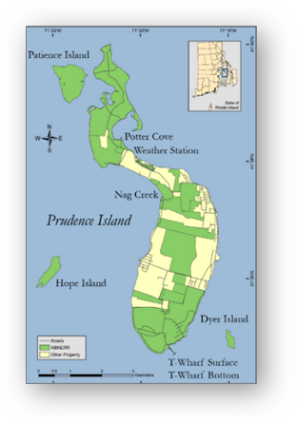

The Narragansett Bay watershed consists of nine subwatersheds draining an area of approximately 4,836square km [1](Pilson, 1985) and numerous and substantial freshwater inputs to the Bay. Approximately 39% of the watershed lies in Rhode Island and 61% in Massachusetts. It is referred to as a shallow estuary; however, its water depth varies considerably. Depth averages approximately 9.0 m throughout the Bay, but it is deeper in the East Passage (approximately 15.2 m) and shallower in the West Passage (approximately 7.5 m). More information and a detailed description of the Narragansett Bay NERR and the Narragansett Bay watershed can be found in [2]Raposa and Schwartz (2007), available to download at <http://nbnerr.org/research-and-monitoring/publications/>.

Figure 1. Map (image at right) showing land preserved by NBNERR (in green) and the location of the long-term water quality monitoring sites (Potter Cove, Nag Creek, T-Wharf Surface, and T-Wharf Bottom) and weather station.

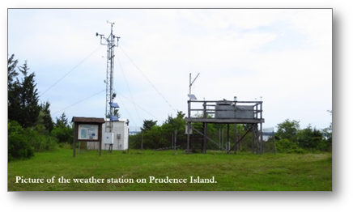The weather station is located on Prudence Island, approximately 389 m south of Potter Cove (41o 38’ 13.703” N, 71o 20’ 21.790” W, Trimble Geo XT, GeoExplorer 2008 Series, Figure 1). All sensors were located in accordance with manufacturer recommendations to avoid the possible influence of shading, wind blocks, etc., as follows. The Wind Monitor is located at the top of a 10 m high aluminum tower, the temperature and humidity sensor are located at approximately 2.0 m off the ground on the same aluminum tower. A large wooden platform approximately 2.4 m W x 1.8 m D x 2.1 m H has been situated at the weather station, approximately, since 1991. It was originally constructed by the U.S. Environmental Protection Agency (EPA) to hold atmospheric deposition equipment, which is no longer in use.

Permission secured from the EPA gave access to this platform for weather station equipment. The Campbell housing unit is situated under the platform and contains the CR1000/CR1000X data logger and all associated hardware (and telemetry equipment) as well as the barometric pressure unit (approximately 1.8 m off the ground). On top of the platform railing, we placed the GPS antenna, solar panel, and Yagi antenna. The PAR meter was also relocated here to make it more accessible for cleaning than the previous location. It is approximately at 3.68 m off the ground. The rain gauge is also on the platform railing at approximately 3.46 m off the ground.

Details of NBNERR SWMP Weather Station Timeline. SWMP Status Column: P = primary SWMP Station, Reason Decommissioned Column and Notes Column: NA = Not applicable.

|  |  |  |  |  |  |  |
| --- | --- | --- | --- | --- | --- | --- |
| **Station Code** | **Station Name** | **SWMP Status** | **Location** | **Active Dates** | **Reason Decommissioned** | **Notes** |
| NARPCMET | Potter Cove | P | 41° 38' 13.70 N  71° 20' 21.79 W | 01/01/2001- present | NA | NA |

## Data Collection Period

Meteorological data has been collected at the weather station on Potter Cove since 1992. However, it was not until 2001 when the meteorological station was updated and became part of NERR-SWMP. Data collected in 2019 are included in files downloaded from the weather station from January 01 to December 31 (Table 1).

Table 1. Date and time of the first and last readings in raw data files downloaded from the CR1000/CR1000X data logger at the weather station on Prudence Island from January to December 2019.

| **First Reading in File** | | **Last Reading in File** | |
| --- | --- | --- | --- |
| **Date** | **Time** | **Date** | **Time** |
| 01/01/19 | 00:00 | 01/31/19 | 23:45 |
| 02/01/19 | 00:00 | 02/28/19 | 23:45 |
| 03/01/19 | 00:00 | 04/07/19 | 23:45 |
| 04/08/19 | 00:00 | 05/15/19 | 23:45 |
| 05/15/19 | 00:00 | 05/31/19 | 23:45 |
| 06/01/19 | 00:00 | 06/30/19 | 23:45 |
| 07/01/19 | 00:00 | 07/31/19 | 23:45 |
| 08/01/19 | 00:00 | 08/31/19 | 23:45 |
| 09/01/19 | 00:00 | 09/17/19 | 11:30 |
| 1 09/17/19 | 12:00 | 09/30/19 | 09:30 |
| 10/01/19 | 11:45 | 10/31/19 | 23:45 |
| 11/01/19 | 00:00 | 11/04/19 | 12:00 |
| 2 11/04/19 | 10:00 | 12/05/19 | 10:15 |
| 12/05/16 | 10:30 | 12/05/19 | 11:45 |
| 3 12/05/16 | 12:00 | 12/05/19 | 23:45 |
| 12/06/19 | 00:00 | 12/23/19 | 11:45 |
| 4 12/23/19 | 13:45 | 12/26/19 | 10:45 |
| 12/26/19 | 11:15 | 12/31/20 | 23:45 |

Notes

1 No data collected from 09/30 09:45 – 10/01 11:30 due to power down for installing new weather box enclosure.

2 No data collected from 11/04 10:15 - 13:00 due to power down for installing a loaner data logger (CR1000M) and sending our data logger for recalibration (CR1000).

3 Data recovered from telemetry due to a program issue.

4 No data collected from 12/23 12:00 – 13:30 due to power down to installing new data logger (CR1000X, second successful attempt).

## Distribution

NOAA retains the right to analyze, synthesize and publish summaries of the NERRS System-wide Monitoring Program data. The NERRS retains the right to be fully credited for having collected and process the data. Following academic courtesy standards, the NERR site where the data were collected should be contacted and fully acknowledged in any subsequent publications in which any part of the data are used. The data set enclosed within this package/transmission is only as good as the quality assurance and quality control procedures outlined by the enclosed metadata reporting statement. The user bears all responsibility for its subsequent use/misuse in any further analyses or comparisons. The Federal government does not assume liability to the Recipient or third persons, nor will the Federal government reimburse or indemnify the Recipient for its liability due to any losses resulting in any way from the use of this data.

Requested citation format:

NOAA National Estuarine Research Reserve System (NERRS). System-wide Monitoring Program. Data accessed from the NOAA NERRS Centralized Data Management Office website: <http://www.nerrsdata.org/>; *accessed* 12 October 2019.

NERR meteorological data and metadata can be obtained from the Research Coordinator at the individual NERR site (please see Principal Investigators and Contact Persons), from the Data Manager at the Centralized Data Management Office (please see personnel directory under the general information link on the CDMO home page) and online at the CDMO home page [www.nerrsdata.org](http://www.nerrsdata.org). Data are available in comma delimited format.

## Associated Researchers and Projects

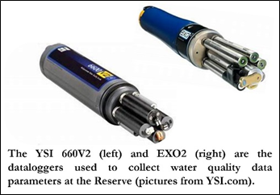The NBNERR System-Wide Monitoring Program (SWMP) has four water quality monitoring sites around Prudence Island (see map on Section 5, Site Location and Character). The principal objective of the SWMP program is to record short-term variability and long-term changes in water quality data in order to observe trends or patterns in water quality over time. Water quality parameters have been collected since 1995 with the establishment of the first water quality monitoring site at Potter Cove. Other three water quality sites (Nag Creek, T-Wharf Surface and T-Wharf Bottom) were brought online in 2002. These sites were selected to represent a gradient in habitat types that range from salt marsh (Nag Creek site) to shallow cove (Potter Cove) to open Bay water (T-Wharf Surface and T-Wharf Bottom). Water temperature, salinity, dissolved oxygen (% saturation, and mg L-1), pH, turbidity, and chlorophyll fluorescence data are collected at each site every 15 minutes using YSI 6600 V2 and YSI EXO2 data loggers (see image above) that are calibrated and swapped out at each site approximately every two to four weeks.

In July 2018, the T-Wharf Bottom site was upgraded with new telemetry equipment compatible with the new EXO2 data logger, which has been deployed at the site since the upgrade. All the other sites have been upgraded to EXO2 sondes as well: Nag Creek and Potter Cove in 2014 and T-Wharf Surface in 2016.

Complementary to the existing long-term water quality monitoring program, the NERRS implemented a new nutrient and chlorophyll monitoring program in 2002. The two sub-components of this program include monthly grab sampling at each of the four water quality sites, and diel sampling once a month at one site. The grab sampling program requires the collection of duplicate water samples every month from each of the 4 long-term water quality monitoring sites with the purpose of quantify seasonal patterns of nutrient and chlorophyll concentrations in different estuarine habitats (marsh creek, cove, surface open water, bottom open water). The diel sampling program requires to collect a series of samples from one site over an approximately a full tidal cycle (lunar day) each month to examine how nutrient and chlorophyll concentrations change over diel and tidal cycles. Previously (from 2002 to 2010) the diel site was located at T-Wharf. However, after analyzing the historic data from the site, no significant trends or patterns were found over time. Therefore, the diel site was moved to Potter Cove in January of 2011 in order to characterize nutrients and chlorophyll from this site. All collected grab and diel samples are analyzed for concentrations of phosphates (PO4), ammonia (NH4), nitrite (NO2), nitrate (NO3), NO2+NO3, dissolved inorganic nitrogen (DIN), silicates (SiO4) and chlorophyll *a*.

Meteorological data collected at the NBNERR since 2001 is continuously used to support the aforementioned water quality and nutrient monitoring programs, the biological monitoring efforts at the Reserve, and to assist scientific research and monitoring projects, as well as stewardship, training, and educational activities around Narragansett Bay.

A Physical Oceanographic Real-Time System (PORTS) meteorological station is housed in the NERRS weather station at Potter Cove and independently records air temperature, atmospheric pressure, wind speed, and wind direction. This is one of six PORTS meteorological stations in Narragansett Bay. The purpose of PORTS is to support safe and cost-efficient navigation. Data are available real-time, and the system is managed for quality control.

Bob Marshall of the Prudence Island Groundwater Task Force has been using the NBNERR precipitation data since 2006. These data are being used in conjunction with groundwater level and stream-flow monitoring efforts to evaluate the status of the groundwater resource on Prudence Island.

Robin Weber, GIS/Natural Resources Specialist from the NBNERR conducted tick population monitoring from 2008 to 2019 during the warmer months of the year, which over time, may inform management of the deer population and indicate the degree of public health risk for tick borne disease. Sampling success for ticks is influenced by environmental conditions (e.g., relative humidity, air temperature, precipitation), thus, meteorological data available from NBNERR’s weather station was incorporated in the data analysis for each sampling date and time to remove potential sources of variation in annual tick abundance levels.

# II. Physical Structure Descriptors

## Sensor Specifications, Operating Range, Accuracy, Date of Last Calibration

Parameter: **Temperature**

Units: Celsius

Sensor type: PT100 RTD, IEC 751 1/3 Class B, with calibrated signal conditioning

Operating Temperature: -40°C to +60°C

Range: -40°C to +60°C

Accuracy: ± 0.1°C at 23°C

*Model #:*  *HC2-S3*

**Serial Number: 60835193**

Date of calibration: 02/12/14

Dates of sensor use: 08/12/14 to 09/17/15

*Model #:*  *HC2-S3*

**Serial Number: 61180509**

Date of calibration: 03/17/15

Dates of sensor use: 09/17/15 to 09/08/16

*Model #:*  *HC2-S3*

**Serial Number: 60835193**

Date of calibration: 02/02/16

Dates of sensor use: 09/08/16 to 08/03/17

*Model #:*  *HC2-S3*

**Serial Number: 61180509**

Date of calibration: 06/16/17

Dates of sensor use: 08/03/17 to 10/22/18

*Model #:*  *HC2-S3*

**Serial Number: 60835193**

Date of calibration: 07/20/18

Dates of sensor use: 10/22/18 to 10/01/19

*Model #:*  *HC2-S3*

**Serial Number: 61180509**

Date of calibration: 03/21/19

Dates of sensor use: 10/01/19 current as of 12/31/19

Parameter: **Relative Humidity**

Units: Percent

Sensor type: ROTRONIC® Hygromer IN-1

Range: 0-100% non-condensing

Accuracy: ± 0.8% RH at 23°C with standard configuration settings

Temperature dependence: ± 3% (-40 to 60C)

*Model #:*  *HC2S3 (Temperature and Relative Humidity Probe)*

**Serial Number: 60835193**

Date of calibration: 02/12/14

Dates of sensor use: 08/12/14 to 09/17/15

*Model #:*  *HC2S3*

**Serial Number: 61180509**

Date of calibration: 03/17/15

Dates of sensor use: 09/17/15 to 09/08/16

*Model #:*  *HC2S3*

**Serial Number: 60835193**

Date of calibration: 02/02/16

Dates of sensor use: 09/08/16 to 08/03/17

*Model #:*  *HC2-S3*

**Serial Number: 61180509**

Date of calibration: 06/16/17

Dates of sensor use: 08/03/17 to 10/22/18

*Model #:*  *HC2-S3*

**Serial Number: 60835193**

Date of calibration: 07/20/18

Dates of sensor use: 10/22/18 to 10/01/19

*Model #:*  *HC2-S3*

**Serial Number: 61180509**

Date of calibration: 03/21/19

Dates of sensor use: 10/01/19 current as of 12/31/19

Parameter: **Barometric Pressure**

Units: millibars (mb)

Sensor type: Vaisala Barocap © silicon capacitive pressure sensor

Operating Range: Pressure: 600 to 1060 mb; Temperature: -40°C to +60°C

Humidity: non-condensing

Accuracy: ± 0.5 mb at +20°C, ± 1.5mb at 0°C to 40°C, ± 2.0 mb at -20°C to +45°C,

± 3.0 mb at -40°C to +60°C

Stability: ± 0.1 mb per year

*Model #:*  *CS-105*

**Serial Number: P4910009**

Date of calibration: 08/09/11

Dates of sensor use: 08/22/12 to 07/02/14

*Model #:*  *CS-105*

**Serial Number: X132022**

Date of calibration: 02/21/14

Dates of sensor use: 07/02/14 to 09/08/16 (retired)

*Model #:*  *CS-105*

**Serial Number: P4910009**

Date of calibration: 02/29/16

Dates of sensor use: 09/08/16 to 08/28/17 (retired)

Parameter: **Barometric Pressure**

Units: millibars (mb)

Sensor type: Vaisala Barocap © silicon capacitive pressure sensor

Operating Range: Pressure: 500 to 1100 mb; Temperature: -40°C to +60°C

Humidity: non-condensing

Accuracy: ± 0.3 mb at +20°C, ± 0.6 mb at 0°C to 40°C, ± 1 mb at -20°C to +45°C,

± 1.5 mb at -40°C to +60°C

Stability: ± 0.1 mb per year

*Model #:*  *CS-106*

**Serial Number: N0410377**

Date of calibration: 01/24/17

Dates of sensor use: 08/28/17 to 10/01/19

*Model #:*  *CS-106*

**Serial Number: P4330409**

Date of calibration: 10/24/18

Dates of sensor use: 10/01/19 current as 12/31/19

Parameter: **Wind Speed**

Units: meter per second (m s-1)

Model # R.M. Young 5305 L - AQ

Sensor type: 20 cm diameter 4-blade helicoid propeller carbon fiber thermoplastic

Range: 0-50 m/s (112 mph)

Accuracy: ±0.2 m/s (0.4 mph)

or

Model # R.M. Young 5103 - 5 Wind Monitor

Sensor type: 18 cm diameter 4-blade helicoids propeller molded of polypropylene

Range: 0-60 m s-1 (0-134 mph); gust survival 100 m s-1 (220 mph)

Accuracy: ± 0.3 m s-1 (± 0.6 mph)

*Model #:*  *R.M. Young 05305 L-AQ Wind Monitor*

**Serial Number: 75311**

Date of calibration: 01/28/13

Dates of sensor use: 07/31/13 to 09/17/15

*Model #:*  *R.M. Young 05103-5 Wind Monitor*

**Serial Number: 83868**

Date of calibration: 03/18/15

Dates of sensor use: 09/17/15 to present

*Model #:*  *R.M. Young 05305 L-AQ Wind Monitor*

**Serial Number: 75311**

Date of calibration: 06/20/17

Dates of sensor use: 08/28/17 to 09/17/19

*Model #:*  *R.M. Young 05103-5 Wind Monitor*

**Serial Number: 83868**

Date of calibration: 04/19/19

Dates of sensor use: 09/17/19 current as of 12/31/19

Parameter: **Wind Direction**

Units: degrees

Model # R.M. Young 5305 L – AQ

Sensor type: balanced vane, 48.3 cm turning radius

Range: 0-360° mechanical, 355° electrical (5° open)

Accuracy: ±3°

or

Model # R.M. Young 5103 -5 Wind Monitor

Sensor type: balanced vane, 38 cm turning radius

Range: 0-360° mechanical, 355° electrical (5° open)

Accuracy: ±3°

*Model #:*  *R.M. Young 05305 L-AQ Wind Monitor*

**Serial Number: 75311**

Date of calibration: 01/28/13

Dates of sensor use: 07/31/13 to 09/17/15

*Model #:*  *R.M. Young 05103-5 Wind Monitor*

**Serial Number: 83868**

Date of calibration: 03/18/15

Dates of sensor use: 09/17/15 to 08/28/17

*Model #:*  *R.M. Young 05305 L-AQ Wind Monitor*

**Serial Number: 75311**

Date of calibration: 06/20/17

Dates of sensor use: 08/28/17 to 09/17/19

*Model #:*  *R.M. Young 05103-5 Wind Monitor*

**Serial Number: 83868**

Date of calibration: 04/19/19

Dates of sensor use: 09/17/19 current as of 12/31/19

Parameter: **Photosynthetic Active Radiation**

Units: mmoles m-2 (total flux)

Sensor type: High stability silicon photovoltaic detector (blue enhanced)

Light spectrum waveband: 400 to 700 nm

Temperature dependence: 0.15% per °C maximum

Stability: <± 2% change over 1 yr. period

Response time: 10µs

Operating range: Temperature: -40°C to 65°C; relative humidity: 0 to 100%

Sensitivity: typically, 5 µA per 1000 µmoles s-1 m-2

*Model #:*  *LI190SB*

**Serial Number: Q31076**

Multiplier: 1.488875125065510, changed on 08/22/12

Date of calibration: 08/16/11

Dates of sensor use: 08/22/12 to 07/02/14 (retired)

*Model #:*  *LI190SB*

**Serial Number: Q22179**

Multiplier: 1.635997172996880, changed on 07/02/14

Date of calibration: 02/14/14

Dates of sensor use: 07/02/14 to 10/13/16 (retired)

Parameter: **Photosynthetic Active Radiation**

Units: mmoles m-2 (total flux)

Sensor type: photodiode

Light spectrum waveband: 410 to 655 nm

Temperature dependence: 0.06% ± 0.06 per °C

Stability: <± 2% change over 1 yr.

Operating range: Temperature: -40°C to 70°C; relative humidity: 0 to 100%

Cosine Response: 45° zenith angle: ± 2%; 75° zenith angle: ± 5%

Sensitivity: 0.2mV per µmoles s-1 m-2

Multiplier 0.025 (Multiplier never changes with the SQ110 Apogee Quantum Model)

*Model #:*  *SQ110 Apogee Quantum Sensor*

**Serial Number: 19451**

Date of calibration: 01/11/15

Dates of sensor use: 10/13/16 to 07/05/17

**Serial Number: 23189**

Date of calibration: 05/01/17

Dates of sensor use: 07/05/17 to 10/01/19

*Model #:*  *SQ110 Apogee Quantum Sensor*

**Serial Number: 19451**

Date of calibration: 03/25/19

Dates of sensor use: 10/01/19 current as of 12/31/19

Parameter: **Precipitation (not heated)**

Units: millimeters (mm)

Sensor type: Tipping bucket/magnetic reed switch

Funnel collector diameter: 6.06 inches (16.4 cm)

Rainfall per tip: 0.01 inch (0.254 mm)

Operating range: Temperature: 0° to 50°C; Humidity: 0 to 100%

Accuracy: ± 1% up to 1 in/hr; +0, -3% from 1 to 2 in/hr; +0, -5% from 2 to3 in/hr

*Model #:*  *TE525*

**Serial Number: 24701-899**

Date of calibration: 03/05/14

Dates of sensor use: 07/02/14 to 09/17/15

*Model #:*  *TR525I-R3*

**Serial Number: 31194-902**

Date of calibration: 03/19/15

Dates of sensor use: 09/17/15 to 10/13/16

*Model #:*  *TR525I-R3*

**Serial Number: 31194-902**

Date of calibration: 10/13/16

Dates of sensor use: 10/13/16 to 01/04/2017

Parameter: **Precipitation (heated)**

Units: millimeters (mm)

Sensor type: Tipping bucket/magnetic reed switch

Funnel collector diameter: 6.36 inches (16.0 cm)

Rainfall per tip: 0.004 inch (0.1 mm)

Operating range: Temperature: -20° to 50°C; Humidity: 0 to 100%

Heated thermostat set point: 10°C ± 3°C

Accuracy: ± 2% up to 1” (25mm)/hr.; 3% for up to 2” (50 mm)/hr.

*Model #:*  52202

**Serial Number: TB13505**

Date of calibration: 11/03/2016

Dates of sensor use: 01/04/2017 to 09/05/17

**Serial Number: TB13505**

Date of calibration: 09/05/17

Dates of sensor use: 09/05/17 to 10/22/18

**Serial Number: TB13505**

Date of calibration: 10/22/18

Dates of sensor use: 10/22/18 to 10/01/19

**Serial Number: TB13505**

Date of calibration: 10/01/19

Dates of sensor use: 10/01/19 current as of 12/31/19

**CR1000 Data logger**

The CR1000 has 2 MB Flash EEPROM that is used to store the Operating System. Another 128 K Flash is used to store configuration settings. A minimum of 2 MB SRAM is (4 MB optional upgrade) available for program storage (16K), operating system use, and data storage. Additional storage is available by using a compact flash card in the optional CFM100 Compact Flash Module.

Serial Number: 5245

Year of Manufacture: 2006

Date Installed: August 01, 2006

Date Calibrated: October 13, 2014

Date of use: Nov 24, 2014 – Nov 4, 2019 (replaced with loaner CR1000M(logger information in Remarks section) until CR1000X installed, see below)

Date Calibrated November 13, 2019

Date of use Not in use at the moment

CR1000 Firmware Version (s): OS32.04 uploaded on 10/10/19 current as of 12/31/2019

OS32.03 uploaded on 10/01/19 to 10/10/19

OS31 uploaded on 02/02/17 to 10/01/19

OS29 uploaded on 09/08/16 to 02/02/17

OS27 uploaded on 06/09/2014 to 09/08/16

CR1000 Program Version(s):

| **Program** | **Changes or notes included in the program** |
| --- | --- |
| narpcmet_7.0_100119.CR1 | Added note in the program about new weather box, new BP sensor, and swapping sensors. |
| narpcmet_7.0_102318.CR1 | Uploaded program to correct barometric sensor multiplier. |
| narpcmet_7.0_102218.CR1 | Uploaded program for air temperature / relative humidity sensor swap. |
| narpcmet_7.0_052118.CR1 | Last modified on May 21, 2018 by Daisy Durant. Uploaded the program to correct the barometric pressure multiplier. |
| narpcmet_7.0_082817.CR1 | Last modified on August 28, 2017 by Daisy Durant. Installed a new barometric pressure sensor C106 PTB110 SN WQ#263492 and updated the program. |
| narpcmet_7.0_080317.CR1 | Last modified on August 03, 2017 by Daisy Durant. Installed sensor to monitor humidity inside the enclosure that houses the telemetry equipment, power and CR1000. |
| narpcmet_7.0_070517.CR1 | Last modified on July 05, 2017 by Daisy Durant. Installed a new PAR sensor (Apogee SQ-110); specs included in the program. |
| narpcmet_7.0_051017.CR1 | Last modified on May 10, 2017 by Daisy Durant. Uploaded the program to delete an incorrect line in the CR1000 code: If RHumidity>100 and RHumidity<108 then RHumidity=100. A decision was made by the DMC to discontinue correcting >100 RH values to 100. |
| narpcmet_7.0_010417.CR1 | Last modified on January 04, 2017 by Daisy Durant. Included the new RM Young heated rain gauge Model 52202. |
| narpcmet_7.0_101316.CR1 | Last modified on October 13, 2016 by Daisy Durant. Included the new PAR sensor, Apogee SQ-110. |
| narpcmet_7.0_090816.CR1 | Uploaded the program after updating the OS27 to OS29, and after switching the air temp/relative humidity and barometric pressure sensor with recalibrated ones. |
| narpcmet_7.0_091815.CR1 | Last modified on September 18, 2015 by Daisy Durant. No major changes to the program, just added a note regarding the new cable installed on the rain gauge. |
| narpcmet_7.0_112414.CR1 | Last modified on November 24, 2014 by Daisy Durant. No major changes to the program, just added a note regarding the calibration of the CR1000. |
| narpcmet_7.0_070214.CR1 | Last modified on July 02, 2014 by Daisy Durant to include the specs of a new ATRH bought and installed in August. |
| narpcmet_6.4_091213.CR1 | Last modified on Sep 12 2013 by Daisy Durant. Installed HMP45C SN 1294801 (same as X3410026) Temperature & Relative Humidity Sensor. Needed changes in the program because this sensor was initially 7-wire but was switched to 6 at Campbell Scientific. |
| narpcmet_6.4_082113.CR1 | Last modified on August 21 2013 by Daisy Durant. Added the details of a different rain gauge to the program. |
| narpcmet_6.3_073113.CR1 | Last modified on July 31, 2013 by Daisy Durant. Uploaded new version of the program that includes models, serial numbers, frequency of calibration, and wiring of all sensors currently being used at this station. |
| narpcmet_V6.2_082312.CR1 | Last modified on August 23, 2012 by Daisy Durant and Jeff Adams (Campbell Sci). Added PAR Multiplier of 1.48887512506610. Added new AT/RH sensor HC2S3 and comment on wiring. |
| narpcmet_V6.2_082212.CR1 | Last modified on August 22, 2012 by Daisy Durant. Added PAR Multiplier of 1.488875125065510. |
| narpcmet_V6.1_082212.CR1 | Last modified on August 04, 2010 by Daisy Durant & Jay Poucher. Added PAR Multiplier of 1.582819445. |

**CR1000X Data logger**

The CR1000X has a total onboard memory of 128 MB of flash and 4MB of battery backed SRAM. There is 8 MB of flash memory reserved for loading the operating system and 1MB of flash reserved for configuration settings. SRAM is used for the CRBasic program operating memory, communication memory, and data storage, with 72 MB of flash for extended data storage. Additional data storage expansion is available with a removable microSD flash memory card of up to 16 GB.

Serial Number: 12962

Year of Manufacture: 2019

Date Installed: December 23rd, 2019

Date Calibrated: October 10, 2019

Date of use: December 23rd, 2019 – current as of 12/31/2019

CR1000X Firmware Version (s): OS 3.02 uploaded on 10/10/19 - current as of 12/31/19

CR1000X Program Version(s):

| **Program** | **Changes or notes included in the program** |
| --- | --- |
| NARPCMET_CR1000X_6.0_122619.CR1X | Uploaded the program to correct the wind meter codes; wind meter was not collecting data due to program error. |
| NARPCMET_CR1000X_6.0_122319.CR1X | Uploaded new program for CR1000X. |

## Coded Variable Definitions

Sampling station: Sampling site code: Station code:

Potter Cove PC narpcmet

## QAQC Flag Definitions

QAQC flags provide documentation of the data and are applied to individual data points by insertion into the parameter’s associated flag column (header preceded by an F_). During primary automated QAQC (performed by the CDMO), -5, -4, and -2 flags are applied automatically to indicate data that is above or below sensor range or missing. All remaining data are then flagged 0, as passing initial QAQC checks. During secondary and tertiary QAQC 1, -3, and 5 flags may be used to note data as suspect, rejected due to QAQC, or corrected.

-5 Outside High Sensor Range

-4 Outside Low Sensor Range

-3 Data Rejected due to QAQC

-2 Missing Data

-1 Optional SWMP supported parameter

0 Passed Initial QAQC Checks

1 Suspect Data

2 *Open - reserved for later flag*

3 *Open - reserved for later flag*

4 Historical Data: Pre-Auto QAQC

5 Corrected Data

## QAQC Code Definitions

QAQC codes are used in conjunction with QAQC flags to provide further documentation of the data and are also applied by insertion into the associated flag column. There are three (3) different code categories, general, sensor, and comment. General errors document general problems with the CR1000/CR1000X, sensor errors are sensor specific, and comment codes are used to further document conditions or a problem with the data. Only one general or sensor error and one comment code can be applied to a particular data point, but some comment codes (marked with an * below) can be applied to the entire record in the F_Record column.

General Errors

GIM Instrument Malfunction

GIT Instrument Recording Error, Recovered Telemetry Data

GMC No Instrument Deployed due to Maintenance/Calibration

GMT Instrument Maintenance

GPD Power Down

GPF Power Failure / Low Battery

GPR Program Reload

GQR Data Rejected Due to QA/QC Checks

GSM See Metadata

Sensor Errors

SDG Suspect due to sensor diagnostics

SIC Incorrect Calibration Constant, Multiplier or Offset

SIW Incorrect Wiring

SMT Sensor Maintenance

SNV Negative Value

SOC Out of Calibration

SQR Data rejected due to QAQC checks

SSD Sensor Drift

SSN Not a Number / Unknown Value

SSM Sensor Malfunction

SSR Sensor Removed

Comments

CAF Acceptable Calibration/Accuracy Error of Sensor

CCU Cause Unknown

CDF Data Appear to Fit Conditions

CML Snow melt from previous snowfall event

CRE* Significant Rain Event

CSM* See Metadata

CVT* Possible Vandalism/Tampering

CWE* Significant weather event

## Other Remarks and Notes

Data are missing due to equipment or associated specific sensors not being deployed, equipment failure, time of maintenance or calibration of equipment, or repair/replacement of a sampling station platform. Any NANs in the dataset stand for “not a number” and are the result of low power, disconnected wires, or out of range readings. If additional information on missing data is needed, contact the Research Coordinator at the reserve submitting the data.

Relative Humidity data greater than 100 are within range of the sensor accuracy of ± 3% and are flagged and coded as suspect, <1> (CAF). Values greater than 103 are rejected <-3>.

Data recorded for all parameters (with the exception of cumulative precipitation) at the midnight timestamp (00:00) are the 15-minute averages and totals for the 23:45-23:59 time period of the previous day. Cumulative precipitation data at the midnight timestamp (00:00) are the sum of raw (unrounded) precipitation data from 00:00 to 23:59 of the previous day. Summing each individual 15-minute total precipitation value from the same period will result in small differences from cumulative precipitation due to rounding. It is especially important to note how data at the midnight timestamp are recorded when using January 1st and December 31st data. **Note: Cumulative precipitation is no longer available via export from the CDMO. Please contact the reserve or the CDMO for more information or to obtain these data.**

The following are descriptions of different events that happened at the weather station during 2019, and explanations to the CSM (Comment-See Metadata) code used in the data file.

**During the NAR 2023 MET review the CDMO discovered that the wind speed multiplier had not been updated in the logger program following sensor swaps. Wind speed and maximum wind speed values were corrected from 09/17/2019 12:00 through the end of 2019. The R.M. Young 5305 model (SN 75311) has a multiplier of 0.1024 while the R.M. Young 5103 (SN 83868) has a multiplier of 0.0980. To make the corrections, data were divided by the incorrect multiplier, 0.1024, and that value was multiplied by correct multiplier, 0.0980. The data were flagged and coded 5 SIC CSM, unless rejected or missing. When telemetry data were used, GIT replaced the SIC code. Corrected data are considered suspect.**

Snow Events

The following were snow events reported by NOAA on the National Weather Service website at https://www.ncdc.noaa.gov/cdo-web/datasets/GHCND/stations/GHCND:USW00014765/detail. The Reserve’s heated rain gauge capture these events and recorded them as snow melt or liquid precipitation in the Total Precipitation Column and the Cumulative Precipitation Column of the dataset. Cumulative precipitation (mm) is measured over a period of 24 hours, and the data reported at midnight timestamp (00:00) are the sum of raw precipitation data from 00:00 to 23:59 of that day. For this reason, any flagging and coding in this column is extended until the midnight timestamp. For the snow events that follow, the data were flagged and coded as 1 GSM CML.

* January 19, 23:00 – January 20 15:15
* February 12, 13:00 – February 13 05:30
* February 18, 02:00 – 11:00
* February 27, 20:30 – 23:00
* February 28, 01:45 – 04:30
* March 02, 04:45 – 13:45
* March 03, 21:30 – March 04 09:00

September 17. The weather station was powered down to swap the wind sensor for a recently serviced one. As a result,

* 09/17 09:30 – the station was powered down for a few minutes to disconnect the wind senor’s wires from the CR1000. These data were rejected because it is possible that this timestamp is not a full 15 minutes of averaged 5 second data. The data were flagged and coded -3 GPD CSM.
* 09/17 09:45 – 11:30 the station collected wind data as ‘0’ because the sensor was removed. These data were rejected and flagged and coded -3 SSR CSM.
* 09/17 11:45 – the station was powered down to reconnect the newly serviced wind sensor. No data were collected; therefore, the missing data were flagged and coded -2 GPD CSM.
* 09/17 12:00 – the station was powered back on and the program (narpcmet_V7.0_091719) was reloaded. These data were rejected because it is possible that this timestamp is not a full 15 minutes of averaged 5 second data. The data were flagged and coded -3 GPR CSM.

September 30th – October 1st. The weather station was powered down for about 26 hrs. to swap several sensors and install a new weather box enclosure. As a result,

* 09/30 09:45 – 10/01 11:30, the station was powered down to remove all instruments from the weather box enclosure, install a new enclosure, and install all instruments back. In addition, the air temperature / relative humidity, new barometric pressure, and photosynthetic active radiation sensors were swapped, and the rain gauge was recalibrated. The missing data were flagged and coded -2 GPD CSM.
* 10/01 11:45 – The station was powered back on and the program was reloaded (narpcmet_V7.0_100119.CR1). These data were rejected because it is possible that this timestamp is not a full 15 minutes of averaged 5 second data. The data were flagged and coded -3 GPR CSM.

November 4th. The weather station was powered down to disconnect the CR1000 data logger and send it to Campbell Scientific for recalibration. While the CR1000 is recalibrated, it was replaced with a data logger borrowed from Campbell Scientific, CR1000M, serial number 2816, calibration date March 07, 2018. As a result,

* 11/04 12:15 – 13:00, the station was powered down to swap the CR1000 with CR1000M. The missing data were flagged and coded -2 GPD CSM.
* 11/04 13:15 – The station was powered back on and the program was reloaded (narpcmet_V7.0_100119.CR1). These data were rejected because it is possible that this timestamp is not a full 15 minutes of averaged 5-second data. The data were flagged and coded -3 GPR CSM.

December 5th 10:30 – 11:45. Data missing. An attempt to replace the CR1000M(loaner) with a new data logger (CR1000X) was made during this period; however, the program was not ready. The CR1000M(loaner) was installed back and wired with the sensors. Missing data was flagged and coded -2 GPD CSM.

December 5th 12:00 – 23:45. Data missing due to an error while downloading from the data logger. As a result,

* Missing data were recovered from telemetry and considered suspect. Data were flagged and coded 1 GIT CSM beginning 12:15. First line of telemetry data (12:00) following the power down were rejected -3 GPD CSM.
* Cumulative Precipitation data could not be recovered from telemetry and were flagged and coded -2 GIT CSM.
* Max Temperature, Max Temperature Time, Minimum Temperature, Minimum Temperature Time could not be recovered; no flags or codes were used.

December 23, 12:00 – 13:30. The new CR1000X data logger was installed at the weather station; serial number 12962, calibrated on October 28, 2019. As a result,

* 12/23 12:00 –13:30, the station was powered down and all instruments were disconnected from the data logger and the new data logger was installed and wired with all instruments. The missing data were flagged and coded -2 GPD CSM.
* 12/23 13:45 – The station was powered back on and a new program was sent to the data logger (NARPCMET_CR1000X_6.0_122319.CR1X). These data were rejected because it is possible that this timestamp is not a full 15 minutes of averaged 5 second data. The data were flagged and coded -3 GPR CSM.

December 23 - 26. All wind-related data collected at the weather station were incorrect due to an error in the wind codes of the program uploaded on December 23. As a result,

* 12/23 14:00 –12/26 10:45. The weather station collected wind data during this period, but all data was equal to 0. These data were rejected since there was an error in the program. Data were flagged and coded -3 SIC CSM.

December 26. A new program was uploaded to correct the wind codes. As a result,

* 12/26 11:00, the station was powered down to check wiring of all sensors. The missing data were flagged and coded -2 GPD CSM.
* 12/26 11:15. The station was powered back on and the program was reloaded (NARPCMET_CR1000X_6.0_122619.CR1X). These data were rejected because it is possible that this timestamp is not a full 15 minutes of averaged 5 second data. The data were flagged and coded -3 GPR CSM.

Calibration Certificate – Air Temperature / Relative Humidity sensors, HC2S3 sensor

Date calibraated – March 21st, 2019

Date installed – October 01, 2019

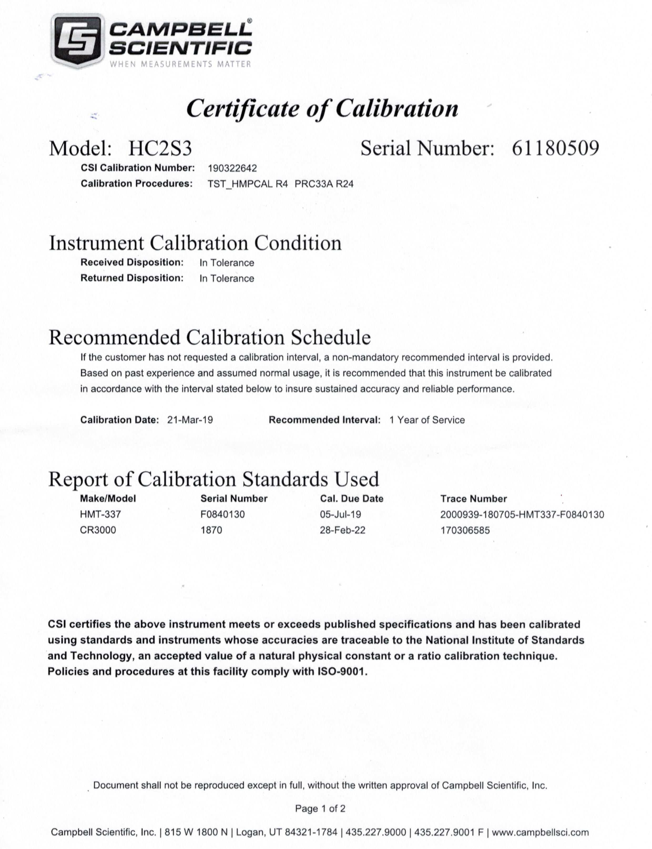

Calibration Certificate – Air Temperature / Relative Humidity sensors, HC2S3 (continued)

Date calibraated – March 21st, 2019

Date installed – October 01, 2019

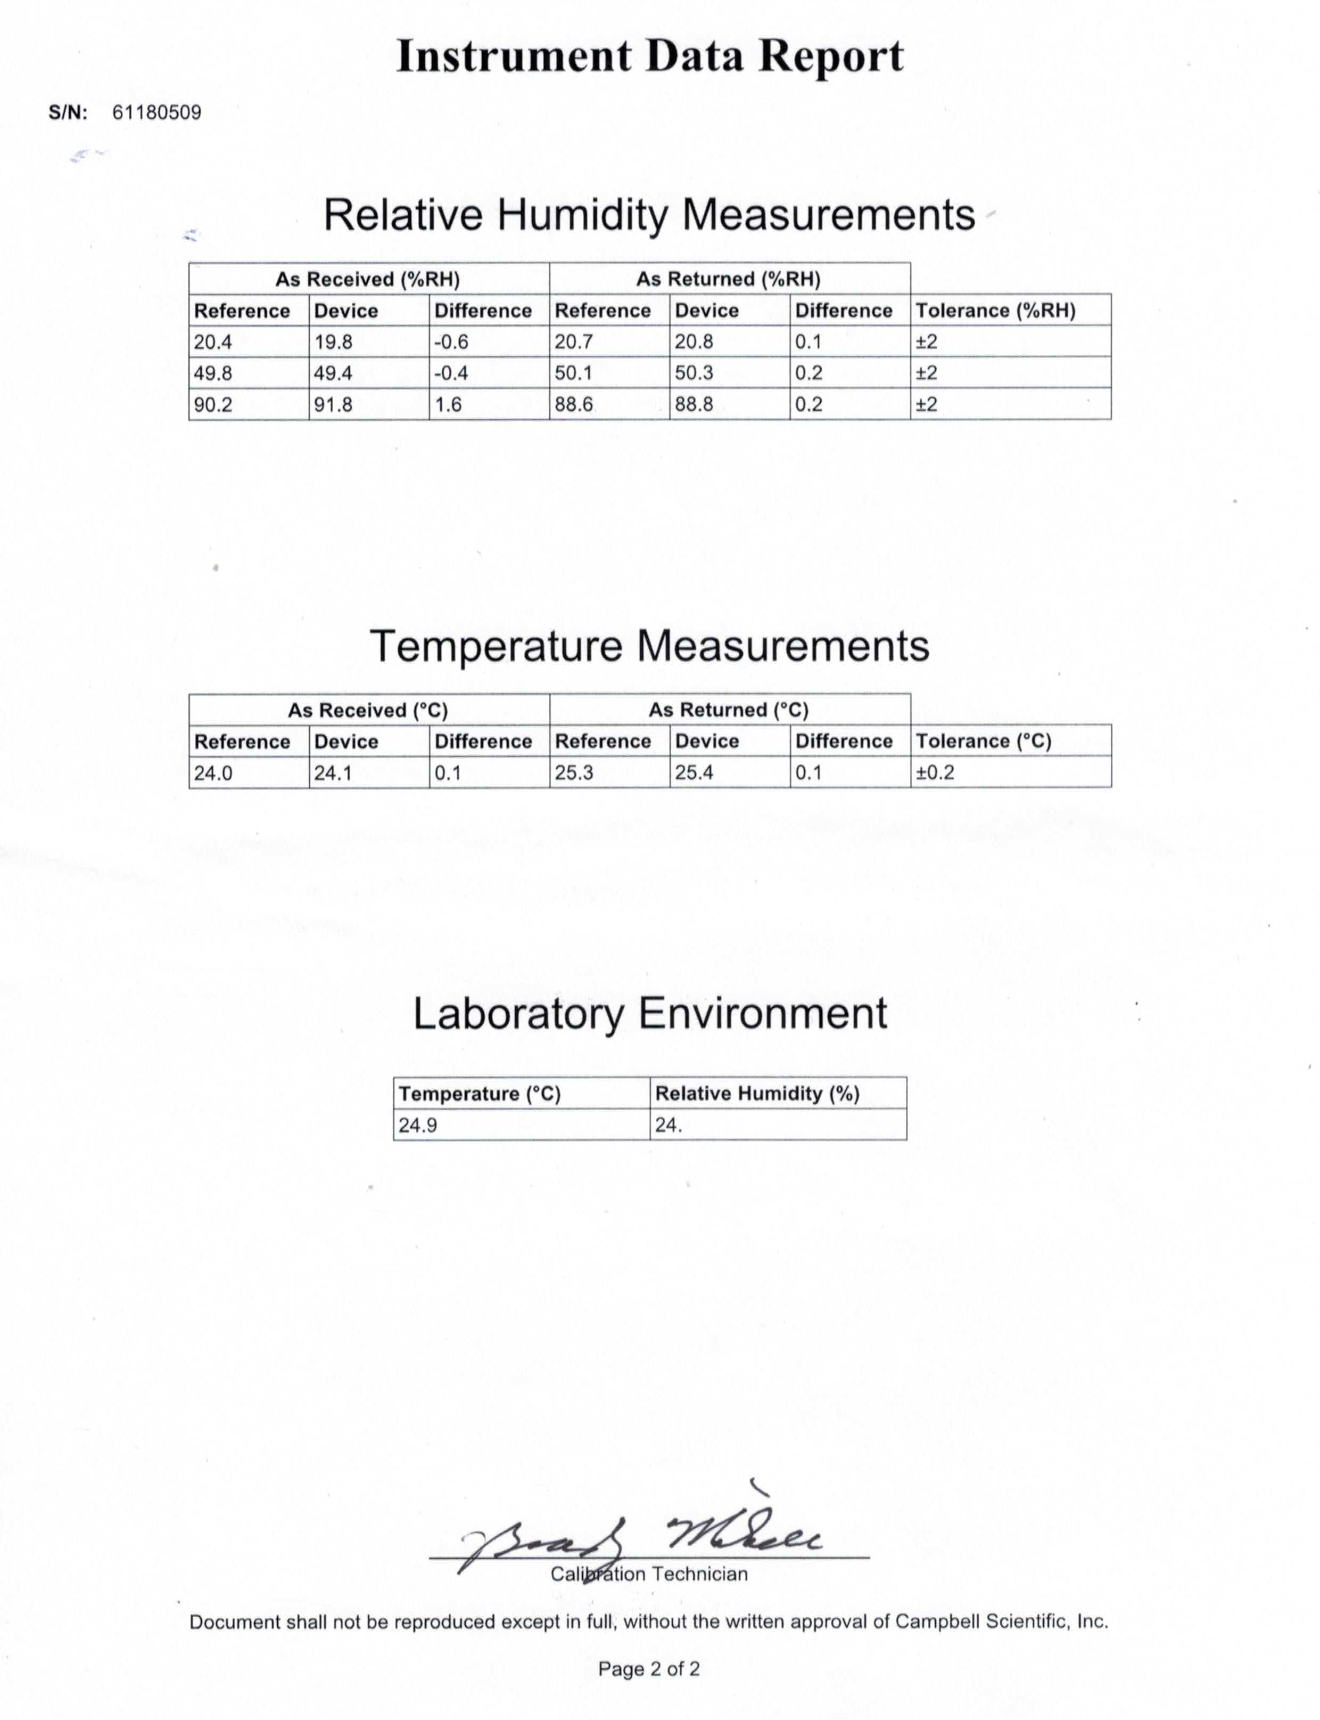

Service Certificate – Wind Sensor, RM Yound Model 05103

Date calibraated – April 19, 2019

Date installed – September 17, 2019

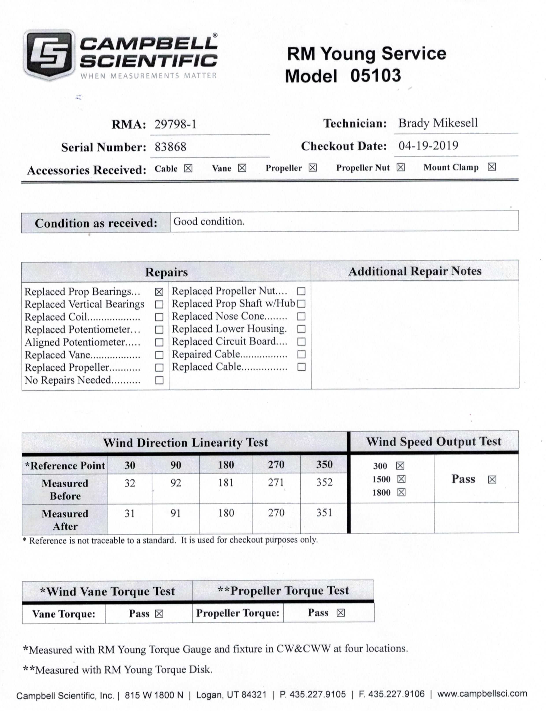

Calibration Certificate – Barometric Pressure sensor, Model PTB110B

Date calibraated – October 24th, 2018

Date installed – October 01, 2019

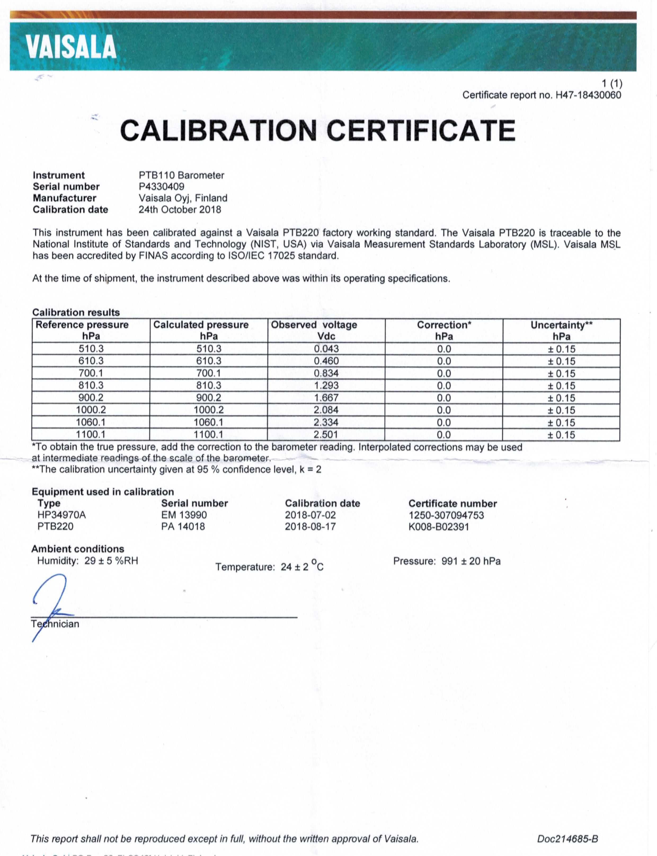

Calibration Certificate – Photosynthetic Active Radiation (PAR) sensor, Apogee SQ-110

Date calibraated – March 25th, 2019

Date installed – October 01, 2019

Calibration Certificate – Data logger CR1000

Date calibraated – November 13, 2019

Last Deployed: Nov 24, 2014 – Nov 4, 2019

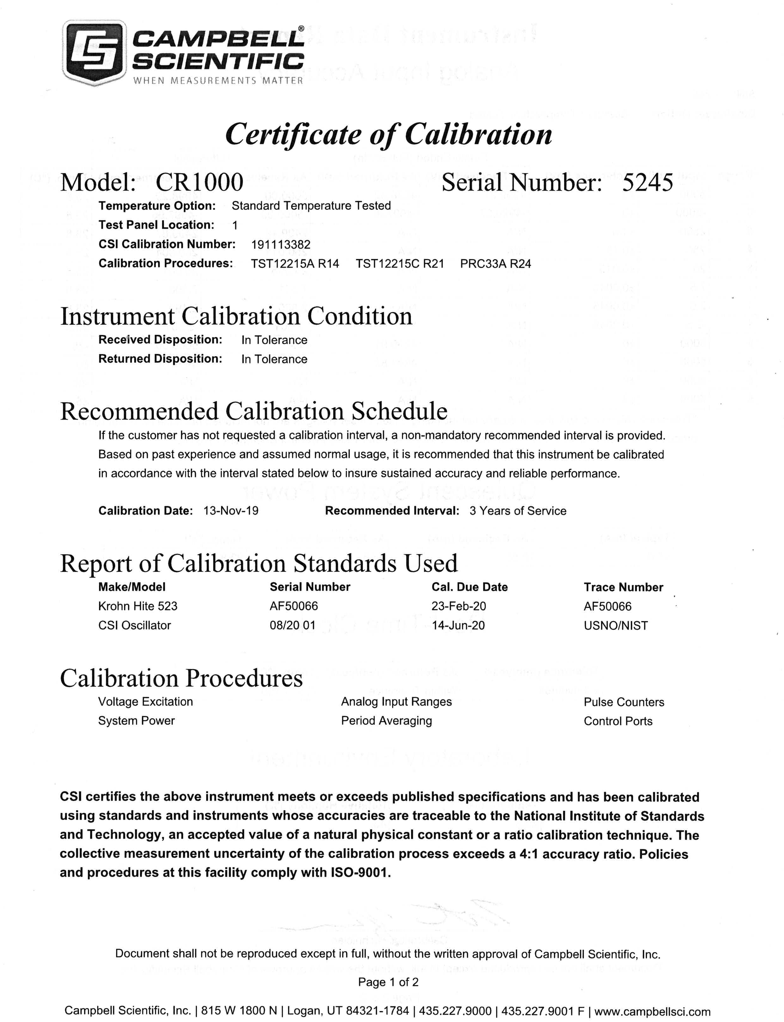

Calibration Certificate – Data logger CR1000 (continued)

Date calibraated – November 13, 2019

Last Deployed: Nov 24, 2014 – Nov 4, 2019

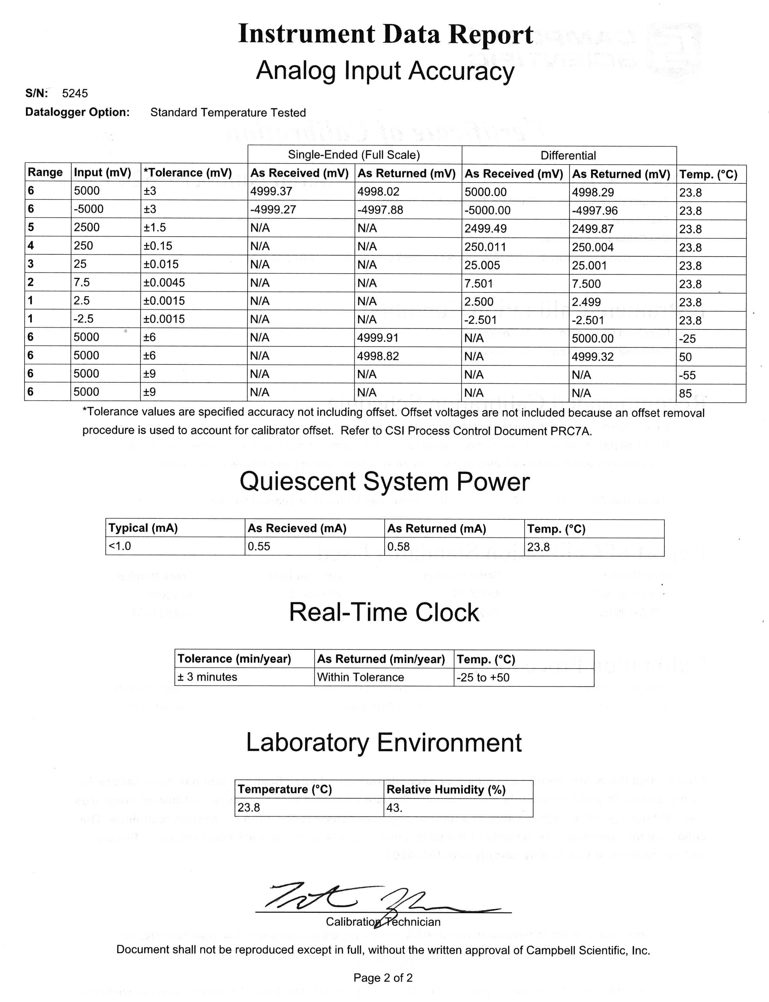

Calibration Certificate – Data logger CR1000X

Date calibraated – October 28, 2019

Date installed – December 23rd, 2019

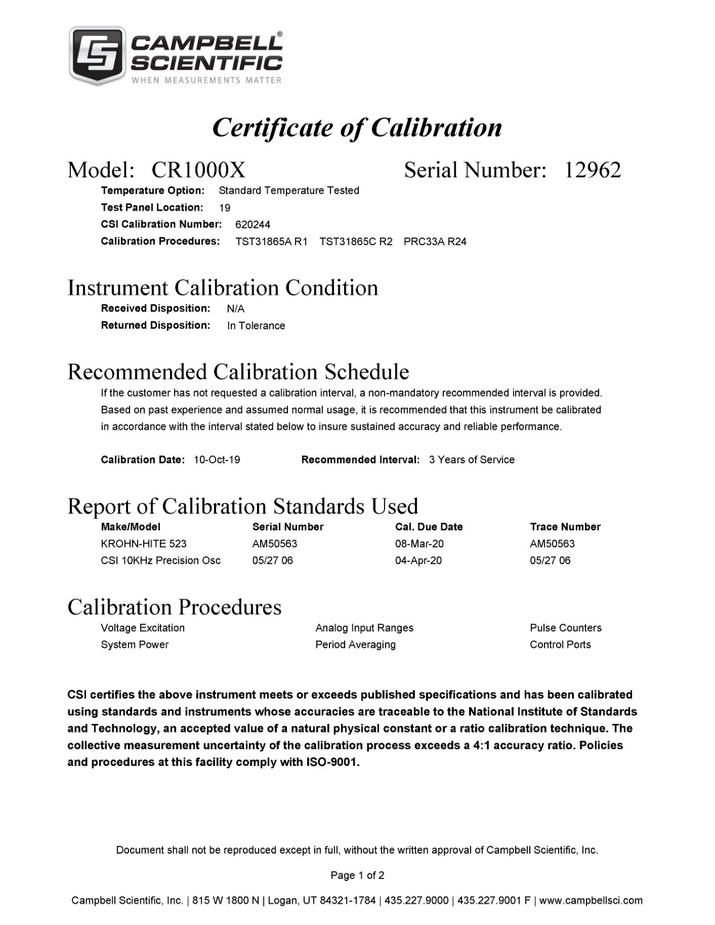

Calibration Certificate – Data logger CR1000X (continued)

Date calibraated – October 28, 2019

Date installed – December 23rd, 2019

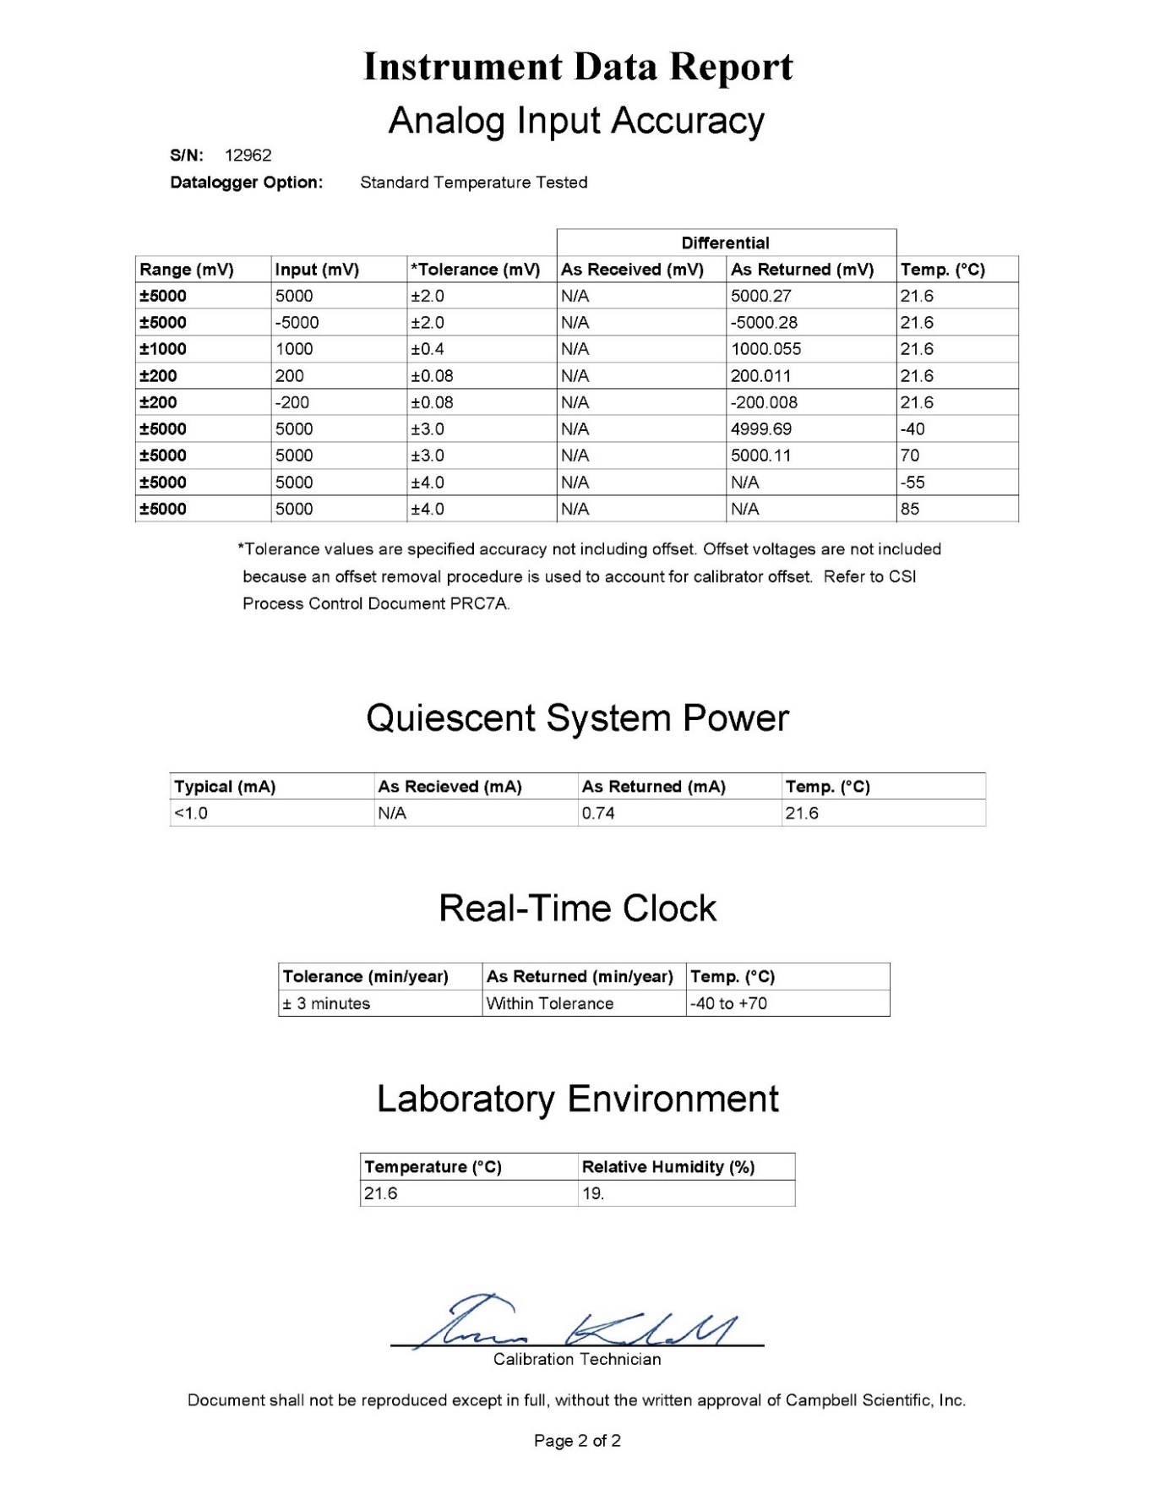

1. Pilson, M.E.Q. 1985. On the residence time of water in Narragansett Bay. *Estuaries* 8:2–14.
2. Narragansett Bay National Estuarine Research Reserve. 2007. An Ecological Profile of the Narragansett Bay National Estuarine Research Reserve. K.B. Raposa and M.L. Schwartz (eds.), *Rhode Island Sea Grant, Narragansett, R.I*. 176pp.