

**Narragansett Bay (NAR) NERR**

**Meteorological Metadata**

January – December 2023

Latest Update: Thursday, September 5, 2024

# I. Data Set and Research Descriptors

## Principal Investigator(s) and Contact Persons

Contact Persons:

Dr. Kenneth Raposa

Research Coordinator

E-mail: [kenneth.raposa@dem.ri.gov](mailto:kenneth.raposa@dem.ri.gov);

(401) 683-7849

Dr. Daisy Durant

SWMP Coordinator and Data Manager

E-mail: [daisy.durant@dem.ri.gov](mailto:daisy.durant@dem.ri.gov);

(401) 683-7368

Address: Narragansett Bay NERR

55 South Reserve Drive

(PO Box 151)

Prudence Island, RI 02872

Phone: 401-683-6780

Fax: 401-682-7366

## Entry Verification

Data are uploaded from the CR1000X data logger to a personal computer with a Windows 7 or newer operating system. Files are exported from LoggerNet in a comma-delimited format and uploaded to the CDMO where they undergo automated primary QAQC and become part of the CDMO’s online provisional database. During primary QAQC, data are flagged if they are missing or out of sensor range. The edited file is then returned to the reserve where it is opened in Microsoft Excel and processed using the CDMO’s NERRQAQC Excel macro. The macro inserts station codes, creates metadata worksheets for flagged data and summary statistics, and graphs the data for review. It allows the user to apply QAQC flags and codes to the data, append files, and export the resulting data file to the CDMO for tertiary QAQC and assimilation into the CDMO’s authoritative online database. For more information on QAQC flags and QAQC codes, see Sections 11 and 12.

Dr. Daisy Durant (SWMP Coordinator) was responsible for compiling and error checking the January through December 2023 weather data covered in this document.

## Research Objectives

The principal objective is to record long-term meteorological data for Narragansett Bay in order to observe any environmental changes or trends over time. These data are also used to support ongoing water quality, biological monitoring, scientific research, as well as stewardship, training, and education activities.

## Research Methods

At the Reserve, the Campbell Scientific data logger CR1000 has been used to collect meteorological parameters data from August 2006 to December 23, 2019, when an upgraded model, the CR1000X, was install. The CR1000 is kept at the Reserve as backup. The data loggers operating system is upgraded when Campbell Scientific releases new upgrades. Both data loggers are programed to collect data every 5 seconds to produce 15-minute averages of those measurements of air temperature, relative humidity, barometric pressure, wind speed, and wind direction; the data loggers collect totals for precipitation and photosynthetic active radiation, not averages. The CR1000/CR1000X program directs how and when the sensors measure and store data. All data are collected in Eastern Standard Time (UTC -5) and stored in the CR1000/CR1000X data logger. Monthly trips to the weather station are done to inspect, clean, and maintain all sensors and all other weather station related equipment. During these monthly trips, data are downloaded from the data logger via a RS-232 connection serial cable or USB cable (CR1000, CR1000X, respectively) to a laptop using the Campbell Scientific LoggerNet (v 3.4.1) program. The LoggerNet program was updated (v 4.6.1) in July 2019. The data logger is housed in a Campbell Scientific weather resistant enclosure. A satellite transmitter (TX312), a 12 V sealed rechargeable battery, a regulator (CH-100, which provides built-in temperature compensation to optimize battery performance), and a barometric pressure sensor (vented to the outside of the enclosure) are housed in the enclosure as well.

Campbell Scientific data telemetry equipment was installed at the Potter Cove weather station on July 31st, 2006, and transmits data to the NOAA GOES satellite, NESDIS ID 3B0211F8. The transmissions are scheduled hourly (transmission time: mm:ss after the hour = 01:40) and contain four (4) data sets reflecting fifteen-minute data sampling intervals. Upon receipt by the CDMO, the data undergoes the same automated primary QAQC process detailed in Section 2 above. The “real-time” telemetry data become part of the provisional dataset until undergoing secondary and tertiary QAQC and assimilation in the CDMO’s authoritative online database. Provisional and authoritative data are available at [http://cdmo.baruch.sc.edu](http://cdmo.baruch.sc.edu/).

The 15-minute data are collected in the following formats for the CR1000/CR1000X:

* Averages from 5-second data:
  + Air Temperature (°C)
  + Relative Humidity (%)
  + Barometric Pressure (mb)
  + Wind Speed (m/s)
  + Wind Direction (degrees)
  + Battery Voltage (volts).
* Maximum and Minimum Air Temperature (oC) and their times from 5-second data (these data are available from the Reserve).
* Maximum Wind Speed (m/s) and time from 5-second data.
* Wind Direction Standard Deviation (degrees).
* Totals:
  + Precipitation (mm)
  + PAR (millimoles/m2)
  + Cumulative Precipitation (mm) (Cumulative precipitation is no longer available via export from the CDMO. Please contact the Reserve or the CDMO for more information or to obtain these data.)

The recommended calibration frequency for the MET station sensors according to manufacturer recommendations are:

* Temperature/Humidity yearly recalibration
* Precipitation Gauge yearly recalibration
* Wind Speed/Direction yearly or every 2 years (depending on the sensor)
* Barometric Pressure every 2 years recalibration
* PAR every 2 years recalibration
* CR1000 every 5 years
* CR1000X every 5 years

Ground-truthing is conducted during the monthly trips, and data on air temperature, relative humidity, barometric pressure, and wind speed are collected with a Kestrel 5000 weather meter; wind direction is determined with a handheld compass; and photosynthetic active radiation is measured with a LiCor 1400 equipped with a LI-190SB quantum sensor; total precipitation is checked from the T.F. Green Airport NOAA weather station in Providence, RI; weather data collected from the airport is available online at <https://w2.weather.gov/climate/index.php?wfo=box>. These ground-truthing data are used to compare with the data collected by the weather station on Prudence Island (PI) to ensure accuracy of the readings. Ground-truthing data are recorded on the meteorological monthly log, kept at the Reserve and at CDMO, and available upon request.

## Site Location and Character

The NAR NERR is located close to the geographic center of Narragansett Bay in Rhode Island. It consists of approximately 1802 hectares (4453 acres: 2544 acres of land plus 1909 acres of surrounding estuarine waters, approximately) of diverse estuarine and terrestrial habitats ranging from deep water to salt marshes to forested uplands. The land holdings include approximately 65% of PI, most of nearby Patience Island, and all of Hope and Dyer Islands. The last land acquisition was the Eugene Chase Farm property in 2015.

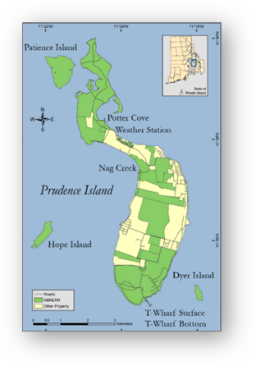

The Narragansett Bay watershed consists of nine subwatersheds draining an area of approximately 4,836square km [1](Pilson, 1985) and numerous and substantial freshwater inputs to the Bay. Approximately 39% of the watershed lies in Rhode Island and 61% in Massachusetts. It is referred to as a shallow estuary; however, its water depth varies considerably. Depth averages approximately 9.0 m throughout the Bay, but it is deeper in the East Passage (approximately 15.2 m) and shallower in the West Passage (approximately 7.5 m). More information and a detailed description of the Narragansett Bay NERR and the Narragansett Bay watershed can be found in [2]Raposa and Schwartz (2007), available to download at <http://nbnerr.org/additional-resources/>.

Figure 1. Map (image at right) show the approximate location of the weather station, and the long-term water quality monitoring sites (Potter Cove, Nag Creek, T-Wharf Surface, and T-Wharf Bottom). Land preserved by NAR NERR is also included (in green).

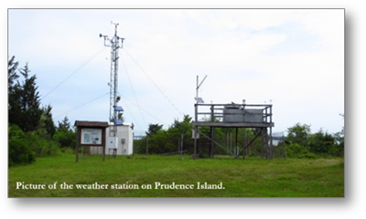

The weather station is located on Prudence Island (41o 38’ 13.703” N, 71o 20’ 21.790” W, Trimble Geo XT, GeoExplorer 2008 Series, Figure 1) in a grassland area bordering the cove, approximately 389 m south of the SWMP long-term water quality monitoring station at Potter Cove that has been collecting data since 1995. Meteorological data has been collected at the weather station since 2001 (Table 2). All sensors were installed in accordance with manufacturer recommendations to avoid the possible influence of shading, wind blocks, etc., as follows in detail, and summarized on Table 1.

In 2001, the wind monitor was installed at the top of a 10 m high aluminum tower, the temperature and humidity sensor were installed at approximately 2.0 m off the ground on the same aluminum tower. The photosynthetic active radiation (PAR) sensor was installed on a shorter (3 m) aluminum tower. The rain gauge was located to the NE, away from the tower and other obstructions. The barometric pressure sensor was located within the housing of the data logger, inside a small wood shed to the east of the aluminum tower.

A large wooden platform approximately 2.4 m W x 1.8 m D x 2.1 m H has been situated at the weather station, approximately, since 1991. It was originally constructed by the U.S. Environmental Protection Agency (EPA) to hold atmospheric deposition equipment, which is no longer in use. Permission secured from the EPA gave access to this platform for weather station equipment. In the summer of 2006, when the telemetry equipment was installed, some sensors were moved to the platform as well. The Campbell Scientific weather resistant enclosure was relocated under the platform and contains the data logger (CR1000/CR1000X) and all associated hardware and telemetry equipment, as well as the barometric pressure unit (approximately 1.8 m off the ground). The GPS antenna, solar panel, and Yagi antenna were installed on top of the platform railing. The PAR meter was also relocated to the platform to make it more accessible for cleaning than the previous location; it sits on the platform railing at, approximately, 3.68 m off the ground. The rain gauge was also moved to the platform railing in November of 2006, sitting at approximately 3.46 m off the ground.

Table 1. Summary of sensor installation specifications.

| **Tower and sensor heights** | **Height (meters)** | **Notes** |
| --- | --- | --- |
| Tower | 10 m | On top of tower |
| Temperature/Relative Humidity | 2 m | On tower |
| Wind | 10 m | On tower |
| Platform, since 2006 | 2.4 m W x 1.8 m D x 2.1 m H | Railing not included in H |
| Barometric Pressure | 1.8 m from the ground | Inside weather resistant housing under platform |
| PAR | 3.68 m off the ground | On platform rail |
| Precipitation gauge | 3.46 m off the ground | On platform rail |

Table 2. Details of NAR NERR SWMP Weather Station Timeline. SWMP Status Column: P = primary SWMP Station, Reason Decommissioned Column and Notes Column: NA = Not applicable.

|  |  |  |  |  |  |  |
| --- | --- | --- | --- | --- | --- | --- |
| **Station Code** | **Station Name** | **SWMP Status** | **Location** | **Active Dates** | **Reason Decommissioned** | **Notes** |
| NARPCMET | Potter Cove | P | 41° 38' 13.70 N  71° 20' 21.79 W | 01/01/2001- present | NA | NA |

## Data Collection Period

Meteorological data has been collected at the weather station on Potter Cove since 1992. However, it was not until 2001 when the meteorological station was updated and became part of NERR-SWMP. Data collected during 2023 are included in files downloaded from the CR1000X data logger from January 01 to December 31 (Table 3).

Table 3. Date and time of the first and last readings in raw data files downloaded from the CR1000X data logger at the weather station on Prudence Island from January to December 2023.

| **First Reading in File** | | **Last Reading in File** | |
| --- | --- | --- | --- |
| **Date** | **Time** | **Date** | **Time** |
| 01/01/2023 | 00:00 | 01/31/2023 | 23:45 |
| 02/01/2023 | 00:00 | 02/28/2023 | 23:45 |
| 03/01/2023 | 00:00 | 03/31/2023 | 23:45 |
| 04/01/2023 | 00:00 | 04/30/2023 | 23:45 |
| 05/01/2023 | 00:00 | 05/31/2023 | 23:45 |
| 06/01/2023 | 00:00 | 06/06/2023 | 12:15 |
| 06/06/2023 | 00:00 | 06/06/2023 | 13:00 |
| 06/06/2023 | 13:15 | 06/30/2023 | 23:45 |
| 07/01/2023 | 00:00 | 07/06/2023 | 10:15 |
| 07/06/2023 | 10:30 | 07/31/2023 | 23:45 |
| 08/01/2023 | 00:00 | 08/31/2023 | 23:45 |
| 09/01/2023 | 00:00 | 09/05/2023 | 10:15 |
| 09/05/2023 | 10:45 | 09/30/2023 | 23:45 |
| 10/01/2023 | 00:00 | 10/31/2023 | 23:45 |
| 11/01/2023 | 00:00 | 11/30/2023 | 23:45 |
| 12/01/2023 | 00:00 | 12/31/2023 | 23:45 |

## Distribution

NOAA retains the right to analyze, synthesize and publish summaries of the NERRS System-wide Monitoring Program data. The NERRS retains the right to be fully credited for having collected and processed the data. Following academic courtesy standards, the NERR site where the data were collected should be contacted and fully acknowledged in any subsequent publications in which any part of the data are used. The data set enclosed within this package/transmission is only as good as the quality assurance and quality control procedures outlined by the enclosed metadata reporting statement. The user bears all responsibility for its subsequent use/misuse in any further analyses or comparisons. The Federal government does not assume liability to the Recipient or third persons, nor will the Federal government reimburse or indemnify the Recipient for its liability due to any losses resulting in any way from the use of this data.

Requested citation format:

NOAA National Estuarine Research Reserve System (NERRS). System-wide Monitoring Program. Data accessed from the NOAA NERRS Centralized Data Management Office website: <http://www.nerrsdata.org/>; *accessed* 12 October 2023.

NERR meteorological data and metadata can be obtained from the Research Coordinator at the individual NERR site (please see Principal Investigators and Contact Persons), from the Data Manager at the Centralized Data Management Office (please see personnel directory under the general information link on the CDMO home page) and online at the CDMO home page [www.nerrsdata.org](http://www.nerrsdata.org). Data are available in comma delimited format.

## Associated Researchers and Projects

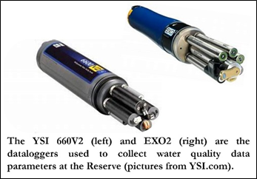The NAR NERR System-Wide Monitoring Program (SWMP) has four long-term water quality monitoring sites around Prudence Island (see map on Section 5, Site Location and Character). The principal objective of the SWMP program is to record short-term variability and long-term changes in water quality data in order to observe trends or patterns in water quality over time. Water quality parameters have been collected since 1995 with the establishment of the first water quality monitoring site at Potter Cove. Other three water quality sites (Nag Creek, T-Wharf Surface, and T-Wharf Bottom) were brought online in 2002. These sites were selected to represent a gradient in habitat types that range from salt marsh (Nag Creek site) to shallow cove (Potter Cove) to open Bay water (T-Wharf Surface and T-Wharf Bottom). Water temperature, salinity, dissolved oxygen (% saturation, and mg L-1), pH, turbidity, depth, and chlorophyll fluorescence data are collected at each site every 15 minutes using YSI 6600 V2 and YSI EXO2 data loggers (see image above) that are calibrated and swapped out at each site approximately every three to four weeks.

In July 2018, the T-Wharf Bottom site was upgraded with new telemetry equipment compatible with the new EXO2 data logger, which has been deployed at the site since the upgrade. All the other water quality sites have been upgraded to EXO2 sondes as well: Nag Creek and Potter Cove in 2014 and T-Wharf Surface in 2016.

Complementary to the existing long-term water quality monitoring program, the NERRS implemented a new nutrient and chlorophyll monitoring program in 2002. The two sub-components of this program include monthly grab sampling at each of the four water quality sites, and diel sampling once a month at one site. The grab sampling program requires the collection of duplicate water samples every month from each of the 4 long-term water quality monitoring sites with the purpose of quantify seasonal patterns of nutrient and chlorophyll concentrations in different estuarine habitats (marsh creek, cove, surface open water, bottom open water). The diel sampling program requires to collect a series of samples from one site over an approximately a full tidal cycle (lunar day) each month to examine how nutrient and chlorophyll concentrations change over diel and tidal cycles. Previously (from 2002 to 2010) the diel site was located at T-Wharf. However, after analyzing the historic data from the site, no significant trends or patterns were found over time. Therefore, the diel site was moved to Potter Cove in January of 2011 in order to characterize nutrients and chlorophyll from this site. All collected grab and diel samples are analyzed for concentrations of phosphates (PO4), ammonia (NH4), nitrite (NO2), nitrate (NO3), NO2+NO3, dissolved inorganic nitrogen (DIN), silicates (SiO4) and chlorophyll *a*.

Meteorological data collected at the NAR NERR since 2001 is continuously used to support the water quality and nutrient monitoring programs, the biological monitoring efforts at the Reserve, and to assist scientific research and monitoring projects, as well as stewardship, training, and educational activities around Narragansett Bay.

A Physical Oceanographic Real-Time System (PORTS) meteorological station is housed in the NERRS weather station at Potter Cove and independently records air temperature, atmospheric pressure, wind speed, and wind direction. This is one of six PORTS meteorological stations in Narragansett Bay. The purpose of PORTS is to support safe and cost-efficient navigation. Data are available real-time, and the system is managed for quality control.

Bob Marshall of the PI Groundwater Task Force has been using the NAR NERR precipitation data since 2006. These data are being used in conjunction with groundwater level and stream-flow monitoring efforts to evaluate the status of the groundwater resource on Prudence Island.

From 2008 to 2019 Robin Weber, GIS/Natural Resources Specialist from the NAR NERR, and then Jon Mitchell, Stewardship Coordinator in 2021, conducted tick population monitoring during the warmer months of the year, which over time, may inform management of the deer population and indicate the degree of public health risk for tick borne disease. Sampling success for ticks is influenced by environmental conditions (e.g., relative humidity, air temperature, precipitation), thus, meteorological data available from NAR NERR’s weather station was incorporated in the collection and analysis of data for each sampling date and time to remove potential sources of variation in annual tick abundance levels.

# II. Physical Structure Descriptors

## Sensor Specifications, Operating Range, Accuracy, Date of Last Calibration

Parameter: **Temperature**

Units: Celsius

Sensor type: PT100 RTD, IEC 751 1/3 Class B, with calibrated signal conditioning

Operating Temperature: -40°C to +60°C

Range: -40°C to +60°C

Accuracy: ± 0.1°C at 23°C

*Model #:*  *HC2S3 (Temperature and Relative Humidity Probe)*

**Serial Number: 60835193**

Date of calibration: 02/12/14

Dates of sensor use: 08/12/2014 to 09/17/2015

**Serial Number: 61180509**

Date of calibration: 03/17/2015

Dates of sensor use: 09/17/2015 to 09/08/2016

**Serial Number: 60835193**

Date of calibration: 02/02/2016

Dates of sensor use: 09/08/2016 to 08/03/2017

**Serial Number: 61180509**

Date of calibration: 06/16/2017

Dates of sensor use: 08/03/2017 to 10/22/2018

**Serial Number: 60835193**

Date of calibration: 07/20/2018

Dates of sensor use: 10/22/2018 to 10/01/2019

**Serial Number: 61180509**

Date of calibration: 03/21/2019

Dates of sensor use: 10/01/2019 to 10/08/2020

**Serial Number: 60835193**

Date of calibration: 08/19/2020

Dates of sensor use: 10/08/2020 to 08/10/2021

**Serial Number: 61180509**

Date of calibration: 06/17/2021

Dates of sensor use: 08/10/2021 to 07/05/2022

**Serial Number: 60835193**

Date of calibration: 06/06/2022

Dates of sensor use: 07/05/2022 to 06/06/2023

**Serial Number: 61180509**

Date of calibration: 04/21/2023

Dates of sensor use: 06/06/2023, current as of 12/31/2023

Parameter: **Relative Humidity**

Units: Percent

Sensor type: ROTRONIC® Hygromer IN-1

Range: 0-100% non-condensing

Accuracy: ± 0.8% RH at 23°C with standard configuration settings

Temperature dependence: ± 3% (-40 to 60C)

*Model #:*  *HC2S3 (Temperature and Relative Humidity Probe)*

**Serial Number: 60835193**

Date of calibration: 02/12/2014

Dates of sensor use: 08/12/2014 to 09/17/2015

**Serial Number: 61180509**

Date of calibration: 03/17/2015

Dates of sensor use: 09/17/2015 to 09/08/2016

**Serial Number: 60835193**

Date of calibration: 02/02/2016

Dates of sensor use: 09/08/2016 to 08/03/2017

**Serial Number: 61180509**

Date of calibration: 06/16/2017

Dates of sensor use: 08/03/2017 to 10/22/2018

**Serial Number: 60835193**

Date of calibration: 07/20/2018

Dates of sensor use: 10/22/2018 to 10/01/2019

**Serial Number: 61180509**

Date of calibration: 03/21/2019

Dates of sensor use: 10/01/2019 to 10/08/2020

**Serial Number: 60835193**

Date of calibration: 08/19/2020

Dates of sensor use: 10/08/2020 to 08/10/2021

**Serial Number: 61180509**

Date of calibration: 06/17/2021

Dates of sensor use: 08/10/2021 to 07/05/2022

**Serial Number: 60835193**

Date of calibration: 06/06/2022

Dates of sensor use: 07/05/2022 to 06/06/2023

**Serial Number: 61180509**

Date of calibration: 04/21/2023

Dates of sensor use: 06/06/2023, current as of 12/31/2023

Parameter: **Barometric Pressure**

Units: millibars (mb)

Sensor type: Vaisala Barocap © silicon capacitive pressure sensor

Operating Range: Pressure: 600 to 1060 mb; Temperature: -40°C to +60°C

Humidity: non-condensing

Accuracy: ± 0.5 mb at +20°C, ± 1.5mb at 0°C to 40°C, ± 2.0 mb at -20°C to +45°C,

± 3.0 mb at -40°C to +60°C

Stability: ± 0.1 mb per year

*Model #:*  *CS-105*

**Serial Number: P4910009**

Date of calibration: 08/09/2011

Dates of sensor use: 08/22/2012 to 07/02/2014

**Serial Number: X132022**

Date of calibration: 02/21/2014

Dates of sensor use: 07/02/2014 to 09/08/2016 (retired)

**Serial Number: P4910009**

Date of calibration: 02/29/2016

Dates of sensor use: 09/08/2016 to 08/28/2017 (retired)

Parameter: **Barometric Pressure**

Units: millibars (mb)

Sensor type: Vaisala Barocap © silicon capacitive pressure sensor

Operating Range: Pressure: 500 to 1100 mb; Temperature: -40°C to +60°C

Humidity: non-condensing

Accuracy: ± 0.3 mb at +20°C, ± 0.6 mb at 0°C to 40°C, ± 1 mb at -20°C to +45°C,

± 1.5 mb at -40°C to +60°C

Stability: ± 0.1 mb per year

*Model #:*  *CS-106*

**Serial Number: N0410377**

Date of calibration: 01/24/2017

Dates of sensor use: 08/28/2017 to 10/01/2019

**Serial Number: P4330409**

Date of calibration: 10/24/2018

Dates of sensor use: 10/01/2019 to 10/08/2020

**Serial Number: N0410377**

Date of calibration: 08/19/2020

Dates of sensor use: 10/08/2020 to 07/05/2022

**Serial Number: P4330409**

Date of calibration: 06/06/2022

Dates of sensor use: 07/05/2022, current as of 12/31/2023

Parameter: **Wind Speed**

Units: meter per second (m s-1)

*Model # R.M. Young 5305 L - AQ*

Sensor type: 20 cm diameter 4-blade helicoid propeller carbon fiber thermoplastic

Range: 0-50 m/s (112 mph)

Accuracy: ±0.2 m/s (0.4 mph)

*or*

*Model # R.M. Young 5103 - 5 Wind Monitor*

Sensor type: 18 cm diameter 4-blade helicoids propeller molded of polypropylene

Range: 0-60 m s-1 (0-134 mph); gust survival 100 m s-1 (220 mph)

Accuracy: ± 0.3 m s-1 (± 0.6 mph)

*Model #:*  *R.M. Young 05305 L-AQ Wind Monitor*

**Serial Number: 75311**

Date of calibration: 01/28/2013

Dates of sensor use: 07/31/2013 to 09/17/2015

*Model #:*  *R.M. Young 05103-5 Wind Monitor*

**Serial Number: 83868**

Date of calibration: 03/18/2015

Dates of sensor use: 09/17/2015 to 08/28/17

*Model #:*  *R.M. Young 05305 L-AQ Wind Monitor*

**Serial Number: 75311**

Date of calibration: 06/20/2017

Dates of sensor use: 08/28/2017 to 09/17/2019

*Model #:*  *R.M. Young 05103-5 Wind Monitor*

**Serial Number: 83868**

Date of calibration: 04/19/2019

Dates of sensor use: 09/17/2019 to 08/16/2021

*Model #:*  *R.M. Young 05305 L-AQ Wind Monitor*

**Serial Number: 75311**

Date of calibration: 07/20/2021

Dates of sensor use: 08/16/2021 to 07/06/2023

*Model #:*  *R.M. Young 05103-5 Wind Monitor*

**Serial Number: 83868**

Date of calibration: 04/24/2023

Dates of sensor use: 07/06/2023, current as of 12/31/2023

Parameter: **Wind Direction**

Units: degrees

*Model # R.M. Young 5305 L – AQ*

Sensor type: balanced vane, 48.3 cm turning radius

Range: 0-360° mechanical, 355° electrical (5° open)

Accuracy: ±3°

*or*

*Model # R.M. Young 5103 -5 Wind Monitor*

Sensor type: balanced vane, 38 cm turning radius

Range: 0-360° mechanical, 355° electrical (5° open)

Accuracy: ±3°

*Model #:*  *R.M. Young 05305 L-AQ Wind Monitor*

**Serial Number: 75311**

Date of calibration: 01/28/2013

Dates of sensor use: 07/31/2013 to 09/17/2015

*Model #:*  *R.M. Young 05103-5 Wind Monitor*

**Serial Number: 83868**

Date of calibration: 03/18/2015

Dates of sensor use: 09/17/2015 to 08/28/2017

*Model #:*  *R.M. Young 05305 L-AQ Wind Monitor*

**Serial Number: 75311**

Date of calibration: 06/20/2017

Dates of sensor use: 08/28/2017 to 09/17/2019

*Model #:*  *R.M. Young 05103-5 Wind Monitor*

**Serial Number: 83868**

Date of calibration: 04/19/2019

Dates of sensor use: 09/17/2019 to 08/16/2021

*Model #:*  *R.M. Young 05305 L-AQ Wind Monitor*

**Serial Number: 75311**

Date of calibration: 07/20/2021

Dates of sensor use: 08/16/2021 to 07/06/2023

*Model #:*  *R.M. Young 05103-5 Wind Monitor*

**Serial Number: 83868**

Date of calibration: 04/24/2023

Dates of sensor use: 07/06/2023, current as of 12/31/2023

Parameter: **Photosynthetic Active Radiation**

Units: mmoles m-2 (total flux)

Sensor type: High stability silicon photovoltaic detector (blue enhanced)

Light spectrum waveband: 400 to 700 nm

Temperature dependence: 0.15% per °C maximum

Stability: <± 2% change over 1 yr. period

Response time: 10µs

Operating range: Temperature: -40°C to 65°C; relative humidity: 0 to 100%

Sensitivity: typically, 5 µA per 1000 µmoles s-1 m-2

*Model #:*  *LI190SB*

**Serial Number: Q31076**

Multiplier: 1.488875125065510, changed on 08/22/2012

Date of calibration: 08/16/2011

Dates of sensor use: 08/22/2012 to 07/02/2014 (retired)

**Serial Number: Q22179**

Multiplier: 1.635997172996880, changed on 07/02/2014

Date of calibration: 02/14/2014

Dates of sensor use: 07/02/2014 to 10/13/2016 (retired)

Parameter: **Photosynthetic Active Radiation**

Units: mmoles m-2 (total flux)

Sensor type: photodiode

Light spectrum waveband: 410 to 655 nm

Temperature dependence: 0.06% ± 0.06 per °C

Stability: <± 2% change over 1 yr.

Operating range: Temperature: -40°C to 70°C; relative humidity: 0 to 100%

Cosine Response: 45° zenith angle: ± 2%; 75° zenith angle: ± 5%

Sensitivity: 0.2mV per µmoles s-1 m-2

Multiplier 0.025 (Multiplier never changes with the SQ110 Apogee Quantum Model)

*Model #:*  *SQ110 Apogee Quantum Sensor*

**Serial Number: 19451**

Date of calibration: 01/11/2015

Dates of sensor use: 10/13/16 to 07/05/2017

**Serial Number: 23189**

Date of calibration: 05/01/2017

Dates of sensor use: 07/05/2017 to 10/01/2019

**Serial Number: 19451**

Date of calibration: 03/25/2019

Dates of sensor use: 10/01/2019 to 08/10/2021

**Serial Number: 23189**

Date of calibration: 07/07/2021

Dates of sensor use: 08/10/2021 to 06/06/2023

**Serial Number: 19451**

Date of calibration: 04/26/2023

Dates of sensor use: 06/06/2023, current as 12/31/2023

Parameter: **Precipitation (not heated)**

Units: millimeters (mm)

Sensor type: Tipping bucket/magnetic reed switch

Funnel collector diameter: 6.06 inches (16.4 cm)

Rainfall per tip: 0.01 inch (0.254 mm)

Operating range: Temperature: 0° to 50°C; Humidity: 0 to 100%

Accuracy: ± 1% up to 1 in/hr; +0, -3% from 1 to 2 in/hr; +0, -5% from 2 to3 in/hr

*Model #:*  *TE525*

**Serial Number: 24701-899**

Date of calibration: 03/05/2014

Dates of sensor use: 07/02/2014 to 09/17/2015

*Model #:*  *TR525I-R3*

**Serial Number: 31194-902**

Date of calibration: 03/19/2015

Dates of sensor use: 09/17/2015 to 10/13/2016

**Serial Number: 31194-902**

Date of calibration: 10/13/2016

Dates of sensor use: 10/13/2016 to 01/04/2017

Parameter: **Precipitation (heated)**

Units: millimeters (mm)

Sensor type: Tipping bucket/magnetic reed switch

Funnel collector diameter: 6.36 inches (16.0 cm)

Rainfall per tip: 0.004 inch (0.1 mm)

Operating range: Temperature: -20° to 50°C; Humidity: 0 to 100%

Heated thermostat set point: 10°C ± 3°C

Accuracy: ± 2% up to 1” (25mm)/hr.; 3% for up to 2” (50 mm)/hr.

*Model #:*  R.M. Young Tipping Bucket Rain Gauge 52202

**Serial Number: TB13505**

Date of calibration: 11/03/2016

Dates of sensor use: 01/04/2017 to 09/05/2017

**Serial Number: TB13505**

Date of calibration: 09/05/2017

Dates of sensor use: 09/05/2017 to 10/22/2018

**Serial Number: TB13505**

Date of calibration: 10/22/2018

Dates of sensor use: 10/22/2018 to 10/01/2019

**Serial Number: TB13505**

Date of calibration: 10/01/2019

Dates of sensor use: 10/01/2019 to 10/14/2020

**Serial Number: TB13505**

Date of calibration: 10/14/2020

Dates of sensor use: 10/14/2020 to 08/11/2021

**Serial Number: TB13505**

Date of calibration: 08/11/2021

Dates of sensor use: 08/11/2021 to 07/06/2022

**Serial Number: TB13505**

Date of calibration: 07/06/2022

Dates of sensor use: 07/06/2022 to 09/05/2023

**Serial Number: TB13505**

Date of calibration: 09/05/2023

Dates of sensor use: 09/05/2023, current as of 12/31/2023

**CR1000 Data logger**

The CR1000 has 2 MB Flash EEPROM that is used to store the Operating System. Another 128 K Flash is used to store configuration settings. A minimum of 2 MB SRAM is (4 MB optional upgrade) available for program storage (16K), operating system use, and data storage. Additional storage is available by using a compact flash card in the optional CFM100 Compact Flash Module.

Serial Number: 5245

Year of Manufacture: 2006

Date Installed: August 01, 2006

Date Calibrated: October 13, 2014

Date of use: Nov 24, 2014 – Nov 4, 2019 [replaced with loaner CR1000M

(Datalogger information in Remarks section) until CR1000X was

installed (see below)].

Date Calibrated November 13, 2019

Date of use Not in use.

CR1000 Firmware Version (s): OS 32.04 uploaded on 10/10/2019 current as of 12/31/2020

OS 32.03 uploaded on 10/01/2019 to 10/10/2019

OS 31 uploaded on 02/02/2017 to 10/01/2019

OS 29 uploaded on 09/08/2016 to 02/02/2017

OS 27 uploaded on 06/09/2014 to 09/08/2016

Table 4. CR1000 Program Versions:

| **Program** | **Changes or notes included in the program** |
| --- | --- |
| narpcmet_7.0_100119.CR1 | Added note in the program about new weather box, new BP sensor, and swapping sensors. |
| narpcmet_7.0_102318.CR1 | Uploaded program to correct barometric sensor multiplier. |
| narpcmet_7.0_102218.CR1 | Uploaded program for air temperature / relative humidity sensor swap. |
| narpcmet_7.0_052118.CR1 | Last modified on May 21, 2018 by Daisy Durant. Uploaded the program to correct the barometric pressure multiplier. |
| narpcmet_7.0_082817.CR1 | Last modified on August 28, 2017 by Daisy Durant. Installed a new barometric pressure sensor C106 PTB110 SN WQ#263492 and updated the program. |
| narpcmet_7.0_080317.CR1 | Last modified on August 03, 2017 by Daisy Durant. Installed sensor to monitor humidity inside the enclosure that houses the telemetry equipment, power and CR1000. |
| narpcmet_7.0_070517.CR1 | Last modified on July 05, 2017 by Daisy Durant. Installed a new PAR sensor (Apogee SQ-110); specs included in the program. |
| narpcmet_7.0_051017.CR1 | Last modified on May 10, 2017 by Daisy Durant. Uploaded the program to delete an incorrect line in the CR1000 code: If RHumidity>100 and RHumidity<108 then RHumidity=100. A decision was made by the DMC to discontinue correcting >100 RH values to 100. |
| narpcmet_7.0_010417.CR1 | Last modified on January 04, 2017 by Daisy Durant. Included the new RM Young heated rain gauge Model 52202. |
| narpcmet_7.0_101316.CR1 | Last modified on October 13, 2016 by Daisy Durant. Included the new PAR sensor, Apogee SQ-110. |
| narpcmet_7.0_090816.CR1 | Uploaded the program after updating the OS27 to OS29, and after switching the air temp/relative humidity and barometric pressure sensor with recalibrated ones. |
| narpcmet_7.0_091815.CR1 | Last modified on September 18, 2015 by Daisy Durant. No major changes to the program, just added a note regarding the new cable installed on the rain gauge. |
| narpcmet_7.0_112414.CR1 | Last modified on November 24, 2014 by Daisy Durant. No major changes to the program, just added a note regarding the calibration of the CR1000. |
| narpcmet_7.0_070214.CR1 | Last modified on July 02, 2014 by Daisy Durant to include the specs of a new ATRH bought and installed in August. |
| narpcmet_6.4_091213.CR1 | Last modified on Sep 12 2013 by Daisy Durant. Installed HMP45C SN 1294801 (same as X3410026) Temperature & Relative Humidity Sensor. Needed changes in the program because this sensor was initially 7-wire but was switched to 6 at Campbell Scientific. |
| narpcmet_6.4_082113.CR1 | Last modified on August 21 2013 by Daisy Durant. Added the details of a different rain gauge to the program. |
| narpcmet_6.3_073113.CR1 | Last modified on July 31, 2013 by Daisy Durant. Uploaded new version of the program that includes models, serial numbers, frequency of calibration, and wiring of all sensors currently being used at this station. |
| narpcmet_V6.2_082312.CR1 | Last modified on August 23, 2012 by Daisy Durant and Jeff Adams (Campbell Sci). Added PAR Multiplier of 1.48887512506610. Added new AT/RH sensor HC2S3 and comment on wiring. |
| narpcmet_V6.2_082212.CR1 | Last modified on August 22, 2012 by Daisy Durant. Added PAR Multiplier of 1.488875125065510. |
| narpcmet_V6.1_082212.CR1 | Last modified on August 04, 2010 by Daisy Durant & Jay Poucher. Added PAR Multiplier of 1.582819445. |

**CR1000X Data logger**

The CR1000X has a total onboard memory of 128 MB of flash and 4MB of battery backed SRAM. There is 8 MB of flash memory reserved for loading the operating system and 1MB of flash reserved for configuration settings. SRAM is used for the CRBasic program operating memory, communication memory, and data storage, with 72 MB of flash for extended data storage. Additional data storage expansion is available with a removable microSD flash memory card of up to 16 GB.

Serial Number: 12962

Year of Manufacture: 2019

Date Installed: December 23rd, 2019

Date Calibrated: October 10, 2019

Date of use: December 23rd, 2019, current as of 12/31/2023

CR1000X Firmware Version (s): OS 6.00 uploaded on 07/05/2022, current as of 12/31/2023

OS 5.01 uploaded 08/10/2021

OS 3.02 uploaded on 10/10/2019 by Campbell Scientific.

Table 5. CR1000X Program Versions:

| **Program** | **Comments** |
| --- | --- |
| narpcmet_CR1000X_6.0.11_090523.CR1X | Precipitation gauge checked and up to specs; program reloaded. |
| narpcmet_CR1000X_6.0.10_070623.CR1X | Wind meter swapped; program reloaded. |
| narpcmet_CR1000X_6.0.9_060623.CR1X | Air temperature/relative humidity and photosynthetic active radiation sensors swapped; program reloaded. |
| narpcmet_CR1000X_6.0.8_070622.CR1X | Heated rain gauge recalibrated, and program reloaded. |
| narpcmet_CR1000X_6.0.7_070522.CR1X | Air temperature/relative humidity and barometric sensors swapped, program reloaded, installed operating system upgrade. |
| narpcmet_CR1000X_6.0.6_081621.CR1X | Wind meter swapped, and program reloaded. |
| narpcmet_CR1000X_6.0.5_081021.CR1X | Air temperature/relative humidity sensors and photosynthetic active radiation sensors swapped. Heated rain gauge recalibrated, and program reloaded. |
| narpcmet_CR1000X_6.0.4_101420.CR1X | Heated rain gauge recalibrated, and program reloaded. |
| narpcmet_CR1000X_6.0.3_010220.CR1X | Program reloaded to correct the enclosure humidity code. |
| narpcmet_CR1000X_6.0.2_122619.CR1X | Uploaded the program to correct the wind meter codes; wind meter was not collecting data due to program error. |
| narpcmet_CR1000X_6.0.1_122319.CR1X | Uploaded new program for CR1000X. |

**GOES Transmitter**

Model Number: TX312

Serial Number: 1342

Date installed: July 31, 2006

## Coded Variable Definitions

Sampling station Sampling site code Station code

Potter Cove PC narpcmet

## QAQC Flag Definitions

QAQC flags provide documentation of the data and are applied to individual data points by insertion into the parameter’s associated flag column (header preceded by an F_). During primary automated QAQC (performed by the CDMO), -5, -4, and -2 flags are applied automatically to indicate data that is above or below sensor range or missing. All remaining data are then flagged 0, as passing initial QAQC checks. During secondary and tertiary QAQC, 1, -3, and 5 flags may be used to note data as suspect, rejected due to QAQC, or corrected.

-5 Outside High Sensor Range

-4 Outside Low Sensor Range

-3 Data Rejected due to QAQC

-2 Missing Data

-1 Optional SWMP supported parameter

0 Passed Initial QAQC Checks

1 Suspect Data

2 *Open - reserved for later flag*

3 *Open - reserved for later flag*

4 Historical Data: Pre-Auto QAQC

5 Corrected Data

## QAQC Code Definitions

QAQC codes are used in conjunction with QAQC flags to provide further documentation of the data and are also applied by insertion into the associated flag column. There are three (3) different code categories, general, sensor, and comment. General errors document general problems with the CR1000/CR1000X, sensor errors are sensor specific, and comment codes are used to further document conditions or a problem with the data. Only one general or sensor error and one comment code can be applied to a particular data point, but some comment codes (marked with an * below) can be applied to the entire record in the F_Record column.

General Errors

GIM Instrument Malfunction

GIT Instrument Recording Error, Recovered Telemetry Data

GMC No Instrument Deployed due to Maintenance/Calibration

GMT Instrument Maintenance

GPD Power Down

GPF Power Failure / Low Battery

GPR Program Reload

GQR Data Rejected Due to QA/QC Checks

GSM See Metadata

Sensor Errors

SDG Suspect due to sensor diagnostics

SIC Incorrect Calibration Constant, Multiplier or Offset

SIW Incorrect Wiring

SMT Sensor Maintenance

SNV Negative Value

SOC Out of Calibration

SQR Data rejected due to QAQC checks

SSD Sensor Drift

SSN Not a Number / Unknown Value

SSM Sensor Malfunction

SSR Sensor Removed

Comments

CAF Acceptable Calibration/Accuracy Error of Sensor

CCU Cause Unknown

CDF Data Appear to Fit Conditions

CML Snow melt from previous snowfall event

CRE* Significant Rain Event

CSM* See Metadata

CVT* Possible Vandalism/Tampering

CWE* Significant weather event

## Other Remarks and Notes

Data are missing due to equipment or associated specific sensors not being deployed, equipment failure, time of maintenance or calibration of equipment, or repair/replacement of a sampling station platform. Any NANs in the dataset stand for “not a number” and are the result of low power, disconnected wires, or out of range readings. If additional information on missing data is needed, contact the Research Coordinator at the reserve submitting the data.

Relative Humidity data greater than 100 are within range of the sensor accuracy of ± 3% and are flagged and coded as suspect, <1> (CAF). Values greater than 103 are rejected <-3>.

Data recorded for all parameters (with the exception of cumulative precipitation) at the midnight timestamp (00:00) are the 15-minute averages and totals for the 23:45-23:59 time period of the previous day. Cumulative precipitation data at the midnight timestamp (00:00) are the sum of raw (unrounded) precipitation data from 00:00 to 23:59 of the previous day. Summing each individual 15-minute total precipitation value from the same period will result in small differences from cumulative precipitation due to rounding. It is especially important to note how data at the midnight timestamp are recorded when using January 1st and December 31st data. **Note: Cumulative precipitation is no longer available via export from the CDMO. Please contact the reserve or the CDMO for more information or to obtain these data.**

Precipitation data collected with rain gauges that are not designed specifically for measuring frozen precipitation (snow/ice/hail), including heated gauges and those that use antifreeze to melt frozen precipitation, may not be measured accurately. Blowing wind, sublimation, and rate of snowfall/ice melt all affect the amount of recorded precipitation. The reserve has made attempts to accurately record dates and times when frozen precipitation and subsequent melting has occurred.

At the NAR NERR weather station on Prudence Island, the heated rain gauge captures and records snow events as snow melt or liquid precipitation in the Total Precipitation Column and the Cumulative Precipitation Column of the dataset. The data collected, local weather observations made by Reserve’s staff, and snow events reported by NOAA on the National Weather Service (NWS) website (<https://www.ncdc.noaa.gov/cdo-web/datasets/GHCND/stations/GHCND:USW00014765/detail>), are used to analyze the data for QAQC purposes. NWS is located at the TF Green Airport in RI (41.72252°, -71.43248°), ~ 12.2 km NW (see red line on picture above) of the weather station (41° 38' 13.70 N, 71° 20' 21.79 W) on Prudence Island. Not all snow events recorded by NWS happens on Prudence Island, hence, the importance of staff observations on local weather patterns.

For the following snow events, Total Precipitation and Cumulative Precipitation (available upon request) data were considered suspect and were flagged and coded as 1 GSM CML. Cumulative precipitation (mm) is measured over a period of 24 hours, and the data reported at midnight timestamp (00:00) are the sum of raw precipitation data from 00:00 to 23:59 of that day. For this reason, any flagging and coding in this column is extended until the midnight timestamp.

**Total Precipitation Column Cumulative Precipitation Column**

February 28 09:15 – March 01 00:00 February 28 09:15 – March 01 00:00

June 06 12:30 – 13:15. The station was powered down to swap the air temperature and relative humidity sensors (ATRH) and the photosynthetically active radiation (PAR) sensor with recently calibrated ones. The program was reloaded.

As a result,

* 06/06 12:30 – 13:00, the station was powered down. During this time, the ATRH and PAR sensors were swapped. Data are missing due to the station power down for which

-2 GPD CSM flag and code were used in the dataset.

* 06/06 13:15, the station was powered back on, data were downloaded, and a new program (NARPCMET_CR1000X_6.0.9_060623.cr1x) was reloaded. These data were rejected because it is possible that this timestamp is not a full 15 minutes of averaged and totaled 5 second data. The data were flagged and coded -3 GPR CSM.

July 06 08:45 – 10:15. The station was powered down briefly to swap the wind meter sensor with recently serviced one. The program was reloaded.

As a result,

* 07/06 08:45, the station was powered down to disconnect the wind meter from the datalogger, then powered back on to keep collecting all the other weather parameters. These data were rejected because it is possible that this timestamp (08:45) is not a full 15 minutes of averaged and totaled 5 second data. The data were flagged and coded -3 GPD CSM.
* 07/06 09:00 – 10:00, while the wind meter was disconnected, removed, and being swapped, wind data during this time shows as zero in the dataset. These data were rejected and flagged and coded -3 SSR CSM.
* 07/06 10:15, the station was powered down to reconnect the wind meter to the datalogger. These data were rejected because it is possible that this timestamp (10:15) is not a full 15 minutes of averaged and totaled 5 second data. The data were flagged and coded -3 GPD CSM.
* 07/06 10:30, data were downloaded and a new program (NARPCMET_CR1000X_6.0.10_070623.cr1x) was reloaded. These data were rejected because it is possible that this timestamp is not a full 15 minutes of averaged and totaled 5 second data. The data were flagged and coded -3 GPR CSM.
* Wind speed and maximum wind speed values were corrected from 07/06/2023 10:45 through the end of the year. The multiplier was not updated in the logger program when the sensor was swapped. The R.M. Young 5305 model (SN 75311) has a multiplier of 0.1024 while the R.M. Young 5103 (SN 83868) has a multiplier of 0.0980. To make the corrections, data were divided by the incorrect multiplier, 0.1024, and that value was multiplied by correct multiplier, 0.0980. The data were flagged and coded 5 SIC CSM.

September 05 09:15 – 10:45. The station was powered down briefly to check/recalibrate the precipitation gauge. The program was reloaded.

As a result,

* 09/05 09:15, the station was powered down briefly to disconnect the precipitation gauge from the datalogger, then powered back on to keep collecting all the other weather parameters. These data were rejected because it is possible that this timestamp is not a full 15 minutes of averaged and totaled 5 second data. The data were flagged and coded -3 GPD CSM.
* 09/05 09:30 – 10:15, while the specs of the precipitation gauge were being checked, total precipitation and cumulative precipitation data show as zero during this time in the dataset. Even though there was no precipitation, these data were rejected and flagged and coded -3 SSR CSM.
* 09/05 10:30, the station was powered down to reconnect the precipitation gauge to the datalogger. No weather data were collected at this time. Missing data were flagged and coded -2 GPD CSM.
* 09/05 10:45, data were downloaded, and a new program was reloaded (NARPCMET_CR1000X_6.0.11_090523.cr1x). These data were rejected because it is possible that this timestamp is not a full 15 minutes of averaged and totaled 5 second data. The data were flagged and coded -3 GPR CSM.

Calibration Certificate – Air Temperature / Relative Humidity sensors

Date calibrated – April 21, 2023

Date installed – June 06, 2023

Calibration Certificate – Air Temperature / Relative Humidity sensors (continued)

Date calibrated – April 21, 2023

Date installed – June 06, 2023

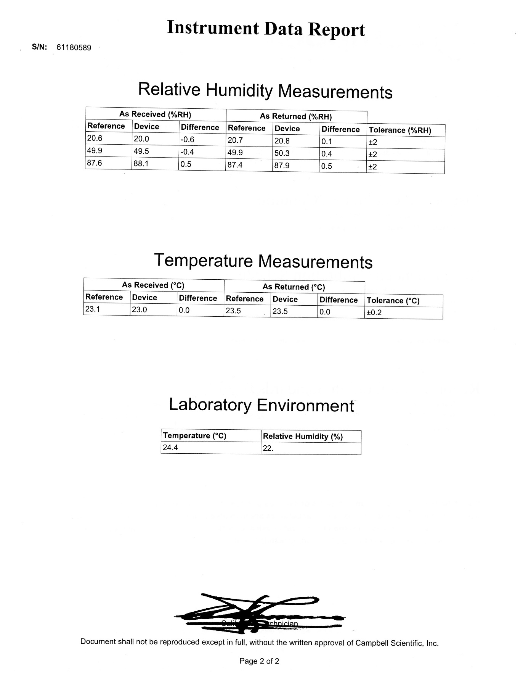

Calibration Certificate – Photosynthetic Active Radiation sensor

Date calibrated – April 26, 2023

Date installed – June 06, 2023

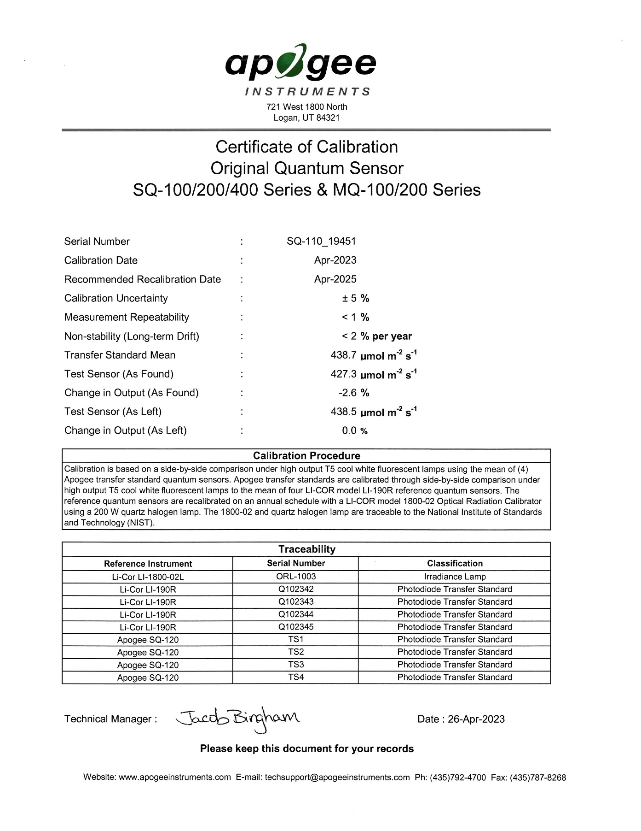

Service Certificate – Wind Sensor, RM Young

Date calibrated – April 24, 2023

Date installed – July 06, 2023

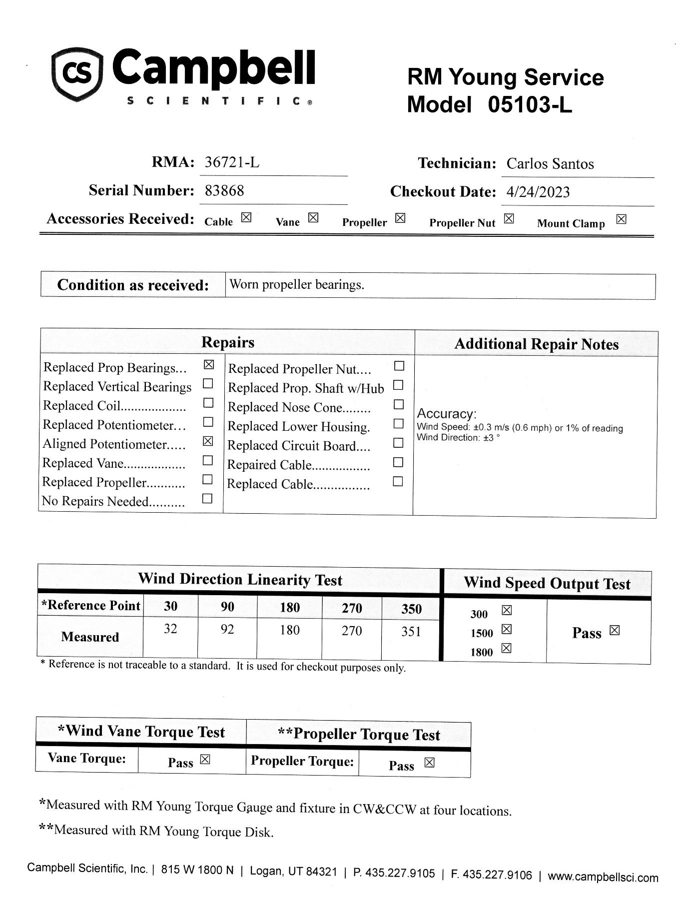

1. Pilson, M.E.Q. 1985. On the residence time of water in Narragansett Bay. *Estuaries* 8:2–14.
2. Narragansett Bay National Estuarine Research Reserve. 2007. An Ecological Profile of the Narragansett Bay National Estuarine Research Reserve. K.B. Raposa and M.L. Schwartz (eds.), *Rhode Island Sea Grant, Narragansett, R.I*. 176pp.