

**Narragansett Bay National Estuarine Research Reserve (NBNERR)**

**Nutrient Program**

**January – December 2015**

**Latest Update:** September 19, 2017

# I. Data Set and Research Descriptors

## Principal investigator(s) and contact persons

### Reserve Contacts

Kenneth B. Raposa, PhD

Research Coordinator

(401) 683-7849

[kenny@nbnerr.org](mailto:Kenny@nbnerr.org)

Daisy Durant, PhD

Marine Research Specialist II

SWMP Coordinator & Data Management

Responsible for data management

(401) 683-7368

[daisy@nbnerr.org](mailto:chris@nbnerr.org)

Address:

Narragansett Bay NERR

PO Box 151 –*or*-

55 South Reserve Drive

Prudence Island, RI 02872

Ph. 401-683-6780

Fax: 401-682-7366

### Laboratory Contacts

**Nutrient Analyses**

Carol Pollard, Lab Manager

Virginia Institute of Marine Science

Analytical Service Center for Nutrients

PO Box 1346

Rt. 1208 Gloucester Point, VA 23062

Phone: (804) 684-7213

Email: [pollard@vims.edu](mailto:pollard@vims.edu)

**Chlorophyll Analyses**

Laura Reed, Lab Technician

Marine Ecosystem Research Laboratory (MERL)

University of Rhode Island

Graduate School of Oceanography

11 Aquarium Rd.

Narragansett, Rhode Island 02882

Phone: (401) 874-6619

E-mail: [reedlhht@aol.com](mailto:reedlhht@aol.com)

## Research Objectives

Nutrient and chlorophyll samples are being collected off Prudence Island in Narragansett Bay as part of the National Estuarine Research Reserve's (NERR) System-Wide Monitoring Program (SWMP). The goal is to develop long-term datasets for representative estuarine systems in order to track changes in water quality over time. Because Prudence Island is located in the geographic center of Narragansett Bay, it is an ideal location for monitoring the status and trends in water quality in the Bay over time. One SWMP long-term monitoring station has been established at Potter Cove, on the island's northeastern shore. This area is impacted by boat traffic and storm runoff from mainland urban and residential areas. Two SWMP monitoring stations are located at T-Wharf, on the southeastern shore of the island facing the open waters of Rhode Island Sound. The two T-Wharf stations (T-Wharf Surface and T-Wharf Bottom) measure conditions in the upper (~1.0 m from the surface) and bottom (~1 m from the bottom) layers of the water column, respectively. These stations are approximately 10 km south of the Potter Cove site. Boat traffic is sparse at T-Wharf and storm runoff is less likely to have a significant impact on water quality. A fourth monitoring site is located in Nag Creek, a salt marsh tidal creek which flows into the West Passage of Narragansett Bay. The addition of this site completes our representation of dominant habitat types occurring in Narragansett Bay, i.e. salt marsh (Nag Creek station), shallow cove (Potter Cove), and open Bay water (T-Wharf Surface and T-Wharf Bottom).

### Monthly Grab Sampling Program

Monthly grab samples are collected once per month from each of the four stations to quantify seasonal patterns of selected nutrient species and chlorophyll in different estuarine habitats (marsh creek, cove, open water surface, open water bottom).

### Diel Sampling Program

Once per month, samples are collected at approximately 2-hour 15-minute intervals over a 24 hour cycle (lunar day) to document changes in nutrients and chlorophyll in response to tidal forcing. Previously (from 2002 to 2010) diel sampling occurred at T-Wharf. However, after analyzing the historic data from the site, no significant trend or patterns were found over time. Thus, the station was moved and has been at Potter Cove since January of 2011, in order to characterize nutrients and chlorophyll from this site.

## Research methods

### Monthly Grab Sampling Program

Monthly grab samples were taken at the four water quality long-term monitoring stations (Potter Cove, Nag Creek, T-Wharf Surface, and T-Wharf Bottom) throughout 2015, except for February at Nag Creek due to ice. All grab samples were collected on the same day between +3 hrs. before slack low-water and slack low-water. No distinction was made between neap and spring tide conditions. Replicate (N=2) samples were collected by hand at Nag Creek and with a horizontal Van-Dorn sampling bottle at the other three sites. At Nag Creek, samples were collected at approximately 0.25 m below the surface, at Potter Cove and T-Wharf Bottom at 1 m off the bottom, and at T-Wharf Surface at 1 m below the surface. In the field, all samples were transferred to Nalgene amber wide-mouth HDPE 500 ml sample bottles. All sampling bottles were previously washed with a phosphate free, biodegradable detergent (Liquinox®), rinsed with tap water and let dry. Subsequently, they were acid washed in a solution of 10 % Hydrochloric acid, rinsed (3x) with distilled-deionized water, and let dry. In the field, the bottles were rinsed (3x) with ambient water prior to collection of the sample. Samples were immediately placed on ice and in the dark and returned to the Reserve’s laboratory for initial filtering the same day of collection. A YSI 556 handheld unit is used to collect field parameter data (water temperature and salinity).

For pigment analyses (chlorophyll and phaeophytin), 20 ml of sample were filtered onto a glass microfiber filter Type GF/F (Whatman 1825-025), added 2 drops of magnesium carbonate (MgCO3) solution to the filter to preserve the sample, folded in half, wrapped in aluminum foil, labeled, and stored at –20 oC for one to two days. Subsequently, the filters are transported to the Marine Ecosystems Research Laboratory (MERL) analytical laboratory at the University of Rhode Island Bay Campus, Graduate School of Oceanography (URI/GSO) in a cooler with ice and stored at –20 oC until analyzed.

For nutrient analyses (ammonia, nitrate-nitrite, nitrite, phosphate and silicate), 60 ml of sample were filtered through a nucleopore polycarbonate Track-Etch membrane 0.4 µm pore size (Whatman 111107) into a small sampling bottle which was acid washed, rinsed and dried as described above for the Nalgene amber bottles. After filtering, all samples were stored at –20 oC for one to two days. Subsequently, all samples were placed in a cooler with ice gel packs and shipped overnight to the Virginia Institute of Marine Science analytical laboratory for nutrient analyses.

### Diel Sampling Program

The diel sampling program was conducted once per month throughout 2015, except for February when the cold temperature froze up Potter Cove. For this program, an ISCO 6712 portable water sampler was deployed each month. This device was programed to automatically sample 500 ml of water at 2-hr 15- min intervals, covering a complete semidiurnal tidal cycle. A total of 12 samples were collected each month. All samples were pumped into polyethylene sample bottles that were previously cleaned and acid washed as described in Section *a* above for Nalgene amber bottles. During the warm months (usually April to November), ice gel packs were used inside the sampler to keep the samples cool during the sampling period. At the end of the 24 hr. period, all the samples were kept cool and in the dark and returned to the Reserve for filtering the same day. For pigment and nutrient analyses, samples were filtered, frozen, and transported to the analytical laboratory as described in Section *a* of the Research Methods above. Field parameter data (water temperature and salinity) included in the dataset are the closest 15-minute readings collected by the YSI 6600 or EXO datasonde associated with SWMP monitoring station.

## Site Location and Character

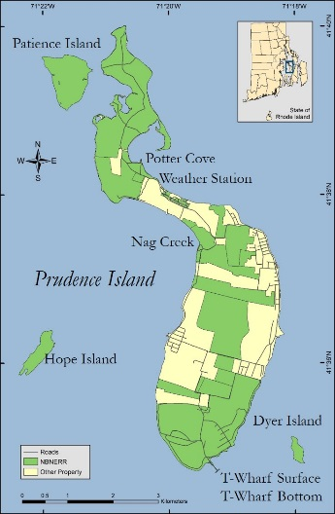The NBNERR consists of approximately 1802 hectares (4453 acres) of diverse estuarine and terrestrial habitats ranging from deep water to salt marshes to forested uplands. The land holdings include approximately 65% of Prudence Island, most of nearby Patience Island, and all of Hope and Dyer Islands (see map at right). The Reserve is located close to the geographic center of Narragansett Bay in Rhode Island.

The Narragansett Bay watershed consists of nine subwatersheds draining an area of approximately 4,836square km 1(Pilson, 1985) and numerous and substantial freshwater inputs to the Bay. Approximately 39% of the watershed lies in Rhode Island and 61% in Massachusetts. It is referred to as a shallow estuary; however, its water depth varies considerably. Depth averages approximately 9.0 m throughout the Bay, but it’s deeper in the East Passage (approximately 15.2 m) and shallower in the West Passage (approximately 7.5 m). More information and a detailed description of the Narragansett Bay NERR and the Narragansett Bay watershed can be found in 2Raposa and Schwartz, available at [www.nbnerr.org](http://www.nbnerr.org).

Specific characteristics of the Narragansett Bay National Estuarine Research Reserve.

Location: 41°38’30” N, 71°20’30” W

Tidal range: -0.2 to 1.7 meters MLW

Salinity: 15 to 32 pp

Temperature: -1.0 to 26 C

Province: North temperate, Virginian bioregion

1Pilson, M.E.Q. 1985. On the residence time of water in Narragansett Bay. *Estuaries* 8:2–14.

2Narragansett Bay National Estuarine Research Reserve. 2007. An Ecological Profile of the Narragansett Bay National Estuarine Research Reserve. K.B. Raposa and M.L. Schwartz (eds.), *Rhode Island Sea Grant, Narragansett, R.I*. 176pp.

Specific characteristics of the Potter Cove site are:

Location: 41o 38' 25.984" N, 71o 20' 27.165" W

Depth: 0.9 to 3.9 meters

Bottom habitat: Sand, silt, some organic mud

Pollutants: Boaters’ wastes, storm runoff from mainland urban areas

Watershed: Narragansett Bay, North Prudence (4801 square km)

Specific characteristics of the Nag Creek site are:

Location: 41o 37' 29.458" N, 71o 19' 27.421" W

Depth: 0.1 to 1.4 meters

Bottom habitat: Organic mud

Pollutants: Negligible

Watershed: Narragansett Bay, West Passage

Specific characteristics of the T-Wharf Surface site are:

Location: 41o 34' 42.099" N, 71o 19' 16.049" W

Depth: 0.2 to 0.9 meters

Bottom habitat: Sand, silt, some organic mud

Pollutants: Negligible

Watershed: Narragansett Bay, South Prudence

Specific characteristics of the T-Wharf Bottom site are:

Location: 41o 34' 42.099" N, 71o 19' 16.049" W

Depth: 4.6 to 6.9 meters

Bottom habitat: Sand, silt, some organic mud

Pollutants: Negligible

Watershed: Narragansett Bay, South Prudence

## Coded Variable Definitions

Station Code Names

narncnut = Nag Creek

narpcnut = Potter Cove

nartbnut = T-Wharf Bottom

nartsnut = T-Wharf Surface

Monthly grab sample program = 1

Diel sample program = 2

## Data collection period

The Narragansett Bay National Estuarine Research Reserve started the monthly grab sampling program at each of the four sites in the spring of 2002. The diel sampling program started in 2002 at T-Wharf Bottom until 2010; it has been at Potter Cove since 2011.

The following tables list the dates and time each grab (Table 1) and diel (Table 2) replicate (R) was collected at each site. For both grab and diel sampling, time is coded based on a 2400 hour format and is referenced to Standard Time format.

**Table 1. Date and time each monthly grab sample replicate was taken at each of the four water quality long-term monitoring sites.**

|  |  |  |  |  |  |  |  |  |
| --- | --- | --- | --- | --- | --- | --- | --- | --- |
| Date | Nag Creek | | Potter Cove | | T-Wharf Bottom | | T-Wharf Surface | |
| R1 | R 2 | R1 | R 2 | R1 | R 2 | R1 | R 2 |
| 01/05/15 | 11:58 | 12:00 | 11:11 | 11:13 | 12:43 | 12:45 | 12:37 | 12:39 |
| 02/18/15 | * | * | 11:13 | 11:15 | 11:53 | 11:55 | 11:43 | 11:45 |
| 03/30/15 | 09:13 | 09:15 | 08:43 | 08:45 | 09:58 | 10:00 | 09:48 | 09:50 |
| 04/27/15 | 08:28 | 08:30 | 08:43 | 08:45 | 08:11 | 08:13 | 08:05 | 08:07 |
| 05/18/15 | 11:28 | 11:30 | 11:13 | 11:15 | 11:58 | 12:00 | 11:52 | 11:54 |
| 06/16/15 | 10:58 | 11:00 | 10:28 | 10:30 | 11:53 | 11:55 | 11:43 | 11:45 |
| 07/13/15 | 09:38 | 09:40 | 10:13 | 10:15 | 08:53 | 08:55 | 08:48 | 08:50 |
| 08/10/15 | 08:58 | 09:00 | 09:28 | 09:30 | 08:35 | 08:37 | 08:28 | 08:30 |
| 09/07/15 | 08:06 | 08:08 | 08:43 | 08:45 | 09:48 | 09:50 | 09:38 | 09:40 |
| 10/26/15 | 10:38 | 10:40 | 09:58 | 10:00 | 11:30 | 11:32 | 11:23 | 11:25 |
| 11/09/15 | 11:08 | 11:10 | 11:43 | 11:45 | 10:13 | 10:15 | 10:08 | 10:10 |
| 12/07/15 | 09:54 | 09:56 | 10:43 | 10:45 | 09:18 | 09:20 | 09:13 | 09:15 |

* No sampling done due to ice.

**Table 1. Start and end date and time of each monthly diel sampling at Potter Cove long-term water quality monitoring station.**

|  |  |  |  |
| --- | --- | --- | --- |
| Start Date | Start Time (ST) | End Date | End Time(ST) |
| 01/05/15 | 11:17 | 01/06/15 | 12:02 |
| 02/17/15* | 09:48 | 02/18/15* | 10:33 |
| 03/30/15 | 08:18 | 03/31/15 | 09:03 |
| 04/27/15 | 09:00 | 04/28/15 | 09:45 |
| 05/18/15 | 10:39 | 05/19/15 | 11:24 |
| 06/16/15 | 10:15 | 06/17/15 | 11:00 |
| 07/13/15 | 10:30 | 07/14/15 | 11:15 |
| 08/10/15 | 09:45 | 08/11/15 | 08:15 |
| 09/07/15 | 08:30 | 09/08/15 | 09:15 |
| 10/26/15 | 09:45 | 10/27/15 | 10:30 |
| 11/09/15 | 11:30 | 11/10/15 | 12:15 |
| 12/07/15 | 10:30 | 12/08/15 | 11:15 |

* No samples collected at the end of the collection period due to ice.

## Associated researchers and projects

In 2004, the NBNERR became involved in the Bay Window Monitoring Program (BWMP). The BWMP housed several programs under different state and federal agencies to study Narragansett Bay’s fish and fisheries, sediment pollution, currents, and hydrography. Even though Bay Window ended in 2010, some programs where able to keep their monitoring with other funding sources. Currently, NBNERR continues to be an essential part of the original network of fixed-sites recording water quality data in the Bay (the Bay Assessment and Response Team -BART, <http://www.dem.ri.gov/programs/emergencyresponse/bart/index.php>) under the Rhode Island Department of Environmental Management (RIDEM). NBNERRs’ unique contribution consists of collecting year-around high frequency water quality data since it is the only fix site within the network deploying sondes during the winter months.

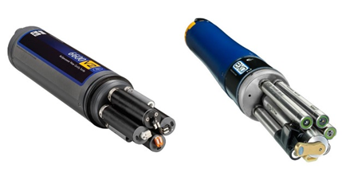The NBNERR System-Wide Monitoring Program (SWMP) has four water quality monitoring station around Prudence Island. The principal objective of the SWMP program is to record short-term variability and long-term changes in water quality data in order to observe trends or patterns in water quality over time. Water quality parameters have been collected since 1995 with the establishment of the first water quality monitoring station at Potter Cove. Other three water quality stations (Nag Creek, T-Wharf Surface and T-Wharf Bottom) were brought online in 2002. These stations were selected to represent a gradient in habitat types that range from salt marsh (Nag Creek station) to shallow cove (Potter Cove) to open Bay water (T-Wharf Surface and T-Wharf Bottom). Water temperature, salinity, dissolved oxygen (% saturation, and mg L-1), pH, turbidity, and chlorophyll fluorescence data are collected at each station every 15 minutes using YSI 6600 V2 (see image at right) and EXO2 data loggers that are calibrated and swapped out at each station approximately every two to four weeks.

YSI 6600 V2 and EXO 2 data loggers, respectively, used to collect water quality data at NBNERR.

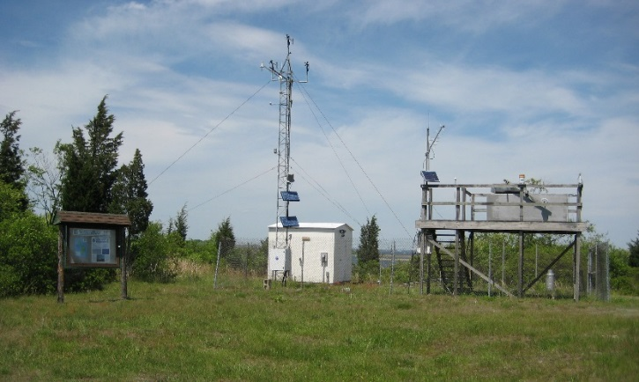Since 2001, meteorological data has been collected as part of the SWMP at the weather station (see image below) located on Prudence Island, approximately 389 m south of Potter Cove (41o 38’ 13.703” N, 71o 20’ 21.790” W, Trimble Geo XT, GeoExplorer 2008 Series; see map on section 5, Site Location and Character). Data on air temperature, relative humidity, barometric pressure, wind speed and direction, photosynthetic active radiation, and precipitation are collected every 15 minutes. Meteorological data is continually used to complement the water quality, biological monitoring and scientific research efforts at NBNERR and at Narragansett Bay, and to assist educational and stewardship activities around the Bay.

All this information is available through the CDMO [www.nerrsdata.org](http://cdmo.baruch.sc.edu/), NBNERR <http://nbnerr.org/>, or directly contacting the Research Coordinator or the Marine Research Specialist II.

The weather station on Prudence Island has been

collecting data since 2001.

Courtney E. Schmidt, Ph.D., staff scientist at the Narragansett Bay Estuary Program is analyzing the chlorphyll *a* data from our long-term nutrient program to include in the Narragansett Bay Water Quality Status and Trends, RI of 2016.

## Distribution

NOAA retains the right to analyze, synthesize and publish summaries of the NERRS System-wide Monitoring Program data.  The NERRS retains the right to be fully credited for having collected and process the data.  Following academic courtesy standards, the NERR site where the data were collected should be contacted and fully acknowledged in any subsequent publications in which any part of the data are used.  The data set enclosed within this package/transmission is only as good as the quality assurance and quality control procedures outlined by the enclosed metadata reporting statement.  The user bears all responsibility for its subsequent use/misuse in any further analyses or comparisons.  The Federal government does not assume liability to the Recipient or third persons, nor will the Federal government reimburse or indemnify the Recipient for its liability due to any losses resulting in any way from the use of this data.

Requested citation format:

NOAA National Estuarine Research Reserve System (NERRS). System-wide Monitoring Program. Data accessed from the NOAA NERRS Centralized Data Management Office website: www.nerrsdata.org; *accessed* 12 October 2012.

NERR nutrient data and metadata can be obtained from the Research Coordinator at the individual NERR site (please see Principal investigators and contact persons), from the Data Manager at the Centralized Data Management Office (please see personnel directory under the general information link on the CDMO home page) and online at the CDMO home page [www.nerrsdata.org](http://cfcdmo.baruch.sc.edu/). Data are available in comma separated version format.

# II. Physical Structure Descriptors

## Entry verification

Nutrient data are entered into a Microsoft Excel worksheet and processed using the NutrientQAQC Excel macro. The NutrientQAQC macro sets up the data worksheet, metadata worksheets, and MDL worksheet; adds chosen parameters and facilitates data entry; allows the user to set the number of significant figures to be reported for each parameter and rounds using banker’s rounding rules; allows the user to input MDL values and then automatically flags/codes measured values below MDL and inserts the MDL; calculates parameters chosen by the user and automatically flags/codes for component values below MDL, negative calculated values, and missing data; allows the user to apply QAQC flags and codes to the data; produces summary statistics; graphs selected parameters for review; and exports the resulting data file to the CDMO for tertiary QAQC and assimilation into the CDMO’s authoritative online database.

The Virginia Institute of Marine Science (VIMS) entered the nutrient data into Microsoft Excel spreadsheets, calculated and reported results in mg L-1, and sent the files electronically to the NBNERR. The Marine Ecosystem Research Laboratory (MERL) entered the chlorophyll and phaeophytin data into Microsoft Excel spreadsheets, calculated and reported the results in µg L-1 and also sent the files electronically to the NBNERR. For purposes of consistency in the NERR System, concentrations are calculated as mg L-1 based on atomic weights of 14.010, 30.97, and 28.09, and 12.01 for N, P, Si, and C, respectively.

Data entry verification was completed by Dr. Daisy Durant. Final verification and this metadata documentation were checked by Dr. Kenneth Raposa, before being sent to the CDMO permanent database.

## Parameter Titles and Variable Names by Category

Required NOAA/NERRS System-wide Monitoring Program nutrient parameters are denoted by an asterisk “*”.

|  |  |  |  |
| --- | --- | --- | --- |
| Data Category | Parameter | Variable Name | Units of Measure |
| Phosphorus and | *Orthophosphate | PO4F | mg/L as P |
| Nitrogen: | *Ammonium, Filtered | NH4F | mg/L as N |
|  | *Nitrite, Filtered | NO2F | mg/L as N |
|  | *Nitrate, Filtered | NO3F | mg/L as N |
|  | *Nitrite + Nitrate, Filtered | NO23F | mg/L as N |
|  | Dissolved Inorganic Nitrogen | DIN | mg/L as N |
| Plant Pigments: | *Chlorophyll a | CHLA_N | µg/L |
|  | Phaeophytin | PHEA | µg/L |
| Other Lab Parameters: | Silicate, Filtered | SiO4F | mg/L as Si |

Notes:

* Time is coded based on a 2400 clock and is referenced to Standard Time format.
* Reserves have the option of measuring either NO2 or NO3 or they may substitute NO23 for individual analyses if they can show that NO2 is a minor component relative to NO3.

## Measured and Calculated Laboratory Parameters

### Parameters Measured Directly

* Nitrogen species: NH4F, NO2F, NO23F
* Phosphorus species: PO4F
* Other: CHLA_N, PHEA, SiO4F

### Calculated Parameters

* NO3F: NO23F-NO2F
* DIN: NO23F+NH4F

## Limits of Detection

Method Detection Limits (MDL), the lowest concentration of a parameter that an analytical procedure can reliably detect, have been established by VIMS Analytical Service Center for Nutrient and by MERL for chlorophyll and phaeophytin. The MDL is determined as 3 times the standard deviation of a minimum of 7 replicates of a single low concentration sample. These values are reviewed and revised periodically.

Method Detection Limits

|  |  |  |  |
| --- | --- | --- | --- |
| Parameter | Start Date | End Date | MDL |
| NH4F | 01/01/2015 | 12/31/2015 | 0.0056 mg L-1 |
| NO23F | 01/01/2015 | 12/31/2015 | 0.0047 mg L-1 |
| NO2F | 01/01/2015 | 12/31/2015 | 0.0016 mg L-1 |
| PO4F | 01/01/2015 | 12/31/2015 | 0.0020 mg L-1 |
| SiO4F | 01/01/2015 | 12/31/2015 | 0.0800 mg L-1 |
| CHLA_N | 01/01/2015 | 12/31/2015 | 0.05 µg L-1 |
| PHEA | 01/01/2015 | 12/31/2015 | 0.05 µg L-1 |

## Laboratory Methods

1. **Parameter:** **Chlorophyll *a* (CHLA_N), Phaeophytin (PHEA)**
   * Marine Ecosystems Research Laboratory Method
   * Method References: Oviatt, C. A., and K. M. Hindle, 1994. Manual of biological and geochemical techniques in coastal areas. pp. 3-7.

* Method Descriptor: Chlorophyll *a* is extracted in 10 ml 90% acetone and fluorescence is measured and recorded (Fo). Two drops of 10% hydrochloric acid are added to convert the chlorophyll to phaeopigments (Phea). The fluorescence is again measured and recorded (Fa). The concentration (μg L-1) of Chl *a* and Phea are calculated using the Fo/Fa ratio.
* Preservation Method: 20 ml of sample is filtered onto a Whatman® Glass Microfiber Filter: Type GF/F (25mm), treated with 2 drops of MgCO3 solution, folded in half, wrapped in aluminum foil, and stored at –20 oC until analysis.

1. **Parameter: NH4F**
   * VIMS Laboratory Method: SA156-350.1 - NH3
   * Method Reference:

* U.S. EPA. 1974. Methods for Chemical Analysis of Water and Wastes, pp. 168-174.
* Standard Methods for the Examination of Water and Wastewater, 14th edition. p 410. Method 418A and 418B (1975).
* Annual Book of ASTM Standards, Part 31. "Water", Standard 1426-74, Method A, p 237 (1976).
* EPA 600/R-97/072 Method 349.0. Determination of Ammonia in Estuarine and Coastal Waters by Gas Segmented Continuous Flow Colorimetric Analysis. IN: Methods for the Determination of Chemical Substances in Marine and Estuarine Environmental Matrices -2nd Edition. National Exposure Research Laboratory, Office of Research and Development U.S. EPA, Cincinnati, Ohio 45268.
  + Method Descriptor: Ammonia reacts with alkaline phenol and hypochlorite to form indophenol blue in an amount that is proportional to the ammonia concentration. The blue color is intensified with sodium nitroprusside. The reaction is catalyzed by heat at 37oC. The range is 0.01 – 2.0 mg L-1.
  + Preservation Method: 60 ml of sample is filtered through a Whatman® Nuclepore Track-Etched Membrane, 0.4 µm disposable disk filter (47mm), and stored at –20 oC until analyzed.

1. **Parameter: NO2F, and NO2F + NO3F**
   * VIMS Laboratory Method: SA461-353.2 - NO2+3, NO2, TDN
   * Method Reference:

* U.S. EPA. 1974. Methods for Chemical Analysis of Water and Wastes, pp. 207 -212.
* Wood, E.D., F.A.G. Armstrong, and F.A. Richards. 1967. Determination of nitrate in seawater by cadmium-copper reduction to nitrite. J. Mar. Biol. Assoc. U.K. 47: 23
* Grasshoff, K., M. Ehrhardt and K. Kremling. 1983. Methods of Seawater Analysis. Verlag Chemie, Federal Republic of Germany. 419 pp.
* EPA 600/R-97/072 Method 353.4. Determination of Nitrate and Nitrite in Estuarine and Coastal Waters by Gas Segmented Flow Colorimetric Analysis. IN: Methods for the Determination of Chemical Substances in Marine and Estuarine Environmental Matrices -2nd Edition. National Exposure Research Laboratory, Office of Research and Development U.S. EPA, Cincinnati, Ohio 45268.
* Method Descriptor: Nitrate is reduced quantitatively to nitrite by cadmium metal in the form of an open tubular reactor. The nitrite thus formed plus any originally present in the sample is colorimetrically detected at 540 nm, following its diazotization with sulfanilamide, and subsequent coupling with N-1-naphthylethylenediamine dihydrochloride. The dissolved nitrate concentrations of the samples are calculated as NO3-N.
  + Preservation Method: 60 ml of sample is filtered through a Whatman® Nuclepore Track-Etched Membrane, 0.4 µm disposable disk filter (47mm), and stored at –20 oC until analyzed.

1. **Parameter:** **SiO4F**
   * VIMS Laboratory Method: Skalar Method Silicates, Catnr. 563-052 issue 101899/MH/99208255
   * Method Reference:

* U.S. EPA. 1974. Methods for Chemical Analysis of Water and Wastes, Method 370.1
* Grasshoff, K., M. Ehrhardt and K. Kremling. 1983. Methods of Seawater Analysis. Verlag Chemie, Federal Republic of Germany. Pp 374-376.
* EPA 600/R-97/072 Method 366.0 Determination of Dissolved Silicate in Estuarine and Coastal Waters by Gas Segmented Flow Colorimetric Analysis. IN: Methods for the Determination of Chemical Substances in Marine and Estuarine Environmental Matrices -2nd Edition. National Exposure Research Laboratory, Office of Research and Development U.S. EPA, Cincinnati, Ohio 45268.
  + Method Descriptor: Based on the reduction of silicomolybdate in acidic solution to “molybedenum blue” by ascorbic acid. Oxalic acid is introduced to the sample stream before the addition of ascorbic acid to eliminate interference from phosphates. The range is 0-1.1 mg Si L-1.
  + Preservation Method: Preservation Method: 60 ml of sample is filtered through a Whatman® Nuclepore Track-Etched Membrane, 0.4 µm disposable disk filter (47mm), and stored at –4 oC until analyzed.

1. **Parameter: PO4F**

* VIMS Laboratory Method SKALAR Method: O-Phosphate / Total Phosphate, Catnr. 503-365.1, issue 042993/MH/93-Demo1
* Method Reference:
  + - Murphy, J. and J.P. Riley. 1962. A modified single solution method for the determination of phosphate in natural waters. Analytica Chim. Acta 27 : 31-36
    - EPA 600/R-97/072 Method 365.5 Determination of Orthophosphate in Estuarine and Coastal Waters by Automated Colorimetric Analysis. IN: Methods for the Determination of Chemical Substances in Marine and Estuarine Environmental Matrices -2nd Edition. National Exposure Research Laboratory, Office of Research and Development. U.S. EPA, Cincinnati, Ohio 45268
  + Method Descriptor: Ammonium molybdate and antimony potassium tartrate react in a sulfuric acid environment to form an antimony-phospho-molybdo complex, which is reduced to a blue colored complex by ascorbic acid. Reaction is heat catalyzed at 40oC.
  + Range is 1 - 50 ppb.
  + Preservation Method: Preservation Method: 60 ml of sample is filtered through a Whatman® Nuclepore Track-Etched Membrane, 0.4 µm disposable disk filter (47mm), and stored at –20 oC until analyzed.

## Field and Laboratory QA/QC Programs

1. **Precision**
   1. **Field Variability** - For the monthly grab sampling program, NBNERR collects two successive grab samples for the determination of water mass variability.
   2. **Laboratory Variability** – replicates of all nutrient samples are run
   3. **Inter-organizational splits** – none
2. **Accuracy**
   1. **Sample Spikes** – blanks
   2. **Standard Reference Material Analysis** – none
   3. **Cross Calibration Exercises** – A cross calibration of the Turner Designs Fluorometer was performed with Battelle Ocean Sciences.

## QAQC flag definitions

QAQC flags provide documentation of the data and are applied to individual data points by insertion into the parameter’s associated flag column (header preceded by an F_). QAQC flags are applied to the nutrient data during secondary QAQC to indicate data that are out of sensor range low (-4), rejected due to QAQC checks (-3), missing (-2), optional and were not collected (-1), suspect (1), and that have been corrected (5). All remaining data are flagged as having passed initial QAQC checks (0) when the data are uploaded and assimilated into the CDMO ODIS as provisional plus data. The historical data flag (4) is used to indicate data that were submitted to the CDMO prior to the initiation of secondary QAQC flags and codes (and the use of the automated primary QAQC system for WQ and MET data). This flag is only present in historical data that are exported from the CDMO ODIS.

-4 Outside Low Sensor Range

-3 Data Rejected due to QAQC

-2 Missing Data

-1 Optional SWMP Supported Parameter

0 Data Passed Initial QAQC Checks

1 Suspect Data

4 Historical Data: Pre-Auto QAQC

5 Corrected Data

## QAQC code definitions

QAQC codes are used in conjunction with QAQC flags to provide further documentation of the data and are also applied by insertion into the associated flag column. There are three (3) different code categories, general, sensor, and comment. General errors document general problems with the sample or sample collection, sensor errors document common sensor or parameter specific problems, and comment codes are used to further document conditions or a problem with the data. Only one general or sensor error and one comment code can be applied to a particular data point. However, a record flag column (F_Record) in the nutrient data allows multiple comment codes to be applied to the entire data record.

General errors

GCM Calculated value could not be determined due to missing data

GCR Calculated value could not be determined due to rejected data

GDM Data missing or sample never collected

GQD Data rejected due to QA/QC checks

GQS Data suspect due to QA/QC checks

GSM See metadata

Sensor errors

SBL Value below minimum limit of method detection

SCB Calculated value could not be determined due to a below MDL component

SCC Calculation with this component resulted in a negative value

SNV Calculated value is negative

SRD Replicate values differ substantially

SUL Value above upper limit of method detection

Parameter Comments

CAB Algal bloom

CDR Sample diluted and rerun

CHB Sample held beyond specified holding time

CIP Ice present in sample vicinity

CIF Flotsam present in sample vicinity

CLE Sample collected later/earlier than scheduled

CRE Significant rain event

CSM See metadata

CUS Lab analysis from unpreserved sample

Record comments

CAB Algal bloom

CHB Sample held beyond specified holding time

CIP Ice present in sample vicinity

CIF Flotsam present in sample vicinity

CLE Sample collected later/earlier than scheduled

CRE Significant rain event

CSM See metadata

CUS Lab analysis from unpreserved sample

*Cloud cover*

CCL clear (0-10%)

CSP scattered to partly cloudy (10-50%)

CPB partly to broken (50-90%)

COC overcast (>90%)

CFY foggy

CHY hazy

CCC cloud (no percentage)

*Precipitation*

PNP none

PDR drizzle

PLR light rain

PHR heavy rain

PSQ squally

PFQ frozen precipitation (sleet/snow/freezing rain)

PSR mixed rain and snow

*Tide stage*

TSE ebb tide

TSF flood tide

TSH high tide

TSL low tide

*Wave height*

WH0 0 to <0.1 meters

WH1 0.1 to 0.3 meters

WH2 0.3 to 0.6 meters

WH3 0.6 to > 1.0 meters

WH4 1.0 to 1.3 meters

WH5 1.3 or greater meters

*Wind direction*

N from the north

NNE from the north northeast

NE from the northeast

ENE from the east northeast

E from the east

ESE from the east southeast

SE from the southeast

SSE from the south southeast

S from the south

SSW from the south southwest

SW from the southwest

WSW from the west southwest

W from the west

WNW from the west northwest

NW from the northwest

NNW from the north northwest

*Wind speed*

WS0 0 to 1 knot

WS1 > 1 to 10 knots

WS2 > 10 to 20 knots

WS3 > 20 to 30 knots

WS4 > 30 to 40 knots

WS5 > 40 knots

## Other Remarks

Data may be missing due to problems with sample collection or processing. Laboratories in the NERRS System submit data that are censored at a lower detection rate limit, called the Method Detection Limit or MDL. MDLs for specific parameters are listed in the Laboratory Methods and Detection Limits Section (Section II, Part 12) of this document. Concentrations that are less than this limit are censored with the use of a QAQC flag and code, and the reported value is the method detection limit itself rather than a measured value. For example, if the measured concentration of NO23F was 0.0005 mg/l as N (MDL=0.0008), the reported value would be 0.0008 and would be flagged as out of sensor range low (-4) and coded SBL. In addition, if any of the components used to calculate a variable are below the MDL, the calculated variable is removed and flagged/coded -4 SCB. If a calculated value is negative, it is rejected and all measured components are marked suspect. If additional information on MDL’s or missing, suspect, or rejected data is needed, contact the Research Coordinator at the Reserve submitting the data.

Note: The way below MDL values are handled in the NERRS SWMP dataset was changed in November of 2011.  Previously, below MDL data from 2007-2010 were also flagged/coded, but either reported as the measured value or a blank cell.  Any 2007-2011 nutrient/pigment data downloaded from the CDMO prior to November of 2011 will reflect this difference.

The following are descriptions of different events that happened during the grab and diel sampling and filtering processes at the Reserve coded as CSM in the dataset of 2015.

* Grab sampling at Nag Creek was not possible because the creek was frozen on February 18, 2015.
* February diel sampling at Potter Cove was not possible because the cove was frozen on February 17, 2015.
* Nutrient sample from the diel sampling 04/27/2015, 15:45 at Potter Cove, was accidentaly lost in the lab.
* The last diel sample of August 10, 2015 was not collected because a storm was approching and the ISCO had to be brougth in the lab to be able to process the rest of the samples.
* The grab and diel nutrient samples collected in October 26 and 27, 2015 are flagged suspect due to a delay by the shipping company in reaching the analytical laboratory which caused the samples to be slightly below the temperature established by our SOP.
* The silicate analysis for grab and diel nutrient samples collected on December 07 and 08, 2015 exceeded the holding time estiblished by CDMO SOP by two days due to a delay by the analytical laboratory.

**Secchi Disk Information:**

During grab sampling, Secchi disk readings are done at T-Wharf Surface and Bottom stations and provided in the data file. At Nag Creek, no Secchi reading is possible because the creek is too shallow and the Secchi will always reach the bottom. At Potter Cove, readings are included in the data file when the Secchi does not reach the bottom. For diel sampling at Potter Cove, Secchi disk readings are done at the beginning and at the end of the sampling; they are included if the Secchi does not reach the bottom.

**Water temperature and Salinity:**

No information on water temperature and salinity was available for the diel sampling of May 18, 2015 at Potter Cove. We obtain this information from the EXO2 sonde deployed at the site, but during this deployment the temperature/conductivity probe failed.

Total Precipitation (inches) per month on Prudence Island for 2015. Data from NBNERR Weather Station.

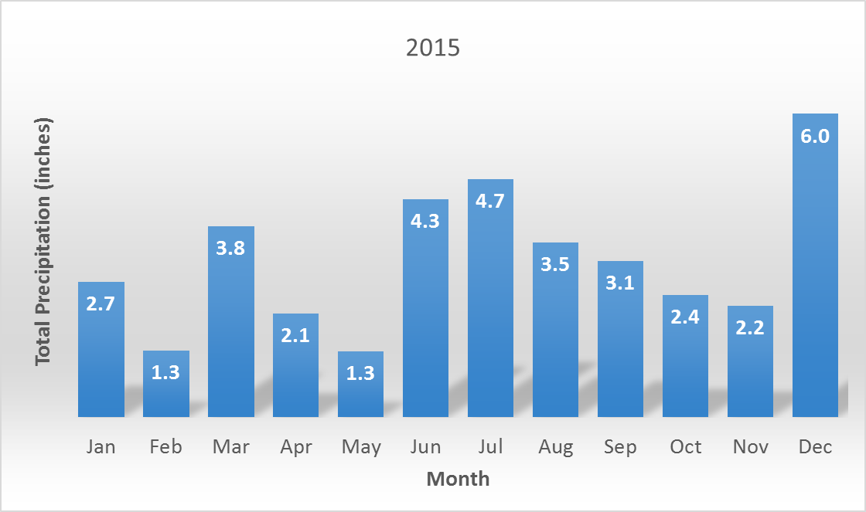

**Preservation and analysis of samples.**

Nutrient and pigment preservation and analysis are time sensitive. To assure proper quality control, the CDMO SOP establishes the following in the ‘NERR Nutrient and Chlorophyll Monitoring Program and Database Design V 1.7’ manual.

**3.3 Sample Preservation**

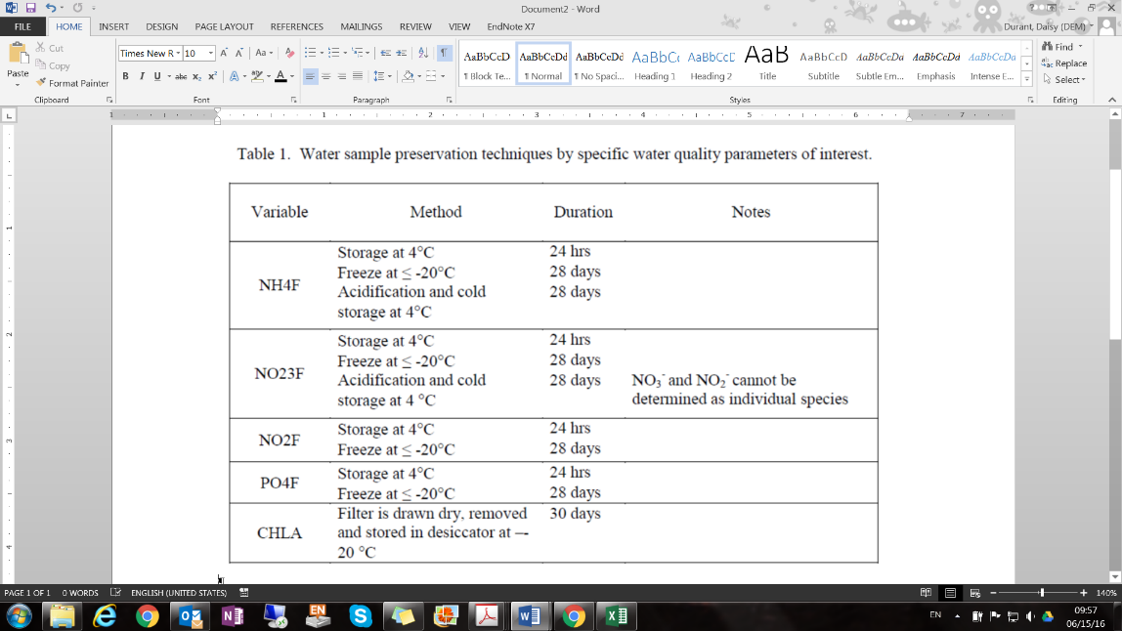If samples are kept in long-term storage, appropriate preservation techniques must be utilized in order to reduce the effects of volatilization, adsorption and biodegradation. Preservation techniques vary depending on analytes of interest; examples of preservation techniques are presented in Table 1. It is recognized that adequate time, on the order of 5 days, must be allowed for reserves to collect, filter, preserve and ship samples to analytical laboratories. Furthermore, it is recognized that whenever possible samples should be analyzed by the laboratory within 24 hours rather than deep freezing and storing.

To assure good QAQC of our data, we ask the analytical laboratories that analyze nutrients and pigments to provide the dates of analysis which we use to calculate holding times and to flag and code the data accordingly (Table 2).

Table 2. Holding time (number of days) calculated for grab and diel sample analyses of nutrient or pigment species. Holding times were calculated based on collection date at NBNERR and the date of analysis provided by the processing lab. **Bold** numbers indicate the samples were held beyond 28 days; maximum holding time recommended by CDMO SOP.

|  |  |  |  |  |  |  |  |
| --- | --- | --- | --- | --- | --- | --- | --- |
| Date | **VIMS** | | | | | **MERL** | |
| **NH4** | **NO23** | **NO2** | **O-PO4** | **Si** | **Chl a** | **Phae** |
| 01/05/15 | 22 | 24 | 22 | 22 | 24 | 09 | 09 |
| 02/18/15 | 13 | 13 | 13 | 13 | 15 | 06 | 06 |
| 03/30/15 | 25 | 25 | 25 | 25 | 28 | 04 | 04 |
| 04/27/15 | 15 | 15 | 15 | 15 | 18 | 10 | 10 |
| 05/18/15 | 25 | 25 | 25 | 25 | 25 | 10 | 10 |
| 06/16/15 | 24 | 24 | 24 | 24 | 24 | 22 | 22 |
| 07/13/15 | 09 | 09 | 09 | 09 | 16 | 18 | 18 |
| 08/10/15 | 17 | 17 | 17 | 17 | 23 | 03 | 03 |
| 09/07/15 | 22 | 22 | 22 | 22 | 24 | 09 | 09 |
| 10/26/15 | 18 | 18 | 18 | 18 | 22 | 16 | 16 |
| 11/09/15 | 24 | 24 | 24 | 24 | 28 | 07 | 07 |
| 12/07/15 | 28 | 28 | 28 | 28 | **30** | 09 | 09 |