

**Narragansett Bay (NAR) National Estuarine Research Reserve**

**Water Quality Metadata**

January to December 2018

Last updated: Wednesday December 18, 2019

# I. Data Set and Research Descriptors

## Principal investigators and contact persons

Dr. Kenneth B. Raposa

Research Coordinator

E-mail: [kenny@nbnerr.org](mailto:kenny@gso.uri.edu)

Ph (401) 683-7849

Dr. Daisy Durant, Marine Research Specialist II

SWMP Coordinator and Data Manager

E-mail: [daisy@nbnerr.org](mailto:daisy@nbnerr.org)

Ph (401) 683-7368

Address: Narragansett Bay NERR

55 South Reserve Drive

PO Box 151

Prudence Island, RI 02872

Phone: (401) 683-6780

Fax: (401) 682-7366

## Entry Verification

Deployment data are uploaded from the YSI data logger to a Personal Computer (IBM compatible). Files are exported from EcoWatch in a comma-delimited format (.CDF), EcoWatch Lite in a comma separated file (CSV) or KOR Software in an Excel File (.XLS) and uploaded to the CDMO where they undergo automated primary QAQC; automated depth/level corrections for changes in barometric pressure (cDepth or cLevel parameters); and become part of the CDMO’s online provisional database. All pre- and post-deployment data are removed from the file prior to upload. During primary QAQC, data are flagged if they are missing or out of sensor range. The edited file is then returned to the Reserve for secondary QAQC where it is opened in Microsoft Excel and processed using the CDMO’s NERRQAQC Excel macro. The macro inserts station codes, creates metadata worksheets for flagged data and summary statistics, and graphs the data for review. It allows the user to apply QAQC flags and codes to the data, remove any overlapping deployment data, append files, and export the resulting data file for upload to the CDMO. Upload after secondary QAQC results in ingestion into the database as provisional plus data, recalculation of cDepth or cLevel parameters, and finally tertiary QAQC by the CDMO and assimilation into the CDMO’s authoritative online database. Where deployment overlap occurs between files, the data produced by the newly calibrated sonde is generally accepted as being the most accurate. For more information on QAQC flags and codes, see Sections 11 and 12.

Dr. Daisy Durant (Marine Research Specialist II) was responsible for compiling and error checking the January through December 2018 water quality data covered in this document.

## Research Objectives

YSI 6600-V2 and EXO2 data loggers (also known as sondes, and used interchangeably in this document) are being deployed off Prudence Island in Narragansett Bay as part of the Narragansett Bay National Estuarine Research Reserve's (NBNERR) System-Wide Monitoring Program (SWMP). The goal is to develop long-term data sets for representative estuarine systems to track changes in water quality over time. Because Prudence Island is in the geographic center of Narragansett Bay, it is an ideal location for monitoring the status and trends in water quality in the Bay over time. One NBNERR water quality monitoring station has been established at Potter Cove since December 1995, on the Island's northeastern shore. This area is impacted by boat traffic and storm runoff from mainland urban and residential areas. The second NBNERR water quality monitoring station, T-Wharf, was established on September 1996 and is situated on the southeastern shore of the island, facing the open waters of Rhode Island Sound. It is approximately 6 miles south of the Potter Cove site. Boat traffic is sparse at this site and storm runoff is less likely to have a significant impact on water quality. A third monitoring site was added in March of 2002. This monitoring site is in Nag Creek, a salt marsh tidal creek that flows into the West Passage of Narragansett Bay. The addition of this site completes our representation of dominant habitat types occurring in Narragansett Bay (i.e. marsh, cove, and open water). In July of 2002, the T-Wharf monitoring station was replaced with two new monitoring sites located a short distance from the original T-Wharf location. The new stations are situated on either side of a wharf support piling. One data logger records water quality near the surface (approximately 1.0 m deep on low tide) while the second records water quality parameters approximately 1.0 m off the bottom. This allows for the identification of both the frequency and duration of any stratification, which may occur in the open waters of Narragansett Bay.

## Research Methods

Calibrating procedures

One data logger is deployed at each permanent monitoring station at the Reserve on Prudence Island (see map on Section 5). The instruments are deployed for approximately three to four weeks at a time (depending on the season), at the end of which are retrieved and newly calibrated sondes are deployed instead. During these extended deployments, the sondes collect data on water temperature, specific conductance, dissolved oxygen, pH, depth, turbidity conditions, and chlorophyll fluorescence every 15 minutes; date-timestamps are in Easter Standard Time. Historically, data from all stations were collected at 30-minute sampling intervals. In 2004, the NBNERR became involved with a statewide fixed site water quality monitoring program at which time data collection at all stations were changed to a 15-minute sampling interval in order to be compliant with this local monitoring effort. Two years later, all Reserves within the Reserve System were required also required to collect at 15-minutes sampling intervals.

For each sampling period, each instrument is calibrated against known standards following the methods recommended in the YSI 6-Series Multi-Parameter Water Quality Monitoring Standard Operating Procedure manual and the EXO User Manual-Advanced Water Quality Monitoring Platform. The specific conductivity probe is calibrated using conductivity calibrator 50,000 µS/cm; a three-point calibration is done for the pH probe using pH buffer 4, 7, and 10; a two point calibration (0, 126 with YSI 6600-V2 sonde or 0, 124 with EXO2 sondes) is done for the turbidity probe using deionized water and YSI 6073G turbidity standard; a one-point calibration is done in air-saturated water for dissolved oxygen (DO) probe; and a one-point calibration (0.0) with deionized water is done for chlorophyll fluorescence probe (data available upon request).

A three-point calibration has been done due to a very slow pH response at the beginning of the deployments at the T-Wharf Bottom site; no other site presented this problem. The three-point pH calibration was adopted in February 2012 per YSI engineers advise for troubleshooting the T-Wharf Bottom site problem; however, it was done for all sites since the same protocol should be implemented at all sites. The T-Wharf Bottom 6600 V2 sondes were retrofitted with a fast response pH probe (6589FR) in July 2013 as an additional step. With these steps, pH data at T-Wharf Bottom improved. In July 2018, the T-Wharf Bottom site was upgraded with new telemetry equipment compatible with the new EXO2 sonde from YSI, which has been deployed at the site since the upgrade. All the other sites have been upgraded to EXO2 sondes: Nag Creek and Potter Cove in 2014 and T-Wharf Surface in 2016. With the sonde upgrade at T-Wharf Bottom, a three-point calibration is not necessary anymore, and a two-point calibration using pH buffer 7 and 10 was implemented once more for all water quality sites.

After calibration, the sondes are programmed to begin taking measurements approximately 10 hours in advance of planned deployment, keeping them in an aerated bucket with water to allow the DO membrane to stabilize. The file is checked for DO sensor drift before the DO probe is calibrated. Calibration of the dissolved oxygen sensor is usually done within 2 hours of deployment. The V2 and EXO2 sondes have optical DO probes (DO ROX) and membranes are changed annually or when readings become unstable; this sensor can be calibrated at the same time as the other sensors; however, it is usually done within 2 hours of deployment in air-saturated water. At the end of each sampling period, the data loggers are retrieved, and freshly calibrated instruments are deployed. The retrieved data loggers are brought back to the laboratory, post-deployment evaluations of the instrument (Section 13) are carried out the same day of retrieval, and the device is cleaned and serviced by methods outlined in the service manuals mentioned above.

During every deployment, sea-truthing is conducted by measuring water quality parameters with an additional data logger taking real-time measurements at the time of deployment. This information is used to compare with the data collected by the sonde to ensure accuracy of the readings. The data is recorded using a hand-held YSI 556-MPS data logger. Values for temperature, specific conductance (and salinity), dissolved oxygen (% saturation and mg/L), and pH are recorded real-time at either 0.5- or 1.0-meter intervals between the surface and bottom at each deployment site. The calibration procedure for the YSI 556 used in sea-truthing follows the same general procedure as that for the sondes used for extended deployments. The YSI 556 specific conductivity and pH sensors are calibrated the day before a planned deployment; dissolved oxygen is calibrated the day of deployment in air-saturated water. Data and calibrating logs for the YSI 556 data logger are kept at the Reserve and available upon request.

Site Infrastructure

The monitoring station at Potter Cove was originally constructed in 1995, and it consisted of a PVC pipe mounted vertically on a piling located approximately 6 feet west of a floating dock. To facilitate water flow across the sensors, openings were cut into the PVC pipes. The pipes were positioned to ensure that the sensors were less than 1 meter from the bottom. In 2006, the infrastructure at Potter Cove was replaced. It currently consists of a short PVC tube attached to an adjacent dock, with a line attached through the pipe to an anchor on the bottom. The sonde is attached to the anchor via a shackle and hook set-up, and a float is attached to the top of the sonde to keep it approximately 0.75 m off the bottom. With this setup, the sonde is free and clear of any pipe affects since the pipe does not extend to the bottom and serves only as a “decoy pipe” to prevent vandalism.

In 1996, the original T-Wharf station was put into service using a PVC pipe mounted on a piling attached to the wharf. In 2002, the two replacement T-Wharf sites (Surface and Bottom) were also deployed in PVC pipes mounted to a piling. The sonde at the T-Wharf Surface station was maintained just below the surface by means of a buoy attached by rope to the adjacent wharf; the sonde at T-Wharf Bottom was maintained approximately 0.5 m off the bottom. On 10/11/06, the PVC deployment pipes and securing structures were replaced. The design was similar to the previous pipe design (following YSI recommendations) and consisted of holes drilled through the pipe and large slits at the bottom of the pipe to allow free water movement at the sonde. The T-Wharf Bottom pipe extends approximately 6 m though the water to the bottom of the site, where the sonde is kept approximately 1.0 m off the bottom. The T-Wharf Surface pipe extends approximately 2 m under the surface of the water (at low tide), where the sonde was attached to a float to keep it approximately 0.5 m below the surface of the water. After Tropical Storm Irene in August of 2011, the deploying structure was damaged; the PVC pipe was lost and the piling where it was attached to was damaged beyond repair. A temporary deploying structure was build consisting of a steel cable attached to the wharf with an anchor at the end to keep the cable straight and in place. The Surface and Bottom sondes were attached to the cable for each deployment and lowered into the water with a security line. The Reserve arranged to build a permanent deploying structure; a new piling was installed on February 2012, two 4” diameter PVC pipes were installed in June (following YSI recommendations), and the sondes were deployed in July in these new structures. The Surface sonde was deployed attached to a float to be approximately 1.0 m below the surface at low tide, and the Bottom sonde 1.0 m above the bottom substrate. Due to the narrow PVC pipes, the Surface sonde was getting jammed inside and not floating free; thus, the deployment was changed to a fixed one at approximately 0.5 m at low tide. As standard procedure, the pipes have been cleaned monthly with a chimney brush as needed but mostly during the warm months (April to November) to reduce the impact of biofouling on the data.

The Nag Creek sonde was originally deployed in a metal cage, which was tethered to the bank. A permanent deployment structure was installed 12/31/02, consisting of a 4” x 4” pressure-treated post with a hinged 2” x 4” horizontal arm. On 09/08/06, the sonde deployment structure was redesigned and changed. The new structure consists of an L-shape wooden structure that held in place in the sediment by a large metal tripod sunk into the mud. The sonde is extended from the arm into the water via a cleat, eye and line system and hangs approximately 0.30 m off the bottom of the creek. In 2012, the deployment structure was changed for a wooden tripod sunken into the mud, which facilitated its removal in the winter when the low temperatures freeze up the creek.

Real-time data transmission

A Sutron Sat-Link2 transmitter was installed at the T-Wharf Bottom monitoring station on 07/27/06 and transmits data to the NOAA GOES satellite, NESDIS ID #3B0335EE. The transmissions are scheduled hourly and contain four (4) data sets reflecting fifteen minute data sampling intervals. Upon receipt by the CDMO, the data undergoes the same automated primary QAQC process detailed in Section 2 above. The “real-time” telemetry data become part of the provisional dataset until undergoing secondary and tertiary QAQC and assimilation in the CDMO’s authoritative online database. Provisional and authoritative data are available at [http://cdmo.baruch.sc.edu](http://cdmo.baruch.sc.edu/).

## Site Location and Character

The NBNERR is located close to the geographic center of Narragansett Bay in Rhode Island. It consists of approximately 1802 hectares (4453 acres: 2544 acres of land plus 1909 acres of surrounding estuarine waters, approximately) of diverse estuarine and terrestrial habitats ranging from deep water to salt marshes to forested uplands. The land holdings include approximately 65% of Prudence Island, most of nearby Patience Island, and all of Hope and Dyer Islands (see map below). The last land acquisition was the Eugene Chase Farm property, made official by the end of year 2015.

The Narragansett Bay watershed consists of nine subwatersheds draining an area of approximately 4,836square km [1](Pilson, 1985) and numerous and substantial freshwater inputs to the Bay. Approximately 39% of the watershed lies in Rhode Island and 61% in Massachusetts. It is referred to as a shallow estuary; however, its water depth varies considerably. Depth averages approximately 9.0 m throughout the Bay, but it is deeper in the East Passage (approximately 15.2 m) and shallower in the West Passage (approximately 7.5 m). More information and a detailed description of the Narragansett Bay NERR and the Narragansett Bay watershed can be found in [2]Raposa and Schwartz, available at <http://nbnerr.org/research-and-monitoring/publications>.

Specific characteristics of the Narragansett Bay National Estuarine Research Reserve

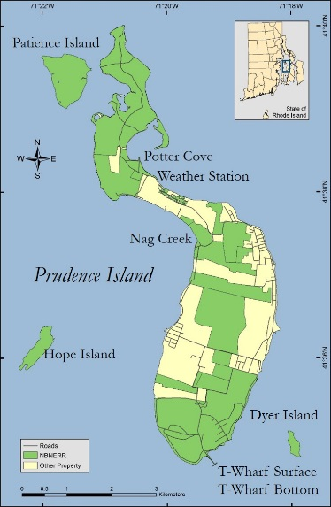Location: 41°38’ 30” N, 71°20’30” W

Tidal range: -0.2 to 1.7 meters MLW

Salinity: 15 to 32 ppt

Temperature: -1.0 to 26 C

Province: North temperate, Virginian bioregion

Specific characteristics of the Nag Creek site are:

Location: 41° 37’ 29.458” N, 71° 19’ 27.421” W

Depth: 0.1 to 1.4 meters

Bottom habitat: Organic mud

Pollutants: Negligible

Watershed: Narragansett Bay, West Passage

Specific characteristics of the Potter Cove site are:

Location: 41° 38’ 25.984” N, 71° 20’ 27.165” W

Depth: 0.9 to 3.9 meters

Bottom habitat: Sand, silt, some organic mud

Pollutants: Boaters’ wastes, storm runoff from mainland urban areas

Watershed: Narragansett Bay, North Prudence (4801 km2)

Specific characteristics of the T-Wharf Surface site are:

Location: 41° 34’ 42.099” N, 71° 19’ 16.049” W

Depth: 0.2 to 0.9 meters

Bottom habitat: Sand, silt, some organic mud

Pollutants: Negligible

Watershed: Narragansett Bay, South Prudence

Specific characteristics of the T-Wharf Bottom site are:

Location: 41° 34’ 42.099” N, 71° 19’ 16.049” W

Depth: 4.6 to 6.9 meters

Bottom habitat: Sand, silt, some organic mud

Pollutants: Negligible

Watershed: Narragansett Bay, South Prudence

Details of NBNERR SWMP Water Quality Stations Timeline. SWMP Status Column: P = primary SWMP Station, Reason Decommissioned Column: NA = Not applicable.

|  |  |  |  |  |  |  |
| --- | --- | --- | --- | --- | --- | --- |
| **Station Code** | **SWMP Status** | **Station Name** | **Location** | **Active Dates** | **Reason Decommissioned** | **Notes** |
| narncwq | P | Nag Creek | 41° 37' 29.46 N  71° 19' 27.42 W | 03/01/02 00:00 - present | NA | NA |
| narpcwq | P | Potter Cove | 41° 38' 25.98 N  71° 20' 27.17 W | 12/01/95 00:00 - present | NA | NA |
| nartbwq | P | T-Wharf Bottom | 41° 34' 42.10 N  71° 19' 16.05 W | 07/01/02 00:00 - present | NA | NA |
| nartswq | P | T-Wharf Surface | 41° 34' 42.10 N  71° 19' 16.05 W | 07/01/02 00:00 - present | NA | NA |
| nartwwq | P | T-Wharf | 41° 34' 45.18 N  71° 19' 17.10 W | 09/01/1996 00:00 - 07/01/2002 00:00 | This location was in line with a summertime pycnocline. | It was decided to move the station further out and established T-Wharf Surface and T-Wharf Bottom to examine patterns of water column stratification. |

## Data collection period

Date and time of the first and last readings in each data file downloaded from the sondes deployed at each of the four water quality stations on Prudence Island for January to December 2018.

**Nag Creek** (Data collection ongoing since 2002).

|  |  |  |  |  |  |
| --- | --- | --- | --- | --- | --- |
| First Reading | |  | Last Reading | | EXO2 Sonde Serial Number |
| Deploy Date | Deploy Time |  | Retrieve Date | Retrieve Time |
| 1 01/01/18 | 00:00 |  | 03/06/18 | 14:30 |  |
| 03/06/18 | 14:45 |  | 14/18/18 | 12:45 | 17L101742 |
| 04/18/18 | 13:15 |  | 05/23/18 | 09:00 | 14A101166 |
| 05/23/18 | 09:15 |  | 06/19/18 | 08:15 | 14A101167 |
| 06/19/18 | 08:30 |  | 07/17/18 | 08:30 | 14A101166 |
| 07/17/18 | 08:45 |  | 08/15/18 | 08:30 | 14A101167 |
| 08/15/18 | 08:45 |  | 09/12/18 | 06:45 | 14A101166 |
| 09/12/18 | 07:00 |  | 10/16/18 | 09:00 | 14A101167 |
| 10/16/18 | 09:15 |  | 11/19/18 | 12:00 | 14A101166 |
| 11/19/18 | 12:15 |  | 12/11/18 | 13:30 | 14A101167 |
| 1 12/12/18 | 13:45 |  | 12/31/18 | 23:45 |  |

Notes

1 No sonde was deployed at Nag during this period because the creek was frozen.

**Potter Cove** (Data collection ongoing since 1995).

|  |  |  |  |  |  |
| --- | --- | --- | --- | --- | --- |
| First Reading | |  | Last Reading | | EXO2 Sonde Serial Number |
| Deploy Date | Deploy Time |  | Retrieve Date | Retrieve Time |
| 1 12/06/17 | 09:30 |  | 01/09/18 | 11:15 | 14A101165 |
| 01/09/18 | 11:30 |  | 02/06/18 | 12:30 | 14A101164 |
| 02/06/18 | 12:45 |  | 03/06/18 | 10:45 | 14A101167 |
| 03/06/18 | 11:00 |  | 04/18/18 | 12:00 | 14A101164 |
| 04/18/18 | 12:15 |  | 05/23/18 | 10:00 | 14A101165 |
| 05/23/18 | 10:15 |  | 06/19/18 | 09:00 | 14A101164 |
| 06/19/18 | 09:30 |  | 07/17/18 | 09:30 | 14A101165 |
| 07/17/18 | 10:00 |  | 08/15/18 | 09:15 | 14A101164 |
| 08/15/18 | 09:30 |  | 09/11/18 | 08:30 | 14A101165 |
| 09/11/18 | 08:45 |  | 10/16/18 | 09:30 | 14A101164 |
| 10/16/18 | 10:00 |  | 11/19/18 | 12:45 | 14A101165 |
| 11/19/18 | 13:00 |  | 12/11/18 | 11:00 | 14A101164 |
| 2 12/11/18 | 11:30 |  | 01/15/19 | 09:30 | 14A101165 |

Notes

1 This deployment started on 12/06/17 09:30, but only data from 2018 are included in this metadata document and corresponding dataset file which starts on 01/01/18 00:00.

2 This deployment ended on 01/15/19 09:30. However, the data included in this metadata document and corresponding QAQC’d dataset file is up until December 31, 2018 23:45.

**T-Wharf Surface** (Data collection ongoing since 2002).

|  |  |  |  |  |  |
| --- | --- | --- | --- | --- | --- |
| First Reading | |  | Last Reading | | EXO2 Sonde Serial Number |
| Deploy Date | Deploy Time |  | Retrieve Date | Retrieve Time |
| 1 12/05/17 | 09:45 |  | 01/09/18 | 12:15 | 16J102354 |
| 01/09/18 | 12:30 |  | 02/06/18 | 11:30 | 16J102353 |
| 02/06/18 | 11:45 |  | 03/16/18 | 09:30 | 14A101166 |
| 03/16/18 | 09:45 |  | 04/18/18 | 10:45 | 16J102353 |
| 04/18/18 | 11:15 |  | 05/24/18 | 09:15 | 16J102354 |
| 05/24/18 | 09:30 |  | 06/20/18 | 08:45 | 16J102353 |
| 06/20/18 | 09:00 |  | 07/18/18 | 08:30 | 16J102354 |
| 07/18/18 | 08:45 |  | 08/15/18 | 10:15 | 16J102353 |
| 08/15/18 | 10:30 |  | 09/11/18 | 09:15 | 16J102354 |
| 09/11/18 | 09:45 |  | 10/17/18 | 08:30 | 16J102353 |
| 10/17/18 | 08:45 |  | 11/19/18 | 13:45 | 16J102354 |
| 11/19/18 | 14:15 |  | 12/11/18 | 10:00 | 16J102353 |
| 2 12/11/18 | 10:15 |  | 01/14/19 | 13:30 | 16J102354 |

Notes

1 This deployment started on 12/05/17 09:45, but only data from 2018 are included in this metadata document and corresponding dataset file which starts on 01/01/18 00:00.

2 This deployment ended on 01/14/19 13:30. However, the data included for this metadata document and corresponding QAQC’d dataset file is up until December 31 23:45.

**T-Wharf Bottom** (Data collection ongoing since 2002).

|  |  |  |  |  |  |
| --- | --- | --- | --- | --- | --- |
| First Reading | |  | Last Reading | | 6600V2 Sonde Serial Number  EXO2 Sonde Serial Number |
| Deploy Date | Deploy Time |  | Retrieve Date | Retrieve Time |
| 1 12/05/17 | 10:00 |  | 01/09/18 | 12:30 | 01E0876AB |
| 01/09/18 | 13:30 |  | 02/06/18 | 11:30 | 06C1207AA |
| 2 02/06/18 | 12:00 |  | 03/14/18 | 21:45 | 01E0876AB |
| 3 03/15/18 | 10:00 |  | 03/16/18 | 13:15 | 06C1207AA |
| 03/28/18 | 09:15 |  | 04/18/18 | 11:00 | 01E0566AA |
| 04/18/18 | 11:30 |  | 05/24/18 | 09:30 | 06C1207AA |
| 05/24/18 | 10:00 |  | 06/20/18 | 09:00 | 00E0937AD |
| 4 06/20/18 | 09:30 |  | 07/09/18 | 12:00 | 06C1207AA |
| 07/10/18 | 08:30 |  | 07/31/18 | 10:00 | 00E0937AD |
| 5 07/31/18 | 11:30 |  | 08/21/18 | 09:00 | 17L101172 |
| 08/21/18 | 09:45 |  | 09/12/18 | 09:45 | 17L101173 |
| 09/12/18 | 10:00 |  | 10/17/18 | 08:45 | 17L101172 |
| 10/17/18 | 09:15 |  | 11/19/18 | 14:00 | 17L101173 |
| 11/19/18 | 14:15 |  | 12/11/18 | 10:15 | 17L101172 |
| 6 12/11/18 | 10:45 |  | 01/14/19 | 13:30 | 14A101166 |

Notes

1 This deployment started on 12/05/17 10:00, but only data from 2018 are included in this metadata document and corresponding dataset file which starts on 01/01/18 00:00.

2 A catastrophic temperature failure occurred during this deployment and batteries failed at the end of the deployment. Sonde was retrieved on 03/15 09:30.

3 During this deployment, no data were collected from 03/16 13:30 to 03/28 08:45 because batteries failed.

4 A catastrophic temperature failure occurred during this deployment and batteries failed. Sonde was retrieved on 07/10 08:00.

5 EXO2 sondes were deployed from July 31st onward at this station.

6 This deployment ended on 01/14/19 13:30. However, the data included for this metadata document and corresponding QAQC’d dataset file is up until December 31 23:45.

## Distribution

According to the Ocean and Coastal Resource Management Data Dissemination Policy for the NERRS System-wide Monitoring Program,

NOAA retains the right to analyze, synthesize and publish summaries of the NERRS System-wide Monitoring Program data. The NERRS retains the right to be fully credited for having collected and process the data. Following academic courtesy standards, the NERR site where the data were collected should be contacted and fully acknowledged in any subsequent publications in which any part of the data are used. The data set enclosed within this package/transmission is only as good as the quality assurance and quality control procedures outlined by the enclosed metadata reporting statement. The user bears all responsibility for its subsequent use/misuse in any further analyses or comparisons. The Federal government does not assume liability to the Recipient or third persons, nor will the Federal government reimburse or indemnify the Recipient for its liability due to any losses resulting in any way from the use of this data.

Requested citation format:

NOAA National Estuarine Research Reserve System (NERRS). System-wide Monitoring Program. Data accessed from the NOAA NERRS Centralized Data Management Office website: <http://www.nerrsdata.org/>; *accessed* 12 October 2018.

NERR water quality data and metadata can be obtained from the Research Coordinator at the individual NERR site (please see Principal Investigators and Contact Persons), from the Data Manager at the Centralized Data Management Office (please see personnel directory under the general information link on the CDMO home page) and online at the CDMO home page [www.nerrsdata.org](http://www.nerrsdata.org). Data are available in text tab-delimited format.

## Associated researchers and projects

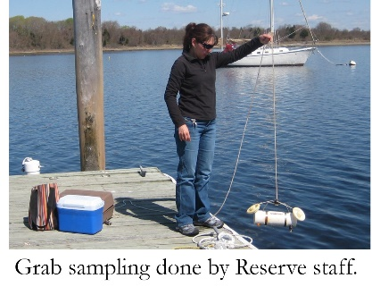Complementary to the existing long-term water quality monitoring program, the NERRS implemented a new nutrient and chlorophyll monitoring program in 2002. The two sub-components of this program include monthly grab sampling at each of the four water quality stations, and diel sampling once a month at one site. The grab sampling program requires the collection of duplicate water samples every month from each of the four long-term water quality monitoring stations with the purpose of quantify seasonal patterns of nutrient and chlorophyll concentrations in different estuarine habitats (marsh creek, cove, surface open water, bottom open water).

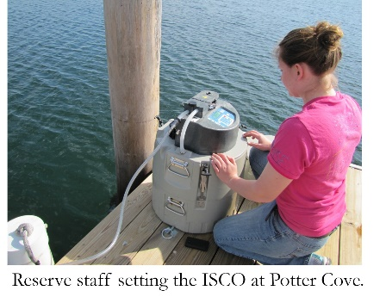The diel sampling program requires to collect a series of samples from one station over an approximately 24-hour period each month to examine how nutrient and chlorophyll concentrations change over diel and tidal cycles. Previously (from 2002 to 2010) the diel station was located at T-Wharf. However, after analyzing the historic data from the site, no significant trends or patterns were found over time. Therefore, the diel station was moved to Potter Cove in January of 2011 in order to characterize nutrients and chlorophyll from this site. All collected grab and diel samples are analyzed for concentrations of phosphates (PO4), ammonia (NH4), nitrite (NO2), nitrate (NO3), NO2+NO3, dissolved inorganic nitrogen (DIN), silicates (SiO4) and chlorophyll *a*.

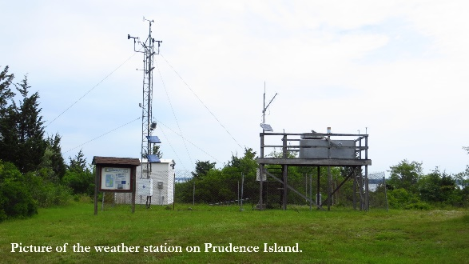Since 2001, meteorological data has been collected as part of the SWMP at the weather station (see image below) located on Prudence Island, approximately 389 m south of Potter Cove (41o 38’ 13.703” N, 71o 20’ 21.790” W, Trimble Geo XT, GeoExplorer 2008 Series; see map on section 5, Site Location and Character). Data on air temperature, relative humidity, barometric pressure, wind speed and direction, photosynthetic active radiation, and precipitation are collected. Meteorological data is continually used to complement the water quality, biological monitoring and scientific research efforts at the Reserve, as well as to assist stewardship, training, and educational activities around the Bay.

All this information is available through the CDMO website [www.nerrsdata.org](http://www.nerrsdata.org), NBNERR <http://nbnerr.org/research-and-monitoring/system-wide-monitoring/>, or directly contacting the Research Coordinator or the Marine Research Specialist II.

In 2004, the NBNERR became involved in the Bay Window Monitoring Program (BWMP). The BWMP housed several programs under different state and federal agencies to study Narragansett Bay’s fish and fisheries, sediment pollution, currents, and hydrography. Even though Bay Window ended in 2010, some programs where able to keep their monitoring with other funding source. Currently, NBNERR continues to be an essential part of the original network of fixed-sites recording water quality data in the Bay as part of the Rhode Island Department of Environmental Management and the Bay Assessment and Response Team –(RIDEM BART, (<http://www.dem.ri.gov/programs/emergencyresponse/bart/index.php>) Our two water quality sites, T-Wharf Surface and T-Wharf Bottom, are part of to the Rhode Island Department of Environmental Management Narragansett Bay Fixed-Site Monitoring Network (RIDEM NBFSMN) nested under the RIDEM Bay Assessment Response Team (BART). The RIDEM BART Program was created for a rapid and effective response to environmental incidents in Narragansett Bay using the water quality data collected by the NBFSMN. NBNFSM is a collaborative monitoring effort of several agencies and organizations (NBNERR, Office of Water Resources, Narragansett Bay Commission, URI Graduate School of Oceanography, Roger Williams University, Narragansett Bay Estuary Program, and URI Coastal Institute) in Narragansett Bay, to monitor water quality with over a dozen fixed-site monitoring network in the Bay, which in turn includes T-Wharf Surface and T-wharf Bottom stations on Prudence Island. The NBNERR SWMP stations provided the only year-round water quality data in the Bay network, and without these stations, the program would have a large gap in the mid/lower East Passage of the Bay. Data from all stations can be found at <http://www.dem.ri.gov/programs/emergencyresponse/bart/netdata.php>.

Dr. Candace Oviatt at URI-GSO is using NAR NERR chlorophyll data to track the timing and magnitude of winter/spring blooms in Narragansett Bay.

Mrs. Heather Stoffel et al. at URI-GSO compiles NAR NERR dissolved oxygen data from T-Wharf Surface, T-Wharf Bottom stations together with data from BART to study hypoxia in the Bay. The peer reviewed article is listed below:

Codiga, D. L., H. E. Stoffel, C. F. Deacutis, S. Kiernan, and C. A. Oviatt. 2009. Narragansett Bay Hypoxic Event Characteristics Based on Fixed-Site Monitoring Network Time Series: Intermittency, Geographic Distribution, Spatial Synchronicity, and Interannual Variability. Estuaries and Coasts 32:621-641. Available at <http://www.gso.uri.edu/merl/merl_pdfs/Codiga_etal_2009.pdf>.

Mrs. Heather Stoffel from URI-GSO is currently working with the long-term pH data from T-Wharf water quality station and other wq station in Narragansett Bay to look at metabolism affect on the daily changes on pH. This work is being done for the RI Department of Environmental Management.

# II. Physical Structure Descriptors

## Sensor specifications

From January to December 2018, NBNERR deployed EXO2 sondes with wiped CT probe (conductivity /temperature) at Nag Creek and T-Wharf Surface, while EXO2 sondes with a non-wiped CT probe were deployed at Potter Cove. At T-Wharf Bottom, YSI 6600V2 sondes were deployed from January to July; from August to December, EXO2 sondes with wiped CT probe were deployed after updating the telemetry station with Storm3 data logger (07/31/18). All the sondes deployed at all sites were equipped with optical dissolved oxygen (ODO) probes.

YSI 6600 V2 data sonde configurations

Parameter: **Temperature**

Units: Celsius - oC

Sensor Type: Thermistor

Model #: 6560

Range: -5 to 50 °C

Accuracy: ± 0.15 °C

Resolution: 0.01 °C

Parameter: **Conductivity**

Units: milli-Siemens per cm (mS/cm)

Sensor Type: 4-electrode cell with autoranging

Model #: 6560

Range: 0 to 100 mS/cm

Accuracy: ± 0.5% of reading + 0.001 mS/cm

Resolution: 0.001 mS/cm to 0.1 mS/cm (range dependent)

Parameter: **Salinity**

Units: Parts per thousand (ppt)

Sensor Type: Calculated from conductivity and temperature

Range: 0 to 70 ppt

Accuracy: ± 1.0% of reading or 0.1 ppt, whichever is greater

Resolution: 0.01 ppt

Sensor Type: **Dissolved Oxygen**

Units: Percent saturation

Model #: 6150 ROX optical probe with mechanical cleaning

Range: 0 to 500% air saturation

Accuracy: 0-200% air saturation: ± 1% of the reading or 1% air saturation, whichever is

greater; 200 500% air saturation: ± 15% of reading

Resolution: 0.1% air saturation

Sensor Type: **Dissolved Oxygen**

Units: milligrams per Liter (mg/L)

Model #: 6150 ROX

Range: 0 to 50 mg/L

Accuracy: 0 - 20 mg/L: ± 0.1% mg/L or 1% of the reading, whichever is greater; 20-50

mg/L: ± 15% of the reading

Resolution: 0.01 mg/L

Parameter: Non-Vented Level – Shallow (Depth)

Units: meters (m)

Sensor Type: Stainless steel strain gauge

Range: 0 to 30 ft. (9.1 m)

Accuracy: ± 0.06 ft. (0.018 m)

Resolution: 0.001 ft. (0.001 m)

Parameter: **pH** (bulb probe)

Units: pH units

Sensor Type: Glass combination electrode

Model #: 6589FR

Range: 0 to 14 units

Accuracy: ± 0.2 units

Resolution: 0.01 units

Parameter: **Turbidity**

Units: Nephelometric turbidity units (NTU)

Sensor Type: Optical, 90° scatter, with mechanical cleaning

Model #: 6136

Range: 0 to 1000 NTU

Accuracy: ± 2 % reading or 0.3 NTU (whichever is greater)

Resolution: 0.1 NTU

Parameter: Chlorophyll Fluorescence

Units: micrograms/Liter

Sensor Type: Optical probe with mechanical cleaning

Model#: 6025

Range: 0 to 400 µg/Liter

Accuracy: Dependent on methodology

Resolution: 0.1 µg /L chl *a*, 0.1% FS

YSI EXO2 data sondes configuration

Parameter: **Temperature**

Units: Celsius (C)

Sensor Type: CT2 Probe, Thermistor

Model#: 599870

Range: -5 to 50 C

Accuracy: -5 to -35: ± 0.01, -35 to -50: ± .005

Resolution: 0.01 C

Parameter: **Conductivity**

Units: milli-Siemens per cm (mS/cm)

Sensor Type: CT2 Probe, 4-electrode cell with autoranging

Model#: 599870

Range: 0 to 200 mS/cm

Accuracy: 0 to 100: ± 0.5% of reading or 0.001 mS/cm; 100 to 200: ± 1% of reading

Resolution: 0.001 mS/cm to 0.1 mS/cm (range dependent)

Parameter: **Salinity**

Units: practical salinity units (psu)/parts per thousand (ppt)

Sensor Type: CT2 probe, Calculated from conductivity and temperature

Range: 0 to 70 psu

Accuracy: ± 1.0% of reading pr 0.1 ppt, whichever is greater

Resolution: 0.01 psu

-OR-

Parameter: **Temperature**

Units: Celsius (C)

Sensor Type: Wiped probe; Thermistor

Model#: 599827

Range: -5 to 50 C

Accuracy: ±0.2 C

Resolution: 0.001 C

Parameter: **Conductivity**

Units: milli-Siemens per cm (mS/cm)

Sensor Type: Wiped probe; 4-electrode cell with autoranging

Model#: 599827

Range: 0 to 100 mS/cm

Accuracy: ±1% of the reading or 0.002 mS/cm, whichever is greater

Resolution: 0.01

Parameter: **Salinity**

Units: practical salinity units (psu)/parts per thousand (ppt)

Sensor Type: Calculated from conductivity and temperature

Range: 0 to 70 psu

Accuracy: ± 1.0% of reading pr 0.1 ppt, whichever is greater

Resolution: 0.01 psu

-AND-

Parameter: **Dissolved Oxygen % Saturation**

Units: Percent saturation

Sensor Type: Optical probe w/ mechanical cleaning

Model#: 599100-01

Range: 0 to 500% air saturation

Accuracy: 0-200% air saturation: ± 1% of the reading or 1% air saturation, whichever is

greater 200-500% air saturation: ± 5% or reading

Resolution: 0.1% air saturation

Parameter: **Dissolved Oxygen** (Calculated from % air saturation, temperature, and salinity)

Units: milligrams/Liter (mg/L)

Sensor Type: Optical probe w/ mechanical cleaning

Model#: 599100-01

Range: 0 to 50 mg/L

Accuracy: 0-20 mg/L: ± 0.1 mg/l or 1% of the reading, whichever is greater 20-50 mg/L:

± 5% of the reading

Resolution: 0.01 mg/L

Parameter: **Non-vented Level - Shallow (Depth)**

Units: feet or meters (ft. or m)

Sensor Type: Stainless steel strain gauge

Range: 0 to 33 ft. (10 m)

Accuracy: ± 0.013 ft. (0.004 m)

Resolution: 0.001 ft. (0.001 m)

Parameter: **pH**

Units: pH units

Sensor Type: Glass combination electrode

Model#: 599702 (wiped)

Range: 0 to 14 units

Accuracy: ± 0.01 units within ± 10° of calibration temperature, ± 0.02 units for entire

temperature range

Resolution: 0.01 units

Parameter: **Turbidity**

Units: formazin nephelometric units (FNU)

Sensor Type: Optical, 90-degree scatter

Model#: 599101-01

Range: 0 to 4000 FNU

Accuracy: 0-999 FNU: 0.3 FNU or ± 2% of reading (whichever greater); 1000-4000 FNU

± 5% of reading

Resolution: 0 to 999 FNU: 0.01 FNU, 1000 to 4000 FNU: 0.1 FNU

Parameter: **Chlorophyll Fluorescence**

Units: micrograms/Liter

Sensor Type: Optical probe

Model#: 599102-01

Range: 0 to 400 µg/Liter

Accuracy: Dependent on methodology

Resolution: 0.1 µg/L chl a, 0.1% FS

### Depth Qualifier:

The NERR System-Wide Monitoring Program utilizes YSI data sondes that can be equipped with either vented or non-vented depth/level sensors. Readings for both vented and non-vented sensors are automatically compensated for water density change due to variations in temperature and salinity; but for all non-vented depth measurements, changes in atmospheric pressure between calibrations appear as changes in water depth. The error is equal to approximately 1.02 cm for every 1 millibar change in atmospheric pressure and is eliminated for vented sensors because they are vented to the atmosphere throughout the deployment time interval.

Beginning in 2006, NERR SWMP standard calibration protocol calls for all non-vented depth sensors to read 0 meters at a (local) barometric pressure of 1013.25 mb (760 mm/hg). To achieve this, each site calibrates their depth sensor with a depth-offset number, which is calculated using the actual atmospheric pressure at the time of calibration and the equation provided in the SWMP calibration sheet or digital calibration log. This offset procedure standardizes each depth calibration for the entire NERR System. If accurate atmospheric pressure data are available, non-vented sensor depth measurements at any NERR can be corrected.

In 2010, the CDMO began automatically correcting depth/level data for changes in barometric pressure as measured by the Reserve’s associated meteorological station during data ingestion. These corrected depth/level data are reported as cDepth and cLevel, and are assigned QAQC flags and codes based on QAQC protocols. Please see sections 11 and 12 for QAQC flag and code definitions.

**NOTE: older depth data cannot be corrected without verifying that the depth offset was in place and whether a vented or non-vented depth sensor was in use. No SWMP data prior to 2006 can be corrected using this method.** The following equation is used for corrected depth/level data provided by the CDMO beginning in 2010:

((1013-BP)*0.0102)+Depth/Level = cDepth/cLevel.

### Salinity Units Qualifier:

In 2013, EXO sondes were approved for SWMP use and began to be utilized by Reserves. While the 6600 series sondes report salinity in parts per thousand (ppt) units, the EXO sondes report practical salinity units (psu). These units are essentially the same and for SWMP purposes are understood to be equivalent, however, psu is considered the more appropriate designation. Moving forward the NERR System will assign psu salinity units for all data regardless of sonde type.

### Turbidity Qualifier:

In 2013, EXO sondes were approved for SWMP use and began to be utilized by Reserves. While the 6600 series sondes report turbidity in nephelometric turbidity units (NTU), the EXO sondes use formazin nephelometric units (FNU). These units are essentially the same but indicate a difference in sensor methodology, for SWMP purposes they will be considered equivalent. Moving forward, the NERR System will use FNU/NTU as the designated units for all turbidity data regardless of sonde type. If turbidity units and sensor methodology are of concern, please see the Sensor Specifications portion of the metadata.

### ****Chlorophyll Fluorescence Disclaimer:****

YSI chlorophyll sensors (6025 or 599102-01) are designed to serve as a proxy for chlorophyll concentrations in the field for monitoring applications and complement traditional lab extraction methods; therefore, there are accuracy limitations associated with the data that are detailed in the YSI manual including interference from other fluorescent species, differences in calibration method, and effects of cell structure, particle size, organism type, temperature, and light on sensor measurements.

## Coded variable definitions

|  |  |  |
| --- | --- | --- |
| Water Quality Sampling Station | Sampling Site Code | Station Code |
| Nag Creek | NC | narncwq |
| Potter Cove | PC | narpcwq |
| T-Wharf Surface | TS | nartswq |
| T-Wharf Bottom | TB | nartbwq |

## QAQC flag definitions

QAQC flags provide documentation of the data and are applied to individual data points by insertion into the parameter’s associated flag column (header preceded by an F_). During primary automated QAQC (performed by the CDMO), -5, -4, and -2 flags are applied automatically to indicate data that is missing and above or below sensor range. All remaining data are then flagged 0, passing initial QAQC checks. During secondary and tertiary QAQC 1, -3, and 5 flags may be used to note data as suspect, rejected due to QAQC, or corrected.

|  |  |
| --- | --- |
| Flag | Description |
| -5 | Outside High Sensor Range |
| -4 | Outside Low Sensor Range |
| -3 | Data Rejected due to QAQC |
| -2 | Missing Data |
| -1 | Optional SWMP Supported Parameter |
| 0 | Data Passed Initial QAQC Checks |
| 1 | Suspect Data |
| 2 | Open-reserved for later flag |
| 3 | Calculated data: non-vented depth/level sensor correction for changes in barometric pressure |
| 4 | Historical Data: Pre-Auto QAQC |
| 5 | Corrected Data |

## QAQC code definitions

QAQC codes are used in conjunction with QAQC flags to provide further documentation of the data and are also applied by insertion into the associated flag column. There are three (3) different code categories, general, sensor, and comment. General errors document general problems with the deployment or YSI datasonde, sensor errors are sensor specific, and comment codes are used to further document conditions or a problem with the data. Only one general or sensor error and one comment code can be applied to a particular data point, but some comment codes (marked with an * below) can be applied to the entire record in the F_Record column.

General Errors

GIC No instrument deployed due to ice

GIM Instrument malfunction

GIT Instrument recording error; recovered telemetry data

GMC No instrument deployed due to maintenance/calibration

GNF Deployment tube clogged / no flow

GOW Out of water event

GPF Power failure / low battery

GQR Data rejected due to QA/QC checks

GSM See metadata

Corrected Depth/Level Data Codes

GCC Calculated with data that were corrected during QA/QC

GCM Calculated value could not be determined due to missing data

GCR Calculated value could not be determined due to rejected data

GCS Calculated value suspect due to questionable data

GCU Calculated value could not be determined due to unavailable data

Sensor Errors

SBO Blocked optic

SCF Conductivity sensor failure

SCS Chlorophyll spike

SDF Depth port frozen

SDG Suspect due to sensor diagnostics

SDO DO suspect

SDP DO membrane puncture

SIC Incorrect calibration / contaminated standard

SNV Negative value

SOW Sensor out of water

SPC Post calibration out of range

SQR Data rejected due to QAQC checks

SSD Sensor drift

SSM Sensor malfunction

SSR Sensor removed / not deployed

STF Catastrophic temperature sensor failure

STS Turbidity spike

SWM Wiper malfunction / loss

Comments

CAB* Algal bloom

CAF Acceptable calibration/accuracy error of sensor

CAP Depth sensor in water, affected by atmospheric pressure

CBF Biofouling

CCU Cause unknown

CDA* DO hypoxia (<3 mg/L)

CDB* Disturbed bottom

CDF Data appear to fit conditions

CFK* Fish kill

CIP* Surface ice present at sample station

CLT* Low tide

CMC* In field maintenance/cleaning

CMD* Mud in probe guard

CND New deployment begins

CRE* Significant rain event

CSM* See metadata

CTS Turbidity spike

CVT* Possible vandalism/tampering

CWD* Data collected at wrong depth

CWE* Significant weather event

## Post deployment information

Post-deployment readings of sondes deployed at each site. The readings are made using calibration standards the same day the sonde comes back from the field. Header abbreviations: PDR=post-deployment readings, Cal=calibration, Sp Cond=specific conductivity, Chl Fl=chlorophyll fluorescence. In August, a two-point pH calibration using pH buffer 7 and 10 was implemented for all water quality sites (please refer to Section 4 Research Methods for details).

Nag Creek

|  |  |  |  |  |  |  |  |  |  |  |  |  |
| --- | --- | --- | --- | --- | --- | --- | --- | --- | --- | --- | --- | --- |
| Deploy Date | PDR Date | EXO2 Sonde | Sp Cond. | Dissolved Oxygen | | pH | | | Turbidity | | Depth | Chl Fl |
| mS/cm | Percent saturation | | units | | | NTU | | Reading (Offset) | µg L-1 |
| mm/dd/yy | mm/dd/yy | Serial No. | 50 | Reading 1 | & 2 | 7 | 10 | 4 | 0 | 124 | (m) | 0 |
| 1 01/01/18 |  |  |  |  |  |  |  |  |  |  |  |  |
| 2 03/06/18 | 04/19/18 | 17L101742 | 50.1 | 99.8 | 99.8 | 7.23 | 10.21 | 4.08 | -0.03 | 124.0 | -0.097 (-0.094) | 0.00 |
| 04/18/18 | 05/23/18 | 14A101166 | 50.1 | 101.3 | 101.3 | 7.21 | 10.24 | 4.10 | 0.52 | 124.1 | -0.027 (-0.023) | 0.05 |
| 05/23/18 | 06/19/18 | 14A101167 | 50.2 | 99.8 | 99.8 | 7.22 | 10.20 | 4.11 | 0.15 | 123.9 | -0.069 (-0.069) | -0.02 |
| 06/19/18 | 07/17/18 | 14A101166 | 50.0 | 99.4 | 99.4 | 7.10 | 10.11 | 4.04 | 0.54 | 123.5 | -0.028 (-0.027) | 0.00 |
| 07/17/18 | 08/15/18 | 14A101167 | 50.0 | 99.3 | 99.3 | 7.09 | 10.14 | 4.02 | 0.04 | 123.8 | -0.030 (-0.031) | 0.22 |
| 08/15/18 | 09/12/18 | 14A101166 | 50.1 | 99.9 | 99.9 | 7.02 | 10.07 |  | 0.20 | 123.7 | 0.108 (0.106) | 0.06 |
| 09/12/18 | 10/16/18 | 14A101167 | 50.2 | 99.8 | 99.8 | 6.97 | 10.08 |  | 0.00 | 124.0 | 0.039 (0.041) | -0.15 |
| 2 10/16/18 | 11/20/18 | 14A101166 | 49.9 | 100.1 | 100.1 | 7.11 | 10.11 |  | 0.02 | 128.1 | -0.038 (-0.035) | 0.19 |
| 2 11/19/18 | 12/12/18 | 14A101167 | 50.0 | 100.8 | 100.8 | 7.01 | 10.06 |  | 0.03 | 126.0 | 0.028 (0.030) | -0.37 |
| 1 12/11/18 |  |  |  |  |  |  |  |  |  |  |  |  |

Notes

1 No sonde was deployed at Nag because the creek was frozen.

2 Post-deployment readings done the day after retrieving the sonde.

Potter Cove

|  |  |  |  |  |  |  |  |  |  |  |  |  |
| --- | --- | --- | --- | --- | --- | --- | --- | --- | --- | --- | --- | --- |
| Deploy Date | PDR Date | EXO 2 Sonde | Sp Cond. | Dissolved Oxygen | | pH | | | Turbidity | | Depth | Chl Fl |
| mS/cm | Percent saturation | | units | | | NTU | | Reading (Offset) | µg L-1 |
| mm/dd/yy | mm/dd/yy | Serial No. | 50.0 | Reading 1 | & 2 | 7 | 10 | 4 | 0 | 124 | (m) | 0 |
| 12/06/17 | 01/09/18 | 14A101165 | 50.1 | 102.3 | 102.3 | 9.67 | 12.11 | 6.92 | -0.03 | 123.3 | 0.192 (0.192) | -0.04 |
| 01/09/18 | 02/06/18 | 14A101164 | 50.1 | 101.4 | 101.4 | 7.04 | 10.12 | 3.98 | -0.4 | 127.4 | 0.125 (0.133) | 0.17 |
| 02/06/18 | 03/06/18 | 14A101167 | 49.8 | 101.8 | 101.8 | 7.06 | 10.10 | 4.00 | -0.1 | 122.5 | 0.019 (0.026) | -0.05 |
| 1 03/06/18 | 04/19/18 | 14A101164 | 50.9 | 99.6 | 99.6 | 7.09 | 10.10 | 3.98 | -0.1 | 123.5 | -0.067 (-0.094) | 0.16 |
| 04/18/18 | 05/23/18 | 14A101165 | 49.9 | 100.7 | 100.7 | 7.10 | 10.13 | 4.02 | 0.5 | 123.5 | -0.021 (-0.020) | 0.27 |
| 05/23/18 | 06/19/18 | 14A101164 | 49.9 | 99.7 | 99.7 | 7.16 | 10.21 | 4.07 | 0.4 | 123.6 | -0.072 (-0.065) | 0.06 |
| 06/19/18 | 07/17/18 | 14A101165 | 48.1 | 99.3 | 99.3 | 7.13 | 10.08 | 4.06 | 0.0 | 124.1 | -0.036 (-0.037) | 0.60 |
| 07/17/18 | 08/15/18 | 14A101164 | 50.0 | 99.2 | 99.2 | 7.16 | 10.17 | 4.12 | -0.01 | 123.9 | -0.032 (-0.031) | 0.28 |
| 08/15/18 | 09/11/18 | 14A101165 | 49.0 | 100.3 | 100.3 | 7.17 | 10.22 |  | 1.5 | 124.5 | 0.072 (0.068) | 0.12 |
| 09/11/18 | 10/16/18 | 14A101164 | 49.8 | 99.5 | 99.5 | 7.07 | 10.09 |  | 0.0 | 123.8 | 0.030 (0.029) | 0.38 |
| 1 10/16/18 | 11/20/18 | 14A101165 | 50.0 | 99.8 | 99.8 | 7.07 | 10.13 |  | 1.4 | 124.5 | -0.054 (-0.050) | -0.23 |
| 1 11/19/18 | 12/12/18 | 14A101164 | 49.9 | 100.8 | 100.8 | 7.04 | 10.10 |  | -0.01 | 126.1 | 0.027 (0.030) | -0.33 |
| 12/11/18 | 01/15/19 | 14A101165 | 49.8 | 100.7 | 100.7 | 7.06 | 10.10 |  | 0.2 | 125.6 | 0.035 (0.035) | 0.07 |

Notes

1 Post-deployment readings were done the next day of retrieving the sonde.

T-Wharf Surface

|  |  |  |  |  |  |  |  |  |  |  |  |  |  |  |  |
| --- | --- | --- | --- | --- | --- | --- | --- | --- | --- | --- | --- | --- | --- | --- | --- |
| Deploy Date | PDR Date | EXO 2 Sonde | Sp Cond. | Dissolved Oxygen | | | pH | | | | Turbidity | | Depth | | Chl Fl |
| mS/cm | Percent saturation | | | units | | | | NTU | | Reading (Offset) | | µg L-1 |
| mm/dd/yy | mm/dd/yy | Serial No. | 50.0 | Reading 1 | & 2 | 7.00 | | 10.00 | 4.00 | 0.0 | | 124.0 | | (m) | 0.00 |
| 12/05/17 | 01/09/18 | 16J102354 | 50.0 | 102.8 | 102.8 | 7.29 | | 10.27 | 4.24 | -0.3 | | 123.3 | | 0.193 (0.192) | 0.01 |
| 01/09/18 | 02/06/18 | 16J102353 | 50.0 | 99.5 | 99.5 | 7.02 | | 10.07 | 4.00 | 0.2 | | 128.6 | | 0.131 (0.136) | -0.05 |
| 02/06/18 | 03/16/18 | 14A101166 | 50.2 | 99.6 | 999.6 | 8.77 | | 11.34 | 6.07 | -0.1 | | 123.4 | | -0.126 (-0.126) | -0.06 |
| 1 03/16/18 | 04/19/18 | 16J102353 | 49.9 | 101.4 | 101.4 | 7.03 | | 10.08 | 3.93 | -0.6 | | 123.5 | | -0.095 (-0.091) | 0.01 |
| 04/18/18 | 05/24/18 | 16J102354 | 50.5 | 101.6 | 101.6 | 7.08 | | 10.17 | 4.00 | 0.0 | | 123.8 | | 0.053 (0.058) | -0.03 |
| 05/24/18 | 06/20/18 | 16J102353 | 50.2 | 99.8 | 99.8 | 7.14 | | 10.18 | 4.07 | 0.2 | | 123.9 | | -0.020 (-0.020) | 0.07 |
| 06/20/18 | 07/18/18 | 16J102354 | 50.1 | 99.6 | 99.6 | 7.05 | | 10.05 | 3.99 | 0.1 | | 124.0 | | -0.031 (-0.031) | 0.03 |
| 07/18/18 | 08/15/18 | 16J102353 | 50.1 | 99.2 | 99.2 | 7.21 | | 10.16 | 4.09 | -0.2 | | 124.3 | | -0.031 (-0.034) | 0.22 |
| 08/15/18 | 09/11/18 | 16J102354 | 50.0 | 100.3 | 100.3 | 7.11 | | 10.15 |  | 0.1 | | 124.4 | | 0.069 (0.069) | 0.00 |
| 09/11/18 | 10/17/18 | 16J102353 | 50.0 | 98.5 | 98.5 | 7.02 | | 10.06 |  | 0.8 | | 123.1 | | -0.022 (-0.022) | -0.05 |
| 1 10/17/18 | 11/20/18 | 16J102354 | 50.0 | 99.2 | 99.2 | 7.08 | | 10.13 |  | 0.05 | | 127.4 | | -0.042(-0.039) | -0.16 |
| 1 11/19/18 | 12/12/18 | 16J102353 | 50.0 | 100.6 | 100.6 | 6.97 | | 10.06 |  | -0.01 | | 126.0 | | 0.026 (0.024) | -0.30 |
| 12/11/18 | 01/14/19 | 16J102354 | 50.2 | 100.6 | 100.6 | 7.00 | | 10.06 |  | 0.1 | | 125.5 | | 0.058 (0.063) | 0.05 |

Notes

1 Post-deployment readings were done the next day of retrieving the sonde.

T-Wharf Bottom

|  |  |  |  |  |  |  |  |  |  |  |  |  |
| --- | --- | --- | --- | --- | --- | --- | --- | --- | --- | --- | --- | --- |
| Deploy Date | PDR Date | 6600V2 | Sp Cond. | Dissolved Oxygen | | pH | | | Turbidity | | Depth | Chl Fl |
| mS/cm | Percent saturation | | units | | | NTU | | Reading (Offset) | µg L-1 |
| mm/dd/yy | mm/dd/yy | Serial No. | 50 | Reading 1 | & 2 | 7 | 10 | 4 | 0 | 126 or 124 | (m) | 0 |
| 1 12/05/17 | 01/09/18 | 01E0876AB |  |  |  |  |  |  |  |  |  |  |
| 01/09/18 | 02/06/18 | 06C1207AA | 52.7 | 101.2 | 101.2 | 7.07 | 10.13 | 4.02 | 0.1 | 130.0 | 0.131 (0.132) | 0.2 |
| 1 02/06/18 | 03/15/18 | 01E0876AB |  |  |  |  |  |  |  |  |  |  |
| 03/15/18 | 03/28/18 | 06C1207AA | 50.5 | 100.9 | 100.9 | 7.12 | 10.16 | 4.03 | 0.2 | 126.3 | 0.031 (0.037) | 0.2 |
| 2 03/28/18 | 04/18/18 | 01E0566AA | 50.6 | 99.7 | 99.7 | 7.11 | 10.15 | 4.03 | 115.1 | 121.6 | -0.092 (-0.086) | 57.4 |
| 04/18/18 | 05/24/18 | 06C1207AA | 49.7 | 104.8 | 104.8 | 7.09 | 10.12 | 4.06 | -1.3 | 125.6 | 0.053 (0.053) | -0.8 |
| 05/24/18 | 06/20/18 | 00E0937AD | 49.9 | 102.2 | 102.2 | 7.12 | 10.13 | 4.09 | -1.7 | 125.4 | -0.029 (-0.029) | -0.2 |
| 1 06/20/18 | 07/10/18 | 06C1207AA |  |  |  |  |  |  |  |  |  |  |
| 07/10/18 | 07/31/18 | 00E0937AD | 50.1 | 100.8 | 100.8 | 7.14 | 10.09 | 4.20 | -1.20 | 124.0 | 0.063 (0.064) | 0.1 |
| 3 07/31/18 | 08/21/18 | 17L101172 | 50.0 | 100.6 | 100.6 | 7.01 | 10.01 |  | 0.17 | 123.9 | 0.055 (0.054) | 0.1 |
| 08/21/18 | 09/12/18 | 17L101173 | 50.2 | 101.4 | 101.4 | 6.99 | 10.04 |  | -0.02 | 123.6 | 0.106 (0.106) | 0.2 |
| 09/12/18 | 10/17/18 | 17L101172 | 50.1 | 99.6 | 99.6 | 6.79 | 9.79 |  | 0.30 | 120.4 | -0.033 (-0.037) | 0.1 |
| 4 10/17/18 | 11/20/18 | 17L101173 | 50.1 | 100.1 | 100.1 | 6.98 | 10.03 |  | -0.13 | 127.7 | -0.058 (-0.056) | -0.7 |
| 4 11/19/18 | 12/12/18 | 17L101172 | 49.9 | 100.4 | 100.4 | 6.41 | 9.51 |  | 0.09 | 125.9 | 0.028 (0.029) | -0.4 |
| 12/11/18 | 01/14/19 | 14A101166 | 50.0 | 100.7 | 100.7 | 7.01 | 10.10 |  | 0.01 | 125.7 | 0.063 (0.065) | -0.2 |

Notes

1 No post-calibration readings were not done because it had a catastrophic temperature failure. Since the readings of all water quality parameters are temperature compensated for the 6600V2 sondes, if any post-deployment readings were made, they would be inaccurate.

2 Turbidity probe failed.

3 From July 31st onwards, EXO2 sondes were deployed at T-Wharf Bottom. Blue colored cells mean that for EXO2 the value of the turbidity standard for calibration is 124.0

4 Post-deployment readings were done the next day of retrieving the sonde.

## Other Remarks / Notes

Data are missing due to equipment or associated specific probes not being deployed, equipment failure, time of maintenance or calibration of equipment, or repair/replacement of a sampling station platform. Any NANs in the dataset stand for “not a number” and are the result of low power, disconnected wires, or out of range readings. If additional information on missing data is needed, contact the Research Coordinator at the reserve submitting the data.

Chlorophyll and fluorescence data were collected along with the data presented in this document, but because chlorophyll and fluorescence are not part of the NERR SWMP Water Quality Program requirements, the data are not reported within this dataset but are available upon request by contacting the Reserve.

Slight depth anomalies frequently occur at the Nag Creek deployment location. Depth at this site may have been influenced to some extent by changes in atmospheric pressure because the sonde was situated in very shallow waters. On occasion, the combination of low atmospheric pressure and shallow water resulted in negative depth values. Weather station data appear to support this theory. It is also suspected that due to its shallow location and location in a salt marsh, freshwater runoff from the island may affect specific conductivity/salinity readings several days after a rain event has occurred. Specific conductivity, salinity, and dissolved oxygen can also vary greatly in Nag Creek over tidal and diel cycles. Nag creek is a very shallow site and is highly affected by tides and rain events. On some occasions, dissolved oxygen (DO) is recorded as negative values at the Nag Creek deployment location. Dissolved oxygen frequently ranges between supersaturation and complete anoxic conditions (DO = 0 % saturation) at this site during the summer months. Ice is also common in Nag Creek. There have been occasions where ice has affected all sonde parameters and are marked in the data as “see metadata”.

It is likely that some of the variability in specific conductivity at Nag Creek is due to freshwater entering the marsh from the red maple swamp abutting it to the east (across the road). The amount of fresh groundwater inflow has not been quantified, but evidence for it comes in the form of 1) the presence of brackish vegetation species along the upland borders of the marsh in areas abutting the swamp, and 2) new data from a salinity mapping project conducted by Dr. Rick McKinney (EPA Atlantic Ecology Division) that quantifies lower salinities along those same borders. The variability is surely exacerbated due to the shallow nature of the creek in which the sonde is located. After rain events, salinities are likely to be relatively high at high tide due to the influx of Bay water, and then correspondingly low at low tide when the surface freshwater predominates.

The following are description of different events that happened during deployment and explanations to the CSM (Comment-See Metadata) code for the four water quality station data files from January to December of 2018.

Nag Creek

Throughout the year there are small turbidity spikes marked 0 GSM CTS and 1 STS CSM. Due to the sonde being deployed in a horizontal position, there is, at times, drift algae that gets caught up on the station and affects the turbidity data.

F_Record column. Nag Creek is a shallow creek that can be totally or partially frozen during winter. According to temperature and/or our observations, ice had formed in the creek from 03/13 06:30 to 03/14 10:30 while the sonde was deployed. The code CIP CSM was used on the F_Record column.

Deployment period 01/01 00:00 - 03/06 14:30. No sonde was deployed during this period because the creek was frozen. Missing data during this period were flagged and coded -2 GIC CSM.

Deployment period 03/17 06:30 – 03/27 09:45. The deploying structure and the sonde fell in the creek during this period. However, the sonde continued collecting data. The sonde is just 30 cm off the bottom. All water quality parameters seemed to be affected, except turbidity, and pH. Affected parameters were flagged and coded 1 GSM CWD, and turbidity data were flagged and coded 0 GSM CWD. For pH, 1 SPC was used since it was determined during the post-deployment readings that pH was out of range.

Deployment 06/19 08:30 – 07/07 12:30. During this period, high water temperature data were recorded at the site. The data stands out when yearly temperature data are plotted (red circle on Figure 1a). After looking at the data and graphs, and considering the sonde is deployed horizontally due to the shallowness of the creek, we believe the line holding the sonde might have been slightly tangle at deployment, making the sonde sit 5 cm shallower than usual deploying depth. The data supports our theory (Figure 1). When plotting water temperature and depth on Figure 1, the purple line indicates the beginning of the deployment (06/19 08:30), a slight decrease in depth (black arrow), and increase in water temperature. We believe the line became untangled on 07/07 12:30 due to a very windy day with winds from the north. For Nag Creek, this kind of wind does not let the tide come in the creek (see green circle on Figure 1b). The creek gets choppy facilitating the sonde getting untangled, especially because the creek was shallower with no tide coming in. In the data file, temperature and depth data are considered suspect and were flagged and coded 1 GSM CWD. When plotting other water quality parameters against depth (Figure 2), it was found they were not affected; therefore, data were flagged and coded 0 GSM CWD.

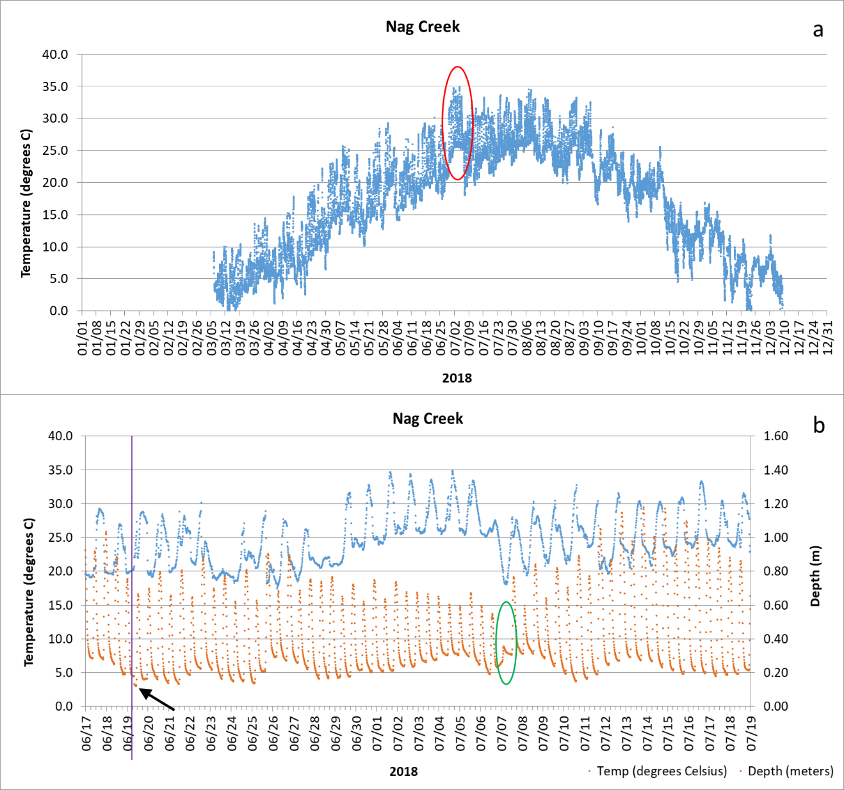

Figure 1. Graphs illustrating increased water temperatures at Nag Creek from June 19 to June 7: a) yearly water temperature data from Nag Creek showing the suspect data (red circle), b) suspect temperature data plotted against depth shows the sonde was deployed slightly shallower than the usual deployment depth. Black arrows indicate the moment the sonde was deployed, and when the sonde went back to the deployment depth.

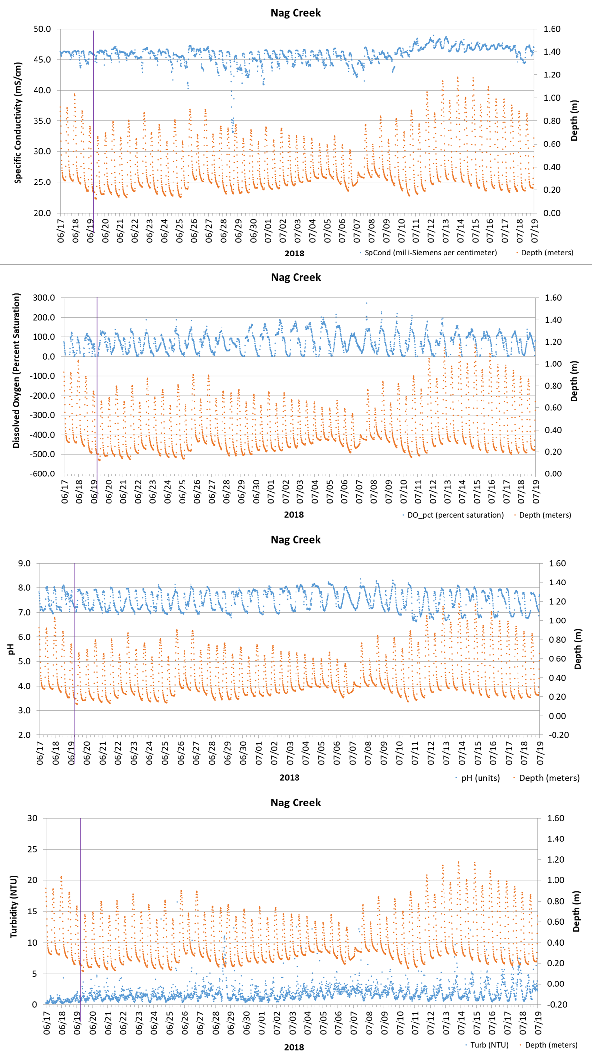

Figure 2. Graphs showing other water quality parameters at the site were not affected by the sonde being deployed slightly shallower on June 19 08:30. Beginning of the deployment is indicated by purple line on the graph.

Deployment period 08/29 10:00 – 18:30: Dissolved oxygen percent saturation (DO%) and DO concentration (mg/L) collected during this period was higher than the rest of the deployment and were flagged and coded as 1 GSM CBF. We believe it is due to the accumulation of drift algae near the sonde, at the bottom of the deploying structure, which produces oxygen through photosynthesis and the oxygen is released in the water making the DO readings higher than they typically are for this site.

Deployment period 11/13 16:45 – 11/15 13:45. Low salinities were recorded at Nag Creek for almost two consecutive days. Even though Nag Creek’s salinity is typically variable due to the continued freshwater input from the marsh and the red maple swamp abutting the creek to the east, this low salinity event lasted more than we typically record at Nag with our sondes. One possible explanation could be the rain event of 11/13 00:45 to 12:30, where our weather station recorded 1.7 inches of uninterrupted rain during this period. Our data showed a decrease in salinity at Nag during the rain event, but it stayed low even after the event, implying that run off from the marsh and red maple swamp was still affecting the creek. During this period, high winds from the north were also recorded at the weather station. The data were flagged and coded 0 GSM CRE.

Deployment period 11/22 18:00 – 11/24 10:00. The deploying structure and the sonde fell in the creek during this period due to the on and off ice formation in the creek. However, the sonde continued collecting data. Depth data were flagged and coded 1 GSM CWD. Water quality parameters affected by this (specific conductivity and salinity) were flagged and coded 1 GSM CWD, the other parameters seem not to be affected so 0 GSM CWD was used.

Deployment period 12/09 11:45 - 12/11 13:30. Nag creek started to freeze over slowly before this period as it usually does in winter. By the time we got to the creek to retrieve the sonde, the deploying structure and sonde were frozen in place and the sonde was partially exposed to the elements. We used the data to determine the date and time this happened. The data collected while the sonde was exposed were rejected and flagged and coded -3 GSM CIP.

Deployment period 12/11 10:15 – 12/31 23:45. The sonde was not deployed during this period because the creek was frozen. The missing data were flagged and coded -2 GIC CSM.

Potter Cove

F_Record column. Potter Cove is a shallow cove that can be partially frozen or there can be ice in the vicinity of the deployment station during winter. The sonde is approximately 75 cm off the bottom, and the cove could be 2 m deep at low tide, approximately. According to temperature and/or our observations, ice had formed in the cove while the sonde was deployed from 01/01 00:00 to 01/20 09:45. The code CIP CSM was used on the F_Record column. Figure 1 below is a picture taken on January 9, 2018 at Potter Cove.

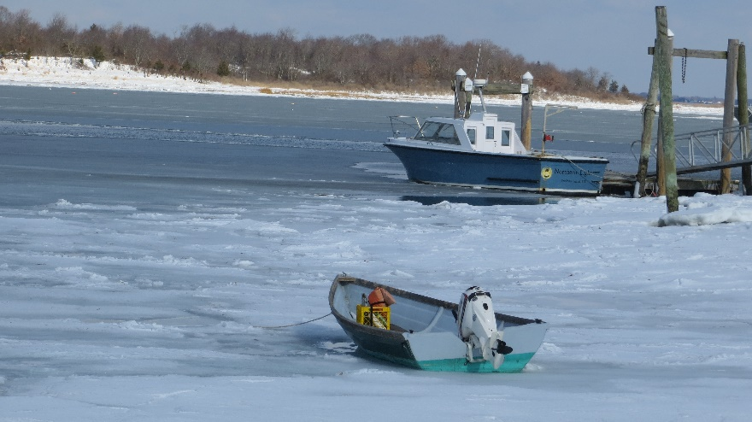

Figure 1. Potter Cove was partially frozen in January 2018.

T-Wharf Surface

F_Record column. T-Wharf Surface sonde is approximately 1 m below the surface at low tide. Low temperatures during several days in a row partially froze the surface water at this station. According to temperature and/or our observations, ice had formed around the station from 01/05 05:00 to 01/21 08:15 while the sonde was deployed. The code CIP CSM was used on the F_Record column. We believe the water quality parameters were not affected beyond the typical readings for this site during a New England winter. Figure 2 below are pictures taken on January 9, 2018 of the ice at T-Wharf.

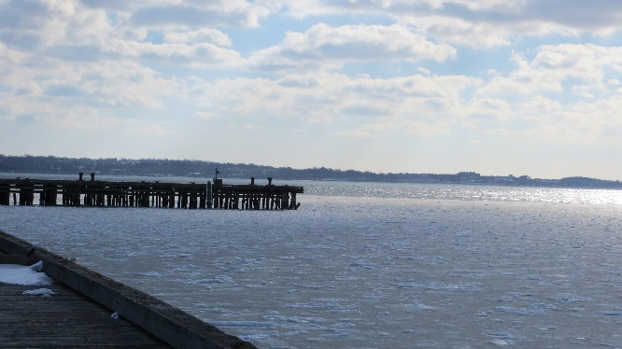A 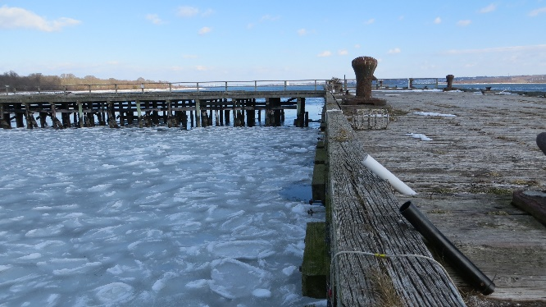B

Figure 2. Pictures of a frozen bay in January 2018. A) General area where the T-Wharf Surface sonde is deployed. Red circle shows the deployment PVC pipes, B) Close up of the wharf.

Deployment period 01/05 13:45 to 01/07 06:00. We believe that some ice had formed inside the deploying PVC pipe because depth was slightly different. The depth data collected were not considered suspect and were flagged and coded as 0 GSM CIP to account for the fact that the sonde was slightly shallower than usual due to ice. No other water quality parameter was affected during this period.

Deployment period 01/17 02:00 to 01/20 19:15. Negative values were recorded for dissolved oxygen (DO, percent saturation and concentration) for a short period of time when the general area at the station was frozen. However, the DO data before and after this period were not affected. No other water quality parameter was affected either. The DO data were rejected and flagged and coded as -3 SSM CIP since there is a high possibility it might have been related to the ice in the area.

At T-Wharf Surface and Bottom sites, sondes are deployed inside a 4” diameter PVC tube with slits and holes to aid in the water circulation. To clean the inside of the tubes of biofouling that can affect the water quality parameters, a reamer attached to a rope is sent down the tube right before each deployment. If there is any debris still floating inside the tube by the time the sondes are deployed, that can be mistaken for an increase in turbidity at the site. In this case data are rejected and flagged and coded 1 GSM CND or 1 CSM.

05/24/2018 09:30

06/20/2018 09:00

Deployment period 10/02 08:15 – 09:30. The sondes were retrieved briefly while divers were cleaning biofouling from the outside of the PVC pipe deploying structures. Data collected during this period were rejected and flagged and coded as -3 GSM CMC.

T-Wharf Bottom

Deployment period 03/08 10:30 -03/10 06:45. During this period, very high turbidity readings were recorded among readings that seem more typical of the site. When retrieved and brought back to the lab, it was found that the probe had failed. High readings were rejected and flagged and coded -3 SSM CSM, the other data that seem typical of the site were suspect and flagged and coded 1 SSM CSM.

Deployment period 03/10 07:00 – 03/15 09:30. During this period, there were two concurrent problems, a temperature/specific conductivity probe failed, and batteries failed. All the data collected during the probe failure, were flagged and coded -3 STF CSM. The missing data due to battery failure, were flagged and coded -2 GPF CSM.

Deployment period 03/16 13:30 – 03/28 08:45. During this period, no data were collected because the batteries failed. The missing data were flagged and coded -2 GPF CSM.

At T-Wharf Surface and Bottom sites, sondes are deployed inside a 4” diameter PVC tube with slits and holes to aid in the water circulation. To clean the inside of the tubes of biofouling that can affect the water quality parameters, a reamer attached to a rope is sent down the tube right before each deployment. If there is any debris still floating inside the tube by the time the sondes are deployed, that can be mistaken for an increase in turbidity at the site. In this case data are rejected and flagged and coded 1 GSM CND or 1 CSM.

05/24/2018 10:00

06/05/2018 11:15

06/21/2018 11:30

06/22/2018 01:30

7/10/2018 10:30

Deployment period 07/02 11:45 – 07/10 08:00. During this period, the sonde collected data that seemed like a temperature/specific conductivity probe failure. After testing the probe in the lab, the probe seemed to be working fine. However, the temperature / specific conductivity port on the sonde itself had failed. Therefore, all parameters recorded during this period were rejected and flagged and coded -3 GIM CSM. During this same period, there are missing data; these missing data were flagged and coded -2 GIM CSM.

Deployment period 07/31/18 10:15 – 11:15. During this period, Reserve staff were finishing the installation of a new telemetry system compatible with the deployment of EXO2 sondes which includes the new Storm 3 data logger by YSI, Inc. No data were collected during this time and missing data were flagged and coded as -2 GSM CMC.

Deployment staring on 07/31/18 11:30 – An EXO2 sonde was deployed after the upgrade of the telemetry equipment. Only EXO2 sondes will be deployed at this station going forward. To account for this fact, the first row of data collected with EXO2 sonde were flagged and coded 0 GSM CND.

Deployment period 10/02/18 08:15 – 09:30. The sondes were retrieved briefly while divers were cleaning biofouling from the outside of the PVC pipe deploying structures. Data collected during this period were rejected and flagged and coded as -3 GSM CMC.

Winter Blizzard March 13, 2018

Nag Creek, Potter Cove, T-Wharf Surface, and T-Wharf Bottom

Deployment period 03/13 00:00 – 03/13 23:45. Winter blizzard Skylar passed through the Northeast. During this period, our weather station recorded the strongest winds and highest amount of the precipitation on Prudence Island. We used CWE CSM code on the F_Record column for this period. We believe the water quality parameters were not affected.

1. Pilson, M.E.Q. 1985. On the residence time of water in Narragansett Bay. *Estuaries* 8:2–14.
2. Narragansett Bay National Estuarine Research Reserve. 2007. An Ecological Profile of the Narragansett Bay National Estuarine Research Reserve. K.B. Raposa and M.L. Schwartz (eds.), *Rhode Island Sea Grant*, Narragansett, R.I. 176pp.