Group Name: Cinema System Group A

Case Study: Cinema System

Group members:

Saira J. Barlas (C12809080), Ben Daan (C13358586), Orla Fahy (C13520633)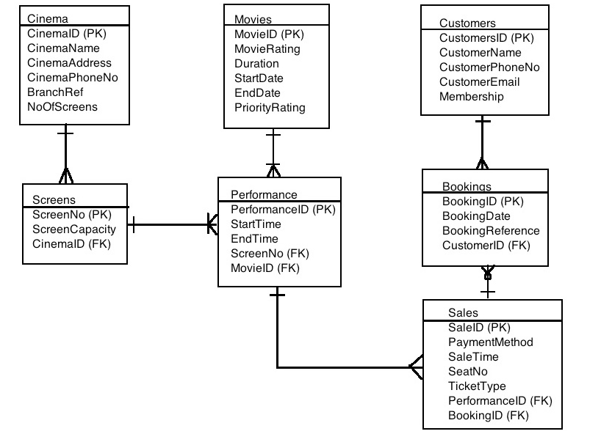

ERD Description:

One customer can have 0 or more bookings either via the phone or through the internet as shown in the Bookings entity. The customer entity also takes into account if a customer has membership or not with the cinema.

One booking or more, made through the aforementioned suggested methods, can have many tickets given out as shown in the Sales entity. This Sales entity also takes into account that a person can buy a ticket off the counter too.

0 or more tickets can be issued for a performance as seen in the Sales entity. The Performance entity basically tells us how many times a certain movie runs in a day.

Movies in the Movies entity tells us that one movie can have many different performances throughout the day.

The Screen entity informs us that a screen can have as many performances throughout the day since the cinema has 10 screens altogether.

The Cinema entity accounts for the many screens that it has to offer in that cinema.