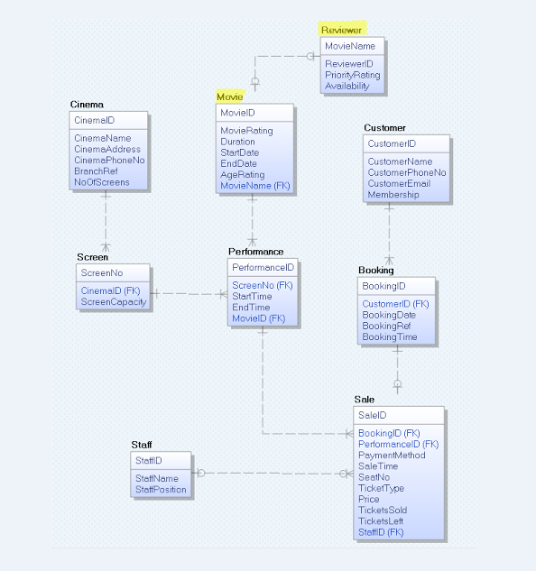I manipulated the tables Reviewer and Movie. As the Reviewer, I decided to manipulate the Movie in order to get access to another table so I can carry out my transactions. I allowed myself to be capable of viewing if the cinema had added the reviewed movie for the audience or not.