Project Dino-Chase: Provisioning and Customizing Scalable Cloud Infrastructure
Samantha Beaver
March 20, 2026

Objective: To provision a cloud-based infrastructure and deploy a customized web application using AWS, Linux, and Nginx.

Phase 1: Cloud Governance and Cost Management
Before deploying any resources, I established a Zero-Spend Budget within the AWS Billing and Cost Management console. By setting a budget threshold of $0.01 with automated email alerts, I ensured this project remains within the AWS Free Tier limits and demonstrated proactive resource monitoring.
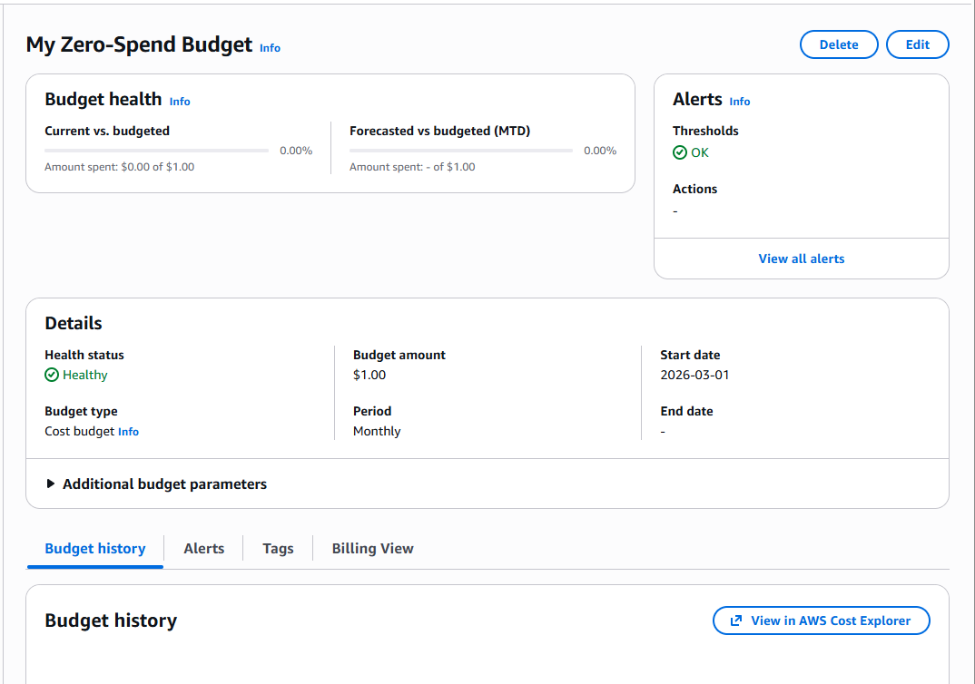
Phase 2: Infrastructure Provisioning
Description: Created a virtualized environment using Amazon EC2. This involved selecting an Ubuntu 24.04 LTS Amazon Machine Image (AMI) and configuring an Instance Type (t3.micro) suitable for the application’s resource requirements.

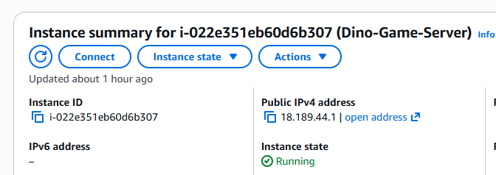

Phase 3: The Security Group Rules
Description: Restricted SSH (Port 22) to a single trusted IP to prevent brute-force attacks. Enabled HTTP (Port 80) for ‘Anywhere’ (0.0.0.0/0) to allow external users to access the web application without compromising the server’s backend integrity.
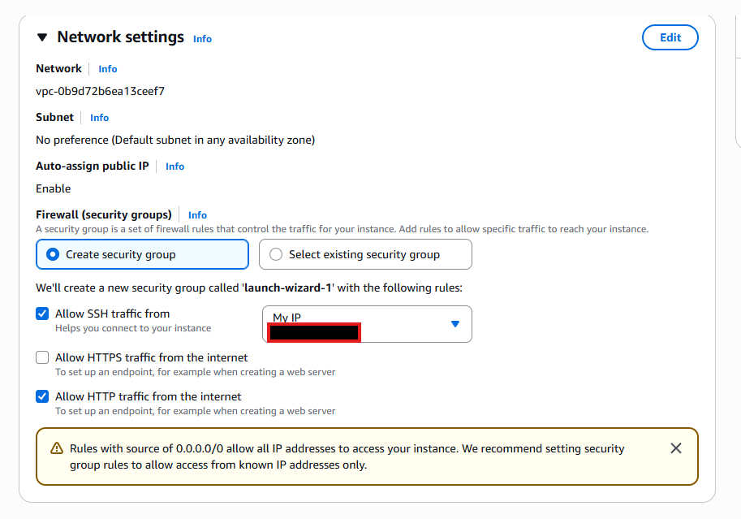

Phase 4: Server Authentication and Access
Description: Established a secure remote connection to the cloud instance using PowerShell and the SSH protocol. Successfully navigated local file paths (handling OneDrive complexities) to authenticate using the private key.

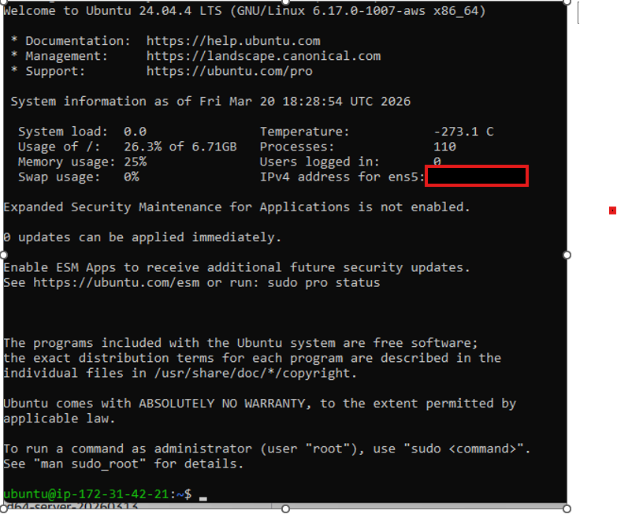

Phase 5: Web Server Installation and Deployment
Description: Initialized the web environment by installing Nginx web server. Once verified I used GIT to clone the application source code from a remote repository into the server’s document root (/var/www/html).
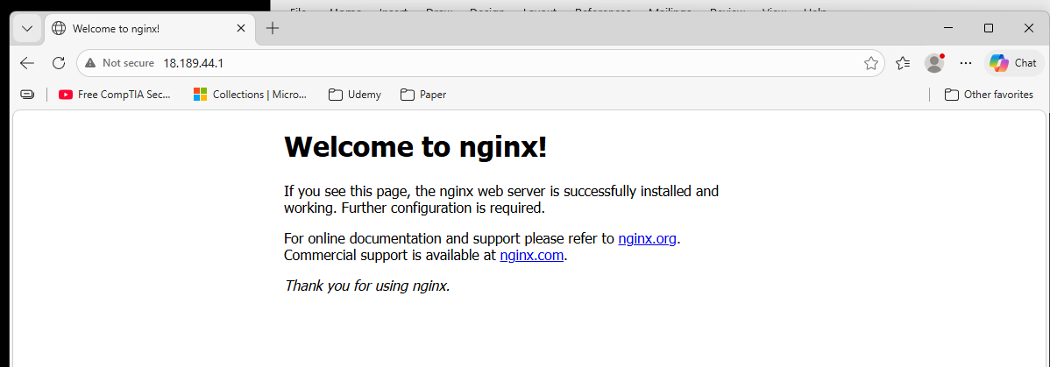

Phase 6: Customization and Final Deployment
Description: Performed live administrative updates to application. Using Nano text editor, I modified the index.html file to include a personalized header and a functional LinkedIn integration for professional networking. I utilized CSS styling and Z-index layering to ensure the UI elements remained visible above the game canvas.
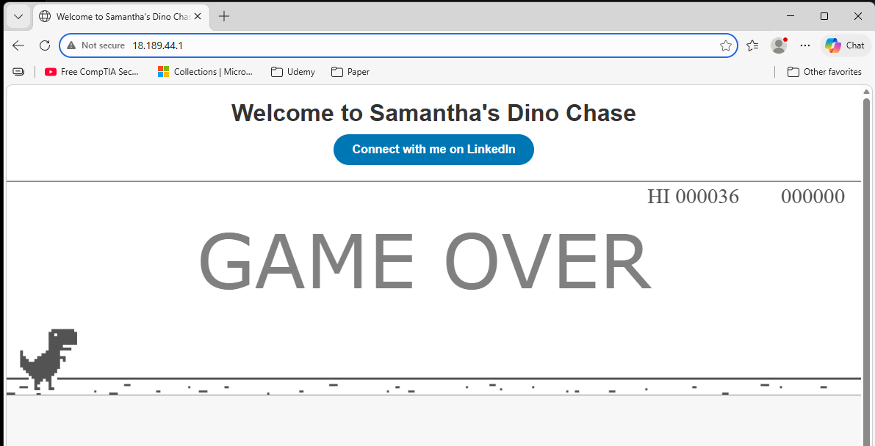

Conclusion:
This project demonstrates proficiency in IaaS (Infrastructure as a Service), Linux Administration, and Cloud Security. By successfully troubleshooting protocol mismatches (HTTP vs HTTPS) and directory pathing issues, I confirmed my ability to manage the full lifecycle of a cloud deployment.

