Splunk on Ubuntu VM – SSH Log Analysis
Project Overview
This project demonstrates deploying Splunk Enterprise on an Ubuntu virtual machine (Oracle VM), ingesting Linux authentication logs and building a dashboard to visualize SSH login activity. The goal was to create a project that shows log ingestion, troubleshooting, field extraction, searching, and visualization.
Objectives
- Install and run Splunk Enterprise on Ubuntu
- Ingest Linux authentication logs (auth.log)
- Troubleshoot common Linux and Splunk issues (ISO, permissions, sourcetypes, fields).
- Extract usernames from raw logs
- Build a dashboard showing SSH login attempts
Environment
- Host: Windows PC
- Hypervisor: Oracle VM / VirtualBox
- SIEM: Splunk Enterprise
- Browser: Firefox (inside VM)
Phase 1 – VM && OS Setup
What Worked
- Created a new Ubuntu VM
  - Name: Splunk-Log-Analysis
Type: Linux
Version: Ubuntu 64-bit
RAM: 4GB
CPU: 2 cores
Disk: 50 GB
- Installed Ubuntu successfully using a verified ISO
- Completed system updates after installation
Issues Encountered && Fixes
Issue | Cause | Fix
Installer Failed | Corrupt or incorrect ISO | Downloaded a clean Ubuntu ISO
“Need a bootable medium” | VM pointed to bad ISO | Attached correct ISO and reinstalled

Phase 2 – Splunk Install
What Worked
- Accessed Splunk Web UI at http://localhost:8000
- Successfully started Splunk and created an admin account
Issues Encountered && Fixes
Issue: | Cause: | Fix:
Downloaded Windows Splunk installer | OS mismatch | Downloaded Linux.deb package
Didn’t know package name | New to Linux | Used ls to list files before installing

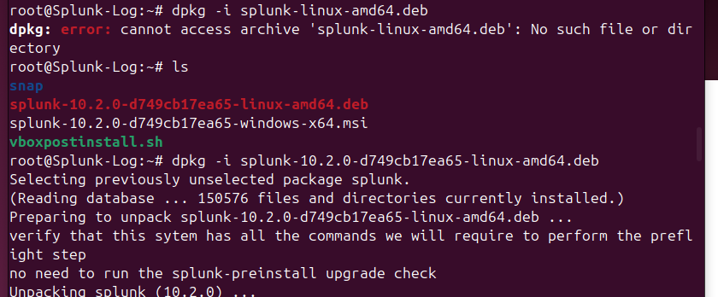

Phase 3 – Preparing Logs for Splunk
Actions Taken
- mkdir ~/splunk-logs
- sudo cp /var/log/auth.log ~splunk-logs/
Issues Encountered && Fixes
Issue: | Cause: | Fix
File had lock icon | Root ownership | Changed ownership && permissions

- sudo chown $USER:$USER auth.log
- chmod 644 auth.log
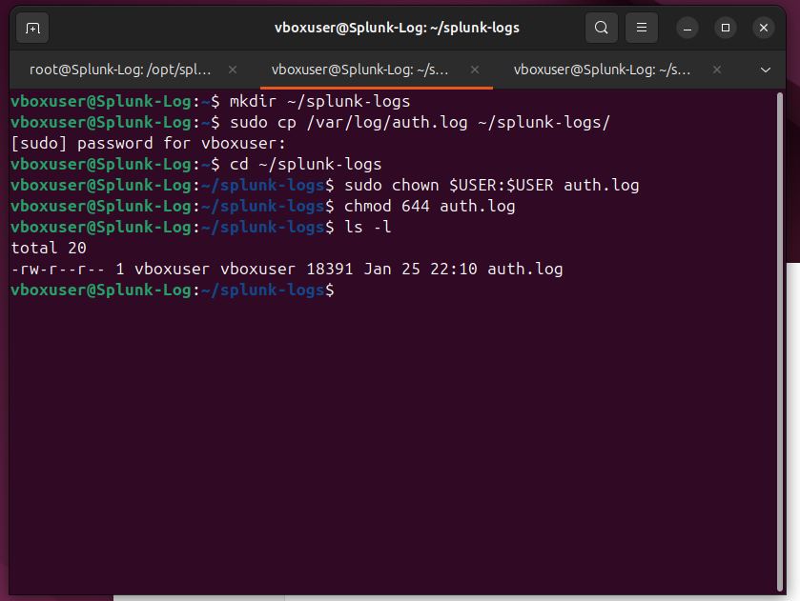

Phase 4 – Data Ingestion into Splunk
Actions Taken
- Used Add Data – Upload in Splunk
- Uploaded auth.log
- Sourcetype assigned automatically as logs
Issues Encountered && Fixes
Issue: | Cause: | Fix:
No search result | Wrong sourcetype used | Updated searches to sourcetype=”logs”

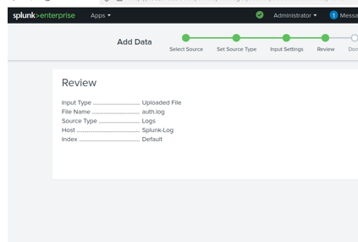

Phase 5 – Searching && Field Extraction
Initial Problem
- Running:
- sourcetype=”logs” | stats count by user, returned no results
Root Cause
- Splunk had not automatically extracted a user field.
- Usernames existed only in raw log
Solution – Manual Field Extraction
- Used a regex extraction:
sourcetype=”logs”
| rex “user (?<user>\w+)”
| stats count by user
Result
- Successfully displayed login activity for
- Root
- Vboxuser
- Gdm
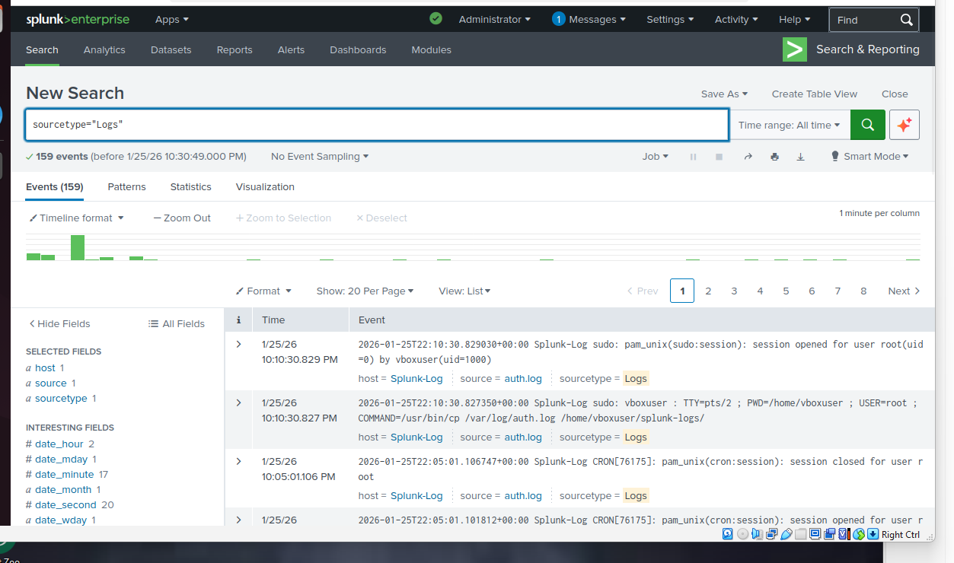
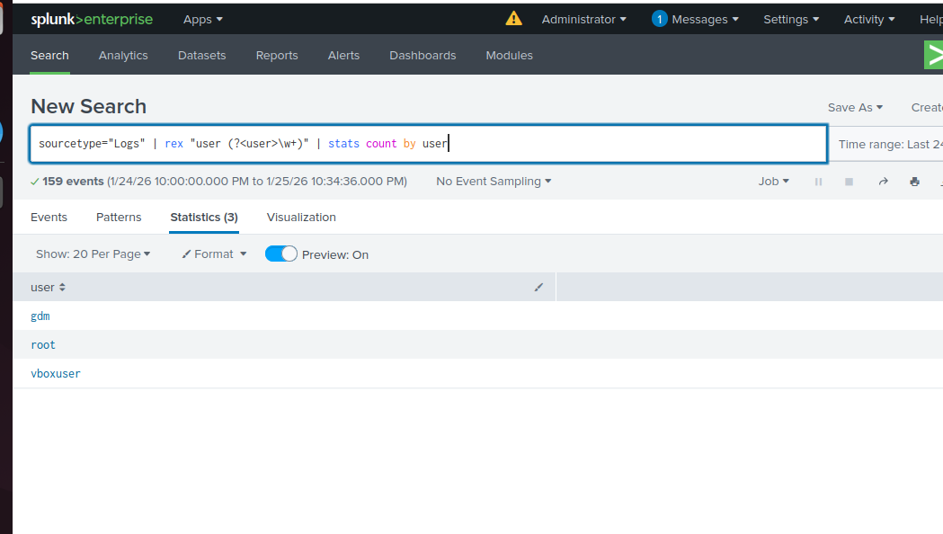

Phase 6 Generating Test SSH Events
Initial Issue
- SSH localhost
- Returned connection refused
Root Cause
- SSH server not installed/running
- Fix
sudo apt install openssh-server -y
sudo systemctl start ssh
sudo systemctl enable ssh
Generating Failed Logins
- ssh fakeuser@localhost
ssh hacker@localhost
Verification
- sudo tail /var/log/auth.log
Re-ingestion
- Copied and updated log back into Splunk and re-uploaded
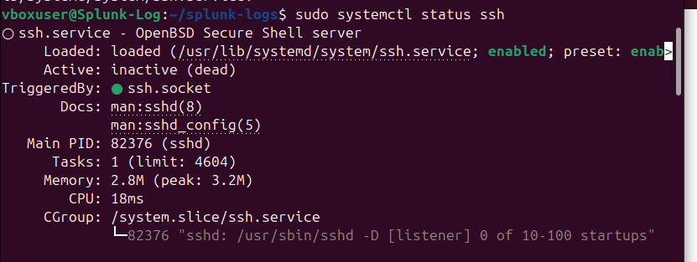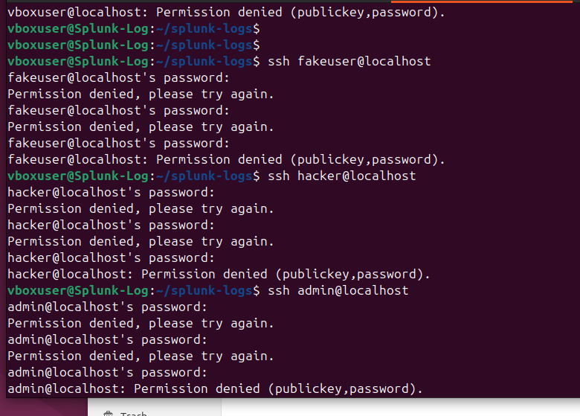
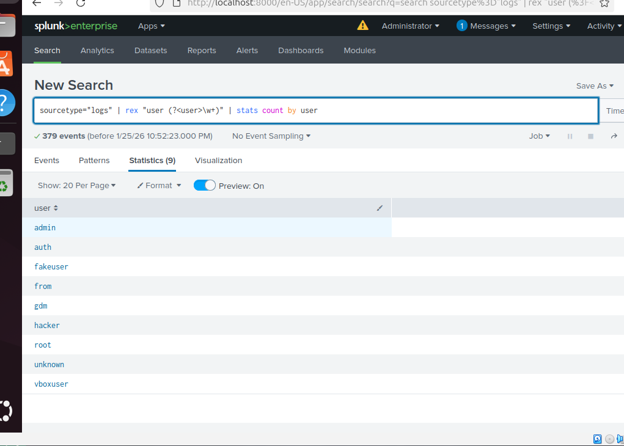

Final Outcome
This project demonstrates:
- SIEM deployment (Splunk)
- Linux log ingestion
- Troubleshooting permissions && services
- Regex field extraction
- Dashboard creation
- Skills Demonstrated
- Linux administration
- SIEM fundamentals
- Log analysis
- Security monitoring
- Problem-solving && debugging
Conclusion
Despite multiple setbacks, including ISO issues, wrong installer downloads, permission errors, sourcetype mismatches, and missing services, each issue was identified and resolved. These challenges strengthened practical Linux and Splunk troubleshooting skills and resulted in a functional monitoring project.
Future Improvements
- Real-time log ingestion (monitoring /var/log/auth.log live)
- Alerts for repeated failed logins
- Time-based SSH attack trends
- Additional data sources (syslog, firewalls)

Author: Samantha Beaver
Date: January 25, 2026

