*Content Warnings for this stream include descriptions and mentions of death, murder, suicide, neglect, grief, and anger. This is an 18+ stream.*

# What is expected of me as a TDOR reader?

1. Prepare to read your part (look at the confirmation email for details)
2. Join Zoom at the call time for tech rehearsal.
3. Read your part when it is your time, and at the end of your month, say:  
   **“What is remembered, lives.”**
4. Remain in the call for the remainder of the event

# What am I supposed to read?

Each reader gets assigned a month of names. Each month spans multiple locations in the world.

* Name
* Age
* What Happened
* City
* State/ Province / Region
* Country
* Date

For example:   
*Jo Acker, age 26, was shot in Boise, Idaho, USA on October 25, 2021.*

# How detailed am I supposed to be?

Please read the details on the reading form or the slide deck (whatever you’re keying off of). Yes, these methods of death are intense. It is important that we convey to our audience how intensely and poorly trans people are being treated. feel free to take your time with reading, take a breath, you don’t have to barrel through.

# How to speak about suicide

We invite readers to use the phrase “died by suicide” instead of “committed suicide.” The verb "commit" implies that suicidality is sinful or criminal, rather than a mental health issue, so we suggest "died by" instead.

# What if it gets to be too much?

We have backup readers for each month if it gets too intense. Just let your fellow readers know in the Zoom chat, and someone will sub in for you.

# When is the event?

Trans Day of Remembrance happens on November 20th every year. Call time (tech rehearsal) is one hour before we go live and starts at 10 am Pacific (8 am Hawai’ian, 11 am Mountain, 12 pm Central, 1 pm Eastern, 6 pm GMT). We will go live an hour after tech starts.

# How long is the event?

Tech is roughly an hour directly before the event. I expect to be live for roughly 2 hours, so the total time for this commitment should be however long you take for personal preparation ahead of time (especially practicing the names in your month), plus up to three hours on the 20th.

# What if I need to leave early?

Hopefully, you’ve communicated that in the google form you filled out. Folks are scheduled accordingly. Those that need to leave early are slotted sooner in the reading lineup. Please let the organizer (GenderMeowster) know ASAP if your availability changes.  
Note: Due to the production limitations and placement of the video feeds, please keep the call and camera running with your mic muted. You are welcome to cover your camera, and please leave it on the whole stream.

# Do I have to look at Twitch too?

Watching the Twitch stream/chat is optional. We have moderators, and I don't expect readers to track Twitch chat. If Twitch is new for you, I suggest you keep it simple (at least while you’re reading) and just focus on your reading task. Folks usually say lovely things in the chat and our moderation container is very strong for this event. If you want to watch Twitch for the slides and chat, you may consider using a PC or laptop instead of mobile, since delay on the mobile and TV apps can be 30+ seconds.

# What about trolls?

The Discord Server and the Twitch Channel have dedicated mods for this event. They have been trained in handling the moderation needs that may come up - readers are not expected to handle any public commentary.

# What time zone is this happening in?

GenderMeowster (they/them) is in the Pacific time zone; they will likely communicate using language revolving around that time zone. If you are in the discord green room, we can also make schedules/communicate time using unix timecode, which auto-converts times for folks.

# What if I don't know how to say something?

You will receive your list of names ahead of time. PLEASE take some time to review your list and practice saying the names a couple of times. We have added a column for phonetic spelling and asked some community members to help us with names that are more likely to be difficult (especially Spanish and Portuguese, for example). We may not get to the whole list, so please take some time to familiarize yourself with your month.

For those with reading challenges (dyslexia etc): So long as you don’t change the order of the names, you may make your own list for personal use that has pronunciation spelled out phonetically. There is a column in our spreadsheet reserved for phonetic spellings if that helps during the reading. If there are names in languages you don’t understand, ask a friend or in the TDOR green room for help before the day of stream.

# This event sounds intense. What recommendations do you have for self-care?

It totally is an emotionally challenging experience! Here are some suggestions from the last several years we have run this event:

* **bookending** - have a trusted person/people to check in with before and after the event. If you find yourself in an emotional crisis before/after, there are trans-affirming warmlines and hotlines listed here <https://linktr.ee/safersupport>
* **Tissues** - keep some tissues or a handkerchief nearby, even if you don’t expect to cry.
* **Water** - Have some water nearby.
* **Time off after** - give yourself time to transition from this activity to your next thing (Meowster is taking 2 days off from streaming after the event; they did not take time off their first year, and it was a mistake!).
* **emotional support stuffie/mammal** - it’s ok to snuggle a plushie or a cat/dog while reading on stream.
* **Eat something nourishing beforehand** - unless speaking/performance anxiety makes that too difficult. It's sometimes hard to eat after an event like this.
* **Have a warm beverage** - a throat coat tea, hot chocolate, coffee, etc to put warm fluid in your belly if it gets into knots (throat coat and/or honey/lemon water/tea can help with the vocal strain that accompanies speaking more than usual).

# What should I wear/ is there a dress code? What if someone comes from a culture where mourning colors are different?

Dress like you're going to a funeral, whatever colors are appropriate in your culture. For example, in the United States, typically black is worn. Whereas in Indian culture, mourning is plain white.

# Previous years' TDOR streams, for reference:

* 2022: <https://www.youtube.com/watch?v=1V87bOvFkvE>
* 2021: <https://www.youtube.com/watch?v=F0ISVNMotSM>
* 2020:<https://youtu.be/7kNZR_Drvc8>

# RSVP and join us live:

If you want to invite friends to watch live, send them the Twitch channel to f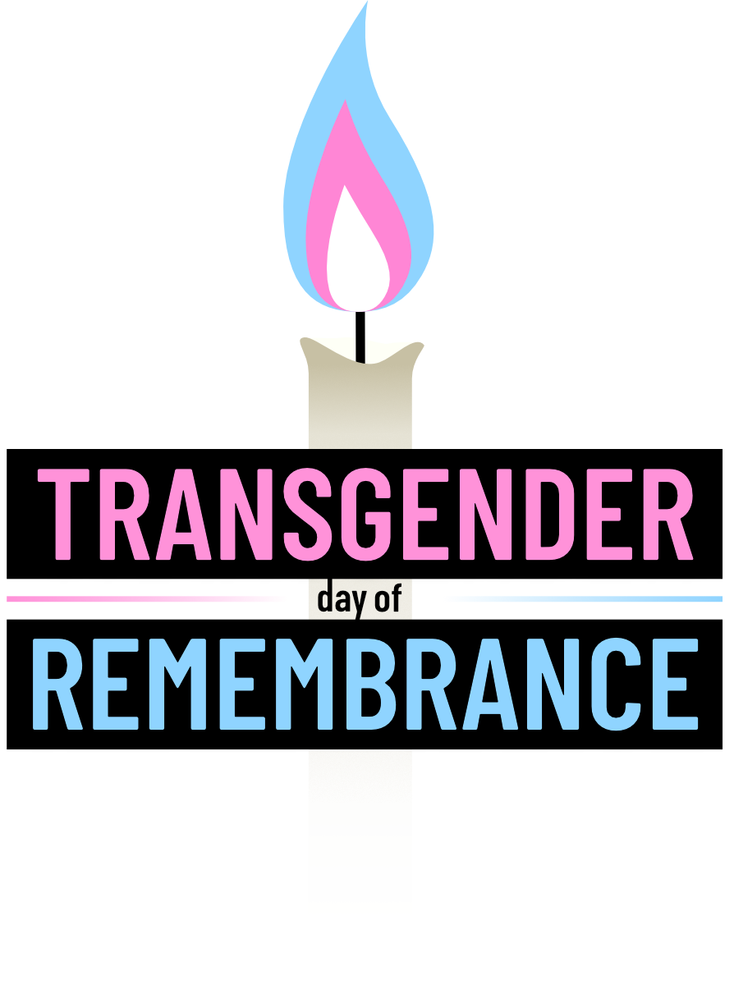

follow<https://www.twitch.tv/GenderMeowster>