|  |  |
| --- | --- |
| **VISVESVARAYA TECHNOLOGICAL UNIVERSITY**  **“JNANA SANGAMA”, Belagavi-590018**    **A Report on**  **“WEB TECHNOLOGY AND ITS APPLICATION PRACTICAL PROGRAMS”**  SUBMITTED IN PARTIAL FULFILLMENT OF THE REQUIREMENT FOR  THE AWARD OF DEGREE OF  **BACHELOR OF ENGINEERING IN**  **INFORMATION SCIENCE AND ENGINEERING**  **SUBMITTED BY**  **B K ABHISHEK(1JB20IS400)**  **Under the Guidance of**  **Prof. Siddanna S R**  **Assistant Professor,**  **Dept. of ISE, SJBIT**  **Bengaluru-60**    **DEPARTMENT OF INFORMATION SCIENCE AND ENGINEERING**  **SJB INSTITUTE OF TECHNOLOGY**  **BGS HEALTH AND EDUCATION CITY, KENGERI, BENGALURU-560060, KARNATAKA, INDIA**.  **2021-2022** | |
| **|| Jai Sri Gurudev ||**  **Sri AdichunchanagiriShikshana Trust ®**  **SJB INSTITUTE OF TECHNOLOGY**  **BGS Health & Education City, Kengeri, Bengaluru – 560 060**  **Department of Information Science & Engineering**    **CERTIFICATE**  Certified that the work entitled “WEB TECHNOLOGY AND ITS APPLICATION  PRACTICAL PROGRAMS**”,** is bonafide work carried out by **B K ABHISHEK(1JB20IS400),** a bonafide students of **SJB Institute of Technology,** in partial fulfilment for 6th semester in **INFORMATION SCIENCE AND ENGINEERING** of the **VISVESVARAYA TECHNOLOGICAL UNIVERSITY**, **BELAGAVI** during the academic year **2021-22.** It is certified that all corrections/suggestions indicated for Internal Assessment have been incorporated in the report deposited in the departmental library. The report has been approved as it satisfies the academic requirements in respect of work prescribed for the said degree.  **Prof. Siddanna S R Dr. Rekha B**  Assistant Professor Professor & Head  Dept. of ISE, SJBIT Dept. of ISE, SJBIT | |
| **ACKNOWLEDGEMENT**  I would like to express my profound thanks to His Divine Soul **Padmabhushan Sri Sri Sri Dr. Balagangadharanatha Maha Swamiji** and His Holiness **Jagadguru Sri Sri Sri Dr. Nirmalanandanatha Maha Swamiji** for providing me an opportunity to pursue my academics in this esteemed institution.  I would also like to express my profound thanks to **Revered Sri Sri Dr. Prakashnath Swamiji**, Managing Director, SJB Institute of Technology, for his continuous support in providing amenities to carry out this work in this admired institution.  I express my gratitude to **Dr. K. V. Mahendra Prashanth**, Principal, SJB Institute of Technology,for providing excellent facilities and academic ambience, which have helped me in satisfactory completion of work.  I extend my sincere thanks to **Dr. Rekha B**, Professor & Head, Department of Information Science and Engineering, for providing an invaluable support.  I wish to express heartfelt gratitude to **Prof. Siddanna S R,** Assistant Professor, Department of Information Science and Engineering for his valuable guidance, suggestions and cheerful encouragement during the entire period of this work.  Finally, I take this opportunity to extend my earnest gratitude and respect to my parents, Teaching & Non-teaching staffs of the department, the library staff and all my friends, for their continuous support and encouragement.  **B K ABHISHEK**  **(1JB20IS400)** | |

# Table of Contents

**SL.No. Program Page No.**

1. Program 1 1-2

1. Program 2 3-4

1. Program 3 5-8

1. Program 4 9-11

1. Program 5 12-14

1. Program 6 15-16

1. Program 7 17-18

1. Program 8 19-23

1. Program 9 24-25

1. Program 10 26-30

# PROGRAM 1

Write a JavaScript to design a simple calculator to perform the following operations: sum, product, difference and quotient.

<!DOCTYPE html>

<html>

<head>

<script> function operation(opr) { var ip1 = parseInt(document.getElementById("input1").value); var ip2 = parseInt(document.getElementById("input2").value); var output; switch (opr) { case '+': output = ip1 + ip2; break; case '-':

output = ip1 - ip2; break;

case '*':

output = ip1 * ip2; break; case '/':

if (ip2 != 0) { output = ip1 / ip2;

} else { document.getElementById("output").innerHTML = "Divide By Zero Error"; return; } break;

} document.getElementById("output").innerHTML = "Result: " + output; }

</script>

</head>

<body>

<label for="input1">Input 1: </label>

<input type="number" id="input1"></input> &emsp;

<label for="input2">Input 2: </label>

<input type="number" id="input2"></input>

<br>

<button onclick=operation('+')>Add</button>

<button onclick=operation('-')>Subtract</button>

<button onclick=operation('*')>Multiply</button>

<button onclick=operation('/')>Divide </button> <br>

<p id="output"></p>

</body>

</html>

**OUTPUT:**

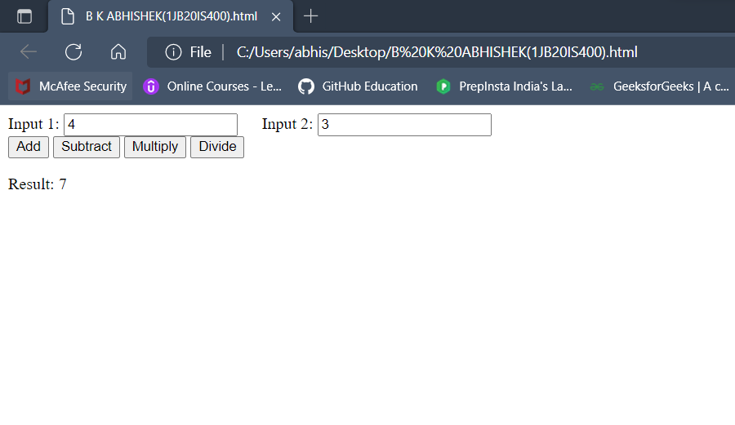

# PROGRAM 2

Write a JavaScript that calculates the squares and cubes of the numbers from 0 to 10 and outputs HTML text that displays the resulting values in an HTML table format.

<!DOCTYPE html>

<html>

<head>

</head>

<body>

<table id="myTable" border="1">

<tr>

<th>Number</th>

<th>Square</th>

<th>Cube</th>

</tr>

</table>

<script>

var table = document.getElementById("myTable"); var i; for (i = 0; i <= 10; ++i) { var row = table.insertRow(-1); var cell1 = row.insertCell(0); var cell2 = row.insertCell(1); var cell3 = row.insertCell(2); cell1.innerHTML = i; cell2.innerHTML = i * i;

cell3.innerHTML = i * i * i;

}

</script>

</body>

</html>

**OUTPUT:**

# PROGRAM 3

Write a JavaScript code that displays text “TEXT-GROWING” with increasing font size in the interval of 100ms in RED COLOR, when the font size reaches 50pt it displays

“TEXTSHRINKING” in BLUE colour. Then the font size decreases to 5pt.

<!DOCTYPE html>

<html>

<head>

<title>3rd program</title>

<style>

#ele { position: absolute; top: 50%; left: 50%; transform: translate(-50%, -50%); }

</style>

</head>

<body>

<p id="ele"></p>

<script> let ele = document.getElementById("ele"); var cur_size = 5;

var increasing = true;

var lower_bound = 5; var upper_bound = 50; var step_size = 5; var time_interval = 100; setInterval(function () { if (cur_size <= lower_bound) {

increasing = true; ele.style.color = "red"; cur_size = lower_bound + step_size; ele.style.fontSize = cur_size + "pt"; ele.innerHTML = "Growing Text";

} else if (cur_size >= upper_bound) { increasing = false; ele.style.color = "blue";

cur_size = upper_bound - step_size;

ele.style.fontSize = cur_size + "pt";

ele.innerHTML = "Shrinking Text";

} else { if (increasing) {

cur_size = cur_size + step_size;

} else { cur_size = cur_size - step_size;

}

ele.style.fontSize = cur_size + "pt";

}

}, time_interval);

</script>

</body>

</html>

**OUTPUT:**

# PROGRAM 4

Develop and demonstrate a HTML5 file that includes JavaScript script that uses functions for the following problems: a. Parameter: Astring

1. Output: The position in the string of the left-mostvowel

1. Parameter: Anumber

1. Output: The number with its digits in the reverseorder

<!DOCTYPE html>

<html>

<head>

<title>Gurushantha program4</title>

</head>

<body>

<input type="text" id="input"><br>

<button type="submit" onclick="action()">Submit</button>

<p id="result"></p>

<script> function action() { var input = document.getElementById("input").value; var par = document.getElementById("result"); if (isNaN(input)) { let index = leftMostVowelIndex(input); if (index != -1) { par.innerHTML = "Position: " + (index + 1);

} else {

par.innerHTML = "No Vowel Found";

}

} else { par.innerHTML = reverseNumber(input);

}

}

function leftMostVowelIndex(input) { input = input.toLowerCase(); for (var i = 0; i < input.length; i++) { if (input[i] == 'a' || input[i] == 'e' || input[i] == 'i' || input[i] == 'o' || input[i] == 'u') { return i;

} } return -1; // No Vowel Found

}

function reverseNumber(input) { return input.split("").reverse().join("");

}

</script>

</body>

</html>

**OUTPUT:**

# PROGRAM 5

Design an XML document to store information about a student in an engineering college affiliated to VTU. The information must include USN, Name, and Name of the College, Programme, Year of Joining, and email id. Make up sample data for 3 students. Create a CSS style sheet and use it to display the document.

<?xml version="1.0" encoding="utf-8"?>

<!DOCTYPE student_information[

<!ELEMENT student_information (ad+)>

<!ELEMENT ad (usn,name,college,branch,year,email)>

<!ELEMENT usn (#PCDATA)>

<!ELEMENT name (#PCDATA)>

<!ELEMENT college (#PCDATA)>

<!ELEMENT branch (#PCDATA)>

<!ELEMENT year (#PCDATA)>

<!ELEMENT email (#PCDATA)>

]>

<?xml-stylesheet type="text/css" href="4a.css"?>

<student_information>

<h1>First Student Information</h1>

<ad><label>USN:</label><usn>1JB11CS001</usn></ad>

<ad><label>NAME:</label><name>ABC</name></ad>

<ad><label>COLLEGE:</label><college>SJBIT</college></ad>

<ad><label>BRANCH:</label><branch>CSE</branch></ad>

<ad><label>YEAR:</label><year>2001</year></ad>

<ad><label>EMAIL:</label><email>abc@gmail.com</email></ad>

<h1>Second Student Information</h1>

<ad><label>USN:</label><usn>1JB11CS002</usn></ad>

<ad><label>NAME:</label><name>DEF</name></ad>

<ad><label>COLLEGE:</label><college>SJBIT</college></ad>

<ad><label>BRANCH:</label><branch>CSE</branch></ad>

<ad><label>YEAR:</label><year>2001</year></ad>

<ad><label>EMAIL:</label><email>def@gmail.com</email></ad>

<h1>Third Student Information</h1>

<ad><label>USN:</label><usn>1JB11CS003</usn></ad>

<ad><label>NAME:</label><name>GHI</name></ad>

<ad><label>COLLEGE:</label><college>SJBIT</college></ad>

<ad><label>BRANCH:</label><branch>CSE</branch></ad>

<ad><label>YEAR:</label><year>2001</year></ad>

<ad><label>EMAIL:</label><email>ghi@gmail.com</email></ad>

</student_information>

**CSS Document for the above XML Document** ad{display:block;} label{font-weight:bold;color:blue;} usn{font-size:14pt;color:red;} name{font-size:14pt;color:red;} college{font-size:14pt;color:red;} branch{font-size:14pt;color:red;} year{font-size:14pt;color:red;} email{font-size:14pt;color:red;}

**OUTPUT:**

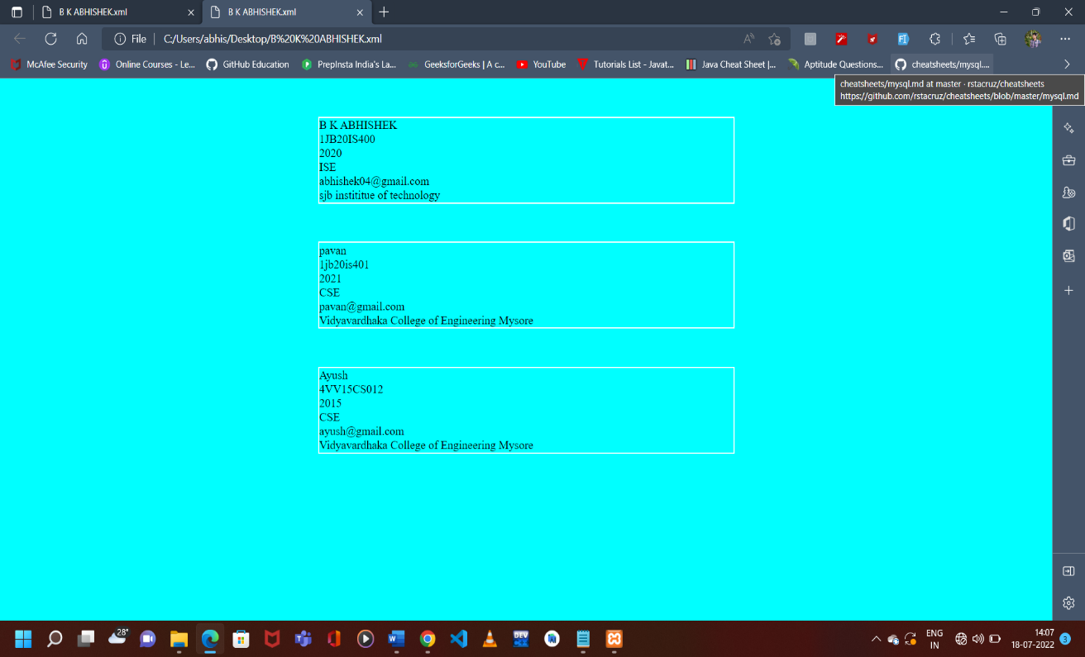

# PROGRAM 6

A PHP program to keep track of the number of visitors visiting the web page and to

display this count of visitors, with proper headings.

<!DOCTYPE html>

<html>

<head>

<title>Visitors</title>

</head>

<body>

<?php

$file_path = "count.txt";

$count = 0;

if (file_exists($file_path)) {

$myFile = fopen($file_path, "r");

$count = fread($myFile, filesize($file_path)); fclose($myFile);

}

$count = $count + 1;

$myFile = fopen($file_path, "w"); fwrite($myFile, $count);

echo "<h1>Visitors: " . $count . "</h1>"

?>

</body>

</html>

**OUTPUT:**

# PROGRAM 7

a PHP program to display a digital clock which displays the current time of the server.

<!DOCTYPE html>

<html>

<head>

<title>7 th program</title>

<!--Required to refresh every 1 second-->

<meta http-equiv="refresh" content="1">

<style> body { position: absolute; top: 50%; left: 50%;

transform: translate(-50%, -50%); background-color: black;

color: white; font-size: 50px;

}

</style>

</head>

<body>

<div> <?php

date_default_timezone_set("Asia/Calcutta");

echo date("h:i:s a");

?>

</div>

</body>

</html>

**OUTPUT:**

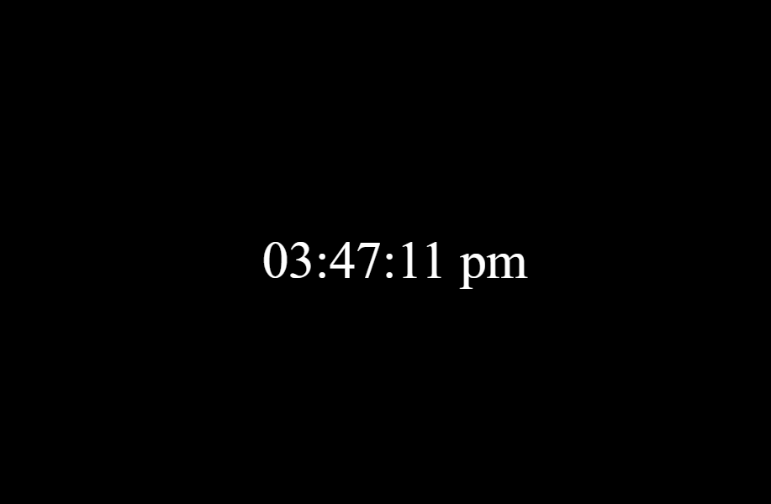

# PROGRAM 8

the PHP programs to do the following:

1. Implement simple calculator operations.

1. Find the transpose of a matrix.

1. Multiplication of two matrices.

1. Addition of two matrices.

**SIMPLE CALCULATOR OPERATIONS**

<!DOCTYPE html>

<html>

<head>

<title>Simple Calculator</title>

</head>

<body>

<form method="post">

<label>

Input 1:

<input type="text" name="num1"/>

</label> <br>

<label>

Input 2:

<input type="text" name="num2"/>

</label> <br>

<input type="submit" value="Calculate">

</form> <?php if (isset($_POST['num1']) and isset($_POST['num2'])) { $num1 = $_POST['num1']; $num2 = $_POST['num2']; if (is_numeric($num1) and is_numeric($num2)) {

echo "<table>"; echo "<tr><td> Addition: </td><td>" . ($num1 + $num2) . "</td>"; echo "<tr><td> Subtraction: </td><td>" . ($num1 - $num2) . "</td>"; echo "<tr><td> Multiplication: </td><td>" . ($num1 * $num2) . "</td>"; echo "<tr><td>Division: </td><td>" . ($num1 / $num2) . "</td>"; echo "</table>";

} else { echo "<script type='text/javascript' > alert('Invalid Numbers');</script>";

}

}

?>

</body>

</html>

**MATRICES OPERATIONS**

<!DOCTYPE html>

<html>

<head>

<title>Matrices Operations</title>

</head>

<body>

<?php

$a = array(array(1, 2, 3), array(4, 5, 6), array(7, 8, 9));

$b = array(array(7, 8, 9), array(4, 5, 6), array(1, 2, 3));

$m = count($a);

$n = count($a[0]);

$p = count($b);

$q = count($b[0]);

function print_matrix($mat)

{

$rows = count($mat); $cols = count($mat[0]); for ($row = 0; $row < $rows; $row++) {

for ($col = 0; $col < $cols; $col++)

echo " " . $mat[$row][$col];

echo "<br/>";

}

}

echo "The First Matrix :" . "<br/>"; print_matrix($a);

echo "The Second Matrix :" . "<br/>"; print_matrix($b);

echo "The Transpose for the First Matrix is:" . "<br/>";

$trans = array(); for ($i = 0; $i < $n; $i++) {

for ($j = 0; $j < $m; $j++)

$trans[$i][$j] = $a[$j][$i];

}

print_matrix($trans);

if (($m === $p) and ($n === $q)) {

$add = array();

echo "The Addition of Matrices is:" . "<br/>"; for ($i = 0; $i < $m; $i++) { for ($j = 0; $j < $n; $j++)

$add[$i][$j] = $a[$i][$j] + $b[$i][$j];

} print_matrix($add);

}

if ($n === $p) { echo " The Multiplication of Matrices: <br/>";

$result = array(); for ($i = 0; $i < $m; $i++) {

for ($j = 0; $j < $q; $j++) { $result[$i][$j] = 0; for ($k = 0; $k < $n; $k++)

$result[$i][$j] += $a[$i][$k] * $b[$k][$j];

} } print_matrix($result);

}

?>

</body>

</html>

**OUTPUT OF SIMPLE CALCULATOR OPERATIONS:**

**OUTPUT OF MATRICES OPERATIONS:**

# PROGRAM 9

Write a PHP program named states.py that declares a variable states with value "Mississippi Alabama Texas Massachusetts Kansas".

Write a PHP program that does the following:

1. Search for a word in variable states that ends in xas. Store this word in element 0 of a list namedstatesList.
2. Search for a word in states that begins with k and ends in s. Perform a case-insensitive comparison. [Note: Passing re.Ias a second parameter to method compile performs a case- insensitive comparison.] Store this word in element1 ofstatesList.
3. Search for a word in states that begins with M and ends in s. Store this word in element 2 of thelist.
4. Search for a word in states that ends in a. Store this word in element 3 of thelist.

<!DOCTYPE html>

<html>

<head>

<title>Regex</title>

</head>

<body>

<?php

$string = "Mississippi Alabama Texas Massachusetts Kansas";

$statesList = [];

$states = explode(' ', $string); echo "Original String Array :<br>"; foreach ($states as $i => $value)

print("STATES[$i]=$value<br>");

foreach ($states as $state) { if (preg_match('/xas$/', ($state)))

$statesList[0] = ($state);

if (preg_match('/^k.*s$/i', ($state)))

$statesList[1] = ($state);

if (preg_match('/^M.*s$/', ($state)))

$statesList[2] = ($state);

if (preg_match('/a$/', ($state)))

$statesList[3] = ($state);

}

echo "<br><br>StatesList Array :<br>"; for ($i = 0; $i < 4; $i++)

print("StatesList[$i]=$statesList[$i]<br>");

?>

</body>

</html>

**OUTPUT:**

# PROGRAM 10

Write a PHP program to sort the student records which are stored in the database using selection sort.

<!DOCTYPE html>

<html>

<body> <style> table, td, th { border: 1px solid black; width: 33%; text-align: center; border-collapse: collapse; background-color: lightblue;

} table

{ margin: auto;

}

</style>

<?php

$servername = "localhost";

$username = "root";

$password = "";

$dbname = "weblab";

$a=[];

$conn = mysqli_connect($servername, $username, $password, $dbname);

if (!$conn)

die("Connection failed: " . $conn->connect_error);

$crt="create table student0(usn varchar(10),name varchar(20),address varchar(20))";

$result0= mysqli_query($conn,$crt);

$crt1="INSERT INTO `student0`(`usn`, `name`, `address`) VALUES

('1JB19IS050','Mohan K T','Banglore')";

$crt2="INSERT INTO `student0`(`usn`, `name`, `address`) VALUES

('1JB19IS053','Vishal N','Banglore')";

$crt3="INSERT INTO `student0`(`usn`, `name`, `address`) VALUES

('1JB19IS085','Sameer','Dubai')";

$crt4="INSERT INTO `student0`(`usn`, `name`, `address`) VALUES

('1JB19CS085','Medico','Bgsgims')";

$result1= mysqli_query($conn,$crt1);

$result2= mysqli_query($conn,$crt2);

$result3= mysqli_query($conn,$crt3);

$result4= mysqli_query($conn,$crt4);

$sql = "SELECT * FROM student0"; $result = mysqli_query($conn,$sql); echo "<br>"; echo "<center> BEFORE SORTING </center>"; echo "<table border='2'>"; echo "<tr>";

echo "<th>USN</th><th>NAME</th><th>Address</th></tr>";

if ($result->num_rows> 0)

{ while($row = $result->fetch_assoc()) { echo "<tr>"; echo "<td>". $row["usn"]."</td>"; echo "<td>". $row["name"]."</td>"; echo "<td>". $row["address"]."</td></tr>"; array_push($a,$row["usn"]);

} } else echo "Table is Empty"; echo "</table>"; $n=count($a);

$b=$a;

for($i=0;$i<($n-1);$i++)

{ $pos= $i; for ( $j = $i + 1 ; $j < $n ; $j++ )

{ if ( $a[$pos] > $a[$j] )

$pos= $j; } if ( $pos!= $i ) {

$temp=$a[$i];

$a[$i] = $a[$pos];

$a[$pos] = $temp;

}

}

$c=[];

$d=[];

$result = $conn->query($sql);

if ($result->num_rows> 0)

{ while($row = $result->fetch_assoc())

{ for($i=0;$i<$n;$i++)

{ if($row["usn"]== $a[$i])

{

$c[$i]=$row["name"];

$d[$i]=$row["address"];

}

}

} } echo "<br>"; echo "<center> AFTER SORTING <center>"; echo "<table border='2'>"; echo "<tr>";

echo "<th>USN</th><th>NAME</th><th>Address</th></tr>";

for($i=0;$i<$n;$i++)

{ echo "<tr>"; echo "<td>". $a[$i]."</td>"; echo "<td>". $c[$i]."</td>"; echo "<td>". $d[$i]."</td></tr>";

} echo "</table>";

$conn->close();

?>

</body>

</html>

**OUTPUT:**

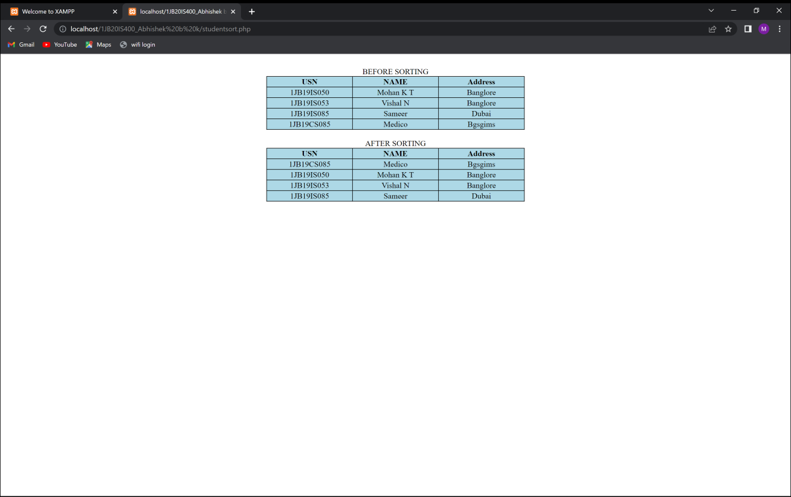

30