|  |  |  |
| --- | --- | --- |
| **Designer:** SJ Bronkhorst | **Project:** 1234 | **Date:** 2016/03/09 12:32:54 |

**Model Properties:File Path:** C:\Users\SJ\Documents\NetBeansProjects\Stripper**Maximum allowable stress:** 354.0**Cross-sectional Area:** 0.0**Ixx:** 0.0**Ixx (principal):** NaN**Izz:** 0.0**Izz (principal):** NaN

**Material Properties: Material name:** S355**Young's Modulus (Ex):** 210000.0**Young's Modulus (Ey):** 210000.0**Poisson Ratio (vx):** 0.3**Poisson Ratio (vy):** 0.3**Shear Modulus (G):** 81000.0**Yield Stress:** 354.0

**Cross-Section:**

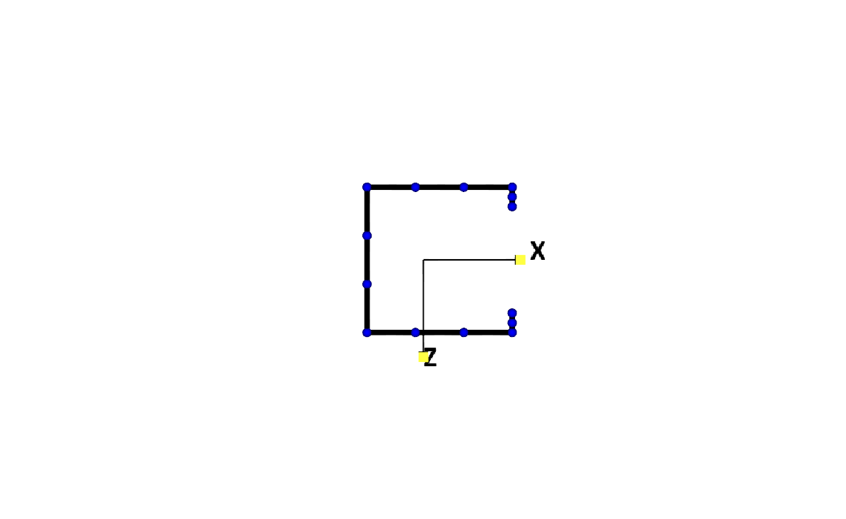

**Local Buckling Factor chosen by user:**

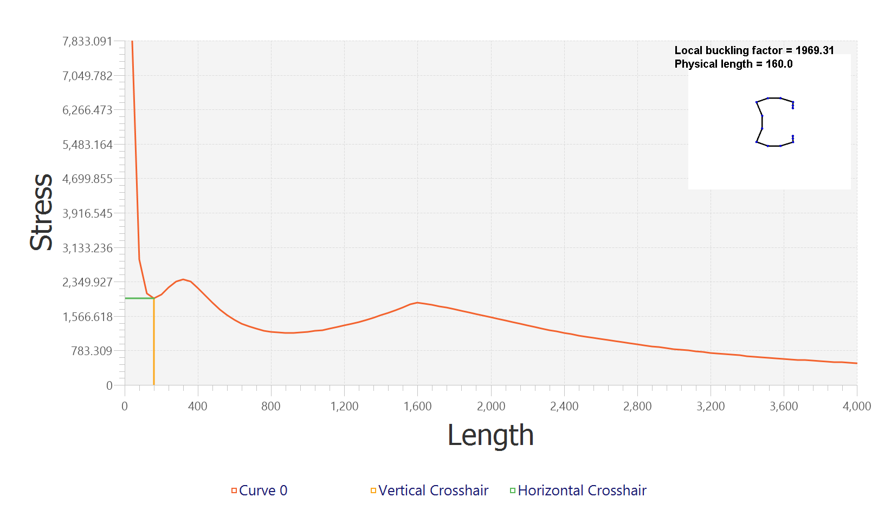

**Distortional Buckling Factor chosen by user:**

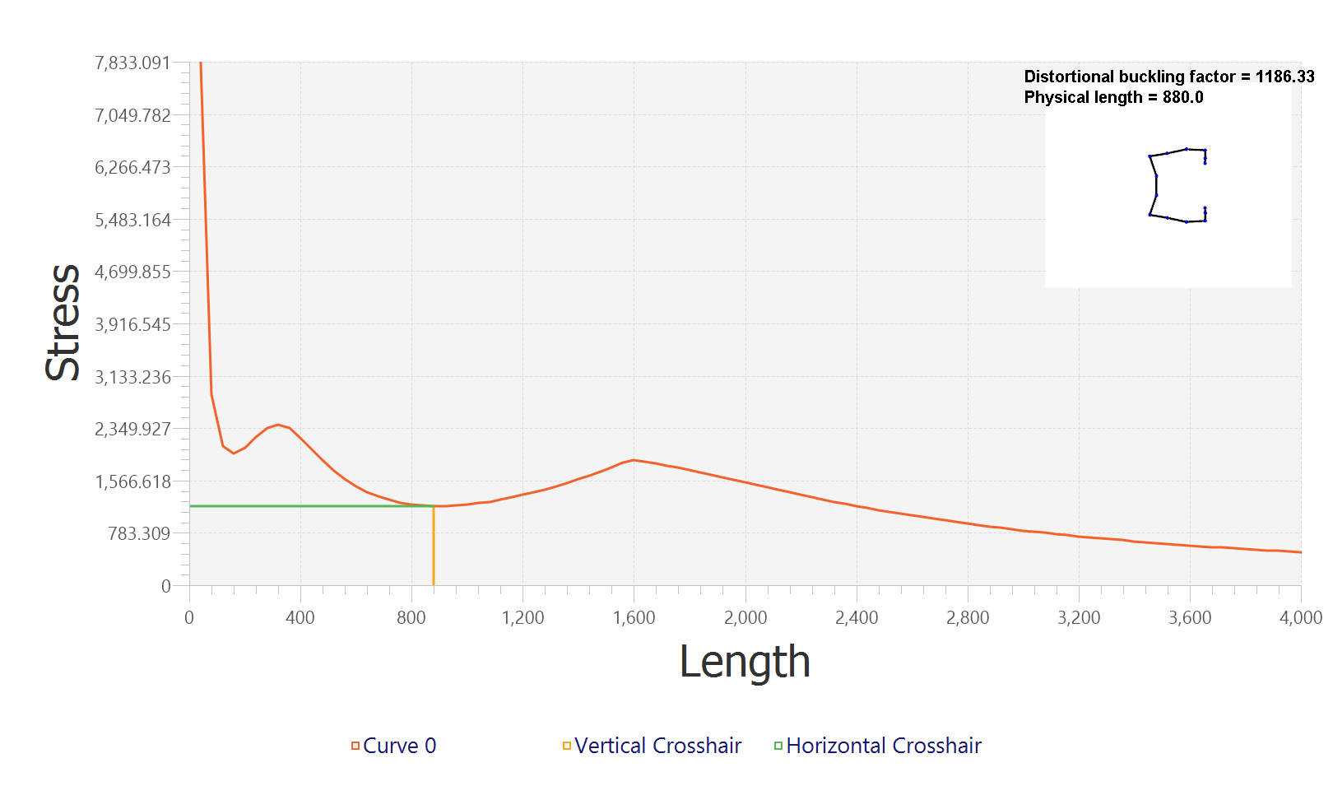

**Global Buckling Factor chosen by user:**

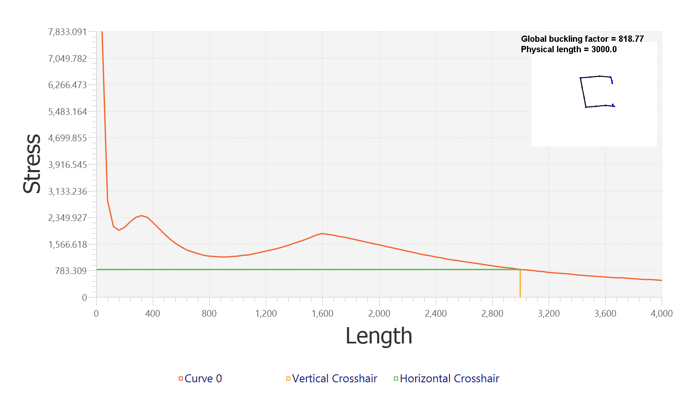

**DSM Input:** Analysis type: ColumnPcrl = 5.8Pcrd = 13.1Pcre = 52.05

**DSM Calculations:** --------------------------------------------------Lateral-torsional buckling check per DSM 1.2.1.1--------------------------------------------------For a fully braced member lateral-torsionalbuckling will not occur and thus Pne = Py, Pnl and Pnd must still be checked.Pne = 48.42--------------------------------------------------Local buckling check per DSM 1.2.1.2--------------------------------------------------λl = 2.8893383086909306 (Eq. 1.2.1-7)If λl > 0.776 Eq. 1.2.1-6Pnl = 19.389864209335858--------------------------------------------------Distortional buckling check per DSM 1.2.1.3--------------------------------------------------λd = 1.9225460218436567 (Eq. 1.2.1-10)if λd > 0.0.561 (Eq. 1.2.1-9)Pnd = 19.577494051348076--------------------------------------------------Predicted compressive strength per DSM 1.2--------------------------------------------------Pne = 48.42Pnl = 19.389864209335858Pnd = 19.577494051348076per DSM 1.2.1, Pn is the minimum of Pne, Pnl, Pnd.Pn = 19.389864209335858LRFD : φc = 0.85φb⋅Mn = 16.48138457793548