A Thousand Faces of Adventure

PLayer GUIDE
July 07 2020

A Thousand Faces of Adventure: Player's Guide
playtest version 0.93 2020-07-07
find latest version at https://1kFA.com
email sjb@ezide.com
Like board games? Get a kick out of those online Dungeons & Dragons videos? Want to try improv? Welcome to A Thousand Faces of Adventure!

Welcome to Roleplaying
A Thousand Faces of Adventure is a framework for telling a story. The authors of the story are you and your friends, sitting around a table.
This story is improvisational, interactive, and collaborative.
The rewards for playing are laughter and excitement while you play, followed up with years of warm conversations that start with "Remember that time we were playing A Thousand Faces of Adventure and..."

How to make a great story
Imagine the audience for this story is the inner children of all the players. What evokes the feelings we had when we were children playing pretend? Can you remember being 11 years old and watching a spectacular Steven Spielberg movie? Or maybe a cheap-but-awesome Sam Raimi movie?
You are going to collaborate with all the other players to make this story, so when you add your parts, think of what will give your friends around the table a thrill, put them in suspense, ratchet up their feelings of tension, or make their jaws drop with awe.
Sometimes inner children get a big kick out of blood and guts. Your inner child might giggle at the brothel scenes in HBO's Game of Thrones. If you don't know what topics your friends consider "off-limits", it is a good idea to ask and tell before you start playing.
The story that emerges is not a precisely crafted thing. That's ok. It doesn't have to be high art or even a cartoon on Adult Swim. It gets shaped by each player, and when your turn comes, you adapt, do your best improvisational "Yes, and" , and see where it goes from there. It might sound like chaos, but with some faith in your friends, you will delight at how the plot solidifies, and how real the characters become.

Specifically, What to do
To play the game, one person will take on the role of the Game Master, or "GM". The other people will be called simply "Players".

The GM
The GM's job is to know all the rules, and say stuff. Occasionally they will write notes and scribble some quick numerical facts.
The GM's domain is the world.

The Players
Player, your domain is your character.
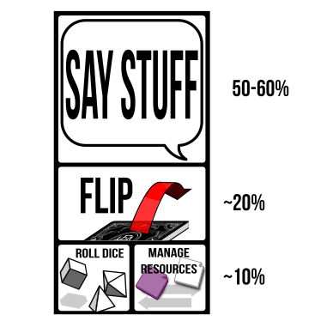
The player's job
Most of your time will be spent saying stuff. You are part of a conversation. Ask questions, use your imagination, chime in when someone inspires you. Think about your character like a hero of a movie, and try playing as the writer of the movie, or the director, or immerse yourself like a method actor standing in the character's boots and seeing with their eyes.
A Thousand Faces of Adventure invites you to:
- Describe your character and their actions
- Act out their dialogue
- Describe how they act
  - flourishes and stunts
  - their facial expressions, voice, and body language
- Tell what they say / hear / see / smell / taste / feel
- Describe their thoughts & memories
- Chime in when they interact with or support the other characters
- Tell parts of the story
- Tell your character's backstory
- Contribute ideas and assert facts when the GM asks questions
- Refer to your moves to generate more ideas and see what boundaries you can push
As the conversation unfolds, the rules will chime in as well. When that happens you will be called do things beyond just "saying stuff":
- Flip cards from your Deckahedron
- Move tokens around
- Roll dice
This guide will teach you how to do those things.

Your Character: A Scrappy Adventurer
This is a game about building up a character, who starts as a scrappy adventurer and grows to become someone whose impact on their world is epic.
TODO: illustration of character sheet
During character creation, you will get to determine all aspects of your character's history, social and economic circumstances, and personality. These are fictional aspects of the character. You will not get to determine all the mechanical aspects of the character though.
Mechanically, characters start out just a little bit more powerful than a common villager. Your character will have 10 Stamina points versus a townsperson's 2-5, and will start with three special moves, but that's all that separates them from Michel the stable-hand and Constance the librarian.
TODO: fluff with one-sentence example characters
You can invent any backstory you like, but you may need to answer questions about how the backstory fits the character's game limitations. Nothing stops you from creating a hulking, 7 foot tall barbarian, with a rich history of warring and slaughtering enemies, but at the very beginning of the game, with a couple unlucky flips, that barbarian may suffer a sound drubbing at the hands of a farmer and his overprotective goat.
This doesn't mean you shouldn't create the barbarian character. You should. That sounds awesome! But if you do, be prepared to find some narrative justification (drunkard? battle-worn? magically cursed?) that the character begins at a "scrappy adventurer" level.
As your character adventures in the world, they will gain experience and equipment making them worthy of the title "hero". See Character advancement for more details.

The Deckahedron
The main activity in the game is "saying stuff", mostly stuff about your character. Often, you'll say something that triggers a move, and that move will be resolved using your Deckahedron.
(If you do not have a physical copy of this game, you can find a digital Deckahedron at 1kFA.com/table )
Every player except the GM gets a Deckahedron. Inspect your Deckahedron. You should have 20 cards. There are 4 symbols, or "suits", on the fronts and backs of the cards:
Name | suit | odds | color | rank
Anvil |  | indicates the weakest odds | red | rank 1
Blade |  | indicates below average odds | blue | rank 2
Crown |  | indicates above average odds | yellow | rank 3
Dragon |  | indicates the best odds | green | rank 4
Shuffle your Deckahedron and place it face-down in front of you.
Whenever your character attempts something risky, where the outcome is not certain, the GM will call for you to take your Deckahedron and "flip".
In conversation with GM and the rest of the table, you'll decide what move your character is triggering and which of your character's attributes -- Str, Dex, or Int -- will be used to resolve the flip. There is a move card or a page in your base moves booklet for every move, so have that move card or page in your booklet ready.
GM Note: The attributes used to resolve a move
are listed at the top of each move card. A card may
give the option of several attributes, so you may
need to ask the player for more detail about their
action before calling for a flip.
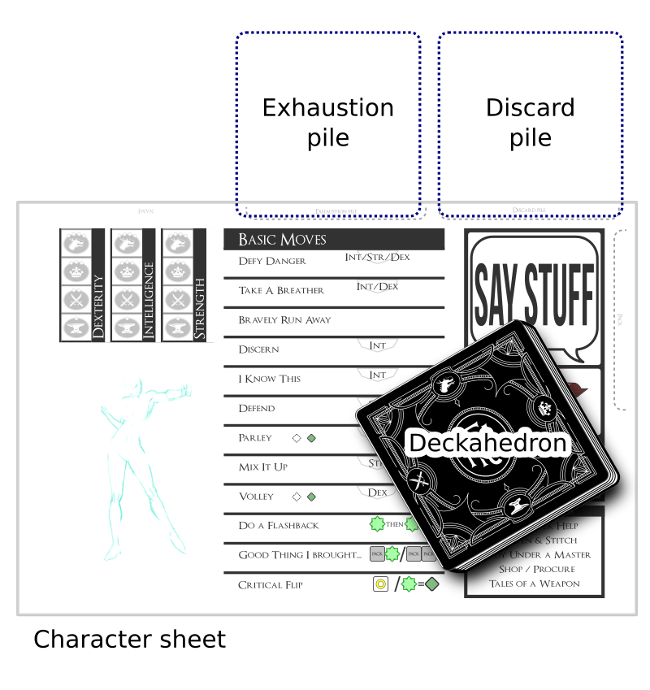
Your Deckahedron and Character Sheet
Take the top card of your Deckahedron and flip it face up. Next, find the suit (Anvil, Blades, Crown, or Dragon) of the chosen attribute on your character sheet.
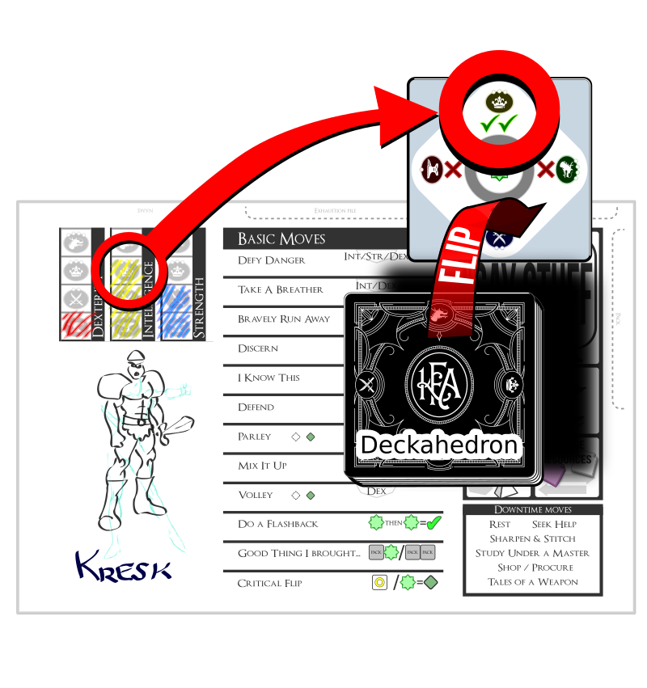
Flipping a card
On the face side of the Deckahedron card, find that suit symbol. The result of the move is the or symbols next to that suit. When you flip, keep in mind that the GM may need to read the result. Being consistent with how you orient the card will help simplify the GM's bookkeeping and keep up the pace of the game.
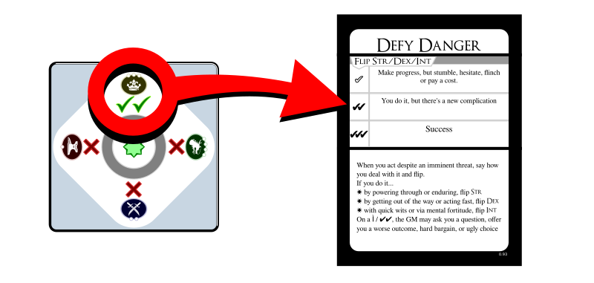
Resolving a move
Finally, read the instructions on your move card. It tells you and the GM how to interpret the s and s.

For example,
You're playing a character named Kresk. You say:
Kresk sees the pit of spikes in front of him, but isn't scared. He just takes a running start and mightily leaps over the pit, landing safely on the other side.
The GM interjects:
Ok, sounds good, but let's see if Kresk's legs are strong enough. Please flip Defy Danger with your Strength.
Ready the Defy Danger page in your booklet (it's the first page). Next, on the character sheet, see that Kresk has rank 3 (Crown) Str. Flip over the top card of your Deckahedron and look for that Crown suit.
Let's say the Deckahedron card shows next to the Crown. The Defy Danger move reads "You do it, but there's a new complication". When you look to the GM to interpret this outcome, they begin to improvise:
You leap through the air, landing with a thud on the other side of the pit, kicking up a cloud of dust on this forgotten jungle trail. Rising to your feet, you notice that more than dust has been stirred. The sounds of movement and a threatening rattle alerts you to something approaching from inside the pit. What do you do?

Reshuffling
After every flip, any face-up Deckahedron card is placed, face-up, in a discard pile. (Later, you will start another pile of cards called an Exhaustion pile. Keep them separate.)
At any time other than during a flip, you may take your discard pile and shuffle it back into your Deckahedron.
Whenever your Deckahedron has 5 or fewer cards, you must take your discard pile and shuffle it back into your Deckahedron.

Interpreting the result of a flip
When a player's character performs a move, the player executes a flip, and the GM leads the table interpreting the narrative result, based on the text of the move card.
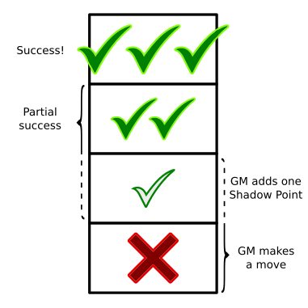
flip results
Usually means an unfettered success, and means success, but with complication.
When the result is a single , it sometimes means the same as a , but often it is slightly worse.
As you read this section it may help to lay out the move cards in front of you.
GM Note: Any time a flip results in a single
the GM gains a Shadow point -- even when the
move card says it has the same narrative effect
as a .
Note: some move cards give choices between several options. If one of the options is impossible (fictionally or mechanically), it may not be chosen. Choose one of the other options instead.
When the result is , it is the GM's turn to make a move. The GM narrates the consequences of the move the player just attempted and has license to take the narrative where they like.
See the GM Guide for explanations of Shadow points and for a list of moves the GM is allowed to make.

Exceptions on and flips
Sometimes a card does not say how a should be interpreted. In that case, the GM gets to make a move, just like .
Rarely, a card will have instructions for how to interpret a result. These instructions should be executed, but might only be part of the GM's move -- the GM gets to decide if they have more to add.
When the card is a FAST move, the GM does not get to make a move on a . Instead, the GM just gains 2 Shadow points.

Move Cards tagged FAST
TODO: illustration of FAST move
Some move cards have the FAST symbol. This indicates they can be used in conjunction with another move during your character's moment in the spotlight.
As the conversation moves around the table, players will have informal "turns" where they talk about what actions their character is taking. The game works best when this "spotlight" is moved around fairly so each player can contribute. The spotlight typically follows a single character's actions until they trigger, then resolve a move.
FAST moves are like "bonus" moves that augment, or quickly follow the initially triggered move.
Characters will trigger at most one FAST move during their moment in the spotlight. Otherwise the pace of the game can slow down, and other players may feel like they aren't getting a fair share.
Examples of cards tagged FAST include Good Cardio, Where It Hurts, and Unknown Benefactor.
A moment in the spotlight might see your swordsman character triggering the move Mix It Up, causing damage to a foe, and then also triggering Where It Hurts as you describe the sword delivering a stunning blow, clanging loud and hard against the foe's helmet.
Or, your professor of alchemy character might trigger Defy Danger as they jump out of the way of a toppling bookcase. After you flip an , the GM may start enumerating the attack power your character must suffer, to which you could respond by invoking Unknown Benefactor to cancel the attack's effects.

Other ways to flip: Advantage / Disadvantage
Some flips are a little more complicated. There are moves that instruct you to "take +1 advantage" or "flip with advantage". Sometimes you are given the opposite instruction "flip with disadvantage" or "your foe gets advantage".

Advantage
With an advantage, flip over your top card as usual, and then flip over the next card as well. Compare the results (the number of s or s next to the relevant suit) and resolve the flip with the card that has the best result.
If it's a tie, you may choose whichever card to be the card that resolves the flip.
After, all flipped cards go face-up in your discard pile.

Complete Flip Rule
You must flip over all the cards you were instructed to, even if the first card shows .

Disadvantage
With a disadvantage, do the same thing, but use the worst result.
Acting against a foe that has advantage is mechanically identical to your character having disadvantage.

Multiple Advantages / Disadvantages
Advantage or disadvantage can stack. Flips can accumulate up to 2 advantage or 2 disadvantage, meaning that you flip 3 cards in total and take the best or worst, respectively.
No flip may use more than 3 cards in total, so stacking advantage beyond 2 is just ignored.
It is possible a situation might arise where you are instructed to both "flip with advantage" and "flip with disadvantage". If this happens, simply add up all the advantages, and then subtract all the disadvantages to arrive at a "net advantage" or "net disadvantage". The maximum number of cards per flip is still 3, so even if the "net disadvantage" is -3, you only flip 3 cards and take the worst.

XP cards
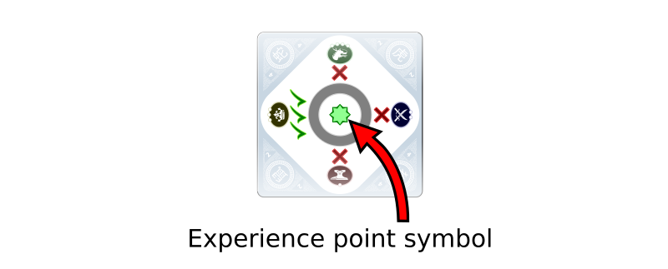
An XP card
Resolving flips is how players acquire experience points (XP). XP are a player's most important mechanical currency in the game.
Some Deckahedron cards show an experience point symbol in the middle. These are XP cards. After a flip is resolved by an XP card, take one XP from the supply.
You may only do this when the card resolves a flip. (ie, when flipping multiple cards, only if the XP card was the one from which the or symbols were used to interpret the result of the move)
XP are a currency you spend to activate "meta" parts of the game. See below for moves that let you "break" or "bend" rules, or partially take control of the narrative.

Blessing cards
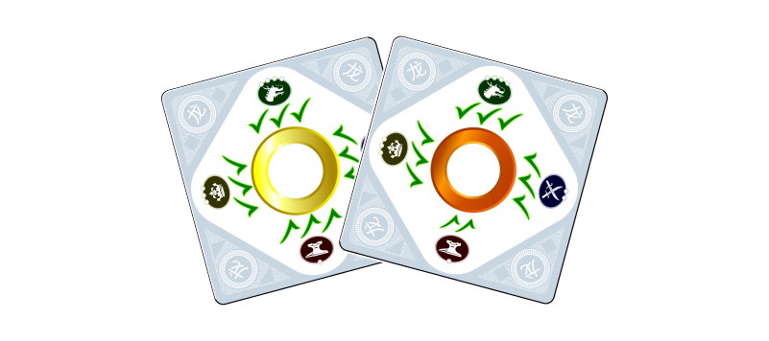
blessing cards
Some move cards will instruct you to take Blessing cards. When instructed to do so, draw one Blessing card at random from the supply, and place it in your discard pile.
Blessing cards improve your Deckahedron by giving you better chances to succeed at moves.
Whenever a move is resolved by a Blessing card, return the Blessing card to the supply rather than keeping it in your discard pile.

Wound cards
Sometimes you flip over a wound card and must lose a Stamina point. See the Combat chapter.

Teamwork Flips
Before a flip is executed, if other players have characters in the same scene as the character taking action, and there is nothing in the fiction preventing it, those other players may choose to have their characters aid the spotlighted character. They just chime in before the flip and say how their character helps out.
Another time the Teamwork Flip is triggered is when the characters are all bound together in success or failure. (eg, Defying Danger in a canoe traveling over whitewater) In that case, the GM asks the players "who is taking the lead?". That player is the spotlighted player, and the other players are supporting.
The spotlighted player flips as they normally would, the supporting players say how they are helping and flip one Anvil.
The players choose the best result to resolve the flip.
Only the card that resolved the flip can generate XP, and only for the player who played it.
If there are any negative consequences (damage, danger, etc) from the result, all the participating characters must suffer them.
Supporting players may not Do a Flashback on Teamwork Flips.

Flips only happen when the situation is uncertain or risky
A GM only calls for a flip when the situation is uncertain or risky for the character. If the outcome is certain, the GM may just narrate what happens. Or they may ask you some clarifying questions.
This game is a conversation between people, so there is variability in how it plays out. Different GMs will draw their line of certainty at different places.
Consider a situation where the GM has described your character, Kresk, waking up after making camp in a forest. Beside Kresk is a squirrel, nibbling an acorn.
You might respond by saying,
"Kresk wants that acorn! I Mix It Up with the squirrel!"
It would be bizarre, but completely within the rules for the GM to write up some stats for the squirrel (1 Stamina, 1 attack power), and begin a melee combat between Kresk and the squirrel, and ask you to flip Str to resolve the Mix It Up move.
But the GM will more likely interpret your action, as described, as having a certain outcome. Perhaps the GM will respond:
- "As you raise your fist to smash the squirrel, it darts off into the forest, never to be seen again."
- "How is Kresk going to overcome the squirrel's natural speed and reflexes?"
- "You smash your fist down and flatten the rodent. Strangely, it didn't even flinch. Does this odd behaviour remind Kresk of the rumors he heard about this forest being enchanted?"

Pushing buttons or staying in character
The GM doesn't always have to invoke a move and call for a flip. But in this example, the player literally names a move ("I Mix It Up..."). That's a strong signal to the GM, and the GM is likely to follow strong signals.
If you enjoy playing in a style where things flow like a conversation or a story, from question to answer, from description to dialogue and back around again, rather than pushing a limited set of buttons laid out in front of you, try playing without naming the moves. Just describe what your character does in a natural way.
"Kresk wants that acorn! I slam my fist down on the squirrel!"

Fictional position matters
Because uncertainty is a key requirement before a flip is called for, the fiction that you and your friends establish matters.
If a character threatens a towering Mountain Giant with a punch in the shin, the GM will not call for a Parley flip. A wound to the arm or hand might be described in such a way that would clearly make using a bow for Volley or Called Shot impossible. Or successful application of an Amulet of Amiability might mean that Pick Pockets can be skipped - the affected NPC might just offer to share their precious items.

Combat - Stamina and Wounds
Your time in this game will mostly be spent saying stuff and flipping cards from your Deckahedron. The remaining time is spent rolling dice and managing resources, and those activities happen during combat.
Your character will confront violent foes and dangerous obstacles. Will they endure exertion and injury to keep venturing forward, or will they be disfavoured by fate and end up completely spent and collapsed in a heap?
In a fight, a character is running, dodging, striking, and being struck by their foe. All of this action is scary and exhausting. A character gets weaker as this exchange goes on, even if they dodge every blow.
This weakening is represented by cards from your Deckahedron being lost into your Exhaustion pile.
Have you ever watched a boxing or martial arts match? During the later rounds, the athletes are worn down, their footwork is less animated, and they drop their guard more frequently. The contest is not always decided with a knockout punch, it often comes down to who can better endure the exertion.
Every PC has 10 Stamina points. When a PC loses all 10, they are incapacitated. After that, their fate is up to the GM.

The Four Ds
When your character gets attacked or falls victim to some other danger, you have choices about exactly how they are affected. They may dodge, and just lose Stamina, they may stand stubbornly against a blow, perhaps absorbing it with their armour, or they may be wounded by it.
The procedure for making these decisions is called "The Four Ds":
- Dice - roll them!
- Decide whether to lose Stamina or take a Wound
- Distribute tokens
- Describe the outcomes in the fiction

Dice
When your character suffers the consequences of violence, you roll dice or read instructions from a move card to get a number. This number is called the attack power.

Decide
After the attack power is known, you have a choice: either take that many Exhaustion tokens or take a Wound token.
You can always choose to absorb the entire amount of attack power by taking a single Wound.
Let's say your character was attacked with a sword and the dice were rolled and summed up to 7. You can either take 7 Exhaustion tokens (thus losing 7 Stamina points), or choose to take one Wound token instead.
Let's further say your character had lost 3 Stamina points earlier in the battle. With only 7 Stamina points left, it's a wise time to take a Wound.

Distribute
In the third step you take Exhaustion or Wound tokens from the supply and either:
- "Absorb" them by placing them on relevant move cards or item cards, or
- Lose Stamina by putting that many cards from your Deckahedron into your Exhaustion pile, then placing the tokens on top (and, in the case of a Wound, putting a Wound card in your Discard pile)

In this step, cards to absorb Exhaustion and Wounds include your character's armour and shield, or move cards like Good Cardio, Mystic Breathwork, Like A Second Skin, and Sangfroid.
Characters have 10 Stamina points. To win at combat, a character's foes must be subdued or pacified before 10 cards are lost from the Deckahedron.

Losing or Expending Stamina
When you are instructed to lose or expend a Stamina point:
- Take a card off the top of your Deckahedron, do not look at the face side.
- Put that card face-down on your Exhaustion pile
- Place an Exhaustion token on your Exhaustion pile
Component layout
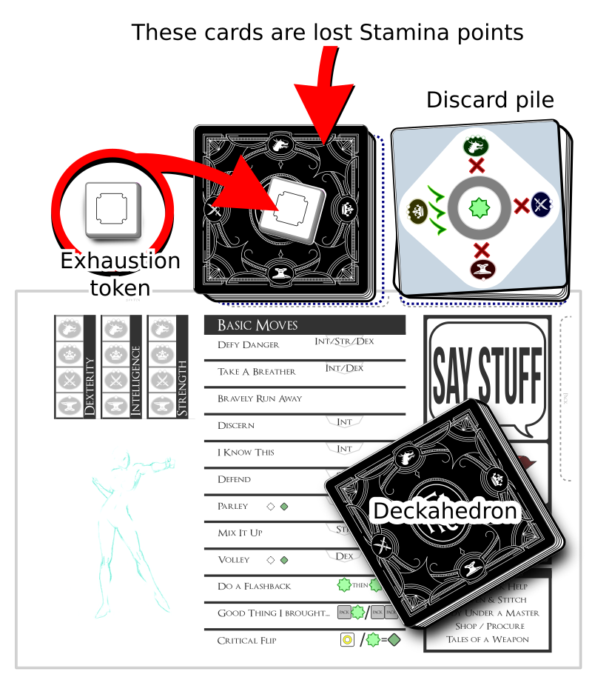
Exhaustion token
(So, if you were instructed to lose 3 Stamina points, you add 3 cards from the top of your Deckahedron onto your Exhaustion pile, then you put 3 Exhaustion tokens on top of it as well.)
If your Deckahedron does not contain enough cards, the player must reshuffle their discard pile into the Deckahedron and continue.
Note: Players may choose to reshuffle their discard pile back into the Deckahedron before moving cards onto their Exhaustion pile.
Once the Exhaustion pile grows to 10 cards, the character is incapacitated and can take no further actions. It is up to the GM to decide what this incapacitation means - whether the character is dead, unconscious, or just unable to stand or move.

Taking Wounds
Getting wounded sucks, and when wounded, all intelligent creatures seek to cure their condition as a very high priority.
When you are instructed to take a Wound:
- If you already have 2 wounds:
- the character is incapacitated
- Otherwise:
- The GM describes how the character was wounded
- Place a Wound token on your Exhaustion pile
- Randomly draw a wound card from the supply and place it in your discard pile. It will now start cycling between your Deckahedron and your discard pile.
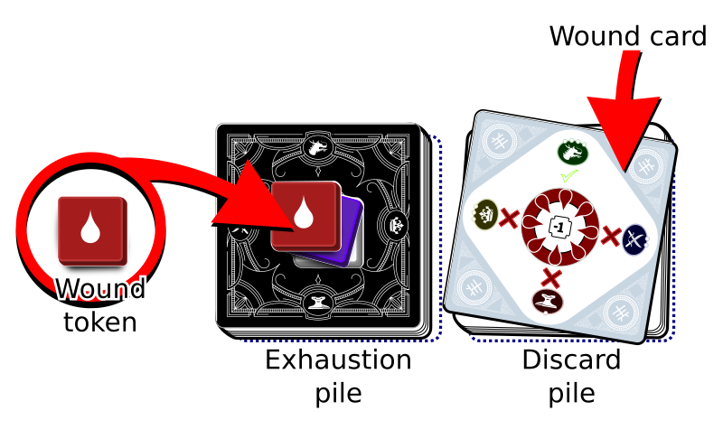
Wound token

A Wound Card
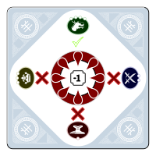
A wound card
Having a wound card in your Deckahedron causes some nasty effects.
Whenever you flip and reveal a wound card, follow these rules:
- Say or act out the guttural noise emitted by your character
- You must immediately stop flipping (eg, if you were instructed you to "flip 3", you stop short once you hit the wound card - resolve the move with only the card(s) you flipped. This overrides the Complete Flip Rule)
- Lose a Stamina point
Wound cards can be used to represent different fictional aspects. They usually represent literal wounds, but may also be used for the effects of disease, poison, or other effects inflicted by monsters or the environment.

Describe
Finally, the fourth step: you interpret those results into the narrative. Did your character dive into the dirt? Did they take a punch to the jaw and respond with a bloodied grin? Did the spear bounce right off their steel breastplate?
GM Note: The act of taking a risk, deciding how
to get hurt, and then later, deciding when and
how to heal, with each stage having its
sacrifices and benefits, is a miniature echo of
the overall structure of the Hero's Journey
campaign. Starting in comfort, choosing to
cross a threshold, deciding which fork to take
in a road of trials, then returning.

Equipment
During character creation, you receive two Pack cards and take some Item cards. These cards represent equipment carried by your character that interacts with mechanisms of the game.
Daily-use amounts of money and food are not tracked. It is assumed your character will always be able to scrounge a meal somehow. Unless it is relevant to the drama of the fictional situation or inspired by the Touchstone List, small monetary transactions may be abridged or assumed.
It is also not necessary to exactly measure movement speed or the sizes of all the gear carried or to track the body part to which the gear is strapped.
Your character has a movement speed, a certain lightness-of-foot, they carry a certain amount of equipment and items, and perhaps even a certain amount of wealth or treasure.
There are some moves that are affected by how much stuff a character carries. These moves have a "Encumbrance Penalty" section, and describe how carried equipment affects their outcomes.
At any time that it makes sense in the fiction, a character can drop items and equipment.

Pack - Precious and regular
Throughout the game, your character will gain, lose, and trade equipment and supplies that are worth tracking. These items don't need to be specified until they actually get used. Instead they are tracked with anonymous Pack cards.
TODO: illustration of Pack and Precious Pack cards
White-side green cards represent "regular" Pack and black-side green cards represent "precious" Pack. Precious Pack is something that is found precious by someone. It may be something made of a rare metal like gold, or it may be simply a full waterskin offered to a parched NPC in the desert.
If the specifics of a Pack card get concretely established in the fiction, and the card is not immediately spent, the Pack card should be returned to the supply and a blank Item card should be taken to replace it, with the name or details of the item written on it.
Your character starts off with 2 Pack cards, enabling the move Good Thing I Brought...

Good Thing I Brought...
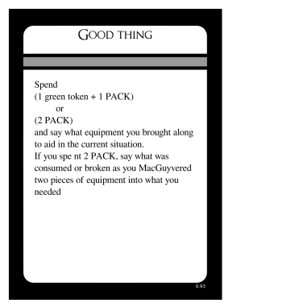
Good Thing I Brought card
Adventurers are always finding themselves in tricky situations. Luckily, they come prepared with adventuring gear. They have been known to carry 50 feet of rope, smelling salts, books of racy poems, sometimes even a 3-day-old pork chop to distract hounds or hungry goblins.
It's a fact. You know this and A Thousand Faces of Adventure knows this, so you won't be asked to keep fine-grained notes of every candle and spare button in your character's inventory.
Reasonable daily-use items are presumed to be in your character's pack. If you're unsure, remember this game is a conversation, so just ask the table.
But sometimes you will be in a situation where having that 50 feet of rope or an old pork chop would really solve a problem for your character.
When your character reaches into their pack and produces the item that solves their current problem or helps them overcome a challenge, just say what it is and execute the "Good Thing I Brought..." move.
The Pack cards represent the adventuring gear a character has brought along. But you do not need to declare exactly what that gear is until you're in a situation where you need something specific.
If the "Good Thing I Brought..." move is executed and the newly "declared" equipment is something that can be returned to the backpack after use, write its name down on a blank card and exchange that card for the "anonymous" Pack card(s) that were the cost of "Good Thing I Brought...".
If the equipment is something that gets consumed immediately when used, the 1 or 2 Pack cards just get discarded.
If 2 red cards are spent, and the character ends up with one card returning to their backpack, use the fiction to justify that. Maybe they didn't have exactly what they needed, so one piece of equipment had to be consumed to create the necessary tool, in a MacGuyver-esque fashion.

Item Damage
TODO item damage diagram
Damage to items is represented as black-side red cards.
The "1-2-bust" mechanism is used to represent damage.
The first two times an item is damaged, place a red card on the Item card, black-side-up.
The third time an item is damaged, it is destroyed. Return it and the red cards to the supply.
All mundane (non-magical) items can be damaged. Usually this happens as the result of a GM move, but it can also be caused by player moves, eg. Armour Mastery.
To repair items, see the move Sharpen and Stitch

Magic
Magic is an element that pervades stories of fantasy. It can be obscure and stemming from nature like in Lord of the Rings, it can be elemental and allegorical like in The Wheel of Time, and it can be linguistic and self-aware like in The Invisibles.
To avoid presuming too much about the narrative, the rules do not dictate the nature of magic or the "how" of magic. That's for you to decide during play. The rules provide a mechanical foundation and some optional narrative paths. You are invited to take this well-tested framework, play with it, and expand into it.
Is magic woven from subtle threads that pervade the universe? Is it based on words of power? Is it high technology hidden in the planet's crust by alien benefactors? Is it copied exactly from a concept in your Touchstone List? You decide.
The rules give you a way to have scrappy adventurers begin with magic items. These artifacts have 3 charges, and are rechargeable during Rest. Your character can eventually build themselves up in power to a point where they can cast magic spells without needing the items.
The rules also give names for two sources of magical power, "The Living Light" and "The Blood-Bound". It's up to you to give these names narrative meaning, if you want.
One thing to keep in mind is that characters may attempt any move that resolves with Str / Dex / Int. (See Move Levels So even if moves like Use a Magic Item or Fundamental Magic were not chosen at character creation or gained via Study Under a Master, any character may attempt them.
That said, using magic invokes some of the more complicated rules. Players are challenged with managing and balancing charges, capacity, stamina, requirements, and narrative effect. This kind of play is ideal for players excited by complexity and the potential of explorable branches.

The ONGOING tag
Upon triggering the Use a Magic Item move, a character "flows magical energy" into the item. Then the magical effects happen.
Some magic effects happen immediately.
Some magic effects persist even after the flow of magical energy into the item has ceased. (eg, _ of Sensation)
Some magic items have the ONGOING tag, and their effects persist only as long as magical energy flows into the item. It is up to the player to declare when their character ceases the flow of magical energy. If the flow of magical energy continues, they are not considered idle for the purposes of the Rest and Seek Help moves.

Charges and Capacity
By default, magic items have capacity for 3 charges. An item is considered "depleted" when all its charges are used. The term used for a card's maximum number of charges is "capacity" or "charge capacity".
When a magic item loses a charge, remove a green card from the item card and place it in the supply. When there are no more green cards on top of it, it is depleted and cannot be used.
Charge capacity can be gained and lost. Every time it changes, players should mark the new capacity on the Magic Item card
TODO: illustration of charge capacity gauge

Use a Magic Item
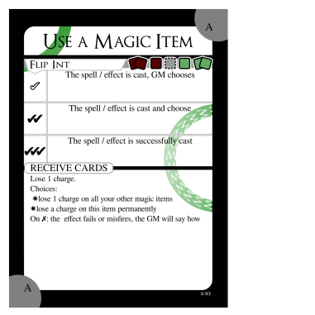
Use a Magic Item
When a character holds a magic item and flows energy into it, the player flips Int, and on any result other than , the item activates and the effects described on the magic item card happen.
Using a magic item causes it to lose a charge. This loss can be avoided with moves like Entreat the Blood-Bound and Channel the Living Light.
Following that, results of and cause a further cost to be incurred, as chosen from the list by the GM or the player, respectively.
Note: if the magic item being used is a magical weapon, another choice is available: "the weapon is damaged".
The RECEIVE CARDS tag: when a player chooses this card during character creation or Study Under a Master, they also receive 1 magic item of their choice.

Entreat the Blood-Bound
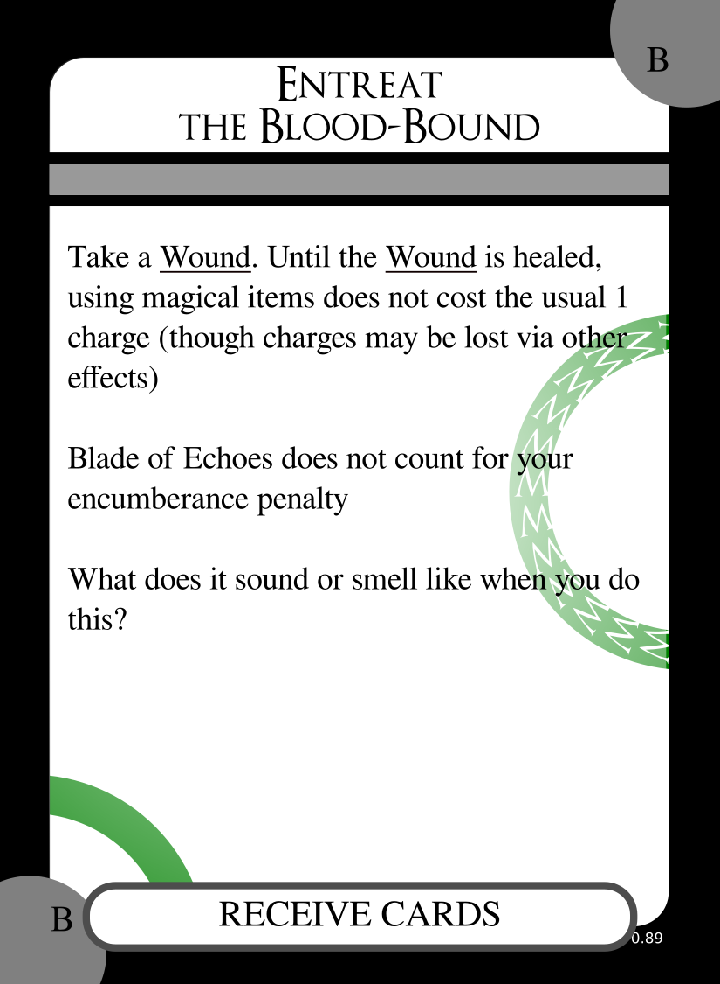
Entreat the Blood-Bound
If it has not yet been established, when a player first uses this move, it's a great time for the GM to ask them a question: "Who or what is the Blood-Bound?"
GM Note: this is a great way to stretch your
improv muscles. Say "Yes, and..." no matter if
they identify the Blood-Bound as tiny, parasitic
insects or as monstrous, extra-dimensional dark gods.
When a player chooses this card during character creation or Study Under a Master, they also receive the item Blade of Echoes.

Channel the Living Light
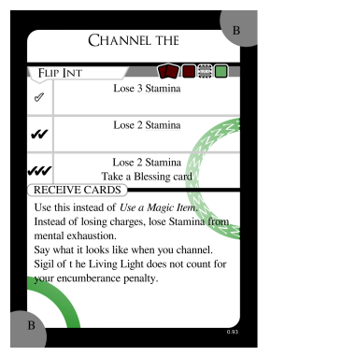
Channel the Living Light
If it has not yet been established, when a player first uses this move, it's a great time for the GM to ask them: "Who or what is the Living Light?"
When a player chooses this card during character creation or Study Under a Master, they also receive the item Sigil of the Living Light.

Notes on Moves

Do a Flashback
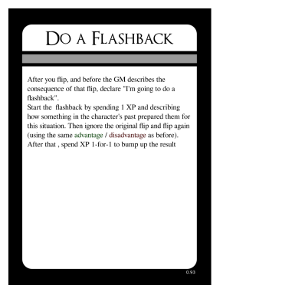
Do a Flashback card
Sometimes you plan out something really great, and then you resolve a flip, and don't get the results you need.
A Flashback serves as sort of a "mulligan" in those situations, but it also provides a way to develop your character's backstory and personality.
After a player makes a flip, and before the GM describes the consequence of the flip, the player can declare they're going to do a flashback.
The player spends 1 XP. Then they describe how something that happened in the past particularly prepared their character for this situation.
Then the original flip is ignored, and a new flip is executed, using the same advantage or disadvantage as the original flip.
The player may then spend additional XP to "bump up" the result. Each XP spent increases the result, from to to to .
Technically, this flip is resolved only after the XP are spent, so if the new card was an XP card, the player should take an XP from the supply only after they finished spending their XP to "bump up" the results.

Mercy Flashbacks
Players may find themselves in a situation where they forgot to do something when they had the chance, like use healing magic while they were resting, or leveling up a move before they left a town, or getting some key information from an NPC before that NPC died.
As long as the player and the GM both agree that the player had the necessary resources when the action was available, the GM may allow the player to spend those resources and effect that action now, as a "Mercy Flashback".
The player must spend one XP, in addition to whatever cost the action incurs.
Even the most conscientious of us sometimes loses track of small details, so the cost is kept "cheap" at only one XP. But there must be a cost. It is necessary to keep the flow of the game going. This is a game of improv storytelling, and improv means rolling with the punches sometimes.

Critical Success
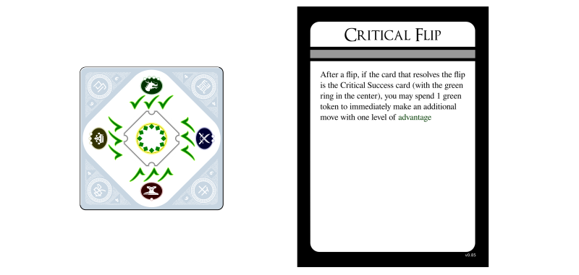
Critical Success card
One of the 20 cards in your Deckahedron is the "Critical Success card". It has a symbol on every edge and a circular green symbol in the middle.
If you resolve a flip with the Critical Success card, you can do two things:
- Say how your character's practice has finally paid off, or how they had an insight or epiphany about the move they just accomplished. Spend XP 1-for-1 to go up levels in the move that was just resolved.
- Take a Blessing card from the supply and put it in their discard pile.

Taking a Breather
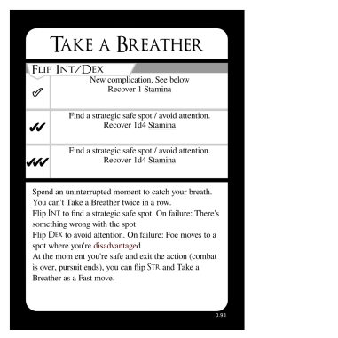
Take a Breather card
Taking a Breather is a move that a character can take during combat. This action allows a character to regain up to 4 Stamina points.
The player may use either Intelligence or Dexterity to perform the Take a Breather action.
If they use Intelligence, they say how they execute a tactic or recognize a favourable position that lets them gather their breath and their wits.
If they use Dexterity, they say how they maneuver into a safe position that offers some temporary safety.
Regaining Stamina may be done either by taking cards from the Exhaustion pile and putting them into the discard pile, or by returning Exhaustion tokens to the supply.
When recovering cards from the Exhaustion pile, the player may choose any cards they want, but may not flip them face-up if they are face-down.
When combat or a pursuit ends, and it is appropriate for the narrative (e.g. when there's a scene transition and the characters reasonably have a few minutes to catch their breath), the players may Take a Breather using Str as an FAST move (ie, no negative narrative consequences if the result is or ).

Good Cardio
This card makes a character an especially resilient fighter and athlete.
In a combat encounter, a player will usually trigger an aggressive move like Mix It Up or Volley. In addition, players often trigger at most one FAST move. If they haven't chosen a different FAST move, they can always trigger Good Cardio, and regain some of their lost Stamina points.
This is a highly recommended strategy for any character who has lost Stamina.

SESSION 2 RULES

The Session Opener
Every session after the first session, there is a special move to execute at the very beginning, The Session Opener. It is a player's opportunity to generate an extra XP.
Your GM will lead you through a story recap and pose some questions about your character. Then you will be given the opportunity to Ask for notes and Give notes to your fellow players.
After this exercise, all participating players will receive an XP.
The details of the Session Opener are described in the GM Guide.

Equipment: acquisition, upgrade, and repair

Sharpen and Stitch
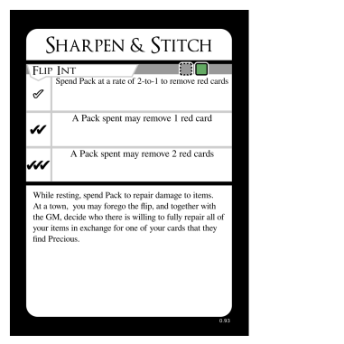
Sharpen and Stitch card
Sharpen and Stitch is a way to repair damaged items by spending Pack cards.
This move must be executed alongside the Rest move.

Shop / Procure
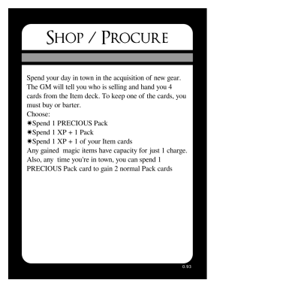
Shop / Procure card
When the Shop / Procure move is used, the scene can be described as an everyday shopping trip or a thieving and bribery escapade, or anything else that makes sense in the narrative, so long as the mechanical outcome would be certain.
The GM presents to the player 4 cards of any mix of items: mundane, magical, a special commodity established in the narrative, or even something purely decorative. It is ok for the GM and player to discuss the items beforehand to any level of detail, and it is also ok for the player to outright say what they want to go shopping for.
The GM should be honest with the narrative, stay true to their goals and try to provide the kind of fun the player has signaled they want to have.
The GM shall not present a player a card the character is unable to use.

Mundane Items: Armor, weapons, etc
There are mundane items in A Thousand Faces of Adventure, as well as magical ones. This text includes rules for weapons, shields, and armour. But characters may have other items as well. Those other items may just be decorative or they may have narrative value (carrying around a small barrel of brandy may earn you a welcome from the thirsty dwarves you meet).

Weapons
Weapons cards describe what the character has armed themself with. These cards might describe "weaponry" rather than a single item, as the Many Knives card demonstrates.
Weapons have "power": d4, d6, or d10. This determines what die to roll when you roll attack power. Generally players can increase weapon power with the Tales of a Weapon move.
The GM should decide if the weaponry incurs any additional costs when calculating encumbrance penalties. Is the item particularly heavy or large?
Here are the default weapons available to characters:
Name | notes
_ Sword
Many Knives | At close range, can be thrown. Maximum power is d6
_ Bow | Long range, not usable at melee range

Armour
When an armour-clad character would normally take Harm or a Wound, the player may put the Harm or Wound token into an appropriate empty slot on their Armour card. This represents the character getting lucky, and their armour absorbing the attack instead of their body. Better armour has more chances to protect its wearer.
TODO illustration of Harm / Wound slots
The armour available to characters during character creation is the weakest kind. This kind of armour has 1 slot that can absorb a Harm or a Wound.
When a character goes shopping, goes a-thieving, discovers treasure, or loots a battlefield, the GM may offer new, more useful armour with more slots drawn on it.
The GM should take a blank card from the supply, and draw up to 3 slots on the card. A slot shall be designated to receive either:
- 1 Harm token
- or 1 Harm or Wound token
The table should decide if the armour incurs any additional costs when calculating encumbrance penalties -- better armour tends to be heavier. Any increased encumbrance penalty should be written on the card.
The player should write a descriptive name for the armour like "Padded" or "Chainmail" or "Full plate" and write that at the top of a card. The description will impact the narrative -- it's hard to sneak or swim in full plate armour.
Here are some example armours:
Suggested Name | slots | encumbrance modifier
Leather Armour | 1 Harm/Wound
Padded Armour | 2 Harm, 1 Harm/Wound | counts as 2 items
Full Plate | 3 Harm/Wound | counts as 4 items

Shields
Shields provide a way to avoid Harm and Wound tokens, but they test a character's Dex to do so.
To make a Shield card, first the GM chooses the , , and effects by choosing 3 sequential effects from this list:
- Avoid the x
- Avoid the x, but choose to lose 1 Stamina or this item takes 1 damage
- Avoid the x, lose 1 Stamina
- Avoid the x, lose 1 Stamina and this item takes 1 damage
The x can be either:
- Harm
- Harm or Wound
Then the GM and player come up with a name for this kind of shield together, using the same rules as the Armour name-creation above.
The fictional description of the "shield" has mechanical consequences. For example, the edge of steel shield could reasonably be used to attack a foe, so the character would have 1d4 attack power with Mix It Up. But a character with no weapon and only leather bracers on their wrists, the character would be "unarmed", doing just 1 attack power.
Blocking attack power with a shield is a FAST move, and players may not make more than one FAST move per turn in the spotlight.

More Power
After character creation, an armed PC will be rolling 1d4 for their attack power. This can be increased later on in the game via the moves Tales of a Weapon and Obsessive Contemplation.

Tales of a Weapon
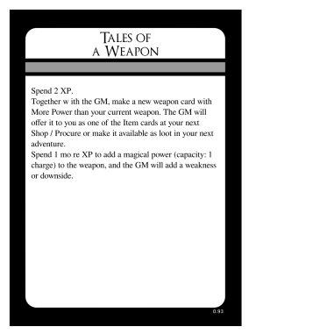
Tales of a Weapon card
The GM should decide whether the weapon will incur any extra cost when calculating an encumbrance penalty. Is the item particularly heavy or large? The GM should weigh that cost against the weapon's other features.

Character preservation and recovery

Bravely Run Away
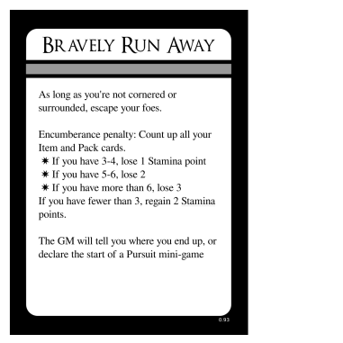
Bravely Run Away card
When players find themselves on the losing side of a battle, or want to avoid a daunting threat, they may choose to run away. If their characters are positioned in a way that their escape is possible, according to the established fiction, the GM will allow them to escape, but there is a cost. The players temporarily lose narrative control and the GM gets to say where the players' characters end up.
There may also be a Stamina cost (or Stamina gain) depending on how weighed down the characters were by their equipment.
The GM can resolve this move by:
- putting the characters somewhere completely safe
- putting the characters in a place where some (new or old) danger exists, but is, for the moment, not directly threatening the characters
- spending a Shadow point and starting the Pursuit Mini-game
- spending a Shadow point and landing the characters in a place where they must directly confront or defy a new danger

Healing
Throughout the game, players are asked to decide how their characters get hurt, how they respond to being hurt, and how they recover from their injuries.
This is a small-scale echo of the whole story - the Hero's Journey itself. At the center of the Hero's Journey is a moment of pain that the hero must fully endure before finding relief - either through their own action or with the help of their friends. The Hero's Journey is a myth that teaches us how to take care of ourselves, and so this game holds a puzzle where the players to learn how to take care of their characters.

Resting
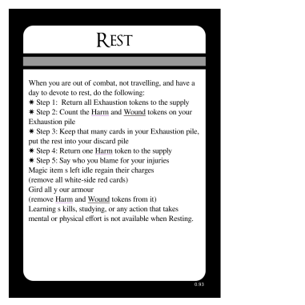
Rest card
Resting is an action that a character may take when they are out of combat, not traveling, and have several hours to devote to rest (sleeping qualifies).
- Step 1: Return all Exhaustion tokens to the supply
- Step 2: Count the Harm and Wound tokens on your Exhaustion pile
- Step 3: Keep that many cards (player chooses which ones) in your Exhaustion pile, put the rest into your discard pile
- Step 4: Return one Harm token to the supply
- Step 5: Say who you blame for your injuries
When resting, magic items that are not being used regain all charges, up to their charge capacity. Take green cards from the supply to represent the charges.
You may gird all your armour, where applicable. Remove all Harm and Wound tokens from your armour cards and from move cards that represent armour effectiveness (eg, Like A Second Skin).
Time devoted to Resting cannot also be devoted to learning skills, studying with a teacher, or any other action that takes mental or physical effort.
The Harm token returned to the supply in Step 4 may come from your Exhaustion pile or from a slot on a move card (eg, Bloody But Unbowed).
It is possible that the object of blame named in step 5 is the character themself.

Seek Help
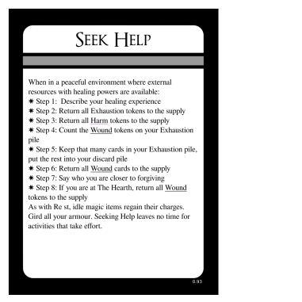
Seek Help card
Seeking Help is an action that a character may take when they are in a peaceful environment where external resources with healing powers are available.
Eg, if they are in a primitive camp possessing medicine men or a contemporary city with doctors and hospitals or a tranquil oasis infused with healing magic.
That the healing powers are external is important. Seek Help is a move where players explore how their characters have limits and cannot do everything on their own.
When you spend a day healing:
- Step 1: Describe your character's healing experience
- Step 2: Return all Exhaustion tokens to the supply
- Step 3: Return all Harm tokens to the supply
- Step 4: Count the Wound tokens on your Exhaustion pile
- Step 5: Keep that many cards (player chooses which ones) in your Exhaustion pile, put the rest into your discard pile
- Step 6: Return one Wound token and one wound card to the supply
- Step 7: Say who you are closer to forgiving
As with Resting, time spent Seeking Help cannot also be used in activities that take effort.
Magic items that are not being used regain all charges, up to their capacity.
You may gird all your armour, where applicable. Remove all Harm and Wound tokens from your armour cards.

Character advancement

Study Under a Master
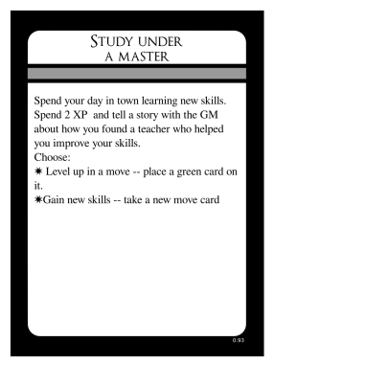
This is the move by which your character becomes a powerful force in the world.
When your character is in a town (a village, city, etc. -- any safe place where resources and commerce present themselves), you can spend 2 XP to either:
- Increase the level of a move you already have (See Move Levels
- Take a new move card from the supply
If you want to take a move card that another player already has or one that was scribbled over in a previous campaign, or just has been ruined by spilled beer, you can copy the text onto a new card.

Move Levels
Some Move cards have icons on them that indicate "levels". These levels represent how good your character is at that skill. For example, the move Pick Pockets has 5 icons.
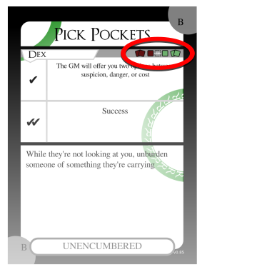
Pick Pockets card
These are the "move levels" for Pick Pockets. From left to right, these icons are called:
-  wild or "2 red"
-  novice or "1 red"
-  "studied" or "base level"
-  expert or "1 green"
-  master or "2 green"
If you chose Pick Pockets during character creation, you would receive the card and your character would be "studied" in the skill.

Increased Move Levels
Later, you can go up a level in Pick Pockets. Either by using the Study Under a Master move, or when you resolve a Pick Pockets flip and happen to get a Critical Success card See Critical Success

Green card
Take a green card, and put it on top of the move card. Put the green card black-side-up.
TODO: diagram
With Pick Pockets leveled up, any time you perform that move in the future, you will add an advantage card when you flip.
Because the Pick Pockets card shows the "2 green" icon, you can repeat this process again later, which would let you add 2 advantage cards when you flip.

Decreased Move Levels
But what about the 2 "red" levels?
Any PC can attempt any move that is performed by flipping Str, Dex, or Int -- even if the player doesn't have that move card!
For any such moves, all characters start at the lowest level shown on the card. So every character is "wild" or "novice" at every skill that is tested by flipping Int, Str, or Dex.
Every character, at any time, can attempt to hit two opponents in combat (via Goreography). Every character can attempt to cast a spell (via Fundamental Magic). But, their odds are very low.
You can attempt moves even if you don't meet the requirements shown.
Just as the "expert" and "master" levels cause the flip to be done with advantage, the "wild" and "novice" levels cause the flip to be done with disadvantage.
- flip with 2 levels of disadvantage
- flip with 1 level of disadvantage
If you perform a "wild" level move, and you resolve that flip with a Critical Success card, you can spend 1 XP to graduate to "novice" level.

Red card
If you choose to do so, take the move card and a red card. Place the red card on top of the move card, black-side-up.

Advanced and Optional Rules

Combat in the 9-hour and 30-hour Campaigns
If you are playing the One-Shot Campaign, you can skip this section. The Harm token rules are for the longer campaign formats.
In the 3-hour campaign, the second phase is a choice between just 2 things: losing Stamina or taking a Wound. In longer campaigns, the choice is more granular.

Second Phase, "Decide"
During the second phase of resolving a combat action, players have the choice between losing Stamina or taking a Wound as explained before, and also a third choice: to turn any 3 attack power into Harm tokens instead.
For example, there are 4 ways to handle an attack power of 7:
- 7 Exhaustion tokens
- 4 Exhaustion tokens & 1 Harm token
- 1 Exhaustion token & 2 Harm tokens
- 1 Wound token

Third Phase, "Distribute"
Think of that boxing match again. If Stamina represents dancing, ducking, and dodging, then Harm represents landing a blow. These rules are also for representing mental strain that is so significant that the negative effects last for a while.
Attack power turns into Harm tokens at exactly a rate of 3-to-1. You cannot choose a Harm token when facing an attack power of 2.
When you are instructed to take a Harm token:
- If you already have 2 Harm tokens on your Exhaustion pile:
  - Take a Wound instead
- Otherwise:
  - Lose a Deckahedron card to your Exhaustion pile as you would when you lose a Stamina point.
  - Place a Harm token on your Exhaustion pile
Note, you will see this "1-2-bust" pattern repeated in many of A Thousand Faces of Adventure's rules
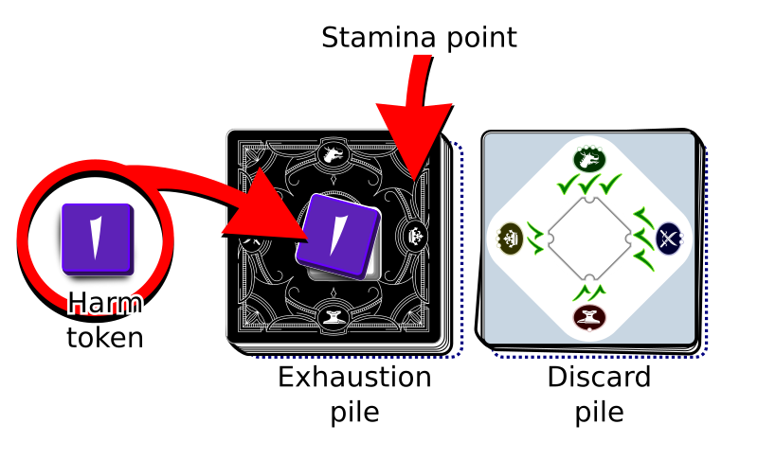
Harm token

Stamina - Heroic Mode
The Stamina rules described above are known as "Lucky Mode". Those rules allow the players to lean on luck at the beginning of the game, because the "worse cards" of the Deckahedron might end up in the Exhaustion pile, shifting the odds to increase a player's chances to succeed at moves.
During the 9-hour and 30-hour campaigns, players will have the choice to switch to "Heroic Mode", sacrificing their potential to get lucky for more knowledge and control over their outcomes.
In "Heroic Mode" characters still have 10 Stamina points. But now, these points are represented only by cards in your Deckahedron with a Stamina symbol
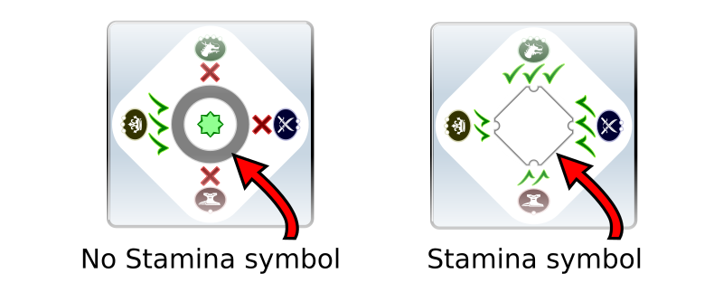
Cards with and without Stamina symbol
When you are instructed to lose or expend a Stamina point, you may absorb it using any relevant move cards and item cards, otherwise:
- Reveal cards in your Deckahedron until you find a card with a Stamina symbol
- Put that card aside, face-up in your Exhaustion pile
- Place an Exhaustion token on your Exhaustion pile
- The other revealed cards go into your discard pile
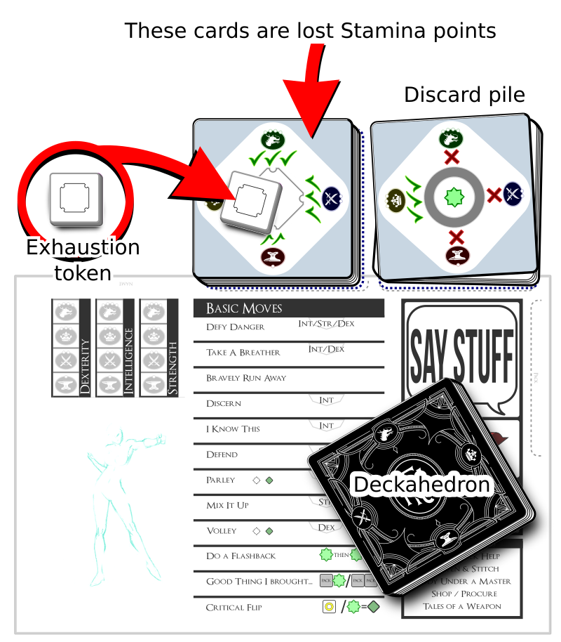
Exhaustion token
(So, if you were instructed to lose 3 Stamina points, you add 3 cards with Stamina symbols onto your Exhaustion pile)
If searching through their Deckahedron does not yield a card with a Stamina symbol, the player must reshuffle their discard pile into the Deckahedron and continue searching.
Note: Players may choose to reshuffle their discard pile back into the Deckahedron before searching for Stamina points.
If there are no Stamina points in the Deckahedron or the discard pile, then all 10 must be in the Exhaustion pile. In this case, the character is incapacitated and can take no further actions.
GM Note: The switch to Heroic Mode is a way
for the players to make a choice that echoes
Chapter 5 in the Hero's Journey. They
themselves become heroes.
By transcending randomness and meeting the
challenges of responsibility, capability, and
commitment, the players will have new power to
get the outcomes they desire.
When playing in Heroic Mode, you may look through the cards of your exhaustion pile at any time.

Mini-games

Corner-matching Mini-games
Some moves can be resolved by laying out Deckahedron cards into certain shapes such that the the Chinese Zodiac symbols on the corners match up.
During corner-matching mini-games, the corner symbols of Wound and Blessing cards are special. The Blessing cards have a "dragon" symbol, which is wild -- it matches all other symbols except for the "goat" symbols on the Wound cards. The corners of Wound cards show the "goat" symbol, which does not match any other symbol, not even itself.

Pick Locks
In the Pick Locks mini-game, the player attempting the move must draw three cards from the top of their Deckahedron and put them down on the table, face-up.
They must then arrange the cards corner-to-corner in a line such that the touching corners show the exact same symbol.
TODO: illustration of Pick Locks mini-game
At any time during the mini-game, they may put one of the cards into their Exhaustion pile (Stamina is lost to mental exhaustion) and replace it with a new card from the top of their Deckahedron. The play may do this as many times as they like.
While the player is attempting the mini-game, play continues at the table, with other players making moves and time moving forward in the world while the character concentrates on their lockpicking task.
At any point in the mini-game, the player can abandon the attempt, and the result shall be interpreted as though they flipped an .

Fundamental Magic
TODO: illustration of Fundamental Magic mini-game
The Fundamental Magic mini-game works the same as the Pick Locks mini-game, except that the player starts with 4 cards and must create a "box" shape.

The Pursuit Mini-game
When dangerous foes are chasing the PCs, use these rules to determine what happens.
When a player first declares that they are going to Bravely Run Away
TODO: finish
- Starting player declares
- Other players declare whether their character joins
- One character - the one with the most Items + PACK is declared the "rabbit"
- Best 3 of 5 rounds
- Rabbit flips solo
- Add the rabbit's Str + Dex, then subtract their encumbrance penalty (the count of all their Item and Pack cards)
- Find their flip rank on the table below
- For the rounds 2 through 5, the rabbit flips, but can be helped by any of the other joining PCs. The best result between the rabbit's flip and the helper's resolves the round. Each one of the rounds can be helped by Int, Str, or Dex, without repeating. The help must be justified by the attribute.
- Int
  - Hiding
  - Using words to influence a crowd
- Str
  - Climbing a wall
  - Making a great leap
- Dex
  - Sliding / tumbling down an embankment
  - Dancing across a precarious rooftop
  - Jumping from the balcony onto a waiting horse
- The last flip must be made by the rabbit alone.
- If the pursuers ever win 2 flips in a row, they can make a move in the middle of the pursuit if appropriate, like firing a volley of arrows or sounding some kind of alarm
Str + Dex - Encumbrance | Flip:
less than 0 | Anvils 2x disadvantage
0 | Anvils with disadvantage
1 | Anvils
2 | Blades
3 | Crowns
4 | Dragons
5 | Dragons with advantage

Player vs Player
This game is a tool for telling stories about a group of characters that work together to overcome some danger that threatens them all. The details of their alliance are discovered through play, and those details can include tension and disagreement. This section provides rules for the tensions to be exhibited in the narrative, but also tries to guide the resolution of those tensions to a state where the characters are afterward unified against their common, non-player, foes.

Combat
When a player asserts their character violently against another player's character, the rules are special. In general, negative consequences are only applied by consent. These are different than the rules for fighting NPCs and monsters.
Fights among player characters can be great to introduce drama and increase tension in your narrative. But they are designed so that one player cannot force another player out of the decision making process. The narrative you create is a shared one.
When a player's character attacks another player's character, moves are triggered as they would normally be, and costs are paid (eg, if the attacker uses a magic item, they may lose a charge), but there are differences:
- XP cards do not generate XP if they resolve a flip
- Critical Success cards cannot be used to go up levels in moves
- Attack power is not rolled
Instead of rolling attack power, the defender alone describes the negative consequences (if any) their character suffers. This includes loss of resources (like Stamina / Harm / Wounds) as well as narrative consequences.
Optionally, the attacker may also describe negative consequences for their own character, mimicking the way the Mix It Up move causes both the attacker and defender to suffer attack power.
The GM can still collaborate with the players to describe narrative outcomes of the altercation, and may even use the situation to bring dangers to bear, but may not reduce player resources as a result of the specific action.
Inter-party conflict can provide some of the most interesting and dramatic moments of a campaign. Those moments arise from a group of friends at the table collaborating together.

Theft, persuasion, mind-control
Just as in PvP combat, when one player tries to:
- reduce another player's resources
  - eg, by using the Pick Pockets move
- use a move to dictate another player's character's action
  - eg, by using mind control magic
XP cards do not generate XP, Critical Success cards cannot be used to go up levels, and the defender gets to say what the result was.

30-hour Campaigns: Green rings
If you are playing the One-Shot Campaign or 9-hour Campaign, you can skip this section.

Green rings
At the beginning of a 30-hour campaign, some move cards will be put into envelopes. When you Study Under a Master, you will only be able to choose the enveloped cards if you can arrange your current move cards to form the number of rings shown on the envelope.
Place the following cards inside the envelope marked with one green ring:
- Mystic Breathwork
- Fury
- Slide
- Not On My Turf
- Void Transfusion
Then, place the following cards inside the envelope marked with two green rings:
- Goreography
- Derring-Do
- Fundamental Magic
- Breach the Dam
The moves inside these envelopes cannot be learned during Study Under a Master until the character has already built up some skill.
Take a look through the move cards and see that there are partial rings printed on them - either in the corners or on the sides.
When you can arrange your own move cards together in such a way that a ring is completed, you "have" a ring. If your cards can arrange to show 2 rings, then you "have" 2 rings.
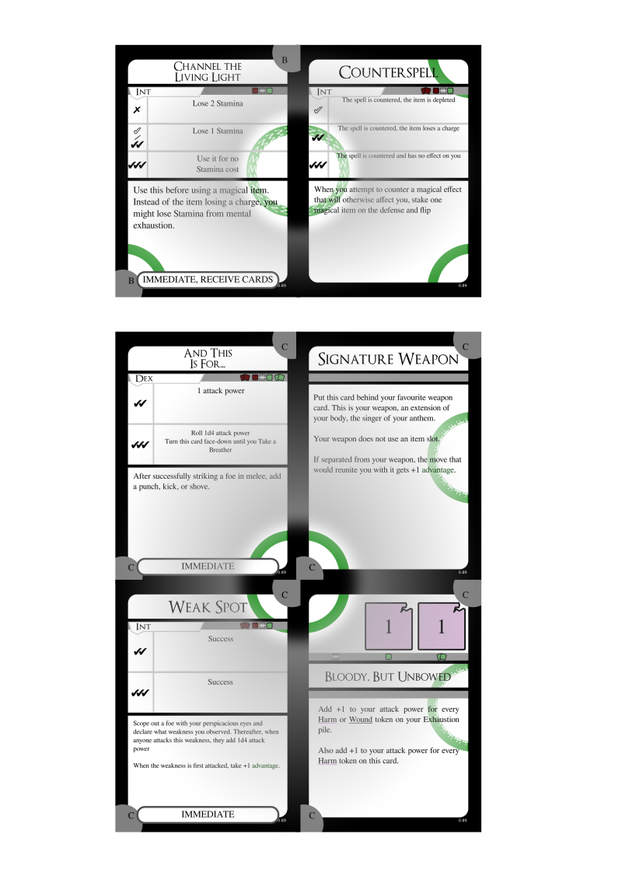
ring arrangements
If your card arrangement had the cards Pick Pockets and Not On My Turf next to each other, you could complete a ring. If you didn't have the Not On My Turf card, but instead had the Fury card, you could arrange it next to Pick Pockets to complete a ring.
You do not have to keep your cards in this arrangement while you play.

Appendices

Diceless Play
Rolling dice is a fun, tactile experience, but not every table has the dice that A Thousand Faces of Adventure asks for. In that case, it is possible to play without owning the physical dice. Each Deckahedron card has symbols that can be used in their place.
To roll a 1d4 or 1d6 with the Deckahedron, flip over a card from the top of your deck, and look for the d4 or d6 symbol on the face side, and read the number therein.
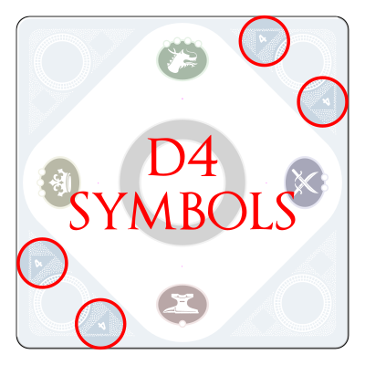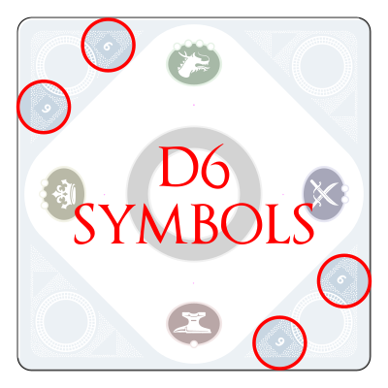
If there is no number, that card doesn't count. Just re-flip and use the next card.
To roll a 1d10, follow the same process, but add up the two numbers inside the triangle and the square. This does not produce results uniformly between 1 and 10, but instead produces results along a specially-designed "2-to-10 curve", which has been chosen to provide statistical results that create a pleasing and dramatic experience.

Glossary
1d4, 1d6, 1d10
This is notation that means "one four-sided die", "one six-sided die", etc.
attack power
the number representing how powerful an attack is
charge capacity
the maximum amount of charges a magic item card has
depleted
the state of a magic item without any remaining charges
halve
When you roll dice and halve the value, divide by 2 and then round up to the nearest whole number. 4 becomes 2, 3 becomes 2, 2 becomes 1, etc.
idle
A magic item is idle only if magical energy is no longer flowing through it
melee
When the details of the fiction put two combatants close enough to each other such that their handheld weapons might connect
More Power
Permanently changing the kind of dice that are rolled when certain Item cards are used
NPC
Non-Player Character (a character controlled by the GM)
PC
Player Character (a character controlled by a non-GM player)
ranged (or "at range")
When the details of the fiction put two combatants far enough apart that their handheld weapons could not connect
session
The contiguous period of time that you're at the table, playing the game
the supply
The area on the table where all the cards and tokens are kept
town
Any place that offers food, shelter, exchange of goods, and the company of others. It could be a primitive circle of huts or a sprawling city
XP
"experience point" or "experience points"

Components
TODO illustration of all components and their names

A Thousand Faces of Adventure

GM GUIDE
July 07 2020

A Thousand Faces of Adventure: Game Master's Guide
playtest version 0.93 2020-07-07
find latest version at https://1kfa.com
email sjb@ezide.com

This guide is intended for a Game Master (GM).
Read this guide if you are the volunteer among your friends to run the game of A Thousand Faces of Adventure (aka 1kFA).
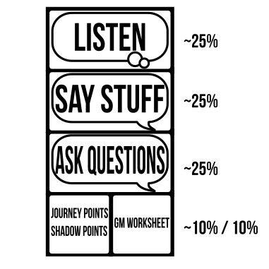
The GM's job
Your responsibilities are:
- pitch the idea of playing A Thousand Faces of Adventure to your friends
- know, teach, and follow the rules
- describe scenes
- give Non-Player Characters (NPCs) names, voices, motivations, and behavior
- confront the other players with challenges and dangers
- ask the other players questions
- gain and spend Journey Points and Shadow Points
- take some notes in your GM Worksheet
- and...
The last responsibility is so important it deserves its own paragraph:
Players will signal the kinds of fun they want to have. It is your responsibility to notice these signals and insert that kind of fun into the game.

To make your job of teaching the rules easier, this guide has scripts. The scripts are written to be read by you to the players at the table.
Before sitting down with your group of players, you should read all the rules. Your players will have questions, and will look to you to to answer them.

Show, Don't Tell
One piece of advice frequently given to anyone trying to convey information is "Show, don't tell".
In that spirit, you are invited to visit https://www.1kfa.com/examples. There, you will see examples of the game being played. For all the author's attempt to make this document clear, brief, and unambiguous, those examples may do a better job of conveying just what the game is and how it is played.

The Pitch
You want to play A Thousand Faces of Adventure with your friends, but there's lots of other games out there, so what can you say to bring your friends to the table around this game?
Here are some things that make A Thousand Faces of Adventure special. You know your friends best, so, as you look at this list, think about what they like and dislike and what they seek from their gaming experience.
- The Hero's Journey - like the stories told in blockbuster movies, your friends will play protagonists who must face adversity to transform themselves and their world
- Players interact with cards and tokens more than sheets of paper, which gives a tactile significance and feels familiar to board game players
- Play your favourite universe - use the setting of your favourite swords-and-magic universe from pop culture, this game will support it!
- The "surprise moment" happens for all players simultaneously - the moment a card is flipped, the result is immediately visible to everyone at the table
- Layered, interlocking mechanisms - choices move game resources and probabilities around - there's depth to explore and skill to build

First-time Players
If there is a player at the table who has never played A Thousand Faces of Adventure before, read the Start Script and play Sarukkan's Chamber.

Start Script
Hi everyone! We're going to play A Thousand Faces of Adventure. This is going to be really fun, I'm glad you could join me for this! I'm reading directly from a script that was designed to get us started fast, by going over just enough of the rules for our first session, so please pay attention now so we can get to the fun of the game quickly!
A Thousand Faces of Adventure is a narrative game.
It's a storytelling game where we all collaborate and tell the story together.
I'm going to be the GM (it's short for Game Master), so I'm going to be responsible for the events in the world and the side characters (they're called NPCs or Non-Player Characters).
Each one of you is going to play a role, kind of like an actor does. You're going to control one character. You get to tell us everything they think and everything that they say and everything that they do.
Imagine we're making an awesome adventure movie with swords and magic. You're the actors just making stuff up as you go, and I'm a combination of director and cinematographer, trying to fill the story with excitement and drama and also deciding how the scenes go together and where the camera cuts to next.
But let me pause for a minute and get specific about what I mean by "you decide everything your character does".
You can't just say "My character Tyrion runs up to the bad guy and punches him in the head and his head goes flying off". You can say "My character runs up to the bad guy and punches him in the head", then, because there's uncertainty about the outcome, and the degree to which Tyrion succeeds would matter in the story we're creating, it's my job as the GM to say you've triggered a move. The game rules will then answer the question "does it happen?" and tell us if the bad guy's head actually goes flying off.
When a move is triggered, it's time to use the cards and dice to see what happens next. Triggering moves is a lot of fun. It's fun to succeed and it's fun to fail, because even in failure, new exciting stuff starts happening. When you trigger moves, you impact the narrative, consequences happen, and we're all going to get surprises when cards flip and dice roll.
Besides face-punching, some other questions that might be answered by triggering moves are:
- Will the old librarian agree to hide me from my pursuers?
- Do I see the giant spider web in my path?
- Is there another way out of this burning tavern?
- Will this magical scepter work just one more time?
The game isn't all triggering moves though.
Distribute a character sheet to each player.
Most of this game is talking. That's why "Say Stuff" is written so boldly on the character sheets. I'm going to be asking you questions, you'll probably have lots of questions for me, and we're going to put everything together to make an epic story. It's gonna have adventure, battles, chases, discoveries, and magic.
It's a fantasy story, so think dangerous, and take risks.
Be true to your character's personality. Remember it's sort of like acting.
Your character will start out as a scrappy adventurer, and rise in power to become a hero. Or villain. Or maybe they'll just die in the attempt. And maybe they'll be resurrected after that.
Each session will be about 3 hours. We might spend a long time bouncing ideas off one another and dealing with each consequence in an improvisational way, or we might engage in a long battle with lots of dice rolling and card flipping.
There's no predetermined story, we're all in this together, and we're going to play to find out the details of what happens.
This first session will need about 40 minutes of preparation, though. Ten minutes has already gone by with this speech (it's almost over).
Next, we're going to play Sarukkan's Chamber, a pre-made adventure for you to get the hang of the rules. It will be short. I'll set a timer for 10 minutes and end Sarukkan's Chamber when it goes off.
Then we'll take 10 minutes to create a Touchstone List for our game.
Then we'll do 10 minutes of Character Creation.
And then, the adventure begins.
Let's start!

Your Deckahedron
Give each player a Deckahedron.
(Print-and-play and mobile app versions are available at www.1kFA.com)
Here's a stack of 20 cards, it's called a Deckahedron. You'll use this to see how successful your character is when moves are triggered. It also represents your character's Stamina points, which we'll discuss later.
Notice the 4 different colored symbols on the edges. They're named Anvil, Blades, Crown, and Dragon. When you trigger a move, I'm going to instruct you to flip the top card of your Deckahedron, and we'll see the result on the flipped-over side. There are 4 possible results:
- : this means you succeed at the thing you tried
- : this usually means something good happens, but maybe with a downside
- : this usually means something "ok", or not-so-good happens
- : this usually means that I get to say what happens and make my own move
When I ask you to flip, I'm going to say something like "flip Anvil" or "flip Blades". That means you find the result on the edge that has that symbol.
When you flip it over, please put it down in a way that everyone can clearly see the result. Try to orient your cards consistently so that we don't get confused about what your result is.
Let's try it: everybody put your Deckahedron on the table and flip Blades.
Step the players through "flipping Blades" using the instructions in the Player's Guide
Make sure each player understands how to execute a flip before you proceed.

Your base moves
Give each player a Move Booklet
Here are the basic moves. You don't have to read this booklet unless you want to. I'll point out moves when they're triggered and we can read them together or you can just let me apply them.
It's hard for me to do everything though, so the more you can participate, reading the text of your moves, and suggesting narrative outcomes, the smoother the game will run. Once we've had some practice, playing the game will feel like a collaborative story we're creating together.
The move you'll be triggering the most will probably be Defy Danger, that's why it's on the first page. The moves in the back of the booklet are "downtime" moves which we won't need until much later.
Let's go through an example of flipping Defy Danger. The move reads from top to bottom. First we would establish in the fiction how your character is defying danger, are they using their Str, Dex, or Int? Once that's decided, we would look at your character sheet to see what value that attribute is. Let's say they were diving to the ground to avoid a spear that was thrown at them. That's Dex. Let's say their Dex was rank 3, or "Crown". So that's the side of the card we're going to look at. Flip your top card. What result do you see on the "Crown" side?
[Take the result, and if it is s, ask the player to help you interpret a potential outcome using the Defy Danger move. If it is , tell them how it would be your turn to make a GM move]

Sarukkan's Chamber
You are going to be running a short tutorial game for 2-3 players. One will control a female protagonist character, and one will control a male protagonist. If there is a third player, they will control a prisoner that the other two characters discover in the first scene.
First, you will need names for the characters and setting of Sarukkan's Chamber. Ask the players these 3 questions. This is an improvisation exercise. Its purpose is to get the creative juices flowing and to signal to the players that they have input over the story.
Ask the players for the name of a medieval fantasy city name. Simply write down the answer. That will be the name of the setting.
Ask "What's a store where women buy clothing?". This time, twist the answer a little to create the female protagonist's name. (eg, "Forever 21" might turn into "Forva", "The Gap" into "Gappalina")
Ask "What's a city in Europe?". Again, twist this answer to create the male protagonist's name with that. Stretch your creativity muscles. (eg, "Paris" might turn into "Croissant", Maybe rearrange "London" to "Donalo")
This mini-game is a GM tool. Often, the players will look to you to
come up with names of characters or places on the fly. Instead of
sitting still and thinking for 30 seconds, you can throw some simple
[lateral questions](#lateral-questions) like these back at them.
Ask each player to write down the names you just came up with on their character sheet.
Next, instruct the players to fill out the attribute boxes on their character sheet like so:
- Both characters have 1 Intelligence (Anvil)
- The female protagonist has 3 Dexterity (Crown) and 2 Strength (Blades)
- The male protagonist has 2 Dexterity (Blades) and 3 Strength (Crown)

Introduce Sarukkan's Chamber
Begin narrating the set-up.
[Addressing her] _ (female protagonist), you are an acrobat. Your troupe of performers set off on the road to perform in the big city _ (city name). You were really excited, because your big brother lives there, and you haven't seen him since you were 13, and that was 10 years ago.
But your excitement soon turned to horror and despair. On the road, your troupe was overrun by masked horsemen. They attacked fiercely and without mercy. Your caravan guards fought bravely, but were outnumbered. You and your companion, Gwendolyn, were captured.
[Ask the player] What was Gwendolyn's role in the troupe?
In the chaos, you remember one phrase uttered by the marauders, "Deliver them to Sarukkan's."
You endured days of travel shackled in a box, Gwendolyn tried to comfort you both by singing a song from her past,
[Name the song, or do an impression of Gwendolyn singing a few bars. try to make the song have something to do with Gwendolyn's role in the troupe]
Finally, you found yourself imprisoned in a small, dark, musty cellar room. Windowless, the only illumination is whatever lamplight filters through the cracks of the door.
You could hear sounds from the hallway though, and on the second day, you heard Gwendolyn being removed from her cell. After that, only silence.
[Dramatic pause]
[Addressing him] _ (male protagonist) you are a thief-catcher. You're not too bright, but your boss, Gandlin, has taken you under his wing and taught you street wisdom. Merchants employ him to recover stolen valuables or they pay for simple retribution against the pilfering scoundrels. You provide the muscle. Gandlin provides the brains. He sniffs them out, you beat 'em up, and each of you shares in the reward.
That's how it had been. Gandlin has now gone missing.
He was investigating a series of thefts from private homes. There was some pattern to it -- artifacts or books taken, but no smashed windows or doors. The mystery of it had Gandlin obsessed, working sometimes until dawn.
[Ask the player] What was Gandlin's favourite breakfast food?
One dawn it was Gandlin that was taken.
[Describe the scene of Gandlin's disappearance, using the favourite breakfast food to paint the picture]
Following the trail of clues, you came to the locked gate to the yard behind Sarukkan's estate. Sarukkan was a powerful player in _ 's (city name) noble circles, but not much was known of him.
After jumping the wall, you didn't get much farther before you were surprised from behind and knocked out, waking up in a tiny, dirt-floored room in the cellar.
[Addressing both] But tonight, something changed. It was noisy tonight. Footsteps and conversations could be heard upstairs. It was some kind of party. And there were no guard patrols of the cellars. In parallel, but without bumping into each other, you both used the lapse to escape.
You freed yourself from your cell.
In some dark corner you grabbed a reveler and took their elaborate costume and mask for a disguise. Tonight must be a masquerade ball.
With no easy opportunity to exit, you kept evading attention by going upstairs, until you reached the third floor.
From different doors, you simultaneously enter an empty bedchamber.
At this point, take out a blank sheet of paper and draw this incomplete map of Sarukkan's Chamber. Then drop a couple tokens representing the players' characters on the paper. If you don't have tokens, you can use coins or nuts or glass beads, anything handy.
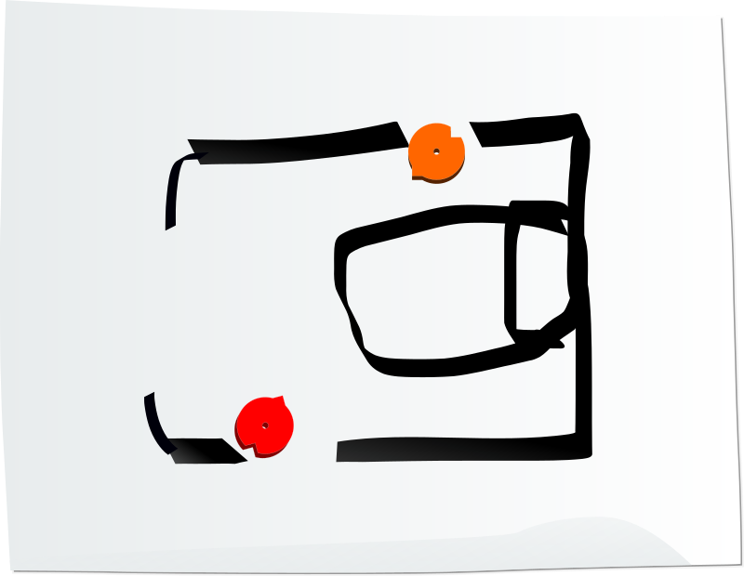
Draw maps, leave blanks
This map will let everyone know roughly where their character is positioned. You don't always need this visual aid, but Sarukkan's Chamber is a tutorial, so it's good to have some practice.
When you draw out a map of an environment like this, be very loose and fast. Leave blanks. Rely on the imagination of the players to fill in the details unless there's something whose position is important to draw.
For example, a player might tell you that they look around the chamber for an exit, and you might say "There's a large window at the front of the room , but it's framed in iron. The ironwork looks old though, maybe it's no longer sturdy?". That would be a good point to draw a few lines to show where the window is in the room.
You turn from the door you carefully and silently closed to see across the room, an apparent party guest in full wardrobe.
[Dramatic pause]
One last thing, with these masks on, you don't know this, but you're brother and sister.
What do you do?
Start a timer for 10 minutes.
This last question "What do you do?" is very important.
When you describe a situation, always end with this kind of prompt. Portray a situation that demands a response. Always.

But now what should I say?
Where's the rest of the script?
If this is your first time being a GM, you might feel intimidated. That's ok. Remember, this is not high art, this is improv. You are playing to find out what happens.
Preparation is the watchword for first-time GMs. Read the Guidance chapter. Check out some examples of how other GMs have run their games.

Sarukkan's Chamber Details - take them or leave them
- Luxurious canopy bed in the middle
- Chamber is full of esoterica - bookcases and desks overflowing with books, sculptures, candlesticks, and votives
- Chamber is empty of any adornments, the only feature is a bed and a precise circle of white powder in the center of the room
- A window at the front of the room - an escape route?
- An alarm triggers when a guard enters the room?
- A creepy portrait of Sarukkan, whose eyes follow you as you move
- A trap-door under the bed - where does it lead?

Goals for Sarukkan's Chamber
Ideally, Sarukkan's Chamber should demonstrate what kind of game this is.
A Thousand Faces of Adventure creates plot questions for players to answer:
- Will the brother & sister who haven't seen each other in a decade discover each other's identities?
- Will the brother & sister escape Sarukkan's imprisonment?
- Will the brother & sister rescue Gandlin or Gwendolyn?
- (3rd player variant) Will the reluctant guard choose to obey an evil master, or rebel?
A Thousand Faces of Adventure creates tension and action:
- Potential combat against guards or kitchen staff or Sarukkan himself
- Potential pursuits involving outsmarting or outmaneuvering pursuers
- Potential to hatch plans and use available resources to set traps or defy traps that been set for them
- Potential to use stealth and social manipulation with guards and party guests

Your group's playing of Sarukkan's Chamber doesn't have to all of this, the players will make choices that surprise you. If they surprise you with something unlikely or risky, be ready to declare that moves are triggered, but also be ready to say "Yes, and..." to their crazy ideas.
It should also help teach the rules.
- Work in an opportunity for each player to do a Deckahedron flip
- If a player flips an XP card, that's an opportunity to explain how they earn XP
- If a player flips the Critical Success card, that's an opportunity to explain the Critical Flip move
- Ideally there will be a combat scene. (see the Combat guidelines) Try to get the PCs to attempt Mix It Up or Volley
- When a PC loses Stamina, explain that losing 10 Stamina points will mean the character is incapacitated
- The brother & sister may trigger Discern and I Know This moves when they try to reveal each others' identities
- The Discern move often comes up when having a look around Sarukkan's Chamber itself.
- If any player-versus-player combat happens, remember to use the PvP combat rules

It should also be a warm-up for your GM skills.
- Remember: "Yes, and..."
- Move the spotlight - be fair, let all players impact the narrative
- Manage the pace. Let the PCs have some dialogue, but when it feels like they're hesitating, push quickly to the approaching dangers.
- Get some guards into the room for a quick fight.
- As the PCs gain the upper hand, show signs of another threat (maybe the wizard himself approaches - it's ok to tell the story of what's happening off-camera)
- Play Sarukkan's Chamber honestly. Set the stakes the same as you would when you play a campaign
- Observe your players for signals about what kind of fun they enjoy

After Sarukkan's Chamber, the players should now understand how the Deckahedron works with character attributes to produce results that affect the narrative. Ask the players if they get it, and explain again if there's still any confusion.

After the timer goes off
When the 10 minute timer goes off, you have a choice.
Take a look at your friends, are they having fun? Are they smiling, are they looking at you eagerly to see what happens next, are they bantering with each other about what actions to take, are they having in-character dialogues?
Sarukkan's Chamber is intended as a 10-15 minute tutorial, but if it seems like everyone wants more, you can keep it going.
Ask the table if they want to keep going with this scenario. If not, just skip forward to Begin a Campaign.
But if they do want to continue, add in the next layer of rules before jumping back into the action:
- Any character still wearing their elaborate costume should get a card entitled "Costume". This is an Item card.
- If the characters have acquired any significant items during their adventure so far, also make Item cards for those.
- The characters do not get any Pack cards, as they were just prisoners

Sarukkan's Chamber 3rd PC variant - The imprisoned guard
If you've got a 3rd player at the table, add a guard character.
Add another 5 minutes to the timer, so now Sarukkan's Chamber will end after 15 minutes, not 10.
Ask "What's a domestic brand of beer?". Use that to create the 3rd character's name. The guard can be any gender, has 3 Int, 2 Str, and 1 Dex.
Let them know that they'll get introduced about 5 minutes into the story.
After the first two PCs have had a chance to orient themselves to their surroundings, and maybe have a dialogue with each other, introduce the 3rd PC
[Addressing guard] _ (guard), you are a guard, but also a prisoner awaiting your doom.
You were the newest hire in Sarukkan's staff, but you didn't even get to collect a week's wage before thing went sideways. Even on day one, you noticed some sketchy stuff going on around here.
Your supervisor, Yogran the Rat had assigned you the simple duty of yard patrol, and when you passed by the cellar you could swear you heard the sounds of women crying. Yogran sternly rebuffed the complaint you made, and then he set you up.
[Ask the player] What employee offense does Sarukkan have zero tolerance for?
[Describe the way Yogran the Rat set up the player's character using that offense]
The last thing you remember is being told that your soul will be used as fuel in a dark ritual on the night of the ball.
You awaken now in Sarukkan's chamber, roused from your sleep by the sound of two voices. You can speak, but your arms and legs are bound.
[Ask the player] Where in the room are they storing you?
What do you do?

Guidance
The GM is part narrator, part host, part referee. It's a lot! How does a GM play this game?
Crucially, know that the GM is a player who makes moves. Primarily, when an gets flipped, you get to make a move.
You also get to make a move when:
- Everyone at the table looks to you
- A move specifically declares that the GM must choose an outcome
- A PC takes an action that you have especially prepared for
Always Describe the immediate situation around the characters. This is how you start a session, how you get things rolling after a snack break, get back on track after a great joke: tell them what the situation is in concrete terms.
Use detail and senses to draw them in. The situation isn't just an orc charging you, it's an orc painted in blood swinging a hammer and screaming orcish battle prayers. You can leverage a lack of information, too. The sound of clattering armor and shuffling feet, for instance.
The situation around the players is rarely "everything's great, nothing to worry about". They're adventurers going on adventures -- give them something to react to.

Here are the 6 main goals a GM pursues in this game.
- Portray the world of the Touchstone List
- Fill the characters' lives with adventure
- Move the spotlight fairly
- Ask the players questions
- Make GM Moves
- Achieve your next Journey point
As the conversation at the table unfolds, refer to this list whenever you find yourself searching for what to say next.

Portray the World of the Touchstone List
One of the first things your group will do when you begin a campaign is create a universe -- the fictional setting in which the PCs will be adventuring. This setting is expressed by something called the Touchstone List.
A Thousand Faces of Adventure is about characters who have decided to take up an adventure in the hopes of fulfilling a strong need. It's your job to participate in that by showing the players a mysterious and dangerous world in which their characters can find that adventure. Without the player characters in the world, calamity would ruin something precious. Maybe even the whole world would fall into chaos or destruction -- it might still, even with them. It's up to you to portray the fantastic and bizarre elements of that world. Show the players the wonders of the world they're in and encourage them to react to it.
Always know that the Touchstone List is there to support you in portraying this world. Look at the titles written there. Remember those books, movies and TV shows, and lift something directly from those stories. Lift animals, characters, environments, situations, lift whole cities if you want to. Remember Picasso's words: "Good artists copy, great artists steal".
The main point is to describe and emphasize the fictional situation to the players at the table. Give the players details so that they can grasp the stakes of their decisions. Give the players inspiring material to help them come up with answers when you ask them questions.

Fill the Characters' Lives With Adventure
Filling the characters' lives with adventure means working with the players to create a world that's engaging and dynamic. Adventurers are always caught up in some dangerous situation or another -- encourage and foster that kind of action in the game.
Always portray a setting in motion -- someplace significant with creatures big and small pursuing their own goals. As the players come into conflict with that setting and its denizens, action is inevitable. You’ll honestly portray the repercussions of that action.
Introduce challenges. Unfriendly NPCs, monsters, puzzles, or the troubles of the setting should regularly confront the characters.

Move the spotlight fairly
The general attention of people sitting at the table is called "the spotlight". Participants tend to talk one-at-a-time, while all others wait in excited anticipation.
The GM is tasked with managing the "when" of the spotlight. When does one player's contribution end, and the next player's begin? When has a player said something that triggers a move? When is it time for the players to all sit back and suffer or delight as the GM describes the consequences of their decisions?
Never let a player's time in the spotlight be inconsequential. A player might wait 10 minutes for their moment to arrive, so if their whole turn in the spotlight ends with "nothing happens", that player's experience will suffer. Give them an opportunity for something. This doesn't mean they have to slay a demon on every turn, merely getting a big laugh can be "something".
Remember, this is a collaborative story. Laughter and excitement are the rewards for everyone.
Allow the players to naturally move the spotlight among themselves.
As the GM, you may take a turn in the spotlight:
- when someone flips (or sometimes just )
- as specifically instructed by a move a player is executing
- when everyone looks to you to see what happens
- when a character encounters something you've been preparing for
Usually your turn in the spotlight will be spent making a GM move. But it may also just be general narration.

Ask the Players Questions
A Thousand Faces of Adventure is a conversation. The GM is not the only storyteller at the table. Ask the players questions and use the answers. Embrace your curiosity.
When you run Sarukkan's Chamber, there are some built-in prompts to give you some practice asking questions that fill in the details of a scene or give personality to NPCs.
There are also questions that you will need to ask to establish what rules apply: "What is your character trying to accomplish?", "Is anyone else helping?", "Who is taking the lead?".
The easiest question to use is "What do you do?". Whenever you make a GM move, end with "What do you do?". You don't even have to ask the person you made the move against. Take that chance to shift focus elsewhere.
The questions that gave the characters flesh during character creation are examples of asking questions and using the answers. You can always go back and pull more buckets up from that well. If a character is religious, ask them what their gods would have to say. If there's a halfling in the party, ask how hungry the current scene makes them.
Try asking the players to describe outcomes. For example, if a player's character is in a fight with a goblin and the player gets an amazing attack power roll of 10, the GM might ask the player, "Describe how your character kills the goblin". This gives the player license to get flowery and really see their character as a powerful hero in this fantasy world.
When you're stumped for what happens next, ask a player to fill in the details. Consider where you are in the Campaign, and ask a leading question. Use their answer to describe the next scene or introduce the next challenge.
Chapter | Question
Home / You | What's the one rule you're not supposed to break?
Need | What do you wish people here could see the beauty of?
Go | Who do you hope won't try to get in your way?
Search | What strange custom do they practice here?
Find | this stage has it's own set of questions
Take / Pay | A great trembling is felt. What's that sound? / A figure approaches. You thought they were dead, who is it? (engage their fear / grief)
Return | this stage has it's own set of questions
Change | Which old friend or adversary is the first to greet you?

Lateral Questions
Other questions to ask are lateral questions. These are questions that have nothing to do with the current scene, but prompt everyone, especially you, to think laterally. These can be great to inspire you:
- If you just need a name for an NPC or location
- If you want to insert a danger into a scene
- If you want an NPC to respond, but don't have dialogue, voice, or personality ready
- If you need an idea for a puzzle or a monster
Example lateral questions:
- What's a city in Europe?
- What vegetable did you eat yesterday?
- Who is the worst Hollywood director?
- What was your worst childhood injury or illness?
- Name a one-hit wonder musical group.
- Name a shop where women buy clothing.
- What's something you buy at a hardware store?
- What's my mother's favourite TV show?
- What do kids find when turning over stones in a garden?
- Name something people believe in that isn't real.

Helping Unsure Players
Sometimes when you ask a player a question, they will simply respond "I don't know". This can be a signal that the player isn't having fun, and might need some direction. It can be difficult to just make stuff up about a character that doesn't really exist moving around in a purely imagined world.
Think about how this player has signaled what they've found fun. Do they seem to enjoy the fictional parts of the game, or the mechanical parts?
If they're enjoying the fiction, ask them what would happen to this character if this was a movie, or use the titles from the Touchstone List. Ask them if they're ok with their character being put in jeopardy, or if that makes them uncomfortable. Ask them what the character's most immediate motivation might be.
If they're enjoying the mechanical game, ask them what resource they're after: XP? precious items? powerful weapons? move cards? Then ask what they think the shortest path is to get the thing they're after. Help them see the necessary steps to get what they want.
In either case, you're nudging them towards making a decision to accomplish a goal. They might need to accept that getting what they want means taking a risk. In fact, the game is designed to reward more XP to riskier choices (triggering lower-level moves is more likely to generate XP than higher-level moves).
Use this as an opportunity to take feedback as well. Have you made the situation clear? It's ok to have a conversation about the conversation.

Make GM Moves
Often the players will move the story forward by having their characters talk and do actions that are certain (you don't call for flips unless actions or consequences are uncertain), so there may be long stretches where a GM doesn't need to jump in.
But when your turn comes, here are the options available to shake things up:
- Escalate the danger
- Reveal an unwelcome truth
- Show signs of an approaching threat
- Deal damage
- Use up their resources
- Turn their move back on them
- Separate them
- Give an opportunity that fits a player's cards or character's background
- Show a downside to their appearance, reputation, or equipment
- Offer an opportunity, with or without cost
- Tell them the requirements or consequences and ask
During the execution of a GM move, tools may be employed to generate ideas and make decisions:
- Ask players questions
- Ask players to reveal a card from their Deckahedron (this doesn't count as a flip, this is just the GM using randomness to help make a decision)
- Put on some music
- Use an improv game
Try to keep up the excitement and pace of play with your GM moves, but also know that it's ok to invest a little in making them significant and to pause for a second to think through some repercussions. Will the move you make drive the story toward your next Journey point?
Note that the move you execute in play may actually overlap multiple moves on this list. That's ok, creating honest fictional responses sometimes demands it. For example, "deal damage" is a move, but other moves may include damage as well.

A GM move is not restricted to the player move that caused it
Understand that when a player resolves a flip with , that doesn't always mean that the thing they were attempting fails.
The GM is free to let the character accomplish the thing, but may use the flip result to bring new action and intrigue into the story.
Let's say a player's character is a thief infiltrating a stronghold, hired to steal a fabled yellow amulet. Maybe the character attempts to climb over a wall to avoid being seen by guards. Consider the following consequences of an :
- You fail to get over in time and the guards start yelling and pulling at your boots (Escalate the danger)
- You climb over, but as you do so, you overhear the guards in friendly conversation with someone that sounds a lot like the fence that hired you for this caper (Reveal an unwelcome truth)
- You climb over. You pause for a second to listen for the guards' passing. You hear their footsteps slow, then stop. Have they found something? Suddenly, one barks an order "Get to the tower and sound the alarm. Run!" (Show signs of an approaching threat)
- You climb over. The camera pans up to the dark sky, we see grey feathered beasts with the faces of birdlike wolves, each flap of their wings loud and ominous. Their tails end in a glowing yellow shape extremely similar to the description of the amulet. (Show signs of an approaching threat)
The first example is pretty straightforward, a thing was tried, it failed, the character suffers the direct consequences.
In the remaining three examples, the character got to the other side of the wall safely. A fictional cue triggered the move, the mechanisms of the rules were engaged, and then the GM chose to create new, separate, fictional badness. The fiction produced by the engaging the rules does not have to be constrained to the fiction that engaged them.
The last example does something even more strange. It talks about a disembodied "camera" and portrays a scene to the players, but not to the characters. This is a fun stylistic choice, but it may not please every group. If you describe the world like a movie, you're asking players to be the audience, not actors. Listen to your players to decide if this is right for your table.
Always be on the lookout for signals from the players for the kind of fun they want to have.

Escalate the Danger
The fictional world is full of danger. Adventurers are constantly being surprised by what's around the next corner or the thing that has been stalking them from the shadows.
Monsters have special attacks. Use these special attacks.
The location itself can produce danger. Are the PCs on a sinking ship, or a crumbling tomb? Announce that the deck they're on floods, or that the passage that led them in is now blocked by tons of rubble.

Reveal an unwelcome truth
An unwelcome truth is a fact the players wish wasn't true: that the room's been trapped, maybe, or that the helpful goblin is actually a spy. Reveal to the players just how much trouble they're in.

Show signs of an approaching threat
This is one of your most versatile moves. "Threat" means anything bad that's on the way. With this move, you just show them that something's going to happen unless they do something about it.

Deal damage
When you deal damage, choose one source of damage that's fictionally threatening a character and apply it. In combat with a lizard man? It stabs you. Triggered a trap? Rocks fall on you.
The amount of damage is decided by the source. In some cases, this move might involve trading damage both ways, with the character also dealing damage.
Most damage is based on a die roll. When a player takes damage, tell them what to roll. You never need to touch the dice.

Use up their resources
Surviving in dangerous places often comes down to supplies. With this move, something happens to use up some resource: weapons, armor, magical item charges, ongoing magical effects. You don’t always have to use it up permanently.
A sword might be flung to the other side of the room. Walking across the shimmering barrier might end any ongoing magic effects, etc.
An easy way to decide on what resource to use up is to look to the cards in front of a player:
- End ONGOING effects of magic items
- Remove green cards from magic items for temporary charge loss
- Reduce magic item charge capacity
- Place black-side red cards on mundane items for damage
- Take away Pack cards
- Take away Item cards (careful with this one - use only when appropriate)
- Take away marker tokens (ie, those created by Where It Hurts, etc.)

Note, a GM cannot take XP from a player. Use of XP should always be a player choice.

Turn Their Move Back On Them
Think about the benefits a move might grant a character and turn them around in a negative way. Alternately, grant the same advantage to someone who has it out for the characters.
If Ivy has learned of Duke Horst's men approaching from the east, maybe a scout has spotted her, too.

Separate Them
There are few things worse than being in the middle of a raging battle with blood-thirsty hawkhounds on all sides -- one of those things is being in the middle of that battle with no one at your back.
Separating the characters can mean anything from being pushed apart in the heat of battle to being teleported to the far end of the dungeon. Whatever way it occurs, it's bound to cause problems.

Give an opportunity that fits a player's cards or character's background
Every character has unique move cards for skills that they shine at, or has a fictional backstory that can overcome social obstacles or tests of knowledge.
Present an opportunity that plays into one character's domain.
It doesn't have to be a character that's in the current scene though. Sometimes a locked door stands between you and treasure and there's no lock-picking expert in sight. This is an invitation for invention, bargaining, and creativity.
Traps, ambushes, and locked doors are great examples. Need some Derring-Do to avoid giant clock-tower gears? Maybe proof of religious or guild affiliation would confer a backstage pass?

Show a downside to their appearance, reputation, or equipment
Just as every character shines, they all have their unique weaknesses too. Do orcs have a special thirst for elven blood? Is an ongoing flow of magic disturbing dangerous forces? The torch that lights the way also draws attention from eyes in the dark.

Offer an opportunity, with or without cost
Show them something they want: riches, power, glory. If you want, you can associate some cost with it too, of course.
Remember to lead with the fiction. You don't say, "This area isn't dangerous so you can make camp here, if you're willing to take the time." You make it a solid fictional thing and say, "Helferth's blessings still hang around the shattered altar. It's a safe area to rest or plan, but the chanting from the ritual chamber is getting louder. What do you do?"

Tell the requirements or consequences and ask
"Ok, everyone flees from the hammer-camels, heading towards the water, but let me ask this first: Samwise is wearing plate armour. If he leaves it behind on the bank of the river, will someone else provide a distraction so he can remove it? Or Samwise can keep it on and clumsily swim, but he will lose 1 Stamina."
This move is particularly good when they want something that's not covered by a player move, or they've failed a move. They can do it, sure, but they'll have to pay the price. Or, they can do it, but there will be consequences.
Base the requirements or consequences in the fiction and make them clear to the characters, not just the players.
This can also be a good move to underscore particularly tricky dangers. Let the players know that if they attempt to dive between the giant clockwork gears, you're going to spend a Shadow point to increase the difficulty.

Achieve Your Next Journey Point
When you have time in the spotlight, and the set-up has been established, take the opportunity to earn a Journey point by taking the plot to another milestone in the Hero's Journey.
Look to the Campaigns section and decide which milestone the current fictional situation is well set-up for.
Remember that the players don't have to bite on every hook. Don't fight it when things to go sideways. You can always skip it or try again.

Begin a Campaign

Universe Creation

1. Create a GM Worksheet
The GM needs a sheet of paper to make notes and track information.
At the top of the sheet write the headings "Journey Points" and "Shadow Points". Leave enough space to track the points under each of those headings.
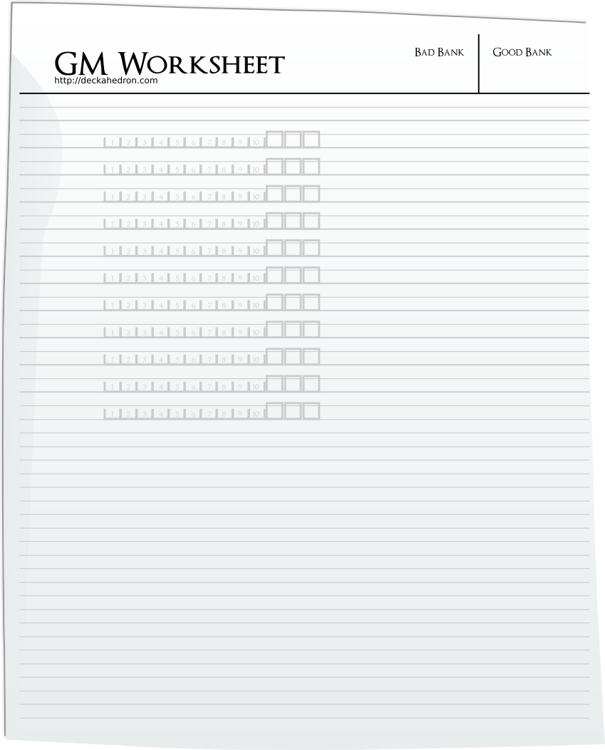
GM Worksheet
When a player flips and resolves a move with a , gain a Shadow point. When a FAST move is resolved with a , gain two Shadow points.
See the Campaign Guide for rules on when to gain Journey points.

2. Establish Touchstones
First, the table needs to get on the same page about the adventure's setting, themes, and tone. Give the players an overview of the steps in creating a Touchstone List, and tell them its purpose. Then start executing the steps.
Take out a new blank sheet of player.
Before we start an adventure, we need to figure out what kind of world your characters come from.
We'll go through a 3-step process to make what's called a Touchstone List.
The Touchstone List is a tool we use to create the setting for the game. I'll also use it for inspiration on tones and themes. And we'll look to it together when your characters are pushing the envelope, to answer questions like "is that action even possible?"
Note: if you want to use "adventure modules" from your library, this is the time to introduce and pitch them.

Brainstorm Titles
The first step is for everyone to grab a pen or pencil and write a few titles from pop culture on this piece of paper. Think of books, movies, games, comics and TV shows whose settings inspire your imagination. Think of ones where you've imagined yourself inside those stories and thought about what decisions you would have made if you were those characters.
Don't censor yourself, and don't shoot down anyone else's title down. This is brainstorming, and we want the ideas to flow.
Stop when you've written 3 or 4 titles.
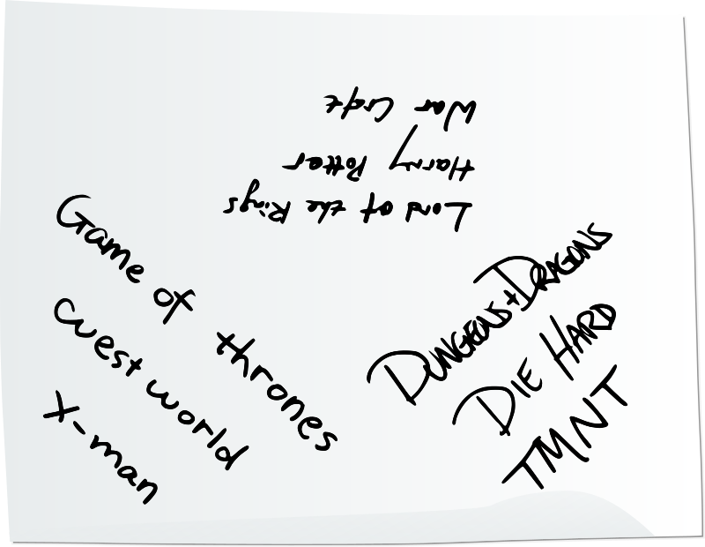
Touchstone List

Narrow it down
Take a look through the titles for anything that may be in a setting that's not well-supported by the rules. If there is such a setting, remind the players that there are rules for swords and magic, and no rules for machine guns or interstellar travel. So choosing sci-fi touchstones might help with themes and tone, but won't have much to offer for establishing setting.
A Thousand Faces of Adventure works best with stories where characters start out "scrappy", that is to say, without extraordinary powers and privileges, characters who struggle, who chafe against their current limitations in the world. So superhero titles or stories where protagonists are genetically imbued with special abilities might also need to be carefully interpreted.
If a title is not recognized by someone at the table, invite the player who wrote the title to briefly describe the setting and what about that title really inspires them.
For step 2, we're going to narrow it down.
Take a turn and circle one of the titles on this list. You are allowed to circle one of your own titles, or any of the other ones.
Only circle one, and don't circle something that's already been circled
Each player gets a chance to circle one of the titles on the list. The GM gets a turn too, and should take that turn after the others are finished.
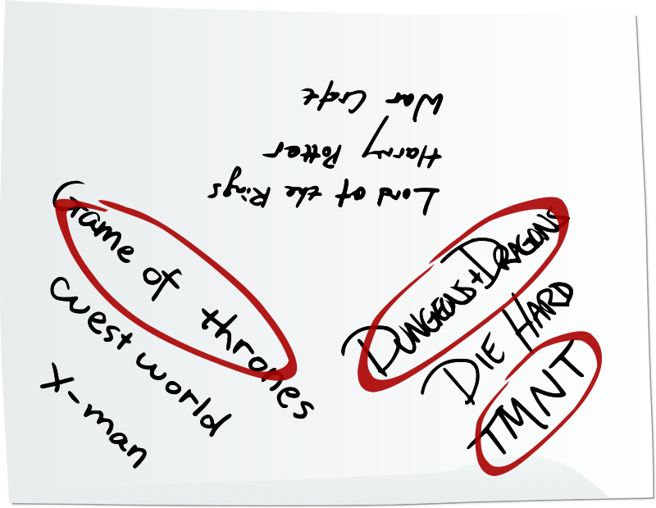
Touchstone List
The "Touchstone List" may be consulted when the table needs to make a judgment about whether facts being proposed make sense in the shared universe you're creating. It can also be used to simply make calls on whether a character's attempt at something is uncertain or impossible (remember, the GM only calls for flips when the outcome is uncertain).
You can ask the question "Did any character accomplish a similar feat in _ ?" (fill in the name of one of the titles in your Touchstone List).
It's also something to consult for what's not special. If the titles on your list never talk about how their heroes acquire horses or boats, and instead just spontaneously present the characters on horseback or sailing at sea, then maybe your game should gloss over questions like "How did you get that horse?".
The Touchstone List is also an early way that the players can signal to the GM the kind of fun they want to have.

3. Set Expectations
Using your knowledge of the rules, read the list and call out any potential conflicts between circled titles and the rules.
Will the players expect their characters to pull off the same feats and use the same powers of the chosen touchstones?
Die Hard is a great touchstone for tone, themes, and relationships, but this game has rules for swords and magic, not helicopters or machine guns.
You should not reject any circled titles, just address what's going to be possible.
Everyone will have more fun if expectations are set at the beginning.
This is our "Touchstone List": [read the circled titles]
Imagine this mashed-up universe.
What kind of world would be the one where some portion from each circled title is mixed together with the others?
What does this world look like?
What are it's dominant features?
What secrets are hidden away in the small places?
Who are the folk that populate it, do their children happily play in the sun?
What monsters lurk, what weakness do the ambitious and powerful exploit?
It's not necessary for anyone to answer these questions, they are mostly to provoke the imagination. But if the table does start imagining out-loud, keep that discussion going for as long as it is productive.
Finally, who will you be in this world? A Thousand Faces of Adventure is a game about a group of scrappy adventurers who grow in power as we play the game.
Your character will start the game with skills and gifts beyond ordinary folk, but they'll still have to work and struggle through adversity to become really powerful.

Character Creation
TODO: include cards as an appendix
Card reference is here.
For a print-and-play experience, the cards can be found in PDF form at https://www.1kfa.com/playtest_files/.

4. Choose move cards
Get the deck of move cards from the supply. If you are playing a One-Shot campaign, remove any cards with a "9" or "30" printed in the corner.
Lay out all of the cards with an "A" in the corner. Then select and lay out (# of players + 1) "B" cards. Then select and lay out (# of players + 1) "C" cards.
These are called move cards. You are going to take turns choosing, and I'm here to explain how they work and answer questions.
The "A" cards are usually the most powerful, so, during character creation, you can only choose one of those. You can choose up to 2 of the B cards, and if you want, you can choose 3 C cards. You will start with 3 move cards in total.
To differentiate the characters, you don't get to choose a card that someone else has already picked. But later on in the game, you can "Study Under a Master" to learn new moves and even choose moves that someone else has.
There's a lot of choices here, so don't get overwhelmed. You don't have to read all of the instructions on each card, just focus on the titles and ask yourself if that sounds like something you want your character to be doing during the game. If a title sounds interesting to you, ask me about it and I'll explain how it works in the game.
If you're the kind of person that really wants to optimize your character you'll probably want to read and understand the rules in the Player's Guide, plus all the text of the move cards, and now might not be the best time for that. This game is more about improvisation than perfection, so listen to your gut and just pick cards that look like fun.
As players choose cards, there may be opportunities to explain some of the deeper rules.
When a player chooses a card with an Encumbrance Penalty, take that opportunity to explain how Item and Pack cards impact those types of moves.
When a player chooses a card with the FAST symbol, take that opportunity to explain that players can only trigger two moves per turn in the spotlight, one normal move and one FAST move, and that FAST moves don't risk a GM move if they flip or .

5. Choose Dex / Int / Str
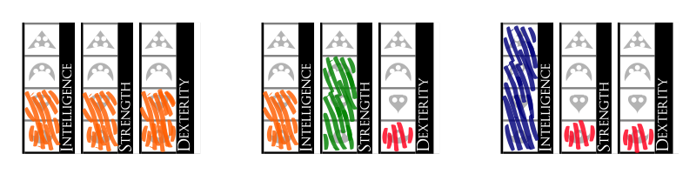
Point distributions
Tell the players to choose how to distribute 6 points among the attributes. No attribute may have a rank of zero. They must all be at least Anvils, and there's no rank above Dragon.
Looking at which attributes get applied to their chosen move cards will help the players decide how to distribute these 6 points.
Now that you've got a few moves, you'll want to fill in your character's attributes. There are three: Dexterity, Intelligence, and Strength, shortened to "Dex", "Int", and "Str" on your character sheet.
You have six points to distribute among them, and each attribute must have at least one point -- you can't have an attribute of rank zero.
Your attributes will affect the degree of success you enjoy when you trigger the different moves. You can see what the moves depend on by looking towards the upper left side of a move card. A move that depends on Str is more likely to get a better result when your Str is really high.
If you're interested in the exact statistical breakdown, there's a page at the end of your move booklet that lays it all out. For now though, you should probably just go with your gut.

6. Name your character
When players have finished picking cards, ask them what their character is called.
Ok, now think of a name for your character and write it down. When you've got it written down, announce it to the table.
Have them write the name on the top of their character sheet bold and large so that you can read it. Using large print with a felt-tipped marker is recommended.

7. Add flesh
Starting with the first player to announce their character's name, ask the questions on this list, one-at-a-time, and make notes of the players' answers. Don't ask each question to each player, address a question to just one player, then move on, asking the next question to the next player. This exercise gets the players thinking about their characters, and gets the table talking, so it's ok for players to blurt out responses out of turn.
For each bulleted question, add a follow-up question of your own. How do the players' responses relate to the established Touchstone List? What further detail would you like to know? Follow your curiosity. This will warm up your improvisational energy and spark ideas for the opening scene of your story.
If you can't think of a follow-up question, you can default to this one:
- Why does that complicate your character's life?
This conversation might also add details to the world, like what kinds of species and religions exist.
- What species is your character, human, or something else from our Touchstone List?
- Does your character steal things, or do they respect the concept of private property?
- Before the adventure starts, is your character engaged in any kind of profession?
- Does your character believe in gods? Is there some kind of religious practice or religious organization for them?
- Does your character enjoy the outdoors, or city life? Are they extreme in that preference?
- Roughly how old is your character? Have they ever killed a person before?
- What's your character's social standing? When they first walk into a room full of people, do they provoke any reaction?
Not everyone will get asked every question, but everyone will start thinking about how each of these questions applies to their character. With some depth and dimensionality in mind, a player will be better able to imagine creative outcomes to the situations their character is confronted with.
As you're asking the players these questions, listen for how the answers signal the kind of fun the players want to have and also measure the expectations they have for the game. This is a game where characters start off as scrappy adventures. If a player is telling you their character is a fire demon or a ten year old shoe-shine boy or a computer hacker, a conversation is needed to establish how that character can fit into the rules.
If a player's character reads as too exotic, that might be the player signaling that the fun they want to have is playing a different game.

8. Choose Fateful Moments
Since this is a game about taking risks, I'm going to give you an opportunity to get some bonuses when you get risky. We're going to create what are called "Fateful Moment" cards.
On your Fateful Moment will be written some goal for your character to achieve in the story. Then I'm going to put 2 XP on the card.
When your character takes a big risk to achieve this goal, you get to take the 2 XP.
The player on your left is going to look at this list of goals then present you with 2 options. You must choose 1 of them. That goal gets written on your Fateful Moment.
- Expose an embarrassment
- Locate a prize
- Extract a secret
- Become enamored
- Sell your services
- Break down a barrier
- Choose a side
- Be an agent of justice
- Take pity on the desperate
- Start a grudge
- Consort with the unsavory
- Believe an impossible claim
- Get called out on your boasting

Write the chosen phrase on a blank card (now called a "Fateful Moment card") and hand it to the player. Place two XP on each player's Fateful Moment card. It's not theirs to spend yet, though. When their character first takes a big risk by the method or for the reason written on their card, the player takes the XP.
Fateful Moments help players with less experience in role-playing games decide what to do. If they are very useful at your table, you can do the Fateful Moment procedure for players after they finish a period of downtime and head out again for adventure.

9. Choose Items and Weapons
Now lets give your characters some equipment.
We'll start with the mandatory stuff, first of all, everyone gets 2 Pack cards. You can use these with the "Good Thing I Brought..." move.
Give each player 2 Pack cards. Pack cards are just white-side green cards.
Next, does anyone have a Move Card that has a "RECEIVE CARDS" tag on it?

RECEIVE CARDS phase
Help them identify the tags on their move cards then give them the items or the choice of items specified in the rules for those cards.
- The "Use a Magic Item" card lets them take 1 magic item of their choice
- The "Channel the Living Light" card lets them take Sigil of the Living Light
- The "Entreat the Blood Bound" card lets them take Blade of Echoes

2 Item Cards phase
Next, everyone gets to choose 2 item cards for your character, these can be weapons, armour, or any other items that have mechanical significance. This game comes with some cards to get us started, but we can also write stuff on blank cards.
It's recommended that your character have some kind of weapon. Without a weapon, their "attack power" will only be 1. Here are the weapon cards that come with the game, but we can also use blank cards and create weapons that would be reasonable for a "scrappy adventurer" to have in the universe we've imagined in our Touchstone List.
When your character strikes an enemy with a weapon, their attack power is 1d4. You can increase your attack power later in the game by using the "Tales of a Weapon" move.
Lay out the weapon cards that come with the game. If two players want the same kind of weapon, just use a blank card to make a second copy.
If a player wants their character to have an unusual weapon, that's fine. Explain to them that at the beginning of the game the die they will roll will be a d4, even if they describe something epic.
The next recommendation is armour or a shield. Armour works by absorbing the attack power of your enemies. Shields work by nullifying your enemies' attack power, but only if you can get your guard up fast enough, and that will challenge your Dexterity.
Lay out the armour and shield cards that come with the game. If two players want the same kind of weapon, just use a blank card to make a second copy.
Players don't have to choose only from weapons, armour and shields. After the cards due players with RECEIVE CARDS tagged cards are chosen, each player can choose at most 1 magic item card as one of their 2 starting item cards. They can take one even if they didn't choose the "Use A Magic Item" move card. But if they choose a magic item, make sure they understand the difficulty and cost of attempting "Use A Magic Item" at the "wild" level.
Any time there is a blank on a card, the player should fill it in, so that you and they know exactly what kind of item the character possesses.
TODO: link to weapon and armor lists

Magic Items charges and capacity
Instruct every player with a Magic Item card to mark the "3" spot on the capacity gauge. Then instruct them to place 3 green cards from the supply on each of their magic items, white-side-up.

Aside: A feather can make you slower
Often during this phase, a player might bring up the issue of why an item they've called a ring or a pair of boots can have an encumbrance penalty. How can sliding on a ring make it harder to run away? How can wearing boots make it impossible to pick a pocket?
The answer is: that's for them to decide.
Play flows between the domain of the fiction and the domain of the rules. All the players create fiction, which triggers rules, then the rules produce mechanical results, which the players are challenged to interpret into fiction. Sometimes that means the GM interprets an attack power roll, and sometimes it means that a player explains that though their ring looks small, it weighs more than anyone expects, or that the magical attunement of the boots sends a chronic tingling sensation up the nerves of the wearer's legs.
Players get to give items descriptive names and dream them into existence, but do not get to change the rule that the items gained during character creation incurs encumbrance penalties.
This doesn't mean that every fictional object introduced in the course of the game reduces a character's speed. After the adventure begins, the fiction may produce a letter from the king, or the eggs of a cursed salamander -- things that may not incur an encumbrance penalty.

10. The Hearth
This is a game where the players play together on the same team.
Before the game begins, establish for every PC, what makes them feel most at home, and how the characters already know each other.
Go around the table and ask:
What makes your character feel most at home, or what activity do they find the most comfort or competence in?
Write down the answers.
Then, ask the group to choose by consensus one of these things that they all have in common, and ask them to describe why this common thing bonds them together and why it makes them comrades that would risk their lives for each other.
- Specific People
- Food
- Song
- Environmental feature
- Ritual or festival
- Group activity
This is a game where you all play together on the same team.
So, let's bring all these characters together. We're going to decide on something that exists in the world of our Touchstone List that all of these characters value. They value it so much that they are going to team up to defend it - maybe even with their lives.
We will call this thing "The Hearth".
The Hearth can be a specific person or people. Maybe each character shares a friendly uncle? The Hearth can be food. Do all these characters depend on the fruit of the quartzberry tree? The Hearth can be a song. Is the valley home of these characters always humming with the melodies of the wood elves? The Hearth can be an environmental feature. Does the village home of all these characters depend on the limestone spring for water? The Hearth can be a ritual or festival. On the equinox, must every tribe send a representative to seal the portal to the netherworld? The Hearth can be a group activity. No warrior may abandon the hunt until the beast is caught. Nor may they abandon each other.
Those are some examples, but the choice is up to you. What will be The Hearth of this band of adventurers?
This answer will be known as The Hearth. Write it down on the same sheet as the Touchstone List and label it "The Hearth".
Next, go around the table again and ask:
Briefly, why would your character risk their life for The Hearth?
Write down the answers.
An important aspect of The Hearth is that it must be something that the characters can be separated from. When the players are deciding on The Hearth, keep this in mind. You will soon need to find an opportunity in the narrative to cause the hearth to be broken, forgotten, moved somewhere else, corrupted, or otherwise threatened.
The Hearth is necessary, with the Seek Help move, to completely heal from wounds.
When the party crosses the first threshold, The Hearth will be made inaccessible, and therefore the characters won't be able to fully heal. It will be made available again when the second threshold is crossed. For details on thresholds, see the Campaign section.
Use what the players describe to get your first Journey point, by starting the story out in a place of normalcy, vitality, and comfort. Remember, it doesn't have to be a Hobbit hole. Characters might be most at home in the middle of a bloody battle.

Begin
Now that the table has established the initial details, it's time to begin.
Shuffle the blessing cards and place them face down in a deck. Shuffle the wound cards and place them face down in a deck. Put a wound token next to the wound deck so you can tell the difference between the wound and blessing decks.
There are many ways to start the narration, so check out the examples to see some.
Players will probably have a couple questions on their mind when the game begins:
- Where am I?
- Where can I go?
- Who else is here that I can interact with?
- How do I start using my special move cards?
Asking the players questions is a tool that's always available to the GM. Might establishing more details about the world spark some plot ideas? Go around the table and start asking the players for a detail about their character or their role in the world of the Touchstone List.
One classic way is to start like some movies start, with an establishing shot that gives us a sense of setting. You could narrate a typical day-in-the-life scene of NPCs. Or maybe start with the atypical, and narrate a scene of trouble brewing.
Another way is to zoom in. Start narrating from a bird's eye view of the continent, zoom in to a specific region, then to a city or town, then to a neighborhood, then to a building and ending when you're in the room with the player's characters.
Everybody at the table has seen movies before, you can use that fact to talk about "the camera". You can use words like "pan" and "fade in", and everyone will naturally get it.
End your initial narration by confronting them with a problem and asking "What do you do?"

Session 1 Rules

These rules are split up into sessions. During the first 3-hour session, the players will probably just be getting the hang of the flow of the game. In session 2, they will probably experience downtime, and be ready to understand how moves interact with each other.

Creating A Combat Encounter
As the narrative develops, the PCs will be faced with challenges and conflicts. Sometimes they will be confronted with NPCs or monsters who mean to do them harm. Nonviolent options like negotiation or escape may still be valid in these situations, but players will often choose to confront their antagonists with steel.
Combat encounters don't have to be simple zero-sum games. Think about the narrative stakes as well. When swords are drawn, put something besides life and limb in jeopardy -- information, resources, social standing, risk of alarm.
When a scene breaks out in violence, you'll need to get your GM worksheet and write down a few stats for the party's foes.
If the foe is a fear-inducing monster, keep in mind the rules of the Monsters chapter as you step through this process.
First, write down the names of each foe. Beside each name, write the foe's attack power (d4, d6, d10). Beside that, draw ticks or spaces for their Stamina points. Beside those, draw up to three armour squares.
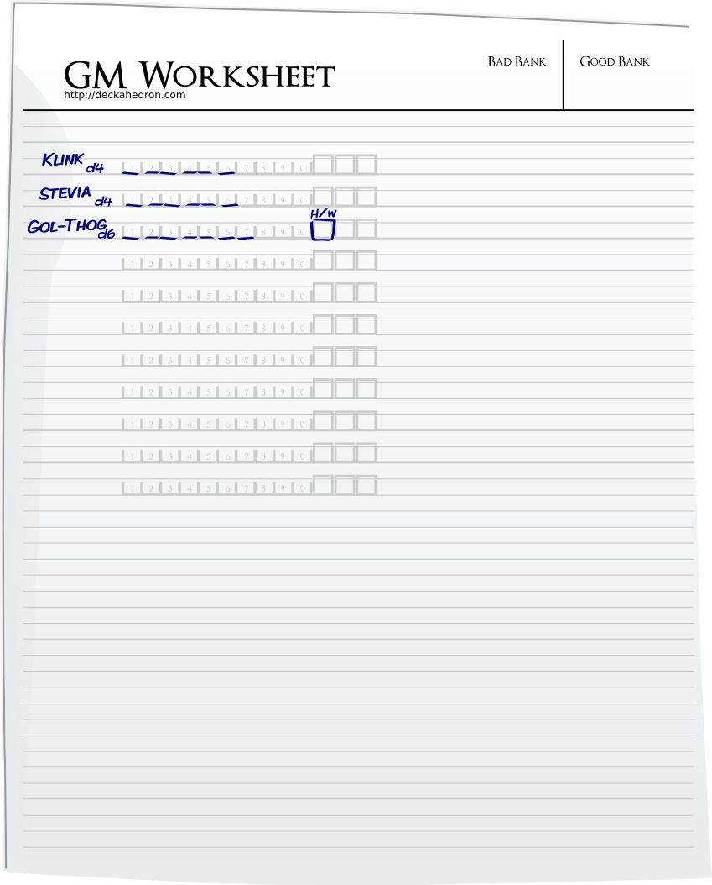
GM Worksheet
Armour squares are a mechanism for foes that work similar to the armour or wound mechanisms for PCs. Whenever a foe is facing any amount of attack power, the GM can just cross out an armour square to absorb the full amount.
When attack power goes above d4 or armour squares are added, spend Shadow points according to this table.
Shadow points | Foe augmentation
1 per | armour square (maximum 3)
2 | attack power d6
4 | attack power d10
1 | monster has 11-15 stamina
2 | monster has 16-20 stamina
1 per | monster special attack / immunity

Foes' Stamina and attack power should be realistically scaled to the "scrappy adventurer" level of the players. Help the players estimate the threat they face by giving the foes fitting descriptions. This table should help.
 | Stamina points | Attack power
Children | 2 | 1
Civilians | 4 | 1 - 1d4
Bouncers, Guards | 5-6 | 1d4
Trained Soldiers, Elite Guards | 7-10 | 1d4 - 1d6
Monsters | 5-20 | 1d4 - 1d10
Villains | 5-10 | 1d4 - 1d10

Generally, human opponents will have 1 attack power when unarmed and 1d4 attack power when armed. Save greater attack power for monsters and special villains.
Remember that foes' power can be exerted in more ways than just their Stamina and attack power. Challenges may arise from the antagonist's superior knowledge of the environment, magical abilities, political connections, or other types of fictional positioning.
As you spend more time playing, you will find it faster and easier to create these encounters and write up the stats in the GM Worksheet. If the players at your table are signaling that they enjoy the challenge of combat encounters and mastering the combat mechanisms embodied by their characters, then you can use the appendix Mathematical Combat Balance to create encounters that are more objectively balanced and satisfy the type of player that delights in system mastery.
However, If all that math feels a little too "gamey" for your table, just wing it. Create encounters as demanded by the established fiction, or take the following pre-balanced examples as a starting point, and adjust as you please.

Example combat encounters

Easy - A pair of guards taken by surprise
TODO: illustration
The PCs way is blocked by a pair of guards who are sleeping or distracted by a game of dice. They have 6 stamina points, and short swords (1d4 attack power). As long as the PCs don't bungle their approach, they will have an opportunity to attack first or attack from range.
If the guards believe they have no hope of winning, they will flee or give up and beg for mercy.

Medium - A lieutenant and his soldiers
TODO: illustration
The PCs turn a corner or open a door and stumble into a planning session presided over by a lieutenant and his subordinates (there are as many subordinates as there are PCs). They are the swords-first, questions-later types and attack immediately at close range. The 3 soldiers have 6 stamina points and do 1d4 attack power. The lieutenant has 8 stamina points and has one armour square.
The lieutenant will never surrender, but if the rest of their allies are cut down, a single soldier left standing may lose his nerve and give up.

Hard - The swamp beast
TODO: illustration
The PCs are surprised by a thing that springs up from the muck and launches a surprise attack.
The beast is introduced when a player flips an , so the GM makes the "Escalate the danger" move and additionally deals 1d4 damage to one of the PCs as the beast makes glancing contact with its fierce claws.
This thing fights to the death and has 12 stamina points. It bites and slashes for 1d10 attack power.
Special attack: the beast can disappear into the muddy terrain and later spring up behind the most vulnerable PC, as long as that PC is standing in the beast's territory.

Give hints
Players will perceive the game as either "fair" or "unfair" partly based on how the foes are described by the GM before the combat begins. Always describe the confrontation in a way that hints at the difficulty.
- The two guards exchange an unsure look and step forward
- The salty pirate flashes his blade, but simultaneously takes a step backwards towards his ship
- The golem is gargantuan and covered in scars from many battles
- The horde of undead wolves stare at you with unrelenting hunger
- The old woman with the walking stick is unfazed by your threats and, after looking you up and down, turns away with an air of dismissal

The feel of combat
In combat, it's ok if play gets more formulaic. Some players enjoy the "abnegation" of a tit-for-tat combat scene that lasts tens of minutes. This can be a combination of exciting and relaxing. Give your players opportunities to press their favourite buttons.
That said, some players don't seek abnegation. What kinds of signals are your players giving you? Maybe they want to get through combat faster. If so, when you make your moves, you can think cinematically. Continually raise the stakes for both sides during the scene. Think dangerous. No character or set piece needs to be safe or sacred.

The Combat Spotlight
Combat can play out in whatever way feels natural and follows from the fiction. That said, it can be taxing on a GM to come up with new, creative responses in combat because flips are happening frequently. So, to relieve some of that pressure, here are some formats to follow that guide the table through a combat encounter.
This game doesn't have turns, but it's ok if moving the spotlight during combat makes it feel that way.

Format 1
This format is simple, and gives the players the most agency.
- Give each player a "turn" where they will probably trigger an aggressive combat move like Mix It Up or Volley
- Pay attention to FAST combat moves that may have triggered
- Execute the moves, make cool stuff happen as consequences
- Go around the table until all the opponents flee or are incapacitated
- Any results may usually be interpreted as "your enemies attack". Choose some opponents that weren't just in a Mix It Up, and declare they attack one of the player's characters. Apply attack power against that character. Use an attack power die from one attacker, and add 1 attack power for each other attacker

Format 2
This format makes the opponents more of a threat.
- Give each player a "turn" where they will probably trigger an aggressive combat move like Mix It Up or Volley, call that a "player round"
- Pay attention to FAST combat moves that may have triggered
- After player turns are complete, and the players look to you to see what happens next, execute an "NPC round"
- Identify the opponents that didn't interact during the "player round"
- Describe how all of those opponents team up on one of the player's characters, and call for one Defy Danger flip. (move the "danger" spotlight fairly, but also try to put pressure on any players with more than 3 unspent XP)
- Failing the Defy Danger flip results in the player's character suffering the opponents' attack. You can calculate attack power thusly:
  - : one attack power die from the lead attacker, and add 1 attack power (not die) for each other attacker
  - : no attack power die is rolled, but 1 attack power per attacker (so 3 foes = 3 attack power)

Format 3
This format imagines the opponents as particularly quick and aggressive.
- Give each player a "turn" where they will trigger a move
- Pay attention to FAST combat moves that may have triggered
- When describing the outcome of a player's move, also describe how the opponents take aggressive action.
- Keeping the spotlight on that player, have them respond to the actions of their foes, usually by needing to follow their first flip with a Defy Danger flip.
- Allow players to avoid the opponent's aggressive action if their first flip specifically provided for it, and it makes sense in the narrative. (See Backstab, Bum Rush, Volley)

Your Format
These combat format suggestions are just that - suggestions. Players often think up creative solutions or approaches that you won't have predicted beforehand, and that might break one of the above formats. The key is to be true to the established fiction. Also realize that you have power to introduce facts into the fiction. For instance, by the GM move you choose in response to player's failed flips.
A GM's role is not to be the opponent of the players. You're not trying to make their characters die. On the contrary, you should be a fan of the characters. The best story is one where they struggle, but succeed.

Loot
After combat, the players may propose that their characters sift through the battlefield looking for valuables. Let the characters find whatever you think would be most fun, or something inspired by the Touchstone List, or ask the players questions to figure out what boons or treasure were won from their adversaries.
Sometimes nobody will have a concrete idea of what the loot was, and that's okay too.
If the characters slay a pack of werewolves, and then search the bodies, and the table can't immediately come up with an idea for what beneficial gear was dropped by feral, nearly naked humanoids, you can write "What we found on the werewolves" on a blank card, and give that to one of the players.
Later in the game, when the rules demand Item or Pack cards be spent, the "What we found on the werewolves" card may be spent, if the players can justify it. It can even be considered precious if the fiction supports it.
If the loot is a weapon, its power should not be greater than the most powerful weapon a party member already possesses, unless it is the weapon created by the Tales of a Weapon move. If the loot has a magical effect, it should only have charge capacity of 1.

Session 2 rules

Prepare
Before your next session starts, you should run through the events of the previous session in your head. Think especially about signals you got from the players. What kind of fun did each player seem to seek out or respond to? Was a player particularly keen to create backstory, to get into combat, to ask a lot of questions about how the world works? Can you think of things to go into the next session to provide that kind of fun?
Think about the plot and how you might get your next couple Journey points. Do you think the characters will make certain decisions? You might imagine 2 or 3 key decisions the party will be confronted with. For every fork in the road, try to imagine how the world and NPCs will respond when the characters choose either branch.
That's important. Prepare for either case.
There is no correct answer for the characters. Never punish a player for making a choice you didn't expect.
Being prepared is different than having a plan. No game ever goes according to a plan.
The purpose of preparation is to use your imagination to assemble a cabinet of narrative spices. At the beginning, you won't know if you're baking a pie or a casserole. You don't even get to see the recipe upfront, it is slowly revealed to you as each ingredient is added to the bowl. Have some cinnamon and sugar ready, but also have some salt and chili powder.
Wait until you play to find out the details of what happens.

Special Move: The Session Opener
From the second session onward, there is a special move that happens once everyone has sat down to play.

Story Recap
First make sure everyone is on the same page. Remind the table of the details of the setting and the characters. Ask the players about what they learned about the world or to remind the table of a way their character's expressed their personality in the last session. Give your recounting of the events that happened in the story so far.

Ask for Notes
Lead each player through a quick check-in. Everyone, including the GM will ask if there's any way they could improve their style of play.
Each time we start a new session, there's going to be an opportunity for players to ask the table how they can make a bigger contribution to the fun.
I'm going to give each of you a turn, and if you'd like, you can "ask for notes". You are free to skip it, but this is a great opportunity before you get into character to see if there's anything about your play-style or any choices your character could make that would amplify the experience for everyone.
When asked to give someone feedback, answer honestly and gently. We are giving suggestions for improvement, and these suggestions can be taken to heart or completely ignored. No response is ever required of the person asking for notes.
Never say "you are having fun wrong". It's better to say "There are more fun parts over here if you want to take a look".
After everyone, including myself, has had a turn, all the players get a free experience point for participating in this exercise.
This move's purpose is to practice an open dialogue and help everyone improve their play. If it feels like bargaining, argumentation, excuse-creation, litanizing of sins, the move has not been executed correctly. Just take a deep breath and move on.
GMs should particularly try to improve their ability to listen for signals. Tell players about the content you added last session in response to a signal you got from them. Ask what signals you missed.

Give Notes
Look at your Touchstone List. Is the group playing the setting and the themes and tones you all wanted when you started? Use this either to re-focus player decision-making, or to discard / add titles on your Touchstone List.
If the players are consistently mis-interpreting a rule or forgetting to use rules when they have an opportunity, now is the time to call those out and answer their questions.

Frequently Given Note: Create Advantages
New players may especially benefit by being reminded about creating advantages at the beginning of their 2nd session.
After session 1, the players may be realizing that they fail often -- more than they'd like. Take the opportunity to talk about the odds, and what a player can do to improve them.
Some psychological studies have shown that odds feel "fair" only when players get wins 60% of the time. Now look at the Deckahedron statistics reference. You'll see that if your players are mostly doing standard flips (flips without advantage), they are likely to feel the game is unfair.
Explain to your players that getting good outcomes often requires creating advantages. There are built-in moves like Discern and Defend that can be used to create advantages. Explain each one of these moves. Discern should be particularly encouraged if you'd like more opportunities to describe the world, environment, and NPCs that you're creating.

Frequently Given Note: Try Wild Moves
When you begin your 3rd session with new players it might be a good time to remind them that they can literally try any of the moves that have Dex, Int, or Str printed at the top of the card.
Even if they don't have the card, they can trigger a move by describing their character taking that kind of action.
They might even discover their character is good at it (via a Critical Flip).
Another good hint for your players is that a good time to try moves wild is when they've built up a +2 advantage.

Other Frequently Given Notes
Generally, the Session Opener can be used to help the players absorb more of the rules. As the game progresses, their characters will open up new ways to be more competent and have a stronger impact on the game world.
This is often a time to open up the Player's Guide and look at one particular section. Give the players all the details of one small section and answer questions.
Examples:
- Gaining new moves
- Increasing move levels
- Getting items with More Power
- Collecting green rings to earn Level Cards

Apologia
After running through the events of last session in your mind, you may realize you're painted into a corner. When the characters are in a situation where you can't imagine a way to keep the game exciting, you need to have a conversation with your players.
This is a shared narrative, so it's allowed to retroactively edit. Collaborate. Get consent.

Ceremonialize
If your gaming session includes food or drink, the Session Opener can be ceremonialized by refraining from the first bite or the first sip until the Session Opener has been completed.
Another idea to add some ritual is to start some exciting, adventure-appropriate music when the Session Opener concludes. Video game soundtracks, or a soundtrack from one of the titles on your Touchstone List are great for this.

Reward Yourselves
If every player has had a chance to get satisfactory feedback it's time to dole out XP. Give a new one to each player.

The Core Game Loop
This game has 2 main types of activities, "downtime" activities, and "adventure" activities. The game transitions from downtime to adventure and back again to downtime, repeating in a "loop".
Adventure activities involve risk, exploration, and confrontation. Adventuring will incur costs on the characters in the form of injury, damage to items, and spent magical charges, but it will also let the players build up resources like XP and loot.
Downtime activities are less risky. In these activities, the costs and benefits are known upfront, like shopping, healing, and studying. When injuries and treasures have built up, the players will seek a town (any place whose inhabitants offer services and trade) to salve their hurts, exchange their loot for exciting new gear, and learn new skills. With that done, the players should be hungry to put their new skills and gear to use, and thus head out again for adventure.
Each transition gives the GM a lot of opportunity to shape the narrative, so when possible, these transitions should be exploited to earn a Journey point.
The core loop is not a rule, nor something a GM needs to enforce, the incentives built into the game should cause it to happen naturally.

Downtime
If the characters are not in a town, the moves available during downtime are:
- Rest
- Sharpen and Stitch
- Seek Help (only if it makes narrative sense)
- Tales of a Weapon
In a town, these moves are also available:
- Study Under a Master
- Shop / Procure
- Obsessive Contemplation
There is an important choice that a player must make during downtime, and that is, what to spend their time doing. Their character can't do everything in one day. In particular, in one day these moves are mutually exclusive:
- Rest
- Study Under a Master
- Shop / Procure
- Obsessive Contemplation
Additionally, Sharpen and Stitch can only be done while resting, so it is effectively mutually exclusive with the latter 3 moves.
If the GM wants to give the players' characters a second day in town before any action takes place, a Journey point must be spent.
Otherwise, on the second day, the GM should present some situation that demands immediate attention. Put something at risk if necessary. Remember, this is a world of danger, nothing is safe or sacred.
The players may still ignore the situation and keep performing downtime moves on the second day -- in that case, narrative consequences should be honestly described. What opportunity has been forever lost? What did the evil forces accomplish because the heroes ignored them?

Adventure
The adventure activities are where the players' characters take risks and get into conflicts. To get out of their literal comfort zone, they must have motivations.
If the players at the table are not yet inventing their own motivations for their characters, Fateful Moment cards can be assigned again -- when the transition from downtime to adventure happens, choose Fateful Moments using the procedure described above. (If they still had a Fateful Moment, the new Fateful Moment replaces the old)

Using Journey Points
Journey points are used to create certain kinds of "Deus Ex Machina" situations to benefit the players' characters.

A Second Day of Peace
In order to give the players' characters a second day of peace and quiet in a town, so that multiple time-consuming downtime actions can be made in a row without any bad consequences happening in the narrative, a Journey point must be spent.

An Unexpected Arrival
When the players find themselves in a situation that looks dire:
- There's no hope and no way out
- They're surrounded and outnumbered
- They've lost the majority of their Stamina points and the foes in the scene are still healthy and looking to fight
- The villain's plot is a hair's breadth from completion
- There's a puzzle they need to solve, but haven't got a clue
Spend a Journey point to have an allied NPC enter into the scene, just in time to save the day or spoil the plot.
The NPC should be someone (or some thing) the PCs have met before and who has an honest reason, based on the fiction, to assist the PCs.
This could be a love interest mentioned in someone’s backstory, a local page boy from the last town, or a double-crossing wizard who had a change of heart. Their arrival changes an otherwise established fate, a victory or defeat.
If combat is underway, as you move the combat spotlight around the scene, the NPC should get a turn to act as often as a PC. However the NPC does not trigger moves, so each turn in the spotlight is limited to a few possible actions:
- The NPC may assist any player character's attack, adding an appropriate die to the attack power
- The NPC may get into a scuffle with one foe, effectively preventing that foe from acting as the combat spotlight moves around
- The NPC may convey or reveal information valuable to the players

Brought Back to Life
If a PC dies, you may spend a Journey point to bring them back to life.
You may not resurrect PCs without spending a Journey point.
Take care to be honest to the fiction. Try not to degrade or insult any emotional journey that the death provoked.
Resurrection can have many forms.
Resurrection can come at a high cost.

A Heroic Spark / A Place Transformed
These two are variations on a theme of change, and so are best suited for the final chapters of the story.
Let the players see the ways that their scrappy-adventurers-turned-heroes have impacted the fantastical world around them.

A Heroic Spark
The heroes have made an indelible mark on the life of someone they encountered, we see the seed of heroism planted in that individual. We know that their destiny is forever altered.
- A young girl practicing with the signature weapon of one of the PCs.
- Townsfolk singing the song of The Hearth with a new verse inserted - a verse about the escapades of our heroes

A Place Transformed
Somewhere previously visited is now magnificently and symbolically changed. This is an opportunity to demonstrate the scale of the PCs actions.
- A once-oppressed hamlet now rebuilding and revitalized.
- A lich king’s castle repurposed as a friendly settlement.
- The forest that was being decimated now verdant with a new kind of tree, that had never been seen before.

Reveal the Hearth
In the 9 and 30-hour campaigns, there is a special GM move called Reveal the Hearth

Using Shadow Points

Fictional Disadvantages
In real life, some actions are more difficult than others. The GM has some tools to reflect this in the game.
There are strict rules. Be realistic and work within the boundaries.
Let's say the party of adventurers is in a dark cave at nighttime and no torches are lit. A multi-winged bat creature swoops down at them, claws slashing. The first player declares they're going to dive out of the way (Defy Danger with DEX). Because of the set-up, it makes sense that this will be more difficult than if the character could clearly see the creature and the cave floor they're diving into.
- You can spend 1 Shadow point to create one level of disadvantage
This level of disadvantage should now be applied consistently whenever any character attempts to avoid the creature's swooping attack in a dark environment. No further expenditure of Shadow points is needed.
Consistency prevents players from feeling the game is unfair or that you are especially aiming negative consequences at one player.

Traps
When the characters are investigating a set piece or entering a new area, it can be trapped to cause instant damage. Inflict damage equal to the amount of Shadow points spent.

The Enemy Strikes First
When an enemy surprises or was otherwise ready for a PC, they can attack without giving the player an opportunity to Defy Danger. The attack power will be equal to the amount of Shadow points spent.

Deadly Pursuits
When a player uses the Bravely Run Away move, spend 1 Shadow point and either:
- land them in a situation where they are again in immediate danger
- start the Pursuit Mini-game

Augmenting Combat Encounters
As specified in the Combat chapter, Shadow points can be spent to increase attack power dice, add armour squares, and outfit fear-inducing monsters.

Creating Challenges for Players

Puzzles
Puzzles are obstacles described in the fiction that are overcome with cleverness. The cleverness can come from the players, by analyzing the facts of the situation out-of-character, or the cleverness can come from the characters, by their fictional actions and by using moves like Discern and I Know This.
Here are some things to think about when presenting a puzzle in your game. (with thanks to The Art of Game Design by Jesse Schell)

Goal
The puzzle's goal should be easy to understand, and the players should be motivated to solve it. Use human instinct and familiar artifacts.
- an obvious symmetry is broken
- pieces that should line up are askew
- a pattern has an interruption
- a narrative cliche is slightly off

Ramp
Make it easy to get started interacting with the puzzle. The players should want to examine and touch the mechanisms that solve it.
Does it look inviting to touch? Does it look attractive? Does it look like something they've seen before? (This might be an opportunity for I Know This)
Don't make it dangerous to interact with. The danger should be in not interacting with the puzzle.

Progress
How is progress visible when they are interacting with the puzzle? Consider the difference between a Sphinx-like riddle and the game of "20 Questions".
What feedback is given when they are making positive versus negative progress?
Can you introduce sub-elements of the puzzle the players can act on while they're stumped on a larger element?

Stumps, Hints, Giveaways
If you make a puzzle, you must be prepared for your players to be stumped.
Know beforehand a couple ways that hints will emerge. Your tools of narration can include more than just plain visual descriptions. You can use NPC dialogue, move "the camera" and engage all of the senses.
Lastly, be open to simply give away the solution. Giving away the answer still lets players have "Aha!" moments.

Monsters

Monsters are part of the fiction
Monsters represent something about the theme, usually the fear that must be overcome, or the anti-premise.
If a monster is used as the threshold guardian during the Return chapter, it should be a realization of the Big Fear of the story, or the anti-premise. If the players cross the first threshold on the premise of "We will save the village", the monster should be the thing that will destroy the village and many villages after it. If the premise is "We will return richer than the king", the monster is the thing that destroys the concept of wealth, maybe by turning the surface of the world into a hellscape where the only currency is suffering.

Monsters are puzzles
Monsters are puzzles that can be brute-forced with violence. Monsters have a weakness or a preferred strategy. That may also include something about the environment in which the monster is encountered or interesting items the characters have previously acquired.
Be ready to follow the fun. A monster's weakness might be something that a player invents that you weren't expecting!
For a threshold guardian monster, blocking the characters' escape out of the unknown world, the weakness or successful strategy should demonstrate the change integrated by the heroes during the Find chapter.

Monsters can be fought
Monsters can be defeated in combat, and work like regular foes, except that they can have more than 10 stamina points and they have special attacks and special immunities. See the Combat chapter for how to spend Shadow points to determine its combat stats.
You get to choose the special attacks and immunities of your monsters. Simplicity and staying on-theme are the way to go here. If your monster is inspired by an animal, ask yourself how that animal would attack in a unique way. If the monster embodies a specific fear, what attack would induce the maximum amount of that kind of fear?
It is recommended to telegraph the special attacks and immunities somehow. Let the players know what kind of threat they're dealing with and the stakes of their decision to fight this creature.

Making monsters
The easiest monsters to include in your story are ones you've already seen before. Look at your Touchstone List -- what can be plucked out of one of those universes and dropped into the path of the adventurers?
Otherwise, it can be a lot of fun to invent your own. Monsters can be generated by mixing two or more concepts, as long as one of those concepts invokes fear.
- giant
- tiny
- multiple
- airborne
- you know it's there, but can't see it
- seeks out your nostrils, eyes, ears
- constricting
- drowning
- surrounding
- fire
- blood
- amputation / missing parts
- sharp or thorny
- fat
- related to corpses or rot
- related to excrement or egg-laying
- signs of disease or infestation
- evoking mucus or slime
- ancient
- brainless
- holes
- beyond comprehension, mind-bending
- taboo or forbidden
- wet and against your skin
- soulless mimicry of human behavior or appearance
- drains potency or causes sleep

Any animal, but especially ones humans are instinctively afraid of
- scorpions, spiders, mosquitoes, wasps
- wolves, jackals, big cats
- elephants, rhinos, hippos
- birds, bats
- crocodiles, alligators
- snakes, eels, worms
- cephalopods, jellyfish
- sharks, killer whales
- lizards, dinosaurs

For a "classical" effect, mix up two or three of the animals - eg, a snake with the wings of a bird, an octopus with scorpion tails for tentacles.
Some monsters are scary because they include an aspect of goodness, nobility, or innocence. This can emphasize corruption, be used as a trap or a trick, or just create contrast.
- babies, children
- gold, wealth
- sexual attractiveness
- mimics a character they love / admire
- religious symbols
If you want more inspiration, there are many great resources in books or on the Internet. Here's a very small sample:
- Dungeon World
- Hot Springs Island
- Carried by Creatures

Villains (aka "Bosses", aka "The Big Bad")
A villain or arch-enemy is not necessary, but can be a very useful tool. Having one "mastermind" behind all the badness in an adventure creates a very focused point of attention when the characters make decisions about what to do next.
Villains have desires. Usually a desire is fundamentally simple, but a story is interesting (and provides more interaction options for the players) if the means to achieve the desire is complicated.
Voldemort wants control, but doesn't run for office, instead he hides 7 horcruxes behind monsters and puzzles, then buries himself as a parasite underneath his sycophant's turban.
Darth Vader wants order, so must build a moon-sized laser beam, blow up all the rebellious planets, promote and demote military subordinates, and convince his estranged son on the value of theocratic rule.
Some fundamentally simple desires:
- freedom
- revenge
- orderliness
- control
- love / infatuation
- satiation
Other useful ideas for villain desires can be found in the Hooks section.
Think about your villain as a full person. You will have to improvise their actions and decisions, so use empathy. Are they driven by reason, dangerously erratic, or myopic and compulsive? When you know who they are, and how they make decisions, you will be able to quickly make calls about how they react to the player-characters' actions.
A meaningful villain often represents a mirror image or "shadow-self" of the story's heroes, with the thematic difference being that the villain stays constant, rejecting the change that a hero must accept to truly be a hero.

Signals From Players

Your job as a GM is to listen and look for signals from the players about what kind of fun they want to have, and then to insert that kind of fun into the game.

Signals From Components
An easy signal to notice is the physical material sitting in front of each player. If it's in front of a player, their choice has put it there, and players want their decisions to matter.
Look at the Dex, Int, and Str on a player's character sheet. Is the fiction providing opportunities for them to use their greatest attribute? Are there opportunities for them to get into trouble with their weakest?
What move cards and items are sitting in front of a player? Are they getting opportunities to use them all? What kinds of names have been written on the items? Have they sketched or doodled on the cards? How can those names or drawings be used to amplify themes or tones of the narrative?
What is the state of a player's Deckahedron and XP? Is there opportunity to play with the tension of stamina and wounds? Is the player waiting to spend XP during epic action sequences?

Subtler Signals
Catching signals is different for every GM. It's a skill that develops with time and its never expressed in quite the same way. Being sensitive to your friends' behavior can help you catch signals that are much less explicit than the physical components.
The most obvious thing to pay attention to is body language - how is a player holding themself? Are they smiling? Laughing? Do they become animated when they describe their character's actions or when they act out dialogue?
How long is a player taking to make a particular decision? A long duration often indicates that the decision is important to the player, so agree with them by creating big consequences from that decision. Keep the other players in mind though, when one player is taking a while, gauge how the delay is affecting others at the table.
Do the players argue with each other? Argument indicates that they believe that there are important stakes of a particular decision. This can be a tricky social dynamic to navigate. As long as arguments stay friendly, a great way to use this signal is to cement those stakes. The good thing happens, but the bad thing happens too. The price is paid. Someone wins, someone loses.
This is just a brief list of suggestions. There are more signals and more ways to interpret them. Also, people will change during the course of the game -- it's an ongoing conversation. Remember, you can always ask players questions. Your table is unique, and you're all working together to create the kinds of fun that are most rewarding.

Campaigns

In A Thousand Faces of Adventure, there are 3 different kinds of Campaigns:
- One-shot (usually 3 hours)
- 9-hour
- 30-hour
The stories you will tell by playing A Thousand Faces of Adventure are told in 3 parts: beginning, middle, and end.
If you've played other RPGs that don't have endings, ones that go on for months or even years, this might seem weird to you. Don't worry, try out a 9-hour campaign and see the results. You may find your doubts erased.
This game is designed to tell a particular kind of story. It's called The Hero's Journey.
The Hero's Journey is a skeleton upon which many successful and popular movies and books are arranged: Star Wars, Lord of the Rings, The Breakfast Club, Die Hard, Beowulf, Forgetting Sarah Marshall, the list goes on. To help you execute a successful and popular campaign, the GM is given Journey points and Shadow points and specific rules for using them.
The main premise of The Hero's Journey is, characters start out in a figurative "ordinary world", they go to a "mysterious world", and finally, they return.
As you and the other players create the narrative, you will have opportunities to shape events. You decide how the world and the NPCs react to the actions of the PCs, and you have the freedom to describe the "meanwhile" -- all the goings-on "off-screen". Use these powers to pull the narrative into a multi-chapter structure, and in each chapter, try to earn Journey points.
The players may just be along for the ride, or they may also want to delve into The Hero's Journey. Be on the lookout for how they signal that they're into this kind of fun, and use what they express about themes, relationships, emotional tone, conflicts, and backstory to co-create the journey.

It's ok to skip it
You don't need to get every available Journey point. You should especially not try to force it if doing so would sacrifice fun for the players. Remember, you're not the only author of this story, and while earning points feels nice, you've got other jobs too, like paying attention to the signals the players give you about the kind of fun they want to have.

It's ok to end it
You may find that you and the players have collectively gone as far as you can. Maybe you've reached the deepest, darkest part of the adventure, and the characters decide to stay and call it their new home. Maybe they find a way to destroy something you thought would be permanent, or make permanent something you thought would be temporary, and that changes the whole conflict structure of the story. Maybe they found a shortcut or outsmarted the Oracle.
Maybe they all died.
Take a break and ponder. Sometimes you can think of a way to reinterpret events or move forward with themes while abandoning specifics. Sometimes you can take a subplot and move it to the forefront.
But sometimes the choice that provides the most fun for everyone is to just admit that it's over.
Getting Journey points is great, but the reason everyone is here sitting around the table is to have fun.

It's ok to blend it
The boundaries between chapters do not need to be strict, explicitly defined lines. There may be a natural blending between two adjacent chapters as you and the players set forth the narrative.
For example, It's common for the 9-hour Campaign to blend chapters 5 and 6. Maybe the treasure of the dungeon is glimpsed, then the ordeal begins, then the ordeal gets really serious, and that's the point to really plumb down to the "dark night of the soul", fully reveal the treasure, and then emerge to complete the ordeal.
Even when there is a threshold, as in chapters 3 and 7, the different players' characters might cross over at different times.

The lengths vary
The final chapter might go very fast, or it might be a long journey home. The first threshold might be crossed so fast that you only notice after the fact. Taking the prize might involve a twisting road of trials, or it might be one explosive boss battle.
Let the story be what it must be, and play to find out the details of what happens, but also take your opportunities to earn Journey points when they arise.

One-Shot Campaign
- Start in a place of normalcy / comfort
- Cross a threshold with a true choice
- Take a thing and pay its (mortal?) price
- Return to the surface, changed.
In a One-Shot campaign, there are 4 potential Journey points to earn.

Chapter 1: Start in a place of normalcy / comfort
The first Journey point is a "gimmie": If you can think of a way to start all of the PCs in their place of normalcy or comfort, gain a Journey point. You did remember to do Step 10 in the Character Creation chapter, right?
Give the players a chance to establish what "normal" is for their characters. This is an environment that they can manage. They know what to expect here, and to survive here requires no fundamental change on their part.
Here, the players can get a feel for taking actions and having some dialogue in-character. Perhaps they have some interactions with NPCs familiar to them. Perhaps they describe their character moving through the environment and pointing out specific details. Perhaps the characters get into conflict: social, or physical.
As you are playing this out, you should be looking out for two things:
- Opportunities to establish a need that will move the story to Chapter 2
  - signs of an approaching threat
  - what about their home annoys, frustrates, or stifles them?
- A premise. Listen for a statement or action that asserts a fundamental truth
  - "Nobody bakes a pie like Herbert"
  - "Shelbyville thinks they're so great, but really, they stink"
  - "I'm just a Hobbit, I can't steal from a dragon"
  - "Things will go on like this forever"
  - "As long as there's a tree to climb, I don't have to worry about wolves"
  - "If only you could see things from my perspective"
You should make a note of any premise, so you can use it later when creating puzzles, monsters and villains.

Chapter 2: Cross a threshold with a true choice
As the game progresses, the conversation at the table will start establishing details about the world and about relationships between characters. Find areas of tension and try to develop that tension. Push characters into discomfort. Raise the stakes. Then look for a threshold. Look for some line that, once crossed, they can't simply turn around and go back. They might enthusiastically seek it out, they might even cross over before you've figured out what it should be (if so, all that's left for you is to mark yourself a Journey point). But you might also need to increase the pressures in their "home" to gently nudge the characters up against that threshold.
But, if you want that Journey point, don't push them through.
See if the players choose to step their characters through the threshold. If all of them cross the threshold and step away from their ordinary world into a mysterious world of danger and adventure, gain a Journey point.

Hooks
A common way to get players to choose to go through the threshold is to create a "hook". Here are some things to think about to help you invent a hook:
- Capture, Obstruct, Prevent
  - What is "loose" and causing trouble?
  - What is in the wrong hands or needs to be brought back into the fold?
- Chase or Race
  - Who else has already begun seeking out the prize?
  - How long until a threat arrives here?
  - How might the hunter become the hunted?
- Rescue or Regain
  - Who or what was taken, and where does it rightfully belong?
  - What power does the precious thing posses?
- Re-order, Rearrange, Fortify
  - What is unbalanced, and what effect does that have on the world?
  - Who is not doing their job?
  - What special protection needs to be put around The Hearth?
- Forbidden Act
  - What is the rule that must not be broken?
  - Who forbids it?
  - What power structure does the rule support?

Chapter 3: Take a thing and pay its (mortal?) price
Give the players an opportunity to earn something epic for their characters. It can be a great treasure, it can be fame and renown, it can be weaponry, a magical boon, the elusive respect of an NPC, it can even be self confidence. It can be an appreciation for the power of friendship. (Pixar and Disney have some incredibly well-done Hero's Journey stories.)
It's important not to create a prize that just seems cool to you, the GM. The prize should follow from the fiction. It should be something that is actually wanted or needed by the players' characters. Pay attention to them, they are the protagonists in an odyssey. What would be miraculous for them to receive?
Maybe you don't have to create the prize at all. What have the players been talking about, is there already a specific goal? What themes have already emerged through the action, dialogue, and relationships?
Put that prize in a terribly difficult location.
It could be at the end of a road of trials, or inside the cave where they must conquer their greatest fear, or in the clutches of their most powerful adversary.

Allot Shadow Points
Whatever the fictional set-up, when you're ready, set up a challenge in the narrative, then draw a circle around all of the Shadow points and use them all before the characters get a chance to Rest.
If you can do this, when they complete the challenge that used up the last of the set-aside Shadow points, give them the prize of this mysterious world and gain a Journey point for yourself.

Death Is Real Here
This is the chapter of the game where characters are most at risk to lose all of their Stamina points. In other chapters of the story, the GM may choose to narrate this as unconsciousness, imprisonment, or something else that the character will naturally recover from.
But not in this chapter.
If the character loses all their Stamina in this chapter of the story, the GM should represent this as "death". Sell it as a permanent removal of the character, and by extension, the player from being able to impact the events of the story.
Don't make this a downer for the player though. Make the death epic. Give the character a final stand that saves the day, or gives the other party members a chance to survive an enormous threat. A moment of tremendous, meaningful sacrifice. Look for what the character symbolized, or what niche they filled in the party's personality, and amplify that symbol or personality aspect to be everyone's salvation.
Also realize you can give them a second chance at life. If you don't want a gritty, hardcore vibe in your campaign, you don't have to let the death stand. For rules on resurrection, see Using Journey Points.

The Prize
The "prize" can be something completely related to the narrative, or it can invoke the mechanisms of the game, or both.
In giving the characters the prize, you may "break the rules" by removing a cost or condition.
So, for example, you may declare that the characters do not have to be "in a town" to execute the Study Under a Master move. Or the Tales of a Weapon move may be skipped to award the characters with a powerful weapon.
This relaxation of the rules only applies to Chapter 3, and should be narratively justified.

Chapter 4: Return to the surface, changed.
In the final chapter, find a way to return the characters "home". It need not be their literal home, nor does it need to be where the adventure started, geographically. The important thing is: at this stage in the narrative The Hearth is available again.
You are free to "re-imagine" The Hearth here. If it was previously the song of the Wood Elves, it can now be the song of the Iron Gnomes. If you keep the emotional core the same, you can change superficial details. But give the players enough superficial hints to recognize it.
The heroes are "home", but they are changed. They have been on an adventure, seen things, done things. They are now masters of a new way of existing, unafraid of crossing into the previously "alien" world.
By dialogue or action, each player character should exhibit their change.
This can play out in many ways:
- by using their newfound power to deal with the bullies that previously tormented them
- though they dutifully swore to their holy order to keep this quest secret, when they travel back through the badlands, they share the seeds of the foreverfruit with the impoverished village that showed them hospitality
- by not screwing up for once in the eyes of their family, and delivering the elves' ointment to cure their grandfather of Medusa's curse
- by re-igniting the war as they were bade, like a good soldier, but then returning to challenge their clan-lord for leadership
- by being cast out of yet another city, but this time they're on the road with mirth in their step and a horse pulling sixteen barrels of mead
Gain your final Journey point if you can hit this note.

9-hour Campaign
The 9-hour Campaign is a bit more complicated. Committing these 8 points to memory will make it go a little easier:
- You
- Need
- Go
- Search
- Find
- Take & Pay
- Return
- Change
(this compact formulation is inspired by Dan Harmon's "Story Circle")

Chapter 1: You
AKA: Start in a place of normalcy / comfort
In the 9-hour campaign, start the game just like you would in the One-shot campaign. See Chapter 1 of the One-Shot Campaign

Chapter 2: Need
AKA: Call to adventure
In this chapter, the characters still feel safe, but discover that there is something they need to do soon, or somewhere they need to go. This is also a great chapter for the characters to express premises.
This chapter is an opportunity for players to elaborate their characters' relationships, interests, and skills. Provide a sandbox to play in, let the players establish what their characters value here in the sandbox. Try to give them some choices that express themes of the Touchstone List. Will they choose harmony over freedom? Freedom over peace? Peace over progress?

The Threat
While this is playing out, reveal that something valuable is threatened. This valuable thing is often The Hearth itself, but it could be many things, up to and including the known universe. If you are ever struggling to decide, just choose The Hearth or ask the table.
The threat might be revealed by an NPC that acts as a "Herald". This is someone that appears with a message about something from the mysterious world where it is dangerous to venture. Usually this mysterious world or one of it's denizens is the force behind the threat.
- The village medium
- A raven arrives from the neighboring kingdom
- A ragged wanderer appears out of the wilderness
The threat might be revealed by using the game rules and playing out a challenge that the PCs cannot yet overcome. If this plays out as combat, be honest about the size of this threat - the PCs may fight something they cannot subdue. It may result in their defeat and incapacitation.

The Mission
Establishing the need serves a purpose for both the narrative and for the game. The characters need the things they will get when the players play the game.
- Maybe the characters are defeated in a first encounter
  - The players need more power, in a broad sense
- Maybe a spell or skill would exploit the threat's weakness
  - The players need more moves / items
- Maybe characters' knowledge is lacking
  - The players need information from the mysterious world
- Maybe characters' place of comfort is exposed as insufficient
  - The players need a dangerous place to grow / explore / stretch their legs
This unstoppable threat should come alongside a suggestion of hope. NPCs can be very useful to propose this last thread of hope.
- "The Oracle will know what to do, she always knows."
- "Khalrielle perished in the badlands, but maybe her sword survived."
- The Herald makes a promise or proposes a trade
- A command from a superior: "Come with me, and do your part. We shall prevail."
When it seems clear that the PCs are aligned towards a common goal, ask the table to formulate their goal as a 2-6 word phrase. When this is decided, write the phrase down on the same sheet as the Touchstone List. If you do this, gain a Journey point and aim to move the plot to the next phase.
This threatening force will progress no matter the characters' choices and will pervade the narrative. A common narrative device in movies is "The Refusal of the Call" wherein the protagonists deny the Call to Adventure. If the PCs refuse their call, continue ramping up the tension and expose the downsides of that choice. It will lead naturally to Chapter 3.

Chapter 3: Go
AKA: Threshold and Threshold Guardian
In the 9-hour campaign, run Chapter 3 just like you would in the "Cross a Threshold" chapter of the One-shot campaign. The Journey point is gained when the PCs cross a threshold with a true choice. See Chapter 2 of the One-Shot Campaign
In a 9-hour campaign, the characters might have built up a little more XP or other resources than they would have in the One-shot campaign. One way to make the threshold-crossing choice more dramatic is to set up a resource-depleting challenge that blocks the threshold. This challenge is called a "Threshold Guardian" and is often expressed in the narrative as a literal guardian - some kind of monster.
Another way to dramatize the threshold crossing is to make the choice about whether or not to enter the mysterious world alone. Maybe the portal is closing, maybe their NPC allies are buying them time. Maybe these PC halflings are the only ones who will fit into the goblin armor.

Chapter 4: Search
AKA: Road of Trials
AKA: Fun & Games
The characters have now entered a situation that is not ordinary, not comfortable. There is mystery here, unknowns, new people, new territory. Their old coping mechanisms and skills will not have the same effectiveness as before. Consequences will change and heighten. New skills will be learned, new friendships established. New enemies will emerge.
The Search should deliver "the promise of the premise". Go back to your Touchstone List and ask yourself some questions. What is the "juice" here? What spectacle, what adventure might the players have been fantasizing about when they chose the titles you see on this list? Don't be shy about copying.

Allot Shadow Points
To begin the Search chapter of the story, circle half of your Shadow points.
This new mysterious world is dangerous. The circled Shadow points represent this. Show the players that they might need to be smarter now. Problems are not solved here as easily as in the place of comfort.

New Problems, New Solutions
At least once during the Search, give each player a chance to use the Study Under a Master or Shop / Procure moves and give each player a chance to use the skill or item they chose.

The Power and Magic of the Mysterious World
Make an exhibition of how this world has power unlike their place of comfort. There are forces here that aren't understood. Those forces can be scary, yes, but they can also be miraculous.
Use one of your Journey points to make this exhibition.

Finishing the Search
You achieve your GM goal in the Search phase if
- you gave each player a chance to "level up" their character and use their new skills or items
- and you used at least one Journey point
- and you used all the circled Shadow points you circled at the beginning
If you do this, gain a Journey point and aim to move the plot to the next phase.

Chapter 5: Find
AKA: Dark night of the soul
AKA: Find the Hero within
When the narrative arrives at a point of relative quiet or peace, maybe during a Seek Help or Rest move, have an honest conversation with your players.
This is a time for total vulnerability, weightlessness, and revelation. It is a time for the entire identity of the protagonists to "hang in the balance. Using dreamlike and mystical imagery in your exposition can be a great way to dress the stage.
Taking a moment to change the background music can be especially effective in Chapter 5.
Tell your players how you interpret the plot so far. Revisit where they've been, reinforce where they've arrived and say what it all means to you. Not as the sole author of a story, but as an interpreter of your shared authorship. Tell them how you see their characters, what they value, what they might represent metaphorically.
Go around to each player and ask them
- What direction forward does your character see as possible from here, or does your character want to just stay right where they are?
- Will your character sacrifice their life for something valuable in the plot? If so, what, and why?
- Have the events of this journey caused your character to give up a "premise" -- a fundamental belief or relationship they held at the beginning of the game?
Make a note of all the answers.
Next, ask any players still using the "Lucky" Stamina system if they're ready to switch over to the "Heroic" Stamina system. This is an opportunity for a player to gain more control in exchange for higher difficulty. If they say yes, make a note of it.
If each character answered "stay", "sacrifice", or "abandon" to any of the questions above, or if any player switched from "Lucky" to "Heroic", gain a Journey point.

Chapter 6: Take & Pay
AKA: The Ordeal
Just before this chapter, if you can give the players an opportunity to gain new skills or equipment for their characters, you should. They're going to need it.
The characters have learned something in this mysterious place that is the key to both worlds. Maybe they learned something about themselves, maybe they received a great boon or symbol. Maybe they met a goddess that whispered a secret of the universe. Maybe they met their father. It could be something very literal, like the skill they just learned or a spear enchanted to pass through dragon's hide.
This is the thing that will answer the Need.

Allot Shadow Points
When you're ready, set up a challenge in the narrative, then draw a circle around all of the unused Shadow points on your GM Worksheet. To earn the Journey point of this chapter, use all the circled points before the characters get a chance to Rest.

Death Is Real Here
Just as in the One-Shot campaign's Chapter 3, in this Chapter, the consequence for full Stamina loss is death.

Chapter 7: Return
This is a time to consider grief and acceptance.
Ask the players what their characters will miss most about the world they're leaving behind. NPCs left behind? A fellow PC that died? It can be anything.
Then ask the players how their characters will be received when they return. Was a Need established in Chapter 2, and if so, will the characters be able to answer it? Will the people of the ordinary world accept the characters back? Will they accept whatever treasure might have been found in Chapter 6? Will the dragon-piercing spear actually work against the dragon?
What changes have happened in the familiar world, with our heroes being gone so long?
Did a player's character die in an earlier chapter? Will their friends and family accept the survivors?
Maybe the answers aren't clear, and you need to set up scenes and get everyone to flesh them out.
Bring the story to a threshold. A doorway that will seal shut once crossed. A monster that once slain, will change everything forever. A volcano that must be extinguished or exploded.
Build one final challenge for your players, a "Threshold Guardian". This can be a mob of villagers whose minds must be changed, it can be their cleverest adversary, or it can be that invulnerable dragon.
Gain a Journey point if you confront the PCs with a monster, challenge, or obstacle that embodies:
- grief: anger, bargaining, depression, denial
- rejection of how the characters have changed
- rejection of emotional growth
- rejection that this story must end

Chapter 8: Change
AKA: Freedom from the fear of death
When the characters return back to the ordinary world, they will have to defeat the Threshold Guardian, or if that chapter was skipped, they will have to come to terms with where they've been and who they are now. Each character's story resolves differently. Where does their new power lie? Items? Skills? Relationships? Knowledge? Something else?

The Chapter 8 Move: Reveal The Hearth
The first time any PC:
- employs skills or treasures the they attained during their adventure to defeat the Threshold Guardian
- attempts to banish something alien that came through the threshold by using a gift they attained in the mysterious world
- inspires an NPC from the ordinary world to be something more, to cast away who they've been historically and to change.
- wishes for something left behind on the other side of the threshold
- presumes they are doomed, but chooses to defy death and struggle on
Use a Journey point to Reveal The Hearth. The Hearth was the specific people, food, song, environmental feature, ritual or festival, or group activity that was identified at the beginning of the game.
Describe how The Hearth which has been inaccessible, snuffed out, or hidden since the characters crossed the first threshold is now rekindled, reborn, re-imagined or its inheritor is revealed. All the PCs now have a chance to fully heal their wounds.
For every wound healed, gain another Journey point.

30-hour Campaign
A 30-hour campaign is a trilogy of 9-hour campaigns, called "Books", with slight rules tweaks in the Book 2 and Book 3.
Book 1 will play just the same as the 9-hour campaign. The PCs will venture from their original home into a mysterious world, and return.

Book 2
At the beginning of Book 2, make a new GM Worksheet. Copy over any leftover Journey points and Shadow points from Book 1 onto this sheet.
During Chapter 7 of Book 2, the PCs do not return to their original home. They return to a place that has some elements of their original home, but it is not where they came from.
These elements may include:
- Characters (friends and family)
- Safety and comfort (even if temporary)
- The Hearth
Only gain a Journey point during Chapter 7 if the threshold they cross brings them to a place like this.

Book 3
At the beginning of Book 3, make a new GM Worksheet. Copy over any leftover Shadow points from Book 2 onto this sheet. This Book starts with zero Journey points.
In Book 3, Shadow points grow at double the normal rate:
- gains you 2 Shadow points
- on FAST moves, gains you 4 Shadow points
Chapter 7 of Book 3 can return the PCs to their original home or wherever makes narrative sense.
In this Book, show downsides of the narrative character changes made earlier. Will the characters give up their earlier accomplishments or boons to attempt for even greater ones?
Try creating some monsters with immunities specific to the PCs' strengths. How will the PCs react if the prizes earned in their earlier adventures are rendered useless?

The real juice
When you gather with friends you care about, sit around a table, and tell stories, you are sharing in a great power.
There is a second journey that happens during play, and that is the journey that the players are on. Not the characters. The players.
Every thought, idea, action expressed in the narrative came from a player, one of your friends. Even the most ephemeral or small contribution is special because it was unique to that person in that context.
To make a campaign really great, pay attention to who your friends are and guess at why they are expressing their character the way they do. Then use those guesses in the story.
This power, this "juice", this "second journey", is difficult to fully express in words. The narrative you create together is a means to explore the human experience. To exist in the moment. Create a model of reality, drop an avatar for yourself into it, distance your "real" self from it, and play at being different. Be free to express anger, affection, pain, the whole field of emotion, even that territory that is kept walled-off to cope with everyday life and behave harmoniously in society.
Just like the fictional characters who cross over to a mysterious world, face the unknown, and return to the ordinary world, we players can choose to cross over and play, explore our unconsciousness, and find ourselves changed by what we confronted, unchained, poked, or set free down there.

Appendix 1 - Mathematical Combat Balance
This is a simple 3-step process.
- Calculate Party Power
- Create the foes
- Augment the foes

Calculate Party Power
Party Power is an estimate of the PCs' combined effectiveness in combat. The fundamental premise is that if a 10-stamina-1d4-damage PC repeatedly triggered the Mix It Up move against a 10-stamina-1d4-damage foe, the result would be a tense battle that could go either way.
Party Power is an easy number to calculate, based on each PC in the scene.
Party power = (10 × (# of PCs)) + (# of XP the PCs have)

Create the foes
Use the Party Power to figure out the number of foes the PCs will face and what attributes those foes will have.
Use this table to allocate Party Power among the foes:
 | Party Power cost
One stamina point | 1
A weapon that does 1d6 damage | 3
One armor square | 3
The first step will be figuring out how many foes the PCs face. A fast way to do this is to roughly divide Party Power by the average Stamina of the foes (6 if the foes are human, or 10 if the foes are monsters).
Example: a group of PCs with Party Power 40 faces some dungeon guards.
40 ÷ 6 is roughly 6, so there are 6 foes. Giving each dungeon guard 6
Stamina points allocates 36 Party Power, so only 4 more of the Party
Power needs to be allocated.

Example: a group of PCs with Party Power 40 faces some earth elementals.
40 ÷ 10 is 4, so there are 4 foes. All of the Party Power has been
allocated into Stamina points.

Augment the foes
After deciding how many foes the PCs face, continue to use the above table to allocate the remainder of the Party Power.
Example: 4 Party Power remains to be allocated to the dungeon guards.
So, one of the guards will be the "leader", who gets an extra Stamina
point and one armor square.
Foe augmentation then proceeds by spending Shadow points as described in Creating A Combat Encounter.

Attribution
Some of this text is from Dungeon World Copyright 2012, Sage Kobold Productions; Authors Sage LaTorra and Adam Koebel.
See LICENSE.txt
Special thanks to Avery Alder.

Optional rules

Character Creation: Choosing move cards
For experienced players, moves can be chosen by drafting cards.
Shuffle the A, B, and C piles, keeping them separate.
Put the B pile on top of the A pile, then put the C pile on top of that, creating a deck. Take that deck in your hand. Don't shuffle it.
Deal out a hand of cards for each player at the table. Some players might get more cards than others, that's ok -- there doesn't need to be the same number of cards in each hand.
Now the draft begins. Each player should look through their hand, take one card from it, then pass the remaining cards to the player on their left. They can take at most 1 A card, and at most 2 B cards.
They do that 3 times.
Any amount of table-talk is allowed during the draft. After the draft is over, if someone doesn't have an A card, they may additionally choose any C card that wasn't chosen in the draft.

