The Deckahedron
Inspect your Deckahedron. You should have 20 cards. There will be 4 symbols on the fronts and backs of the cards:
Name | symbol | odds | color | rank
Anchor |  | indicates the weakest odds | red | rank 1
Bulb |  | indicates below average odds | yellow | rank 2
Crescent |  | indicates above average odds | green | rank 3
Dart |  | indicates the best odds | blue | rank 4
Shuffle your Deckahedron and place it face-down in front of you.
Whenever your character attempts something risky, where the outcome is not certain, the GM will call on you to use your Deckahedron and "flip".
First, the GM will name the move you're attempting and which of your character's attributes -- Strength, Dexterity, or Intelligence -- you will use to resolve the flip.
GM Note: The attributes used to resolve a move are listed at the top
of each card. Sometimes a card will give the option of several
attributes, like "Str / Dex". You may need to ask the player for more
detail about what they are attempting before calling for a flip.
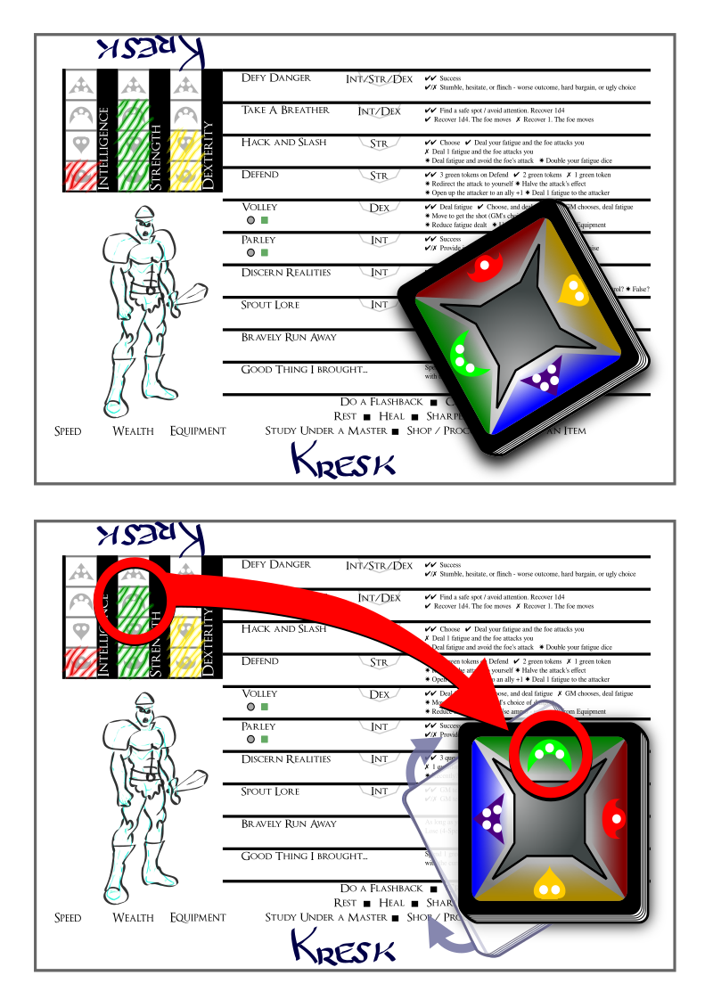

Look at the attribute on your character sheet -- what symbol is it, Anchor, Bulb, Crescent, or Dart? Rotate your Deckahedron so that the symbol is facing forward (away from you).

Then flip the top card forward (so that when it's face-up, the symbol is facing forward)
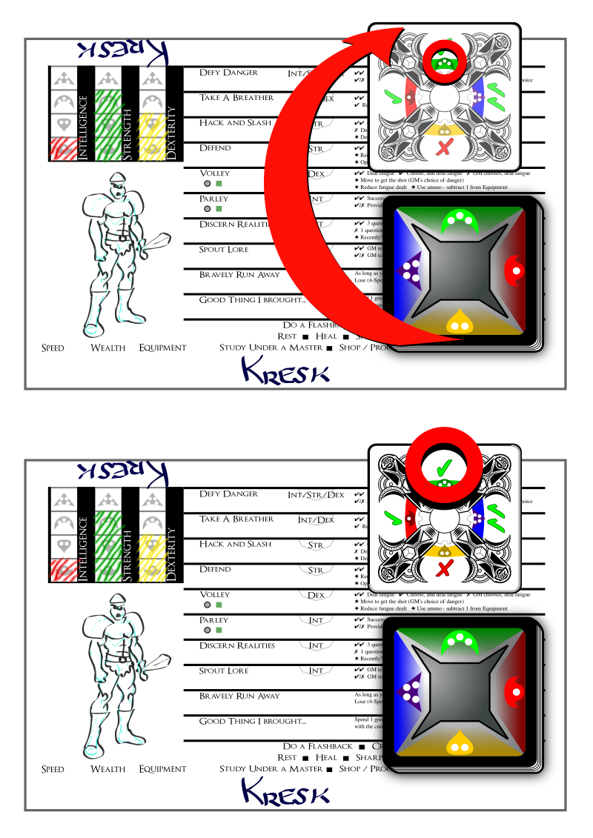
The top of the flipped card will show ✗s or ✔s.
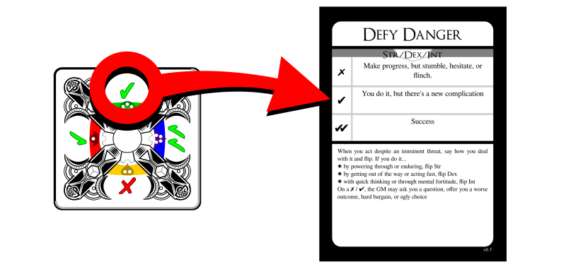
Finally, find the move card named by the GM and read its instructions. It will tell you how the GM should interpret the ✗s and ✔s.
Put the face-up Deckahedron card in your discard pile.

For example,
You're playing a character named Kresk. You say:
Kresk sees the pit of spikes in front of him, but isn't scared. He just takes a running start and mightily bounds over the pit, landing safely on the other side.
The GM might say to you:
Ok, sounds good, but let's see if Kresk's legs are strong enough. Please flip Defy Danger with your Strength.
Look over at the character sheet and see that Kresk has rank 3 (Crescent) Strength. This means you would rotate your Deckahedron so that the Crescent symbol is forward, then you would flip over the top card.
Maybe you get a single ✔. The GM would use the instructions on the Defy Danger card ("You do it, but there's a new complication") to improvise what happens next:
You leap through the air, landing with a thud on the other side of the pit, kicking up a cloud of dust on this forgotten jungle trail. As you rise to your feet, you notice it's more than dust that stirs, as you hear movement and a threatening rattle approaching from the pit. What do you do?

Other ways to flip: Advantage / Disadvantage
Some flips are a little more complicated. Some moves in Deckahedron World instruct you to "add an advantage card" or "flip with advantage". Sometimes you will be given the opposite instruction, "add a disadvantage card or "flip with disadvantage".

Advantage
With an advantage, you flip over your top card as usual, and then you flip over the next card on the top of the Deckahedron. Compare the results (the number of ✗s or ✔s) and resolve the flip with the card that has the best result.
If it's a tie, you may choose whichever card to be the card that resolves the flip.
All cards that got flipped face-up go in your discard pile.

Complete Flip Rule
You must flip over all the cards you were instructed to, even if the first card shows ✔✔.

Disadvantage
With a disadvantage, do the same thing, but use the worst result.

Multiple Advantages / Disadvantages
For a given flip, you may be instructed to add two advantage cards or two disadvantage cards. This means you would flip 3 cards in total and take the best or worst, respectively.
No flip may use more than 3 cards in total, so adding advantage cards past 2 is just ignored.
Sometimes you're in a situation where you are instructed to both "flip with advantage" and "flip with disadvantage". To resolve any move, simply add up all the advantages, and then subtract all the disadvantages to arrive at your sum of advantage or disadvantage. The maximum is two extra cards, so if the sum is -3, you only flip with two disadvantage cards.

Other flip complications: Green token cards
Some of your Deckahedron cards have a green token symbol in the middle. After a flip is resolved by a card showing a green token symbol, you have a choice:
- Take a green token (these can be spent to perform certain moves)
- Go up one level in the move you just performed (see Move Levels)
You may only do this when the card resolves a flip.

Other flip complications: Wound cards
Sometimes you will flip over a Wound card. See the Combat chapter.

Reshuffling
At any time before a flip, or after a flip is resolved, you can take your discard pile and shuffle it back into your Deckahedron.
Whenever your Deckahedron is down to 5 or fewer cards, you must take your discard pile and shuffle it back into your Deckahedron.

