Combat

When a character is in a fight, they are running, dodging, striking, and being struck and assailed by their foe. All of this stuff is scary and exhausting. So a character will get weaker the longer they're in this exchange, even if they're dodging every blow.

This weakening is represented by cards from your Deckahedron being lost into your Exhaustion pile.

Stamina / Exhaustion

Characters have 10 Stamina points. These points are represented by cards in your Deckahedron with a Stamina symbol

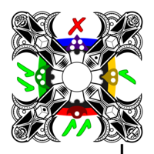 | 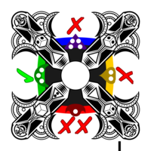
Card with a Stamina symbol | Card without a Stamina symbol

To win at combat, a character's foes must be subdued or pacified before the player's Deckahedron has been emptied of Stamina points.

When you are instructed to lose a Stamina point:
- reveal cards in your Deckahedron until you find a card with a Stamina symbol
- put that card aside, face-up in your Exhaustion pile
- the other revealed cards go into your discard pile

(You can put an Exhaustion token on top of the Exhaustion pile to distinguish it from your discard pile)

(So, if you were instructed to lose 2 Stamina points, you would add 2 cards with Stamina symbols onto your Exhaustion pile)

If searching through their Deckahedron does not yield a card with a Stamina symbol, the player must reshuffle their discard pile into the Deckahedron and continue searching.
Note: Players may choose to reshuffle their discard pile back into the Deckahedron before searching for Stamina points.

If there are no Stamina points in the Deckahedron or the discard pile, then all 10 must be in the Exhaustion pile. In this case, the character is incapacitated and can take no further actions. It is up to the GM to decide what this incapacitation means – whether the character is dead, unconscious, or just unable to stand or move.

Harm

Strains, sprains, and bruises are meant to represent either bodily harm or mental strain that is so significant that the negative effects will last for a while.

When you are instructed to take a harm token (a strain, sprain, or bruise):
- If you already have 2 Harm tokens on your Exhaustion pile:
  - Take a wound instead
- Otherwise:
  - the GM will describe what kind of harm this represents
  - lose a Stamina point
  - place a harm token on your Exhaustion pile

Sacrificing the body

A player might have strategic reasons to receive harm tokens or to preserve Stamina, so, when the player is instructed to lose at least 3 Stamina points, they can choose to convert exactly 3 of those points to take harm token (ie, follow the above instructions) instead.

Wounds

Getting wounded sucks, and when wounded, all intelligent creatures seek to cure their condition as a very high priority.

When you are instructed to take a Wound:
- If you already have 2 wounds:
  - the character is incapacitated
- Otherwise:
  - the GM will describe how the character was wounded
  - lose a Stamina point
  - place a wound token on your Exhaustion pile
  - place a wound card in your discard pile. It will now start cycling between your Deckahedron and your discard pile.

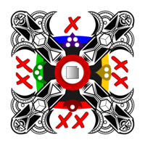
A wound card

Having a wound card in your Deckahedron causes some nasty effects.

Whenever you flip and reveal a wound card:
- say or act out the gutteral noise emitted by your character
- you must immediately stop flipping (eg, if your the move instructed you to "flip 3", you would stop short once you hit the wound card - resolve the move with only the card(s) you flipped)
- lose a stamina point

Sacrificing the body

A player might have strategic reasons to receive wound tokens or to preserve Stamina, so, when the player is instructed to lose at least 6 Stamina points, they can choose to convert exactly 6 of those points into a wound.

