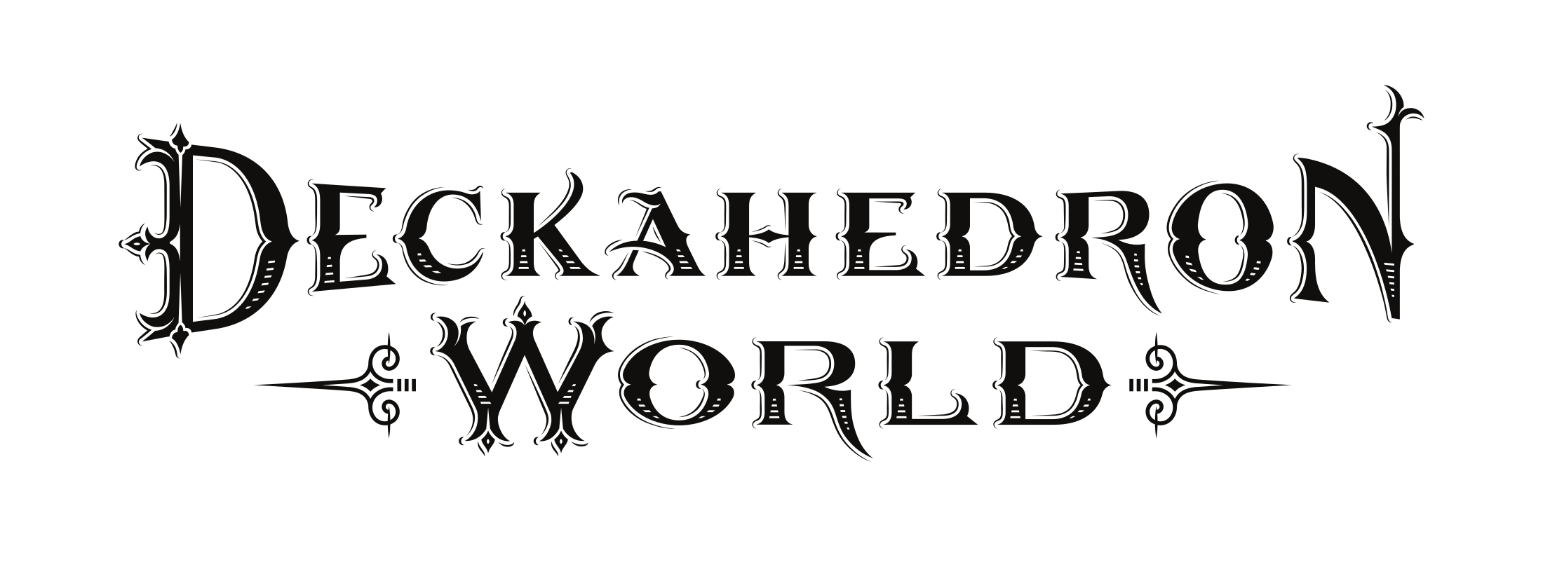

Player’s Guide

V0.86

http://deckahedron.com

Deckahedron World

Player's Guide

Like board games? Remember Dungeons & Dragons? Think you can improv? Welcome to Deckahedron World!

Welcome to Role-Playing
Deckahedron World is a system for telling a story. The authors of the story are you and your friends, sitting around a table.
This story is improvisiational, interactive, and collaborative.
The rewards for playing are laughter and excitement while you play, and warm conversations for years afterwards that start with "Remember that time we were playing Deckahedron World and..."

How to make a great story
Imagine the audience for this story is the inner children of all the players. What evokes the feelings we had when we were children playing pretend? Can you remember being 11 years old and watching a spectacular Steven Spielberg movie? Or maybe a cheap-but-awesome Sam Raimi movie?
You are going to collaborate with all the other players to make this story, so when you add your parts, think of what will give your friends around the table a thrill, put them in suspense, ratchet up their feelings of tension, or make their jaws drop with awe.
Sometimes inner children get a big kick out of blood and guts. Your inner child might giggle at the brothel scenes in HBO's Game of Thrones. If you don't know what topics your friends consider "off-limits", it is a good idea to ask and tell before you start playing.
The story that emerges from Deckahedron World is not a precisely crafted thing. That's ok. It doesn't have to be high art or even a cartoon on Adult Swim. It gets shaped by each player, and when your turn comes, you adapt, do your best improvisational "Yes, and" , and see where it goes from there. It might sound like chaos, but with some faith in your friends, you will delight at how the plot solidifies, and how real the characters become.

Specifically, What to do
In a game of Deckahedron World, one person will take on the role of the Game Master, or "GM". The other people will be called simply "Players".

The GM
The GM's job is to know all the rules, and say stuff. Occassionally they will write notes and scribble some quick numerical facts.
The GM's domain is the world.

The Players
Player, your domain is your character.
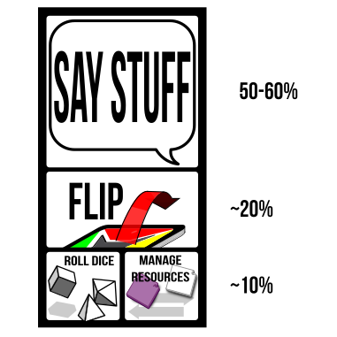
The player's job
Most of your time will be spent saying stuff. You are part of a conversation. Ask questions, use your imagination, chime in when someone inspires you. Think about your character like a hero of a movie, and try playing as the writer of the movie, or the director, or immerse yourself like a method actor standing in the character's shoes and seeing with their eyes.

Deckahedron World invites you to:
- Describe your character and their actions
- Act out their dialogue
- Describe how they act
  - flourishes and stunts
  - their facial expressions, voice, and body language
- Tell what they say / hear / see / smell / taste / feel
- Describe their thoughts & memories
- Chime in when they interact with or support the other characters
- Refer to your moves to get ideas for your character
- Tell parts of the story
- Tell your character's backstory
- Control your character's hirelings and animal companions
- Refer to your moves to see what boundaries you can push
As the conversation unfolds, the rules will chime in as well. When that happens you will be called do things beyond just "saying stuff":
- Flip your Deckahedron
- Move tokens around
- Roll dice
This guide will teach you how to do those things.

The Deckahedron
Every player except the GM gets a Deckahedron. Inspect your Deckahedron. You should have 20 cards. There are 4 symbols on the fronts and backs of the cards:
Name | symbol | odds | color | rank
Anchor |  | indicates the weakest odds | red | rank 1
Bulb |  | indicates below average odds | yellow | rank 2
Crescent |  | indicates above average odds | green | rank 3
Dart |  | indicates the best odds | blue | rank 4
Shuffle your Deckahedron and place it face-down in front of you.
Whenever your character attempts something risky, where the outcome is not certain, the GM calls on you to use your Deckahedron and "flip".
First, the GM names the move you're attempting and which of your character's attributes -- Strength, Dexterity, or Intelligence -- you use to resolve the flip.
GM Note: The attributes used to resolve a move are listed at the top
of each card. Sometimes a card gives the option of several
attributes, like "Str / Dex". You may need to ask the player for more
detail about what they are attempting before calling for a flip.
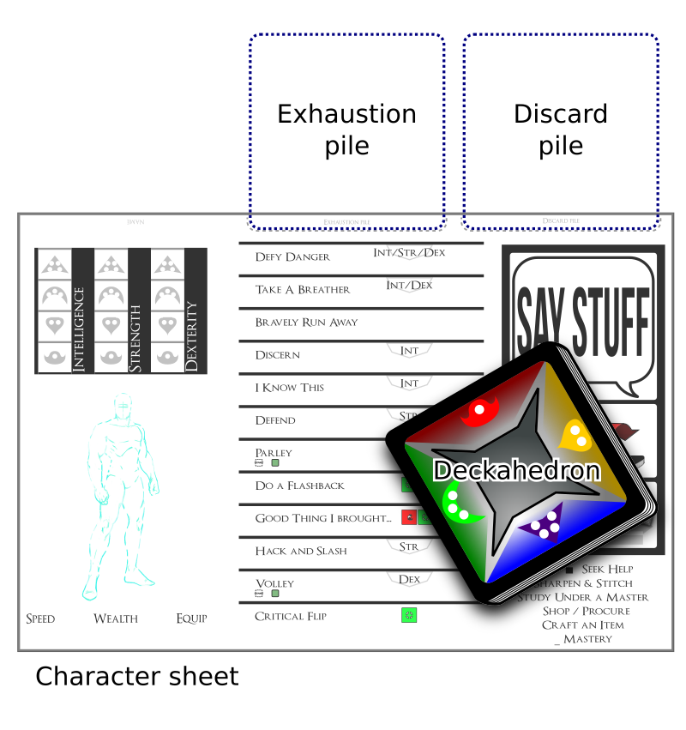
What’s in front of you
Look at the attribute on your character sheet -- what symbol is it, Anchor, Bulb, Crescent, or Dart? Take the top card and flip it face up. Put it down so that the symbol faces the GM. (Saying "Bam!" or making some other sound effect is optional.)
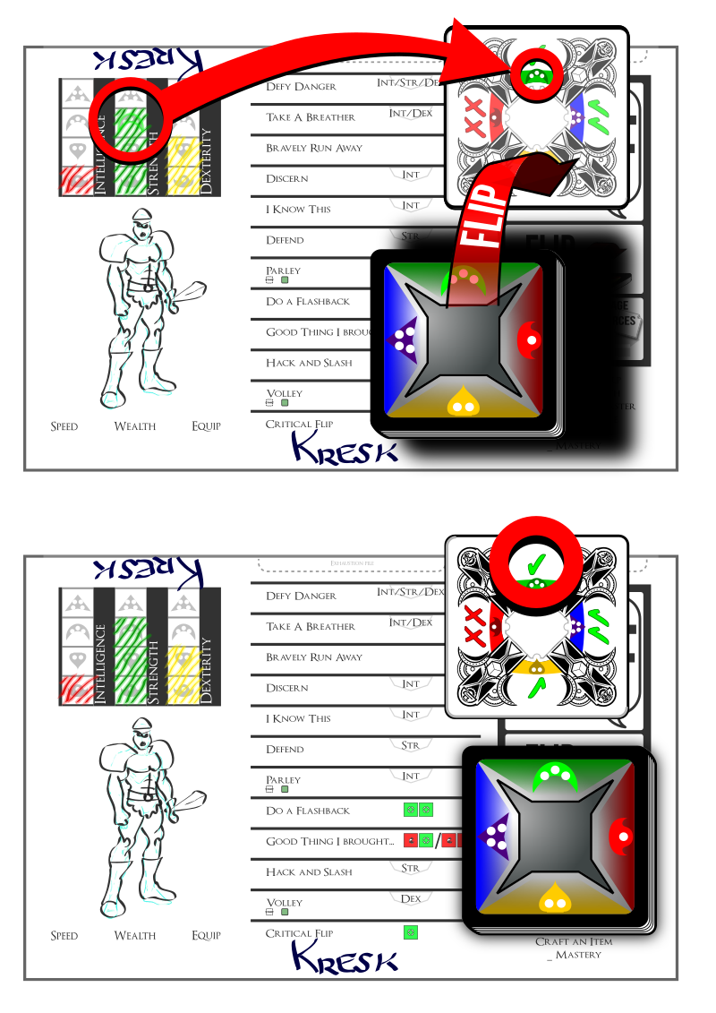
Illustration of flipping a card forward
The top of the flipped card shows ✗s or ✔s. These tell you the result of the move. Consistently facing the result towards the GM helps simplify the GM's bookkeeping and helps the game stay fast-paced.
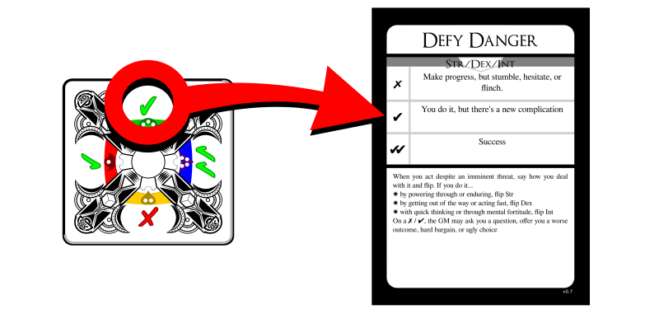
Illustration of reading a card
Finally, find the move card named by the GM and read its instructions. It tells you how the GM should interpret the ✗s and ✔s.
Afterward, any card used during a flip goes face-up in a discard pile. Later, you will start another pile of face-up cards called an Exhaustion pile. Keep them separate.

For example,
You're playing a character named Kresk. You say:
Kresk sees the pit of spikes in front of him, but isn't scared. He just takes a running start and mightily leaps over the pit, landing safely on the other side.
The GM might say to you:
Ok, sounds good, but let's see if Kresk's legs are strong enough. Please flip Defy Danger with your Strength.
Look over at the character sheet and see that Kresk has rank 3 (Crescent) Strength. Flip over the top card of your Deckahedron and look for that Crescent symbol.
Maybe you get a single ✔. The GM uses the instructions on the Defy Danger card ("You do it, but there's a new complication") to improvise what happens next:
You leap through the air, landing with a thud on the other side of the pit, kicking up a cloud of dust on this forgotten jungle trail. Rising to your feet, you notice that more than dust has been stirred. The sounds of movement and a threatening rattle alerts you to something approaching from inside the pit. What do you do?

Other ways to flip: Advantage / Disadvantage
Some flips are a little more complicated. Some moves in Deckahedron World instruct you to "take +1 advantage", "add an advantage card" or "flip with advantage". Sometimes you are given the opposite instruction, "add a disadvantage card" or "flip with disadvantage".

Advantage
With an advantage, flip over your top card as usual, and then flip over the next card as well. Compare the results (the number of ✗s or ✔s next to the relevant symbol) and resolve the flip with the card that has the best result.
If it's a tie, you may choose whichever card to be the card that resolves the flip.
All cards that got flipped go face-up in your discard pile.

Complete Flip Rule
You must flip over all the cards you were instructed to, even if the first card shows ✔✔.

Disadvantage
With a disadvantage, do the same thing, but use the worst result.

Multiple Advantages / Disadvantages
For a given flip, you may be instructed to add two advantage cards or two disadvantage cards. This means you flip 3 cards in total and take the best or worst, respectively.
No flip may use more than 3 cards in total, so adding advantage cards beyond 2 is just ignored.
Sometimes there's a situation where you are instructed to both "flip with advantage" and "flip with disadvantage". To resolve any of these combinations, simply add up all the advantages, and then subtract all the disadvantages to arrive at your sum of advantage or disadvantage. The maximum is still two extra cards, so if the sum is -3, you only flip with two disadvantage cards.

Other flip complications: Green token cards
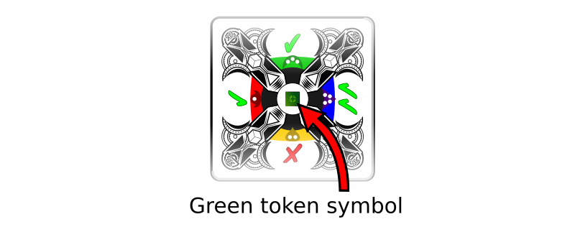
A green token card
Some Deckahedron cards have a green token symbol in the middle. After a flip is resolved by a card showing a green token symbol, you have a choice:
- Take a green token from the supply (these may be spent later to perform certain moves)
- Go up one level in the move just performed (see Move Levels)
You may only do this when the card resolves a flip. (ie, when flipping multiple cards, only if the green token card was the one from which the ✗ or ✔ symbols were used to interpret the result of the move)
Green tokens are a currency you spend to activate "meta" parts of the game. See below for moves that let you "break" or "bend" rules, or partially take control of the narrative.

Other flip complications: Wound cards
Sometimes you flip over a Wound card and must lose a Stamina point. See the Combat chapter.

Reshuffling
At any time before a flip, or after a flip is resolved, you may take your discard pile and shuffle it back into your Deckahedron.
Whenever your Deckahedron is down to 5 or fewer cards, you must take your discard pile and shuffle it back into your Deckahedron.

Interpreting the result of a flip
When a player performs a move, the player executes a flip, and the GM interprets the narrative result, based on the text of the move card.
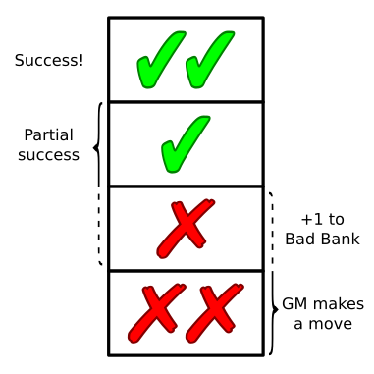
flip results
Usually ✔✔ means an unfettered success, and single ✔ means success, but with complication.
When the result is a single ✗, it sometimes means the same as a single ✔, but often it is slightly worse.
Any time a flip results in a single ✗ the GM should add a point to the Bad Bank. -- even when the move card says it has the same narrative effect as a single ✔.
Sometimes a card does not say how a ✗ should be interpreted. In that case, the GM gets to make a move, just like ✗✗.
When the result is ✗✗, it is the GM's turn to make a move. The GM narrates the consequences of the move the player just attempted and has license to take the narrative where they like.
Rarely, a card will have instructions for how to interpret a ✗✗ result. These instructions should be executed, but might only be part of the GM's move.
There is an exception to the GM moves on ✗ and ✗✗. When the move card has the tag IMMEDIATE, the GM does not add points to the Bad Bank on a ✗ and they don't make a move on a ✗✗.
See the GM Guide for explanations of the Bad Bank and for a list of moves the GM is allowed to make.

Flips only happen when the situation is uncertain or risky
A GM only calls for a flip when the situation is uncertain or risky for the character. If the outcome is certain, the GM may just narrate what happens. Or they may ask you some clarifying questions.
Deckahedron World is a conversation. Different GMs will draw the line of certainty at different places.
Consider a situation where the GM has described your character, Kresk, waking up after making camp in a forest. Beside you is a squirrel nibbling an acorn.
One response might be:
"Kresk wants that acorn! I Hack and Slash the squirrel!"
It would be bizarre, but completely within the rules for the GM to write up some stats for the squirrel (1 Stamina, 1 attack power), and begin a melee combat between Kresk and the squirrel, and ask you to flip Strength to resolve the Hack and Slash move.
Perhaps better responses from the GM might be:
- "As you raise your fist to smash the squirrel, it darts off into the forest, never to be seen again"
- "How is Kresk going to overcome the squirrel's natural speed and reflexes?"
- "You smash your fist down and flatten the rodent, strangely, it didn't even flinch. This odd behaviour has you wondering about the rumors you've heard about this forest being enchanted..."
The GM doesn't always have to invoke a move and call for a flip. But in this example, the player literally names a move ("I Hack and Slash..."). That's a strong signal to the GM, and the GM is likely to follow strong signals.
If you enjoy playing in a style where things flow like a conversation or a story, from question to answer, from description to dialogue and back around again, rather than pushing a limited set of buttons laid out in front of you, try playing without naming the moves. Just describe what your character does in a natural way.
"Kresk wants that acorn! I slam my fist down on the squirrel!"

Combat - Stamina/Harm/Wounds
Here are rules to determine when your character is able to endure exertion and injury to keep moving forward or when they're completely spent and collapsed in a heap.
When a character is in a fight, they are running, dodging, striking, and being struck and assailed by their foe. All of this stuff is scary and exhausting. So a character gets weaker the longer they're in this exchange, even if they're dodging every blow.
This weakening is represented by cards from your Deckahedron being lost into your Exhaustion pile.
Think of a boxing match or a mixed martial arts match. During the later rounds, the athletes are worn down, don't jump around the ring with as much vigor, and drop their guard more frequently. The contest is not always decided with a knockout punch, it often comes down to who can better endure the exertion.
By default, your character has 10 Stamina points. When your character loses all 10, they are incapacitated.

Phases
When your character gets attacked or falls victim to some other danger, you have choices about exactly how they are affected. They may dodge, and just lose Stamina, they may stand stubbornly against a blow, taking Harm to perhaps absorb the blow with their armour (or with their face), or they may be wounded by the attack.
The first phase is rolling dice to arrive at a number. This number is called the attack power.
The second phase is deciding how to split that number among 3 categories, Stamina, Harm, or Wounds.
The third phase is optional: absorbing some points using any relevant move cards and item cards.
Finally, the fourth phase: you interpret those results into the narrative. Did your character dive into the dirt? Did they take a punch to the jaw and respond with a bloodied grin? Did the spear bounce right off their steel breastplate?

First Phase
When your character suffers the consequences of violence, you roll dice to get a number. This number is called the attack power.

Second Phase
If you don't split up the attack power, it translates directly into Stamina points. So by default, your character loses that amount of Stamina points.
Let's say your character was attacked with a sword and the dice were rolled and summed up to 7. The simplest choice is to lose 7 Stamina points.
But maybe you already lost 3 Stamina points earlier. You only have 7 Stamina points left, and you don't want your character to be incapacitated. You have a couple options:
- Turn attack power into Harm tokens at a rate of 3-for-1
- Turn attack power into Wound tokens at a rate of 6-for-1
For example, you may split the attack power of 7 into:
- 4 Stamina points
- 1 Harm token
You may even do that twice, splitting the attack power of 7 into:
- 1 Stamina point
- 2 Harm tokens
Another option is to take a Wound, using a rate of 6-for-1. In our example, you may split the attack power of 7 into:
- 1 Stamina point
- 1 Wound token
Note: as described later, taking Wound and Harm tokens can sometimes also cause loss of Stamina points.
Attack power turns into Harm tokens at exactly a rate of 3-to-1, and Wound tokens at exactly a rate of 6-to-1. You cannot choose a Harm token if facing an attack power of 2.

Stamina / Exhaustion
Characters have 10 Stamina points. These points are represented by cards in your Deckahedron with a Stamina symbol
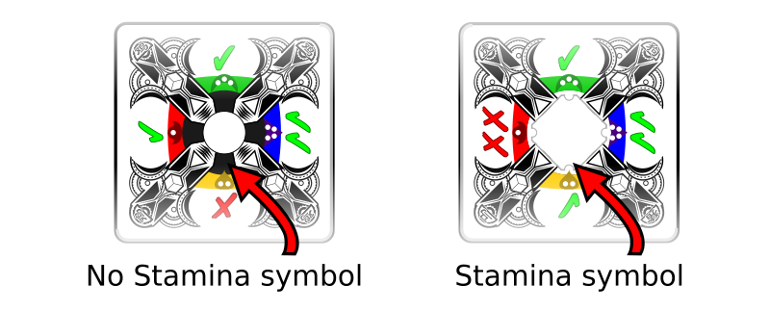
To win at combat, a character's foes must be subdued or pacified before the player's Deckahedron has been emptied of Stamina points.
When you are instructed to lose a Stamina point, you may absorb it using any relevant move cards and item cards, otherwise:
- reveal cards in your Deckahedron until you find a card with a Stamina symbol
- put that card aside, face-up in your Exhaustion pile
- the other revealed cards go into your discard pile

You should put an Exhaustion token on top of the Exhaustion pile to distinguish it from your discard pile. But, unlike Harm and Wound tokens, you don't have to put an Exhaustion token on the pile for each Stamina point lost, that's what the cards are for.
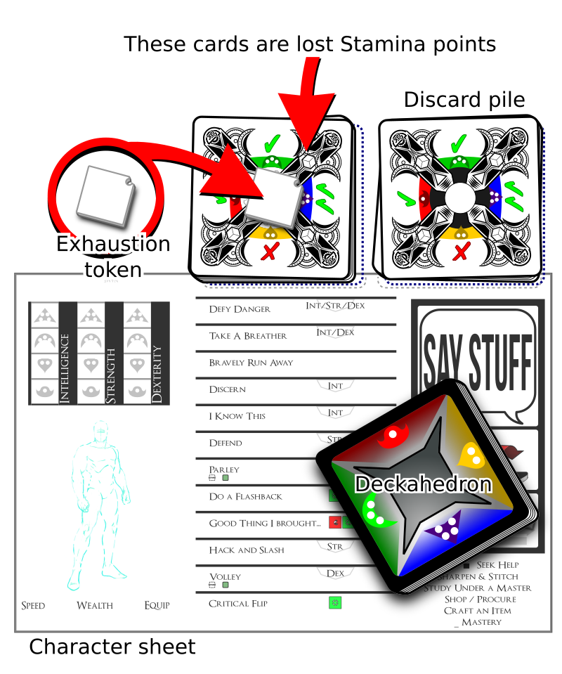
(So, if you were instructed to lose 3 Stamina points, you add 3 cards with Stamina symbols onto your Exhaustion pile)
If searching through their Deckahedron does not yield a card with a Stamina symbol, the player must reshuffle their discard pile into the Deckahedron and continue searching.
Note: Players may choose to reshuffle their discard pile back into the Deckahedron before searching for Stamina points.
If there are no Stamina points in the Deckahedron or the discard pile, then all 10 must be in the Exhaustion pile. In this case, the character is incapacitated and can take no further actions. It is up to the GM to decide what this incapacitation means - whether the character is dead, unconscious, or just unable to stand or move. The GM has rules for this, see the GM Guide.

Harm
Think of that boxing match again. If Stamina represents dancing, ducking, and dodging, then Harm represents landing a blow. These rules are also for representing mental strain that is so significant that the negative effects last for a while.
When you are instructed to take a Harm token, you may absorb it using any relevant move cards and item cards, otherwise:
If you already have 2 Harm tokens on your Exhaustion pile:
- Take a Wound instead
Otherwise:
- Lose a Stamina point
- Place a Harm token on your Exhaustion pile
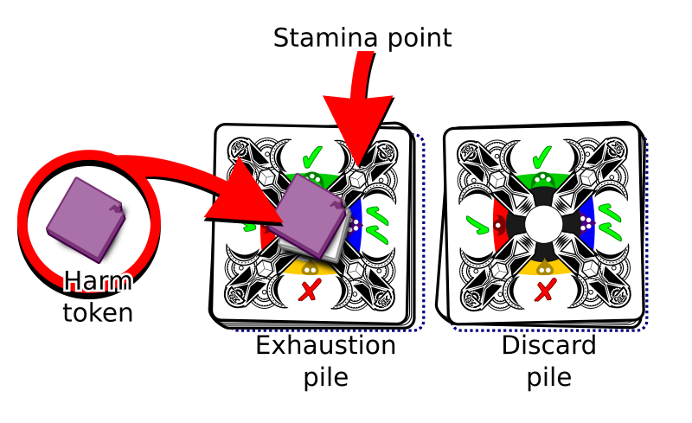
Note, this "one-hit, two-hit, over" pattern is repeated in many of Deckahedron World's rules

Wounds
Getting wounded sucks, and when wounded, all intelligent creatures seek to cure their condition as a very high priority.

When you are instructed to take a Wound token, you may absorb it using any relevant move cards and item cards, otherwise:
If you already have 2 wounds:
- the character is incapacitated
Otherwise:
- the GM describes the wounding
- Lose a Stamina point
- Place a Wound token on your Exhaustion pile
- Place a Wound card in your discard pile. It will now start cycling between your Deckahedron and your discard pile.
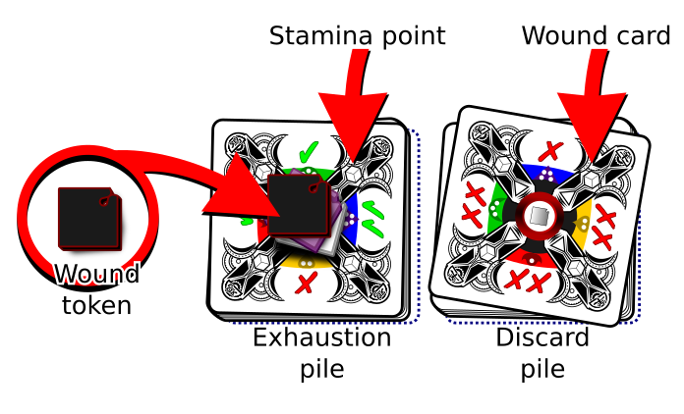

A Wound Card
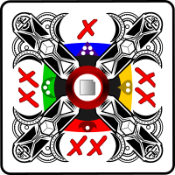
Having a Wound card in your Deckahedron causes some nasty effects.
Whenever you flip and reveal a wound card:
- Say or act out the guttural noise emitted by your character
- You must immediately stop flipping (eg, if you were instructed you to "flip 3", you stop short once you hit the wound card - resolve the move with only the card(s) you flipped. This overrides the Complete Flip Rule)
- Lose a Stamina point

Speed/Wealth/Equip
Your character has a movement speed, a certain lightness-of-foot, they carry a certain amount of equipment and items, and they carry a certain amount of wealth. These attributes are tracked with the Speed/Wealth/Equip system. The more equipment and wealth carried, the lower their speed.
Daily-use amounts of money and food are not tracked. It is assumed your character will always be able to scrounge a meal somehow.
Movement speed is not an exact measurement in meters-per-second. It will matter when attempting moves where being laden with loot and gear matters. Particularly moves with the tag "UNENCUMBERED". When your speed goes below 4, you may not perform any "UNENCUMBERED" moves.
You have 6 tokens that can be allocated between 3 slots on your character sheet (Speed, Equip, Wealth) and Item cards.
If you don't want to carry any items, equipment or wealth, you can put all 6 tokens on Speed.
Tokens represent weight or difficulty to carry, when they're not on speed.
Some Item cards require more than 1 token.
The GM may interpret a Speed of 0 as limiting a character's gait to walking.

Moves

Good Thing I Brought...
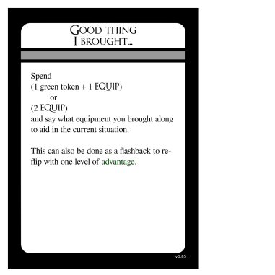
Good Thing I Brought card
Adventurers are always finding themselves in tricky situations. Luckily, they come prepared with adventuring gear. They have been known to carry 50 feet of rope, smelling salts, books of saucy poems, sometimes even a 3-day-old pork chop to distract hounds or hungry goblins.
It's a fact. You know this and Deckahedron World knows this, so it doesn't ask you to keep fine-grained notes of every candle and spare button in your character's inventory.
Reasonable daily-use items are presumed to be in your character's pack. If you're unsure, remember Deckahedron World is a conversation, so just ask the table.
But sometimes you will be in a situation where having that 50 feet of rope or old pork chop would really solve a problem for your character.
When your character reaches into their pack and produces the item that solves their current problem or helps them overcome a challenge, just say what it is and spend the tokens.

Do a Flashback
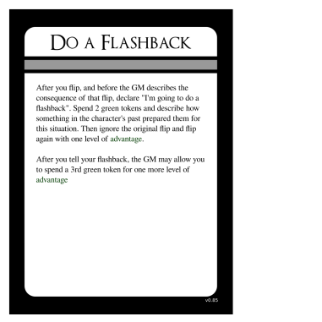
Do a Flashback card
Sometimes you plan out something really great, and then you resolve a flip, and don't get the results you need.
A Flashback serves as sort of a "mulligan" in those situations, but it also provides a way to develop your character's backstory and personality.
After a player makes a flip, and before the GM describes the consequence of the flip, the player can declare they're going to do a flashback.
The player spends 2 green tokens. Then they describe how something that happened in the past particularly prepared them for this situation.
Then they can ignore the original flip, and flip again, with one level of advantage. (eg, if they were doing a flip-three-take-worst flip, now they do a flip-two-take-worst)
After they tell their flashback, the GM may allow them to spend additional green tokens for more advantage levels. This is a subjective judgment left up to the GM.

Mercy Flashbacks
Players may find themselves in a situation where they forgot to do something when they had the chance, like use healing magic while they were resting, or leveling up a move before they left a steading, or getting some key information from an NPC before that NPC died.
As long as the player and the GM both agree that the player had the necessary resources when the action was available, the GM may allow the player to spend those resources and effect that action now, as a "Mercy Flashback".
The player must spend a green token, in addition to whatever cost the action incurs.
Forgetting happens to the best of us, and there are lots of variables to keep track of, so the cost is kept "cheap" at only one green token. But there must be a cost. It is necessary to keep the flow of the game going. This is a game of improv storytelling, and improv means rolling with the punches sometimes.

Critical Flip
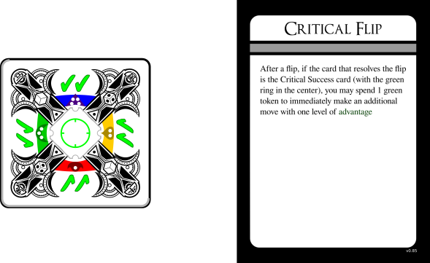
Critical Flip card
One of the 20 cards in your Deckahedron is the "Critical Success card". It has a ✔✔ symbol on every edge and a green circle in the middle.
If you resolve a flip with the Critical Success card, you can use the Critical Flip move to get an advantage card on your next move.
If you choose to Critical Flip, the spotlight stays on you for a little bit longer while you make your bonus move.

Making your own character
The GM has rules to guide you through creating your character in the GM Guide.
Take turns picking your starting moves. During character creation, you can't pick a move another player has already picked, but you can study those moves later if you want, see the Study Under a Master description below.
Moves with the RECEIVE CARDS tag allow you to get some item cards during character creation.
- "Use a Magic Item" move gives you 1 magic item of your choice
- "Channel the Living Light" move gives you Sigil of the Living Light
- "Entreat the Blood-Bound" move gives you Blade of Echoes
After you choose your starting moves, Choose 2 items * a weapon is a popular choice. Unarmed, your attack power will be 1d2 * You may choose 1 magical item * Without studying the Use A Magic Item move, it's still possible to use magic items.

Carrying Items Reduces Speed
There are blanks on some cards, and some cards are entirely blank. You get to define what your items are. But you do not get to change the rule that each item you carry reduces your speed.
A player inevitably asks why the magic amulet or ring they've created, a trinket that is normally a couple grams, reduces their speed. At that point the GM may return the question, "Yes, why does it weigh you down? What about magic in this world, or what about your character makes them especially burdened by magical items?"
The narrative of Deckahedron World is a collaboration.

Fitting the fiction
One of the joys of Deckahedron World is building your character up from a scrappy adventurer to a force to be reckoned with.
Characters start out as "scrappy adventurers" that are not much more powerful than a common villager. They've got an edge over regular folk, (their special abilities) but they're not mechanically that much stronger. You can invent any backstory you like, but you may need to answer questions about how the backstory fits where the characters is, mechanically.
Nothing stops you from creating a hulking, 7 foot tall barbarian, with a rich history of warring and slaughtering enemies, but at the very beginning of the game, with a couple unlucky flips, they may get beat up by a farmer with a shovel and a pet goat.
This doesn't mean don't create the barbarian character. It means, if you do, find some narrative justification (drunkard? battle-worn? magically cursed?) that they're currently at a "scrappy adventurer" level.

More Moves

Taking a Breather
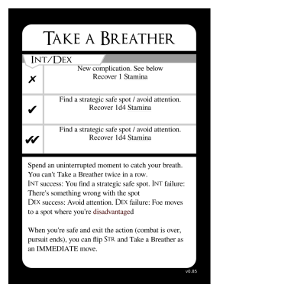
Take a Breather card
Taking a Breather is a move that a character can take during combat. This action allows a character to regain up to 4 Stamina points.
The player may use either Intelligence or Dexterity to perform the Take a Breather action.
If they use Intelligence, they say how they execute a tactic or recognize a favourable position that lets them gather their breath and their wits.
If they use Dexterity, they say how they maneuver into a safe position that offers some temporary safety.
Regaining Stamina may be done either by taking cards from the Exhaustion pile and putting them into the discard pile, or by returning Exhaustion tokens to the supply.
When recovering cards from the Exhaustion pile, the player may choose any cards they want.
When combat or a pursuit ends, and it is appropriate for the narrative (e.g. when there's a scene transition and the characters reasonably have a few minutes to catch their breath), the players may Take a Breather using Str as an IMMEDIATE move (ie, no negative consequences to ✗ or ✗✗).

Resting
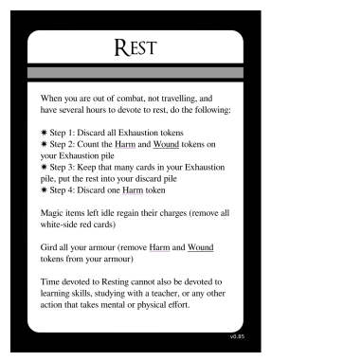
Rest card
Resting is an action that a character may take when they are out of combat, not travelling, and have several hours to devote to rest (sleeping qualifies).
- Step 1: Return all Exhaustion tokens to the supply
- Step 2: Count the Harm and Wound tokens on your Exhaustion pile
- Step 3: Keep that many cards (player choses which ones) in your Exhaustion pile, put the rest into your discard pile
- Step 4: Return one Harm token to the supply
When resting, magic items that are not being used regain all charges, up to their maximum capacity. Remove all white-side red cards on your magic items.
You may gird all your armour, where applicable. Remove all Harm and Wound tokens from your armour cards and from move cards that represent armour effectiveness (eg, Like A Second Skin).
Time devoted to Resting cannot also be devoted to learning skills, studying with a teacher, or any other action that takes mental or physical effort.
The Harm token returned to the supply in Step 4 may come from your Exhaustion pile or from a slot on a move card that represents bodily toughness (eg, Bloody But Unbowed).

Seek Help
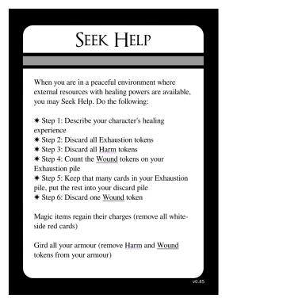
Seek Help card
Seeking Help is an action that a character may take when they are in a peaceful environment where external resources with healing powers are available.
Eg, if they are in a primitive camp posessing medicine men or a contemporary city with doctors and hospitals or a tranquil oasis infused with healing magic.

When you spend a day healing:
- Step 1: Describe your character's healing experience
- Step 2: Return all Exhaustion tokens to the supply
- Step 3: Return all Harm tokens to the supply
- Step 4: Count the Wound tokens on your Exhaustion pile
- Step 5: Keep that many cards (player choses which ones) in your Exhaustion pile, put the rest into your discard pile
- Step 6: Return one Wound token and one Wound card to the supply
As with Resting, time spent Seeking Help cannot also be used in activities that take effort.
Magic items that are not being used regain all charges, up to their maximum capacity. Remove all white-side red cards on your magic items.
You may gird all your armour, where applicable. Remove all Harm and Wound tokens from your armour cards.

Bravely Run Away
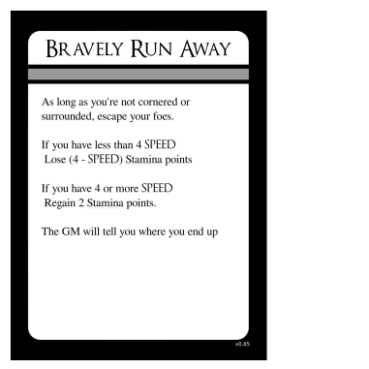
Bravely Run Away card
TODO

Shop / Procure
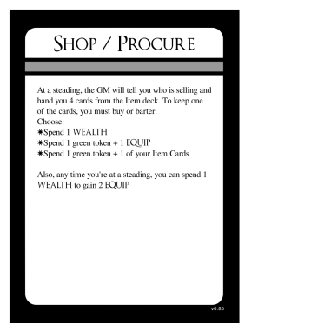
Shop / Procure card
Make mundane items - here's the process... TODO
GM Note: Don't hand a player a card they can't use because they
lack the requirements.

Magic Items
TODO

Charges and Capacity
By default magic items have capacity for 3 charges. When a charge is lost on a magic item, place a red card on it, white-side-up.
Sometimes charges are lost permanently. When this happens, place a red card on it black-side-up.
Magic items cannot be damaged.
(Weapons granted magical effects via Tool Twisting can still be damaged)
TODO

Armor, weapons
Damage to items is represented as black-side red cards
TODO

Armour Table
Name | token cost | slots | notes
Leather Armour | 1 | 2 Harm
_ Armour | 2 | 2 Harm, 1 Harm/Wound
Plate Armour | 3 | 3 Harm/Wound | requires help to don / doff
TODO

Weapon Table
Name | token cost | notes
_ Sword | 1
Many Knives | 1 | At close range, can be thrown
_ Bow | 1
TODO

More Moves - Use a Magic Item, Entreat the Blood-Bound, Channel the Living Light
TODO
Ask that player "Who is the Blood-Bound"?
GM Note: this is a great way to stretch your improv muscles. Say "Yes,
and..." no matter if they identify the Blood-Bound as tiny, parasitic
insects or as monstrous, extradimensional dark gods.

Move Levels
Some Move cards have icons on them that indicate "levels". These levels represent how good your character is at that skill. For example, the move Pick Pockets has 5 icons.
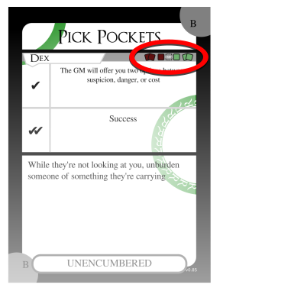
Pick Pockets card
These are the "move levels" for Pick Pockets. From left to right, these icons are called:
-  wild or "2 red"
-  novice or "1 red"
-  "base level"
-  expert or "1 green"
-  master or "2 green"
If you chose Pick Pockets during character creation, you would receive the card and your character would be "studied" in the skill. The word "STUDY" is over "base level", so that's the level you would start at.
Note: some moves, like Void Transfusion, don't start you off at the base level.

Increased Move Levels
Later, you can go up a level in Pick Pockets. Either by using the Study Under a Master move, or when you resolve a Pick Pockets flip and happen to get a green token card. See Green token cards

Green card
Take a green card, and put it on top of the move card. Put the green card black-side-up.
With Pick Pockets leveled up, any time you perform that move in the future, you will add an advantage card when you flip.
Because the Pick Pockets card shows the "2 green" icon, you can repeat this process again later, which would let you add 2 advantage cards when you flip.

Decreased Move Levels
But what about the 2 "red" levels?
In Deckahedron World, any character can attempt any move that is performed by flipping Str, Dex, or Int -- even if the player doesn't have that move card!
For any such moves, all characters start at the lowest level shown on the card. So every character is "wild" or "novice" at every skill that is tested by flipping Int, Str, or Dex.
Every character, at any time, can attempt to hit two opponents in combat (via Goreography). Every character can attempt to cast a spell (via Fundamental Magic). But, their odds are very low.
You can attempt moves even if you don't meet the requirements shown.
Just as the "expert" and "master" levels cause the flip to be done with advantage, the "wild" and "novice" levels cause the flip to be done with disadvantage.
- with 2 levels of disadvantage
- with 1 level of disadvantage
If you perform a "wild" level move, and you resolve that flip with a green token card, you can use that card to graduate to "novice" level.
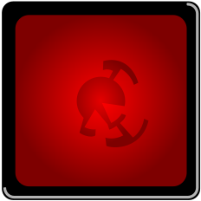
Red card
If you choose to do so, take the move card and a red card. Place the red card on top of the move card, black-side-up.

More Moves - Study Under a Master

Study Under a Master
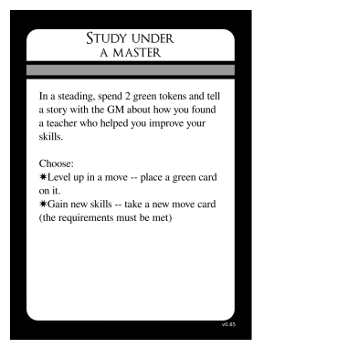
This is the move by which your character becomes a powerful force in the world.
When your character is in a steading (a village, city, etc. -- any safe place where resources and commerce present themselves), you can spend 2 green tokens to either:
- Increase the level of a move you already have (See Move Levels
- Take a new move card from the supply
If you want to take a move card that another player already has or one that was scribbled over in a previous campaign, or just has been ruined by spilled beer, you can copy the text onto a new card.
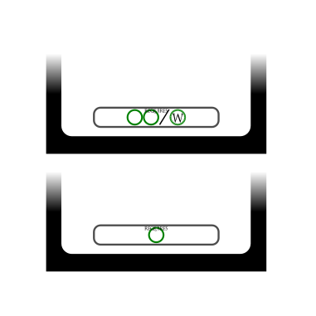
requirements
Some moves have requirements. These are illustrated as green circles, sometimes with a letter inside -- R, F, or W. Requirements are sometimes separated by a slash, /, which means "or".
For example, using the Study Under a Master move can gain you the card Fundamental Magic only if you have two green circles or one W circle.
What, then, are these circles?
Take a look through the move cards and see that there are partial circles printed on them - either in the corners or on the sides.
When you can arrange your own move cards together in such a way that a circle is complete, you "have" a circle. If your cards can arrange to show 2 circles, then you "have" 2 circles.
If your card arrangement had the cards Pick Pockets and Not On My Turf next to each other, you could complete an R circle. If you had the Scent of Blood card instead of the Not On My Turf card, you could arrange it next to Pick Pockets to complete a circle, but it would not be an R circle or an F circle, it would just be a regular green circle.
You do not have to keep your cards in this arrangement while you play,

The RECEIVE CARDS tag
When you Study Under a Master and take
the move card... | You also take...
Channel The Living Light | Sigil of the Living Light
Entreat The Blood-Bound | Blade of Echoes
Use a Magic Item | Any magic item card
Use the RECEIVE CARDS tag only when you gain a move card via Study Under a Master. You do not use it when you gain competence with the skill by flipping green token cards.

Level circles
At the beginning of a session, players should arrange their move cards to count how many green circles they have.
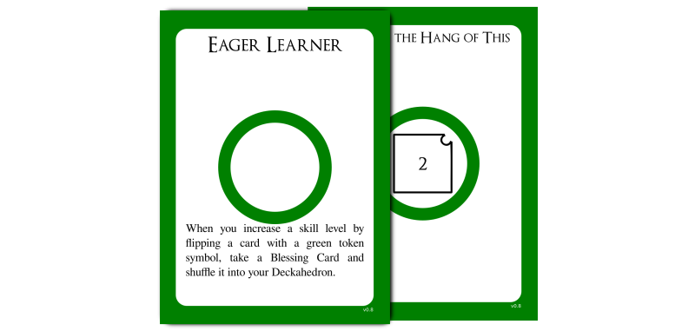
level cards
If you have a new green circle this session, you get to take a Level card.
Like move cards, level cards may also have requirements. Some require that you have a certain amount of circles to access them.
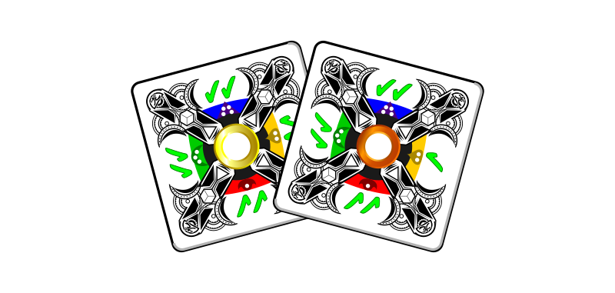
blessing cards
Some level cards will instruct you to take blessing cards.

Sharpen and Stitch
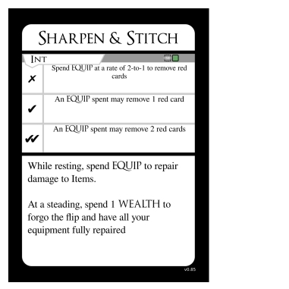
Sharpen and Stitch card
Damage to items is represented as black-side red cards
TODO

Item damage
Non-magical items can be damaged in Deckahedron World. Usually this happens narratively as the result of a GM move, but it can also be caused by player moves, eg. Armour Mastery.
The "one-hit, two-hit, over" mechanism is used to represent damage.
The first two times an item is damaged, place a red card on the Item card, black-side-up.
The third time an item is damaged, it is destroyed. Return it and the red cards to the supply.

More Power

Craft a Weapon
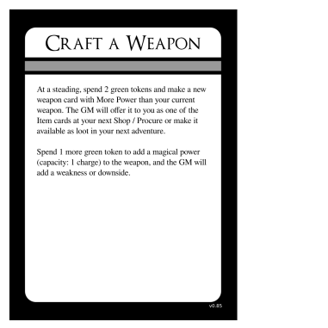
Craft a Weapon card

Weapon Mastery
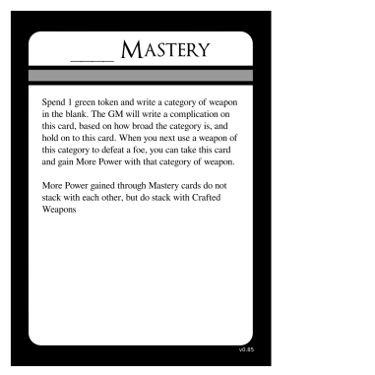
Weapon Mastery card

TODO

