Applying nsp_au_template.ott in OpenOffice.org
1. Open OpenOffice.org. (This next part is optional. If you do not wish to save the template to your templates section, skip to Step 3.) Press ctrl-O and navigate to and select nsp_au_template.ott. It should open. (Note: the template is in OOo 2.x format.)
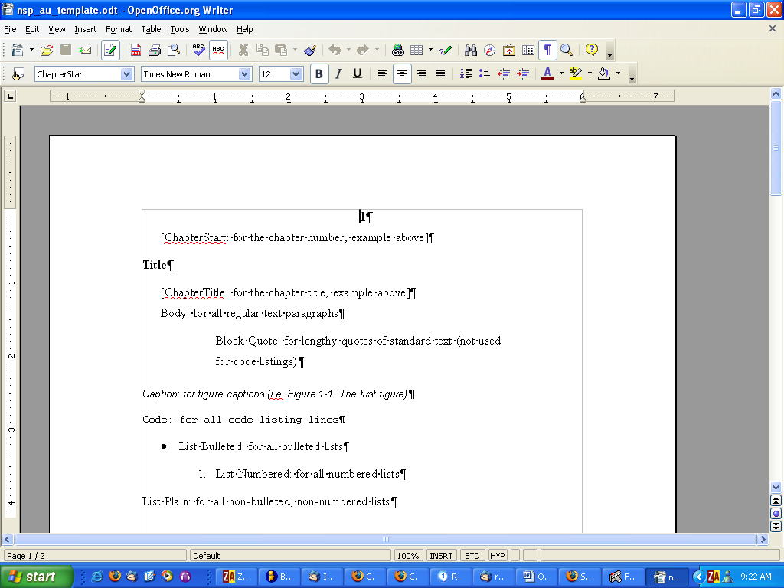

2. Choose FileTemplatesSave. Type nsp_au_template.ott into the Name field at the top of the window. Make sure that My Templates is highlighted, then click OK.
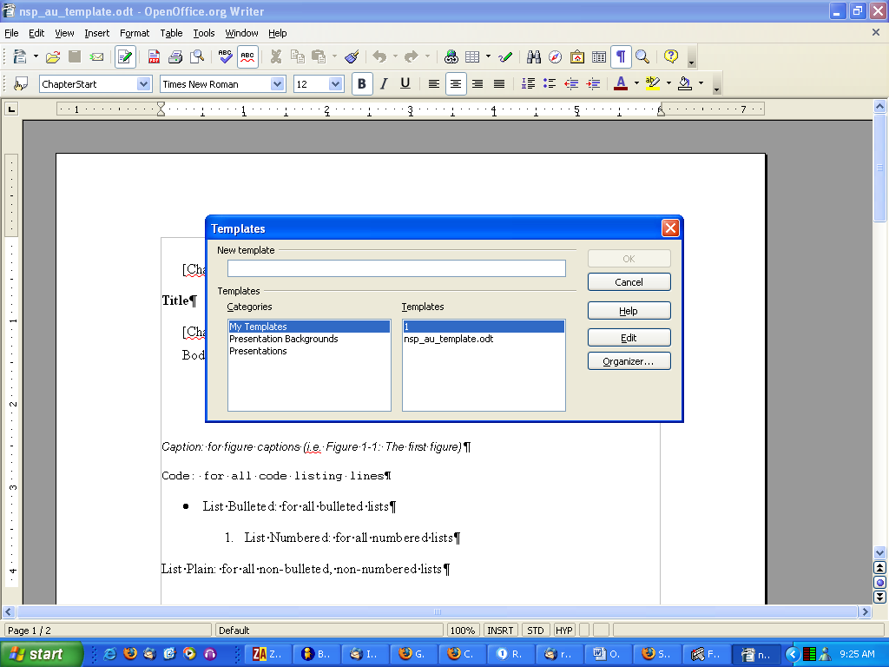

3. Open the chapter you are working on in OpenOffice.org.
4. Press F11 to open the Styles and Formatting window.
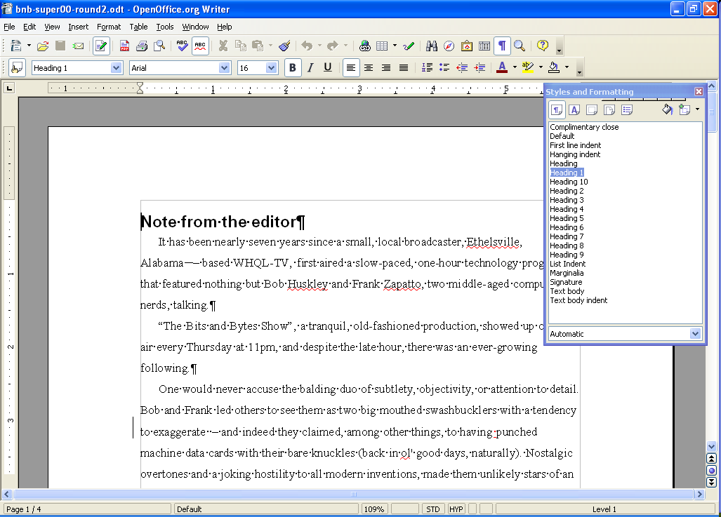
5. Click the button at the top right of the Styles and Formatting window (it has a + sign and a drop-down arrow), and select Load Styles. The Load Styles window should pop up (it is the same as the window you saw in step 2). If you are not saving the template, click the From File... button, navigate to your saved template, and click OK. If you’ve saved the template, be sure that My Templates and 1 are highlighted, then click OK.
6. Return to the Styles and Formatting window. Click the drop-down arrow at the very bottom (likely next to the word Automatic) and select All Styles. You should now see all the No Starch Press styles. If you want to see only the No Starch Press styles, choose Custom Styles.
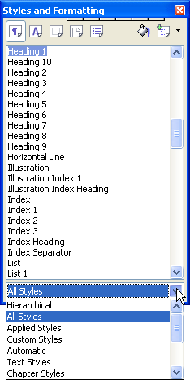

Here are some tips.
- Consider docking the Styles and Formatting window to one side of your OOo workspace. Just drag it off to the very edge and it should dock there.
- Once you’ve applied some styles (headings and such), you can choose Applied Styles from the drop-down menu at the bottom of the Styles and Formatting window to show only applied styles and reduce the clutter.
- Click the uppercase “A” icon to show character styles (EmphasisBold and such).

