SCHOOL FACILITIES RESERVATION AND MANAGEMENT SYSTEM
(SFRMS)



By:
Campilan, Stephen
Sambogan, Rosemarie
Uy, Esnaira

October 2024
Table of Contents

Introduction
Background of the Study 2

Statement of the Problem 3
Research Objectives 3
Data Flow Diagram
Context Diagram 7
Diagram 0 8
Child Diagram 9
Entity Relationship Diagram
Mapping Entity Relationship Diagram 10
Entity Relationship Diagram Relational Tables

INTRODUCTION

In University of Mindanao Digos College, effective management of resources is critical for enhancing the learning environment. The reservation of school facilities—such as gymnasiums, classrooms, computer laboratories, science laboratories, chapels, cookery rooms, taekwondo rooms, music rooms, and sports fields—plays a significant role in optimizing their use and ensuring equitable access for all students.
Each facility serves distinct educational purposes, catering to diverse learning styles and activities. For instance, gymnasiums are essential for physical education and extracurricular sports, promoting health and teamwork. Classrooms are the primary spaces for instruction, where foundational knowledge is imparted. Computer laboratories support technological literacy, equipping students with essential skills for the modern workforce. Science laboratories provide hands-on experience in experimentation and inquiry-based learning, fostering critical thinking.
Specialized facilities like cookery rooms and music rooms contribute to the development of practical and creative skills, encouraging students to explore their interests beyond traditional academics. The taekwondo room promotes physical fitness and discipline through martial arts, while chapels serve as spaces for reflection and community building. Additionally, sports fields are vital for outdoor activities, team sports, and physical development, enhancing students’ social skills and resilience.
Given the varying demands for these resources, effective reservation systems are vital. They help manage scheduling conflicts, ensure that all students have access to facilities, and maximize their usage throughout the school day. A systematic approach to reserving these facilities not only enhances logistical efficiency but also promotes a more inclusive and well-rounded educational experience.

Background of the Study

The management of school facilities has become increasingly complex due to rising enrollment numbers and diverse program that is offered by the university. As schools expand, the demand for various facilities—such as classrooms, laboratories, and sports venues—has intensified (Smith & Jones, 2020). Inefficient scheduling can lead to conflicts and ineffectiveness, negatively impacting both academic and extracurricular activities. This highlights the necessity for an organized approach to facility reservation that meets the needs of all users within the school community.
Information systems have been instrumental in optimizing various organizational processes, and the education sector is no exception. The integration of technology into facility management can enhance accessibility, allowing users to view real-time availability and make informed decisions (Taylor, 2019). By automating scheduling processes, educational institutions can minimize administrative overhead and reduce the likelihood of human error, which can lead to further complications in facility usage.
Moreover, the COVID-19 pandemic has underscored the importance of flexible facility management systems that can adapt to changing circumstances, such as social distancing requirements and the need for alternative learning environments (Johnson, 2021). This evolving landscape calls for a robust information system that not only facilitates reservations but also accommodates various scenarios and user needs. Such a system can ensure that facilities are used efficiently and safely, aligning with current health guidelines.
The development of a reservation system for school facilities is not only timely but essential for enhancing operational efficiency in educational institutions. By leveraging technology, schools can address the complexities of facility management while providing a user-friendly experience for students and staff alike (Lee & Kim, 2022).
Statement of the Problem

The management of school facilities is often hindered by inefficient scheduling practices, resulting in conflicts. Many educational institutions still use manual or outdated reservation methods, leading to issues such as double bookings and communication breakdowns among users. This study, the development of Digital School Facilities Reservation and Management System, will get rid of this apparent problem and will make the reservation process simpler and faster. Thus promoting a university that embraces the advancement of technology and integrates it to the day to day life and transactions. Specifically, this study aims to produce an information system (IS) and to answer the following questions:
1. How can an automated reservation system improve the efficiency of facility management in schools?
2. What specific features are necessary to enhance transparency and accessibility for all?
3. How can such a system foster better communication among students, staff, and administrators to optimize the utilization of school facilities?

Research Objectives
The study aims to investigate the current practices and challenges related to the reservation of these facilities, assessing their impact on student engagement, resource utilization, and overall educational outcomes. By understanding these dynamics, the research seeks to propose recommendations for improving facility management and access in educational settings.

1. To assess current reservation practices evaluate the existing processes for reserving school facilities and identify their strengths and weaknesses.
2. To identify barriers investigate challenges faced by students and administrators in accessing and managing reservations.
3. Enhance efficiency develop recommendations to streamline the reservation process and reduce scheduling conflicts.
4. To promote inclusivity ensure that all students have equitable access to various facilities to support diverse learning experiences.
5. To measure impact and analyze how improved reservation practices affect student engagement and overall educational outcomes.

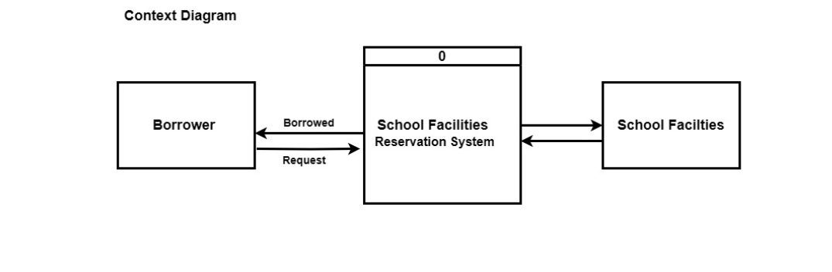

Data Flow Diagram

Diagram 0
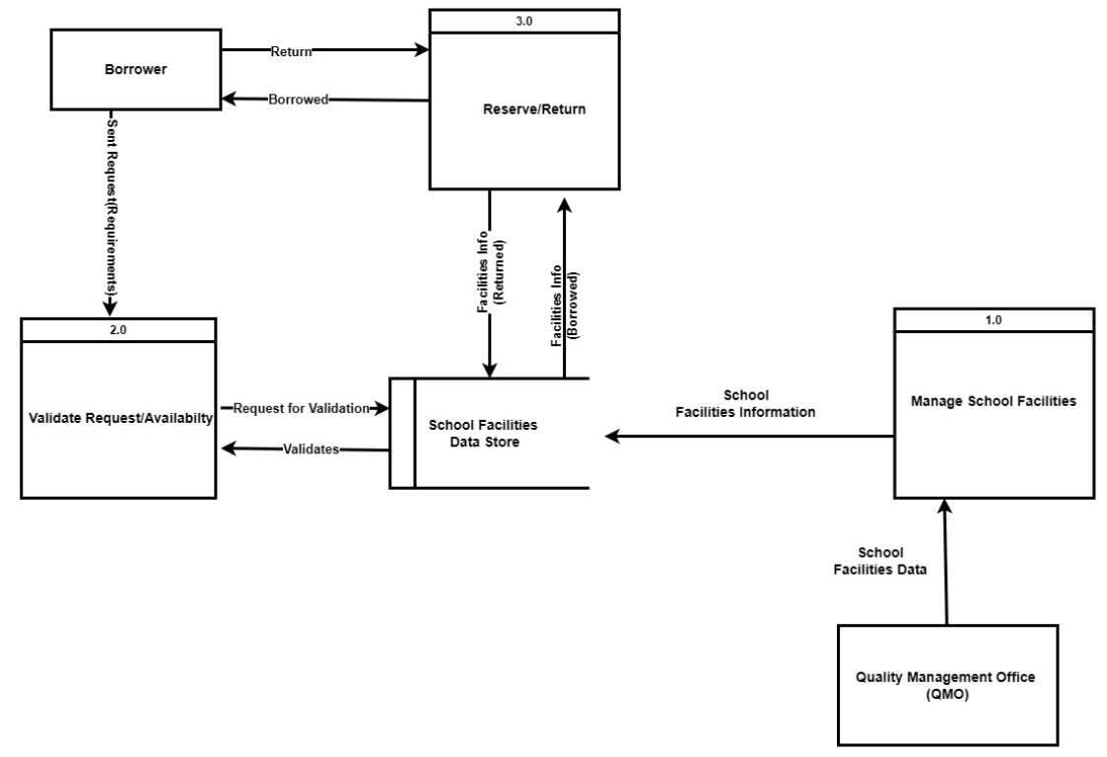

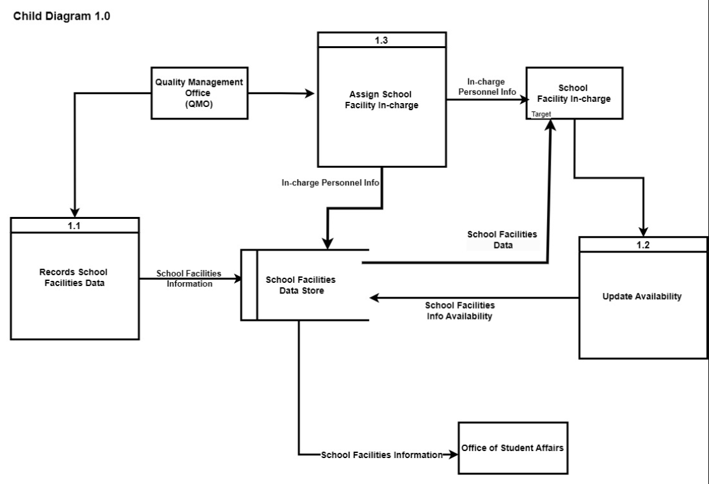

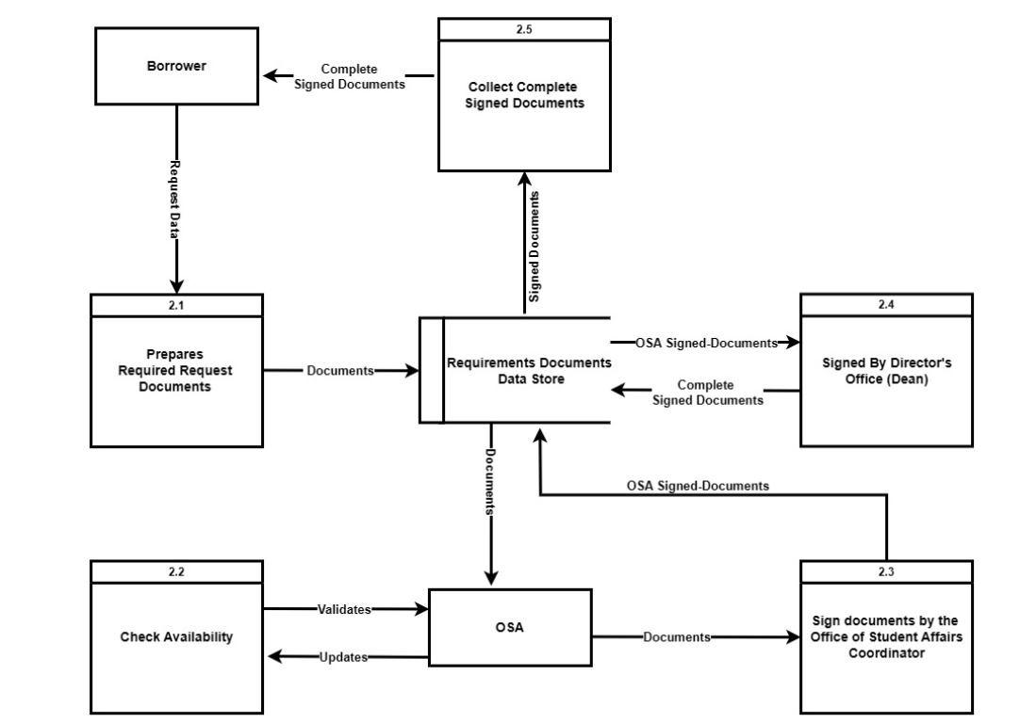
Child Diagram 2.0

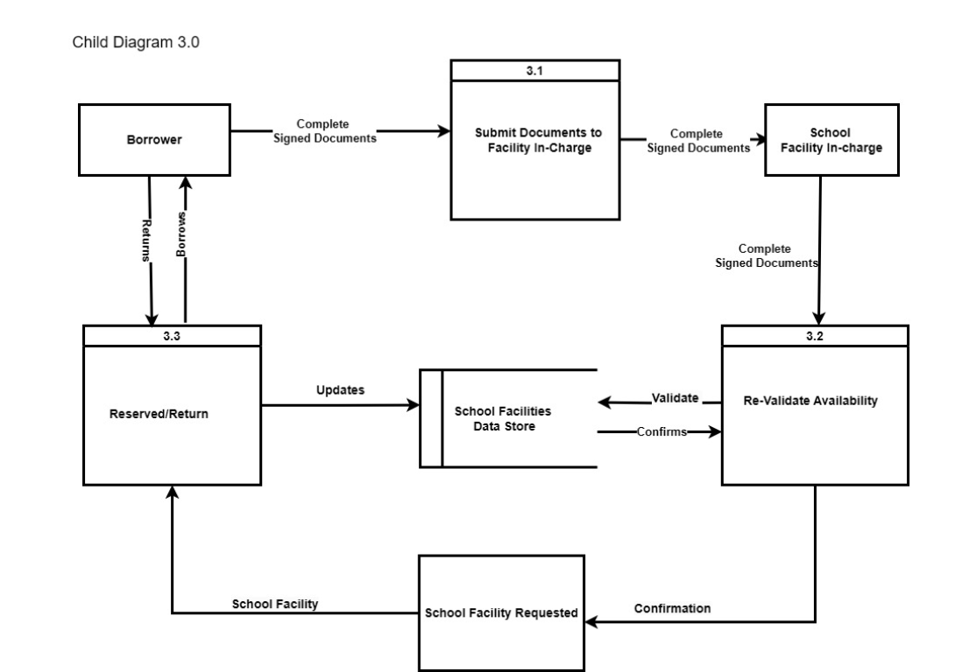

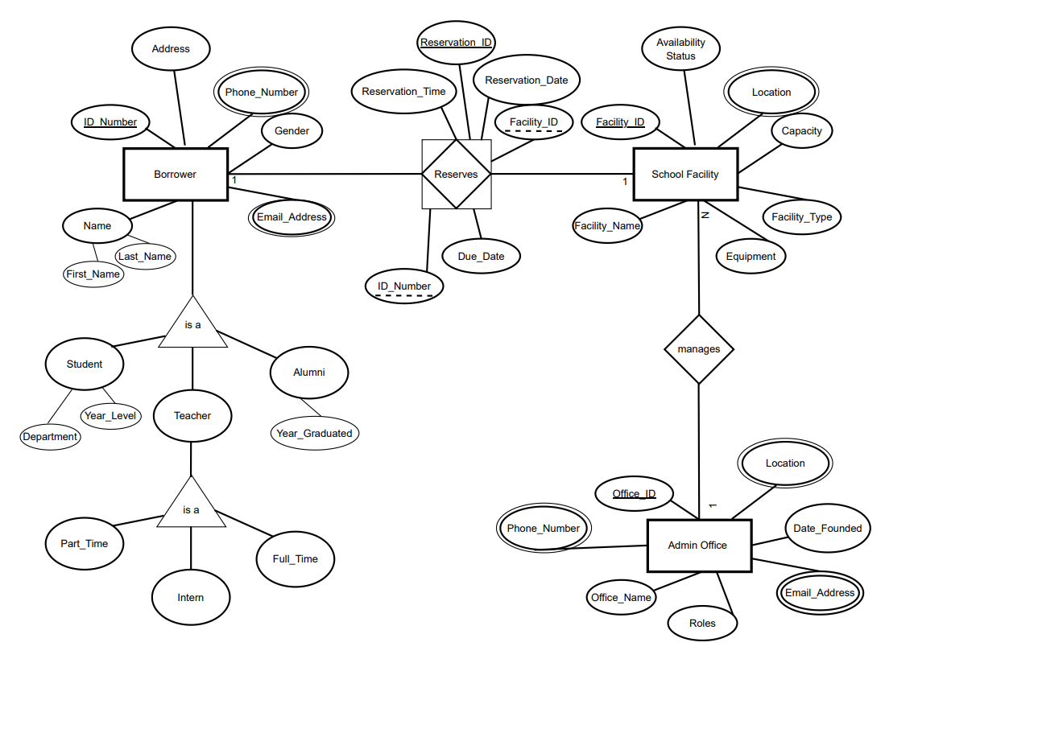
Entity Relationship Diagram

