XeroPathGenerator

# Introduction

One of the big challenges in FRC robotics is the autonomous mode. This is the 15 second time period at the start of a match where the robot must be 100% controlled by software. Within autonomous, moving the robot to a desired location is a big part of the problem. To date, the best approach for doing this is some form of path following algorithm. Path following is exactly what is sounds like it should be. A path is defined and the robot does its best to follow the path. Generally, the path is defined on a computer and then downloaded to the robot. The robot follows the path using a follower algorithm. There are several types of follower algorithms and it is not the intent of this document to get into these algorithms here. What is key is that these following algorithms either want the waypoints along the path as input, or they want periodic input of a very small scale. The XeroPathGenerator was written to provide a powerful and flexible application to generate the paths to be followed.

The XeroPathGenerator was written to be easy to extend. There are two key ways to extend the program. Fields can be added to the program by providing a graphics image for the field and a JSON file describing the field. Generators can be added by adding a new executable program that reads path description and robot descriptions, and outputs trajectories. This new executable is accompanied by a JSON file describing the generator.

The program ships with the PowerUp field and the Deep Space field. The program ships with the PathFinder V1 which is a blatant copy of the work from Jaci. It also ships with a backend generator known as CheesyGen which is a blatant copy of the path generation approach found in the Cheesy Poofs robot code. The CheesyGen generated paths have not been run (as of yet) on a real robot and therefore are considered very much alpha quality.

The program supports tank drive and swerve drive style drive bases. Error Code Xero is actively building a swerve drive as a summer project, but as of the writing of this document, it is not ready for test of this code by software. Therefore, all swerve drive support is very experimental and has not been tested on a real robot yet.

# Coordinates

Anytime we are dealing with the location of the robot, there is a coordinate system used as a reference. The XeroPathGenerator uses and X/Y coordinate system with the origin at the lower left-hand corner of the field. The X axis increases left to right and the Y axis increases top to bottom. The heading is measured in degrees. Zero degrees heading is looking in the direction of the positive X axis. Ninety degrees heading is looking in the direction of the Y axis.

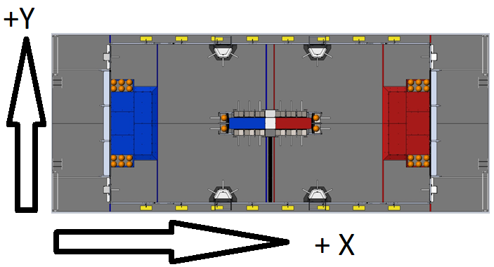

# Definitions

Waypoint A waypoint describes the location and orientation of the robot. It is represented by an X and Y coordinate as well as a heading angle.

Path A path is a set of waypoints that describe the desired path of travel for the robot.

Path Group A path group is a set of paths grouped together. While these paths can be grouped based on any organization, generally path groups are intended to describe a single autonomous mode.

Velocity This is the speed of the robot, measures in distance per time.

Acceleration This is the change in speed of the robot over time, measured in distance per time squared.

Jerk This is the change in acceleration of the robot over time, measured in distance per time cubed.

TrajectoryPoint A trajectory point describes the position, velocity, acceleration, and jerk for a single entity (robots, wheel, etc.) at specific point in time.

Trajectory A trajectory is a set of trajectory points that describe a path for and entity to follow. These points are usually provided at a fixed time or distance, but that is not a requirement.

# Windows

## Path File Window

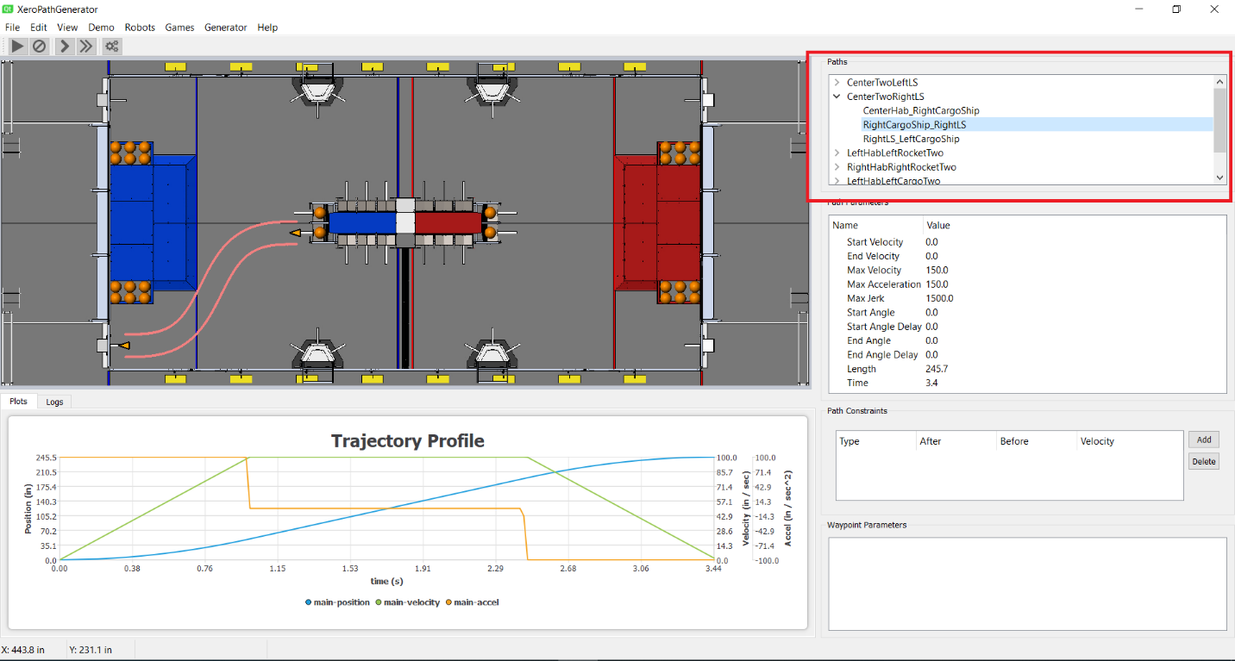

The path file window is in the upper right side of the application (highlighted here in red). It is a two-level display with the list of elements at the top level being the set of Path Groups. The elements below Path Groups are the Paths. Selecting a specific Path causes the path to be displayed in the Path View window and causes the Trajectory Profile to be displayed in the Trajectory Profile window.

## Path Properties Window

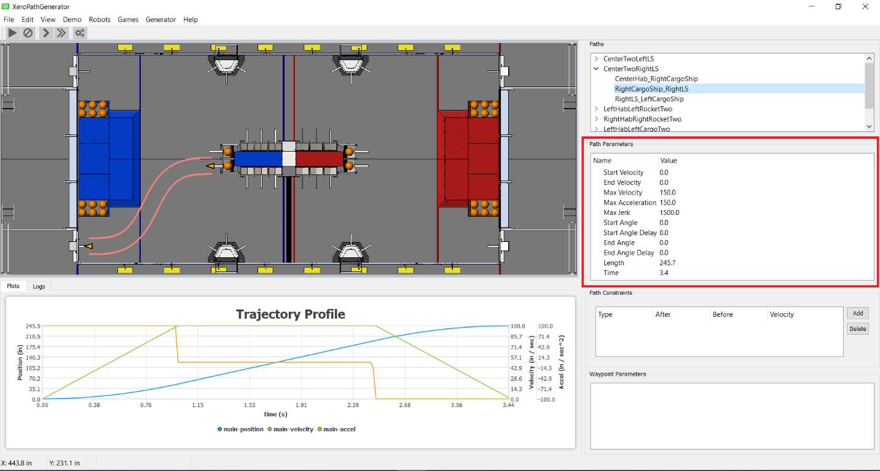

The path properties window is a property editor window just below the Path File window. This property editor provides a way for the properties associated with a path to be changed. The following properties are available.

|  |  |
| --- | --- |
| Name | Description |
| Start Velocity | The starting velocity of the robot when this path is started. This allows two paths to be concatenated with the robot in motion. |
| End Velocity | The ending velocity of the robot when the path is complete. |
| Max Velocity | The maximum velocity of the robot when executing this path. |
| Max Acceleration | The maximum acceleration of the robot when executing this path. |
| Max Jerk | The maximum jerk of the robot when executing this path. Not all path generators honor this value. |
| Start Angle | For swerve drive only, this is the angle the robot is facing at the start of the path. |
| Start Angle Delay | For swerve drive only, this is the delay from the start of the path before the robot starts to rotate to the desired end angle. This value gives the robot time to clear any obstructions before trying to rotate. |
| End Angle | For swerve drive only, this is the angle the robot is facing at the end of the path. |
| End Angle Delay | For swerve drive only, this is the delay from the end of the path when the robot much reach the end angle. This prevents the robot from trying to complete a rotation as it approaches and obstruction. |
| Length | This property is read only and display the length of the path in the user’s chosen distance units. |
| Time | This property is read only and displays the time of the path in seconds. |

## Constraint Window

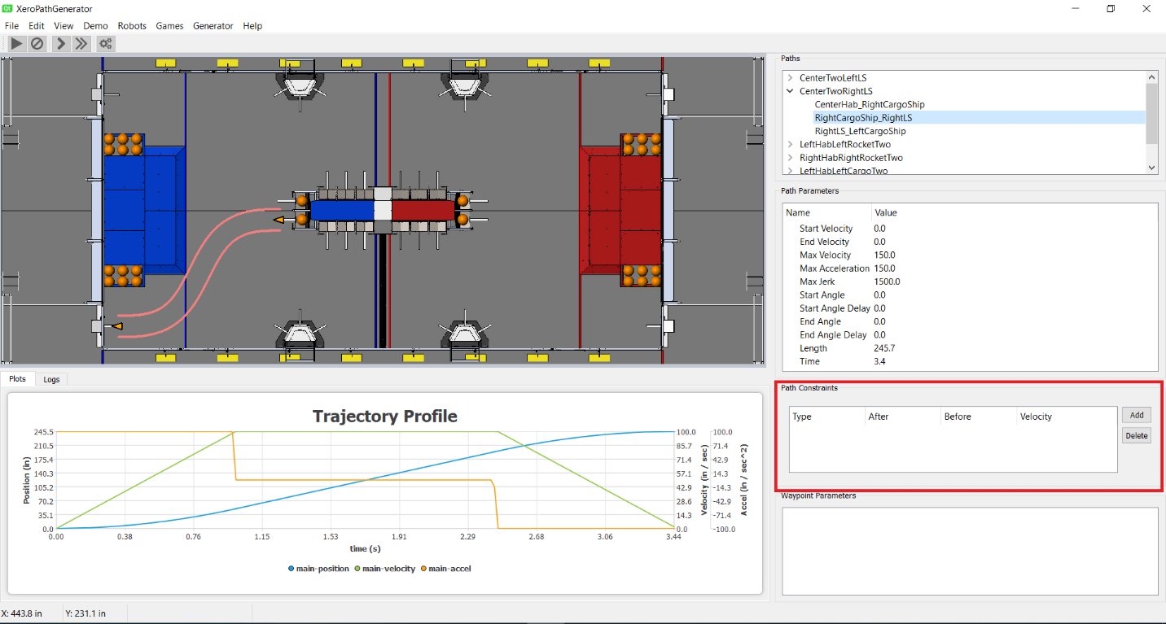

The constraint window provides a way to add constraints to the current path. Currently the only type of constraint is the ability to limit the velocity of the path for portions of the path. The portion of the path is selected by an “after” distance along the path and a “before” distance along the path. The constraint is specified by the velocity given and is applied after the “after” distance and before the “before” distance. Note, not all path generators can process these constraints. If a path generator cannot honor the constraints, the entire path is constrained to the lowest constraint velocity in the path.

## Waypoint Window



The waypoint window displays the properties of the current waypoint if a waypoint is selected. This window displays the X and Y coordinates, the heading, the index, and the distance along the path for the selected waypoint. The X and Y coordinates as well as the heading can be edited in this window.

## Path Editing Window

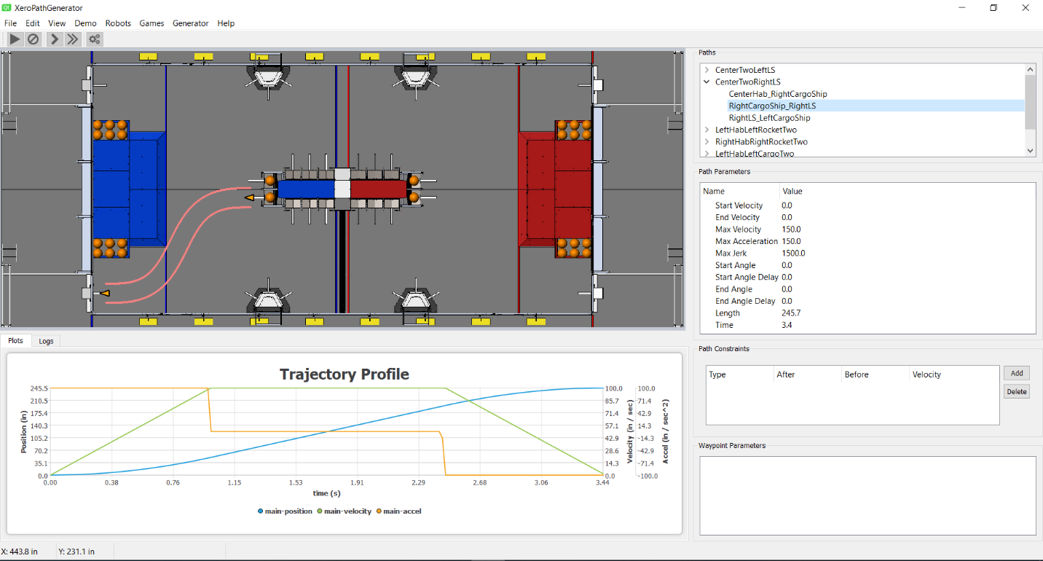

The path editing window is used the edit path. When a path is selected in the Path File window, the path is displayed in the path editing window. Here, individual waypoints can be selected with the left mouse button. Selected waypoints can be moved by dragging the waypoint with the left mouse button down. Finally, a waypoint can be rotated by dragging the yellow rotation circle attached to a selected waypoint and moving the mouse around the waypoint. In addition the following keys are useful.

Up Arrow – moves the waypoint up 12 inches

Shift Up Arrow – moves the waypoint up 1.0 inches

Down Arrow – moves the waypoint down 12 inches

Shift Down Arrow – moves the waypoint down 1.0 inches

Left Arrow – moves the waypoint left 12 inches

Shift Left Arrow – moves the waypoint left 1.0 inches

Right Arrow – moves the waypoint right 12 inches

Shift Right Arrow – moves the waypoint right 1.0 inches

Page Up - Rotate current waypoint counterclockwise 5.0 degrees

Shift Page Up - Rotate current waypoint counterclockwise 0.5 degrees

Page Down - Rotate current waypoint clockwise 5.0 degrees

Shift Page Down - Rotate current waypoint clockwise 0.5 degrees

Insert – Insert a new waypoint after the current waypoint, unless you have the last waypoint selected

Delete – Delete the currently selected waypoint, unless it is the first or last waypoint

## Trajectory Profile Window

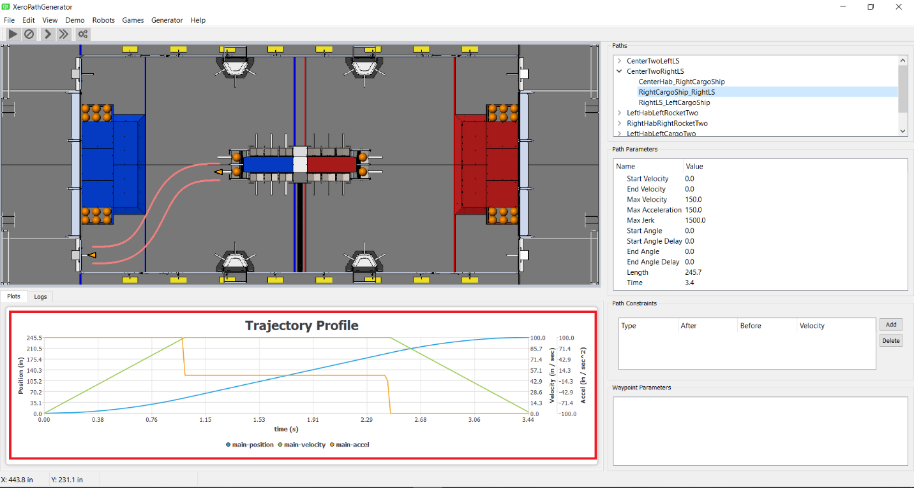

The trajectory window is located below the Path Editing window when the Trajectory tab is selected. This shows the generated trajectory for the currently selected path. There are many different variables that can be displayed and these are selected by the View/Plot Variables menu item. By default, the position, velocity, and acceleration of the robot are displayed.

## Log Window

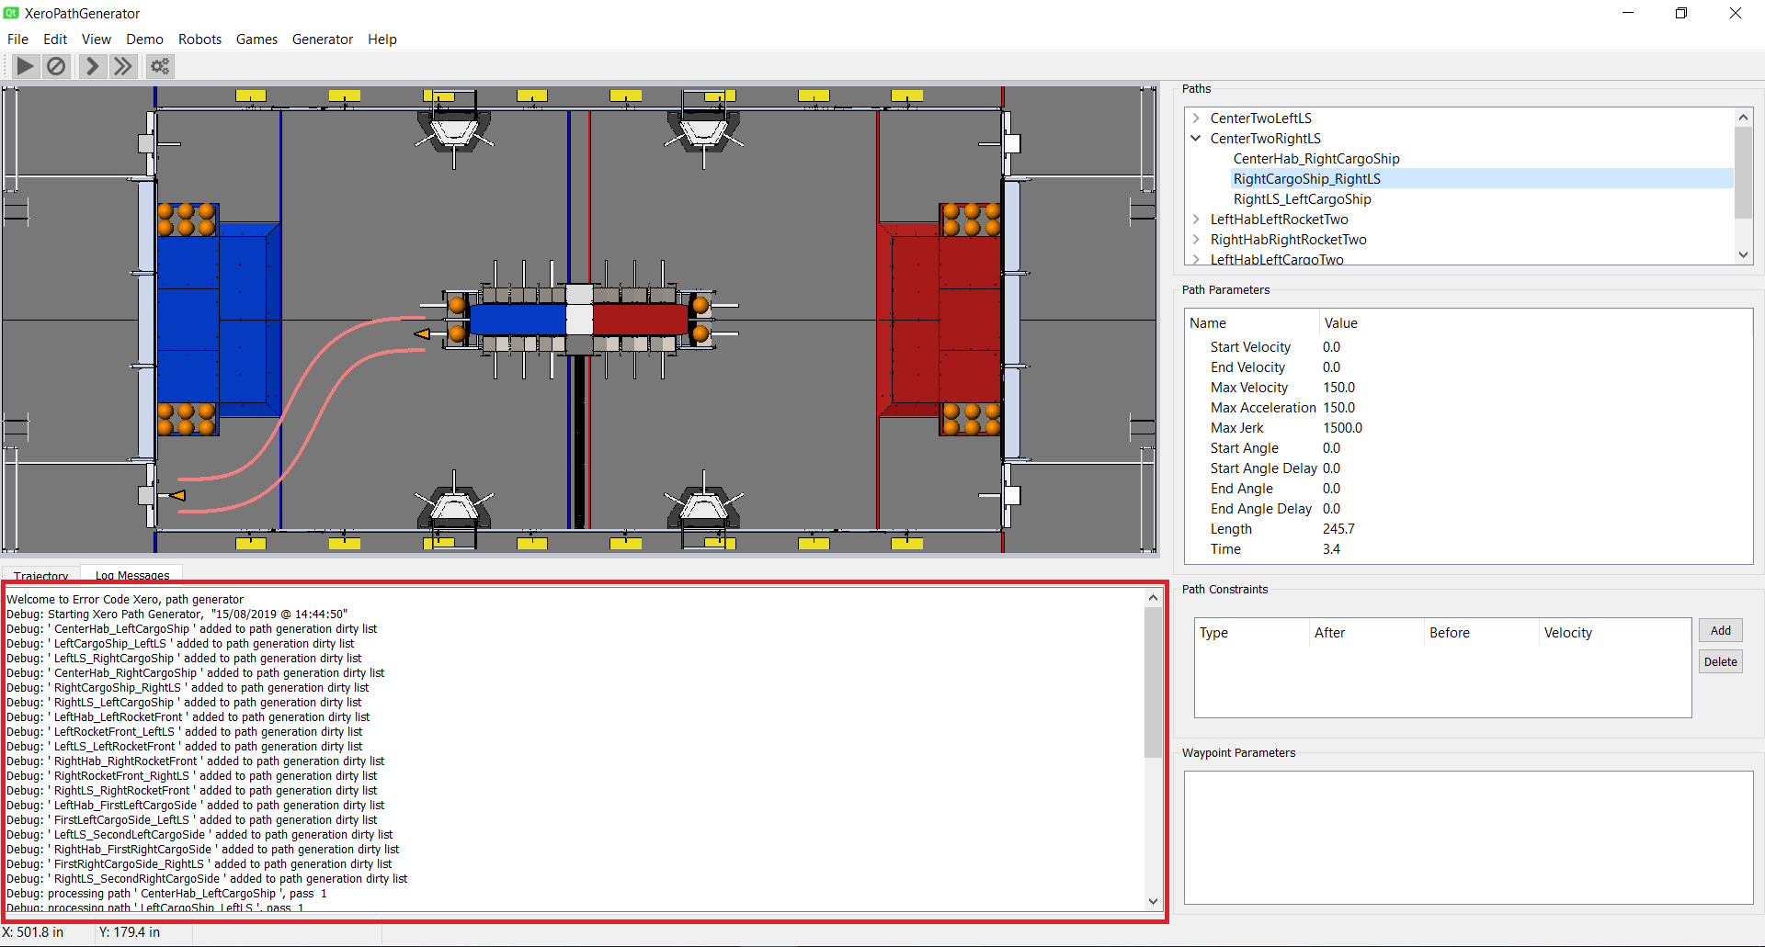

The Log File window is displayed below the Path Editing window when the Log File tab is selected. This window should be rarely needed but is useful when something is not working as expected.

# Getting Start

## Define a robot

When the program is first started, no robot is defined. The program will prompt you to create a robot. Creating a robot consists of describing the physical attributes of the robot. This includes the width, length, maximum velocity, maximum acceleration, maximum jerk, drive type, and the timestep for the robot control loop controlling the drive base. Note, additional robots can be defined at any time via the Robots/New Robot menu item. Robots may also be delete via the Robots/Delete Robot menu item.

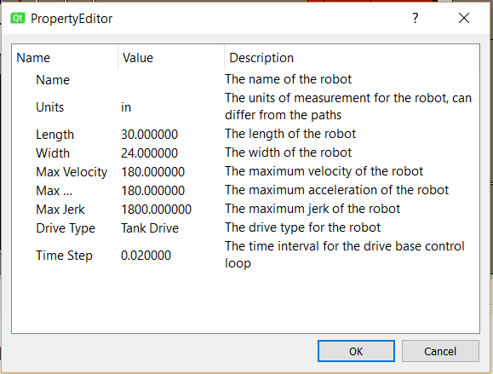

## Create a path group

Now create a new path group. Creating a new path group is done with the Edit/Add Path Group menu item. This creates a new path group named “New Group” which will be seen in the Path File window. This path can be renamed by double clicking the name “New Group” in the Path File window.

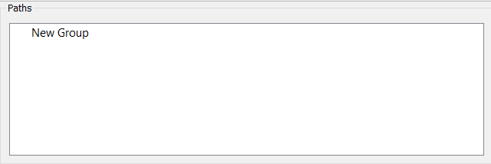

## Create a path

Now create a new path by selecting the path group in the Path File window and selecting the menu item Edit/Add Path. A new path named “New Path” will be created and can be seen in the Path File window.

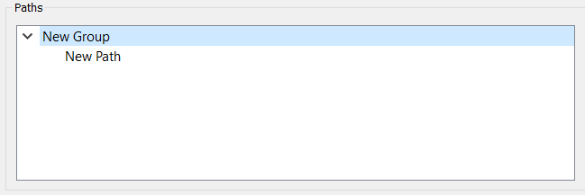

## Edit the path

Selecting the path in the Path File window will cause the path to be displayed in the Path Editing window. Each new path starts at the origin (0, 0) and extends right 100 inches. To edit the path, grab the first waypoint at the origin and move it to a new location on the field. To make fine adjustments for a path location, either use the arrow keys (with shift down for really fine adjustments), or type the coordinates desired in the waypoint window. Insert new waypoints using the insert key. Note as the path is edited, the trajectory window will update after a small delay with the updated trajectory.

## Save the path file

When all the desired paths are complete, save the path file via the menu item File/Safe (or File/Save As). Navigate to the desired folder and save your paths.

## Generate the trajectories

Finally, to generate paths, use the File/Generate (or file Generate As) menu item. This will generate a set of trajectory files in the chosen directory. Several files will be generated for each path. Each of these files will contain the name of the path group, the name of the path, and the target element for the output file. Target elements include the robot, and for a tank drive, the left and right motors. For a serve drive, a trajectory file is generated for the main robot and each of the four wheels.

# Menus

## File Menu

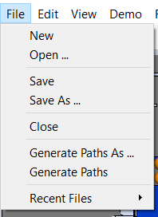

The file menu contains the following menu items:

|  |  |
| --- | --- |
| New | Create a new path file. If there are any unsaved changes with the existing path file, you will be prompted to ensure they are not lost. |
| Open | Open a new path file. A file dialog is opened to allow you to select a new path file. If there are any unsaved changes with the existing path file, you will be prompted to ensure they are not lost. |
| Save | Save the current path file to disk. If there is no filename associated with the current path file, the program will prompt for a new file name. |
| Save As | Save the current path file to disk, prompting for the name of a file on disk. |
| Close | Close the current path file. |
| Generate Paths As | Generate trajectory files for the current paths. The program prompts for a directory to store the generated trajectory files. |
| Generate Paths | Generate trajectory files for the current paths. If there is already a destination directory, these files will be saved there. If not, the program prompts for the name of a directory. |
| Recent Files | This is a submenu that contains the names of the last four path files that have been successfully opened. This is an easy shortcut to open a recently used file. |

## Edit Menu

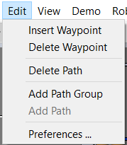

## View Menu

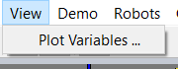

## Demo Menu

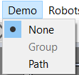

## Robots

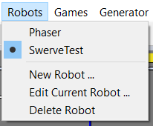

## Games

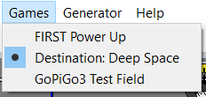

## Generators

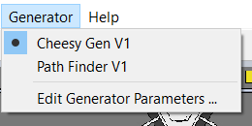

## Help

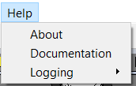

# Demo Mode

The