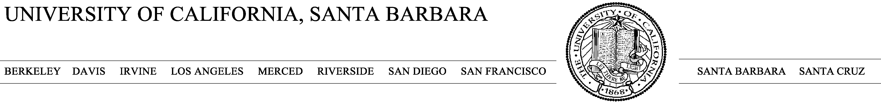

Hillary Young

Ecology, Evolution and Marine Biology

UC Santa Barbara

Santa Barbara, CA 93111 October 23, 2023

To CDFW:

I am writing to indicate my sponsorship Stephanie Copeland for a CDFW permit. Below I highlight some of Stephanie's qualifications.

Research Background: Stephanie is very qualified to conduct this research Stephanie has extensive research background in a wide range of field contexts. Notably she has multiple publications already accepted with others in review or in preparation. During her undergraduate work she won awards for the quality and promise of her independent research, and she has been awarded NSF’s GRFP for the quality and promise of her research ideas. Between her graduate and her undergraduate work, she has taken a suite of relevant coursework, including GIS, ecological modeling, and statistics. She served as my lab manager and technician for two years before I brought her on as a graduate student and during that time was the day-to-day lead in managing a large NSF funded project, including organizing and supervising large teams in the field and making real-time decisions on data collection and curation, which she always did superbly, often in difficult and remote conditions.

Mentorship: Stephanie has repeatedly demonstrated a strong commitment to mentorship. In this past year she has been working closely with several undergraduates and is now working to find a way to allow them to coauthor a paper from this work. She also has training in wilderness medicine which will help ensure the safety of her field team.

Proposed Activities: Stephanie’s research revolves around understanding interacting effects of changing faunal communities, human use and climate on mosquito and their feeding behavior in California. Her field work will use natural experiment variation in human use, trout presence and climate to answer this question. Stephanie has been working on mosquitos and other vectors for several years now and has all the skills necessary to conduct this important work.

In short, I believe Stephanie is well qualified to conduct this work and I am happy to sponsor her in this application.

Sincerely,

