Simulate a random normal distribution for 5,whose mean is 5 and standard deviation 2.5, find the result in array

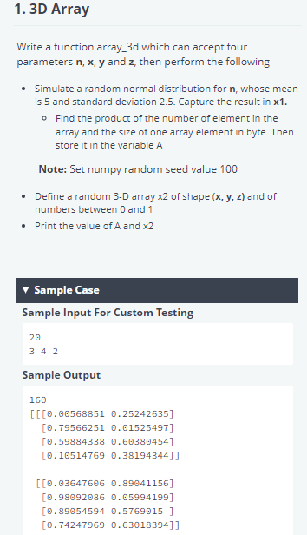

import numpy as np

# Enter your code here. Read input from STDIN. Print output to STDOUT

def array_3d(n, x, y, z):

    #Write your code below

    np.random.seed(100) # setting seed

    x1=np.random.normal(5.0, 2.5, n)

    #mean=5, Standard Deviation=2.5,

A=(x1.size)*(x.itemsize)

X2=np.random.rand(x,y,z)

print(A)

Print(x2)

if __name__ == "__main__":

    n=int(input())

    x, y, z=list(map(int,input().split()))

    array_3d(n, x, y, z)

**Explanation:**

import numpy as np

np.random.seed(100)

# Enter your code here. Read input from STDIN. Print output to STDOUT

def array_3d(n, x, y, z):

   #Write your code below

   norm=np.random.normal(loc=5,scale=2.5,size=n)

   a=norm.itemsize*norm.size

   print(a)

   # First Part over

   # lets start second part

   Threedarr=np.random.rand(x,y,z)

   print(Threedarr)