John Wetters

Autoassociative Memory performance with and without pseudoinverse weight matrix

Objective
Develop a Matlab program to demonstrate a neural network autoassociative memory. Show the importance of using the pseudoinverse in reducing cross correlation matrix errors. Show the performance of the autoassociative memory in noise. The results are contained in the Matlab file assoc_mem_demo.m

Theory
Autoassociative memory is used in pattern recognition to store and recall a set of patterns even if the input vector has been corrupted by noise. For autoassociative memory the target vector t equals the input vector p. The weight matrix W is then

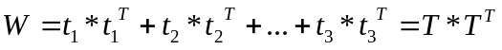 Equation 1

where T is a matrix made up of the target vectors and 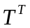is the transpose of the target matrix.

To recover the stored pattern from the noisy input we use the symmetrical hard limit function at –1 and 1, hardlims provided in the neural network toolbox. If you don’t have the neural network toolbox it is easy to make you own function, just make a function who’s output is limited to –1 and 1. The output of the function a, is the hardlims function of 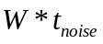

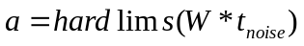 Equation 2

We can then calculate the number of errors of the target vector vs. the recovered vector a by calculating 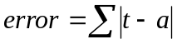.

When the target input patterns are not orthogonal (independent column space), errors are made in the autoassociative memory output, a. To fix this problem we can take the pseudoinverse of the target matrix T to minimize the cross correlation between input vectors t.

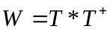 Equation 3

The weight matrix W is the target matrix T times the pseudoinverse of the matrix T (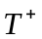). Many problems have non-orthogonal target input patterns where the number of rows m of the target matrix is greater than the rank r of the target matrix, therefore the pseudoinverse is needed to use autoassociative memory. For example in the character recognition problem below the target character matrix is 35x26 (35 rows with 26 columns). The rank of the matrix is 26. Therefore the target matrix in non-orthogonal and to use autoassociative memory without errors in the output vector, the pseudoinverse is needed to generate the weight matrix W. The demo program (assoc_mem_demo.m) illustrates the difference in the number of errors using the pseudoinverse and not using the pseudoinverse.

Method
Matlab was used as the program to test the character recognition autoassociative memory problem. The problem is to recover the letters of the alphabet (A-Z) in noise using an autoassociative network. The characters are encoded into 26, 35 length target vectors that can be plotted in a 7 by 5 output matrix. The problem is divided into 5 sections 1) generating the alphabetical target vectors, 2) calculating the weight matrix W with the pseudoinverse, 3) testing the autoassociative memory without noise,
4) testing the autoassociative memory with noise, and 5) comparing to the results without using the pseudoinverse. The Matlab file assoc_mem_demo generates all the test sections.

Generating the target vector matrix
The first task is to develop the target vectors of letters of the alphabet.

%%%%%%%%%%%%%%%%%%%%%%%%%%%%%%%%%%%%%%%%%%%%%%%
%1) generating the alphabetical target vectors
%%%%%%%%%%%%%%%%%%%%%%%%%%%%%%%%%%%%%%%%%%%%%%%

load alpha.mat %matrix of 35x26,7x5 alphabetical characters

[m,n] = size(alpha) %check matrix loaded correctly m=35 n=26

%A=alpha(:,1); %A is the first column of alpha
%A to Z are the columns of alpha

%plot out A
A=alpha(:,1); %A is the first column vector
plot_vector7_5(A)
title('7x5 plot of "A"')
Figure 1 Code to develop target vectors

Since we are using a hard limiting transfer function at –1 and 1 in the autoassociative network, we need to map the range of the alphabetical characters from –1 to 1. The next step is to develop a routine to plot out the 35x1 vectors characters into a 7x5 array. This is done by the plot_vector7_5 function listed below.

%plot a 2 dimensional matrix using image command
%Plot a 35 element vector as a 7x5 grid.

function plot_vector7_5(vector)

%convert 35x1 vector into 7x5 array out
n=1;
for i=1:7
out(i,:)=vector(n:n+4)';
n=n+5;
end
%plot out vector with imagesc function
figure
min_value=min(min(out));%find min value of out array
max_value=max(max(out));%find max value of out array
clims=[min_value max_value];%set min and max colorbar limits
imagesc(out,clims)
colormap('jet')
colorbar
H = gca;
set(H,'YDir','reverse')
Figure 2 –plot_vector7_5 function for plotting 7x5 character matrix

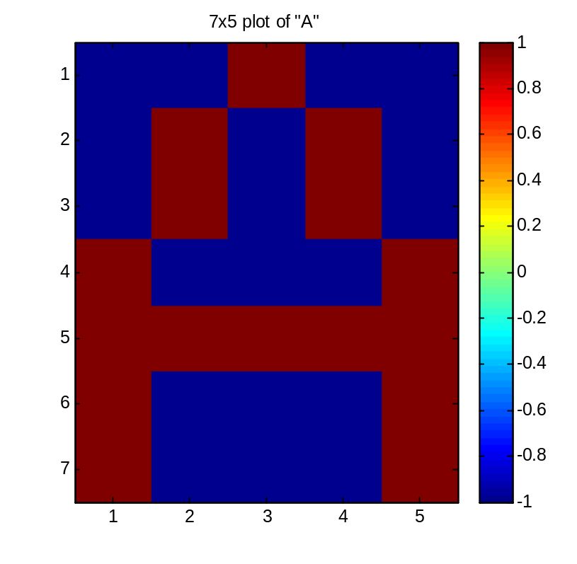
Figure 3 – plot of the letter “A”

Figure 4 illustrates the target vector for “A” plotted in the 7x5 matrix. The plot_vector7x5 function can be used to plot all the letters from A to Z by typing plot_vector7x5(alpha(i)) in the Matlab command window where i is the corresponding number of the alphabetical character from 1 to 26.

Calculating the weight matrix W with the pseudoinverse
An important step in using associative memory is to make the column space of the weight matrix independent, otherwise character errors will result in the output. The column space of the alpha matrix is not invertable since the row space is larger than the column space (35x26). The solution is to take the character matrix alpha times the pseudoinverse of the character matrix alpha to get the character weight matrix W.

%%%%%%%%%%%%%%%%%%%%%%%%%%%%%%%%%%%%%%%%%%%%%%%
% 2) calculating the weight matrix W with the pseudoinverse
%%%%%%%%%%%%%%%%%%%%%%%%%%%%%%%%%%%%%%%%%%%%%%%

pinv_alpha=pinv(alpha);%take the pseudoinverse of alpha to make orthogonal matrix to reduce errors

[m,n] = size(pinv_alpha)

if (strcmp(reply,'y'))
W=alpha*pinv_alpha;%calculate weight vectors W using alpha*pseudoinverse
PlotRealMatrix(W)
title('weight matrix with psuedoinverse')
else
%%%%%%%%%%%%%%%%%%%%%%%
%5) comparing to the results without using the pseudoinverse
%this is a test to see what happens without pseudoinverse
%%%%%%%%%%%%%%%%%%%%%%%
W=alpha*alpha';
PlotRealMatrix(W)
title('weight matrix without psuedoinverse')
end

Figure 4 Calculation of the weight matrix W

In the code shown in Figure 4, the user can select between calculating the weight matrix W with the pseudoinverse as shown in equation 3 and without the pseudoinverse (equation 1).

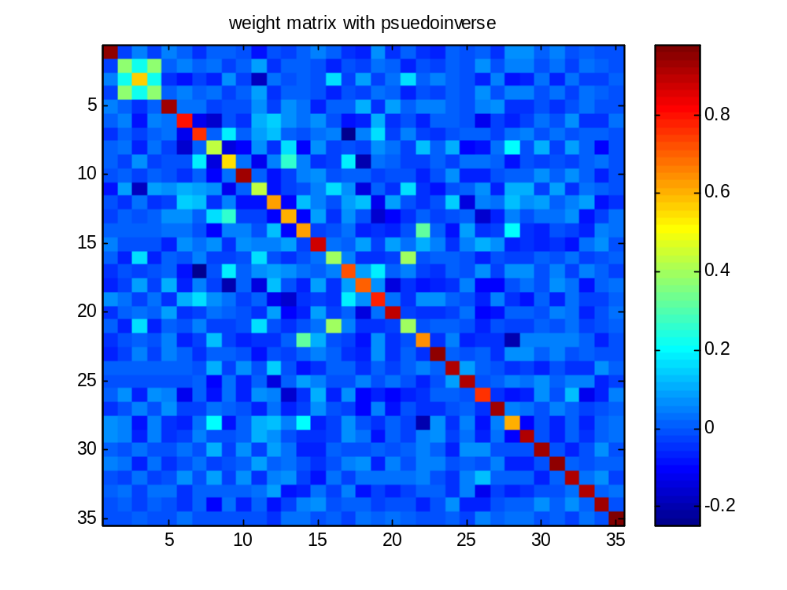
Figure 5 – Matrix image of Weight matrix with pseudoinverse

As shown in Figure 5 using the pseudoinverse for the weight matrix calculation results in a matrix with the appearance close to the identity matrix.

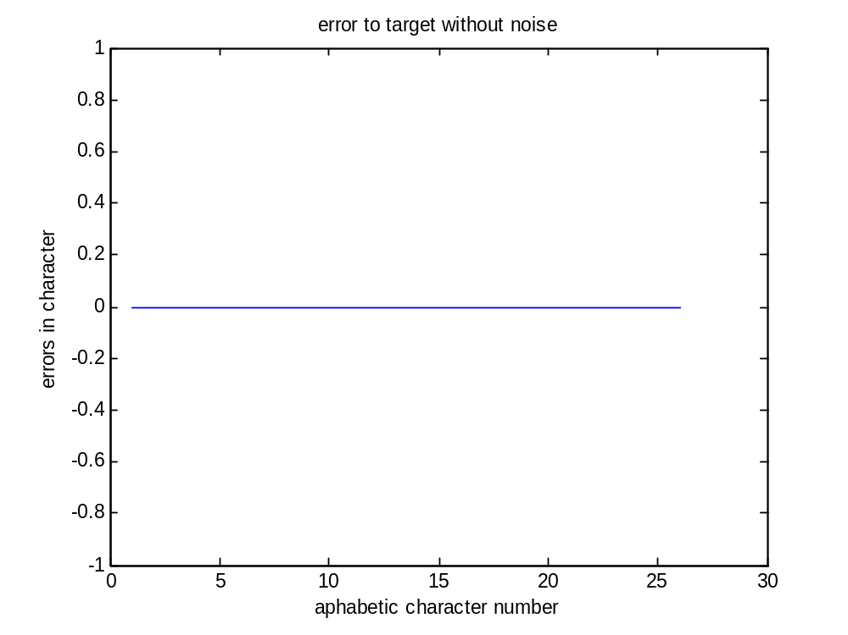
Figure 6 – Character errors with no noise
As shown in Figure 6 there were no errors in all 26 alphabetical characters (A-Z) with no added noise in the signal.

Testing the autoassociative memory without noise
%%%%%%%%%%%%%%%%%%%%%%%%%%%%%%%%%%%%%%%%%%%%%%%
%3) testing the autoassociative memory without noise
%%%%%%%%%%%%%%%%%%%%%%%%%%%%%%%%%%%%%%%%%%%%%%%

error_save=[]

%plot without noise
for i=1:26

a=hardlims(W*alpha(:,i));
t=alpha(:,i);
error=sum(abs(t-a)) %calculate number of errors
error_save=[error error_save];

% plot_vector7_5(t) %plot target
% title('target')
%
% plot_vector7_5(a) %compare to simulated output
% title('simulated')

end

figure
plot(error_save)
title('error to target without noise')
xlabel('aphabetic character number')
ylabel('errors in character')

Figure 7 –Code to calculate autoassociative memory and error plot w/o noise

Testing the autoassociative memory with noise
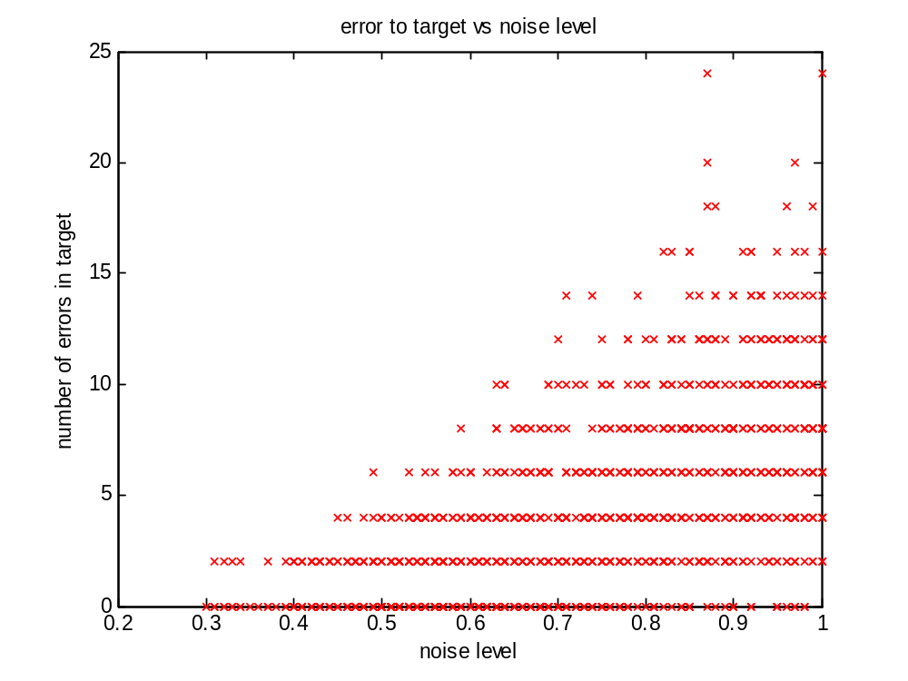
Figure 8 – Character errors vs. noise level

As shown in Figure 8 character errors start at a noise level of about .3 or about –10dB from the signal level (1).

%%%%%%%%%%%%%%%%%%%%%%%%%%%%%%%%%%%%%%%%%%%%%%%
%4) testing the autoassociative memory with noise
%%%%%%%%%%%%%%%%%%%%%%%%%%%%%%%%%%%%%%%%%%%%%%%
error_save=[]
noise_save=[]

noise_range = .3:.01:1;
for noiselevel = noise_range
%plot noise
P = alpha + randn(35,26)*noiselevel;
for i=1:26

in=P(:,i); %input has noise
% test=W*t;
% plot_vector7_5(test)
% title(['with noise without limiting ' num2str(noiselevel)])

a=hardlims(W*in);
% plot_vector7_5(a)
%title(['with noise with limiting' num2str(noiselevel)])
t=alpha(:,i);
error=sum(abs(t-a)) %calculate number of errors
error_save=[error error_save];
noise_save=[noiselevel noise_save];
end
end

figure
plot(noise_save,error_save,'rx')
title('error to target vs noise level')
xlabel('noise level')
ylabel('number of errors in target')

Figure 9 –Code to calculate and plot character errors in noise

Errors using weight matrix without pseudoinverse
What happens to character errors if we don’t take the pseudoinverse in calculating the weight function? We rerun the program exactly as before selecting the option to not use the pseudoinverse and look at the new image of the weight matrix and autoassociative network errors with and without noise.

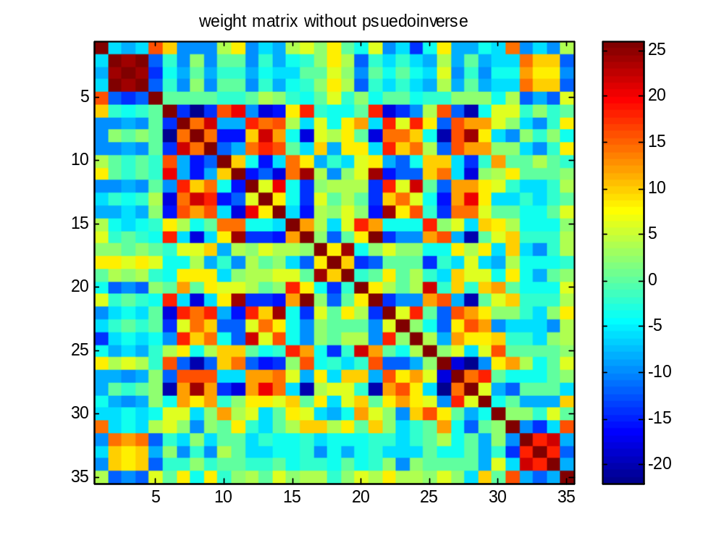
Figure 10 – Weight matrix without pseudoinverse

Notice the difference in the magnitude of the values of the weight matrix with and without using the pseudoinverse (Figures 5 and 10). Using the pseudoinverse in Figure 5 limits the range of the weight matrix from 0 to 1. Not using the pseudoinverse results in a larger range of values –20 to 25. The off diagonal elements have a lot higher values. This indicates cross correlation between characters. Next we find the character errors without noise.
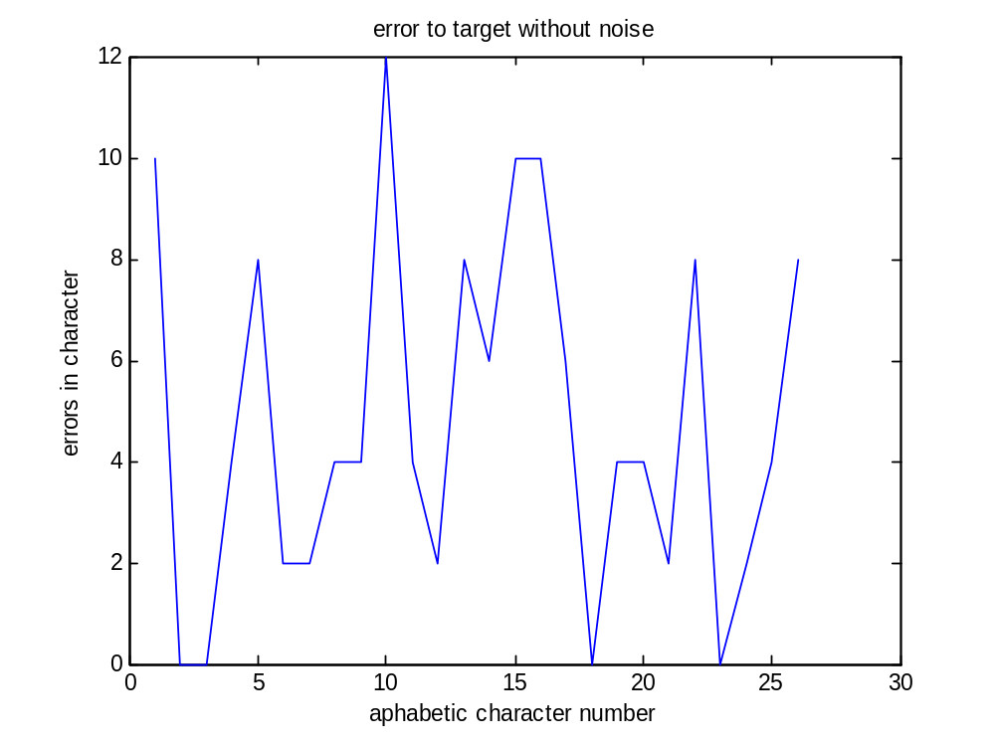
Figure 11 – character errors without pseudoinverse weight matrix

Notice that in Figure 11 (vs Figure 6) there are significantly more character errors without noise when the pseudoinverse is not used in the weight matrix! This is caused by the cross correlation in the column space between characters that are in the autoassociative memory calculation. This is the main reason for using the pseudoinverse. Finally let’s look at the performance of autoassociative memory with noise.

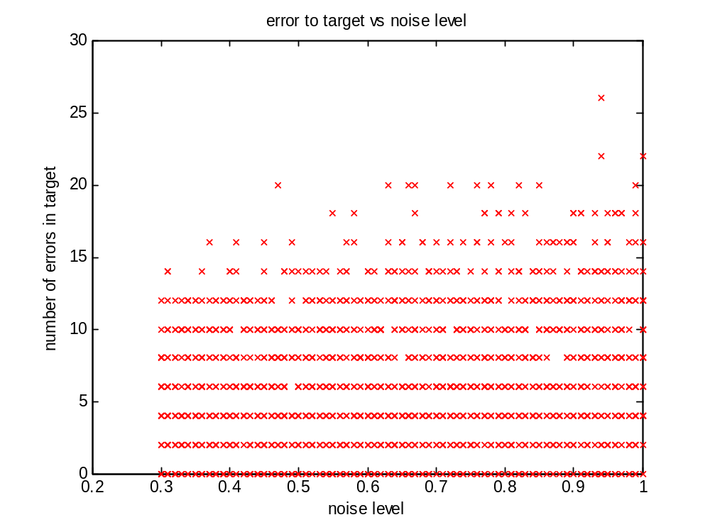

Figure 12 – performance of autoassociative memory in noise without pseudoinverse weight matrix

Comparing Figure 8 and Figure 12 the autoassociative memory using the pseudoinverse has much improved performance in noise which follows from the performance without noise.

Utility functions
Function plot_matrix1 to plot a 2 dimensional matrix of real numbers.

%plot a 2 dimensional matrix of real numbers using imagesc command
function PlotRealMatrix(matrix)

figure
min_value=min(min(matrix));
max_value=max(max(matrix));
clims=[min_value max_value];
imagesc(matrix,clims)
colormap('jet')
colorbar
H = gca;
set(H,'YDir','reverse')

