1)

X1 = Atlanta - Los Angeles

X2 = Atlanta - New York

X3 = Tulsa - Los Angeles

X4 = Tulsa - New York

X5 = Seattle - Los Angeles

X6 = Seattle - New York

X7 = Baltimore- Los Angeles

X8 = Baltimore - New York

Objective Function: Minimize $8X1 + $5X2 + $4X3 + $7X4 + $5X5 + $6X6 + $4X7 + $6X8

X1 + X2 <= 600

X3 + X4 <=900

X5 + X6 <= 500

X7+ X8 <=500

X1 + X3 +X5 +X7 <=800

X2 + X4 +X6 +X8 <=1200

X1, X2, X3, X4, X5, X6, X7, X8 >=0

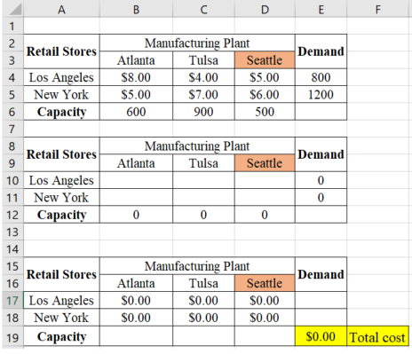

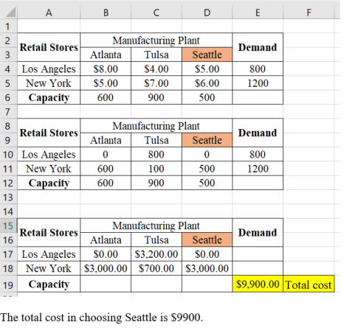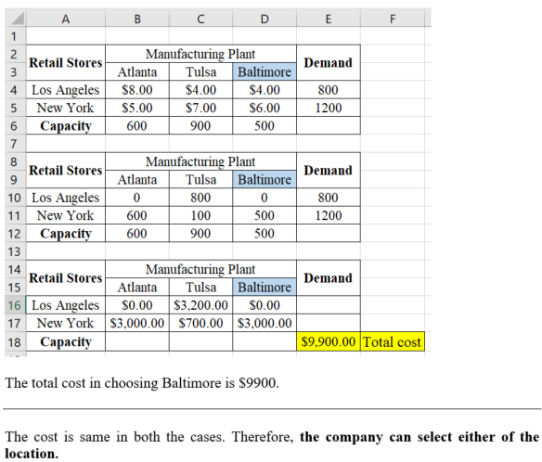

2)

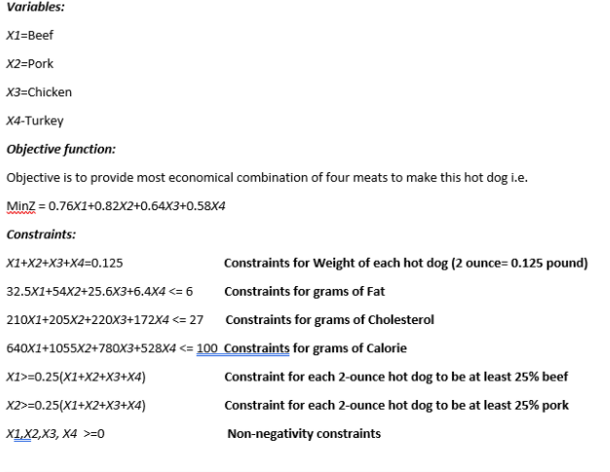

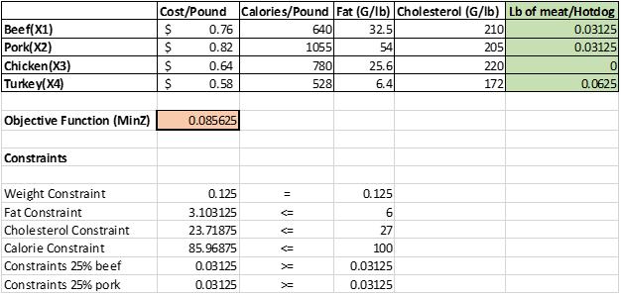

3)

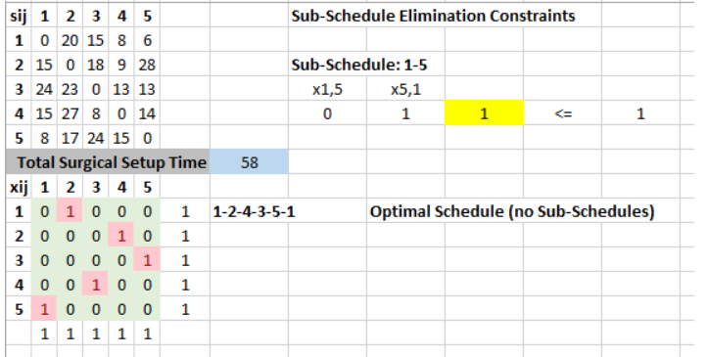

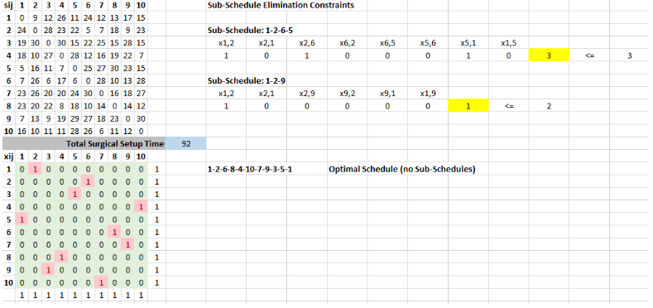

4)

|  |  |  |  |
| --- | --- | --- | --- |
| Goals | Description | Rank | Wt |
| Goal 1 | Minimize overutilization of plastic | 2 | 0.364 |
| Goal 2 | Minimize overutilization of metals | 1 | 0.182 |
| Goal 3 | Minimize overutilization of rubber | 1 | 0.182 |
| Goal 4 | Minimize overutilization of budget | 0.5 | 0.091 |
| Goal 5 | Minimize underutilization of budget | 0.5 | 0.091 |
| Goal 6 | Maximize available hours usage (i.e. Minimize underutilization) | 0.5 | 0.091 |

Decision Variables:

X1 = No. of Tiny Tanks produced

X2 = No. of Tiny Trucks produced

X3 = No. pf Tiny Turle produced

'Oi' = Excess of right side of the goal w.r.t. the goal 'i' and

'Ui' = Deficit of right side of the goal w.r.t. the goal 'i' for all i = 1,2,...,6

Objective Function:

Min (0.364O1 + 0.182O2 + 0.182O3 + 0.091O4 + 0.091U5 + 0.091U6)

Subject to,

1.5X1 + 2.0X2 + 1.0X3 + U1 - O1 = 16000

0.5X1 + 0.5X2 + 1.0X3 + U3 - O3 = 5000

0.3X1 + 0.6X2 + 0.0X3 + U2 - O2 = 9000

2.0X1 + 2.0X2 + 1.0X3 + U6 - O6 = 40

7.0X1 + 5.0X2 + 4.0X3 + U4 - O4 = 164000

7.0X1 + 5.0X2 + 4.0X3 + U5 - O5 = 164000

X1, X2, X3, Oi, Ui >= 0

5)

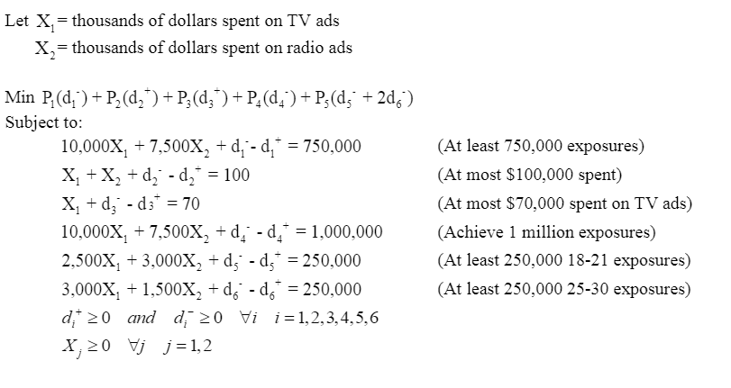

Extra Credit:

a)

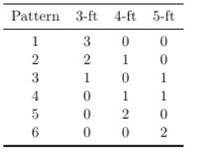

b)

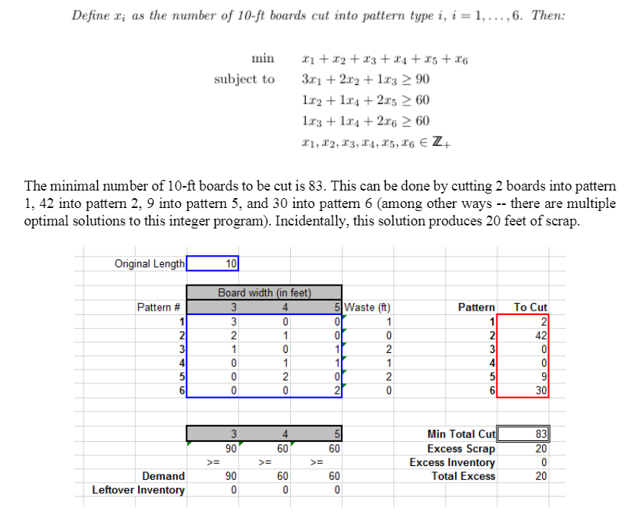

c)

