**Project Charter Plan**

**2020 Election Dashboards**

**Sonny Desai**

**182 Garden gate Lane**

**Irvine, CA 92620**

**06/28/2020**

**Table of Contents**

**Project Charter Plan**………………………………………………………………………………………………………….………1

Executive Summary 5

Project Purpose/Justification 5

Business Need/Case 5

Business Objectives 5

Project Description 5

Project Objectives and Success Criteria 6

Requirements 6

Constraints 6

Assumptions 6

Preliminary Scope Statement 6

Risks 6

Project Deliverables 7

Summary Milestone Schedule 7

Summary Budget 8

Project Approval Requirements 8

Project Manager 9

Authorization 10

**Communication Management Plan**…………………………………………………………………………………………11

Introduction 12

Communications Management Approach 12

Communications Management Constraints 12

Stakeholder Communication Requirements 12

Roles 12

Project Team Directory 13

Communication Methods and Technologies 15

Communications Matrix 17

Communication Flowchart 18

Guidelines for Meetings 18

Communication Standards 20

Communication Escalation Process 21

Glossary of Communication Terminology 22

**Stakeholder Management Strategy**………………………………………………………………………………………..23

1.Introduction 24

2.Identify Stakeholders 24

3.Key Stakeholders 25

4.Stakeholder Analysis 25

**Stakeholder Register**……………………………………………………………………………………………………………….29

**WBS**………………………………………………………………………………………………………………………………………...30

**Project Scope Statement………………………………………………………………………………………………………**31

Introduction 32

Project Purpose and Justification 32

Scope Description 32

High Level Requirements 32

Boundaries 33

Strategy 33

Deliverables 33

Acceptance Criteria 33

Constraints 34

Cost Estimate 34

Cost Benefit Analysis 35

**Statement of Work (SOW)**……………………………………………………………………………………………………….37

Introduction/Background 38

Scope of Work 38

Period of Performance 38

Place of Performance 38

Work Requirements 39

Schedule/Milestones 40

Acceptance Criteria 40

Other Requirements 39

**Priority Matrix……………………………………………………………………..………………………………………………**41

Project Priority Matrix…………………………………………………………………………………………………………..….42

**Scope Management Plan……………………………………………………………………………………………………..**43

Introduction 44

Scope Management Approach 44

Roles and Responsibilities 44

Scope Definition 46

Project Scope Statement 46

Work Breakdown Structure 46

Scope Verification 47

Scope Control 48

Sponsor Acceptance 49

**Cost Management Plan**……………………………………………………………………………………………………………50

Introduction 51

Cost Management Approach 51

Measuring Project Costs 51

Reporting Format 52

Cost Variance Response Process 52

Cost Change Control Process 52

Project Budget 53

**Cost Labor Estimate**…………………………………………………………………………………………………………………55

**Network Information**………………………………………………………………………………………………………………56

**Precedence Diagram**……………………………………………………………………………………………………………….57

**Schedule Management Plan**……………………………………………………………………………………………………58

Introduction 59

Schedule Management Approach 59

Schedule Control 60

Schedule Changes and Thresholds 60

Scope Change 61

**Risk Management Artifacts**…………………………………………………………………………………………………….66

Risk Identification Table/Risk Register…………………………………………………………………………………..…67

Risk Breakdown Structure……………………………………………………………………………………………………..…69

Risk Assessment Form……………………………………………………………………………………………………………….70

Risk Severity Matrix…………………………………………………………………………………………………………………..71

Risk Response Matrix………………………………………………………………………………………………………………..72

Change Control Form………………………………………………………………………………………………………………..73

Change Request Process/Plan…………………………………………………………………………………………………..74

**Risk Management Plan**…………………………………………………………………………………………………………….75

Introduction 76

Top Three Risks 77

Risk Management Approach 78

Risk Identification 78

Risk Qualification and Prioritization 78

Risk Monitoring 79

Risk Mitigation and Avoidance 79

**Schedule Management Plan**…………………………………………………………………………………………………….82

Introduction 83

Schedule Management Approach 83

Schedule Control 84

Schedule Changes and Thresholds 84

Scope Change 85

Resources loaded/leveled baseline

**Human Resources Management**

Introduction 3

Roles and Responsibilities 3

Project Organizational Charts 5

Staffing Management 6

**Schedule Management Plan**

Introduction 3

Schedule Management Approach 3

Schedule Control 4

Schedule Changes and Thresholds 5

Scope Change 6

# Executive Summary

This current year, 2020. Is a general election year and the United States will decide its president for the next 4 years. Although the race is still wide open, it will be important to view the breakdowns of the polls by state. National and state polls will be crucial for determining strategy of political ads and campaign energy. This project will give detailed reporting of the polls by creating a dashboard visualization of the polling data, its changes, and trends in the run up to the election. Along with the 50 state polls, a national poll will be followed, along with the president’s approval poll, and polling amongst certain categories and sub groups that will factor into the election.

# Project Purpose/Justification

## Business Need/Case

This project has been created to help formulate political strategy and understand complex data, especially polling data, per state, in clear visualizations and storytelling form

## Business Objectives

The business objectives for this project are to help with strategy, visualizing, and analyzing data.

* Create a dashboard for visualizations for all 50 states polls
* Show national poll
* Visualize variance from week to week

# Project Description

This project will show a dashboard which will include a visualization for national polls between the two candidates, visualizations of polls for all 50 states, and the president’s approval ratings. Variance will be calculated weekly for all of the polls where data is attainable, showing variance from week to week.

## Project Objectives and Success Criteria

The objectives which mutually support the milestones and deliverables for this project have been identified. In order to achieve success on the project, the following objectives must be met within the designated time and budget allocations:

* Obtain data source(s) for polling data and approval polls
* Create database or central storage are for data
* Complete list of required hardware/software which meets budget allocation within the next 25 days
* Implement the solution across the organization within the next 120 days

## Requirements

This project must meet the following list of requirements in order to achieve success.

* The database must be created before creation of visualizations. Data quality assurance must also be done
* Available data sources
* Data visualization tool (Power BI)
* Solution must be implemented without disruption to operations

Additional requirements may be added as necessary, with project sponsor approval, as the project moves forward.

## Constraints

The following constraints pertain to the project:

* All security hardware and software must be compatible with our current IT platforms
* All hardware and software must be purchased in accordance with the allocated budget and timeline

## Assumptions

The following are a list of assumptions. Upon agreement and signature of this document, all parties acknowledge that these assumptions are true and correct:

* This project has the full support of the project sponsor, stakeholders, and all departments
* The purpose of this project will be communicated throughout the company prior to deployment
* The election this year will go forward as planned and will not be delayed or canceled due to covid-19

## Preliminary Scope Statement

This project will include gathering of various data sources of polling data regarding the 2020 election that will be stored in a database. The database will be created in a sql platform most likely mysql. From there, the data will go through a QA test to ensure data quality by matching it against other sources. Then visualizations will be created in a visualization tool, most likely power bi. The visualizations will be one fore each of the 50 states in the United States, a national poll, and the president’s approval rating. Variance or changes will be noted in the visualizations and will be calibrated by updating the database from various data sources.

# Risks

The following risks for the ISA project have been identified. The project manager will determine and employ the necessary risk mitigation/avoidance strategies as appropriate to minimize the likelihood of these risks:

* The lack of arability of data – either it is difficult to get or reliable data sources cannot be confirmed
* The election could be either canceled or delayed for which it will be difficult to achieve the desired outcomes

# Project Deliverables

The following deliverables must be met upon the successful completion of the ISA project. Any changes to these deliverables must be approved by the project sponsor.

* Fully deployed dashboard with all visualizations
* Visualizations of polling data of all 50 states and presidents approval
* Variance calculations of changes between polls per week

# Summary Milestone Schedule

The project Summary Milestone Schedule is presented below. As requirements are more clearly defined this schedule may be modified. Any changes will be communicated through project status meetings by the project manager.

|  |  |
| --- | --- |
| **Summary Milestone Schedule – List key project milestones relative to project start.** | |
| **Project Milestone** | **Target Date (mm/dd/yyyy)** |
| 1. Project Start | 06/28/2020 |
| * Data Source Requirements | 07/05/2020 |
| 1. Database creation | 07/12/2020 |
| 1. Visualizations and Dashboard creation | 07/19/2020 |
| 1. Updating and validation | 07/26/2020 |
| 1. Updating and Validation | 08/02/2020 |
| 1. Project Complete | 08/30/2020 |

# Summary Budget

The following table contains a summary budget based on the planned cost components and estimated costs required for successful completion of the project.

|  |  |
| --- | --- |
| **Summary Budget – List component project costs** | |
| **Project Component** | **Component Cost** |
| 1. Personnel Resources | $100 |
| * Hardware | $100 |
| 1. Software and Licensing | $100 |
| 1. IT Lab Preparation | $100 |
| **Total** | **$400** |

# Project Approval Requirements

Success for the project will have functioning and updatable data sources that will feed into a database. From this database, QA and validation must be done to ensure data quality. Visualizations will also be created from a direct link to the database. The pertinent visualizations: all 50 states, the president’s approval, and further categories ie racial or demographic breakdowns will be held in the dashboard. The visualizations will be updated weekly and the variance from previous weeks will be shown.

# Project Manager

Sonny Desai is named Project Manager for the duration of the Project. Mr. Desai’s responsibility is to manage all project tasks, scheduling, and communication regarding the project. Mr. Desai is authorized to approve all budget expenditures up to, and including, the allocated budget amounts.

# Authorization

Approved by the Project Sponsor:

Date:

<Project Sponsor>

<Project Sponsor Title>

**Communication Management Plan**

**2020 Election Dashboards**

**Sonny Desai**

**182 Garden gate Lane**

**Irvine, CA 92620**

**06/28/2020**

# Introduction

This Communications Management Plan sets the communications framework for this project. It will serve as a guide for communications throughout the life of the project and will be updated as communication needs change. This plan identifies and defines the roles of persons involved in this project. It also includes a communications matrix which maps the communication requirements of this project. An in-depth guide for conducting meetings details both the communications rules and how the meetings will be conducted, ensuring successful meetings. A project team directory is included to provide contact information for all stakeholders directly involved in the project.

# Communications Management Approach

The Project Manager will take a proactive role in ensuring effective communications on this project. The communications requirements are documented in the Communications Matrix presented in this document. The Communications Matrix will be used as the guide for what information to communicate, who is to do the communicating, when to communicate it and to whom to communicate.

As with most project plans, updates or changes may be required as the project progresses or changes are approved. Changes or updates may be required due to changes in personnel, scope, budget, or other reasons. Additionally, updates may be required as the project matures and additional requirements are needed. The project manager is responsible for managing all proposed and approved changes to the communications management plan. Once the change is approved, the project manager will update the plan and supporting documentation and will distribute the updates to the project team and all stakeholders. This methodology is consistent with the project’s Change Management Plan and ensures that all project stakeholders remain aware and informed of any changes to communications management.

# Communications Management Constraints

All project communication activities will occur within the project’s approved budget, schedule, and resource allocations. The project manager is responsible for ensuring that communication activities are performed by the project team and without external resources which will result in exceeding the authorized budget. Communication activities will occur in accordance with the frequencies detailed in the Communication Matrix in order to ensure the project adheres to schedule constraints. Any deviation of these timelines may result in excessive costs or schedule delays and must be approved by the project sponsor.

# Stakeholder Communication Requirements

As part of identifying all project stakeholders, the project manager will communicate with each stakeholder in order to determine their preferred frequency and method of communication. This feedback will be maintained by the project manager in the project’s Stakeholder Register. Standard project communications will occur in accordance with the Communication Matrix; however, depending on the identified stakeholder communication requirements, individual communication is acceptable and within the constraints outlined for this project.

In addition to identifying communication preferences, stakeholder communication requirements must identify the project’s communication channels and ensure that stakeholders have access to these channels. If project information is communicated via secure means or through internal company resources, all stakeholders, internal and external, must have the necessary access to receive project communications.

Once all stakeholders have been identified and communication requirements are established, the project team will maintain this information in the project’s Stakeholder Register and use this, along with the project communication matrix as the basis for all communications.

# Roles

**Project Sponsor**

The project sponsor is the champion of the project and has authorized the project by signing the project charter. This person is responsible for the funding of the project and is ultimately responsible for its success. Since the Project Sponsor is at the executive level communications should be presented in summary format unless the Project Sponsor requests more detailed communications.

**Program Manager**

The Program Manager oversees the project at the portfolio level and owns most of the resources assigned to the project. The Program Manager is responsible for overall program costs and profitability as such they require more detailed communications than the Project Sponsor.

**Key Stakeholders**

Normally Stakeholders includes all individuals and organizations who are impacted by the project. For this project we are defining a subset of the stakeholders as Key Stakeholders. These are the stakeholders with whom we need to communicate with and are not included in the other roles defined in this section. The Key Stakeholders includes executive management with an interest in the project and key users identified for participation in the project.

**Change Control Board**

The Change Control Board is a designated group which is reviews technical specifications and authorizes changes within the organizations infrastructure. Technical design documents, user impact analysis and implementation strategies are typical of the types of communication this group requires.

**Customer**

The customer for this project is ABC Corp. As the customer who will be accepting the final deliverable of this project they will be informed of the project status including potential impacts to the schedule for the final deliverable or the product itself.

**Project Manager**

The Project Manager has overall responsibility for the execution of the project. The Project Manager manages day to day resources, provides project guidance and monitors and reports on the projects metrics as defined in the Project Management Plan. As the person responsible for the execution of the project, the Project Manager is the primary communicator for the project distributing information according to this Communications Management Plan.

**Project Team**

The Project Team is comprised of all persons who have a role performing work on the project. The project team needs to have a clear understanding of the work to be completed and the framework in which the project is to be executed. Since the Project Team is responsible for completing the work for the project they played a key role in creating the Project Plan including defining its schedule and work packages. The Project Team requires a detailed level of communications which is achieved through day to day interactions with the Project Manager and other team members along with weekly team meetings.

**Steering Committee**

The Steering Committee includes management representing the departments which make up the organization. The Steering Committee provides strategic oversight for changes which impact the overall organization. The purpose of the Steering Committee is to ensure that changes within the organization are effected in such a way that it benefits the organization as a whole. The Steering Committee requires communication on matters which will change the scope of the project and its deliverables.

**Technical Lead**

The Technical Lead is a person on the Project Team who is designated to be responsible for ensuring that all technical aspects of the project are addressed and that the project is implemented in a technically sound manner. The Technical Lead is responsible for all technical designs, overseeing the implementation of the designs and developing as-build documentation. The Technical Lead requires close communications with the Project Manager and the Project Team.

# Project Team Directory

The following table presents contact information for all persons identified in this communications management plan. The email addresses and phone numbers in this table will be used to communicate with these people.

|  |  |  |  |  |  |
| --- | --- | --- | --- | --- | --- |
| **Role** | **Name** | **Title** | **Organization/ Department** | **Email** | **Phone** |
| **Project Sponsor** |  |  |  |  |  |
| **Program Manager** | Sonny Desai | Project Manager | Data Science | [Sjdesai87@gmail.com](mailto:Sjdesai87@gmail.com) | (310) 869-1121 |
| **Project Manager** |  |  |  |  |  |
| **Project Stakeholders** | See Stakeholder Register | See Stakeholder Register | See Stakeholder Register | See Stakeholder Register | See Stakeholder Register |
| **Customer** | J. Doe ABC Corp | Manager | IT | [J.Doe@xyz.com](mailto:J.Doe@xyz.com) | (615) 555-8121 |
| **Project Team** |  |  |  |  |  |
| **Technical Lead** |  |  |  |  |  |
|  |  |  |  |  |  |
|  |  |  |  |  |  |
|  |  |  |  |  |  |
|  |  |  |  |  |  |

# Communication Methods and Technologies

The project team will determine, in accordance with ABC Corp. organizational policy, the communication methods and technologies based on several factors to include: stakeholder communication requirements, available technologies (internal and external), and organizational policies and standards.

ABC Corp. maintains a SharePoint platform within the PMO which all projects use to provide updates, archive various reports, and conduct project communications. This platform enables senior management, as well as stakeholders with compatible technology, to access project data and communications at any point in time. SharePoint also provides the ability for stakeholders and project team members to collaborate on project work and communication.

For stakeholders who do not have the ability to access SharePoint, a web site will also be established for the project. Access to the website will be controlled with a username and password. Any stakeholders identified who are not able to access SharePoint will be issued a unique username and password in order to access the web site. The project manager is responsible for ensuring all project communications and documentation are copied to the web site and that the content mirrors what is contained on the SharePoint platform.

ABC Corp. maintains software licenses for MS Project software. All project teams are responsible for developing, maintaining, and communicating schedules using this software. PERT Charts are the preferred format for communicating schedules to stakeholders. The project schedule will be maintained on both the SharePoint platform and the project website.

All project communication and documentation, in addition to being maintained on the SharePoint platform and project website, will be archived on the internal ABC Corp. shared drive which resides in the PMO program directory. Organizational naming conventions for files and folder will be applied to all archived work.

# Communications Matrix

The following table identifies the communications requirements for this project.

|  |  |  |  |  |  |  |  |
| --- | --- | --- | --- | --- | --- | --- | --- |
| **Communication Type** | **Objective of Communication** | **Medium** | **Frequency** | **Audience** | **Owner** | **Deliverable** | **Format** |
| Kickoff Meeting | Introduce the project team and the project. Review project objectives and management approach. | * Face to Face | Once | * Project Sponsor * Project Team * Stakeholders | Project Manager | * Agenda * Meeting Minutes | * Soft copy archived on project SharePoint site and project web site |
| Project Team Meetings | Review status of the project with the team. | * Face to Face * Conference Call | Weekly | * Project Team | Project Manager | * Agenda * Meeting Minutes * Project schedule | * Soft copy archived on project SharePoint site and project web site |
| Technical Design Meetings | Discuss and develop technical design solutions for the project. | * Face to Face | As Needed | * Project Technical Staff | Technical Lead | * Agenda * Meeting Minutes | * Soft copy archived on project SharePoint site and project web site |
| Monthly Project Status Meetings | Report on the status of the project to management. | * Face to Face * Conference Call | Monthly | * PMO | Project Manager | * Slide updates * Project schedule | * Soft copy archived on project SharePoint site and project web site |
| Project Status Reports | Report the status of the project including activities, progress, costs and issues. | * Email | Monthly | * Project Sponsor * Project Team * Stakeholders * PMO | Project Manager | * Project Status Report * Project schedule | * Soft copy archived on project SharePoint site and project web site |

# Communication Flowchart

The communication flowchart below was created to aid in project communication. This flowchart provides a framework for the project team to follow for this project. However, there may be occasions or situations which fall outside of the communication flowchart where additional clarification is necessary. In these situations the Project Manager is responsible for discussing the communication with the Project Sponsor and making a determination on how to proceed.

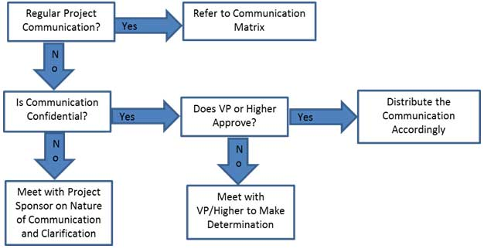

# Guidelines for Meetings

**Meeting Agenda**

Meeting Agenda will be distributed 5 business days in advance of the meeting. The Agenda should identify the presenter for each topic along with a time limit for that topic. The first item in the agenda should be a review of action items from the previous meeting.

**Meeting Minutes**

Meeting minutes will be distributed within 2 business days following the meeting. Meeting minutes will include the status of all items from the agenda along with new action items and the Parking Lot list.

**Action Items**

Action Items are recorded in both the meeting agenda and minutes. Action items will include both the action item along with the owner of the action item. Meetings will start with a review of the status of all action items from previous meetings and end with a review of all new action items resulting from the meeting. The review of the new action items will include identifying the owner for each action item.

**Meeting Chair Person**

The Chair Person is responsible for distributing the meeting agenda, facilitating the meeting and distributing the meeting minutes. The Chair Person will ensure that the meeting starts and ends on time and that all presenters adhere to their allocated time frames.

**Note Taker**

The Note Taker is responsible for documenting the status of all meeting items, maintaining a Parking Lot item list and taking notes of anything else of importance during the meeting. The Note Taker will give a copy of their notes to the Chair Person at the end of the meeting as the Chair Person will use the notes to create the Meeting Minutes.

**Time Keeper**

The Time Keeper is responsible for helping the facilitator adhere to the time limits set in the meeting agenda. The Time Keeper will let the presenter know when they are approaching the end of their allocated time. Typically a quick hand signal to the presenter indicating how many minutes remain for the topic is sufficient.

**Parking Lot**

The Parking Lot is a tool used by the facilitator to record and defer items which aren’t on the meeting agenda; however, merit further discussion at a later time or through another forum.

A parking lot record should identify an owner for the item as that person will be responsible for ensuring follow-up. The Parking Lot list is to be included in the meeting minutes.

# Communication Standards

For this project, ABC Corp. will utilize standard organizational formats and templates for all formal project communications. Formal project communications are detailed in the project’s communication matrix and include:

Kickoff Meeting – project team will utilize ABC Corp. standard templates for meeting agenda and meeting minutes. Additionally, any slides presented will use the ABC Corp. standard slideshow template.

Project Team Meetings – project team will utilize ABC Corp. standard templates for meeting agenda and meeting minutes. Additionally, any slides presented will use the ABC Corp. standard slideshow template.

Technical Design Meetings - project team will utilize ABC Corp. standard templates for meeting agenda and meeting minutes. Additionally, any slides presented will use the ABC Corp. standard slideshow template.

Monthly Project Status Meetings - project team will utilize ABC Corp. standard templates for meeting agenda and meeting minutes. Additionally, any slides presented will use the ABC Corp. standard slideshow template.

Project Status Reports – project team will utilize ABC Corp. standard templates for meeting agenda and meeting minutes. Additionally the standard project status report document, available on the share drive, will be used to provide project status.

Informal project communications should be professional and effective but there is no standard template or format that must be used.

# Communication Escalation Process

Efficient and timely communication is the key to successful project completion. As such, it is imperative that any disputes, conflicts, or discrepancies regarding project communications are resolved in a way that is conducive to maintaining the project schedule, ensuring the correct communications are distributed, and preventing any ongoing difficulties. In order to ensure projects stay on schedule and issues are resolved, ABC Corp. will use its standard escalation model to provide a framework for escalating communication issues. The table below defines the priority levels, decision authorities, and timeframes for resolution.

|  |  |  |  |
| --- | --- | --- | --- |
| **Priority** | **Definition** | **Decision Authority** | **Timeframe for Resolution** |
| Priority 1 | Major impact to project or business operations. If not resolved quickly there will be a significant adverse impact to revenue and/or schedule. | Vice President or higher | Within 4 hours |
| Priority 2 | Medium impact to project or business operations which may result in some adverse impact to revenue and/or schedule. | Project Sponsor | Within one business day |
| Priority 3 | Slight impact which may cause some minor scheduling difficulties with the project but no impact to business operations or revenue. | Project Manager | Within two business days |
| Priority 4 | Insignificant impact to project but there may be a better solution. | Project Manager | Work continues and any recommendations are submitted via the project change control process |

** NOTE: Any communication including sensitive and/or confidential information will require escalation to VP level or higher for approval prior to external distribution.

# Glossary of Communication Terminology

|  |  |
| --- | --- |
| Term | Definition |
| Communication | The effective sending and receiving of information. Ideally, the information received should match the information sent. It is the responsibility of the sender to ensure this takes place. |
| Stakeholder | Individuals or groups involved in the project or whose interests may be affected by the project’s execution or outcome. |
| Communications Management Plan | Portion of the overall Project Management Plan which details how project communications will be conducted, who will participate in communications, frequency of communications, and methods of communications. |
| Escalation | The process which details how conflicts and issues will be passed up the management chain for resolution as well as the timeframe to achieve resolution. |
|  |  |

**Stakeholder Management Strategy**

**2020 Election Dashboards**

**Sonny Desai**

**182 Garden gate Lane**

**Irvine, CA 92620**

**06/28/2020**

# Introduction

The Stakeholder Management Strategy for 2020 Election Dashboards Project will be used to identify and classify project stakeholders; determine stakeholder power, interest, and influence; and analyze the management approach and communication methodology for project stakeholders. This will allow us to identify key influential stakeholders to solicit input for project planning and gain support as the project progresses. This will benefit the project by minimizing the likelihood of encountering competing objectives and maximizing the resources required to complete the project.

Early identification and communication with stakeholders is imperative to ensure the success of the Dashboards Project by gaining support and input for the project. Some stakeholders may have interests which may be positively or negatively affected by the Dashboards Project. By initiating early and frequent communication and stakeholder management, we can more effectively manage and balance these interests while accomplishing all project tasks.

# Identify Stakeholders

The Dashboards Project Team will conduct a brainstorming session in order to identify stakeholders for the project. The brainstorming session will include the primary project team and project sponsor. The session will be broken down into two parts. The first part will focus on internal stakeholders within ABC Corp. These stakeholders may include functional managers, operations personnel, finance personnel, warehouse and material handlers, and any other ABC Corp employee who will be affected by the Dashboards project. The second part of the session will focus on external stakeholders. These may include suppliers, trial customers, partner organizations, or any other individuals who reside outside of ABC Corp.

The following criteria will be used to determine if an individual will be included as a stakeholder:

1. Will the person or their organization be directly or indirectly affected by this project?
2. Does the person or their organization hold a position from which they can influence the project?
3. Does the person have an impact on the project’s resources (material, personnel, funding)?
4. Does the person or their organization have any special skills or capabilities the project will require?
5. Does the person potentially benefit from the project or are they in a position to resist this change?

Any individual who meets one or more of the above criteria will be identified as a stakeholder. Stakeholders from the same organization will be grouped in order to simplify communication and stakeholder management.

# Key Stakeholders

As a follow on to Identify Stakeholders, the project team will identify key stakeholders who have the most influence on the project or who may be impacted the most by it. These key stakeholders are those who also require the most communication and management which will be determined as stakeholders are analyzed. Once identified, the Project Manager will develop a plan to obtain their feedback on the level of participation they desire, frequency and type of communication, and any concerns or conflicting interests they have.

Based on the feedback gathered by the project manager, the determination may be made to involve key stakeholders on steering committees, focus groups, gate reviews, or other project meetings or milestones. Thorough communication with key stakeholders is necessary to ensure all concerns are identified and addressed and that resources for the project remain available.

# Stakeholder Analysis

Once all Dashboard Project stakeholders have been identified, the project team will categorize and analyze each stakeholder. The purpose of this analysis is to determine the stakeholders’ level of power or influence, plan the management approach for each stakeholder, and to determine the appropriate levels of communication and participation each stakeholder will have on the project.

The project team will categorize stakeholders based on their organization or department. Once all stakeholders have been categorized, the project team will utilize a power/interest matrix to illustrate the potential impact each stakeholder may have on the project. Based on this analysis the project team will also complete a stakeholder analysis matrix which illustrates the concerns, level of involvement, and management strategy for each stakeholder.

The chart below will be used to establish stakeholders and their levels of power and interest for use on the power/interest chart as part of the stakeholder analysis.

|  |  |  |  |  |
| --- | --- | --- | --- | --- |
| Key | Organization | Name | Power (1-5) | Interest (1-5) |
| A | Operations | S. Desai | 2 | 2 |
| B | Operations |  | 4 | 5 |
| C | Supplier |  | 1 | 1 |
| D | Supplier |  | 1 | 2 |
| E | Trial Customer |  | 3 | 5 |
| F | Engineering |  | 4 | 1 |
| G | Engineering |  | 2 | 4 |
|  |  |  |  |  |

Below is the power/interest chart for the Dashboards Project stakeholders. Each letter represents a stakeholder in accordance with the key in the chart above.



Based on the power and interest analysis and chart above, stakeholders A, C, and D will require minimal management effort as they reside in the lower left quadrant of the matrix. Stakeholder F, in the upper left quadrant, must be kept satisfied by ensuring concerns and questions are addressed adequately. Stakeholder G, in the lower right quadrant, must be kept informed through frequent communication on project status and progress. Stakeholders B and E, in the upper right quadrant, are key players and must be involved in all levels of project planning and change management. Additionally, stakeholders B and E should be participatory members in all project status meetings, gate reviews, and ad hoc meetings as required.

The stakeholder analysis matrix will be used to capture stakeholder concerns, level of involvement, and management strategy based on the stakeholder analysis and power/interest matrix above. The stakeholder analysis matrix will be reviewed and updated throughout the project’s duration in order to capture any new concerns or stakeholder management strategy efforts.

|  |  |  |  |
| --- | --- | --- | --- |
| Stakeholder | Concerns | Quadrant | Strategy |
| A | Ensuring proper handover of project to operations team | Minimal Effort | Communicate project specifications as required |
| B | Resource and scheduling constraints for production once project is transitioned to operations | Key Player | Solicit stakeholder as member of steering committee and obtain feedback on project planning. Frequent communication and addressing concerns are imperative |
| C | Ensuring on time delivery of materials | Minimal Effort | Communicate project schedule and material requirements ahead of time to ensure delivery |
| D | Possible union strike may impact material delivery | Minimal Effort | Solicit frequent updates and develop plan for alternative supply source |
| E | Product performance must meet or exceed current product | Key Player | Communicate test results and performance specifications and obtain feedback on customer requirements or any changes. Provide frequent status reports and updates. |
| F | Concerns regarding resources to assist project team with product design | Keep Satisfied | Communicate resource requirements early and ensure resources are released back to engineering when they’re no longer required |
| G | Questions regarding design of Dashboard product | Keep Informed | Allow technical staff to work with stakeholder to answer questions and address concerns and provide test results for validation |

# 

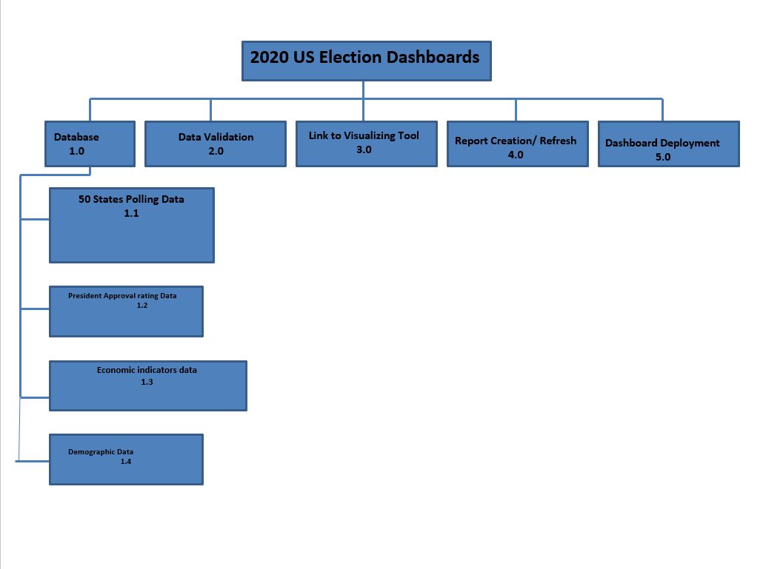

**Project Scope Statement**

**2020 Election Dashboards**

**Sonny Desai**

**182 Garden gate Lane**

**Irvine, CA 92620**

**07/05/2020**

This Project Scope Statement serves as a baseline document for defining the scope of the 2020 US Elections Dashboard Project, project deliverables, work which is needed to accomplish the deliverables, and ensuring a common understanding of the project’s scope among all stakeholders. All project work should occur within the framework of the project scope statement and directly support the project deliverables. Any changes to the scope statement must be vetted through the approved Project Change Management Process prior to implementation. This completion date for this project is 8/28/2020.

# Project Purpose and Justification

The Dashboard Project has been approved to collect relevant and pertinent data, construct a database to hold said data, create report visualizations for polling data for all 50 states, the president’s approval rating, economic indicators, and demographic data. The database will then be linked to the visualizations directly and offer weekly refresh of visualization of the data. The visualizations will be pinned to a select few dashboard based on category type, and the dashboard will be deployed for viewing. The purpose of the project is to help visualize complex and broad data in more simpler and narrower terms, and to provide analysis for which campaigns can then adjust their strategy based upon data outcomes.

# Scope Description

The scope of the Dashboards Project is to collect relevant and pertinent data, construct a database to hold said data, create report visualizations for polling data for all 50 states, the president’s approval rating, economic indicators, and demographic data. The database will then be linked to the visualizations directly and offer weekly refresh of visualization of the data. The visualizations will be pinned to a select few dashboard based on category type, and the dashboard will be deployed for viewing. The scope of this project includes all requirements gathering, planning, design, development, and implementation of the Dashboards.

# High Level Requirements

The Dashboards have been approved to meet a business need for ABC Corp. In order to meet this business need there are several requirements which must be met as part of the successful execution of this project. The following high level requirements have been identified for the Dashboard Project Project:

* Database for central data collection
* Data sources
* Data visualization tool
* Site for deployment of dashboard

# Boundaries

The DASHBOARDS Project includes all work associated with planning, designing, building, and implementing the DASHBOARDS Tool for ABC Corp. This includes requirements gathering, gathering input from all departments, conceptual and technical design and coding work, server configuration, testing, troubleshooting, and deployment of the DASHBOARDS across the organization. This also includes training manuals and materials associated with operating the Dashboards. Not included in the scope of this project are: ongoing maintenance of the system, implementing commercial database products, ongoing help desk and/or service support, or hardware/software upgrades.

# Strategy

For the DASHBOARDS Project strategy, the project team will leverage the expertise of several database developers from the ABC Corp Information Technology (IT) group. These experts will be in matrixed support as part of the project team. They will aid the project manager and other team members in conceptual and technical design, coding, server configuration, testing and troubleshooting, and deployment. The project manager will ensure that the IT experts incorporate all input from stakeholders and gathered requirements.

# Deliverables

There are several deliverables which will be produced as a result of the successful completion of the DASHBOARDS Project. If all of the following deliverables are not met then the project will not be considered successful. The Project Manager is responsible for ensuring the completion of these deliverables.

1. Deliverable 1 – A tested and operational Program Management Database tool free of errors and meeting the specifications described in the Project Scope Description
2. Deliverable 2 – Tested and operational reports visualizations which will be correctly linked to the database
3. Deliverable 3 – Dashboards showing the various visualizations categorized by 50 states, president approval etc

# Acceptance Criteria

Acceptance criteria have been established for the DASHBOARDS Project to ensure thorough vetting and successful completion of the project. The acceptance criteria are both qualitative and quantitative in nature. All acceptance criteria must be met in order to achieve success for this project:

1. Meet all deliverables within scheduled time and budget tolerances
2. Reduce schedule delays by at least 30%
3. Reduce budget overruns by at least 30%
4. Improve ABC Corp’s resource allocation ability
5. Accomplish an overall performance improvement in program metrics

# Constraints

Several constraints have been identified for the DASHBOARDS Project. It is imperative that considerations be made for these constraints throughout the project lifecycle. All stakeholders must remain mindful of these constraints as they must be carefully planned for to prevent any adverse impacts to the project’s schedule, cost, or scope. The following constraints have been identified for the DASHBOARDS Project:

1. IT experts will only work 50% of billable hours on this project
2. Project manager will only work 75% of billable hours on this project
3. The Project Manager working only 75% of billable hours on this project is adequate to complete the project by 8/28/2020
4. The DASHBOARDS Project has full support from senior management across all departments within ABC Corp

# Cost Estimate

The estimated costs for this project are included in the table below. As the project proceeds and any additional costs become known, this cost estimate will be refined and communicated to all project stakeholders.

|  |  |  |  |  |
| --- | --- | --- | --- | --- |
| **Expense** | **Estimated Budget** | **Expended to Date** | **Estimate to Complete** | **Variance** |
| Labor |  |  |  |  |
| Internal | $100 | $0 | $0 | +/- $0 |
| External | $100 | $0 | $0 | N/A |
| Software | $100 | $0 | $0 | N/A |
| Hardware | $100 | $0 | $0 | N/A |
| Other | $100 | $0 | $0 | +/- $0 |
| Total | $500 | $0 | $0 |  |

# Cost Benefit Analysis

A cost benefit analysis has been performed for the DASHBOARDS Project. The successful completion of this project will provide significant benefits to ABC Corp. It is imperative that all stakeholders understand these benefits as well as the importance of the successful completion of this project.

|  |  |  |
| --- | --- | --- |
|  | With DASHBOARDS Project | Without DASHBOARDS Project |
| Costs of Project |  |  |
| Recurring Cost | $0 | $0 |
| Non-Recurring Cost | $0 | $0 |
| Capital Costs | $0 | $0 |
| **Total Cost of DASHBOARDS Project** | **$0** | **$0** |
|  |  |  |
| Benefits (1 year) |  |  |
| Reduce Delays by 30% | $0 | -$0 |
| Reduce Overruns by 30% | $0 | -$0 |
| Improve Resource Allocation | $0 | -$0 |
| **Total Benefits of DASHBOARDS Project** | **$0** | **-$0** |
|  |  |  |
| **Net Benefits of DASHBOARDS Project** | $0 | -$0 |
|  |  |  |

Sponsor Acceptance

Approved by the Project Sponsor:

Date:

<Project Sponsor>

<Project Sponsor Title>

**Statement of Work (SOW)**

**2020 Election Dashboards**

**Sonny Desai**

**182 Garden gate Lane**

**Irvine, CA 92620**

**07/05/2020**

# Introduction/Background

This current year, 2020. Is a general election year and the United States will decide its president for the next 4 years. Although the race is still wide open, it will be important to view the breakdowns of the polls by state. National and state polls will be crucial for determining strategy of political ads and campaign energy. This project will give detailed reporting of the polls by creating a dashboard visualization of the polling data, its changes, and trends in the run up to the election. Along with the 50 state polls, a national poll will be followed, along with the president’s approval poll, and polling amongst certain categories and sub groups that will factor into the election. This project will show a dashboard which will include a visualization for national polls between the two candidates, visualizations of polls for all 50 states, and the president’s approval ratings. Variance will be calculated weekly for all of the polls where data is attainable, showing variance from week to week.

# Scope of Work

The scope of the Dashboards Project is to collect relevant and pertinent data, construct a database to hold said data, create report visualizations for polling data for all 50 states, the president’s approval rating, economic indicators, and demographic data. The database will then be linked to the visualizations directly and offer weekly refresh of visualization of the data. The visualizations will be pinned to a select few dashboard based on category type, and the dashboard will be deployed for viewing. The scope of this project includes all requirements gathering, planning, design, development, and implementation of the Dashboards.

# Period of Performance

The period of performance for the Website Redesign Project is 3 months (90 days) beginning on 22 June 2020 through 31 August 2020. All work must be scheduled to complete within this timeframe. Any modifications or extensions will be requested through ABC Corp and vendor contracting officers for review and discussion.

# Place of Performance

The selected vendor for the Dashboards project will perform a majority of the work at its own facility. The vendor will be required to meet at ABC’s facility once per week (day and time TBD) for a weekly status meeting. Additionally, all project gate reviews will be held at ABC’s facility and attended by the vendor. ABC will provide and arrange for meeting spaces within its facility for all required vendor meetings. Once the project reaches the training phase, all training will be conducted at ABC’s facility.

# Work Requirements

As part of the Dashboards Project the vendor will be responsible for performing tasks throughout various stages of this project. The following is a list of these tasks which will result in the successful completion of this project:

Kickoff:

* Vendor will create and present detailed project plan including schedule, WBS, testing plan, implementation plan, training plan, and transition plan
* Vendor will present project plan to ABC for review and approval

Design Phase:

* Work with ABC to gather requirements and establish metrics
* Create site design based on collected requirements
* Develop site design proposal for ABC review and approval
* Present written status at weekly meeting

Build Phase:

* Vendor will complete all coding for approved site design
* Vendor will provide ABC with a detailed testing plan
* Vendor will include all content provided by ABC on redesigned web site
* Vendor will resolve any coding and site issues identified in testing
* Vendor will compile a testing report to present to ABC for review/approval
* Present written status at weekly meeting

Implementation Phase:

* Vendor will implement the newly redesigned web site on ABC servers
* Vendor will begin providing 24x7 web site support at this point forward until the end of the period of performance
* Present written status at weekly meeting

Training Phase:

* Vendor will provide training in accordance with approved training plan provided in the kickoff
* Present written status at weekly meeting

Project Handoff/Closure:

* Vendor will provide ABC with all documentation in accordance with the approved project plan
* Vendor will present project closure report to ABC for review and approval
* Vendor will complete the project requirements checklist showing that all project tasks have been completed
* Vendor will conclude 24x7 web support at 11:59pm on the final day of the period of performance
* Present written status at weekly meeting

# Schedule/Milestones

The below list consists of the initial milestones identified for the Dashboards Project:

Data collection July 12th, 2020

Data QA July 19th, 2020

Database Creation July 26th, 2020

Initial Reports Created August 2nd, 2020

Secondary Reports Created August 9th, 2020

Database and Visualization link created August 16th, 2020

Performance Review August 23rd, 2020

Dashboard Created August 30th, 2020

Project Completion Review September 6, 2020

Project Closure/Archives Complete September 13, 2020

# Acceptance Criteria

For the Dashboards Project the acceptance of all deliverables will reside with Dan Roth. Once a project phase is completed and the vendor provides their report/presentation for review and approval, the Dan Roth will either sign off on the approval for the next phase to begin, or reply to the vendor, in writing, advising what tasks must still be accomplished.

Once all project tasks have been completed, the project will enter the handoff/closure stage. During this stage of the project, the vendor will provide their project closure report and project task checklist to Dan Roth. The acceptance of this documentation by Dan Roth will acknowledge acceptance of all project deliverables and that the vendor has met all assigned tasks.

Any discrepancies involving completion of project tasks or disagreement between ABC and the chosen vendor will be referred to both organizations’ contracting offices for review and discussion.

# Other Requirements

All vendor project team members will submit security forms to ABC for clearance and access badges to the facility. All vendor programmers and quality control team members will be granted access to ABC servers and all necessary IT functions. They will also be given temporary ABC accounts which are to be used only for work pertaining to the Dashboards Project. Upon completion of the project these accounts will be closed.

**Priority Matrix**

**2020 Election Dashboards**

**Sonny Desai**

**182 Garden gate Lane**

**Irvine, CA 92620**

**07/12/2020**

**Scope Management Plan**

**2020 Election Dashboards**

**Sonny Desai**

**182 Garden gate Lane**

**Irvine, CA 92620**

**07/05/2020**

# Introduction

The Scope Management Plan provides the scope framework for this project. This plan documents the scope management approach; roles and responsibilities as they pertain to project scope; scope definition; verification and control measures; scope change control; and the project’s work breakdown structure. Any project communication which pertains to the project’s scope should adhere to the Scope Management Plan.

This project is for designing, programming, and testing a new software product which will be used to track the company’s finances and improve various financial processes. This includes design of the software, all programming and coding, and testing/validation of the software. No external resources or outsourcing are anticipated for this project.

# Scope Management Approach

For this project, scope management will be the sole responsibility of the Project Manager. The scope for this project is defined by the Scope Statement, Work Breakdown Structure (WBS) and WBS Dictionary. The Project Manager, Sponsor and Stakeholders will establish and approve documentation for measuring project scope which includes deliverable quality checklists and work performance measurements. Proposed scope changes may be initiated by the Project Manager, Stakeholders or any member of the project team. All change requests will be submitted to the Project Manager who will then evaluate the requested scope change. Upon acceptance of the scope change request the Project Manager will submit the scope change request to the Change Control Board and Project Sponsor for acceptance. Upon approval of scope changes by the Change Control Board and Project Sponsor the Project Manager will update all project documents and communicate the scope change to all stakeholders. Based on feedback and input from the Project Manager and Stakeholders, the Project Sponsor is responsible for the acceptance of the final project deliverables and project scope.

# Roles and Responsibilities

The Project Manager, Sponsor and team will all play key roles in managing the scope of this project. As such, the project sponsor, manager, and team members must be aware of their responsibilities in order to ensure that work performed on the project is within the established scope throughout the entire duration of the project. The table below defines the roles and responsibilities for the scope management of this project.

|  |  |  |
| --- | --- | --- |
| **Name** | **Role** | **Responsibilities** |
| John Doe | Sponsor | * Approve or deny scope change requests as appropriate * Evaluate need for scope change requests * Accept project deliverables |
|  |  |  |
| Sonny Desai | Project Manager | * Measure and verify project scope * Facilitate scope change requests * Facilitate impact assessments of scope change requests * Organize and facilitate scheduled change control meetings * Communicate outcomes of scope change requests * Update project documents upon approval of all scope changes |
| Bob Jones | Team Lead | * Measure and verify project scope * Validate scope change requests * Participate in impact assessments of scope change requests * Communicate outcomes of scope change requests to team * Facilitate team level change review process |
| John Smith | Team Member | * Participate in defining change resolutions * Evaluate the need for scope changes and communicate them to the project manager as necessary |
| Tom Brown | Team Member | * Participate in defining change resolutions * Evaluate the need for scope changes and communicate them to the project manager as necessary |

**Table 1.1, *Scope Management Roles and Responsibilities***

# Scope Definition

The scope for this project was defined through a comprehensive requirements collection process. First, a thorough analysis was performed on the company’s current software applications based on employee and user feedback. From this information, the project team developed the project requirements documentation, the requirements management plan, and the requirements traceability matrix for what the new software application must accomplish.

The project description and deliverables were developed based on the requirements collection process and input from subject matter experts in software design, technical support, programming and business applications. This process of expert judgment provided feedback on the most effective ways to meet the original requirements of providing a new software platform from which the company can improve its financial tracking and internal financial processes.

# Project Scope Statement

The project scope statement provides a detailed description of the project, deliverables, constraints, exclusions, assumptions, and acceptance criteria. Additionally, the scope statement includes what work should not be performed in order to eliminate any implied but unnecessary work which falls outside the of the project’s scope.

The Dashboard Project has been approved to collect relevant and pertinent data, construct a database to hold said data, create report visualizations for polling data for all 50 states, the president’s approval rating, economic indicators, and demographic data. The database will then be linked to the visualizations directly and offer weekly refresh of visualization of the data. The visualizations will be pinned to a select few dashboard based on category type, and the dashboard will be deployed for viewing. The purpose of the project is to help visualize complex and broad data in more simpler and narrower terms, and to provide analysis for which campaigns can then adjust their strategy based upon data outcomes.

# Work Breakdown Structure

In order to effectively manage the work required to complete this project, it will be subdivided into individual work packages which will not exceed 40 hours of work. This will allow the Project Manager to more effectively manage the project’s scope as the project team works on the tasks necessary for project completion. The project is broken down into three phases: the design phase; the programming phase; and the testing phase. Each of these phases is then subdivided further down to work packages which will require no more than 40 hours of work and no less than 4 hours of work (see WBS structure below).

**Figure 1.1, *Work Breakdown Structure (WBS)***

In order to more clearly define the work necessary for project completion the WBS Dictionary is used. The WBS Dictionary includes an entry for each WBS element. The WBS Dictionary includes a detailed description of work for each element and the deliverables, budget and resource needs for that element. The project team will use the WBS Dictionary as a statement of work for each WBS element.

|  |  |  |  |  |  |  |
| --- | --- | --- | --- | --- | --- | --- |
| Level | WBS Code | Element Name | Description of Work | Deliverables | Budget | Resources |
|  |  |  |  |  |  |  |
|  |  |  |  |  |  |  |
|  |  |  |  |  |  |  |
|  |  |  |  |  |  |  |
|  |  |  |  |  |  |  |

**Table 1.2, *WBS Dictionary***

# Scope Verification

As this project progresses the Project Manager will verify interim project deliverables against the original scope as defined in the scope statement, WBS and WBS Dictionary. Once the Project Manager verifies that the scope meets the requirements defined in the project plan, the Project Manager and Sponsor will meet for formal acceptance of the deliverable. During this meeting the Project Manager will present the deliverable to the Project Sponsor for formal acceptance. The Project Sponsor will accept the deliverable by signing a project deliverable acceptance document. This will ensure that project work remains within the scope of the project on a consistent basis throughout the life of the project.

# Scope Control

The Project Manager and the project team will work together to control of the scope of the project. The project team will leverage the WBS Dictionary by using it as a statement of work for each WBS element. The project team will ensure that they perform only the work described in the WBS dictionary and generate the defined deliverables for each WBS element. The Project Manager will oversee the project team and the progression of the project to ensure that this scope control process if followed.

If a change to the project scope is needed the process for recommending changes to the scope of the project must be carried out. Any project team member or sponsor can request changes to the project scope. All change requests must be submitted to the Project Manager in the form of a project change request document. The Project Manager will then review the suggested change to the scope of the project. The Project Manager will then either deny the change request if it does not apply to the intent of the project or convene a change control meeting between the project team and Sponsor to review the change request further and perform an impact assessment of the change. If the change request receives initial approval by the Project Manager and Sponsor, the Project Manager will then formally submit the change request to the Change Control Board. If the Change Control Board approves the scope change the Project Sponsor will then formally accept the change by signing the project change control document. Upon acceptance of the scope change by the Change Control Board and Project Sponsor the Project Manager will update all project documents and communicate the scope change to all project team members stakeholders.

# Authorization

Approved by the Project Sponsor:

Date:

<Project Sponsor>

<Project Sponsor Title>

# This free Project Charter Template is brought to you

**Cost Management Plan**

**2020 Election Dashboards**

**Sonny Desai**

**182 Garden gate Lane**

**Irvine, CA 92620**

**07/12/2020**

# Introduction

The Project Manager will be responsible for managing and reporting on the project’s cost throughout the duration of the project. During the monthly project status meeting, the Project Manager will meet with management to present and review the project’s cost performance for the preceding month. Performance will be measured using earned value. The Project Manager is responsible for accounting for cost deviations and presenting the Project Sponsor with options for getting the project back on budget. The Project Sponsor has the authority to make changes to the project to bring it back within budget.

# Cost Management Approach

Costs for this project will be managed at the fourth level of the Work Breakdown Structure (WBS). Control Accounts (CA) will be created at this level to track costs. Earned Value calculations for the CA’s will measure and manage the financial performance of the project. Although activity cost estimates are detailed in the work packages, the level of accuracy for cost management is at the fourth level of the WBS. Credit for work will be assigned at the work package level. Work started on work packages will grant that work package with 50% credit; whereas, the remaining 50% is credited upon completion of all work defined in that work package. Costs may be rounded to the nearest dollar and work hours rounded to the nearest whole hour.

Cost variances of +/- 0.1 in the cost and schedule performance indexes will change the status of the cost to cautionary; as such, those values will be changed to yellow in the project status reports. Cost variances of +/- 0.2 in the cost and schedule performance indexes will change the status of the cost to an alert stage; as such, those values will be changed to red in the project status reports. This will require corrective action from the Project Manager in order to bring the cost and/or schedule performance indexes below the alert level. Corrective actions will require a project change request and be must approved by the Project Sponsor before it can become within the scope of the project.

# Measuring Project Costs

Performance of the project will be measured using Earned Value Management. The following four Earned Value metrics will be used to measure to projects cost performance:

* Schedule Variance (SV)
* Cost Variance (CV)
* Schedule Performance Index (SPI)
* Cost Performance Index (CPI)

If the Schedule Performance Index or Cost Performance Index has a variance of between 0.1 and 0.2 the Project Manager must report the reason for the exception. If the SPI or CPI has a variance of greater than 0.2 the Project Manager must report the reason for the exception and provide management a detailed corrective plan to bring the projects performance back to acceptable levels.

|  |  |  |
| --- | --- | --- |
| **Performance Measure** | **Yellow** | **Red** |
| Schedule Performance Index (SPI) | Between 0.9 and 0.8 or Between 1.1 and 1.2 | Less Than 0.8 or Greater than 1.2 |
| Cost Performance Index (CPI) | Between 0.9 and 0.8 or Between 1.1 and 1.2 | Less Than 0.8 or Greater than 1.2 |

# Reporting Format

Reporting for cost management will be included in the monthly project status report. The Monthly Project Status Report will include a section labeled, “Cost Management”. This section will contain the Earned Value Metrics identified in the previous section. All cost variances outside of the thresholds identified in this Cost Management Plan will be reported on including any corrective actions which are planned. Change Requests which are triggered based upon project cost overruns will be identified and tracked in this report.

# Cost Variance Response Process

The Control Thresholds for this project is a CPI or SPI of less than 0.8 or greater than 1.2. If the project reaches one of these Control Thresholds a Cost Variance Corrective Action Plan is required. The Project Manager will present the Project Sponsor with options for corrective actions within five business days from when the cost variance is first reported. Within three business days from when the Project Sponsor selects a corrective action option, the Project Manager will present the Project Sponsor with a formal Cost Variance Corrective Action Plan. The Cost Variance Corrective Action Plan will detail the actions necessary to bring the project back within budget and the means by which the effectiveness of the actions in the plan will be measured. Upon acceptance of the Cost Variance Corrective Action Plan it will become a part of the project plan and the project will be updated to reflect the corrective actions.

# Cost Change Control Process

The cost change control process will follow the established project change request process. Approvals for project budget/cost changes must be approved by the project sponsor.

# Project Budget

The budget for this project is detailed below. Costs for this project are presented in various categories...

Fixed Costs: $1,000.00

Material Costs $1,000.00

Contractor Costs $1,000.00

Total Project Cost $5,000.00

Management Reserve $50,000.00 **Sponsor Acceptance**

Approved by the Project Sponsor:

Date:

<Project Sponsor>

<Project Sponsor Title>

This free Project Cost Management Plan Template is brought to you by [www.ProjectManagementDocs.com](http://www.ProjectManagementDocs.com)

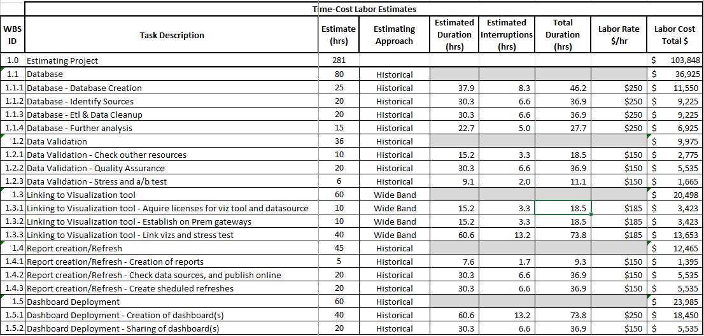

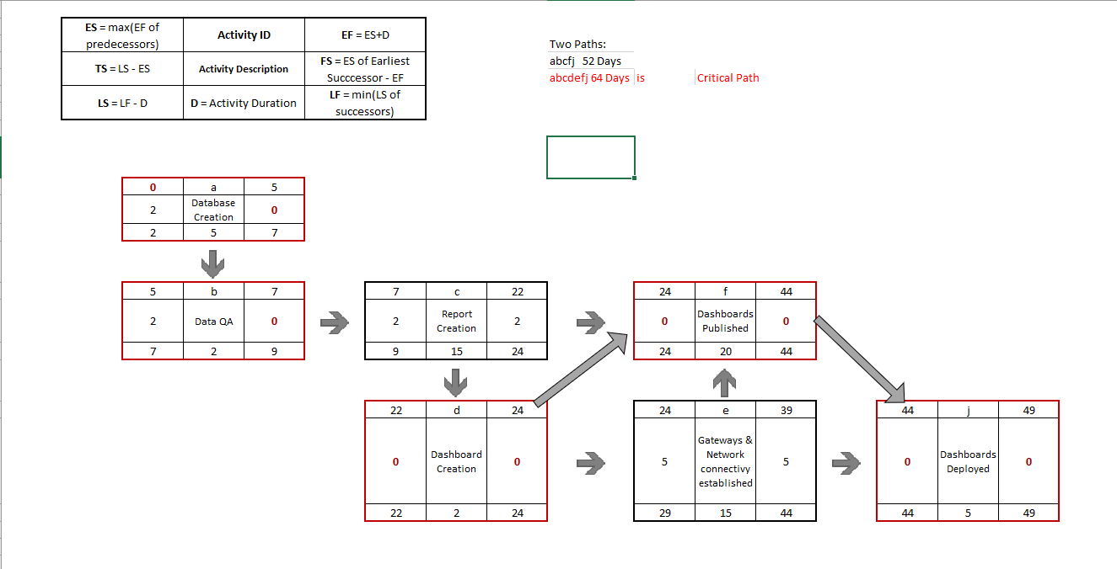

**Schedule Management Plan**

**2020 Election Dashboards**

**Sonny Desai**

**182 Garden gate Lane**

**Irvine, CA 92620**

**06/28/2020**

Introduction

The project schedule is the roadmap for how the project will be executed. Schedules are an important part of any project as they provide the project team, sponsor, and stakeholders a picture of the project’s status at any given time. The purpose of the schedule management plan is to define the approach the project team will use in creating the project schedule. This plan also includes how the team will monitor the project schedule and manage changes after the baseline schedule has been approved. This includes identifying, analyzing, documenting, prioritizing, approving or rejecting, and publishing all schedule-related changes.

# Schedule Management Approach

Project schedules will be created using MS Project 2007 starting with the deliverables identified in the project’s Work Breakdown Structure (WBS). Activity definition will identify the specific work packages which must be performed to complete each deliverable. Activity sequencing will be used to determine the order of work packages and assign relationships between project activities. Activity duration estimating will be used to calculate the number of work periods required to complete work packages. Resource estimating will be used to assign resources to work packages in order to complete schedule development.

Once a preliminary schedule has been developed, it will be reviewed by the project team and any resources tentatively assigned to project tasks. The project team and resources must agree to the proposed work package assignments, durations, and schedule. Once this is achieved the project sponsor will review and approve the schedule and it will then be baselined.

The following will be designates as milestones for the project schedule:

* Completion of scope statement and WBS/WBS Dictionary
* Baselined project schedule
* Approval of final project budget
* Project kick-off
* Approval of roles and responsibilities
* Requirements definition approval
* Completion of data mapping/inventory
* Project implementation
* Acceptance of final deliverables

Roles and responsibilities for schedule development are as follows:

The project manager will be responsible for facilitating work package definition, sequencing, and estimating duration and resources with the project team. The project manager will also create the project schedule using MS Project 2007 and validate the schedule with the project team, stakeholders, and the project sponsor. The project manager will obtain schedule approval from the project sponsor and baseline the schedule.

The project team is responsible for participating in work package definition, sequencing, and duration and resource estimating. The project team will also review and validate the proposed schedule and perform assigned activities once the schedule is approved.

The project sponsor will participate in reviews of the proposed schedule and approve the final schedule before it is baselined.

The project stakeholders will participate in reviews of the proposed schedule and assist in its validation.

# Schedule Control

The project schedule will be reviewed and updated as necessary on a bi-weekly basis with actual start, actual finish, and completion percentages which will be provided by task owners.

The project manager is responsible for holding bi-weekly schedule updates/reviews; determining impacts of schedule variances; submitting schedule change requests; and reporting schedule status in accordance with the project’s communications plan.

The project team is responsible for participating in bi-weekly schedule updates/reviews; communicating any changes to actual start/finish dates to the project manager; and participating in schedule variance resolution activities as needed.

The project sponsor will maintain awareness of the project schedule status and review/approve any schedule change requests submitted by the project manager.

# Schedule Changes and Thresholds

If any member of the project team determines that a change to the schedule is necessary, the project manager and team will meet to review and evaluate the change. The project manager and project team must determine which tasks will be impacted, variance as a result of the potential change, and any alternatives or variance resolution activities they may employ to see how they would affect the scope, schedule, and resources. If, after this evaluation is complete, the project manager determines that any change will exceed the established boundary conditions, then a schedule change request must be submitted.

Submittal of a schedule change request to the project sponsor for approval is required if either of the two following conditions is true:

* The proposed change is estimated to reduce the duration of an individual work package by 10% or more, or increase the duration of an individual work package by 10% or more.
* The change is estimated to reduce the duration of the overall baseline schedule by 10% or more, or increase the duration of the overall baseline schedule by 10% or more.

Any change requests that do not meet these thresholds may be submitted to the project manager for approval.

Once the change request has been reviewed and approved the project manager is responsible for adjusting the schedule and communicating all changes and impacts to the project team, project sponsor, and stakeholders. The project manager must also ensure that all change requests are archived in the project records repository.

# Scope Change

Any changes in the project scope, which have been approved by the project sponsor, will require the project team to evaluate the effect of the scope change on the current schedule. If the project manager determines that the scope change will significantly affect the current project schedule, he/she may request that the schedule be re-baselined in consideration of any changes which need to be made as part of the new project scope. The project sponsor must review and approve this request before the schedule can be re-baselined.

**Sponsor Acceptance**

Approved by the Project Sponsor:

Date:

<Project Sponsor>

<Project Sponsor Title>

# This free Project Schedule Management Plan Template is brought to you by [www.ProjectManagementDocs.com](http://www.ProjectManagementDocs.com)

**Risk management**

**2020 Election Dashboards**

**Sonny Desai**

**182 Garden gate Lane**

**Irvine, CA 92620**

**07/26/2020**

Project name: 2020 Election Dashboards

Project manager: Sonny Desai

|  |  |  |  |  |  |  |  |  |  |  |
| --- | --- | --- | --- | --- | --- | --- | --- | --- | --- | --- |
| **ID** | **Date raised** | **Risk description** | **Likelihood** | **Impact** | **Severity** | **Owner** | **Mitigating action** | **Contingent action** | **Progress on actions** | **Status** |
| 1 | 07/26/2020 | The election might be postponed | Low | High | High | Project Manager | The dashboards would have to be edited for scope; data would have to be continued to be collected | It will push back the date of dashboard deployment and further push reporting | Updated weekly | Open |
| 2 | Candidate could concede | The election would be over | Low | High | High | PM | Same as election being postponed except that dashboards would no longer be needed | The project would be canceled because of no longer having use | Updated monthly | Open |
|  |  |  |  |  |  |  |  |  |  |  |
|  |  |  |  |  |  |  |  |  |  |  |

## Severity table aka risk matrix

|  |  |  |  |  |
| --- | --- | --- | --- | --- |
|  |  | Likelihood | | |
|  |  | 1 | 2 | 3 |
| Impact | 1 | Low | Low | Medium |
| 2 | Low | Medium | High |
| 3 | Medium | High | High |

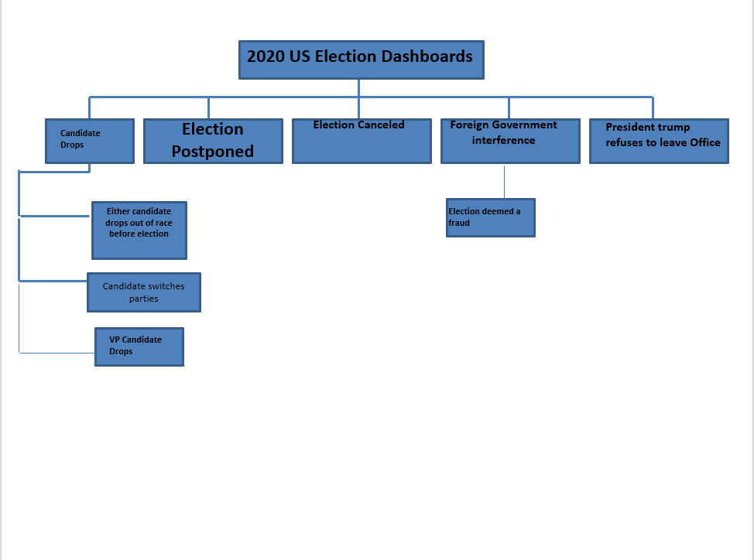

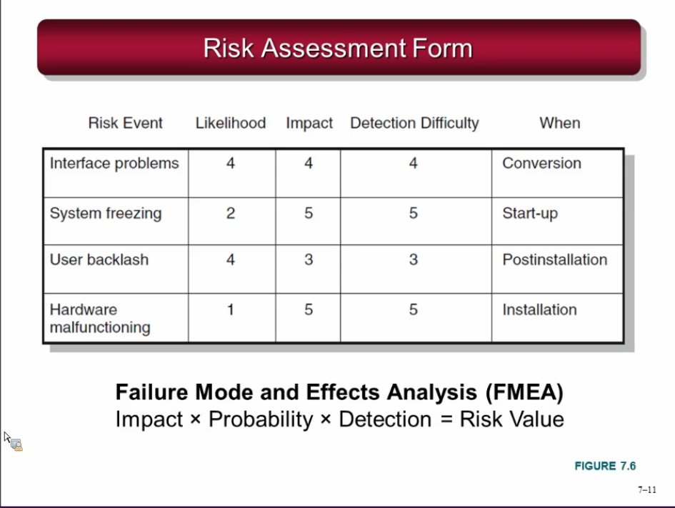

**Risk Management Plan**

**2020 Election Dashboards**

**Sonny Desai**

**182 Garden gate Lane**

**Irvine, CA 92620**

**07/26/2020**

# Introduction

As organizations begin new projects they begin operating in an area of uncertainty that comes along with developing new and unique products or services. By doing so, these organizations take chances which results in risk playing a significant part in any project. The purpose of the risk management plan is to establish the framework in which the project team will identify risks and develop strategies to mitigate or avoid those risks. However, before risks can be identified and managed, there are preliminary project elements which must be completed. These elements are outlined in the risk management approach.

This project is considered a medium risk project as it has an overall risk score of 24 on a scale from 0 to 100. The project risk score is the average of the risk scores of the most significant risks to this project. A risk score below 16 is low risk project, a score between 16 and 45 is a medium risk project and a score above 45 is a high risk project.

Before risk management begins it is imperative that a foundation is established for providing structured project information, thus, the following project elements were completed and defined prior to developing this Risk Management Plan:

* Define work scope, schedule, resources, and cost elements
  + Develop project WBS/WBS dictionary
  + Develop master schedule and detailed schedules
  + Estimate project cost and finalize budget
  + Identify required and available resources
  + Establish performance measurement metrics
* Define minimum and maximum baseline thresholds
  + Schedule
  + Resources
  + Cost
* Baseline reporting requirements
  + Format
  + Frequency of distribution
  + Distribution list
* Define Risk Management Roles and Responsibilities
  + Project Manager chairs the risk assessment meetings
  + Project team participates in risk assessment meetings and members serve as meeting recorder and timekeeper
  + Key stakeholders participate in risk assessment meetings
  + Project Sponsor may participate in risk assessment meetings

# Top Three Risks

The top three high probability and high impact risks to this project are:

**Candidate Drops Out**

If a candidate drops out, whether it be Joe Biden or Donald Trump, or one of their selected running mates, it could severely change the election and cause no need for dashboard to be viewed as there would a presume winner.

**Election Postponed**

Due to COVID-19, the election could be postponed to a later date, either later this year or next, causing delays to data collection, and the final result

**Foreign Government Interference**

Russia is presumed to have interfered in the last election, 2016 and the 2018 non-presidential election as well. China and Russia are presumed to possibly interfere with this election either through fake news or fake ads. Either manipulation could lead to the election being deemed fraudulent.

# Risk Management Approach

The approach we have taken to manage risks for this project included a methodical process by which the project team identified, scored, and ranked the various risks. The most likely and highest impact risks were added to the project schedule to ensure that the assigned risk managers take the necessary steps to implement the mitigation response at the appropriate time during the schedule. Risk managers will provide status updates on their assigned risks in the bi-weekly project team meetings, but only when the meetings include their risk’s planned timeframe. Upon the completion of the project, during the closing process, the project manager will analyze each risk as well as the risk management process. Based on this analysis, the project manager will identify any improvements that can be made to the risk management process for future projects. These improvements will be captured as part of the lessons learned knowledge base.

# Risk Identification

For this project, risk identification was conducted in the initial project risk assessment meeting. The method used by the project team to identify risks was the Crawford Slip method. The project manager chaired the risk assessment meeting and distributed notepads to each member of the team and allowed 10 minutes for all team members to record as many risks as possible.

**Expert Interview**

Two Expert Interviews were held for this project. The interviews revealed several risks which were then mitigated by making changes to the project plan. The remaining risks are included in the Risk Register.

**Risk Assessment Meeting**

A risk assessment meeting was held with key team members and stakeholders. The risks identified during this meeting were added to the project plan and Risk Register.

**Historical Review of Similar Projects**

The project team reviewed the history of similar projects in order to determine the most common risks and the strategies used to mitigate those risks.

# Risk Qualification and Prioritization

In order to determine the severity of the risks identified by the team, a probability and impact factor was assigned to each risk. This process allowed the project manager to prioritize risks based upon the effect they may have on the project. The project manager utilized a probability-impact matrix to facilitate the team in moving each risk to the appropriate place on the chart.

Once the risks were assigned a probability and impact and placed in the appropriate position on the chart, the recorder captured the finished product and the project manager moved the process on to the next step: risk mitigation/avoidance planning.

# Risk Monitoring

The most likely and greatest impact risks have been added to the project plan to ensure that they are monitored during the time the project is exposed to each risk. At the appropriate time in the project schedule a Risk Manager is assigned to each risk. During the bi-weekly project team meeting the Risk Manager for each risk will discuss the status of that risk; however, only risks which fall in the current time period will be discussed. Risk monitoring will be a continuous process throughout the life of this project. As risks approach on the project schedule the project manager will ensure that the appropriate risk manager provides the necessary status updates which include the risk status, identification of trigger conditions, and the documentation of the results of the risk response.

# Risk Mitigation and Avoidance

The project manager has led the project team in developing responses to each identified risk. As more risks are identified, they will be qualified and the team will develop avoidance and mitigation strategies. These risks will also be added to the Risk Register and the project plan to ensure they are monitored at the appropriate times and are responded to accordingly.

The risks for this project will be managed and controlled within the constraints of time, scope, and cost. All identified risks will be evaluated in order to determine how they affect this triple constraint. The project manager, with the assistance of the project team, will determine the best way to respond to each risk to ensure compliance with these constraints.

In extreme cases it may be necessary to allow flexibility to one of the project’s constraints. Only one of the constraints for this project allows for flexibility as a last resort. If necessary, funding may be added to the project to allow for more resources in order to meet the time (schedule) and scope constraints. Time and scope are firm constraints and allow for no flexibility. Again, the cost constraint is flexible only in extreme cases where no other risk avoidance or mitigation strategy will work.

**Risk Register**

The Risk Register for this project is a log of all identified risks, their probability and impact to the project, the category they belong to, mitigation strategy, and when the risk will occur. The register was created through the initial project risk management meeting led by the project manager. During this meeting, the project team identified and categorized each risk. Additionally, the team assigned each risk a score based on the probability of it occurring and the impact it could potentially have. The Risk Register also contains the mitigation strategy for each risk as well as when the risk is likely to occur.

Based on the identified risks and timeframes in the risk register, each risk has been added to the project plan. At the appropriate time in the plan—prior to when the risk is most likely to occur—the project manager will assign a risk manager to ensure adherence to the agreed upon mitigation strategy. The each risk manager will provide the status of their assigned risk at the bi-weekly project team meeting for their risk’s planned timeframe.

The Risk Register will be maintained as an appendix to this Risk Management Plan.

**Sponsor Acceptance**

Approved by the Project Sponsor:

Date:

<Project Sponsor>

<Project Sponsor Title>

# This free Project Risk Management Plan Template is brought to you by [www.ProjectManagementDocs.com](http://www.ProjectManagementDocs.com)

**Schedule Management Plan**

**2020 US Election Dashboards**

**Sonny Desai**

**182 Garden gate Lane**

**Irvine, CA 92620**

**07/26/2020**

# Introduction

The project schedule is the roadmap for how the project will be executed. Schedules are an important part of any project as they provide the project team, sponsor, and stakeholders a picture of the project’s status at any given time. The purpose of the schedule management plan is to define the approach the project team will use in creating the project schedule. This plan also includes how the team will monitor the project schedule and manage changes after the baseline schedule has been approved. This includes identifying, analyzing, documenting, prioritizing, approving or rejecting, and publishing all schedule-related changes.

# Schedule Management Approach

Project schedules will be created using US Election Dashboards starting with the deliverables identified in the project’s Work Breakdown Structure (WBS). Activity definition will identify the specific work packages which must be performed to complete each deliverable. Activity sequencing will be used to determine the order of work packages and assign relationships between project activities. Activity duration estimating will be used to calculate the number of work periods required to complete work packages. Resource estimating will be used to assign resources to work packages in order to complete schedule development.

Once a preliminary schedule has been developed, it will be reviewed by the project team and any resources tentatively assigned to project tasks. The project team and resources must agree to the proposed work package assignments, durations, and schedule. Once this is achieved the project sponsor will review and approve the schedule and it will then be baselined.

The following will be designates as milestones for the project schedule:

* Completion of scope statement and WBS/WBS Dictionary
* Baselined project schedule
* Approval of final project budget
* Project kick-off
* Approval of roles and responsibilities
* Requirements definition approval
* Completion of data mapping/inventory
* Project implementation
* Acceptance of final deliverables

Roles and responsibilities for schedule development are as follows:

The project manager will be responsible for facilitating work package definition, sequencing, and estimating duration and resources with the project team. The project manager will also create the project schedule using MS Project 2007 and validate the schedule with the project team, stakeholders, and the project sponsor. The project manager will obtain schedule approval from the project sponsor and baseline the schedule.

The project team is responsible for participating in work package definition, sequencing, and duration and resource estimating. The project team will also review and validate the proposed schedule and perform assigned activities once the schedule is approved.

The project sponsor will participate in reviews of the proposed schedule and approve the final schedule before it is baselined.

The project stakeholders will participate in reviews of the proposed schedule and assist in its validation.

# Schedule Control

The project schedule will be reviewed and updated as necessary on a bi-weekly basis with actual start, actual finish, and completion percentages which will be provided by task owners.

The project manager is responsible for holding bi-weekly schedule updates/reviews; determining impacts of schedule variances; submitting schedule change requests; and reporting schedule status in accordance with the project’s communications plan.

The project team is responsible for participating in bi-weekly schedule updates/reviews; communicating any changes to actual start/finish dates to the project manager; and participating in schedule variance resolution activities as needed.

The project sponsor will maintain awareness of the project schedule status and review/approve any schedule change requests submitted by the project manager.

# Schedule Changes and Thresholds

If any member of the project team determines that a change to the schedule is necessary, the project manager and team will meet to review and evaluate the change. The project manager and project team must determine which tasks will be impacted, variance as a result of the potential change, and any alternatives or variance resolution activities they may employ to see how they would affect the scope, schedule, and resources. If, after this evaluation is complete, the project manager determines that any change will exceed the established boundary conditions, then a schedule change request must be submitted.

Submittal of a schedule change request to the project sponsor for approval is required if either of the two following conditions is true:

* The proposed change is estimated to reduce the duration of an individual work package by 10% or more, or increase the duration of an individual work package by 10% or more.
* The change is estimated to reduce the duration of the overall baseline schedule by 10% or more, or increase the duration of the overall baseline schedule by 10% or more.

Any change requests that do not meet these thresholds may be submitted to the project manager for approval.

Once the change request has been reviewed and approved the project manager is responsible for adjusting the schedule and communicating all changes and impacts to the project team, project sponsor, and stakeholders. The project manager must also ensure that all change requests are archived in the project records repository.

# Scope Change

Any changes in the project scope, which have been approved by the project sponsor, will require the project team to evaluate the effect of the scope change on the current schedule. If the project manager determines that the scope change will significantly affect the current project schedule, he/she may request that the schedule be re-baselined in consideration of any changes which need to be made as part of the new project scope. The project sponsor must review and approve this request before the schedule can be re-baselined.

**Sponsor Acceptance**

Approved by the Project Sponsor:

Date:

<Project Sponsor>

<Project Sponsor Title>

# This free Project Schedule Management Plan Template is brought to you by [www.ProjectManagementDocs.com](http://www.ProjectManagementDocs.com)

**Human Resource Plan**

**2020 US Election Dashboards**

**Sonny Desai**

**182 Garden gate Lane**

**Irvine, CA 92620**

**08/02/2020**

**Introduction**

Human resources management is an important part of the Software Upgrade Project. The human resources management plan is a tool which will aid in the management of this project’s human resource activities throughout the project until closure. The human resources management plan includes:

* Roles and responsibilities of team members throughout the project
* Project organization charts
* Staffing management plan to include:
  1. How resources will be acquired
  2. Timeline for resources/skill sets
  3. Training required to develop skills
  4. How performance reviews will be conducted
  5. Recognition and rewards system

The purpose of the human resources management plan is to achieve project success by ensuring the appropriate human resources are acquired with the necessary skills, resources are trained if any gaps in skills are identified, team building strategies are clearly defines, and team activities are effectively managed.

# Roles and Responsibilities

The roles and responsibilities for the Software Upgrade Project are essential to project success. All team members must clearly understand their roles and responsibilities in order to successfully perform their portion of the project. For the Software Upgrade Project the following project team roles and responsibilities have been established:

**Project Manager (PM), (1 position):** responsible for the overall success of the Software Upgrade Project. The PM must authorize and approve all project expenditures. The PM is also responsible for approving that work activities meet established acceptability criteria and fall within acceptable variances. The PM will be responsible for reporting project status in accordance with the communications management plan. The PM will evaluate the performance of all project team members and communicate their performance to functional managers. The PM is also responsible for acquiring human resources for the project through coordination with functional managers. The PM must possess the following skills: leadership/management, budgeting, scheduling, and effective communication.

**Design Engineer (DE), (2 positions):** responsible for gathering coding requirements for the Software Upgrade Project. The DEs are responsible for all upgrade design, coding, and testing of the upgraded software. The DEs will assist the implementation lead in the distribution and monitoring of the software upgrades throughout the network infrastructure. The DEs will be responsible for timely status reporting to the PM as required by the communications management plan. The DEs may not authorize any project expenditures nor allocate any resources without PM approval. DE’s performance will be managed by the PM and communicated to the Design Technology Group Manager (DE’s Functional Manager). DEs must be proficient in programming html, C++, and Java programming languages.

**Implementation Manager (IM), (1 position):** The IM is responsible for the distribution, implementation, and monitoring of the new software upgrade. The IM is responsible for working with the DEs to ensure all coding on new software conforms with organizational security regulations. The IM is responsible for coordination outage windows with each department to facilitate the rollout of the software upgrades with minimal/no disturbance to operations. The IM will report status to the PM in accordance with the project’s communications management plan. The IM’s performance will be evaluated by the PM and communicated to the IM’s functional manager (Network Manager). The IM must be proficient in managing network architecture.

**Training Lead (TL), (1 position):** The TL is responsible for training all network users on the features provided by the upgrades to the existing software. The TL will coordinate training times/locations with each department’s training advocate. The TL will provide training status to the PM in accordance with the project communications management plan.

**Functional Managers (FM), (2 positions):** While not part of the project team, functional managers are responsible for providing resources for the project in accordance with the project staffing plan. Functional managers are responsible for working with the PM to determine skill sets required and approving resource assignments. Functional managers are also responsible for conducting performance appraisals of assigned resources based, in part, on the PM’s feedback regarding project performance.

# Project Organizational Charts

The following RACI chart shows the relationship between project tasks and team members. Any proposed changes to project responsibilities must be reviewed and approved by the project manager. Changes will be proposed in accordance with the project’s change control process. As changes are made all project documents will be updated and redistributed accordingly.

|  |  |  |  |  |  |  |
| --- | --- | --- | --- | --- | --- | --- |
|  | Project Manager | Design Engineers | Implementation Manager | Training Leads | Functional Managers | Department Managers |
| Requirements Gathering | A | R | R | C | C | I |
| Coding Design | A | R | C |  | C | I |
| Coding Input | A | R |  |  |  |  |
| Software Testing | A | R | C |  | I | I |
| Network Preparation | A | C | R |  | I | I |
| Implementation | A | C | R | C | C | C |
| Conduct Training | A |  |  | R | C | C |

Key:

R – Responsible for completing the work

A – Accountable for ensuring task completion/sign off

C – Consulted before any decisions are made

I – Informed of when an action/decision has been made

# Staffing Management

**Staff Acquisition:**

For the Software Upgrade Project the project staff will consist entirely of internal resources. There will be no outsourcing/contracting performed within the scope of this project. The Project Manager will negotiate with functional and department managers in order to identify and assign resources in accordance with the project organizational structure. All resources must be approved by the appropriate functional/department manager before the resource may begin any project work. The project team will not be co-located for this project and all resources will remain in their current workspace.

**Resource Calendars:**

The Software Upgrade Project will last for five weeks. All resources are required before the project can begin. The resource histogram below illustrates that design engineers are required to perform 40 hours per week per engineer for the first three weeks of the project. Their requirements are then scaled back to 5 hours per engineer in the fourth week. After the fourth week the design engineers will be released from the project. The implementation manager will also be released from the project after week 4. The training lead will be required to perform 15 hours of work in the first week and a full 40 hours of training during week 5.



**Training:**

There is currently no training scheduled with regards to the Software Upgrade Project since the organization has adequate staff with required skill sets. However, if training requirements are identified, funding will be provided from the project reserve.

**Performance Reviews:**

The project manager will review each team member’s assigned work activities at the onset of the project and communicate all expectations of work to be performed. The project manager will then evaluate each team member throughout the project to evaluate their performance and how effectively they are completing their assigned work. Prior to releasing project resources, the project manager will meet with the appropriate functional manager and provide feedback on employee project performance. The functional managers will then perform a formal performance review on each team member.

**Recognition and Rewards:**

Although the scope of this project does not allow for ample time to provide cross-training or potential for monetary rewards there are several planned recognition and reward items for project team members.

* Upon successful completion of the Software Upgrade Project, a party will be held to celebrate the success of each team member with the team members’ families present.
* Upon successful completion of the project, any team member who satisfactorily completed all assigned work packages on time will receive a certificate of thanks from the CEO.
* Team members who successfully complete all of their assigned tasks will have their photo taken for inclusion in the company newsletter.
* The company will provide free family movie tickets for the top two performers on each project.

**Sponsor Acceptance**

Approved by the Project Sponsor:

Date:

<Project Sponsor>

<Project Sponsor Title>

This free Project Human Resource Plan Template is brought to you by [www.ProjectManagementDocs.com](http://www.ProjectManagementDocs.com)

**Schedule Management Plan**

**2020 US Election Dashboards**

**Sonny Desai**

**182 Garden gate Lane**

**Irvine, CA 92620**

**08/02/2020**

# Introduction

The project schedule is the roadmap for how the project will be executed. Schedules are an important part of any project as they provide the project team, sponsor, and stakeholders a picture of the project’s status at any given time. The purpose of the schedule management plan is to define the approach the project team will use in creating the project schedule. This plan also includes how the team will monitor the project schedule and manage changes after the baseline schedule has been approved. This includes identifying, analyzing, documenting, prioritizing, approving or rejecting, and publishing all schedule-related changes.

# Schedule Management Approach

Project schedules will be created using 2020 US Elections Dashboard starting with the deliverables identified in the project’s Work Breakdown Structure (WBS). Activity definition will identify the specific work packages which must be performed to complete each deliverable. Activity sequencing will be used to determine the order of work packages and assign relationships between project activities. Activity duration estimating will be used to calculate the number of work periods required to complete work packages. Resource estimating will be used to assign resources to work packages in order to complete schedule development.

Once a preliminary schedule has been developed, it will be reviewed by the project team and any resources tentatively assigned to project tasks. The project team and resources must agree to the proposed work package assignments, durations, and schedule. Once this is achieved the project sponsor will review and approve the schedule and it will then be baselined.

The following will be designates as milestones for the project schedule:

* Completion of scope statement and WBS/WBS Dictionary
* Baselined project schedule
* Approval of final project budget
* Project kick-off
* Approval of roles and responsibilities
* Requirements definition approval
* Completion of data mapping/inventory
* Project implementation
* Acceptance of final deliverables

Roles and responsibilities for schedule development are as follows:

The project manager will be responsible for facilitating work package definition, sequencing, and estimating duration and resources with the project team. The project manager will also create the project schedule using MS Project 2007 and validate the schedule with the project team, stakeholders, and the project sponsor. The project manager will obtain schedule approval from the project sponsor and baseline the schedule.

The project team is responsible for participating in work package definition, sequencing, and duration and resource estimating. The project team will also review and validate the proposed schedule and perform assigned activities once the schedule is approved.

The project sponsor will participate in reviews of the proposed schedule and approve the final schedule before it is baselined.

The project stakeholders will participate in reviews of the proposed schedule and assist in its validation.

# Schedule Control

The project schedule will be reviewed and updated as necessary on a bi-weekly basis with actual start, actual finish, and completion percentages which will be provided by task owners.

The project manager is responsible for holding bi-weekly schedule updates/reviews; determining impacts of schedule variances; submitting schedule change requests; and reporting schedule status in accordance with the project’s communications plan.

The project team is responsible for participating in bi-weekly schedule updates/reviews; communicating any changes to actual start/finish dates to the project manager; and participating in schedule variance resolution activities as needed.

The project sponsor will maintain awareness of the project schedule status and review/approve any schedule change requests submitted by the project manager.

# Schedule Changes and Thresholds

If any member of the project team determines that a change to the schedule is necessary, the project manager and team will meet to review and evaluate the change. The project manager and project team must determine which tasks will be impacted, variance as a result of the potential change, and any alternatives or variance resolution activities they may employ to see how they would affect the scope, schedule, and resources. If, after this evaluation is complete, the project manager determines that any change will exceed the established boundary conditions, then a schedule change request must be submitted.

Submittal of a schedule change request to the project sponsor for approval is required if either of the two following conditions is true:

* The proposed change is estimated to reduce the duration of an individual work package by 10% or more, or increase the duration of an individual work package by 10% or more.
* The change is estimated to reduce the duration of the overall baseline schedule by 10% or more, or increase the duration of the overall baseline schedule by 10% or more.

Any change requests that do not meet these thresholds may be submitted to the project manager for approval.

Once the change request has been reviewed and approved the project manager is responsible for adjusting the schedule and communicating all changes and impacts to the project team, project sponsor, and stakeholders. The project manager must also ensure that all change requests are archived in the project records repository.

# Scope Change

Any changes in the project scope, which have been approved by the project sponsor, will require the project team to evaluate the effect of the scope change on the current schedule. If the project manager determines that the scope change will significantly affect the current project schedule, he/she may request that the schedule be re-baselined in consideration of any changes which need to be made as part of the new project scope. The project sponsor must review and approve this request before the schedule can be re-baselined.

**Sponsor Acceptance**

Approved by the Project Sponsor:

Date:

<Project Sponsor>

<Project Sponsor Title>

# This free Project Schedule Management Plan Template is brought to you by [www.ProjectManagementDocs.com](http://www.ProjectManagementDocs.com)