**Assumptions Made**

1.A patient can be admitted even for few hours a day and get discharged

2.Only 8 beds are available

3.Only 2 nurses available

4.Patient personal information is already captured and stored in database, so that while admitting a patient, just need to select only patient name from the patient dropdown

**Description of the Solution**.

I have used 3 layers for this application as shown in below screen shot

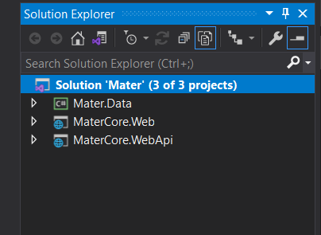

1.**Mater.Data** This project used as a data access layer to get data from the database. The webapi layer call this to get the data.

2.**MateCore.Web** -This project used as front-end web application which makes **Restful API** calls to the MaterCore- Web API layer to get data

3.**MaterCore.Webpi**-This project contains all the restful API calls to perform various operation which the front end requires.

Used **Stored Procedures** to perform all CRUD activities

**TechStack Used** : DotNet Core 3.1,C#, SQL server 14.0 Database.

**IDE Used**: Visual Studio 2019

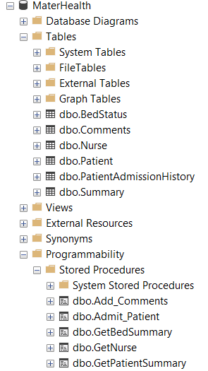

**Above is the screenshot of the Database Table and Stored Procedures**.

**Installation and Testing Instructions**

**Below is screenshot of folders and files you should see after you download**

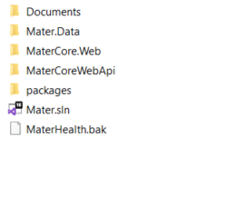

**1.Documents Folder:** It Contains DescriptionAndInstallation.docx and UserManual.docx

**2.MaterHealth.bak:** This is database backup which needs to be restored to SQLserver 14.0

**3.Mater.Sln:** This is the solution file which contains three projects ie 1. Mater.Data 2.MaterCore.Web,3.MareCoreWeb.api

**Used Visual Studio 2019 IDE**

**Installation and Running the Solution**

**STEP1**

Restore the MaterHealth.bak file to SQLserver 14.0

STEP2

Open the Mater.Sln in visual studio 2019 which should load all the three projects as shown below



STEP3. Rebuild the solution so that there are no errors

Step 4.

**1.Choose Multiple Startup project option as shown below**

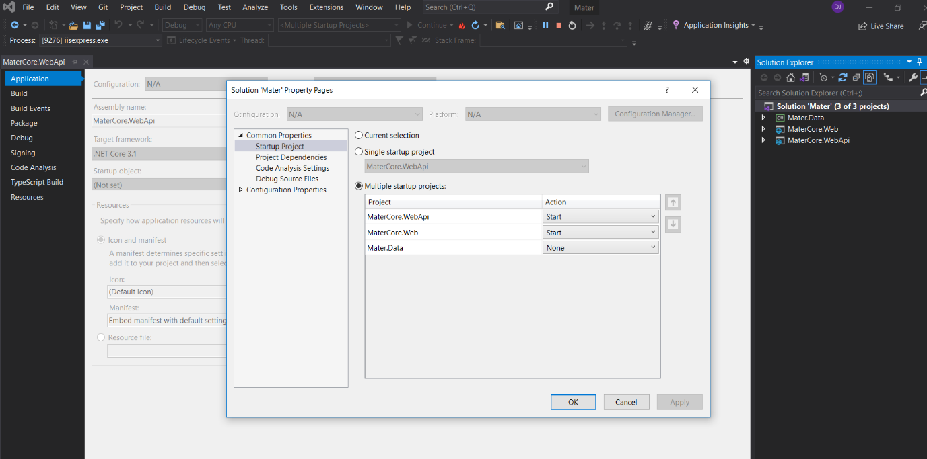

**Step5**

**Change the Database sql connection string accordingly in appsettings.json file located in WEBAPI project**

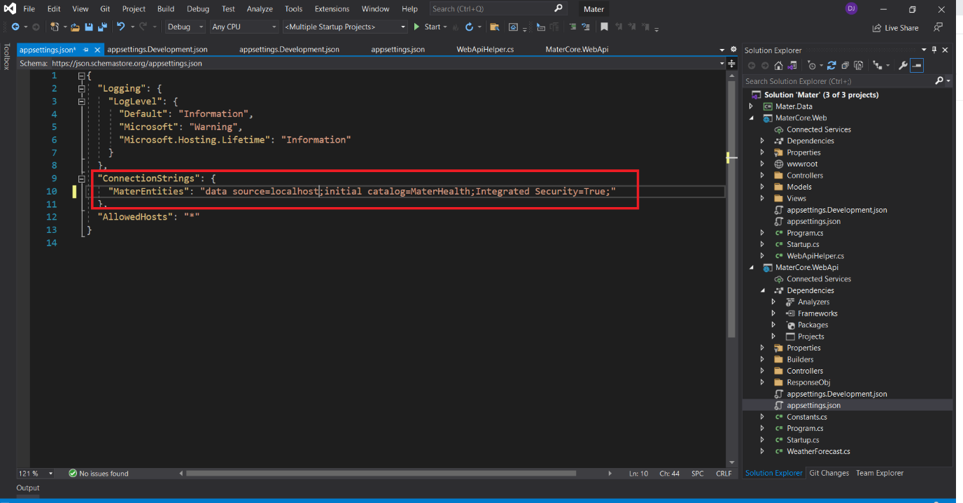

**Step 6.**

**Once you run the project two browser should load one is the Webapi restful calls and other the front end application as shown in below screenshot**

**1.WEBApi calls**

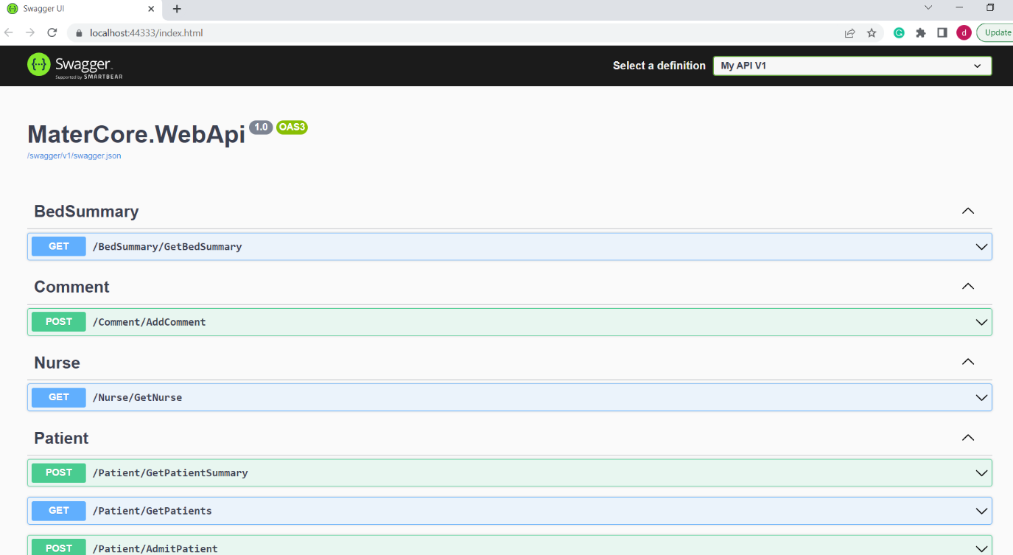

**2.Front End Web application .**

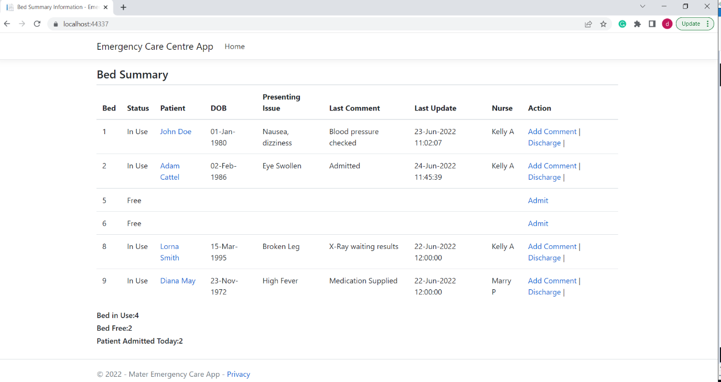

**Step 7 :IF the front End application is not able to connect to WEBAPI .Make sure the URL is correct in WebApiHelper.cs file located in Matercore.web project as shown in below screenshot**

**The below URL should match to WEBAPI URL address**

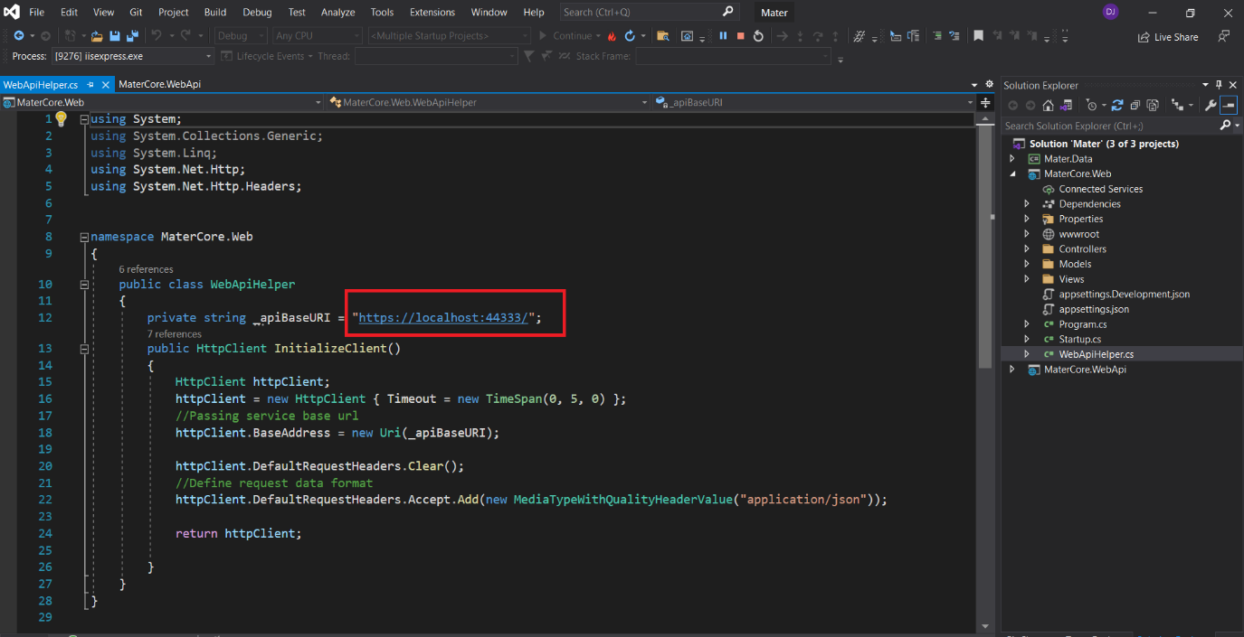

**Step 8**

**Test the functionalities. Have included the User Manual in the Documents folder.**