1.**Home Page** -Show summary of bed Information

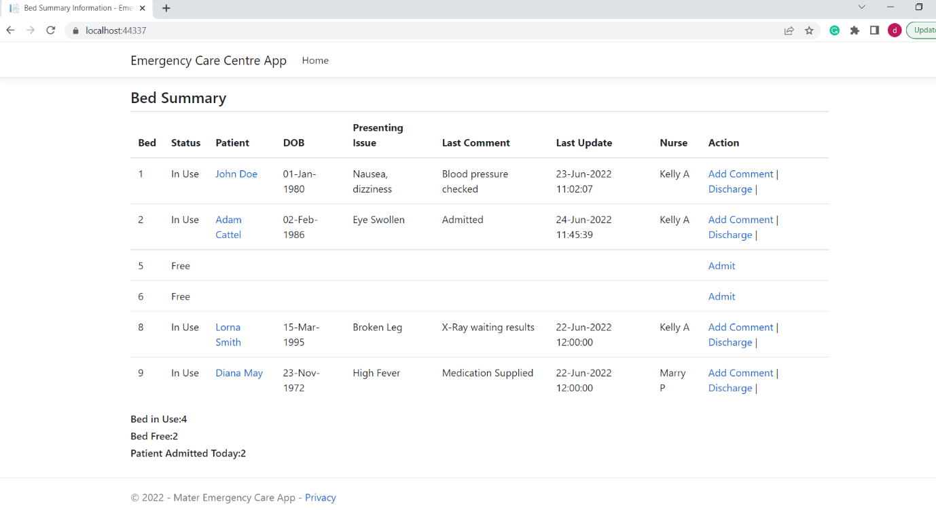

2.**Patient Detailed Summary Page** -On click of the patient name in bed summary table, it Shows patient information with the coments summary.

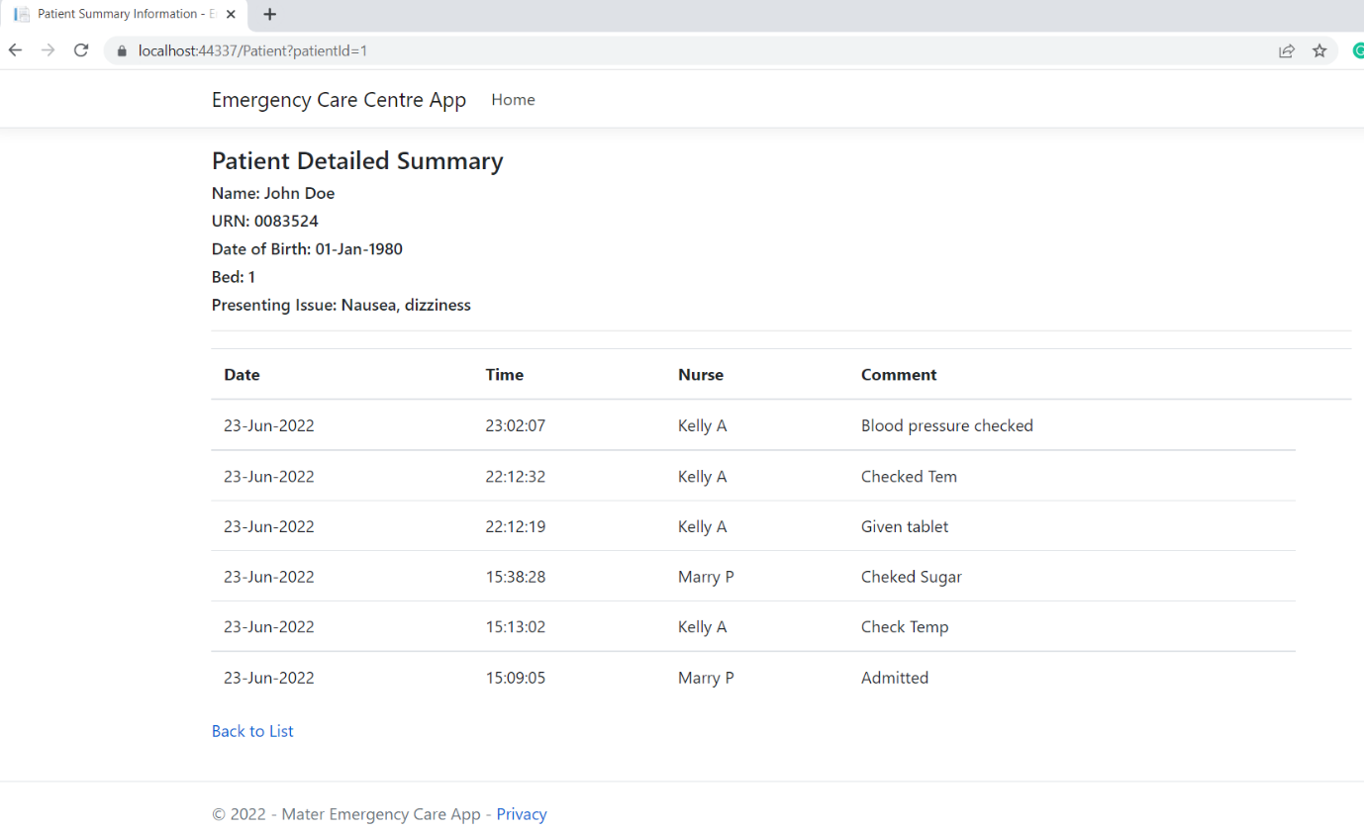

3.**Add Comment Page** – On click of the Add Comment option in the bed summary table, it shows below page where user can add comment by selecting the nurse name under the nurse dropdown and adding the comment.

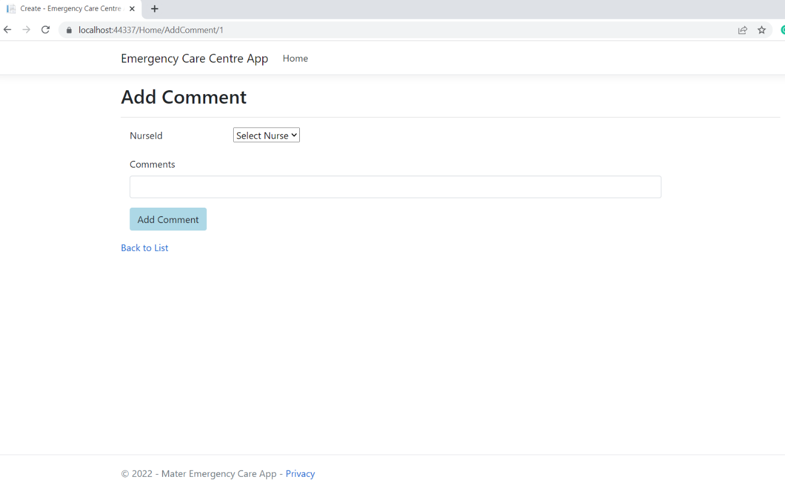

4..**Discharge Page** – On click of the Discharge option in the bed summary table, it shows below page where user can add comment by selecting the nurse name under the nurse dropdown and adding the comment.

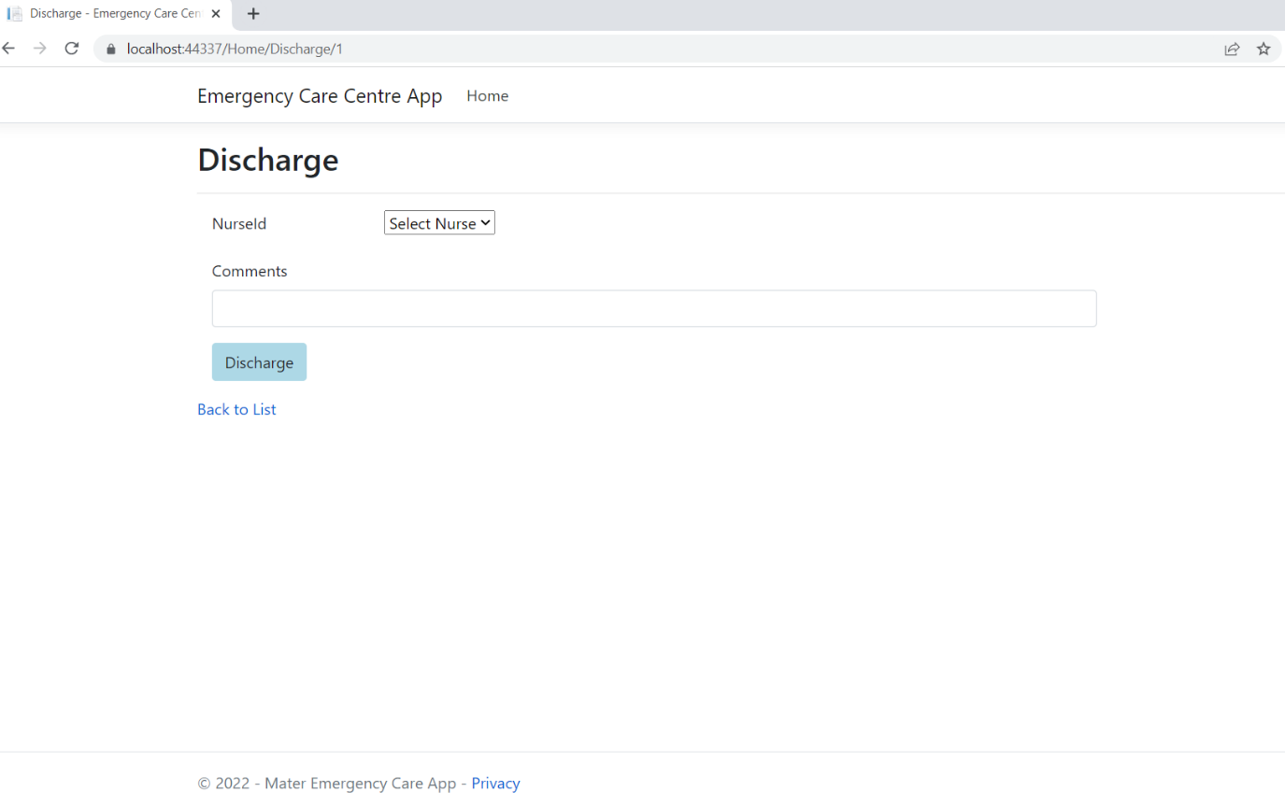

5.**Admit Patient page**- On click of the Admit option in the bed summary table ,it shows below page where user can admit patient by selecting the patient name , nurse name under the patient and nurse dropdown and adding the Issue and comment.

