**PROJECT: VULNERABILLITITES IDENTIFY**

1. **Objectives:** In this report, How Attackers gathered information.
2. **Tools and Resources:** [www.hackthissite.org](http://www.hackthissite.org) , [www.netcraft.com](http://www.netcraft.com) , [www.mxtoolbox.com/domain/](http://www.mxtoolbox.com/domain/) , NMAP.
3. **Information gathering:**

* **www.netcraft.com:**
* **Steps to reproduce:**

**Step1: Go to Browser and enter the** [**url:www.netcraft.com**](url:www.netcraft.com) **.**

**Step2: Enter the Target Domain** [**www.hackthissite.org**](http://www.hackthissite.org) **and click the Analyze.**

**Proof:**

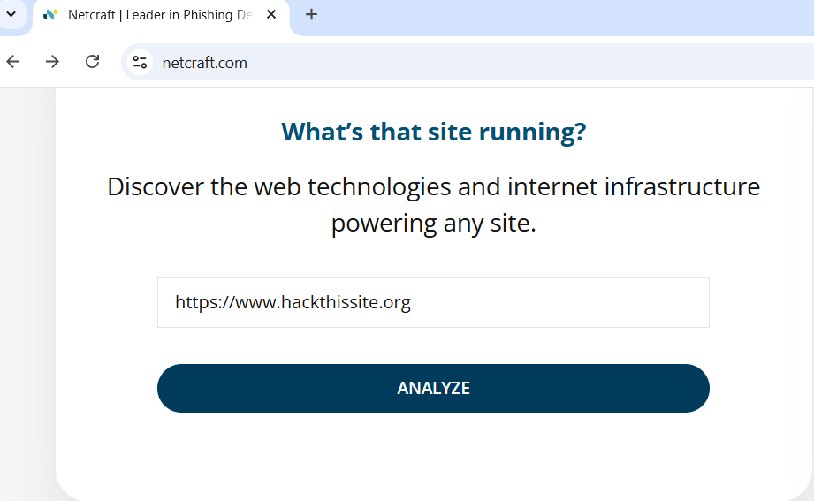

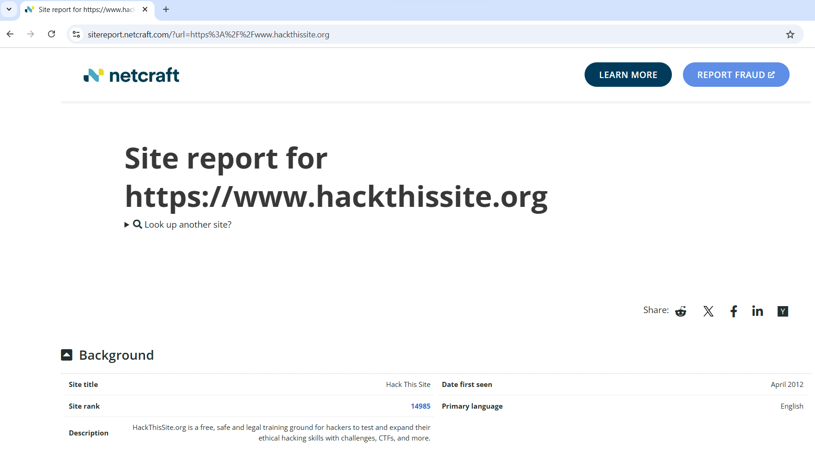

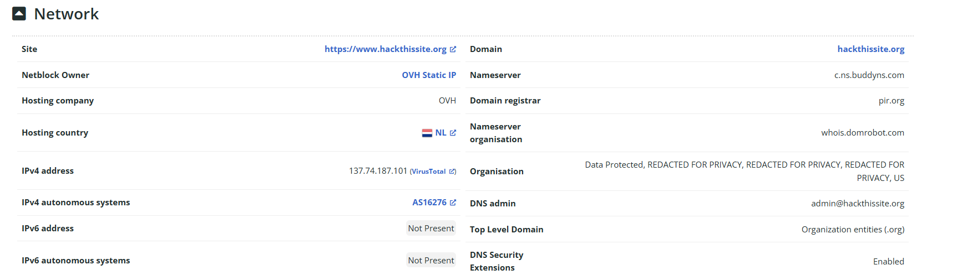

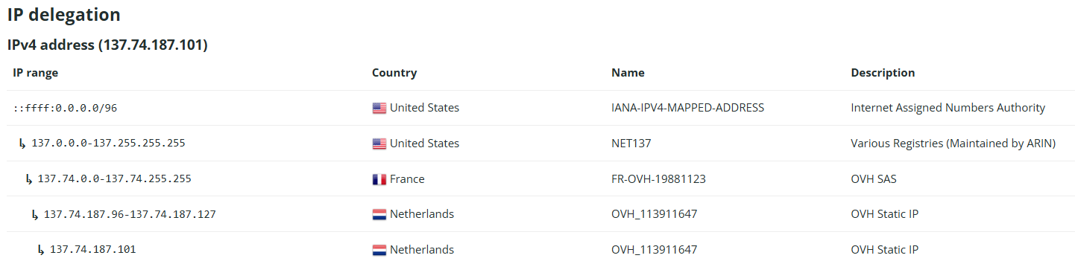

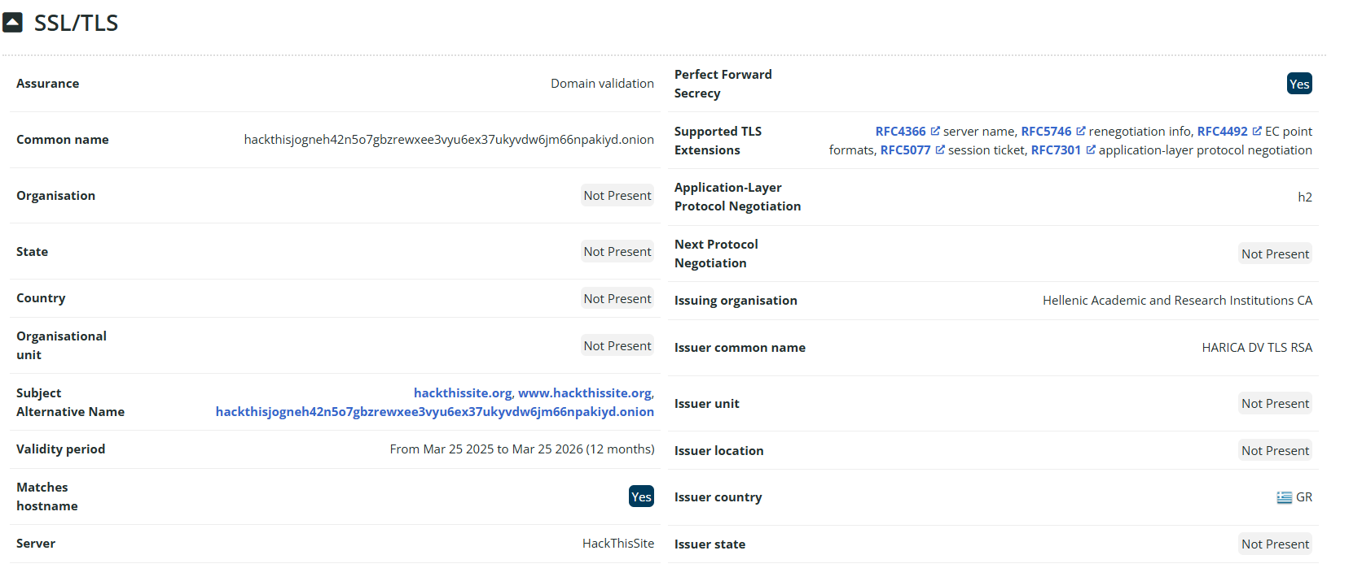

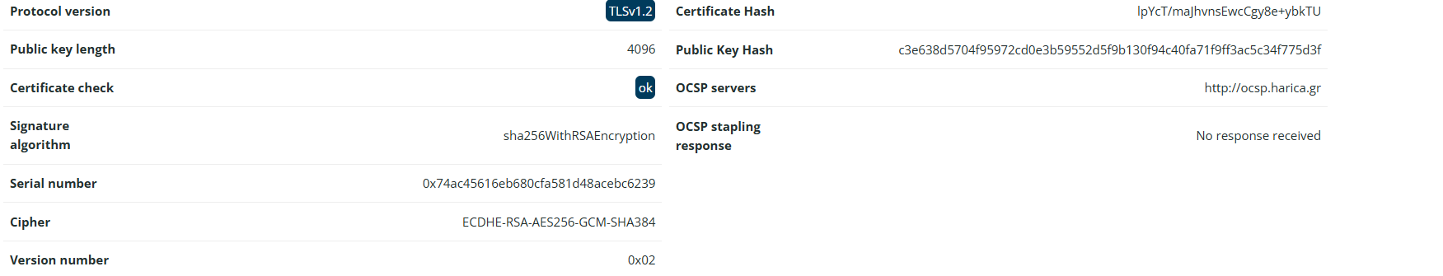

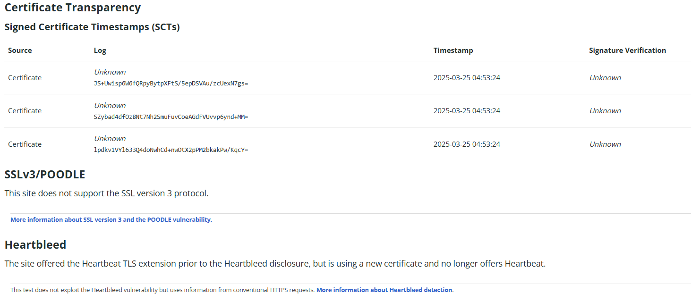

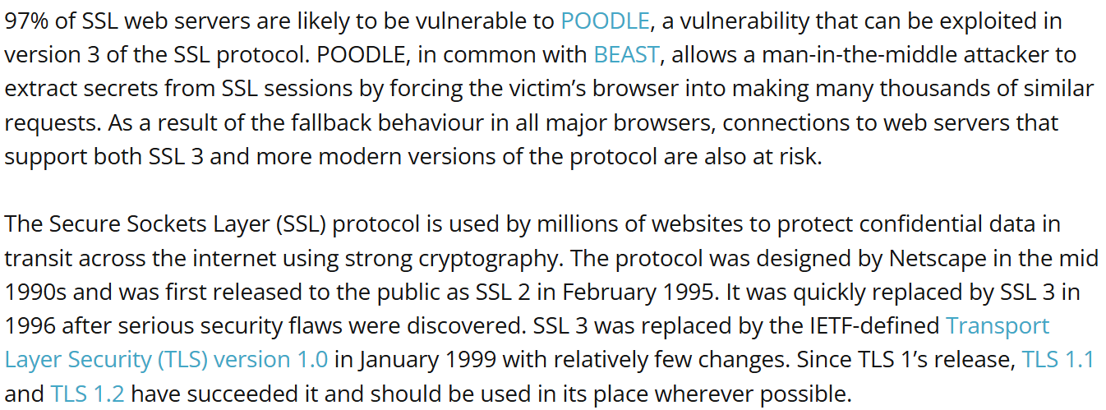

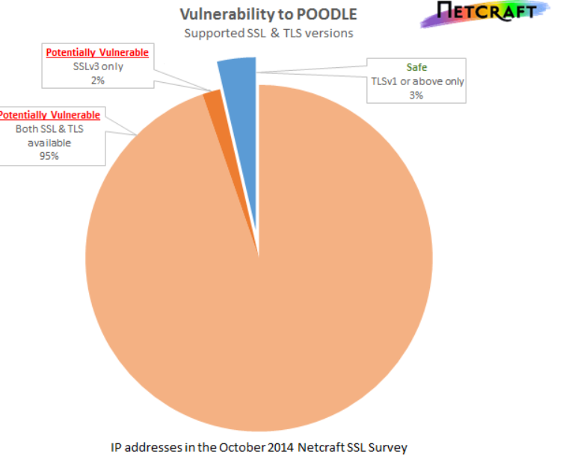

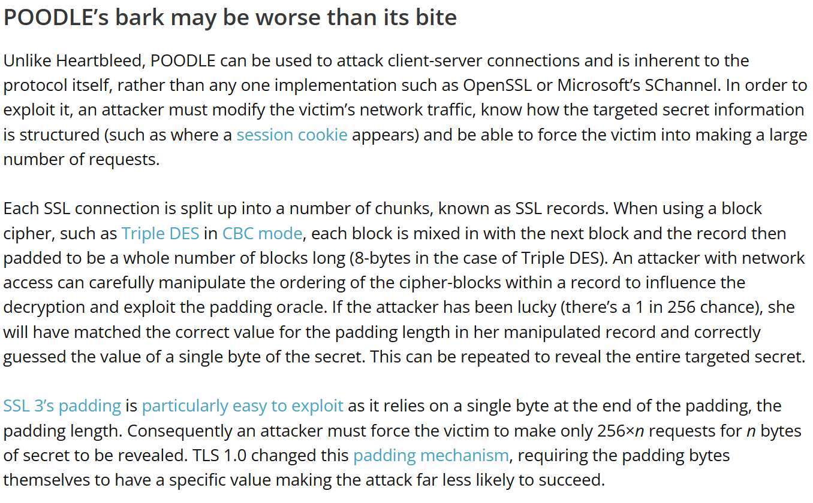

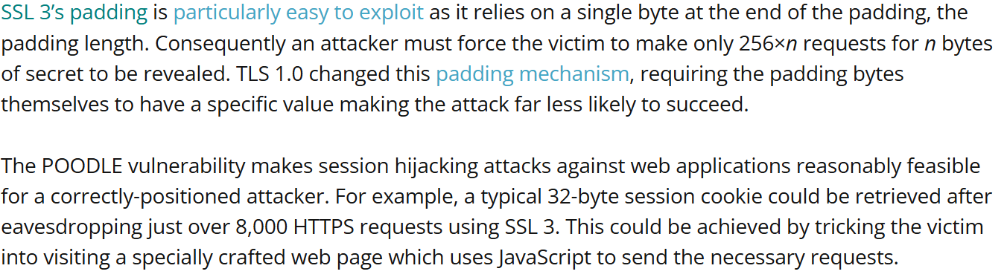

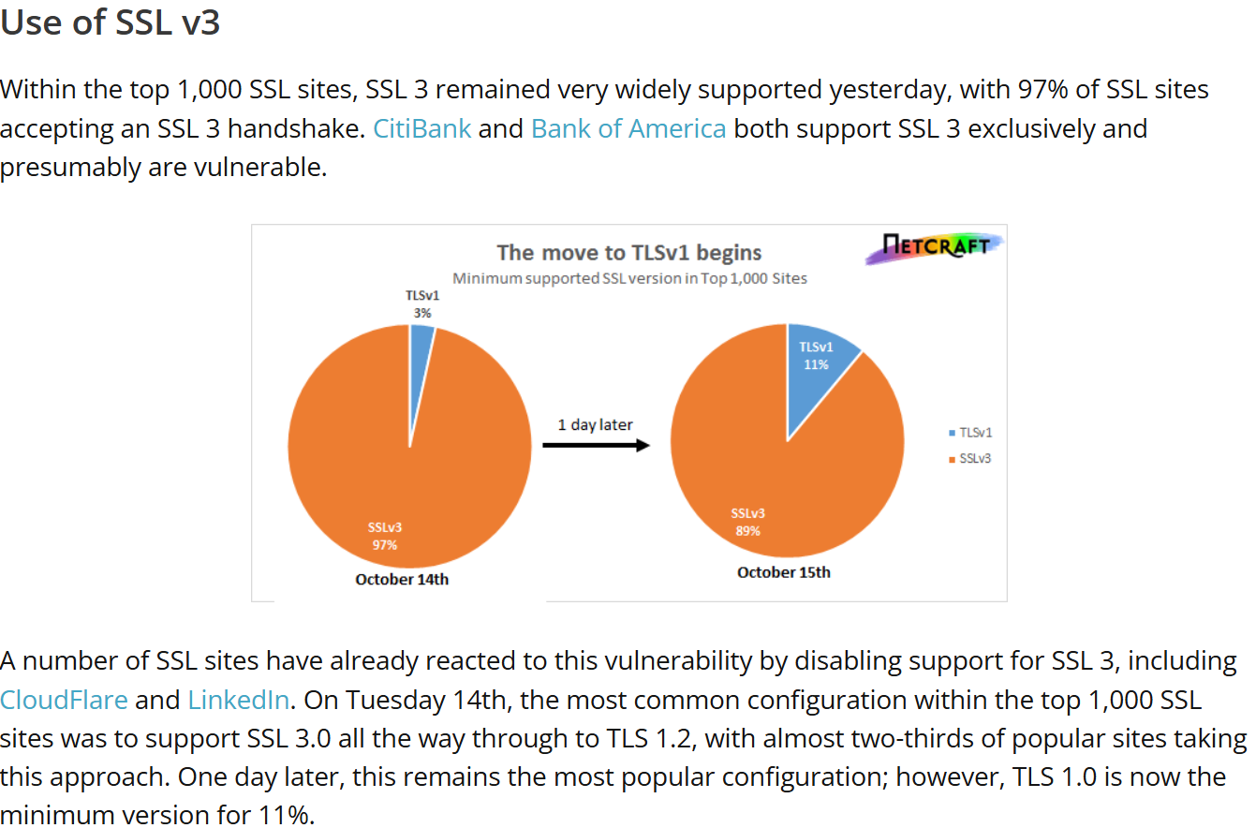

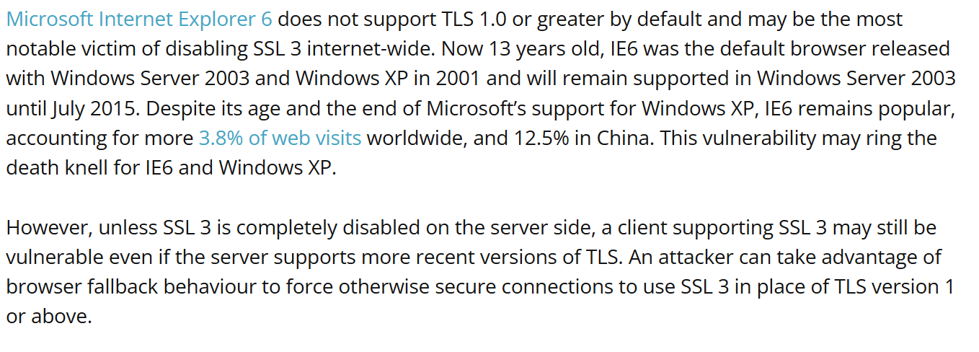

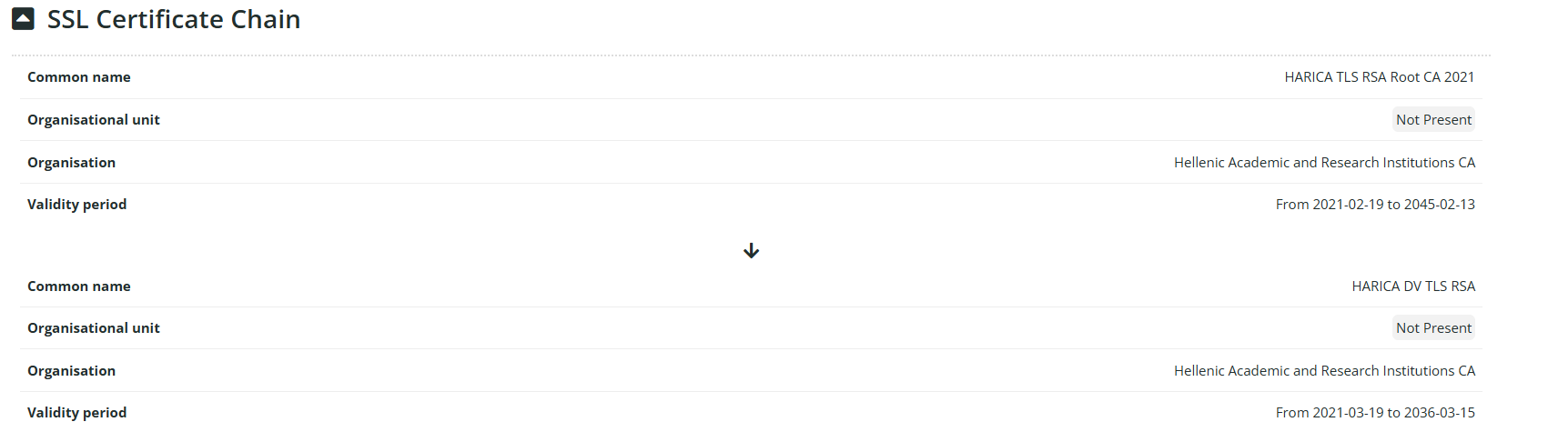

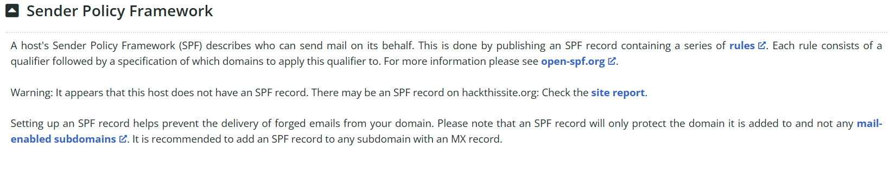

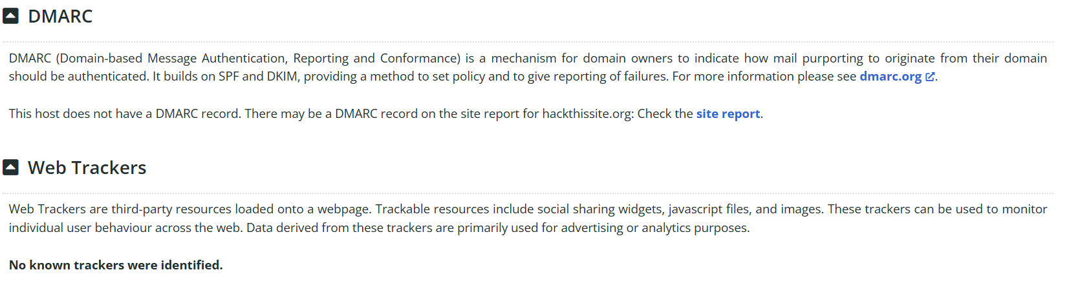

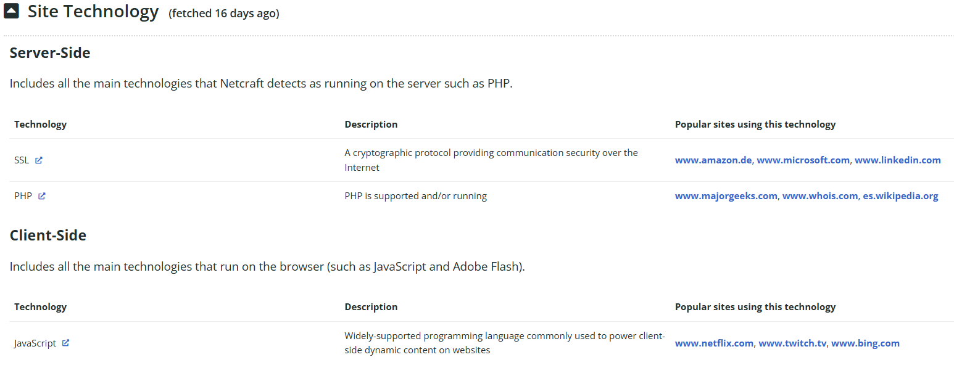

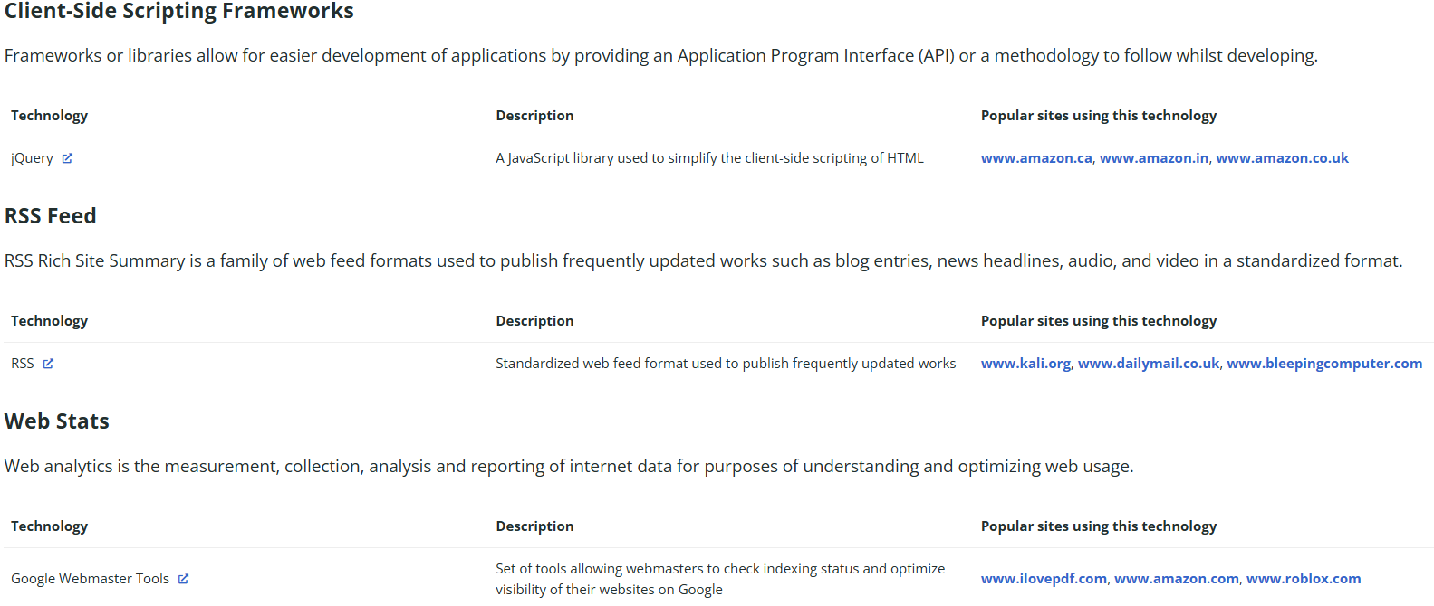

* [www.mxtoolbox.com/domain/](http://www.mxtoolbox.com/domain/) **:**
* **Steps to reproduce:**

**Step1: Go to browser and enter the url:** [www.mxtoolbox.com/domain/](http://www.mxtoolbox.com/domain/)

**Step2: Enter the Email Address or Domain and click the Check Domain Health.**

**Proof:**

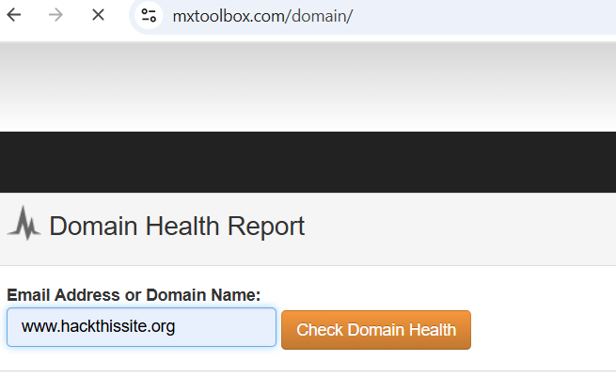

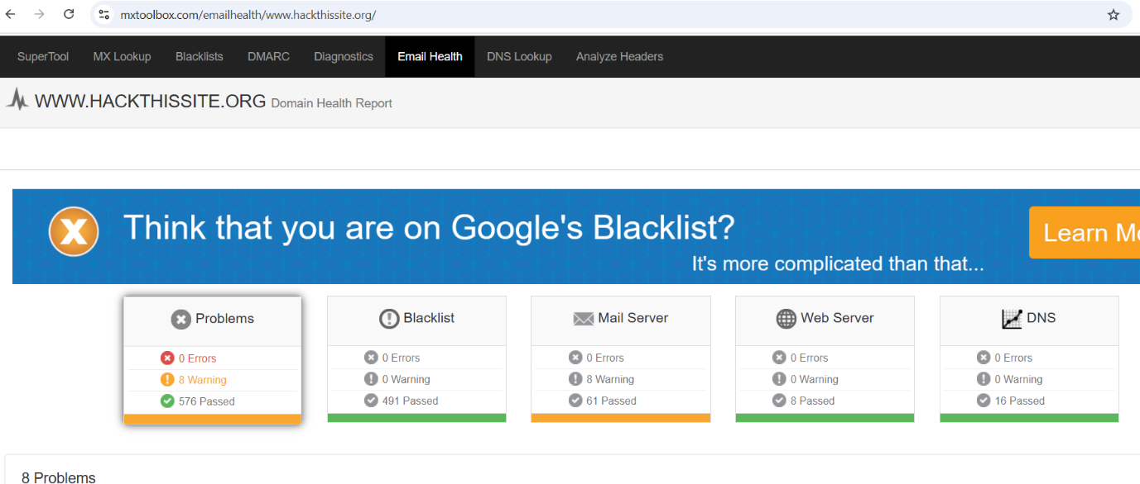

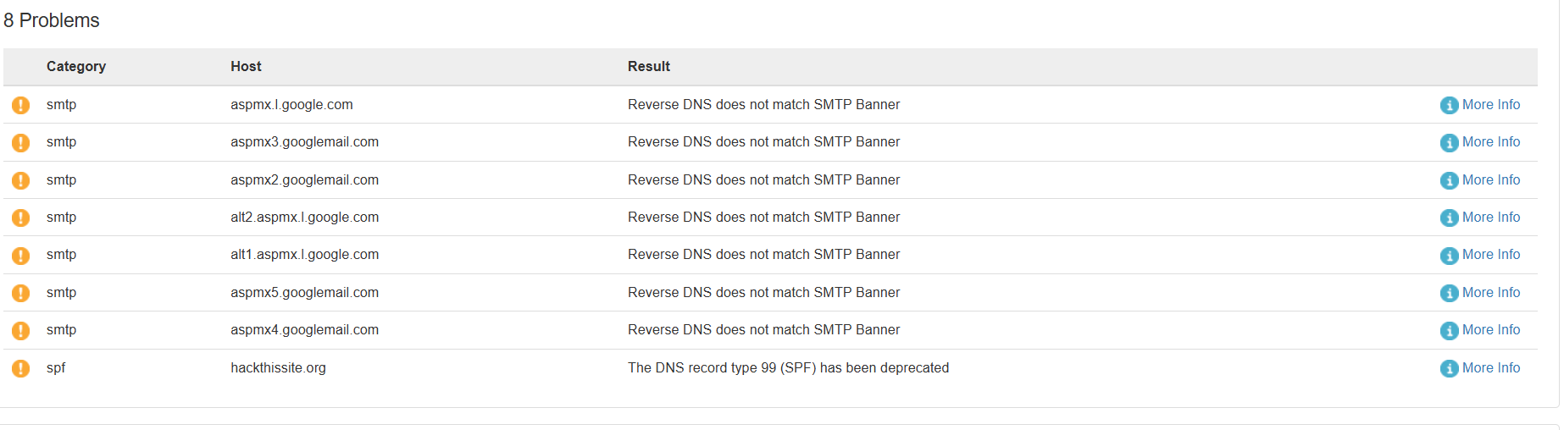

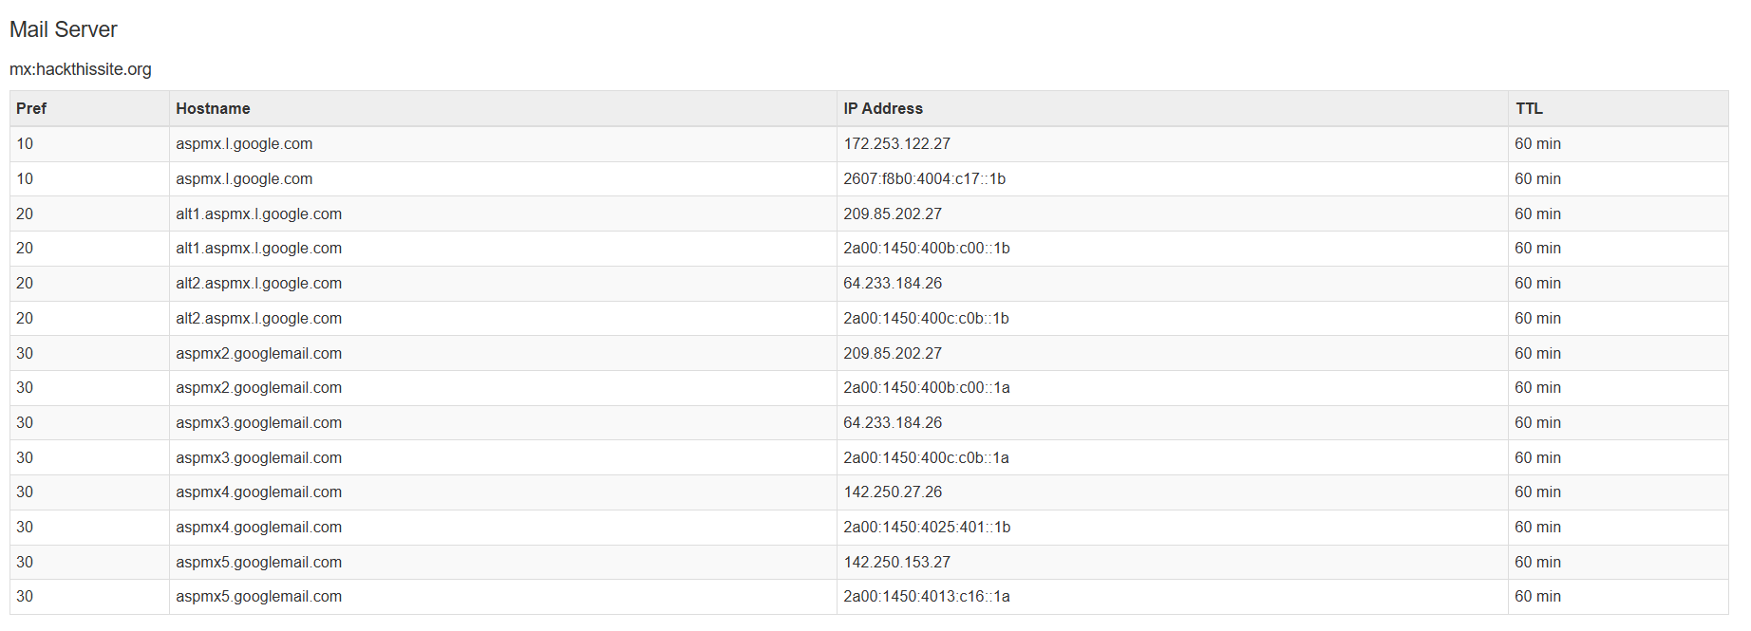

* **NMAP:**
* **Steps to Produce:**

**Step1: Go to Start button, Search Command Prompt run as Administrator and enter the command nmap -v -A** [**www.hackthissite.org**](http://www.hackthissite.org)

**Proof:**

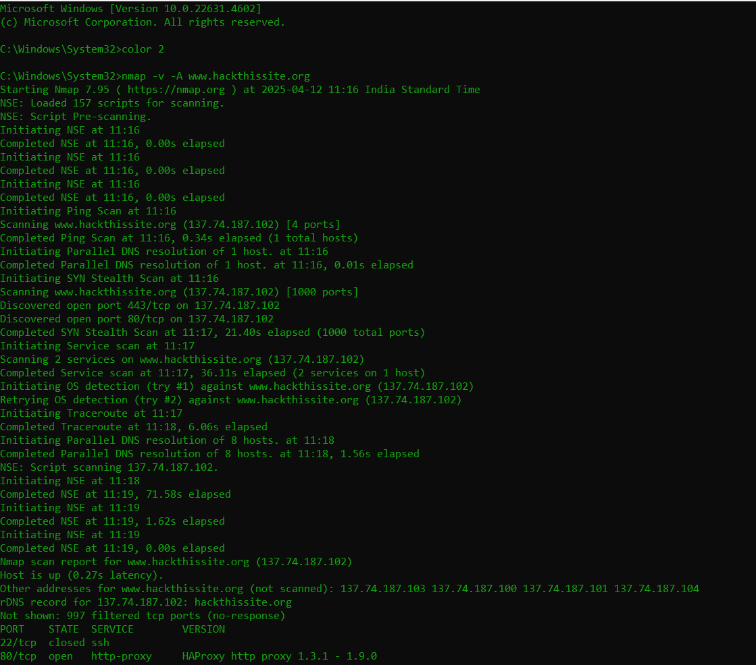

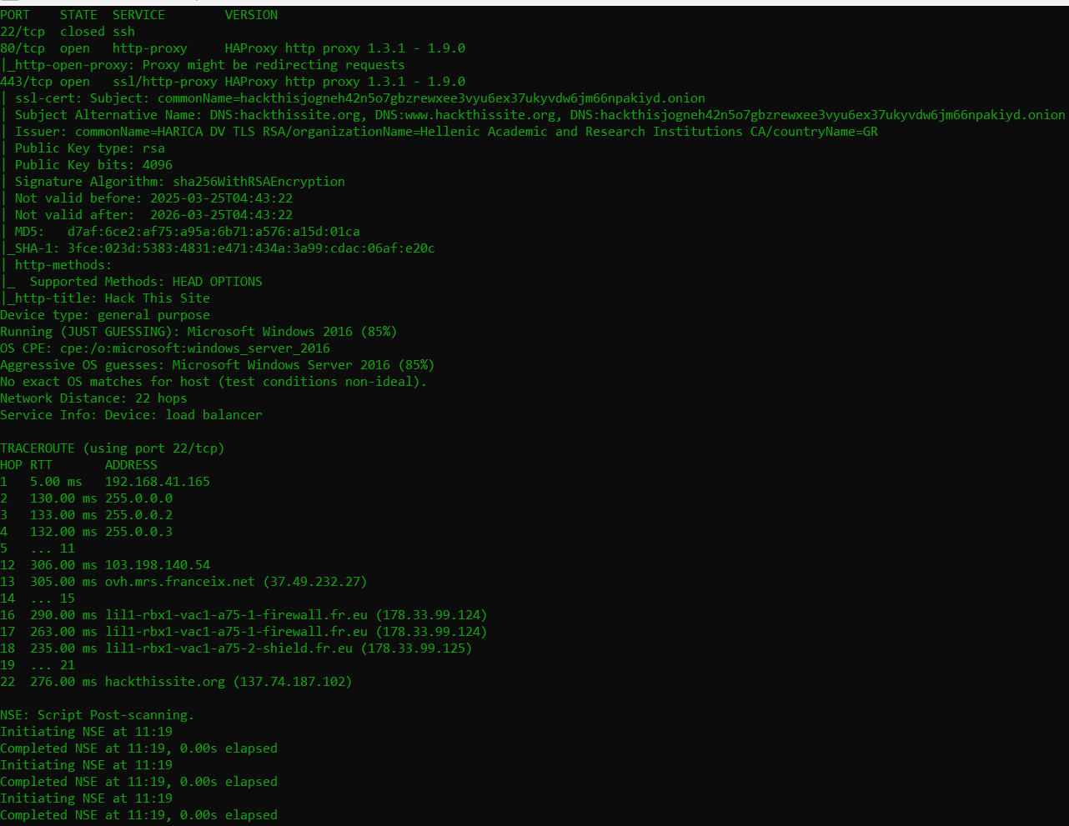

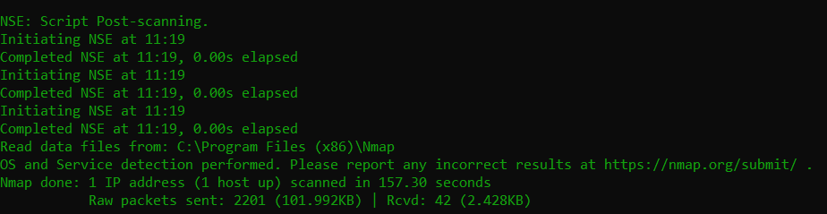

**Step2: Go to Start button, Search the Command Prompt run as Administrator and enter the command nmap -v -A** [**www.hackthissite.org**](http://www.hackthissite.org) **-p80,443**

**Proof:**

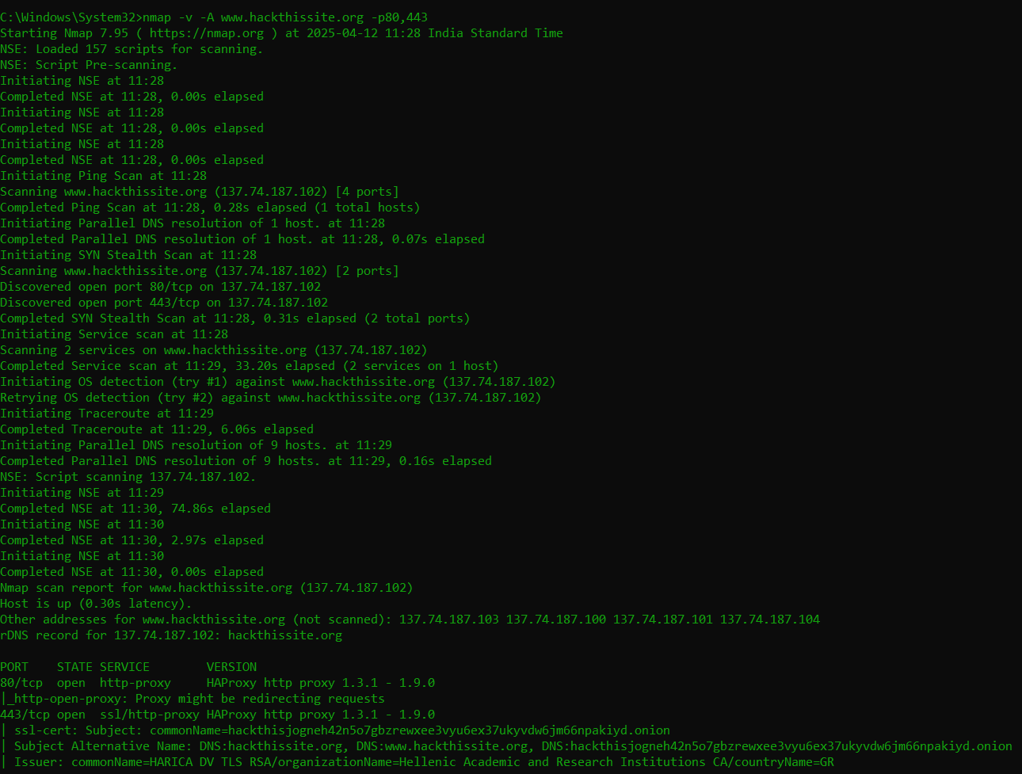

**Step3: Go to Start button, Search the Command Prompt run as Administrator and enter the command nmap -sS** [**www.hackthissite.org**](http://www.hackthissite.org)

**Proof:**

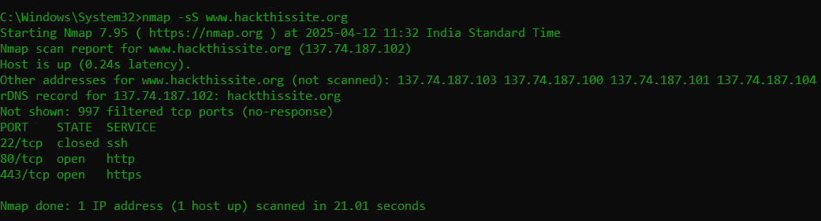

**Step4: Go to Start button, Search the Command Prompt run as Administrator and enter the command nmap -sT** [**www.hackthissite.org**](http://www.hackthissite.org) **-p80**

**Proof:**

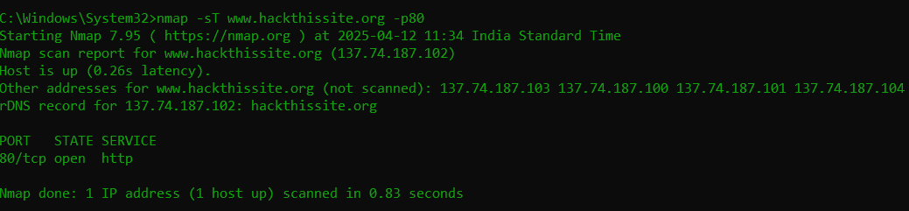

**Step5: Go to Start button, Search the Command Prompt run as Administrator and enter the command nmap -sY** [**www.hackthissite.org**](http://www.hackthissite.org)

**Proof:**

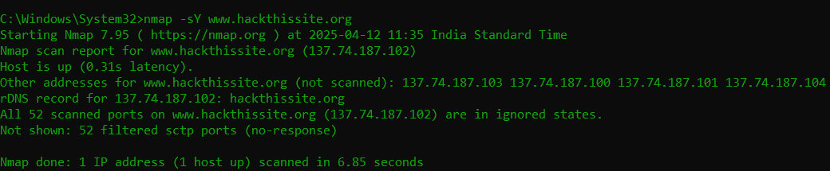

**Step6: Go to Start button, Search the Command Prompt run as Administrator and enter the command nmap -sX** [**www.hackthissite.org**](http://www.hackthissite.org)

**Proof:**

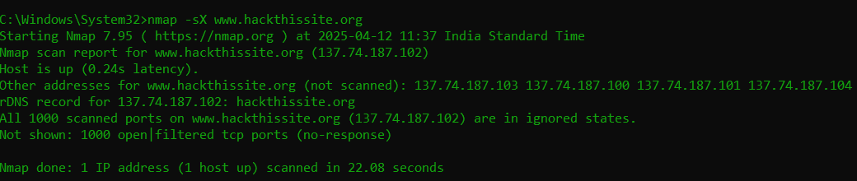

**Step7: Go to Start button, Search the Command Prompt run as Administrator and enter the command nmap -sM** [**www.hackthissite.org**](http://www.hackthissite.org)

**Proof:**



**Step8: Go to Start button, Search the Command Prompt run as Administrator and enter the command nmap -sV** [**www.hackthissite.org**](http://www.hackthissite.org)

**Proof:**

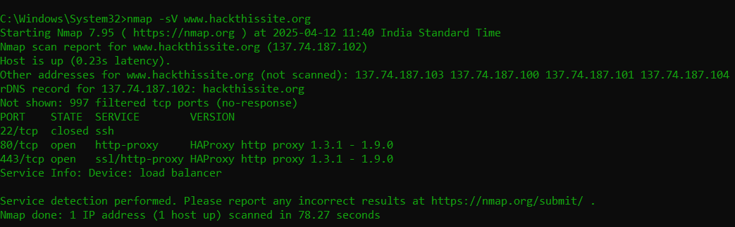

**Step9: Go to Start button, Search the Command Prompt run as Administrator and enter the command nmap -O -v** [**www.hackthissite.org**](http://www.hackthissite.org)

**Proof:**

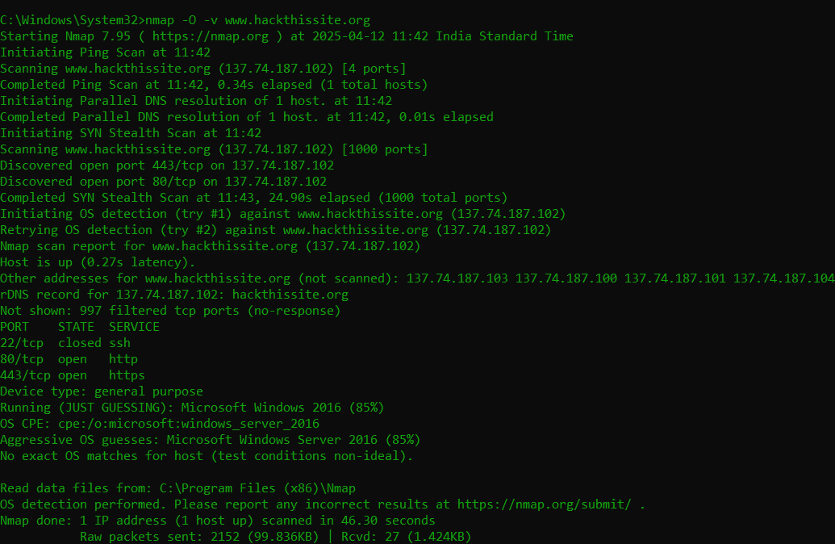

**Step10: Go to Start button, Search the Command Prompt run as Administrator and enter the command nmap -sC -p80,443 -T4**

[**www.hackthissite.org**](http://www.hackthissite.org)

**Proof:**

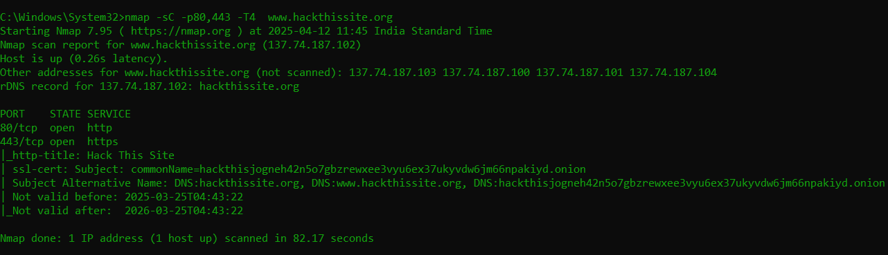

**Step11: Go to Start button, Search the Command Prompt run as Administrator and enter the Command nmap -v -A 137.74.103 137.74.100 137.74.101 137.74.104**

**Proof:**

