**ABOUT ME**

My name is Cady. I received a bachelor’s degree in English in 2014. My interests include DIY projects, home décor, lifestyle, photography, movies, and I am very family oriented. I wouldn’t consider myself to be inherently creative, but I love creating things. If I see something I like, I’ll try to make it because there’s just a different level of accomplishment I receive knowing that I created something with my own two hands. Even if I’m just arranging pieces I buy or setting up décor in a new space, I like knowing I contributed to making something more beautiful and more my own.

I’m very organized and a bit of a perfectionist. I’m a homebody, and love working on projects around the house. I also really enjoy setting up pieces and scenes around the home to photograph. I would describe my style as pretty simple and traditional. I don’t care too much for clutter or things that are very kitschy. I like to keep things fairly neutral and natural paired with rustic elements. I can be pretty specific with my style, but I know I like things when I see them, so I’m always looking out for new projects and ideas. This blog will really reflect my interests and style, and I can’t wait to share my own projects and inspiration.

**OVERVIEW**

Hi, and welcome to my blog!

So, my fiancé and I moved into our first house together in October of 2016. Though stressful and, at times, an overwhelming undertaking, I was very excited to have our own blank canvas to decorate and make into a home.

I’ve always been a pretty crafty person; I would often do little projects with my grandma growing up. I’m also very organized and take pride in presentation. So when I began using Pinterest and following other online communities (blogs, Youtube) dedicated to DIYs, décor, and home decorating, I was elated to find so much inspiration and projects I couldn’t wait to try. At that time in my life, I was just starting college and living at home with my parents, so my DIY décor was mostly limited to my bedroom. Now, I’m very luck and happy to have my own, larger space to work with and really make my own.

My aspirations for this blog are to showcase home décor, share DIYs and decorating tips for everyday as well as seasonally and for holidays, and mostly just contribute to a community that has really helped spark my love for home décor. I wish to offer any inspiration and/or helpful advice through my posts. I’m also always looking for new ideas and projects, so a huge goal for me is to be able to communicate, share, and learn new things through my work on this blog.

I’m excited to finally be hosting a creative outlet for my hobbies. I can’t wait to get started, and I hope you enjoy!

**4th of July**

The 4th of July is probably my second favorite holiday, after Christmas. I love summer time, and hanging outside on summer evenings. And the 4th is that plus family, food, and fireworks. I love listening to classic rock while eating hotdogs as the breeze is blowing the smell of gun powder around. I’m just really into the whole Americana, vintage, young summer feel, so when I started seeing all of the 4th of July home décor out in stores, I got very excited to do some holiday decorating.

We are hosting a cookout at our home this year to celebrate the 4th, so I’ll be getting themed party decorations (plates, table covers, balloons). The event will mostly outside on our deck, so we’ll have decorations out there, but I’m also putting up some general patriotic décor pieces around the main areas of our house. It may seem like a little too much, but I feel like summertime is patriotic time, and this décor will be up from Memorial Day to Labor Day. It’s more seasonal décor than a specific holiday, so I’m going to get a good, long use out of it.

The first things I want to share are pillows. Pillows are a great, fast way to make an impact seasonally and even just generally for everyday décor. I like how they sit out on the couches so they’re in the open for everyone to see. I found some really cute ones this month from a few different places, and I’m very happy with how they all look together.

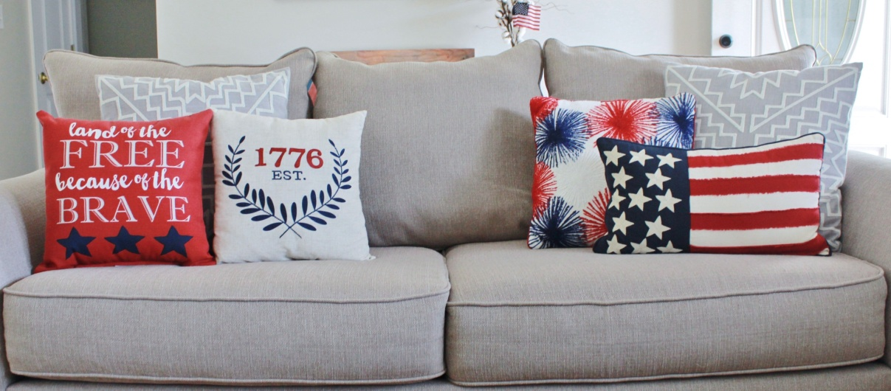

Red brave pillow – Lowes Est. 1776 pillow – Michaels Firework pillow – Michaels

Flag pillow – Cost Plus World Market

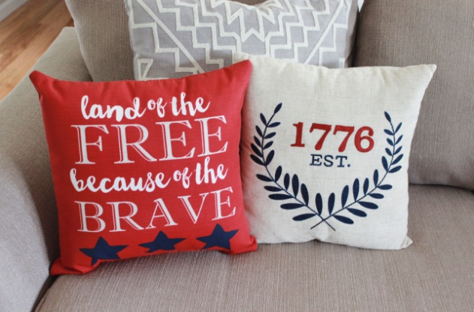 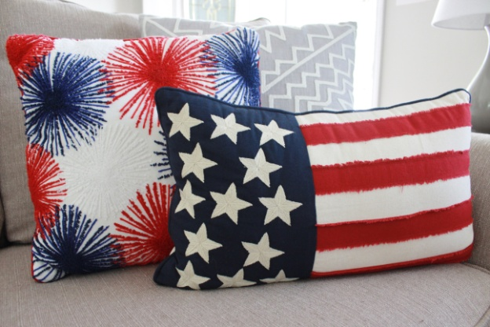

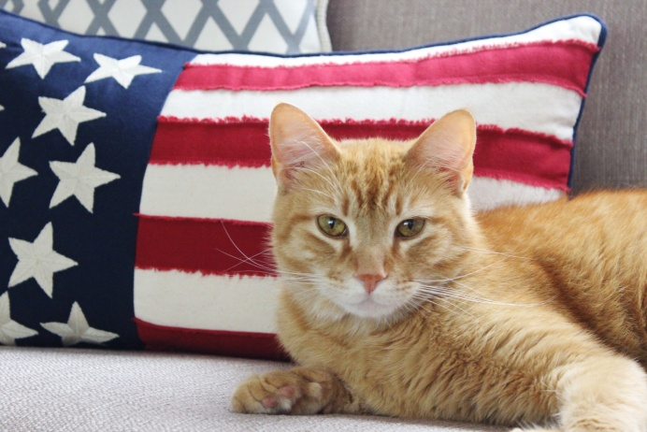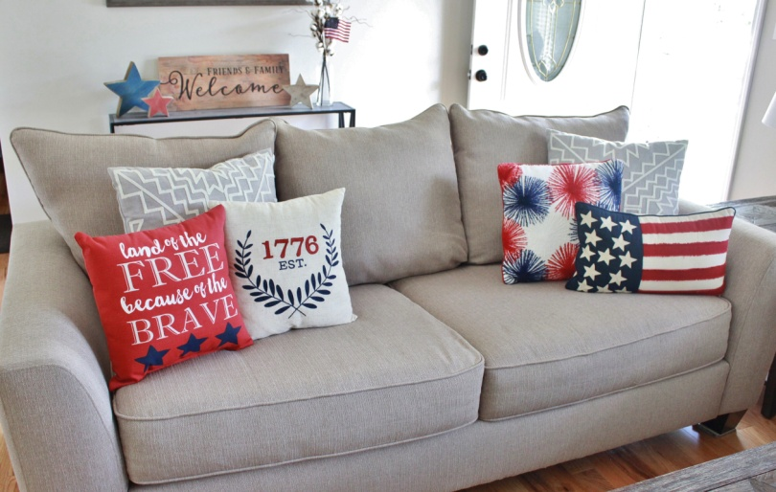

The next things are little American flags. I bought two 3 packs from the dollar section in Target and I’ve just stuck them all around the house, mostly in plants. Simple. Easy. Cute.

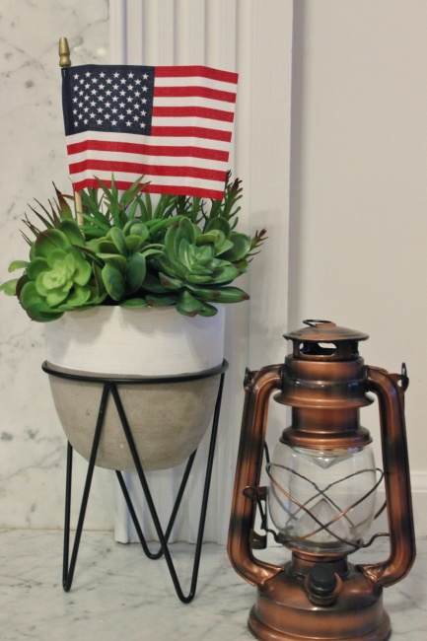

These stars are so simple, but I think they’re so adorable. I love wood pieces and I especially love how these have that rustic Americana look, yet they’re so basic. I found these ones at Michaels. They were a little pricey for what they are, but I purchased them while they were 50% off and got to use an additional coupon on top of that. They’re also something that would be extremely easy to DIY. It would just take some plain wooden star shapes, paint, and sandpaper. In fact, I would love something like this in pumpkin and Christmas tree shapes as well, so maybe I’ll have to try making some for other holidays.

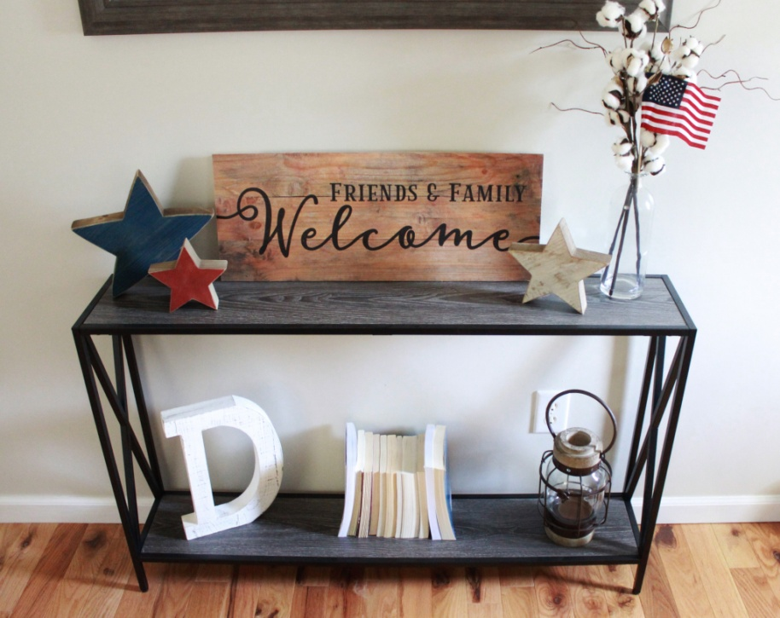

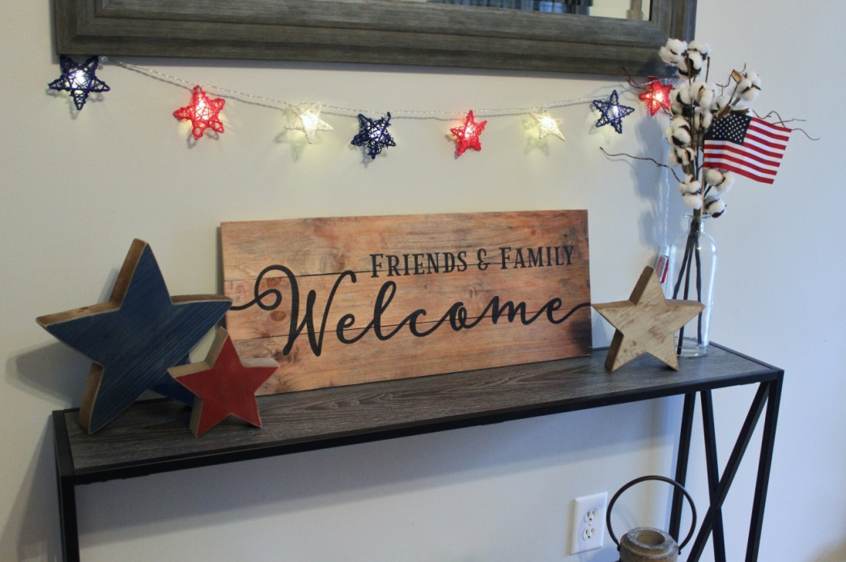

[PICTURE] *Close up of stars*

Along with the stars and flag I stuck in the cotton, I strung up some lights ($3 section of Target) to finish off the sofa table.

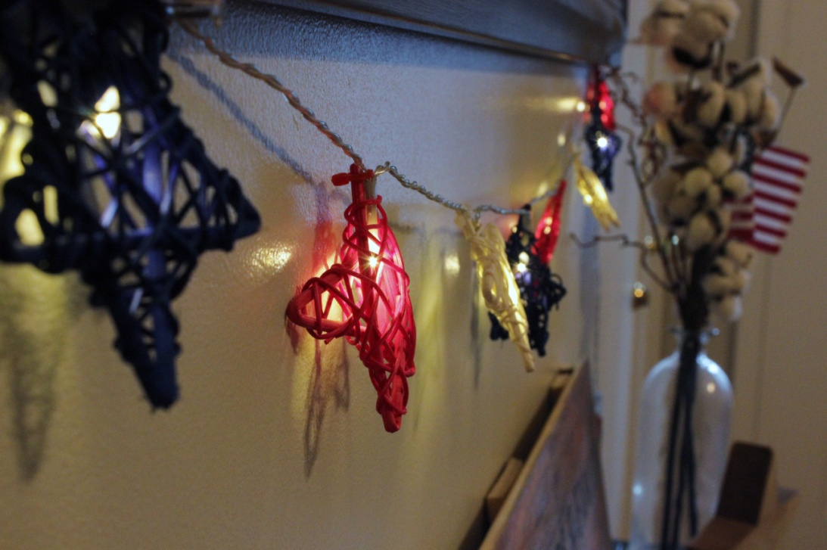

When we were house hunting last year, I remember a front porch is something I was adamant about having, and it was mostly because of patriotic bunting. Whenever I drove past a house with the red, white, and blue bunting stung across their front porch, I would always think of how I would definitely be doing that with my own house one day. It just screams summer to me, and now I’m lucky enough have some gracing my own front porch. These that I got came in a pack of 2 (I bought 3 packs), and were also pretty pricey. They’re from Michaels and are made of fabric, not that plastic material like those outdoor Christmas bow. The fabric bunting was more expensive than the plastic one, but I preferred the look of this one, and I thought it would hold up better. I most definitely want to have this to use for several years.

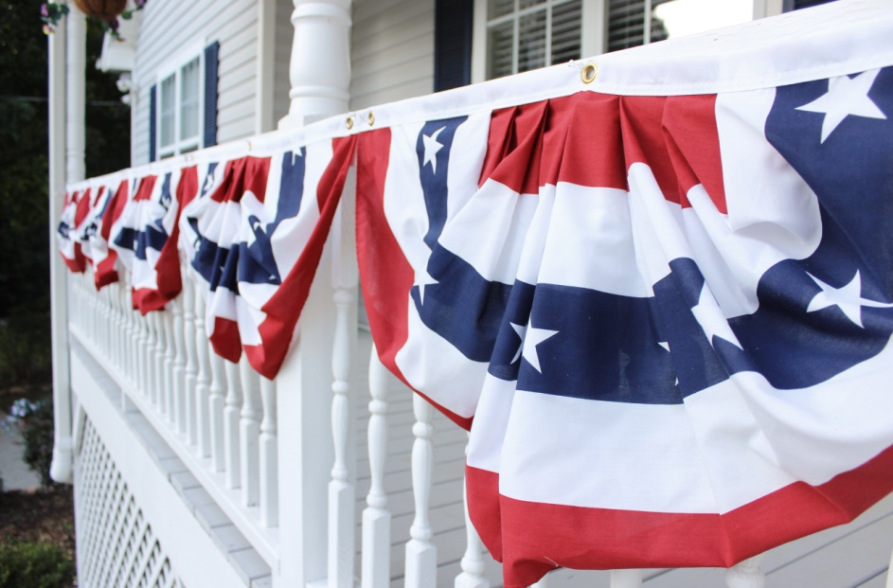

I was in Wal-Mart, and I found that they had one of the same exact bunting styles as Michaels for cheaper. They also have a triangle flag print made from plastic that’s a much more inexpensive, cost effect, and nice option. Something like that would be great to put as a border around a food table for a cookout in lieu of a table cloth or to dress up a plain table cloth.

While I was at the Dollar Tree, I found these metal star yard stakes and thought they’d be perfect lining the walkway. They’re not the best quality, but for $1 a piece, you can’t beat it. They’re shaped like stars, but they also remind me of pinwheels. I felt like glutton at the checkout counter because I had about 15 of these things, but I love how they look, and I also gave some to my mom to line her walkway as well.

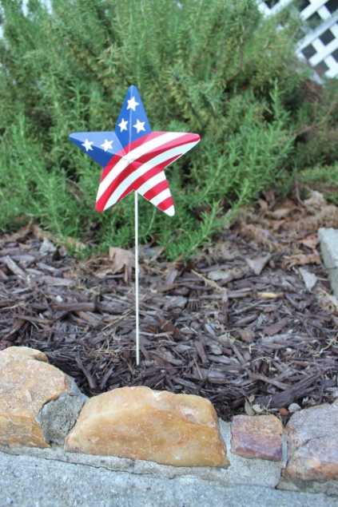

This flag print letter is a DIY, and I couldn’t be happier with how it turned out. I came across this [link] pin on Pinterest, and decided to make my own. I purchased a plain white letter at Michaels, and gave the entire letter a base of satin white acrylic paint. I did this to mask any scuffs or scratches the letter already had, and also so the white stripes would have a satin finish like the rest of the painted areas. If I had left the white stripes as the original white of the letter, it would have had a more matte finish. I used painters tape to tape off the stripes and used clear contact paper to make my own star stickers to use as stencils. Very easy. Very cute. I made one for my mom as well.

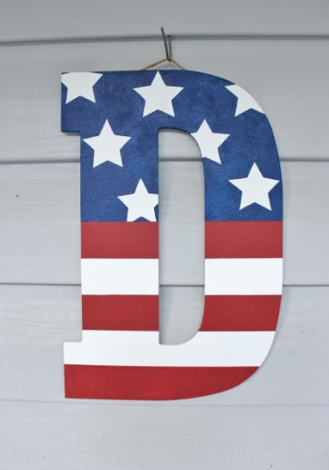

Finished off the front porch with two flags in our flower pots to frame the doorway.

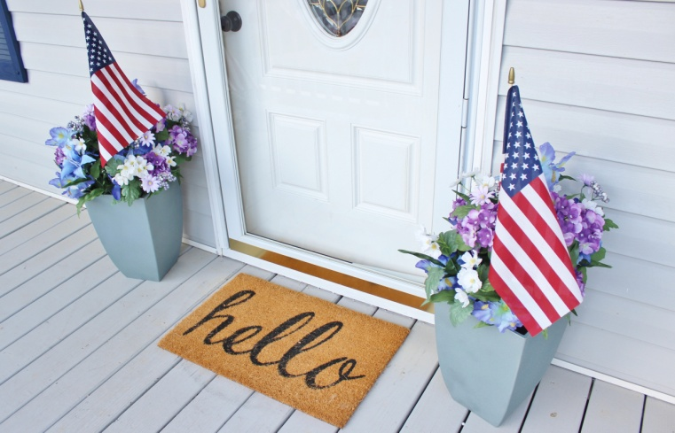

Here’s how it all looks together.

