Configurable Radar

Architecture Design



# High Level Spectral Growth Analysis



# Path Characteristics

## Bandwidth

The transmit signal will not be a continuous waveform. Instead it will be a periodically pulsed 3 GHz signal.

Let the bandwidth be the first point where the Fourier coefficient becomes 0.

|  |  |  |  |  |
| --- | --- | --- | --- | --- |
| Pulse Width (ns) | Duty Cycle | n | Bandwidth (MHz) | Min. Distance (m) |
| 10 | 0.0250 | 80 | 100 | 2.25 |
| 15 | 0.0375 | 54 | 135 | 3.00 |
| 20 | 0.0500 | 40 | 50 | 3.75 |
| 25 | 0.0625 | 32 | 40 | 4.50 |
| 30 | 0.0750 | 27 | 67 | 5.25 |
| 35 | 0.0875 | 23 | 57 | 6.00 |
| 40 | 0.1000 | 20 | 25 | 6.75 |

## Free Space Path Loss (FSPL)

## Link Budget

# Analog-to-Digital Converter

## Acquisition Range

The signal that is expected at the input of the ADC is an amplified version of the Minimum / Maximum Power. The ADC must have a dynamic range large enough to support the full power range expected at the output of the receiver block.

The following table lists the minimum input power detectable with an ideal ADC and a given voltage reference.

|  |  |  |  |
| --- | --- | --- | --- |
| Bits | Reference (V) | Resolution (mV) | Power (dBm) |
| 8 | 1.8 | 7.03 | -33 |
| 10 | 1.8 | 1.76 | -45 |
| 12 | 1.8 | 0.439 | -57 |
| 14 | 1.8 | 0.110 | -69 |

This table ignores any temperature drifting and aging effects that might cause the effective number of bits (ENOB) to be reduced. When the input power is near the LSB each increment has an uncertainty of about 6 dB. This is far too large for our application so to mitigate this the design must ensure that the signal power seen at the ADC input has an uncertainty of 0.5 dB.

|  |  |  |  |
| --- | --- | --- | --- |
| Bits | Reference (V) | (dB) | Minimum Input Power (dBm) |
| 8 | 1.8 | < 0.5 | -8 |
| 10 | 1.8 | < 0.5 | -20 |
| 12 | 1.8 | < 0.5 | -32 |
| 14 | 1.8 | < 0.5 | -44 |

This table shows that to have an input power measurement uncertainty less than 0.5 dB the input power must be greater than the calculated minimum power. Since the expected dynamic range is -65 dBm – (-90 dBm) = 25 dB and given that most devices saturate somewhere at or near 0 dBm the only options available to us is to use 12 bit or 14 bit ADC.

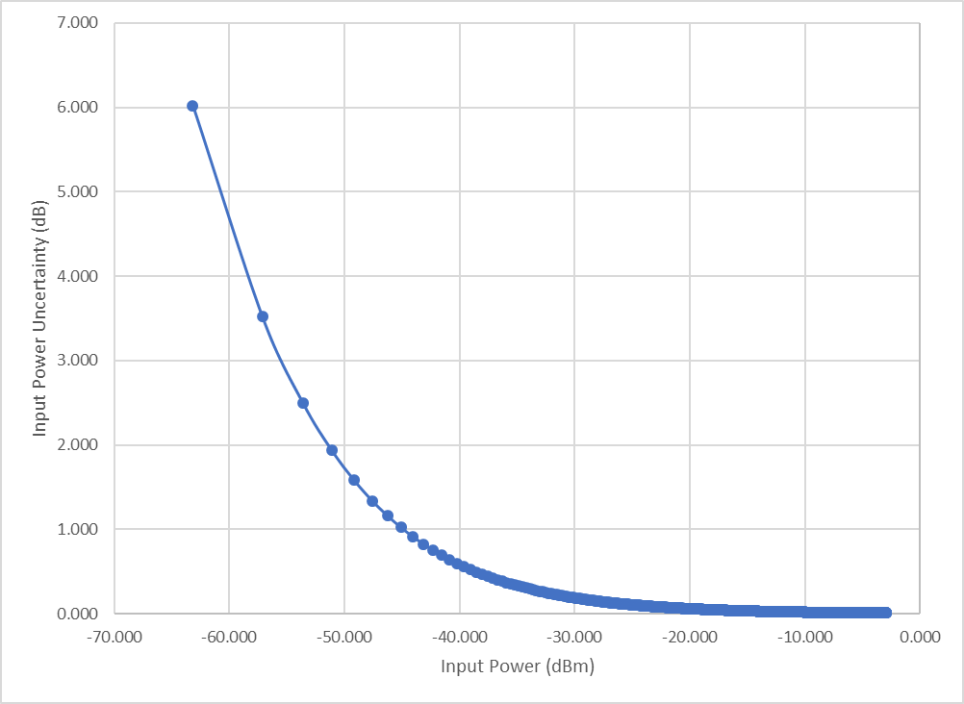

To ensure that the resolution error is less than 0.5 dB the input power to the ADC should be greater than -35 dBm. The system gain should be enough to bring the minimum input of -90 dBm to our minimum ADC level of -35 dBm. This puts the system gain at 55 dB. The maximum input power is -65 dBm which means the maximum level at the ADC input will be -10 dBm.

## Sampling Rate

# Radar Characteristics

## Pulse Radar

### Minimum Distance

The minimum distance is determined by the minimum detectable time difference between when a pulse is sent and when it is received. The receiver will not be able to distinguish between sent and received pulse if the pulse is returned during the pulse width.

|  |  |  |
| --- | --- | --- |
| Pulse Width (ns) | Sampling Rate (MSps) | Minimum Distance (m) |
| 10 | 200 | 2.25 |
| 15 | 200 | 3.00 |
| 20 | 200 | 3.75 |
| 25 | 200 | 4.50 |

### Maximum Distance

The maximum distance is determined by the minimum detectable signal. With the design requirement that the minimum detectable signal be -90 dBm the maximum distance can be achieved using the radar range equation.

### Maximum Input Power

The maximum returned power is achieved when an object is at the minimum detectable distance.

## FMCW Radar

### Range Resolution

### Velocity Resolution