Service Desk Knowledge Base Installation Guide

Required Software

- Windows 2003 Server
- IIS web server installed and configured
- MS SQL 2005, including Full Text search engine.

Installation Procedure

This document assumes Windows has been configured, along with IIS, MSSQL FTS.

Note: Make sure of the following:

- MS SQL Service is Running
- You know the sa password or your domain account has sysadmin role on sql.
- IIS Services are running (www Service)

This document will step you through the remaining tasks of installing/configuring PHP, the KB files and initialization of the KB database.

Installing PHP 5

The provided Installation Kit Bundle (PHPInstall.exe) will install PHP 5.2.8 and configure the required IIS settings for use with PHP.

Start the install by running PHPInstall.exe as shown below. All files will be installed into the C:\PHP folder. This destination folder cannot be changed.

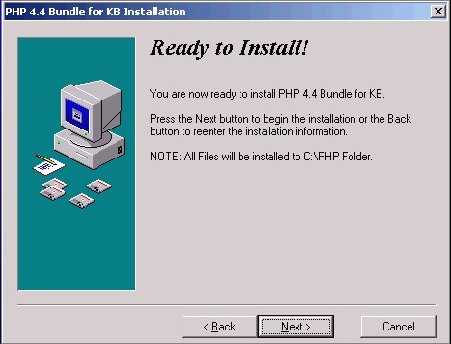
Once this setup program completes, PHP is installed and you may continue installing the Knowledge base using its own setup procedure below.

Installing Knowledge Base

Run the KBInstall.EXE file to start the installation wizard as shown below.

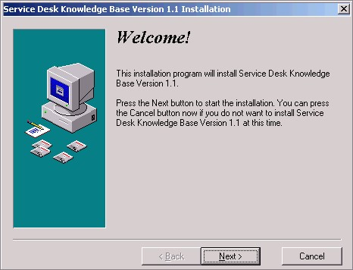

If you wish you may choose a different Home Directory folder other than the default folder of C:\KB.
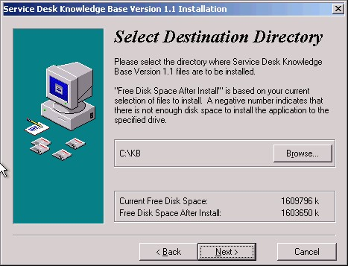
The First Instance of KB you install should be called KB. You can configure other instances by installing this kit again and selecting a different installation folder and a different instance name.

The Instance Name will also be the name of the Database that is created and the Web Site folder name, so it must be brief and not contain any spaces or punctuation characters.

For example an Instance name of KBTech will create a database called KBTech and a site name of http://hostname/KBTech

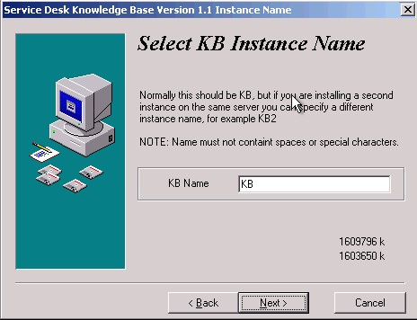
After the installation and system configuration have been completed, the dialog below will display. When you press Finish a browser window will open to guide you through the creation of the SQL database. You will need to know the current MSSQL sa password.

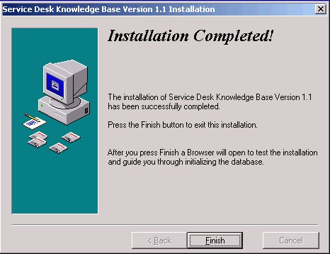

Database Initialization

The following browser window will open after the KBInstall kit completes. You must provide an MS SQL Server account and password or leave blank if your windows account has sysadmin role on the sql server. When you press submit the database will be created and initialized.

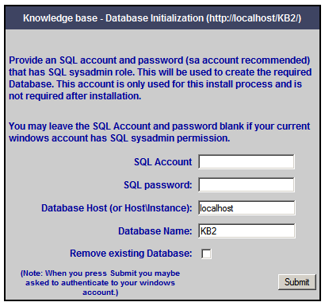

The initialization procedure may take up to a minute to complete. Once complete you should see the following screen. Press Next and login as instructed.

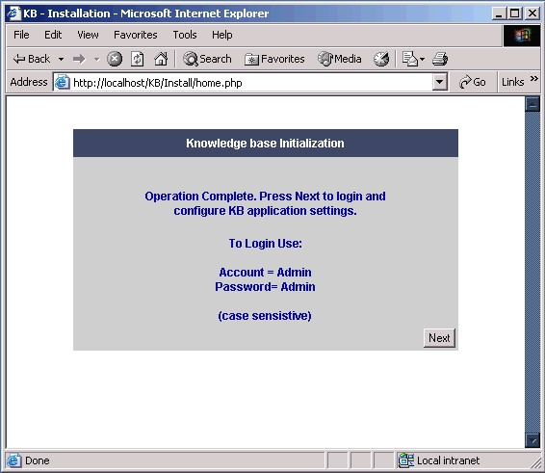

At this point you can adjust any settings that are required, including whether to display advanced filters on home page, bulletin permissions, etc.
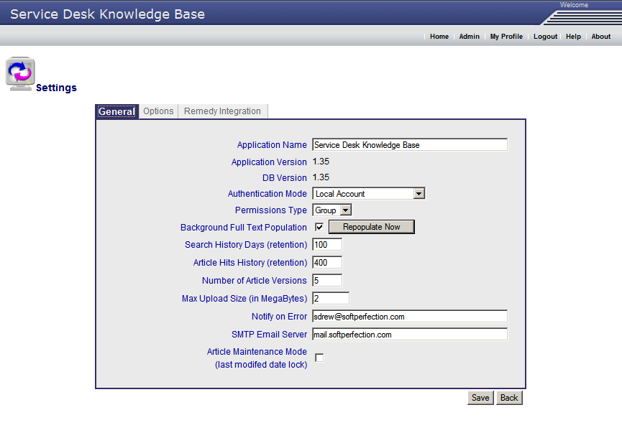

Warning, do not set the Authentication Mode to NT unless you have first created a KB Administrator account that maps to a corresponding domain account that you will be connecting with, otherwise you will have no access to the tool. See below.

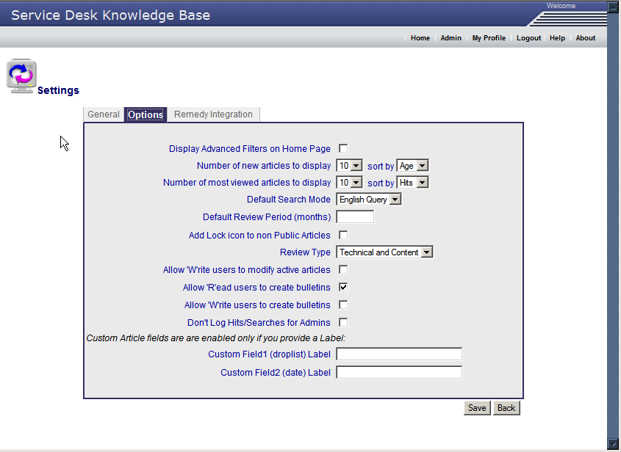

Setting Name | Purpose
Application Name | Sets the name that is displayed in the header of the page.
Application Version | Read only, displays the current version of the application.
DB Version | Displays the Database structure version.
Authentication Mode | Local Account or NT Authentication. With Local Account mode, each user has a local account and password to login with, in order to use the knowledge base.  For NT authentication, the browser will pass the current domain login and that login id will be checked in the knowledge base.  (You add users using their domain login id and no password).
Permissions Type | Simple or Group. With Simple mode no group memberships are required and the tool works in a very simple permissions mode. Group mode is recommended.
Background Full Text population | By default enabled, so as to repopulate the full text catalogs in real time. (Recommended).
Repopulate Now | Forces a Full Text Repopulation operation under SQL Server.
Search History Days | How many days that search history records are kept.
Article Hits History | How many days back should Article hits audit records be kept.
Number of Article Versions | Each time a change is made to the content of the article an archive copy of the article is created. Set this value to indicate how many versions to keep.
Display Advanced Filters on Home Page | The default is just to show the search box on the home page. If this box is check the advanced filters such as product name, group etc are also displayed.
Number of new Articles to display | Sets the number of new articles to display on the home page. Default is 10 sorted by Age.
Number of most Viewed Articles to display | Default is 10 sorted by hits
Allow Read users to create bulletins | Default is to allow an Read users (users that can read but not modify articles) to always be permitted to create/edit bulletin messages. Uncheck this box to force Write permission to be required to create bulletins.
Article Maintenance Mode | When this box is checked any articles modified will not have their time stamps updated. Intended for administration or when bulk changes maybe required.,
Don’t log hits/searches for Admins | If checked when an Administrator of the tool searches or reads articles, no hits or search audits are recorded.
Notify on Error | If any unexpected database errors occur notify this account with the details.
SMTP Email Server | Required so as to send Article email notifications and any error notifications.

Post Installation Tasks

Adding Users

Add users using the User icon in the Admin page. If you are using NT Authentication mode, then you need to add the NT Account, along with the Name and Email information for the user. Use the Add Group button to add the user to one or more groups with either “R” Read, “W” Write, or “A” Approver permission.

If using Local account authentication mode, then also set a password for the user. The user may change their password later under the “My Profile” page.

You can also click on the “View Searches” or “View Articles Read” to get a quick report of activity by the current user.

Before switching to NT Authentication mode, add your account with blank password (no password required since NT authentication is used) and add yourself to the Administrators group with Approval privilege as shown below and then press Save.

