FIT5183 Mobile and Distributed Computing Systems 2016
Calorie Counter Application
Practical Assignment Phase 1

Task 1 – Database
You need to design and create a database with a correct schema for the described scenario.
Requirement:
1). the tables are created correctly with attributes that have the correct data type and appropriate name.
2). All tables need to be populated with meaningful data (at least 5 records for all the tables BUT the Calorie table should have minimum 30 records.
3).You need to use an appropriate schema (PKs and FKs) to implement the relationships, not only accurately (maintaining all the integrity rules) but efficiently (avoiding adding unnecessary attributes or tables).

- Create database
CREATE DATABASE IF NOT EXISTS `id27315894` /*!40100 DEFAULT CHARACTER SET utf8 */;
USE `id27315894`;

- Create tables
I created 4 tables which are user, food, food_consumed and report.

  - user table
DROP TABLE IF EXISTS `user`;
/*!40101 SET @saved_cs_client = @@character_set_client */;
/*!40101 SET character_set_client = utf8 */;
CREATE TABLE `user` (
`userid` int(11) NOT NULL,
`username` varchar(45) NOT NULL,
`userage` varchar(45) NOT NULL,
`userheight` varchar(45) NOT NULL,
`userweight` varchar(45) NOT NULL,
`usergender` varchar(45) NOT NULL,
`levelOfActivity` varchar(45) NOT NULL,
`stepsPerMile` varchar(45) NOT NULL,
PRIMARY KEY (`userid`)
) ENGINE=InnoDB DEFAULT CHARSET=utf8;
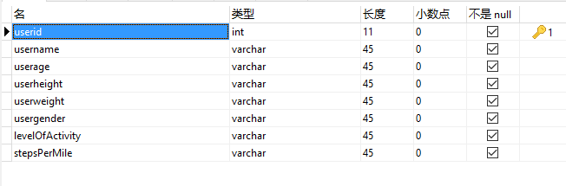
Figure 2.1.1
As you can see, “userid” is the primary key.

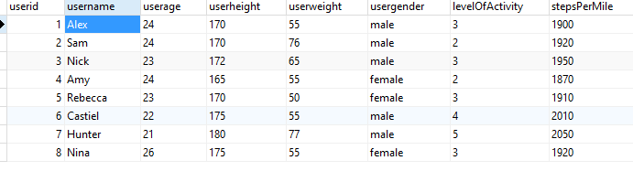
Figure 2.1.2
The records stored in this table.

  - food table
DROP TABLE IF EXISTS `food`;
/*!40101 SET @saved_cs_client = @@character_set_client */;
/*!40101 SET character_set_client = utf8 */;
CREATE TABLE `food` (
`foodid` int(11) NOT NULL,
`foodname` varchar(45) NOT NULL,
`foodfat` varchar(45) NOT NULL,
`foodserving` varchar(45) NOT NULL,
`foodcol` varchar(45) NOT NULL,
PRIMARY KEY (`foodid`)
) ENGINE=InnoDB DEFAULT CHARSET=utf8;
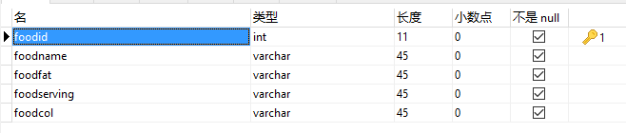
Figure 2.2.1
As you can see, “foodid” is the primary key.

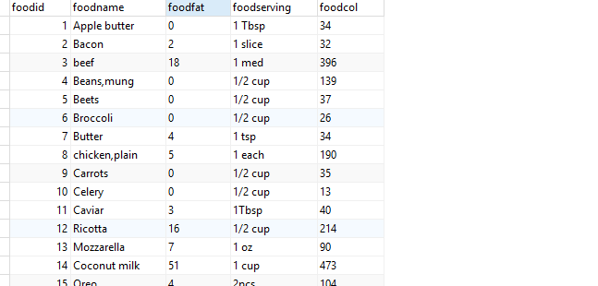
Figure 2.2.2
The records stored in this table.

  - food_consumed table
DROP TABLE IF EXISTS `food_consumed`;
/*!40101 SET @saved_cs_client = @@character_set_client */;
/*!40101 SET character_set_client = utf8 */;
CREATE TABLE `food_consumed` (
`consumedid` int(11) NOT NULL,
`userid` int(11) NOT NULL,
`foodid` int(11) NOT NULL,
`date` datetime NOT NULL DEFAULT CURRENT_TIMESTAMP,
PRIMARY KEY (`consumedid`),
KEY `userid_idx` (`userid`),
KEY `foodid_idx` (`foodid`),
CONSTRAINT `foodid` FOREIGN KEY (`foodid`) REFERENCES `food` (`foodid`),
CONSTRAINT `userid` FOREIGN KEY (`userid`) REFERENCES `user` (`userid`)
) ENGINE=InnoDB DEFAULT CHARSET=utf8;
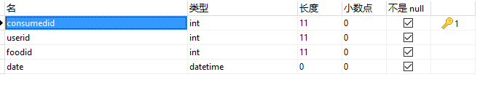
Figure 2.3.1
As you can see, consumedid is the primary key and userid and foodid are foreign key whitch are connected to user table and food table.
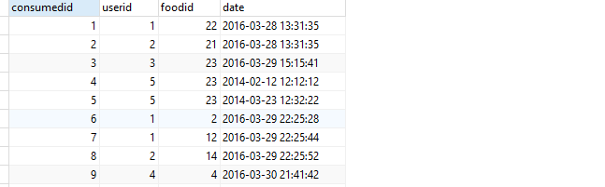
Figure 2.3.2
These are some records stored in this table.

  - report table
DROP TABLE IF EXISTS `report`;
/*!40101 SET @saved_cs_client = @@character_set_client */;
/*!40101 SET character_set_client = utf8 */;
CREATE TABLE `report` (
`reportid` int(11) NOT NULL,
`userid` int(11) NOT NULL,
`username` varchar(45) NOT NULL,
`calorie_consumed` double DEFAULT NULL,
`calorie_burned` double DEFAULT NULL,
`total_steps` double NOT NULL,
`calorie_set_goal` double DEFAULT NULL,
`remaining` double DEFAULT NULL,
`date` datetime DEFAULT NULL,
PRIMARY KEY (`reportid`),
KEY `userid_idx` (`userid`),
CONSTRAINT `userid1` FOREIGN KEY (`userid`) REFERENCES `user` (`userid`)
) ENGINE=InnoDB DEFAULT CHARSET=utf8;
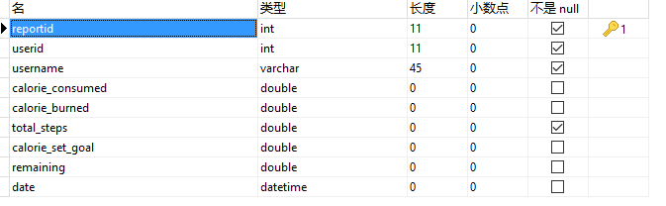
Figure 2.4.1
In this table, “reportid” is the primary key and userid is foreign key whitch linked to user table.

- E-R diagram
Here is the E-R diagram to discribe the relation between these tables.
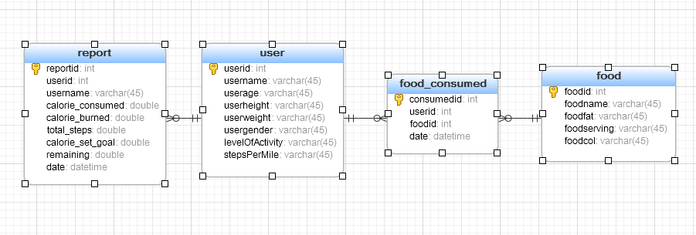
Figure 3.1

Task 2 – RESTful web service
1. RESTful Web Service – Basic:
- A RESTful web service should be created based on the above-mentioned database and tested on the browser without any problem. (5%)
The picture bellow shows the result of all user’s information in user table.
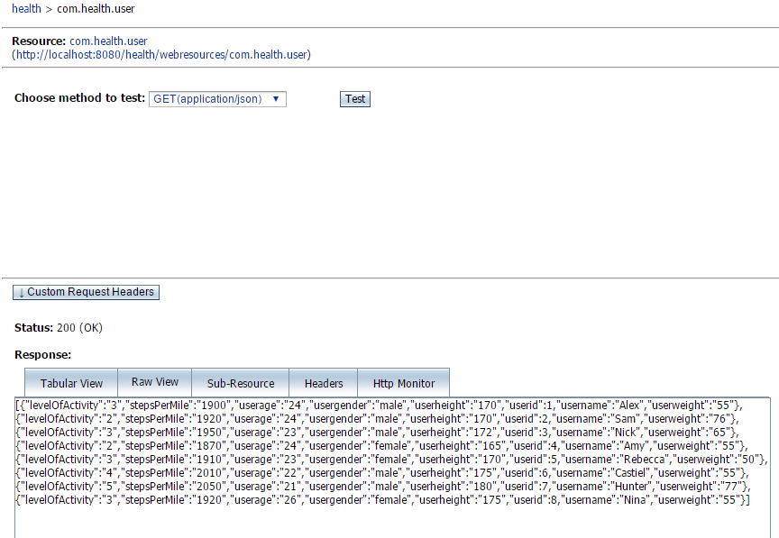
Figure 2.1.1

2. RESTful Web Service – Advanced
a) You need to write additional REST methods to enable querying the tables based on any of their attributes. (7%)
@GET
@Path("findByUserid/{userid}")
@Produces({"application/json"})
public List<User> findByUserid(@PathParam("userid") Integer userid) {
Query query =em.createNamedQuery("User.findByUserid");
query.setParameter("userid",userid);
return query.getResultList();
}

@GET
@Path("findByUsername/{username}")
@Produces({"application/json"})
public List<User> findByUsername(@PathParam("username") String username) {
Query query =em.createNamedQuery("User.findByUsername");
query.setParameter("username",username);
return query.getResultList();
}

@GET
@Path("findByUserage/{userage}")
@Produces({"application/json"})
public List<User> findByUserage(@PathParam("userage") String userage){
Query query = em.createNamedQuery("User.findByUserage");
query.setParameter("userage",userage);
return query.getResultList();
}

@GET
@Path("findByUserheight/{userheight}")
@Produces({"application/json"})
public List<User> findByUserheight(@PathParam("userheight") String userheight){
Query query = em.createNamedQuery("User.findByUserheight");
query.setParameter("userheight", userheight);
return query.getResultList();
}

@GET
@Path("findByUserweight/{userweight}")
@Produces({"application/json"})
public List<User> findByUserweight(@PathParam("userweight") String userweight){
Query query = em.createNamedQuery("User.findByUserweight");
query.setParameter("userweight", userweight);
return query.getResultList();
}

@GET
@Path("findByUsergender/{usergender}")
@Produces({"application/json"})
public List<User> findByUsergender(@PathParam("usergender") String usergender) {
Query query =em.createNamedQuery("User.findByUsergender");
query.setParameter("usergender",usergender);
return query.getResultList();
}

@GET
@Path("findByLevelofactivity/{levelOfActivity}")
@Produces({"application/json"})
public List<User> findByLevelOfActivity(@PathParam("levelOfActivity") String levelOfActivity) {
Query query =em.createNamedQuery("User.findByLevelOfActivity");
query.setParameter("levelOfActivity",levelOfActivity);
return query.getResultList();
}

@GET
@Path("findByStepsPerMile/{stepsPerMile}")
@Produces({"application/json"})
public List<User> findByStepsPerMile(@PathParam("stepsPerMile") String stepsPerMile){
Query query = em.createNamedQuery("User.findByStepsPerMile");
query.setParameter("stepsPerMile",stepsPerMile);
return query.getResultList();
}

Above codes are from “User” table. Here is the result of last method.
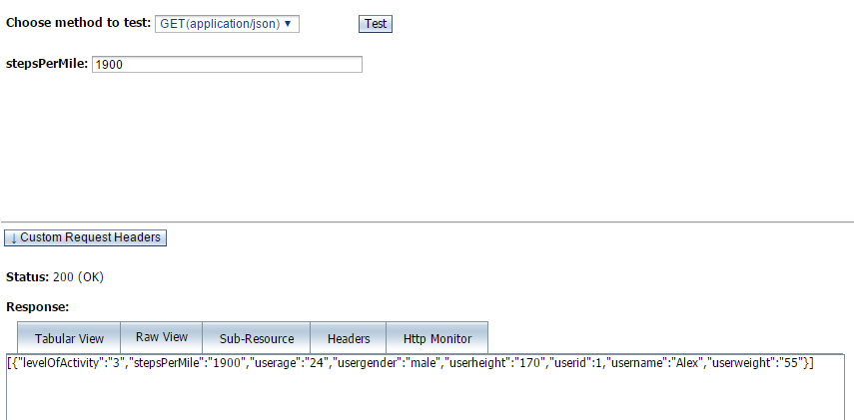

@GET
@Path("findByFoodid/{foodid}")
@Produces({"application/json"})
public List<Food> findByFoodid(@PathParam("foodid") Integer foodid) {
Query query =em.createNamedQuery("Food.findByFoodid");
query.setParameter("foodid",foodid);
return query.getResultList();
}

@GET
@Path("findByFoodname/{foodname}")
@Produces({"application/json"})
public List<Food> findByFoodname(@PathParam("foodname") String foodname) {
TypedQuery<Food> q = em.createQuery("SELECT f FROM Food f WHERE f.foodname like "+"'%"+foodname+"%'",Food.class);
return q.getResultList();
}

@GET
@Path("findByFoodfat/{foodfat}")
@Produces({"application/json"})
public List<Food> findByFoodfat(@PathParam("foodfat") String foodfat){
Query query = em.createNamedQuery("Food.findByFoodfat");
query.setParameter("foodfat", foodfat);
return query.getResultList();
}

@GET
@Path("findByFoodserving/{foodserving}")
@Produces({"application/json"})
public List<Food> findByFoodserving(@PathParam("foodserving") String foodserving){
Query query = em.createNamedQuery("Food.findByFoodserving");
query.setParameter("foodserving", foodserving);
return query.getResultList();
}

@GET
@Path("findByFoodcol/{foodcol}")
@Produces({"application/json"})
public List<Food> findByFoodcol(@PathParam("foodcol") String foodcol){
Query query = em.createNamedQuery("Food.findByFoodcol");
query.setParameter("foodcol", foodcol);
return query.getResultList();
}

Codes from “Food” table.
@GET
@Path("findByConsumedid/{consumedid}")
@Produces({"application/json"})
public List<FoodConsumed> findByConsumedid(@PathParam("consumedid") int consumedid) {
Query query = em.createNamedQuery("FoodConsumed.findByConsumedid");
query.setParameter("consumedid", consumedid);
return query.getResultList();
}

@GET
@Path("findByUsername/{username}")
@Produces({"application/json"})
public List<FoodConsumed> findByUsername(@PathParam("username") String username) {
TypedQuery<FoodConsumed> q = em.createQuery("SELECT c FROM FoodConsumed c WHERE c.userid.username like " + "'%" + username + "%'", FoodConsumed.class);
return q.getResultList();
}

@GET
@Path("findByFoodname/{foodname}")
@Produces({"application/json"})
public List<FoodConsumed> findByFoodname(@PathParam("foodname") String foodname) {
TypedQuery<FoodConsumed> q = em.createQuery("SELECT f FROM FoodConsumed f WHERE f.foodid.foodname like " + "'%" + foodname + "%'", FoodConsumed.class);
return q.getResultList();
}

@GET
@Path("findByDate/{date}")
@Produces({"application/json"})
public List<FoodConsumed> findByDate(@PathParam("date") String date) {
TypedQuery<FoodConsumed> q = em.createQuery("SELECT c FROM FoodConsumed c WHERE c.date like " + "'%" + date + "%'", FoodConsumed.class);
return q.getResultList();
}

Codes from “Food_consumed” table.

@GET
@Path("findByReportid/{reportid}")
@Produces({"application/json"})
public List<Report> findByReportid(@PathParam("reportid") int reportid) {
Query query =em.createNamedQuery("Report.findByReportid");
query.setParameter("reportid",reportid);
return query.getResultList();
}

@GET
@Path("findByUserid/{userid}")
@Produces({"application/json"})
public List<Report> findByUserid(@PathParam("userid") int userid) {
Query query =em.createNamedQuery("Report.findByUserid");
query.setParameter("userid",userid);
return query.getResultList();
}

@GET
@Path("findByUsername/{username}")
@Produces({"application/json"})
public List<Report> findByUsername(@PathParam("username") String username) {
Query query =em.createNamedQuery("Report.findByUsername");
query.setParameter("username",username);
return query.getResultList();
}

@GET
@Path("findByCalorieConsumed/{calorieConsumed}")
@Produces({"application/json"})
public List<Report> findByCalorieConsumed(@PathParam("calorieConsumed") int calorieConsumed) {
Query query =em.createNamedQuery("Report.findByCalorieConsumed");
query.setParameter("calorieConsumed",calorieConsumed);
return query.getResultList();
}

@GET
@Path("findByCalorieBurned/{calorieBurned}")
@Produces({"application/json"})
public List<Report> findByCalorieBurned(@PathParam("calorieBurned") int calorieBurned) {
Query query =em.createNamedQuery("Report.findByCalorieBurned");
query.setParameter("calorieBurned",calorieBurned);
return query.getResultList();
}

@GET
@Path("findByTotalsteps/{totalSteps}")
@Produces({"application/json"})
public List<Report> findByTotalSteps(@PathParam("totalSteps") int totalSteps) {
Query query =em.createNamedQuery("Report.findByTotalSteps");
query.setParameter("totalSteps",totalSteps);
return query.getResultList();
}

@GET
@Path("findByCalorieSetGoal/{CalorieSetGoal}")
@Produces({"application/json"})
public List<Report> findByCalorieSetGoal(@PathParam("calorieSetGoal") int calorieSetGoal) {
Query query =em.createNamedQuery("Report.findByCalorieSetGoal");
query.setParameter("calorieSetGoal",calorieSetGoal);
return query.getResultList();
}

@GET
@Path("findByRemaining/{remaining}")
@Produces({"application/json"})
public List<Report> findByRemaining(@PathParam("remaining") int remaining) {
Query query =em.createNamedQuery("Report.findByRemaining");
query.setParameter("remaining",remaining);
return query.getResultList();
}

Codes from “Report” table.

- You need to create a REST method that enables querying from one table using a combination of attributes (dynamic query). You will decide on the attributes combination based on their usefulness in the query. (7%)
@GET
@Path("findByConsumedidANDDate/{consumedid}/{date}")
@Produces({"application/json"})
public List<FoodConsumed> findByConsumedidANDDate(@PathParam("consumedid") int consumedid, @PathParam("date") String date) {
TypedQuery<FoodConsumed> q = em.createQuery("SELECT c FROM FoodConsumed c WHERE c.consumedid = '" + consumedid + "' AND c.date like " + "'%" + date + "%'", FoodConsumed.class);
return q.getResultList();
}
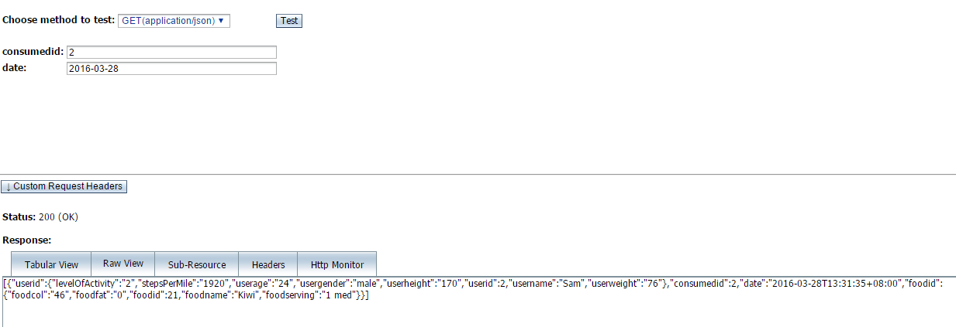
Here is a method from “Food_consumed” table and the searching results is bellow figure.

@GET
@Path("findByRemainingANDUsername/{remaining}/{username}")
@Produces({"application/json"})
public List<Report> findByRemainingANDUsername(@PathParam("remaining") int remaining,@PathParam("username") String username) {
String info = remaining + ":" + username;
System.out.println("info:" + info);
TypedQuery<Report> query = em.createQuery("SELECT c FROM Report c WHERE c.remaining = '" +remaining + "' and c.username = '" +username+ "'" , Report.class);
List<Report> results = query.getResultList();
System.out.println("size:" + results.size());
return results;
}

This is another method from “Report” table.

- You need to create a REST method that enables querying from more than one table using a combination of attributes (using a dynamic query). (8%)
@GET
@Path("findByUserageANDDate/{userage}/{date}")
@Produces({"application/json"})
public List<FoodConsumed> findByUserageANDDate(@PathParam("userage") int userage, @PathParam("date") String date) {
TypedQuery<FoodConsumed> q = em.createQuery("SELECT c FROM FoodConsumed c WHERE c.userid.userage = '" + userage + "' AND c.date like " + "'%" + date + "%'", FoodConsumed.class);
return q.getResultList();
}
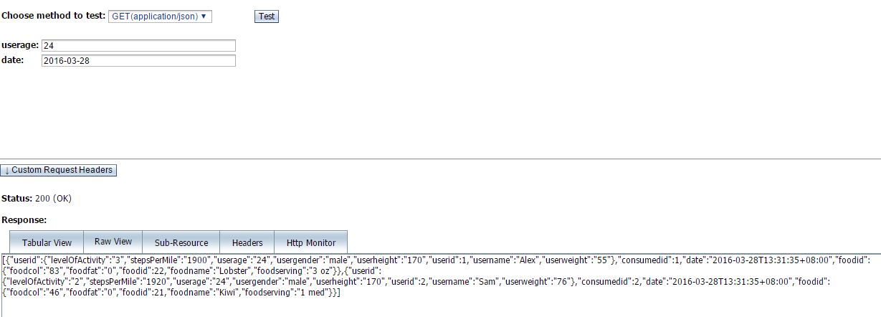
By attribute userage in user table and attribute date in Food_consumed table, it can find records that suitable for the query condition. The type of attributes userage is String and the type of attribute date is datetime.

- You need to create a REST method that enables querying from more than one table using a combination of attributes using @NamedQuery with an explicit JOIN between tables in NamedQuery (using a static query). (8%)

Report.java
@NamedQuery(name = "Report.findByUserheightANDUserweight", query = "SELECT r FROM Report r where r.userid.userheight = :userheight AND r.userid.userweight = :userweight "),

ReportFacadeREST.java
@GET
@Path("findByUserheightANDUserweight/{userheight}/{userweight}")
@Produces({"application/json"})
public List<Report> findByUserheightANDUserweight(@PathParam("userheight") String userheight,@PathParam("userweight") String userweight) {
Query query
= em.createNamedQuery("Report.findByUserheightANDUserweight");
query.setParameter("userheight", userheight);
query.setParameter("userweight", userweight);
return query.getResultList();
}

Attribute userweigt and userhight are both from “User” table.
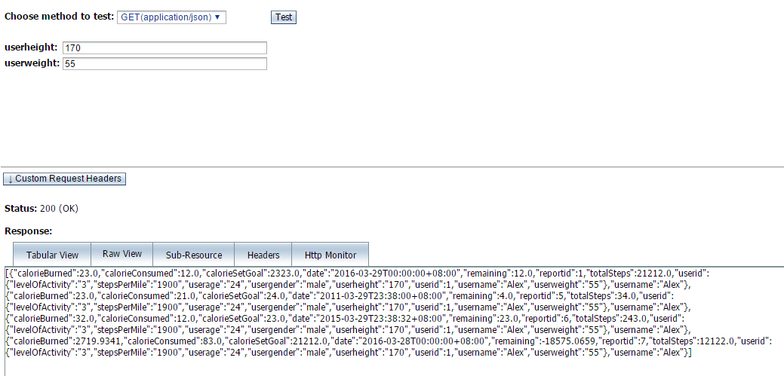
Above figure is the result of this method.

Task 3 - Extra REST methods
1. Calculate BMR

- You need to create a REST method to calculate BMR for a user based on their gender, weight, height and age.

@GET
@Path("calculateBMR/{userid}")
@Produces({"application/json"})
public String calculateBMR(@PathParam("userid") int userid){
Query query = em.createNamedQuery("User.findByUserid");
query.setParameter("userid", userid);
DecimalFormat df = new DecimalFormat("0.000");
User result = (User)query.getSingleResult();
String weight = result.getUserweight();
String height = result.getUserheight();
String age = result.getUserage();
if(result.getUsergender().equals("male")){
return df.format(13.75*Integer.parseInt(weight)+5*Integer.parseInt(height)-6.76*Integer.parseInt(age)+66);
}else{
return df.format(9.56*Integer.parseInt(weight)+1.85*Integer.parseInt(height)-4.68*Integer.parseInt(age)+665);
}
}

This method is in “Report” table and parameter is “userid” here is the result.
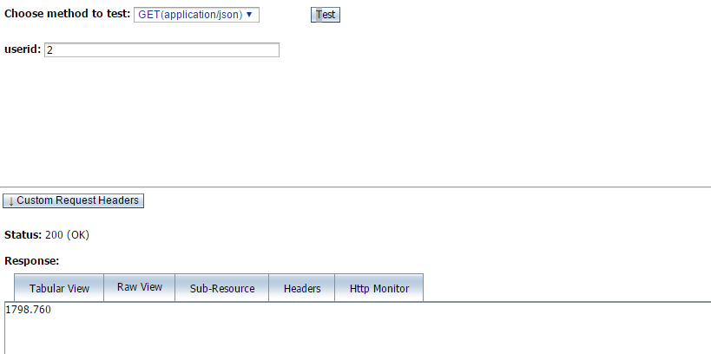
The result is user’s BMR which userid is 2.

2. Calculate the total daily calorie burned
- After calculating BMR, you need to write another REST method that calculate the total daily calorie burned
while at rest based on the user’s BMR and their activity level.
This is a method to calculate total calorie burned according to their level.
@GET
@Path("calculateTotalDailyCalorieBurned/{userid}")
@Produces({"application/json"})
public String calculateTotalDailyCalorieBurned(@PathParam("userid") int userid){
double BMR = Double.parseDouble(calculateBMR(userid));
double calorieTotalDailyBurned=0;
DecimalFormat df = new DecimalFormat("0.0000");
Query q = em.createQuery("select u from User u where u.userid = "+userid);
User user = (User)q.getSingleResult();
String level = user.getLevelOfActivity();
int i = Integer.parseInt(level);
switch(i){
case 1:
calorieTotalDailyBurned = BMR*1.2;
break;
case 2:
calorieTotalDailyBurned = BMR*1.375;
break;
case 3:
calorieTotalDailyBurned = BMR*1.55;
break;
case 4:
calorieTotalDailyBurned = BMR*1.725;
break;
case 5:
calorieTotalDailyBurned = BMR*1.9;
break;
}
return df.format(calorieTotalDailyBurned);
}

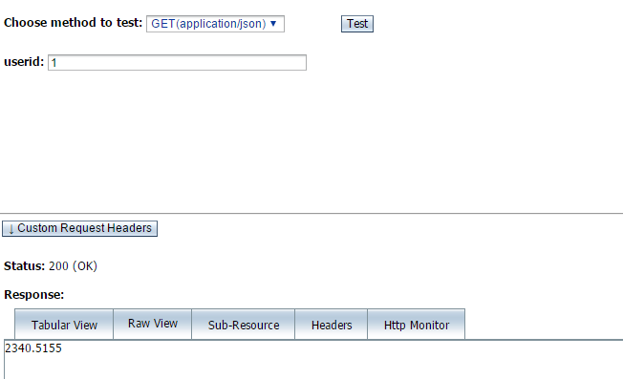

The result is user’s total daily calorie burned which userid is 1.

3. Calculate calories for all food consumed per day

- You need to create a REST method that calculates the total number of calories for all the food items consumed by a user per day (a certain date).

This method is in “FoodConsumed.java”. It use “userid” to get “foodid” then get “Foodcol”.

//******************************Calories From Total Food*************************
@GET
@Path("calculateCaloriesFromTotalFood/{userid}/{date}")
@Produces({"application/json"})
public String calculateCaloriesFromFood(@PathParam("userid") int userid,@PathParam("date") String date){
DecimalFormat df = new DecimalFormat("0.0000");
TypedQuery<FoodConsumed> q = em.createQuery("SELECT c FROM FoodConsumed c WHERE c.userid.userid = '"+userid+"' AND "+" c.date like "+"'%"+date+"%'",FoodConsumed.class);
double totalCalories = 0;
List <FoodConsumed> result = q.getResultList();
for(FoodConsumed r :result){
totalCalories+=Double.parseDouble(r.getFoodid().getFoodcol());
}
return df.format(totalCalories);
}

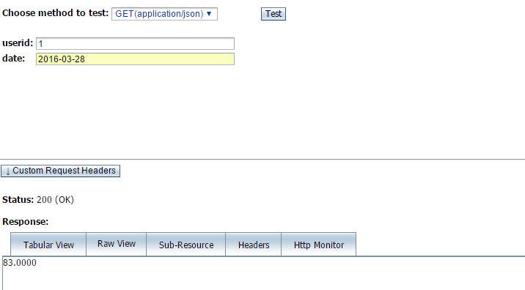
This is result of the method.

4. Calculate the calorie burned per steps
- You need to write a REST method that calculates the calories burned per steps taken for a user.

//******************************Calories Per Steps Taken*************************
@GET
@Path("calculateCaloriesPerStepsTaken/{userid}")
@Produces({"application/json"})
public String calculateCaloriesPerStepsTaken(@PathParam("userid") int userid){
DecimalFormat df = new DecimalFormat("0.0000");
Query query = em.createNamedQuery("User.findByUserid");
query.setParameter("userid",userid);
User user = (User)query.getSingleResult();
double average = Integer.parseInt(user.getUserweight())*0.49*2.2046/Integer.parseInt(user.getStepsPerMile());
return df.format(average);
}

It can use “userid” as a parameter to get “userweight”.
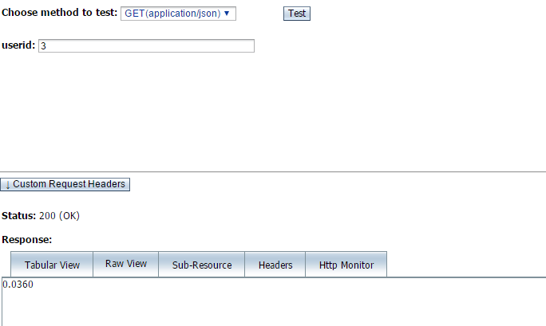
This is result of the method.

5. Provide the total calories burned and consumed for a user for specific day.
- You need to add another method to your RESTful web service. This method will accept a date as a parameter and provides the total calories burned and consumed for a user for that day.

This method use “userid” and “date” as the parameter to get burned and consumed calorie.
//*********************Total Calories Burned and Consumed One Day*************************
@GET
@Path("calculateTotalCaloriesBurnedAndConsumedOneDay/{userid}/{date}")
@Produces({"application/json"})
public String calculateTotalCaloriesBurnedAndConsumedOneDay(@PathParam("userid") int userid,@PathParam("date") String date){
DecimalFormat df = new DecimalFormat("0.0000");
TypedQuery<Report> q = em.createQuery("SELECT r FROM Report r WHERE r.userid.userid = "+userid+" AND r.date like "+"'%"+date+"%'",Report.class);
System.out.println(q);
Report r = q.getSingleResult();
String result = "{totalCalorieBurned :"+df.format(r.getCalorieBurned())+"} {calorieConsume:"+df.format(r.getCalorieConsumed())+"}";
return result;
}

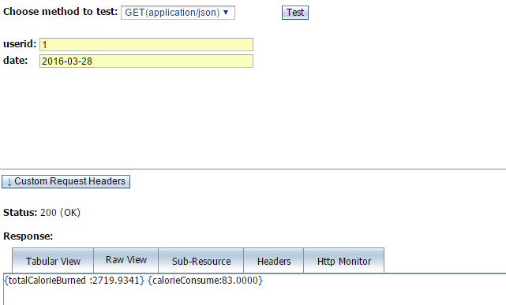
This is result of the method.

6. Provide the total calories burned and consumed for a user during specific period.
- You need to add the second method that will accept a starting date and ending date and provides the total calories burned and consumed for a user during that period.

//*******************Total Calories Burned and Consumed One Period*************************
@GET
@Path("calculateCalorieBurnedAndConsumeOnPeriod/{userid}/{begindate}/{enddate}")
@Produces({"application/json"})
public String calculateCalorieBurnedAndConsumeOnPeriod(@PathParam("userid") int userid,@PathParam("begindate") String begindate,@PathParam("enddate") String enddate) throws ParseException{
DecimalFormat df = new DecimalFormat("0.0000");
TypedQuery<Report> q = em.createQuery("SELECT r FROM Report r WHERE r.userid.userid ="+userid+" AND r.date between '"+begindate+"' AND '"+enddate+"'",Report.class);
List<Report> l =q.getResultList();
double totalCalorieBurned= 0;
double totalCalorieConsumed = 0;
for(Report r : l){
totalCalorieBurned+=r.getCalorieBurned();
totalCalorieConsumed+=r.getCalorieConsumed();
}
String result = "{TotalCalorieBurned :"+df.format(totalCalorieBurned)+"} {TotalCalorieConsumed:"+df.format(totalCalorieConsumed)+"}";
return result;
}

As you can see, the parameters are userid, begindate and enddate. I use method of “getCalorie_____” to calculate total.
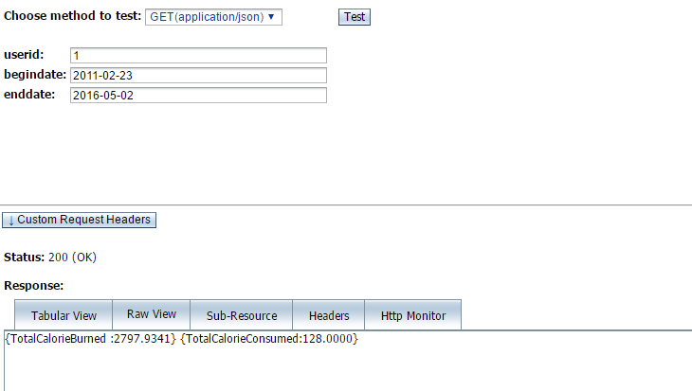
This is result of the method.

