Project Name:

Name | Serena Jeblee | Dina Sabie | Person C | Person D
Picture  (please ensure the photo is clear, cropped to fit the space, and the file is compressed) | 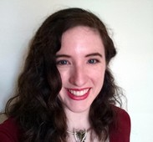 | 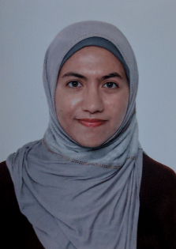 | 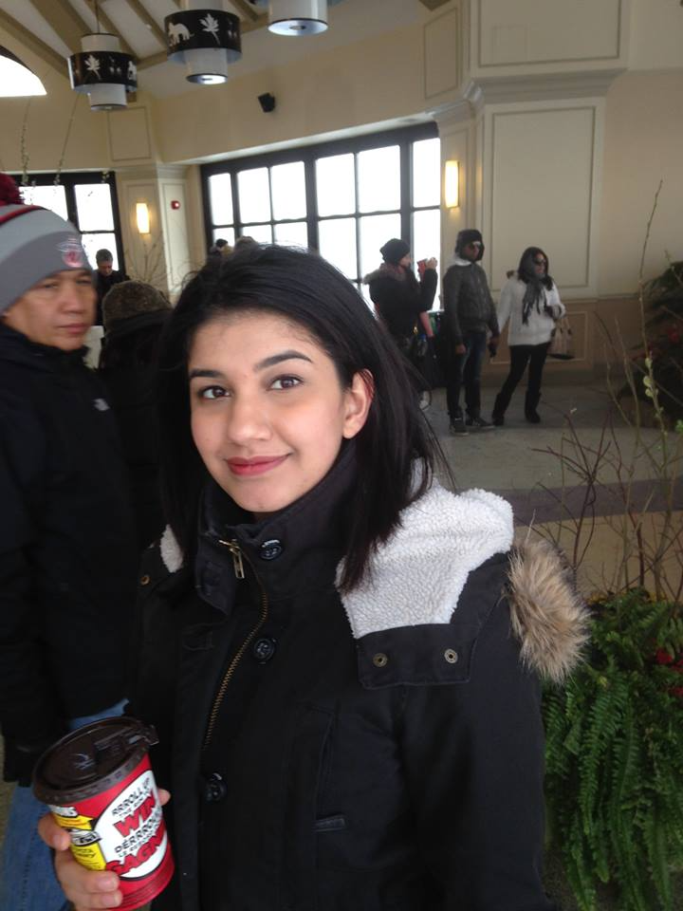 | 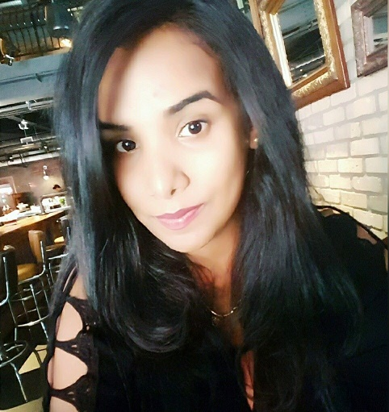
Email | sjeblee@cs.toronto.edu | dina.sabie@mail.utoronto.ca | shamama.khattak@mail.utoronto.ca | gurleen.kaur@mail.utoronto.ca
Instant Messenger ID
Phone Number | 437-777-4199 | 647-860-4948 | 416-757-9191 | 647-765-9494
Best times for meetings? | Any time but 2-4 Thurs | Any time | Mondays - before 12; 1-4  Wednesdays- before 12; 1-4; after 5  Thursdays – before 3; 5-6  Friday – before 12 ; 1-4; after 6 | Monday – before 6  Tuesday – 3-6  Wednesday - Anytime  Thursday – before 1; 3-6
Writing skills? | Good | Good | Average | Average
Organizational skills? | Excellent | Excellent | Average | Average
Research skills? | Excellent | Excellent
Behavioural/ social science background? | Fair | Good | None | None
Stats background? | Good | Fair | Good | Good
Experimental design background? | Fair | Fair | Fair | Fair
Special areas of interest? | AI, Machine Learning, NLP |  |  | AI, Web Designing
Anything else your team should know? |  | N/A

