Machine Translation of Egyptian Arabic
Using Morphological Analysis

Weston Feely, Serena Jeblee
Language Technologies Institute
Carnegie Mellon University
5000 Forbes Ave, Pittsburgh PA, 15213
wfeely@cs.cmu.edu, sjeblee@cs.cmu.edu

Abstract
We present the results of a machine translation experiment for Egyptian Arabic to English translation, using a newly created morphological analyzer for Egyptian Arabic and the freely available Moses decoder. The translation system we create is trained on an Egyptian Arabic-English bitext and a Levantine Arabic-English bitext. The BLEU scores attained on held out test sets for three data conditions (Egyptian data only, Levantine data only, and Egyptian and Levantine data) are compared, with each data set having no morphological analysis, with each data set pre-processed using our own morphological analyzer, and with each data set being pre-processed using MADA, a freely available morphological analyzer for Modern Standard Arabic. The best BLEU score of 17.51 is obtained using the MADA analyzer on the full Egyptian and Levantine data sets.
- Introduction
While there has been much research done on Modern Standard Arabic (MSA) in the Machine Translation community, there has been little work done on dialectal Arabic. We attempt to address the lack of research in dialectal Arabic MT by building an MT system for Egyptian Colloquial Arabic (EGY), the most spoken dialect of Arabic.
MSA is the standardized variety of Arabic used for formal speech and writing, which is based on millenia of Arabic literary history and is taught in schools. It exists in diglossia with a number of Arabic dialects. Diglossia is a phenomenon that is present in other languages such as Greek. This situation makes language processing difficult because the written language and the spoken language are not the same. Until recently, MSA was the only written form of Arabic, and so most of the available Arabic corpora are in MSA.
However, with the rise of the internet and social media, people have begun to write in dialectal Arabic, although Arabic dialects have no standardized spelling. In colloquial discourse, native Arabic speakers use their local dialects, many of which have low mutual intelligibility with each other and with MSA. Many of these dialects have several million speakers; Egyptian Arabic has 54 million speakers worldwide. Additionally, Egyptian Arabic is widely understood in other Arabic-speaking countries because of Egypt's large entertainment and movie industry.
Figure 1 is an example of the morphosyntactic differences between MSA and EGY for a sentence meaning "I do not speak Arabic."

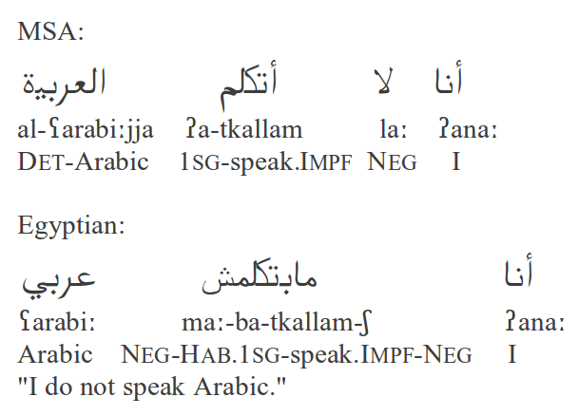
Figure 1: MSA and Egyptian Arabic Morphology Example

This is an example of how MSA and Egyptian Arabic differ in their use of a morphological affixes. The same verb for “speak” is accompanied by a negation auxiliary “la:” in MSA, while in Egyptian Arabic, a negation circumfix “ma- -$” performs the same grammatical function. The Egyptian verb prefix “ba-” carries the first person singular agreement features for the verb, but also carries habitual aspect. In contrast, the MSA first person singular verb prefix “?a-” does not have habitual aspect, since MSA does not have habitual aspect. In order to correctly translate such Egyptian Arabic verbs, these complex morphological affixes must be segmented and translated separately. However, currently there is no freely-available morphological analyzer that can do this for Egyptian Arabic, and popular morphological analyzers for MSA will fail to capture the morphemes like the negation circumfix described above when applied to Egyptian Arabic, which differ drastically from MSA morphemes.
As an example of current state-of-the-art MT for MSA and Egyptian Arabic, below is the Google Translate output of the same sentences as in the above figure. The Google Translate output for the above MSA sentence is the correct translation:
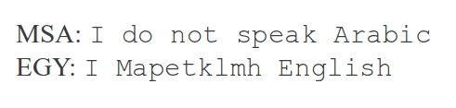
Figure 2: Google output of Arabic sentences from figure 1

Google Translate performs significantly better on MSA, as expected, because it is trained on MSA data. Figure 2 serves as an example that translation for Egyptian Arabic cannot be accomplished by a system that was only trained on MSA data.
- Previous Work
We base our approach to Egyptian Arabic-English machine translation on Zbib et al. (2012). The data sets for our experiments were also provided by Zbib et al, which included an Egyptian Arabic-English bitext and a Levantine Arabic-English bitext. They demonstrate the morphological decomposition (using Habash and Rambow 2005) improves Arabic translation, even when the decomposition is designed for MSA and used for dialectal Arabic.
Zbib et al (2012) acquired monolingual Arabic data that had been crawled from the web from the LDC, and created their bitext corpora by hiring workers on Amazon Mechanical Turk to identify the dialect of each sentence and translate it into English. They also attempted to filter out segments that were very similar to MSA.
Despite the quality control measures that Zbib et al used, the data was still translated by amateurs, and therefore the English reference translations are not always fluent or correct. It is also important to note that the Arabic data was pulled from the web, and is also not necessarily completely grammatical.
Zbib et al created different datasets by combining the dialect data with large amounts of MSA data, and their results show that adding another dialect or MSA to the target dialect can improve translation simply because the training set is much larger.
- Methods
Our experimental design includes using Moses (Koehn et al, 2007) to train a phrase-based machine translation system on several data sets. The three data sets are simply the Egyptian Arabic-English bitext, the Levantine Arabic-English bitext, and the two bitexts combined. We randomly choose 80% of the sentence pairs in each bitext as a training set, 10% as a development set for tuning, and the final 10% are used as the test set for each language condition. Table 1 shows the size of each dataset.

#Words | Train | Dev | Test
EGY | 260K | 36K | 36K
LEV | 916K | 116K | 116K
EGYLEV | 1.2M | 152K | 151K

Table 1: Dataset sizes in words
We train three translation systems using Moses (Koehn et al, 2007), with the only modification to the data being text normalization, a common pre-processing step for consistency in Arabic text languages, which removes Arabic diacritics from the text and normalizes the alif and final ya.. We report the BLEU scores for these three systems as our "no analysis" condition, for each language condition's test set, respectively.
We then train three more translation systems using the same data, with morphological analysis performed on the data beforehand, using MADA, a freely available MSA morphological analyzer and tokenizer created at Columbia University by Habash and Rambow (2005). MADA was created using a large MSA treebank, and it creates multiple morphological analyses for each word and chooses one best analysis using an SVM classifier trained on morphosyntactic features. The resulting three BLEU scores on the MADA analyzed test sets for each language are used for comparison with our own morphological analyzer.
We built our own Egyptian morphological analyzer using FOMA (Hulden, 2009), a freely available finite state transducer-based morphological analysis toolkit. We chose FOMA because it allows for rapid development of a morphological analyzer and it supports Arabic text.
The analyzer matches different parts of speech and various prefixes and suffixes that those words can take. We split off object suffixes and preposition prefixes, in addition to determiners and negation circumfixes. We leave number and gender markers in tact. The output is a tokenization of the input word, which may be several new pseudo-words. Figure 3 shows the kind of morphology-based tokenization that our analyzer produces.
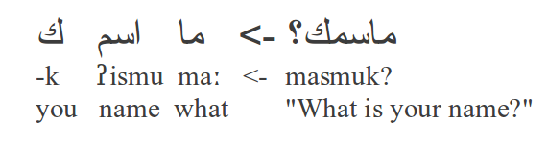
Figure 3: Morphological decomposition

Our FOMA analyzer produces multiple analyses for some Egyptian Arabic words, in which case we randomly choose one analysis, since we did not have labeled data to train a classifier to choose the best analysis. We pre-process the original data from the original "no analysis" condition using own FOMA analyzer, and report the BLEU scores on the FOMA analyzed test sets for each language condition.
Additionally, we used FOMA to create Levantine-to-Egyptian Arabic transformation rules, which replace single Levantine lexical items with their Egyptian Arabic equivalents. Although Levantine is classified as a different dialect, it is perhaps the most similar dialect to Egyptian, and the syntax is very similar. By converting certain functions and patterns to be more like Egyptian, we can leverage the larger amount of Levantine data that is available to train a better Egyptian translation system. Figure 4 is an example of one of the lexical substitutions that the transformation produces.
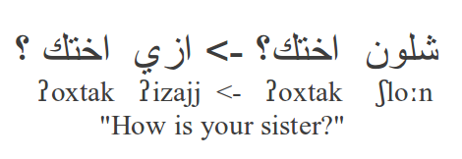
Figure 4: Levantine to Egyptian transformation

In order to determine whether these transformations rules have a greater effect on our BLEU score improvements over the "no-analysis" condition, we separate out the analysis and transformation into two FOMA modules, and use each to pre-process the original data for three additional conditions: one for the FOMA analyzer only and no transformation rules, one condition for the FOMA transformation rules only and no analysis, and one combined condition for both FOMA analysis and Levantine-to-Egyptian transformation rules. Due to lack of time, we only report the BLEU scores for the Egyptian and Levantine combined data condition, in the separated FOMA analysis only and Levantine-to-Egyptian transformation rules only conditions.
- Results

Data Set | No Analysis | MADA Analysis | FOMA Analysis | LEV Transformation Rules | FOMA Analysis + LEV Transformation Rules
EGY | 13.26 | 15.28 |  | N/A | 13.88
LEV | 15.80 | 17.10 |  |  | 16.03
EGYLEV | 16.09 | 17.51 | 16.35 | 16.17 | 16.39

Table 2: BLEU Scores Results from Moses Decoder

We evaluate the output of our system with BLEU, following Zbib et al.
- Discussion
We obtain the best results using MADA with the EGYLEV dataset. The EGYLEV dataset performs the best overall because it has the largest amount of data.
By applying the Levantine transformation rules to the data, we gain 0.08 BLEU improvement. With morphological analysis alone we gain 0.26 BLEU points, and both analysis and transformation gains 0.30 BLEU points over the baseline. However, applying MADA gets a 1.42 BLEU improvment.
- Conclusions and Future Work
In the future we would like to test different levels of morphological analysis to find the optimal tokenization scheme for Egyptian Arabic. We currently use a scheme that attempts to create tokens that will align well with English, however, this may not be the best approach, so we would like to empirically determine the best level of segmentation for this translation task.
We would also like to add more complicated rules for converting Levantine into Egyptian. We do some simple lexical replacements, but we would like to add word re-ordering and more specific pattern-matching to make the syntax and style of the Levantine sentences more like Egyptian.
In order to the pick the best analysis from the multiple options output by the analyzer, we would like to use an unsupervised machine learning approach to learn to pick the best analysis. This will make our morphological decomposition more accurate, and hopefully improve translation.

TODO: Further investigate the effect of analysis vs. transformation rules on results (plan to report more results here)

To further compare to the results of Zbib et al, we hope to train a system on a combination of MSA and dialect data to see if the addition of MSA data will still improve translation with a dialect-specific morphological analyzer. This is a practical approach because of the volume of monolingual and bitext MSA corpora that are available.
References
Nizar Habash and Owen Rambow. 2005. Arabic tokenization, part-of-speech tagging and morphological disambiguation in one fell swoop. In Proceedings of the 43rd Annual Meeting of the Association for Computational Linguistics (ACL). Ann Arbor, Michigan.
Hulden, M. 2009. foma: a finite-state compiler and library. In EACL 2009 Proceedings, pages 29-32.
Philipp Koehn et al. 2007. Moses: Open Source Toolkit for Statistical Machine Translation. In Proceedings of the Annual Meeting of the Association for Computational Linguistics (ACL), demonstration session. Prague, Czech Republic.
Rabih Zbib et al. 2012. Machine Translation for Arabic Dialects. In Proceedings of NAACL 2012. Montreal, Canada.

