Title Goes Here

Gwanggyu Sun1,✉, Stevan Jeknic1,✉, and Tom Handley1,✉

10 December, 2021

Text of abstract

1 Stanford University

✉ Correspondence: [Gwanggyu Sun <[ggsun@stanford.edu](mailto:ggsun@stanford.edu)>](mailto:ggsun@stanford.edu), [Stevan Jeknic <[sjeknic@stanford.edu](mailto:sjeknic@stanford.edu)>](mailto:sjeknic@stanford.edu), [Tom Handley <[thandley@stanford.edu](mailto:thandley@stanford.edu)>](mailto:thandley@stanford.edu)

Keywords: transcription; mRNA degradation; elongation

Highlights: Quantitative halflives and elongation rates for individual mRNA species.

# 1 Introduction

Quantitative data regarding the rates of mRNA degradation and transcript elongation are sparse. Typically, mathematical models involving these processes, use a single rate constant that applies to all mRNA species. However, recent work1 has shown that this assumption is not valid. As such, we focused on using some of these recently collected data to visualize the distribution of individual mRNA lifetimes and elongation rates.

# 2 Background

# 3 Methods

We are using RNA-seq data that were collected in exponentially growing *E*. *coli* cells by Chen et al.1.

# 4 Results

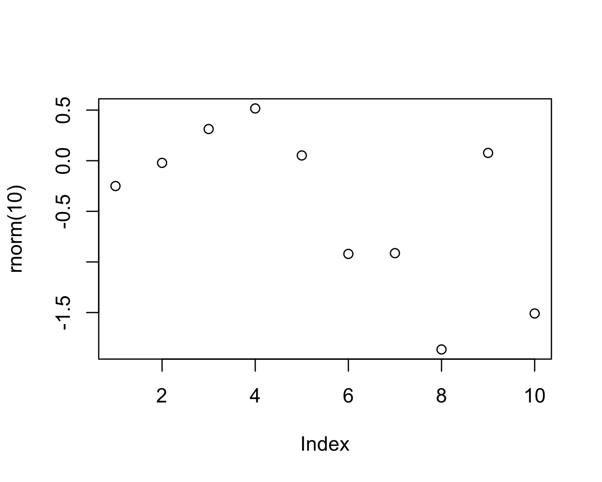

Figure 4.1: A plot of random numbers

Figure 4.1 shows how we can have a caption and cross-reference for a plot

Here is an example of inline code 3.14 in the middle of a sentence.

# 5 Discussion

# 6 Conclusion

# 7 Acknowledgements

# 8 References

1. Chen, H., Shiroguchi, K., Ge, H. & Xie, X. S. Genome-wide study of mRNA degradation and transcript elongation in escherichia coli. *Molecular Systems Biology* **11**, 781 (2015).

### 8.0.1 Colophon

This report was generated on 2021-12-10 10:28:16 using the following computational environment and dependencies:

The current Git commit details are: