Maxspeed

Stevan Jeknic1,✉

29 November, 2021

1 Stanford University

✉ Correspondence: [Stevan Jeknic <[sjeknic@stanford.edu](mailto:sjeknic@stanford.edu)>](mailto:sjeknic@stanford.edu)

Keywords:

Highlights:

# 1 Introduction

This is a replication of (Fig. 4.1) from

$$@hirt2017$$

.

# 2 Background

# 3 Methods

# 4 Results

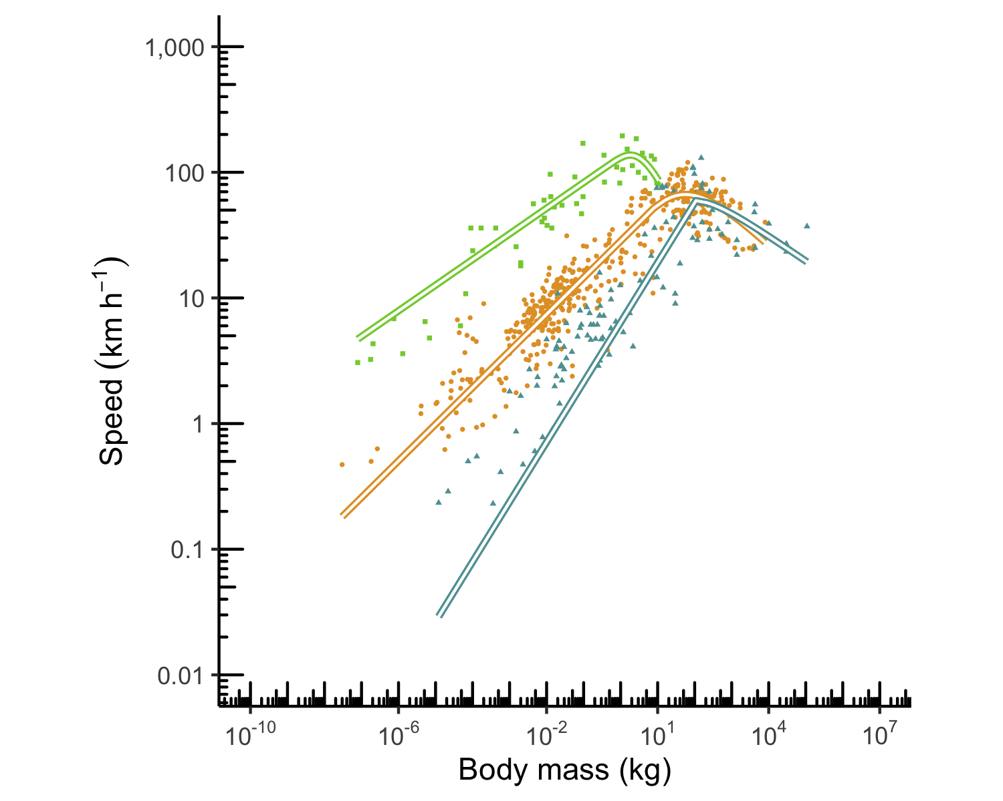

Figure 4.1: Replication of figure 2a from1

# 5 Discussion

# 6 Conclusion

# 7 Acknowledgements

# 8 References

1. Hirt, M. R., Jetz, W., Rall, B. C. & Brose, U. A general scaling law reveals why the largest animals are not the fastest. *Nature Ecology & Evolution* **1**, 1116–1122 (2017).

### 8.0.1 Colophon

This report was generated on 2021-11-29 12:02:44 using the following computational environment and dependencies:

#> ─ Session info 🔶 🙏🏾 💑 ─────────────────────────────────────────────────  
#> hash: large orange diamond, folded hands: medium-dark skin tone, couple with heart  
#>   
#> setting value  
#> version R version 4.1.2 (2021-11-01)  
#> os macOS Monterey 12.0.1  
#> system x86_64, darwin21.1.0  
#> ui unknown  
#> language (EN)  
#> collate en_US.UTF-8  
#> ctype en_US.UTF-8  
#> tz America/Los_Angeles  
#> date 2021-11-29  
#> pandoc 2.14.0.3 @ /Applications/RStudio.app/Contents/MacOS/pandoc/ (via rmarkdown)  
#>   
#> ─ Packages ───────────────────────────────────────────────────────────────────  
#> ! package * version date (UTC) lib source  
#> assertthat 0.2.1 2019-03-21 [1] CRAN (R 4.1.2)  
#> bookdown 0.24 2021-09-02 [1] CRAN (R 4.1.2)  
#> cachem 1.0.6 2021-08-19 [1] CRAN (R 4.1.2)  
#> callr 3.7.0 2021-04-20 [1] CRAN (R 4.1.2)  
#> cellranger 1.1.0 2016-07-27 [1] CRAN (R 4.1.2)  
#> cli 3.1.0 2021-10-27 [1] CRAN (R 4.1.2)  
#> colorspace 2.0-2 2021-06-24 [1] CRAN (R 4.1.2)  
#> commonmark 1.7 2018-12-01 [1] CRAN (R 4.1.2)  
#> crayon 1.4.2 2021-10-29 [1] CRAN (R 4.1.2)  
#> DBI 1.1.1 2021-01-15 [1] CRAN (R 4.1.2)  
#> desc 1.4.0 2021-09-28 [1] CRAN (R 4.1.2)  
#> devtools 2.4.2 2021-06-07 [1] CRAN (R 4.1.2)  
#> digest 0.6.28 2021-09-23 [1] CRAN (R 4.1.2)  
#> dplyr * 1.0.7 2021-06-18 [1] CRAN (R 4.1.2)  
#> ellipsis 0.3.2 2021-04-29 [1] CRAN (R 4.1.2)  
#> evaluate 0.14 2019-05-28 [1] CRAN (R 4.1.2)  
#> fansi 0.5.0 2021-05-25 [1] CRAN (R 4.1.2)  
#> farver 2.1.0 2021-02-28 [1] CRAN (R 4.1.2)  
#> fastmap 1.1.0 2021-01-25 [1] CRAN (R 4.1.2)  
#> fs 1.5.0 2020-07-31 [1] CRAN (R 4.1.2)  
#> generics 0.1.1 2021-10-25 [1] CRAN (R 4.1.2)  
#> ggplot2 * 3.3.5 2021-06-25 [1] CRAN (R 4.1.2)  
#> glue 1.5.0 2021-11-07 [1] CRAN (R 4.1.2)  
#> gtable 0.3.0 2019-03-25 [1] CRAN (R 4.1.2)  
#> here 1.0.1 2020-12-13 [1] CRAN (R 4.1.2)  
#> highr 0.9 2021-04-16 [1] CRAN (R 4.1.2)  
#> htmltools 0.5.2 2021-08-25 [1] CRAN (R 4.1.2)  
#> knitr 1.36 2021-09-29 [1] CRAN (R 4.1.2)  
#> lifecycle 1.0.1 2021-09-24 [1] CRAN (R 4.1.2)  
#> magrittr 2.0.1 2020-11-17 [1] CRAN (R 4.1.2)  
#> R maxspeed * 0.0.0.9000 <NA> [?] <NA>  
#> memoise 2.0.1 2021-11-26 [1] CRAN (R 4.1.2)  
#> munsell 0.5.0 2018-06-12 [1] CRAN (R 4.1.2)  
#> pillar 1.6.4 2021-10-18 [1] CRAN (R 4.1.2)  
#> pkgbuild 1.2.0 2020-12-15 [1] CRAN (R 4.1.2)  
#> pkgconfig 2.0.3 2019-09-22 [1] CRAN (R 4.1.2)  
#> pkgload 1.2.3 2021-10-13 [1] CRAN (R 4.1.2)  
#> prettyunits 1.1.1 2020-01-24 [1] CRAN (R 4.1.2)  
#> processx 3.5.2 2021-04-30 [1] CRAN (R 4.1.2)  
#> ps 1.6.0 2021-02-28 [1] CRAN (R 4.1.2)  
#> purrr 0.3.4 2020-04-17 [1] CRAN (R 4.1.2)  
#> R6 2.5.1 2021-08-19 [1] CRAN (R 4.1.2)  
#> Rcpp 1.0.7 2021-07-07 [1] CRAN (R 4.1.2)  
#> readxl 1.3.1 2019-03-13 [1] CRAN (R 4.1.2)  
#> remotes 2.4.1 2021-09-29 [1] CRAN (R 4.1.2)  
#> rlang 0.4.12 2021-10-18 [1] CRAN (R 4.1.2)  
#> rmarkdown 2.11 2021-09-14 [1] CRAN (R 4.1.2)  
#> roxygen2 7.1.2 2021-09-08 [1] CRAN (R 4.1.2)  
#> rprojroot 2.0.2 2020-11-15 [1] CRAN (R 4.1.2)  
#> rstudioapi 0.13 2020-11-12 [1] CRAN (R 4.1.2)  
#> scales 1.1.1 2020-05-11 [1] CRAN (R 4.1.2)  
#> sessioninfo 1.2.1 2021-11-02 [1] CRAN (R 4.1.2)  
#> stringi 1.7.6 2021-11-29 [1] CRAN (R 4.1.2)  
#> stringr 1.4.0 2019-02-10 [1] CRAN (R 4.1.2)  
#> testthat 3.1.0 2021-10-04 [1] CRAN (R 4.1.2)  
#> tibble 3.1.6 2021-11-07 [1] CRAN (R 4.1.2)  
#> tidyselect 1.1.1 2021-04-30 [1] CRAN (R 4.1.2)  
#> usethis 2.1.3 2021-10-27 [1] CRAN (R 4.1.2)  
#> utf8 1.2.2 2021-07-24 [1] CRAN (R 4.1.2)  
#> vctrs 0.3.8 2021-04-29 [1] CRAN (R 4.1.2)  
#> withr 2.4.2 2021-04-18 [1] CRAN (R 4.1.2)  
#> xfun 0.28 2021-11-04 [1] CRAN (R 4.1.2)  
#> xml2 1.3.2 2020-04-23 [1] CRAN (R 4.1.2)  
#> yaml 2.2.1 2020-02-01 [1] CRAN (R 4.1.2)  
#>   
#> [1] /usr/local/Cellar/r/4.1.2/lib/R/library  
#>   
#> R ── Package was removed from disk.  
#>   
#> ──────────────────────────────────────────────────────────────────────────────

The current Git commit details are:

#> Local: main /Users/sjeknic/Documents/Stanford_University/Year7/software_eng/maxspeed  
#> Remote: main @ origin (https://github.com/sjeknic/maxspeed.git)  
#> Head: [74ea3dc] 2021-11-29: updated readme